VicGrid

Proposed North West

Renewable Energy Zone
  - August 2025
A renewable energy zone is proposed between Kerang and Swan Hill as part of the 2025 Victorian Transmission Plan (see Figure 2). Before being officially declared by the Minister for Energy and Resources, there will be a further chance to provide your feedback. See section ‘Next steps’ below.

What is a renewable energy zone?
Renewable energy zones are areas identified as the best places to host wind and solar projects and batteries for storage. In designing these areas we’ve considered community and industry feedback as well as information about cultural heritage, existing uses of land, and quality of wind and solar energy in the region.

Why do we need renewable energy zones?
Victoria’s energy system is changing as coalfired power stations are becoming unreliable and closing down. VicGrid is working to put in place a long-term plan to deliver the safe, reliable and affordable power Victoria needs to keep the lights on. Renewable energy zones will:
- unlock new economic benefits for regional communities and Traditional Owners
- limit the need for additional transmission infrastructure
- help set clear expectations for how project developers engage and involve the community
- provide greater certainty about how and where renewables projects should be built.
Figure 1 North West Renewable Energy Zone Location
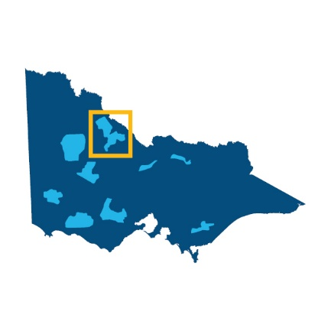
Six proposed zones have been identified in regional Victoria. Together, they cover 7.9% of the state’s land area.

It’s your choice
Developers must talk to landholders to get permission to build renewable generation projects (such as wind turbines, large scale solar farms or batteries) on their land. Landholders can choose whether or not to host a project.
Landholders who do host renewable generation projects will receive financial payments and benefits that they negotiate with the developer. Dedicated community benefits will also apply to projects developed in renewable energy zones. This ensures the whole community benefits from development.

Have your say
The proposed North West Renewable Energy Zone will soon be placed on public notice for 6 weeks to provide the opportunity for comments and submissions. The Minister for Energy and Resources must consider any submissions when determining whether the renewable energy zone should be officially declared. For more information, see ‘Next steps’ below.

The proposed North West Renewable Energy Zone
The proposed North West Renewable Energy Zone includes parts of the Swan Hill, Gannawarra, Loddon and Buloke local government areas. It sits within the Registered Aboriginal Party boundaries of Wamba Wemba Aboriginal Corporation, Dja Dja Wurrung Clans Aboriginal Corporation and across areas of Country to the east that do not have a formally recognised Traditional Owner group.
When identifying this zone we aimed to carefully balance community concerns about the potential impacts of uncoordinated widespread development with developer interest and the pressing need to position renewable energy zones with access to strong wind and solar energy and near existing transmission lines.
This proposed zone will help contain development and coordinate connections to the Victoria to New South Wales Interconnector West (VNI West) project and existing lines, and ensure regional benefits are delivered to those experiencing the impacts of infrastructure development.
In response to feedback that the size and generation capacity of renewable energy zones needed to provide more flexibility, further assessment was undertaken to identify potential areas suitable to include in the zone. Given the sensitive areas of biodiversity and land use surrounding the proposed North West Renewable Energy Zone, changes to the zone were limited to a small expansion south-west along the Victoria to New South Wales Interconnector West (VNI West) corridor, providing more options for future generation projects to connect to VNI West.

How to read the map
The map in ‘figure 2’ shows the proposed North West Renewable Energy Zone, including some of the significant land use and landscape values that influenced its location, size and shape. The identified land use and landscape values in the region are a sub-set only and are not exhaustive of the values present.

How much new energy are we planning for in the proposed North West Renewable Energy Zone?
Once renewable energy zones are declared, VicGrid proposes to run a competitive allocation process to decide which projects in each zone have the authority to connect the energy they produce to the grid.
We will consider:
- the amount of electricity Victoria needs to generate to meet expected demand as outlined in the Victorian Transmission Plan
- ensuring the level of development inside each zone can be supported by available transmission lines
- the density of projects within each renewable energy zone
- how development can be coordinated to avoid the ‘spaghetti effect’ of many powerlines crossing the landscape
- whether developers are meeting expectations for landholder, community and Traditional Owner engagement and benefits.
This will ensure we ultimately produce enough energy to meet demand while also considering the impact on communities, Traditional Owners, agriculture and the environment.
We are proposing to set access limits for each zone at the maximum amount that can be managed by the planned build-out of the transmission network.
This is not the level of development people should expect in each zone but is the maximum that the transmission network can support within the zone

The proposed North West Renewable Energy Zone
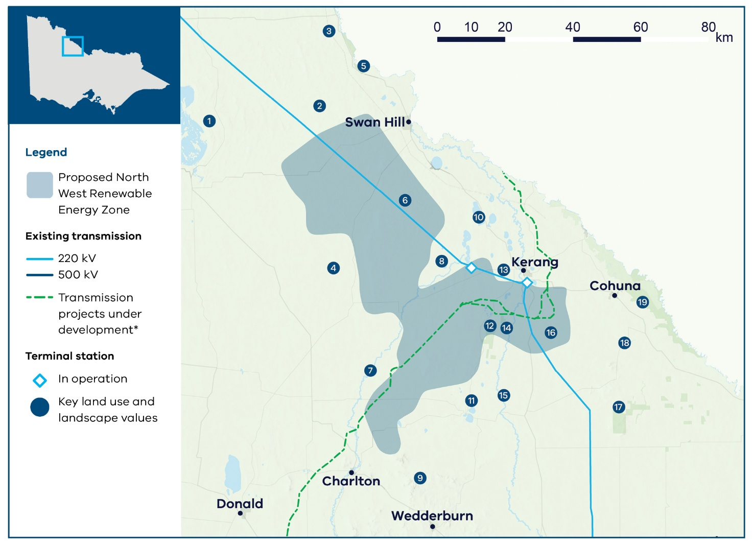
Figure 2 The proposed North West Renewable Energy Zone
Note:Transmission projects under development - The map shows transmission projects under development including transmission projects defined as Committed and Anticipated or Actionable under the Australian Energy Market Operator’s 2024 Integrated System Plan. This map displays the proposed alignment for Western Renewables Link.
Note: Committed terminal station’ includes new terminal stations on the Victorian Declared Shared Network that are proposed to be operational in the coming years, as identified by AEMO Victorian Planning in its Terminal Stations in Victoria report dated 2 September 2024.

Key land use and landscape values
- Biodiversity/cultural/ community: Lake Tyrrell and surrounding sensitive landscape
- Mining: Minerals retention licence
- Agriculture: High agricultural productivity area with irrigated horticulture, dairy and cropping along the Murray River
- Biodiversity/cultural: Lalbert Lake, Lalbert Creek and surrounding areas of sensitivity
- Biodiversity/cultural/ community: Murray River and surrounding sensitive landscapes
- Biodiversity/cultural: Avoca River and surrounding areas of sensitivity
- Mining: Mining licence applications and retention licence
- Biodiversity: Protected biodiversity area for native flora and fauna
- Biodiversity/cultural: Wychitella Nature Conservation Reserve, home to native flora and fauna
- Biodiversity: Kerang Lakes Ramsar-listed wetlands
- Biodiversity/cultural: Wetlands and parks surrounding Boort
- Biodiversity/cultural: Leaghur State Park and Meran Lakes Complex, protected biodiversity area for native flora and fauna
- Biodiversity: Protected biodiversity area for native flora and fauna
- Flooding risk: Floodplains across the Loddon River catchment area
- Biodiversity/cultural: Loddon River and surrounding areas of sensitivity
- Agriculture: High agricultural productivity area with irrigated horticulture, dairy and cropping within the Goulburn Murray Irrigation District
- Biodiversity/cultural/ community: Terrick Terrick National Park
- Biodiversity/cultural: Wetlands and waterways with surrounding areas of sensitivity, including protected biodiversity areas
- Biodiversity/cultural/ community: Gunbower National Park and surrounding sensitive parks and wetlands (swamps)

Acting on community feedback
Community and industry views have been crucial to the design of the 2025 Victorian Transmission Plan.
VicGrid’s role is to balance the need for new renewable projects that will deliver reliable and affordable power as coal closes with a range of other factors, including how we minimise impacts on landholders, communities, agriculture, the environment and power bills.
Not all community or industry requests have been adopted. The Victorian Transmission Plan reflects difficult choices, made by weighing up many factors to deliver a plan that best serves all Victorians.
We have used the feedback received during engagement on the renewable energy zone study area and draft Victorian Transmission Plan Guidelines in 2024 and again during engagement on the draft Victorian Transmission Plan in 2025 to shape the size and location of the proposed renewable energy zone.

What we heard
- Protect important agricultural land.
- Address concerns about widespread uncoordinated development, including cumulative impacts associated with the VNI West project.
- Protect local wetlands and habitat for many species, including the wedge-tailed eagle.
- Protect local lakes and forests, including Lake Meran and Leaghur State Park.
- Strong opposition to renewable energy generation in parts of the broader region.
- Some support to extend the renewable energy zone north of Kerang and calls from developers, landholders and local governments to increase the generation capacity of the zone to accommodate pipeline projects.

What we did
- Avoided irrigated farmland along the Murray River.
- Positioned the proposed renewable energy zone along an existing 220 kilovolt (kV) line.
- Avoided areas of high environmental value, including rivers, lakes, wetland systems, parks and reserves, particularly near the Murray River, Koorangie Wildlife Reserve and Korrak Korrak Nature Conservation Reserve.
- Sized and located the proposed zone to balance developer interest and community concerns.
- Added a small expansion south-west along the VNI West corridor providing more options for future generation projects to connect to VNI West.
- We recognise there are still rivers, lakes, wetland systems, parks and reserves within this zone that are not suitable for development. All of these will need to be carefully considered during project-level planning when assessing potential sites and designing projects.

Transmission network upgrades
The 2025 Victorian Transmission Plan also proposes 7 transmission infrastructure investment programs needed over 2025-2040, to enable development of renewable energy zones and offshore wind energy.
The programs include 4 new transmission projects: a Gippsland offshore wind transmission stage 2 project, a new line between Tarrone in South West Victoria and Sydenham in Melbourne’s north, a new line between Truganina and Deer Park in Melbourne, and an additional short line between Hazelwood and Yallourn in Gippsland. The other projects across the 7 programs range from augmentations within existing terminal stations to significant reconstruction of existing transmission lines.
Learn more about the transmission projects in the 2025 Victorian Transmission Plan on our website.

What will it be like living in a renewable energy zone?
If you live in or near a renewable energy zone, over time you will see more development of renewable energy generation and storage. You can choose whether or not to host new renewable energy such as wind turbines, solar farms or batteries on your property. It’s your decision and we encourage you to talk to your neighbours about it.
Existing planning and environment controls will still apply. All proposed projects will continue to be subject to the planning and environmental approval processes under the Planning and Environment Act 1987 and Environment Effects Act 1978.
VicGrid will work with developers to coordinate new development and associated transmission to minimise impacts on landscapes and the environment. Only a small proportion of land in a renewable energy zone will be needed for development.
You will also see new community and regional economic benefits delivered over time as part of the Victorian Government’s new Renewable Energy Zone Community Benefits Plan. This new approach will feature:
- the introduction of new Renewable Energy Zone Community Energy Funds to benefit regional and rural communities
- payments for landholders who host transmission
- guidance for payments for significantly impacted neighbours of new transmission
- a commitment to co-design a new approach to economic benefits for Traditional Owners.
Renewable Energy Zone Community Energy Funds are an opportunity to invest directly in projects that improve local outcomes and create other benefits for communities in regions hosting energy infrastructure.
Local decision-making that responds to local needs and priorities will be a cornerstone of these funds and decisions about investments will be made in consultation with regional community reference groups with broad community and industry representation.
In addition to government initiatives, developers of projects will be required to implement their own community benefits programs.
The final Renewable Energy Zone Community Benefits Plan is set to be released in coming months. Learn more about community benefits.

Next steps
Communities within proposed renewable energy zones can continue to provide feedback and seek more information about renewable energy zones, including through face-to-face meetings with VicGrid.
We will invite formal feedback about the proposed North West Renewable Energy Zone as part of the official declaration process. There will be 6 weeks of consultation, to begin in coming weeks, which will give landholders, communities and Traditional Owners another opportunity to provide feedback and shape decision-making.

Email updates
To stay up to date about the renewable energy zone declaration process and VicGrid’s work, subscribe for our email updates at vicgrid.vic.gov.au

Call or email us
Call us on 1800 418 341 or email vicgrid@deeca.vic.gov.au

Contact us
Phone: 1800 418 341
Email: vicgrid@deeca.vic.gov.au
Deaf, hearing or speech impaired? Please contact the National Relay Service on 133 677 or communications.gov.au/accesshub/nrs
Need an interpreter? Contact Translating and Interpreting Service (TIS) on 131 450 (within Australia) or visit www.tisnational.gov.au
ISBN 978-1-76176-461-5 (Print)
ISBN 978-1-76176-462-2 (pdf/online/MS word)
Disclaimer: The information in this document is current at the time of printing, may be subject to change and should not be relied upon. Please visit vicgrid.vic.gov.au for the latest updates.

