Draft 2025 Victorian Transmission Plan Final Engagement Report
  - What We Heard
  - August 2025

Acronyms
Term | Definition
AEC | Australian Energy Council
AEIC | Australian Energy Infrastructure Commissioner
AEMO | Australian Energy Market Operator
AER | Australian Energy Regulator
BESS | Battery energy storage system
CEC | Clean Energy Council
CEFC | Clean Energy Finance Corporation
CEIG | Clean Energy Investor Group
CER | Consumer Energy Resources
CFA | Country Fire Authority
C4NET | Centre for New Energy Technologies
DEECA | The Department of Energy, Environment and Climate Action
DSN | Declared Shared Network
EES | Environmental Effects Statement
EUAA | Energy Users Association of Australia
FCA | Farmers for Climate Action
GIA | Grid Impact Assessment
GPS | Global positioning system
HVAC | High voltage alternating current
HVDS | High voltage distribution system
IAP2 | The International Association of Public Participation
OSW | Offshore Wind
OG12 | Offshore Gippsland 12
PiLoR | Payment in Lieu of Rates
RCV | Regional Cities Victoria
REZ | Renewable energy zone
RIT-T | Regulatory Investment Test for Transmission
VAGO | Victorian Auditor-General’s Office
VFF | Victorian Farmers Federation
VNI West | Victoria to New South Wales Interconnector West
VTIF | Victorian Transmission Investment Framework
VTP | Victorian Transmission Plan
WRL | Western Renewables Link

Acknowledgment of Traditional Owners
We acknowledge and respect Victoria’s Traditional Owners as the original custodians of Victoria’s land and waters, their unique ability to care for Country and deep spiritual connection to it. We honour Elders past and present whose knowledge and wisdom has ensured the continuation of culture and traditional practices.
We are committed to genuinely partnering and meaningfully engaging with Victoria’s Traditional Owners and First Peoples to support the protection of Country, the maintenance of spiritual and cultural practices and their broader aspirations in the 21st century and beyond

Contents
Contents
Executive summary 4
Engagement results overview 5
Community and local government themes 5
Traditional Owner themes 6
Energy industry themes 7
How this feedback will be applied 8
Next steps 9
Introduction 10
The engagement journey so far 10
Methodology 12
Engagement principles 12
VicGrid engaged with the following stakeholder groups 12
Engagement opportunities included 13
Thematic insights 15
Statewide community and local government feedback 15
Agriculture sector feedback 20
Energy industry feedback 21
Regional insights 25
Central Highlands 25
South West 29
Grampians Wimmera 32
Wimmera Southern Mallee 35
North West 39
Central North 43
Gippsland 47
Gippsland Shoreline 51
Greater Melbourne 54
Application of feedback on the draft Victorian Transmission Plan 56
Application of community and industry feedback on the draft proposed renewable energy zones 58
Central Highlands 58
Western 59
North West 61
Central North 61
Gippsland 62
Gippsland Shoreline Renewable Energy Zone 62
Feedback on the impact to the regions, community benefits and access and connections 63
Feedback on transmission planning 64
Feedback on storage 64
Next steps 65
Appendix 1 66
Engagement events 66
Appendix 2 69
Contact us 71

Executive summary
VicGrid is the Victorian Government body responsible for implementing a new approach to planning and developing the infrastructure that will carry renewable energy to Victorian homes, businesses, hospitals, schools and other vital services. This new approach includes delivering a long-term strategic plan for renewable energy infrastructure and transmission development in Victoria – the Victorian Transmission Plan (VTP). Central to this approach is giving landholders, communities and First Peoples a real voice in the process.
VicGrid’s role is to balance the need for new renewable energy and transmission projects that will deliver reliable and affordable power as coal-fired power stations close with a range of other factors, including how we minimise impacts on landholders, communities, agriculture and the environment.
VicGrid is also committed to engaging with communities, landholders, regional stakeholders and the energy industry to explore how we can effectively work to incorporate local insights and values in the detailed design of future transmission projects. Incorporating community and industry views early and often means we can make better decisions that minimise impacts and maximise benefits for Victorians.
This report summarises engagement on the draft 2025 VTP and builds on engagement that began in 2023 with the Renewable Energy Planning Survey. This survey informed the process to identify a renewable energy zone study area, which mapped areas of the state to investigate for suitability to host renewable energy generation. This helped ensure that land use, social, cultural and environmental factors were taken into account from the very start of the process, where in the past the only considerations were technical and economic.
The study area and the draft VTP Guidelines were released on 22 July 2024, giving communities, landholders, First Peoples and industry the opportunity to provide further feedback on the methodology behind the VTP and the study area.
This feedback was then incorporated into the draft 2025 VTP, which was released on 16 May for consultation. The draft 2025 VTP sets out:
- how much more wind and solar energy Victoria is expected to need over the next 15 years
- draft proposed renewable energy zones – 7 areas across the state identified as suitable to host new renewable energy generation, such as wind turbines and solar farms, and energy storage
- a draft proposed Gippsland Shoreline Renewable Energy Zone (REZ) – a limited area where offshore wind developers will need to locate onshore infrastructure to connect their projects to the grid
- proposed transmission projects needed over 2025-2040, to enable development of renewable energy zones and offshore wind farms.
The release of the draft 2025 VTP commenced a formal 6-week consultation period. This report outlines the feedback received during engagement with First Peoples, landholders, communities and industry on the draft 2025 VTP.
It covers feedback on the 7 draft proposed renewable energy zones that were included in the draft 2025 VTP, while acknowledging there are now 6 proposed renewable energy zones included in the final 2025 VTP.
Engagement opportunities included:
- In-person community drop-in sessions
- Online community and industry webinars
- Meetings with councils, community groups and members
- Opportunity to provide feedback via email and a purpose-designed contact centre
- Briefings with Victoria’s formally recognised Traditional Owner corporations
- Briefings with peak bodies, local government authorities and other key stakeholders
- Meetings with renewable energy developers
- Written submissions
- Feedback forms.
Between 16 May and 24 June 2025, we received more than 260 feedback forms, more than 460 submissions, conducted more than 50 industry briefings, more than 100 community briefings and held conversations with 400-plus community members during drop-in sessions.
Thanks to those who gave their time to be involved and provided feedback on the draft 2025 VTP. These responses provided valuable insights that we will continue to draw on as we develop the 2025 VTP and beyond.
In total we received the following engagement responses:
- 261 feedback forms
- 70 project survey response forms
- 461 submissions
- 69 contact centre enquires
- 65 community and industry events
- Over 100 briefings with local councils, community groups and community members
- Over 20 briefings with energy industry peak bodies
- 50 meetings with renewable energy developers
- 18,187 unique visitors to the draft VTP Engage Victoria webpage.

Engagement results overview

Community and local government themes
Responses to the feedback forms, submissions, meetings, briefings, emails, contact centre enquiries and community drop-in sessions revealed some key themes.
Impact on the regions: We heard concerns about the impost on regional areas to service metropolitan energy demands, community division linked to developer behaviour, and concerns about industrialisation of regions. There was also feedback about compounding stresses on communities from multiple projects and plans across renewable energy and beyond.
Transmission planning: We heard feedback about potential impacts of transmission infrastructure, particularly overhead high-voltage lines. Communities raised concerns about potential impacts of above-ground transmission on visual amenity, perceived fire risk, health concerns and farming activities, advocating for underground alternatives. We also heard feedback about the Western Renewables Link (WRL) and the Victoria to New South Wales Interconnector West (VNI West) with frustration around perceptions of unclear route planning, inadequate consultation, and cost prioritisation over long-term community and environmental wellbeing.
Engagement feedback: We heard feedback about the accessibility of the VTP, the choice of engagement channels, awareness of engagement and concerns about the impact feedback would have on the VTP. Some respondents felt the consultation process was tokenistic, while others praised the inclusivity of channels and responsiveness of engagement. Additional concerns included government coordination and consultation fatigue.
Agriculture and land use: Respondents stressed the need to protect high-value farmland and raised concerns about impacts to farming activities and farm productivity. There was also some positive feedback about VicGrid’s efforts to avoid farmland in the draft proposed renewable energy zones.
Renewable energy zone design: Feedback suggested specific changes to renewable energy zones including requests to extend or shift boundaries of some zones. These requests were often related to geographical features or areas of local importance.
Energy source: Feedback was received about different types of energy. Some respondents questioned the reliability of renewable energy, while others were supportive.
VTP feedback: Feedback on the VTP as a whole ranged from support to rejection of the plan.
Biodiversity and natural environment: We heard concerns about impacts on biodiversity and water systems including endangered species’ habitats. This theme has been less prevalent during this round of engagement, reflecting efforts to avoid areas of high biodiversity when designing the draft proposed renewable energy zones.
Regional economic development: There was both optimism for community benefits and regional development opportunities such as job creation and infrastructure investment, and concerns about how benefits would be distributed and the impacts on local resources. Community members called for a more balanced approach that supported community prosperity without compromising existing industries or social cohesion.
Natural hazard vulnerability: Feedback highlighted concerns about infrastructure development in flood and bushfire-prone areas. This included concerns about potential impact of infrastructure on firefighting and flood waters.

Traditional Owner themes
VicGrid has continued engagement with formally recognised Traditional Owner groups and some non-formally recognised Traditional Owner groups through the draft 2025 VTP engagement period, in recognition that engagement on the renewable energy transition and renewable energy zones will be ongoing and deepen over time. VicGrid remains committed to supporting self-determination and to partnering with Traditional Owners throughout the energy transition to protect cultural heritage, deliver real benefits and ensure concerns and priorities are addressed.
Timing of engagement: We have heard consistently that engagement on the draft 2025 VTP and renewable energy zones has not allowed enough time to incorporate important mapping of cultural heritage values across the state or meaningful input from Traditional Owners and First Peoples into this VTP.
Impact of existing development: We have heard consistently about the impact of renewable energy development and development more generally on Country and on First Peoples over many decades. We have heard that existing renewable energy development has disturbed tangible and intangible cultural heritage and largely has not been done with appropriate engagement with First Peoples. We have heard that the renewable energy transition has not yet delivered real value for First Peoples and that this must change as the transition continues.
Cultural heritage within draft proposed renewable energy zones: We have heard strongly that all Country is significant for First Peoples, and while there is support for the renewable energy transition, this must be done in a way that protects cultural heritage. Feedback has been received on areas of particular cultural significance and sensitivity inside the draft proposed renewable energy zones.
Need for better understanding of cultural values across the state: We have heard consistently that cultural values assessments are required at least within renewable energy zones to better understand the presence of cultural heritage and how it can be best protected. We heard that this would allow for appropriate development to occur in more appropriate areas to the benefit of developers, government and First Peoples.
Importance of decommissioning: We have heard concerns about the impact of renewable energy, particularly wind developments, on native species and the natural environment.
Protection of biodiversity and natural environment: We have heard concerns about the impact of renewable energy, particularly wind developments, on native species and the natural environment.
Setting expectations for developers: We have heard feedback that there should be higher expectations from government for how developers engage with First Peoples. We heard that developers should be engaging early in project lifecycles and in an ongoing way with First Peoples, particularly on how environment and cultural heritage could be protected and how value could be shared.
Opportunities in transmission development: We have heard feedback that there are opportunities with the transmission projects proposed in the draft 2025 VTP to better protect cultural heritage along transmission routes.
Capacity and resourcing: Feedback has raised concerns that Traditional Owner groups can struggle with capacity and resourcing to respond to renewable energy development or to fully seize opportunities from the renewable energy transition.

Energy industry themes
Interrelated industry themes have emerged through feedback forms, submissions, industry briefings and meetings with renewable energy developers. Feedback from the energy industry on the aim of the draft 2025 VTP was generally positive, but there were multiple suggestions for improvement.
Access and connections: There was a significant body of feedback requesting clarity on access and connections policies, particularly as they relate to pipeline projects and transitional arrangements. There was also a focus on the potential impact of the draft VTP on developer confidence in Victoria.
Inputs and assumptions: There was feedback about the inputs and assumptions underlying the draft VTP. These focused on the appropriateness of scenarios, reliance on offshore wind targets, storage, gas price projections, distributed energy resource uptake and electricity demand forecasts, particularly related to data centres. There was also feedback questioning cost assumptions used in the draft VTP.
Transmission planning: Feedback about transmission planning and the optimal development pathway included concerns about transmission delivery, timelines and infrastructure coordination, as well as feedback about prioritising specific programs and considering distribution networks. Concerns were raised about alignment with existing ports, substations and interconnectors, and how potential delays might impact targets and investor confidence.
Storage strategy and system strength: We heard concerns that the draft VTP underestimated storage needs and lacked clarity on long-duration storage, grid-forming batteries and system strength series. Feedback expressed a perceived mismatch between modelled storage and Victoria’s legislated targets. Some comments criticised the focus on 2-hour storage, calling it outdated, and advocated for hybrid battery energy storage system (BESS) projects and statewide deployment, not just inside renewable energy zones. Many people felt that BESS should be treated as grid enablers, with the potential to boost capacity and replace gas generation amid rising prices.
Renewable energy zone design, capacity and flexibility: There was significant feedback about renewable energy zone boundaries and hosting capacity, with concerns the modelled generation might deter investment and impact existing developments. There was feedback that the scale of generation proposed in the draft VTP did not reflect the size of viable renewable developments and would deter investment in the new generation Victoria needed to replace coal. Feedback also called for changes to renewable energy zone shapes and sizes, often to incorporate pipeline projects.
Engagement feedback: We heard concerns from industry that timelines for engagement on the draft VTP and related policies were compressed, and that this might impact the quality of the products.
Regulatory complexity: There were calls for streamlined planning to increase the value proposition of renewable energy zones and reduce duplicated processes. Concerns were raised about the Grid Impact Assessment creating bottlenecks for projects located outside of zones, with calls for clear, replicable criteria and project pathways.

How this feedback will be applied
The purpose of consultation on the draft 2025 VTP was to gather feedback from communities, local councils, First Peoples and industry on the draft proposed renewable energy zones and transmission projects in the draft optimal pathway.
Not all community or industry requests have been adopted. The 2025 VTP reflects difficult choices, made by weighing up many factors to deliver a plan that best serves all Victorians.
Feedback about design of renewable energy zones has been used to refine the shapes, sizes and locations of zones.
There are now 6 proposed renewable energy zones included in the 2025 VTP, with several split across 2 sections. These proposed zones will be open for further feedback during a formal consultation as part of the renewable energy zone declaration process.
Some of the proposed zones have been adjusted to avoid areas of sensitive biodiversity and local significance. A key factor in determining the location of zones is areas where the typical farming practices can co-exist with renewable projects.
Some zones have been increased in size to allow for more flexibility and provide greater opportunity for areas to benefit from an orderly and just transition. Opportunities for expanding zones were often limited due to land use constraints and biodiversity concerns.
Feedback about transmission projects in the draft optimal pathway has been used to test project timelines.
There was also a body of feedback that related to other VicGrid policies and initiatives. This included feedback on access and connections, community benefits, the need for more information about hosting renewable energy infrastructure, and feedback about guidelines for developer behaviour.
There was a bulk of feedback asking for clarity on changes to the access regime.
The draft Access and Connections Consultation Paper and draft Grid Impact Assessment Guidelines have been developed to address these concerns and invite feedback on VicGrid’s proposed new approach. There will be opportunities for industry, landholders, communities and First Peoples to provide feedback on these documents.
Feedback about guidelines for developer behaviour will be integrated into the new access and connections products, and governed by updated guidelines to be released for consultation soon on engagement, benefit sharing and social value creation. Additionally, requests for further information are being addressed through landholder guides for renewable energy infrastructure, which are currently under development.
The 2025 VTP will take a 15-year view of transmission and renewable energy zone development in Victoria, while the next plan to be published in 2027 will take a 25-year view, as will subsequent plans published every 4 years.

Next steps
VicGrid is committed to ongoing engagement with communities and industry as we implement the 2025 VTP.
The feedback received on the draft VTP has been applied to the 2025 VTP and will continue to shape decisions as we refine the proposed renewable energy zones as part of the declaration process.
Once the 2025 VTP has been published, draft renewable energy zone Orders showing the proposed zones will be placed on public notice for a minimum of 6 weeks. During this time, community and industry will be able to provide further feedback on zone boundaries and the proposed hosting capacities. Feedback will be used to inform final renewable energy zone Orders, intended to be released in late 2025.
We will also consult with communities and industry as we implement the Renewable Energy Zone Community Energy Funds and access schemes. In addition, VicGrid will carry out targeted engagement with directly impacted First Peoples, landholders, neighbours and communities throughout the planning process for VTP transmission projects.
We will continue to seek to partner with First Peoples, work closely with local communities using a place- based engagement approach, and engage with industry in future design phases and updates to the VTP.

Introduction
VicGrid has developed a new approach to planning renewable energy zones and transmission infrastructure as we transition away from coal- fired power. This new approach is called the Victorian Transmission Plan (VTP). The plan aims to ensure that we build the right amount of energy infrastructure in the right places at the right time to keep the lights on and deliver power to Victorian homes and businesses as coal-fired power plants close.
The plan aims to minimise impacts to regional communities, landholders and First Peoples, keep costs low for consumers and give industry long-term certainty to invest in and deliver the renewable energy Victoria needs for the future. Early and meaningful engagement is at the heart of our new approach. We will seek to partner with First Peoples and engage early and often with landholders, communities and industry to develop the plan.
VicGrid has released the 2025 VTP – the first plan of its kind in Victoria. It outlines a predictable and coordinated approach to developing energy generation and transmission infrastructure. This plan will set the pathway to a fair and orderly energy transition, providing much-needed certainty to communities and clear signals to industry on where to invest.
Before releasing the 2025 VTP, VicGrid published a draft for consultation, to seek feedback and input from First Peoples, landholders, communities and industry. Engagement on the draft VTP helped identify important issues and opportunities that we may have missed in our planning. More than 5,400 individual pieces of feedback were assessed alongside technical and environmental data, which have been used to refine proposed renewable energy zones and transmission investment programs included in the 2025 VTP.

The engagement journey so far
VicGrid has remained committed to meaningful engagement with First Peoples, landholders, communities and industry throughout our journey to develop the 2025 VTP. Through a place-based approach, we have incorporated early, deeper and ongoing engagement at all stages of planning, and will continue to work with stakeholders so they have the agency and opportunity to meaningfully participate in future design phases and updates of the VTP.
Engagement began in November 2023 with the Renewable Energy Planning Survey and mapping exercise. From 17 November 2023 to 16 February 2024, we received more than 2,015 survey responses and 2,465 map pin-drops, highlighting key community values and concerns related to areas considered more and less appropriate for renewable energy zone development. This informed the process to identify the renewable energy zone study area, which formed the basis for the next round of consultation.
On 22 July 2024, VicGrid released the draft VTP Guidelines and renewable energy zone study area map for formal consultation. During a 5-week consultation period, we received more than 1,300 feedback forms, 170 submissions, conducted 10 industry briefings and spoke with more than 450 community members. This enabled quantitative and qualitative factors to be considered alongside energy market modelling as the study area was narrowed to draft proposed renewable energy zones.
The feedback received during this round of consultation directly influenced the design of the draft proposed zones. It enabled us to validate and further clarify areas to include and avoid as well as to consider the impacts of cumulative development and the integration of planned projects.
The draft VTP was released on 16 May 2025, with a 6-week consultation period that helped shape VicGrid’s approach to finalising the proposed renewable energy zones and priority transmission projects in the 2025 VTP. Between 16 May and 24 June, VicGrid received more than 260 feedback forms, 461 submissions, conducted more than 50 industry briefings, more than 100 community briefings and held conversations with more than 400 community members during drop-in sessions.
The draft VTP includes information about:
- how much more wind and solar energy Victoria is expected to need over the next 15 years,
- draft proposed renewable energy zones – the 7 areas across the state most suitable to host new renewable energy generation, such as wind and solar, and storage,
- a draft proposed Gippsland Shoreline Renewable Energy Zone – a limited area where offshore wind developers will need to locate onshore infrastructure to connect their projects to the grid, and
- proposed transmission projects needed over 2025 and 2040, to enable development of renewable energy zones and offshore wind farms.

Methodology
Engagement on the draft VTP built on previous engagement.
From May to June 2025, VicGrid ran a suite of activities to seek feedback on the draft 2025 VTP. This included community and industry events in regional locations across Victoria, engagement with formally recognised Traditional Owner groups, answering phone and email enquiries, and receiving feedback via forms and submissions. There has also been significant effort to engage in interagency and interdepartmental collaboration. Consultation and feedback on the draft 2025 VTP officially closed on 24 June 2025.

Engagement principles
Our engagement framework across all stages of developing the VTP, including consultation on the draft VTP, is modelled on existing best-in-class frameworks for public consultation and engagement for public sector entities.
We adopted the core principles of public engagement as outlined in the Victorian Public Sector Public Engagement Framework 2021–25, namely that all of our engagements are and continue to be:
- Meaningful: The process of public engagement is genuine and informs the final decisions.
- Inclusive: The engagement is respectful, inclusive and accessible.
- Transparent: The engagement is clear and open about what the public can and cannot influence.
- Informed: The engagement provides relevant and timely information to the public.
- Accountable: The engagement is high quality and responsive to the public.
- Valuable: The engagement creates value for the community and government. This can include social, economic, and environmental value.
We also draw heavily on the Victorian Auditor-General's Office (VAGO) Public Participation in Government Decision-making guide, influenced by the International Association for Public Participation (IAP2).

VicGrid engaged with the following stakeholder groups
- Community members
- Community groups
- Community peak bodies
- Local governments
- Formally recognised Traditional Owner corporations
- Federation of Victorian Traditional Owner Corporations
- Agricultural peak bodies
- Energy industry peak bodies
- Renewable energy developers
- Transmission network service providers
- Distribution network service providers
- Other industry representatives
- Local business and chambers of commerce
- Government agencies, departments and authorities
Engagement opportunities were designed to align with the diverse needs, interests and capacities of stakeholders, reflecting best practice in engagement planning. This included offering multiple ways to participate - such as in-person sessions, online forums, one-on-one meetings and written submissions - to ensure accessibility and inclusivity. Engagement was tailored to the context and preferences of different stakeholder groups, including formally recognised Traditional Owners, local communities, industry participants and local government, with dedicated efforts to build trust, respect cultural protocols and support informed participation. Timing, language and communication methods were considered to reduce barriers and enable meaningful input, in line with IAP2 principles and a commitment to transparent, responsive decision-making.

Engagement opportunities included
- In-person community drop-in sessions
- Online community and industry webinars
- Meetings with individual community members
- Meetings with renewable energy developers
- Opportunity to provide feedback via email and a purpose-designed contact centre
- Briefings with Victoria’s formally recognised Traditional Owner corporations
- Briefings with peak bodies, local government authorities and other key stakeholders
- Ongoing meetings and collaboration with other government stakeholders
- Feedback forms
- Project survey response forms
- Submissions.

Engagement summary
Thank you to everyone who gave their time to be involved and provided feedback. Feedback provided valuable insights that shaped the 2025 VTP and that we will continue to draw on as we implement the VTP and develop future updates.
In total we received the following engagement responses
- 261 feedback forms
- 70 project survey response forms
- 461 submissions
- 69 contact centre enquires
- 65 community and industry events
- over 100 briefings with local councils, community groups and community members
- over 20 briefings with energy industry peak bodies
- 50 meetings with renewable energy developers.

Feedback forms and submissions
A draft proposed renewable energy zone feedback form asked people to provide feedback on their chosen geographic area(s), with a total of 261 feedback forms received. This included questions regarding impacts or opportunities VicGrid may have missed in planning the draft proposed zones, any issues that should be considered when finalising the boundaries of the draft proposed zones, and any thoughts on the approach to the size of the zones.
A project status survey asked developers for information about generation or storage projects currently under way or in planning. A total of 70 survey responses were received. Feedback will be used to ensure VicGrid takes into account the latest information about pipeline projects.
Feedback was also received via submissions with a total of 461 received from community members, shires and councils, and industry.

Community events
VicGrid held 64 community events, including 57 community drop-in sessions across 28 regional towns and cities and 6 community webinars. Events were designed to give community members who live in or near draft proposed renewable energy zones an opportunity to learn more about the draft VTP, to ask questions and to provide feedback directly to VicGrid staff, or through online or paper feedback forms.
More than 400 community members attended the drop-in sessions, and 277 community members attended the community webinars.

Meetings
VicGrid held 91 community meetings with peak bodies, local government authorities and other community stakeholders.
The regional engagement team also held 68 meetings with regional and statewide stakeholders to further explore regional concerns and aspirations.
VicGrid also worked closely with other government departments including Agriculture Victoria, the Department of Energy, Environment and Climate Action (DEECA) regions, Regional Development Victoria, Regional Development Australia and Resources Victoria to collaborate and share insights. VicGrid continues to work together with regional colleagues, an approach that will evolve as VicGrid moves towards becoming a state business corporation.

Traditional Owner engagement
VicGrid invited feedback from formally recognised Traditional Owner groups on the draft VTP, in recognition that engagement with Traditional Owners on the renewable energy transition and renewable energy zones will be ongoing and deepen over time.
We engaged directly with formally recognised Traditional Owner corporations, including dedicated briefings on the draft VTP, with a focus on the impacts and opportunities of the draft plan on Aboriginal cultural values and areas of cultural significance.
VicGrid also engaged with some non-formally recognised Traditional Owner groups and First Peoples more broadly through the community events held across regional towns and cities.

Industry events
VicGrid held 36 industry briefings, an industry webinar and 50 meetings with renewable energy developers to discuss the potential impact of the draft VTP on pipeline projects.
These events offered an opportunity for industry to learn more about the draft VTP, to ask questions, to prepare for submissions and provide information on pipeline projects. It also allowed VicGrid to continue to strengthen relationships with industry by demonstrating a commitment to ongoing consultation.
More than 390 people attended the industry webinar.

Enquiries
Feedback was also received via email and a dedicated phone contact centre. The contact centre received 69 phone calls, and many email enquiries were received throughout the engagement period, including 49 emails providing feedback on the draft VTP.

Thematic insights
This report summarises feedback received during consultation across all channels and reflects the views of people who took part in engagement activities.

Statewide community and local government feedback
Figure 1 below shows the feedback received by theme in the statewide and local government consultation and how often the themes were mentioned by percentage. Table 1 lists out the themes and percentages displayed in the chart.
Figure 1: Statewide community and local government feedback
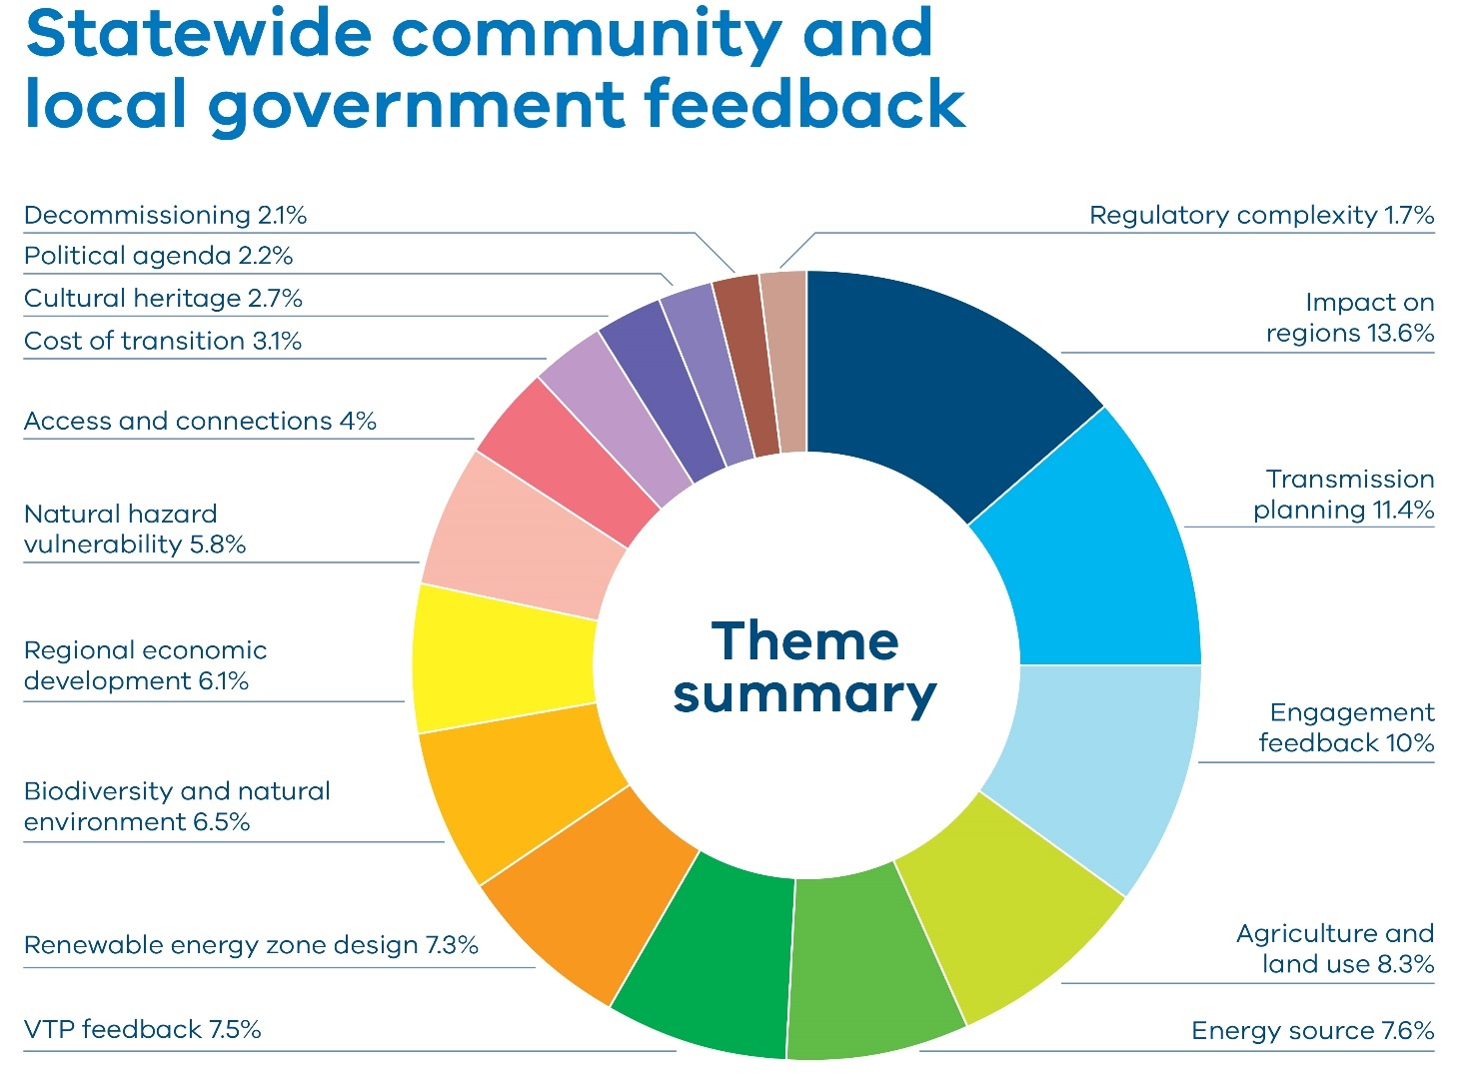

Table 1: Statewide community and local government feedback
Theme | Percentage
Impact on regions | 13.6%
Transmission planning | 11.4%
Engagement feedback | 10%
Agriculture and land use | 8.3%
Energy source | 7.6%
VTP feedback | 7.5%
Renewable energy zone design | 7.3%
Biodiversity and natural environment | 6.5%
Regional economic development | 6.1%
Natural hazard vulnerability | 5.8%
Access and connections | 4%
Cost of transition | 3.1%
Cultural heritage | 2.7%
Political agenda | 2.2%
Decommissioning | 2.1%
Regulatory complexity | 1.7%

Feedback forms, submissions, direct enquiries, community events, briefings and meetings were analysed to identify overarching themes.
Impact on the regions: We heard concerns about the impost on regional areas to service metropolitan energy demands, community division linked to developer behaviour, and concerns about industrialisation of regions. There was also feedback about compounding stresses on communities from multiple projects and plans across renewable energy and beyond.
Transmission planning: We heard feedback about both the future transmission projects proposed in the VTP and existing projects already under way including the Western Renewable Link (WRL) and the Victoria to New South Wales Interconnector West (VNI West).
Engagement feedback: We heard feedback about the accessibility of the VTP, the choice of engagement channels, awareness of engagement and concerns about the impact feedback would have on the VTP.
Agriculture and land use: Community members stressed the need to protect high-value farmland and raised concerns about impacts to farming activities and farm productivity.
Energy source: Feedback was received about different types of energy sources and generation technologies.
VTP feedback: People provided feedback on the VTP, expressing both support for and rejection of the plan as a whole.
Renewable energy zone design: Feedback was received suggesting specific changes to renewable energy zones including requests to extend or shift boundaries of some zones.
Biodiversity and natural environment: We heard concerns about impact on biodiversity and water systems including endangered species’ habitats.
Regional economic development: There was both optimism for community benefits and regional development opportunities such as job creation and infrastructure investment, and concerns about uneven benefit distribution and the impact on local resources.
Natural hazard vulnerability: Feedback highlighted concerns about infrastructure development in flood and bushfire-prone areas. This included concerns about the potential impact of infrastructure on firefighting and flood waters.
We received significant feedback about the impact on regions associated with the transition. This included feedback about the perceived injustice of regions shouldering the burden to provide energy to the city, with requests for the city to “do their part”. Suggestions included developing solar farms around the city and wind turbines on city buildings. Feedback included concerns about the industrialisation of rural landscapes and the impact of development on local infrastructure. There were also reports of community division caused by prior experiences with development, both generation and transmission.
Across the state, some communities were unclear about the benefits of hosting renewable energy infrastructure, and people raised concerns about how development might impact land prices and local infrastructure. Impact was felt differently across regions and was often related to prior experience with transmission and generation projects. The sentiment that the regions were shouldering the burden of the energy transition was heard consistently across the state, with feedback reflecting the idea that the city was not doing its fair share. This theme also encompassed feedback regarding the competing pressures regions face from multiple different projects and plans, including mineral sands mining.
Example comment from respondent: “This is not why the people of Country Victoria choose to live and to work the land where they do. We love our countryside just the way it is, without the industrial monstrosities that will be forced upon us if this draft plan goes ahead. Finding ourselves suddenly living in a location that has been designated as a Renewable Energy Zone is likened to living in suburban Melbourne and suddenly having your leafy neighbourhood street rezoned from Residential to Industrial.”– Quote from an individual, Central Highlands.
Across all regions, there was a bulk of feedback about transmission planning and infrastructure. Communities consistently gave feedback about the impact of overhead transmission on visual amenity. Many people also raised concerns about potential fire risk, health impacts and disruption to farming operations. Some feedback advocated for underground transmission, citing concerns about safety, durability and land use impacts. People shared frustrations about previous experiences with transmission planning, related to transparency in route planning, inadequate consultation with landholders, and the perceived prioritisation of cost-saving over long-term community and environmental wellbeing. Regions provided feedback about local transmission projects, particularly Western Renewables Link (WRL) and Victoria to New South Wales Interconnector West (VNI West). Many people questioned that these projects were treated as baseline inputs in the draft VTP, and provided feedback about alternative plans and proposals.
Example comment from respondent: “It is disappointing that undergrounding alternatives have not been adequately considered, particularly in areas with existing residential development or significant visual sensitivity. Modern technology and international best practices support undergrounding as a viable, safer, and more community-acceptable option in such areas.” – Quote from an individual, statewide.
Feedback about the engagement process focused on the complexity of the draft VTP, a lack of awareness about the process so far, surprise at being located in a renewable energy zone, and criticism of the Engage Victoria interface. Some people questioned whether their input would meaningfully influence decisions about the final plan. The engagement process was sometimes described as a “box-ticking exercise”. There was also feedback about the lack of coordination across agencies and projects, contributing to confusion and consultation fatigue. There was some positive feedback about the engagement process, describing it as inclusive and accessible. Some people said it was clear that prior feedback had been considered in shaping the draft VTP.
Example comment from respondents:
- “Consultation efforts have been inadequate and often tokenistic, with key decisions made before meaningful input from affected stakeholders. There is little evidence that community feedback has influenced the design or scope of the plan.” – Quote from a landholder, statewide.
- “I attended the office at Hamilton and was very impressed with the information available, the clear explanation and the obvious desire to listen to feedback. A very good initiative.” – Quote from an a Landholder, South West.
Feedback relating to agriculture and land use included concerns about impacts of large-scale renewable infrastructure on farmland. Farmers raised concerns about potential interruption to farming activities, biosecurity risks, and disruption to irrigation systems and livestock operations and impacts to property values. There was a strong sentiment that farms were for food and fibre and not for hosting renewable energy infrastructure. There were also concerns that agriculture was not adequately considered despite its contribution to the economy. There was some positive feedback about efforts to avoid farmland.
Example comment from respondent: “The proposed zones often overlap with high- value, productive farmland. This reduces the land available for food production, disrupts operations (e.g. aerial spraying, stock movement), and undermines long- term agricultural sustainability. Farming is a generational livelihood, not just a land use, and this has not been fully acknowledged.” – Quote from an individual, Central North.
Feedback about suggestions for alternative energy sources was more prominent than in previous engagement periods. There was also some feedback about increasing the ability to feed rooftop solar into the grid. Feedback included negative views about the reliability and sustainability of renewable energy, as well as some support for renewables.
Example comment from respondent: “I propose that gas and coal be given a new lease of life in Victoria. Upgrade the coalfired power stations. You say the coalfired power stations are becoming unreliable and closing down. Inject money into them. It provides a reliable & cheap form of power for our state and has for DECADES.” – Quote from a landholders, Central North.
Feedback about the draft VTP reflected both support for and rejection of the plan as a whole. Some people raised concerns that social, environmental and agricultural considerations had not been adequately balanced with planning objectives. There were calls for the plan to better align with local land uses, prioritise fair compensation and deliver genuine engagement. Feedback from community organisations and local governments voiced broad support for the intent of the draft VTP, often with suggestions for improvement.
Example comment from respondent: “We support the intent of the renewable energy zones as a coordinated development approach and signal to potential generators and communities as to where energy generation projects are best placed to be developed.” – Quote from Swan Hill Sustainability Group.
There was a body of feedback relating to renewable energy zone design . Suggestions included changing zone boundaries, moving zones to different locations and requests to be included in a zone. Some of these requests related to certain areas or geographical features, such as mountain ranges or areas of local importance. There was also feedback asking for certain areas to be considered for inclusion within a zone to allow for greater participation by landholders.
Example comment from respondents:
- “I believe you could have extended the Wimmera mallee REZ zone to allow more projects access to the grid. Allowing our communities to access to the benefits that these projects offer.” – Quote from landholder, Wimmera Southern Mallee.
- “It is the opinion of our group that the Wimmera Southern Mallee is totally unsuitable to be included as a Victorian Renewable Energy Zone, and the methodology of choosing this area is totally inappropriate and fundamentally flawed.” – Quote from Wimmera Mallee Environmental and Agricultural Protection Association.
Feedback on biodiversity and the natural environment was less prominent compared to previous engagement. This could reflect efforts to avoid areas of key biodiversity when designing the size, shape and location of the draft proposed renewable energy zones. Community members and local governments consistently highlighted the risks posed by renewable energy infrastructure to sensitive ecosystems, endangered species and culturally significant landscapes.
Example comment from respondent: “I have looked at the Central Highlands map and of major concern is the northerly tip of the map which stretches from the Sunraysia Highway upwards. This area is regionally significant landscape. It has huge biodiversity and habitat value and the 400 million year old granitic landscape known as the island uplands is of huge importance in the area.” – Quote from landholder, Central Highlands.
There were many comments and questions about the benefit to communities associated with hosting transmission and regional economic development opportunities. The theme of regional economic development across Victoria’s proposed renewable energy zones reflected both optimism and concern. While some communities and councils saw potential for job creation, infrastructure investment and economic diversification, many others raised concerns about how benefits would be fairly distributed. There was strong advocacy for community benefit schemes that were hyper-local, transparent and inclusive of non-host landholders and councils impacted by infrastructure. However, feedback also highlighted risks such as increased pressure on housing, roads and local services due to temporary workforces, and the lack of long-term planning to support regional resilience. Overall, communities called for a more balanced approach that would ensure renewable energy development contributed meaningfully to regional prosperity without compromising existing industries or social cohesion.
Example comment from respondent: “We only see opportunities. There are many wind towers surrounding our farm, but not on our farm, (within 400m) and there have been no adverse impacts. Our sheep are not disturbed and in fact lie in a line of their shade on hot days. Our resident wedge tailed eagles (for over 50 years) are still there and their hatchlings survive and thrive each year. We only wish we had a few of the towers on our farm - it would appear that most of the infrastructure is in place (transmission lines, etc) and we and the locals are all very used to wind towers after these years.” – Quote from landholder, Central Highlands.
Some feedback raised concerns about natural hazard vulnerability, expressing concern about placing transmission infrastructure and renewable energy developments in areas prone to bushfires. Concerns were also raised about potential impacts to firefighting. Flooding was also raised as a major issue in areas where wetlands, irrigation channels and low-lying agricultural land could be disrupted by infrastructure placement. Community feedback stressed that poor planning in hazard-prone areas could lead to environmental degradation, increased insurance costs, and potential impacts to human health and safety.
Example comment from respondent: “Overhead towers increase ignition risk through conductor clashing, line sag, mechanical failure, and human error during maintenance. The presence of large towers and access roads in fire-prone terrain also hinders emergency access and aerial firefighting capabilities. VicGrid has not conducted a fire ignition risk analysis in the draft VTP. There is no fire agency modelling. No community risk mitigation plan.” – Quote from individual, statewide.

Agriculture sector feedback
Feedback was received from a number of agriculture advocacy groups and research and development organisations.
The Victorian Farmers Federation (VFF) raised concerns about the social, economic, environmental and operational impacts of transmission and renewable energy development on agricultural land and rural communities. The VFF said it supported a just and market-driven transition to renewable energy, provided it respected agricultural production and was based on genuine commercial consent from landholders. It noted farmland was a critical national asset — not surplus land for infrastructure highlighting the 2024 Parliamentary Inquiry into securing Victoria’s food supply, which warned of the risks to local food security if farmland was not protected.
The VFF stressed that any renewable energy infrastructure must deliver tangible benefits to local communities and criticised recent transmission planning as unjust and strategically flawed, arguing that rural landholders were being asked to bear disproportionate burdens while receiving minimal benefit. VFF feedback highlighted issues with Western Renewables Link (WRL) and Victorian to New South Wales Interconnector West (VNI West) and suggested that alternative routes and undergrounding be further considered. The submission also raised operational challenges posed by transmission lines, such as interference with irrigation systems, machinery access and livestock movement.
The VFF asked that renewable energy zone declarations be contingent on clear, transparent information about project scale, land requirements, buffer zones and enforceable benefit-sharing arrangements. Without these, it said community opposition would continue to grow, undermining project delivery and public trust.
Dairy Australia’s submission said the overall impact of renewable energy zones on the dairy industry was limited, with about 80 farms within or near zone boundaries. Key concerns included biosecurity risk, fire hazard, operational efficiency, impacts to the construction of worker housing and land values.
Dairy Australia recommended providing targeted support for landholders within renewable energy zones to ensure they were fully informed about their rights, equipped to negotiate appropriate compensation and land use agreements, and had access to independent legal, financial and technical advice. They recommended VicGrid produce a comprehensive landholder guide: this is currently in development.
Dairy Australia also called for developers to be held to clear codes of conduct and suggested collaboration between industry and local government to preserve the integrity and productivity of agricultural land when planning renewable energy zone infrastructure.
Farmers for Climate Action (FCA) commended VicGrid for its proactive engagement and improved consultation practices. The group’s submission said the consultation was a significant departure from past experiences and signalled a genuine effort to build trust and social licence among landholders and rural communities.
FCA highlighted that renewable energy infrastructure was already delivering drought-proof income to farmers. Its submission projected more than $8 billion in payments to landholders across Australia by 2050, including $1.5 billion in Victoria alone. It said these payments, alongside community benefits exceeding $300 million, were seen as vital to maintaining farm profitability amid climate challenges such as droughts and floods.
FCA raised concerns about the tax treatment of payments to landholders for hosting transmission infrastructure. The organisation warned that taxing these payments at income tax rates of up to 45% could undermine incentives and foster disillusionment among farmers. FCA called for the payments to be tax-exempt to preserve the financial viability of hosting arrangements.
FCA also stressed the importance of genuine and extensive community consultation and urged continued investment in engagement to ensure local voices shaped the transmission planning process.

Energy industry feedback
A number of interrelated industry themes emerged through feedback forms, submission and industry briefings. Feedback from industry on the intent of the draft VTP was generally positive but there were suggestions for improvement.
Figure 2 below is a chart that shows the themes identified by the energy industry and how often the themes were mentioned by percentage. Table 2 lists out the themes and percentages in the chart.
Figure 2 Energy industry feedback by theme
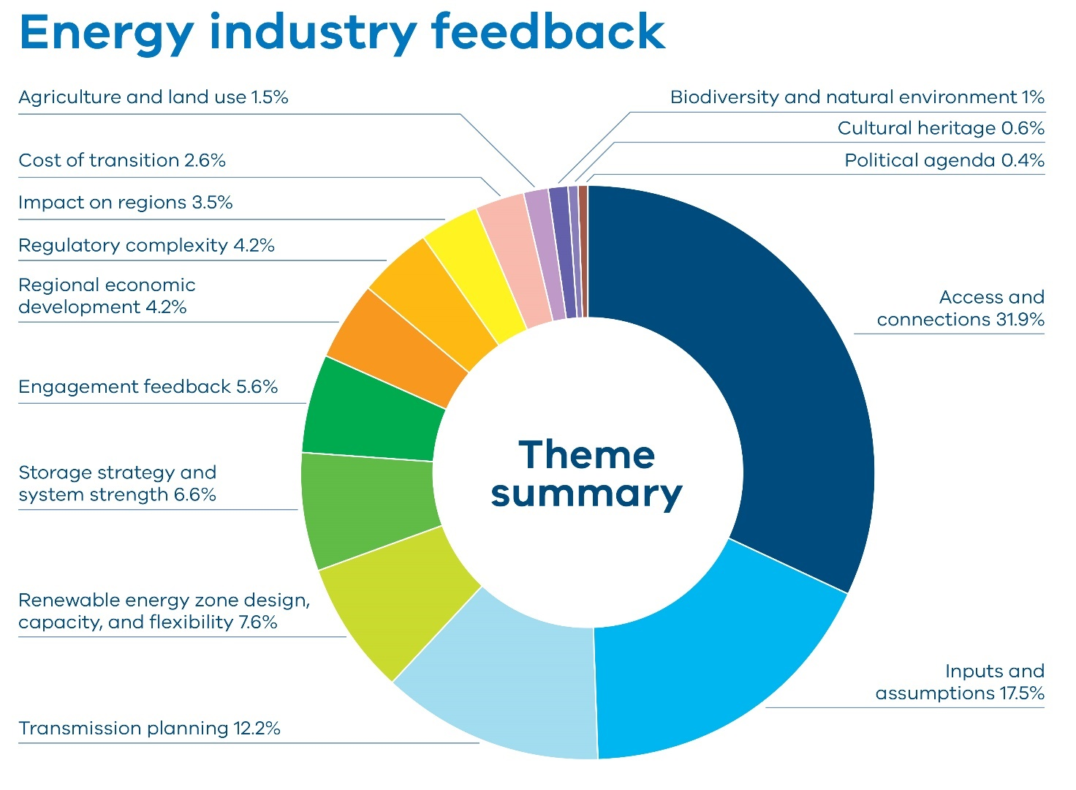
Table 2 Theme summary and percentage raised by industry
Theme | Percentage
Access and connections | 31.9%
Inputs and assumptions | 17.5%
Transmission planning | 12.2%
Renewable energy zone design, capacity, and flexibility | 7.6%
Storage strategy and system strength | 6.6%
Engagement feedback | 5.6%
Regional economic development | 4.2%
Regulatory complexity | 4.2%
Impact on regions | 3.5%
Cost of transition | 2.6%
Agriculture and land use | 1.5%
Biodiversity and natural environment | 1%
Cultural heritage | 0.6%
Political agenda | 0.4%

Access and connections: There was a significant body of feedback requesting clarity on access and connections policies, particularly as they relate to pipeline projects and transitional arrangements. There was also a focus on the potential impact of the draft VTP on developer confidence in Victoria.
Inputs and assumptions: There was a large body of feedback about the inputs and assumptions underlying the draft VTP. These focused on scenario reliance on offshore wind targets, cost assumptions, storage, gas price projections, distributed energy resource uptake and electricity demand forecasts, particularly related to data centres.
Transmission planning: Feedback about transmission planning and the optimal development pathway included concerns about transmission delivery, timelines and infrastructure coordination, as well as feedback about prioritising specific programs and considering distribution networks.
Storage strategy and system strength: We heard concerns that the draft VTP underestimated storage needs and lacked clarity on long-duration storage, grid-forming batteries and system strength series.
Renewable energy zone design, capacity and flexibility: There was significant feedback about renewable energy zone boundaries and hosting capacity, with concerns the modelled generation might deter investment and impact existing developments. This theme also included feedback calling for changes to zone design.
Engagement feedback: We heard concerns from industry that timelines for engagement on the draft VTP and related policies were too compressed, and that this might impact the quality of the products.
Regulatory complexity: There were calls for streamlined planning to increase the value proposition of renewable energy zones and reduce duplicated processes.
Cost of transition: There was feedback received that VicGrid has underestimated project costs, capital expenditure, and potential delays in delivery timelines.
With the policies related to access and connections not finalised at the time of the draft VTP release, there was a bulk of feedback asking for clarity on changes to the access regime. This included questions about proposed transitional arrangements for obtaining access allocations. Feedback related to this theme also highlighted the impact of the draft VTP and of new proposed access and connections arrangements on broader developer confidence and what this may mean for future plans in the state. The draft Access and Connections Consultation Paper and draft Grid Impact Assessment Guidelines have been developed to address these concerns and invite feedback on VicGrid’s proposed new approach.
Example comment from respondent: “While the CEC appreciates that the purpose of this round of consultation is focused on the modelled ODP underpinning the draft VTP, consultation with our members has identified a degree of uncertainty and anxiety for proponents in the process of developing renewable projects throughout Victoria, with many seeking clearer information on the implications of the draft VTP for projects inflight.” – Quote from Clean Energy Council.
A bulk of feedback related to inputs and assumptions and a large portion of this feedback focused on the appropriateness of demand forecasting scenarios. We heard calls for a more diversified and flexible approach including accelerating transmission in Gippsland and increasing onshore wind capacity. Feedback said onshore generation was seen as more mature, cost-effective and deployable at scale compared to offshore wind energy. Other feedback on inputs and assumptions called for greater transparency of how decisions were made. There was a bulk of feedback about assumptions related to data centre growth, calling for more responsive and metropolitan-focused planning. There were also suggestions that the VTP take a more contingency- based approach to the role of consumer energy resources (CER) to stress-test the transmission network against a range of plausible CER and electrification scenarios. There were suggestions that some inputs and assumptions were out of date and suggestions that modelled wind capacity factors were considerably lower than wind being observed in some regions by renewable energy developers. In addition, there were calls to reassess assumptions about gas prices.
Example comment from respondent: “Whilst CEIG supports in principle the seven proposed REZs and welcomes the integration of land use, environmental and community factors in REZ design, investors are concerned that the initial sizes and capacities of the REZs is too small and that the plan relies too heavily on meeting offshore wind targets when that looks increasingly unlikely.” – Quote from Clean Energy Investment Group
Feedback about transmission planning and the optimal development pathway focused on delivery timelines and infrastructure coordination. There were calls to prioritise specific programs to meet generation targets. Some feedback focused on the role of distribution networks and whether they have potential to provide a faster and more cost-effective solution during the long lead times associated with major transmission developments. There was also feedback about the lack of coordination with other infrastructure such as ports, substations and interconnectors, raising concerns about impacts of potential delays including on increased costs and investor and developer confidence.
Example comment from respondent: “The assumed sequencing of some proposed transmission programs appears compressed, particularly for those identified for delivery by 2028 … Without early procurement and clear delivery accountability, there is a risk that critical transmission capacity may not be available in time to meet the needs of advanced generation projects or align with expected coal plant retirements.” – Quote from Wind Prospect
Feedback about renewable energy zone design, capacity and flexibility said the draft proposed renewable energy zones were too narrow in geographic size and location, and too conservative in modelled generation capacity, to accommodate the scale and diversity of renewable energy projects in development. Industry raised concerns that the proposed capacity was not aligned with the scale of modern wind farms and the long-term needs of the energy transition, and could result in stranded investment, particularly for projects just outside zone boundaries or located in zones with insufficient hosting capacity. There were calls for a more dynamic and forward-looking approach, including mechanisms for expanding zones , scenario-based contingency planning, and greater transparency around how zone boundaries and capacities were determined. Across the board, industry stakeholders advocated for renewable energy zones to be capable of evolving with market conditions, technological advances and community input. This included calls for VicGrid to adopt processes similar to NSW’s ‘headroom assessments’ and to provide clear pathways for zone boundary changes and capacity reallocations.
The overarching message was renewable energy zone design needed greater flexibility and transparency to encourage investment and ensure Victoria would make the most of its renewable resource potential and achieve its decarbonisation goals. There were multiple requests to change zones’ design and capacity to accommodate pipeline projects.
Example comment from respondent: “Of most concern for us in the draft VTP as an onshore investor is the material risk of grid under-build and the potential for underestimation of onshore REZ hosting capacity. The lack of ambition for onshore build- out (both grid and generation), appears to send a signal that the biggest, most cost-effective onshore projects are not wanted in Victoria.” – Quote from RWE Renewables
There was a bulk of feedback about the role of storage, and whether storage needs had been underestimated. Feedback asked for more details about the role of long-duration energy storage, grid-forming batteries and system strength services. Feedback highlighted a discrepancy between the draft 2025 VTP’s modelled storage by 2040 and the Victorian Government’s legislated target. There were also suggestions that the draft 2025 VTP’s emphasis on 2-hour storage durations would be increasingly outdated as the market shifted towards 4-hour- plus and long-duration storage. There were also many calls to reconsider the role of hybrid projects, such as wind and solar generation with battery energy storage systems (BESS). Many argued that BESS projects should be supported in any area of Victoria, not just renewable energy zones, as they were modular, could be delivered at small, medium and large scale, and needed only an extremely small area of land compared to other renewable infrastructure. There were criticisms that the VTP appeared to model BESS as an access competitor rather than a grid enabler, with arguments that properly coordinated and remunerated storage could increase zone hosting capacity, improve network utilisation and enhance system security.
Feedback also suggested that storage, particularly medium and long-term, be more prominently considered as a substitute for gas-powered generation, especially given rising gas prices and supply constraints.
Example comment from respondent: “While there are clear co-benefits in locating BESS assets within or nearby to a REZ ... the incentive structures for BESS assets to locate in those regions is not as clear”. – Quote from Akaysha Energy.
There were some concerns raised about the cost of the energy transition . There was criticism of vague and insufficient cost estimates, lack of project-level financial transparency and fears that rigid planning could lead to stranded transmission assets and higher consumer costs. Many submissions called for clearer financing mechanisms, more flexible infrastructure planning, and contingency strategies to avoid economic inefficiencies and ensure affordability.
Many people noted that the timelines to respond to the draft VTP were compressed and recommended extending them to allow industry and communities to respond meaningfully. Feedback on engagement also highlighted engagement fatigue, the need for locally tailored community engagement and expressed strong support for partnership-based approaches with First Peoples.
Example comment from respondent: “As a starting point, we strongly recommend VicGrid adopt a longer consultation process to ensure all views are accounted for and that the final plan and documents are workable.” – Quote from Clean Energy Council.
Feedback on regulatory complexity included calls for renewable energy zone-wide environmental assessments and streamlined planning processes to increase the value proposition of zones. This included recommendations to leverage existing tools such as the strategic land use assessment to avoid duplicate project by project reviews. There were also concerns that new access arrangements, and in particular the Grid Impact Assessment, risked creating bottlenecks for projects outside zones. This was accompanied by calls for clear, replicable criteria and project pathways.
Example comment from respondent: “The 2025 VTP should include consideration of which technical assessments should be uniquely and separately investigated by each project, and which could be elevated to a REZ- level strategic assessment. This will signal to developers that the creation of REZs will create some efficiencies, to offset the VTP’s additional processes and barriers.” – Quote from Neoen.

Regional insights
Regional concerns reflected the broader themes, though the weight and nuance of each theme varied by region. Feedback about impact on the regions included a range of concerns, including potential impacts on tourism, different experiences with renewable energy development and a sense of industrialisation of the landscape.
Prior experiences, particularly with transmission projects, shaped community attitudes towards future developments. Experiences shaped expectations about how development would be managed, how benefits would be shared and how communities would be engaged. Past experiences also influenced levels of trust, perceptions of fairness and community members’ support of or opposition to renewable energy zone development.
Feedback collected through feedback forms, submissions, direct enquiries, community events, briefings and meetings has been analysed to identify themes for each zone. In addition to local councils, community groups and community members, feedback from regional government departments has also been incorporated.

Central Highlands
Figure 3 shows the feedback received from stakeholders by theme in the Central Highlands region, and how often the themes were mentioned by percentage. Table 3 lists the themes and percentages displayed in the chart.
Figure 3: Feedback by theme received by stakeholders in the Central Highlands
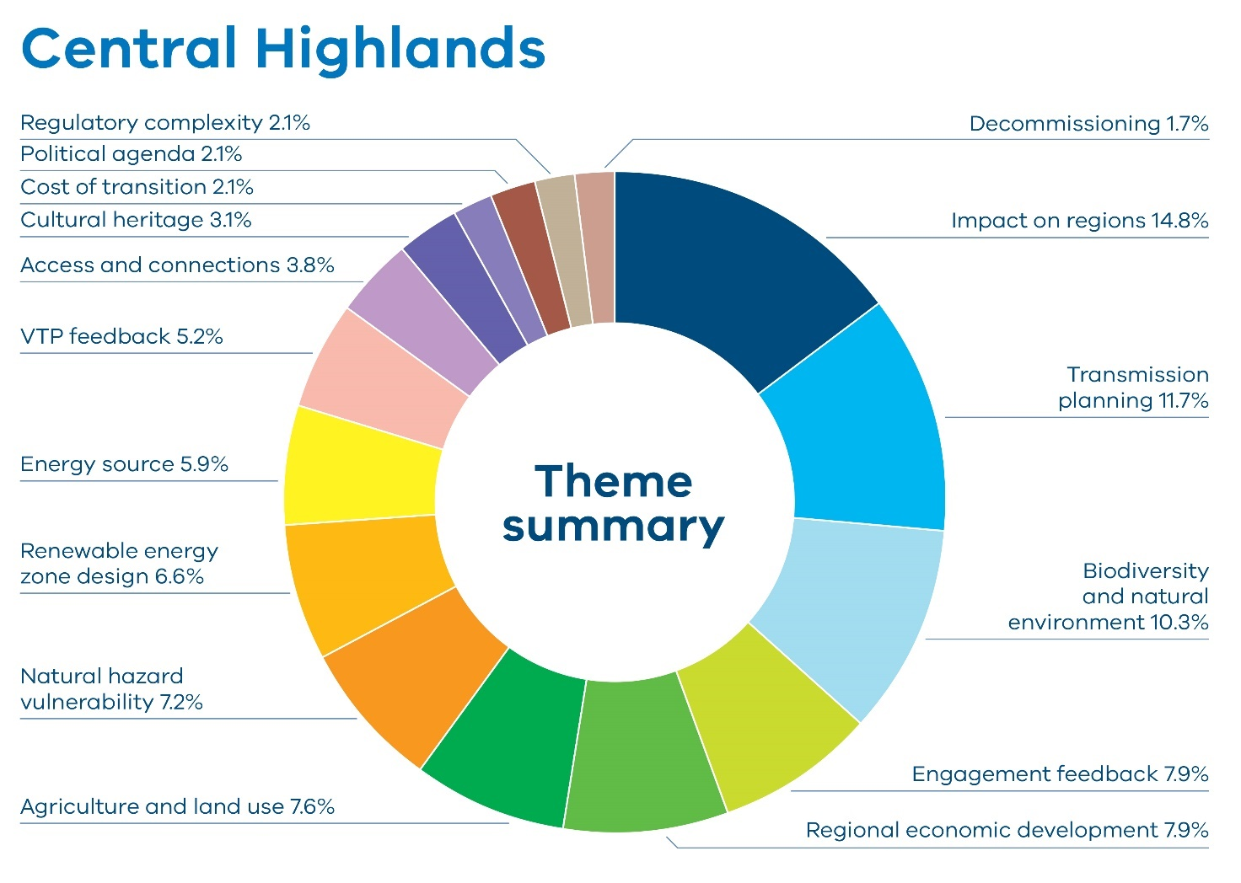
Table 3: Feedback by theme received by stakeholders in the Central Highlands
Theme | Percentage
Impact on regions | 14.8%
Transmission planning | 11.7%
Biodiversity and natural Environment | 10.3%
Engagement feedback | 7.9%
Regional economic development | 7.9%
Agriculture and land use | 7.6%
Natural hazard vulnerability | 7.2%
renewable energy zone design | 6.6%
Energy source | 5.9%
VTP feedback | 5.2%
Access and connections | 3.8%
Cultural heritage | 3.1%
Cost of transition | 2.1%
Political agenda | 2.1%
Regulatory complexity | 2.1%
Decommissioning | 1.7%
The Central Highlands region of Victoria has been at the forefront of Australia’s renewable energy development with multiple large-scale generation projects that have substantially contributed to the state’s renewable energy capacity.
However, landowners and farmers have provided feedback about the potential impact of large-scale development on agricultural land, property values and local ecosystems.
The proposed Western Renewables Link (WRL) has faced opposition due to perceived inadequate consultation and concerns about impacts to farming operations. During engagement on the draft VTP, concerns regarding WRL were frequently raised. While some feedback about this region supported the transition to renewable energy, there was significant concern about the environmental, cultural, economic and social impacts of projects.
Feedback related to impact on regions focused on the impact of large-scale infrastructure on visual amenity and the local landscape. People raised concerns about wind turbines, transmission towers and battery energy storage systems in areas of high scenic and cultural value, such as Mount Beckworth, the Lollipop tree, Mount Bolton, Deep Lake and the Avenue of Honour in Kingston. Feedback said these landmarks were valued for their natural beauty but also their historical and cultural significance. The visual impacts were seen as incompatible with the rural character and tourism appeal of the region.
Example comment from respondent: “This is not why the people of Country Victoria choose to live and to work the land where they do. We love our countryside just the way it is, without the industrial monstrosities that will be forced upon us if this draft plan goes ahead. Finding ourselves suddenly living in a location that has been designated as a Renewable Energy Zone is likened to living in suburban Melbourne and suddenly having your leafy neighbourhood street rezoned from Residential to Industrial.” – Quote from individual, Central Highlands.
Mental health and social cohesion were frequent concerns. Some community members said they were experiencing anxiety, sleep disruption and a sense of powerlessness in response to the WRL proposal and the anticipated changes it might bring. People raised questions about impacts of electromagnetic fields from overhead powerlines, insurance costs and impacts on quality of life. Proposed projects were described as divisive for communities and straining relationships. There were calls for more meaningful engagement and transparent, inclusive and respectful planning processes.
Example comment from respondent: “We echo broader community concerning the impact of the proposed project on social cohesion and mental health. Over recent years, uncertainty surrounding WRL’s developments has caused considerable anxiety among our residents, negatively affecting community wellbeing. Our members report increased stress and disillusionment stemming from ongoing uncertainties and inadequate consultation.” – Quote from individual, Central Highlands.
There were also concerns raised about the impact of renewable energy development on local infrastructure, particularly the effects of heavy construction traffic on local roads and the limitations of volunteer emergency services in responding to industrial fires.
Example comment from respondent: “It appears there has been insufficient consideration given to the capacity and condition of local road networks, particularly in the Mingay and surrounding district. These areas rely heavily on rural roads that were not designed or rated for frequent use by large, heavy construction vehicles or ongoing operational traffic associated with utility-scale renewable energy developments.” – Quote from landholder, Central Highlands.
Concerns related to transmission planning included criticism of considering WRL as a baseline input to the VTP and perceptions of inadequate consultation and transparency. Feedback also focused on fire risks in bushfire-prone areas and economic inequity in compensation.
Example comment from respondent: “The inclusion of WRL as a “committed” project, despite its absence of approvals, incomplete land acquisition, and ongoing environmental review bypass the conditions outlined in the Australian Energy Regulator’s (AER) Regulatory Investment Test for Transmission (RIT-T).” – Quote from individual, Central Highlands.
Feedback about biodiversity and the natural environment was also prominent. Submissions highlighted sensitive local flora and fauna, including endangered species such as the southern brolga, wedge-tailed eagles and native frogs. There was also a body of feedback about the landscapes around Mount Bolton and Mount Beckworth. People called for exclusion zones around sensitive habitats and more rigorous biodiversity assessments, reporting concerns about potential impacts of WRL and existing wind farms. Concerns also focused on fire risks related to transmission lines and potential turbine malfunctions, especially in bushfire-prone zones including Berringa and Enfield State Park.
Example comment from respondent: “The Victorian Transmission Plan and renewable energy rollout will have devastating impacts on the surrounding areas, particularly Mount Bolton and Mount Beckworth, both of which contain a huge biodiversity of flora, fauna with Mount Bolton having been officially recognised as an area of natural beauty and special significance. During the time we have lived here we have counted 87 different varieties of birds on Mount Bolton, including a resident breeding pair of wedge tailed eagles, powerful owls, yellow tailed black cockatoos and also an assortment of bats, many of which will be at risk from transmission lines and wind turbine blades.” – Quote from individual, Central Highlands.
On the topic of engagement feedback, community members reported feeling excluded from meaningful participation in renewable energy and transmission planning. Many submissions described a breakdown in trust between government, developers and residents, particularly in relation to previous planning of major transmission such as WRL. Feedback highlighted community members felt their input, concerns and contributions had been ignored.
Example comment from respondent: “The draft VTP proudly claims that community input has shaped its design. This is fantasy. The WRL corridor has been met with unprecedented resistance … We have attended sessions, lodged submissions, met with ministers, staged rallies, and offered alternatives. We have shown up in good faith to workshops, meetings and public events. We have been measured, constructive, and solutions-focused … And we have been ignored.” – Quote from individual, Central Highlands.
In terms of regional and economic development opportunities, there were calls for a regulated and equitable process for distributing community benefits, ideally managed at a local level to deliver benefits to directly impacted landholders, neighbours and community groups.
Example comment from respondent: “We would like to see an organisation which oversees an agreed code of practice for the distribution of benefits. This code of practice could be developed with input from stakeholders such as windfarm developers, municipalities, government, affected community group representatives. This could be at State level but would be faster and simpler at local level. Benefits are preferably paid to groups and communities directly affected by the development, with a decreasing preference for those more distant groups and communities.” – Quote from Lismore Progress Association.
Concerns about impacts on agriculture and land use also featured in this region. The renewable energy zone boundaries include farmland, and landholders raised concerns that infrastructure could undermine food security, reduce farming flexibility and impact the viability of local agricultural enterprises. Feedback about WRL said its route cut through intensively farmed areas, with concerns about biosecurity, irrigation disruption and economic impacts.
Example comment from respondent: “The farms are relatively small, tightly held by generations of families, and intensively farmed and irrigated. This region is prized for its high quality fertile soils, reliable rainfall and invaluable underground water resources, unlike most other farming areas of Australia.” – Quote from landholder, Central Highlands.
Suggestions from the community included underground transmission infrastructure to reduce visual and environmental impacts, and fire risks; revising zone boundaries to exclude sensitive landscapes and high-value farmland; improving planning and governance through independent panels and local government involvement; community benefit frameworks with legislated social operating licences; and stronger formally recognised Traditional Owner involvement through cultural values assessments and co-designed regulatory frameworks.

Local government feedback
The Pyrenees Shire Council’s submission to the draft VTP raised strong concerns about the cumulative and ongoing impacts of renewable energy infrastructure on the shire’s landscapes, communities and planning processes. The submission said there was a lack of social licence for WRL, criticising its inclusion as a baseline input despite sustained community opposition and perceptions of inadequate consultation. It also said there was already extensive renewable infrastructure in the shire, and called for this to be recognised in renewable energy zone planning. The submission called for regionally significant landscapes to be excluded from renewable energy zones, clearer guidance on development outside zones, and more transparent and inclusive planning and approval processes. It advocated for a statewide, balanced approach to infrastructure rollout that genuinely incorporates community input and protects environmental and cultural values.
Moorabool Shire Council welcomed the transition to renewable energy but raised significant concerns about the draft 2025 VTP, particularly regarding WRL and the proposed Central Highlands Renewable Energy Zone. The submission raised concerns about planning clarity, impacts to agricultural land and biodiversity, and the need for stronger community engagement and cumulative impact assessments. The council urged VicGrid to provide clearer policy guidance, ensure landowner consent, and align renewable energy development with local planning frameworks to protect community wellbeing, environmental and long-term strategic growth.

South West
Figure 4 shows the feedback received from stakeholders by theme in the South West region, and how often the themes were mentioned by percentage. Table 4 lists the themes and percentages in the chart.
Figure 4: Feedback by theme received by stakeholders in the South West
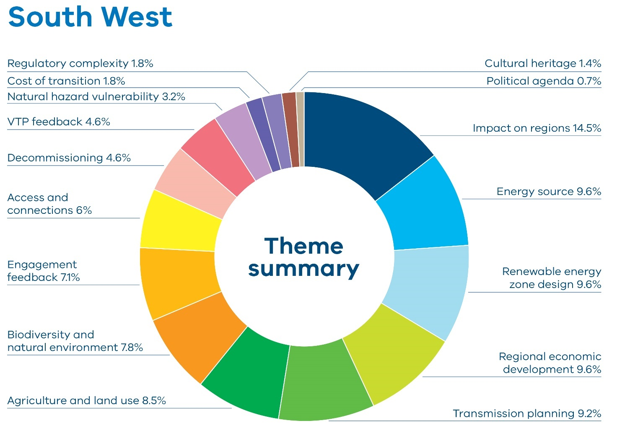
Table 4: Feedback by theme received by stakeholders in the South West
Theme | Percentage
Impact on regions | 14.5%
Energy source | 9.6%
Renewable energy zone design | 9.6%
Regional economic development | 9.6%
Transmission planning | 9.2%
Agriculture and land use | 8.5%
Biodiversity and natural environment | 7.8%
Engagement feedback | 7.1%
Access and connections | 6%
Decommissioning | 4.6%
VTP feedback | 4.6%
Natural hazard vulnerability | 3.2%
Cost of transition | 1.8%
Regulatory complexity | 1.8%
Cultural heritage | 1.4%
Political agenda | 0.7%
South West Victoria has played a pivotal role in Australia’s renewable energy landscape, particularly in wind energy generation. The region’s access to strong wind has attracted investment in many large-scale wind farms, such as those near Portland and Mortlake, contributing significantly to the state’s renewable energy targets.
The South West is also the home of Australia’s first commercial wind farm, which is due to be decommissioned soon. Feedback from this region on the draft 2025 VTP reflected a deeply engaged community grappling with the implications of renewable energy development. While some people voiced support for the transition and asked to be included in the renewable energy zone, many others raised concerns about regional planning, infrastructure impacts, and broader economic and environmental impacts.
A central theme in the South West was the impact on regions, particularly the cumulative impacts and perceived imbalance between state-level energy planning and regional realities. Many community members argued that the South West region was already heavily burdened by existing and proposed renewable energy infrastructure, including wind farms, transmission corridors and proposed offshore wind developments. There was a strong sentiment that the region had “done the heavy lifting” for Victoria’s energy transition without receiving proportional benefits. This included concerns about visual amenity, ecological degradation and cumulative impacts on local communities, particularly in areas including Mortlake and Hawkesdale with many people citing noise, light flicker and the industrialisation of rural landscapes as detrimental to health and quality of life. The cumulative impact of multiple wind farms, particularly in towns such as Hawkesdale, was seen as overwhelming, with some residents feeling their communities were being “surrounded” and ignored.
Example comment from respondent: “Many regions now face the cumulative burden of transmission corridors, energy generation projects, and associated infrastructure. Planning must account for overlapping impacts, not assess projects in isolation. Communities should not be disproportionately affected simply because they are rural or less politically resourced.“ – Quote from individual, South West.
Feedback about alternative energy sources was provided and concerns about the reliability and cost of renewables were also raised.
Example comment from respondent: “I feel like limiting to specific energy zones is a waste. Like I said about roof top solar there are millions of homes we can cover.” – Quote from individual, South West.
There were many suggestions about reshaping the zone under the renewable energy zone design theme. Some community members questioned the need for the north-west part of the zone due to its distance to the existing transmission network. There was also some support for including the area between Coleraine and Cavendish, viewing renewable energy as an opportunity for economic development and drought resilience. These supporters stressed the importance of fair compensation and community involvement.
Example comment from respondent: “The south west should be included in the renewable energy zone. It’s a great opportunity for our region to host a wind farm project. It will create jobs and economic activity.” – Quote from landholder, South West.
Regional economic benefits, including the topic of tangible community benefits, was a strong theme in this region, reflecting the region’s prior experience with development. As with other areas in the state, doubts were expressed about the delivery of long- term, tangible benefits. Grievances were expressed about the absence of benefits from existing development, and questions raised about how whole towns might be able to benefit in the future. People also sought clarity on the implementation processes required to ensure local benefits are sustained, such as bringing skilled workers and new upgraded infrastructure to support the region. There were also many concerns regarding what would happen when projects were sold and who was responsible for decommissioning and disposal.
Example comment from respondent: “Very important that there are significant and long-term community benefits as a result of the rollout of renewable energy. Not only benefits for landholders who have the renewable energy projects on their properties.” – Quote from landholder, South West.
Feedback about transmission planning in this area focused on concern over new transmission and the history of uncoordinated planning of connection powerlines leading to the ‘spaghetti effect’ of multiple lines crossing the landscape. There was a preference for underground transmission lines compared to overhead structures, which were viewed as unsightly, vulnerable to severe weather and a fire risk. However, there was some acceptance that locating the proposed new 500 kilovolt (kV) transmission line in the vicinity of the existing line where possible was logical.
Example comment from respondent: “My main concern is the overhead transmission lines, the visual impact, and the possibility of major damage by severe weather events. This has already occurred in various parts of Australia and has resulted in extended power outages. It may be better and less costly to locate these underground.” – Quote from individual, South West.
When the draft proposed South West Renewable Energy Zone was originally designed, efforts were made to avoid high-value agricultural land. There was significantly less feedback about the impact on agriculture and land use, but concerns remained about farmland becoming unusable for dairy operations and the potential impacts of buffer zones on the development of accommodation for farm workers. There were also concerns about the impact of renewable infrastructure on grazing and cropping in the north of the zone.
Example comment from respondent: “Wind turbines on prime agricultural land makes the land unusable, it would be decades before the land could be farmed again for dairy farming, it also prevents farmers from building workers accommodation on their farms if it is within the exclusion zone.” – Quote from landholder, South West.
There was significantly less feedback about the brolga in this round of engagement, reflecting efforts to avoid brolga habitat when siting the draft proposed renewable energy zone. However, new data regarding flocking sites identified some flocking sites on the border. Other biodiversity and natural environment feedback focused on the impact to birds in general and the impact to national parks and state forests.
Example comment from respondent: “I believe transmission lines destroy the environment and natural fauna and flora of the areas. We are losing much of our green spaces and wildlife now without putting up ugly turbines. CLEAN natural gas is the way to go here.” – Quote from individual, South West.

Local government feedback
Moyne Shire Council’s submission to VicGrid expressed strong concerns about the cumulative impacts of renewable energy infrastructure – particularly wind farms and connection assets – on the region’s environment, agriculture and communities. While acknowledging the importance of renewable energy, the council called for more nuanced planning that considered local land use, biodiversity and community wellbeing. It advocated for increased transparency, equitable funding and planning mechanisms that reflected the region’s existing energy generation and agricultural significance. The council also sought clarity on how the VTP would apply to current and future projects, and how community benefits would be distributed.
Glenelg Shire Council emphasised the need for equitable, regionally sensitive planning that aligned with local values and strategic land use. While supportive of the renewable energy transition, the council expressed concern over the limited inclusion of the Glenelg Shire in the draft proposed South West Renewable Energy Zone despite its existing infrastructure and potential for diverse energy projects. The submission called for greater detail, transparency and community benefit mechanisms, particularly for areas outside designated zones, and urged VicGrid to better integrate local opportunities, cultural heritage considerations and industrial zones into future planning.
Corangamite Shire Council emphasised the significance of agriculture in the region and expressed strong concern over the cumulative impacts of renewable energy development on productive farmland, community wellbeing and regional identity. While acknowledging improvements in VicGrid’s engagement and planning processes, the council urged a more tailored, locally informed approach to renewable energy zone development, advocating for the protection of high-value agricultural zones and the need for meaningful community involvement. The submission called for better coordination, and tangible legacy benefits for affected communities, while opposing further renewable development in the southern part of the shire due to its agricultural, environmental and cultural significance.

Grampians Wimmera
Figure 5 shows the feedback received from stakeholders by theme in the Grampians Wimmera region, and how often the themes were mentioned by percentage. Table 5 lists the themes and percentages in the chart.
Figure 5: Feedback by theme received by stakeholders in the Grampians Wimmera
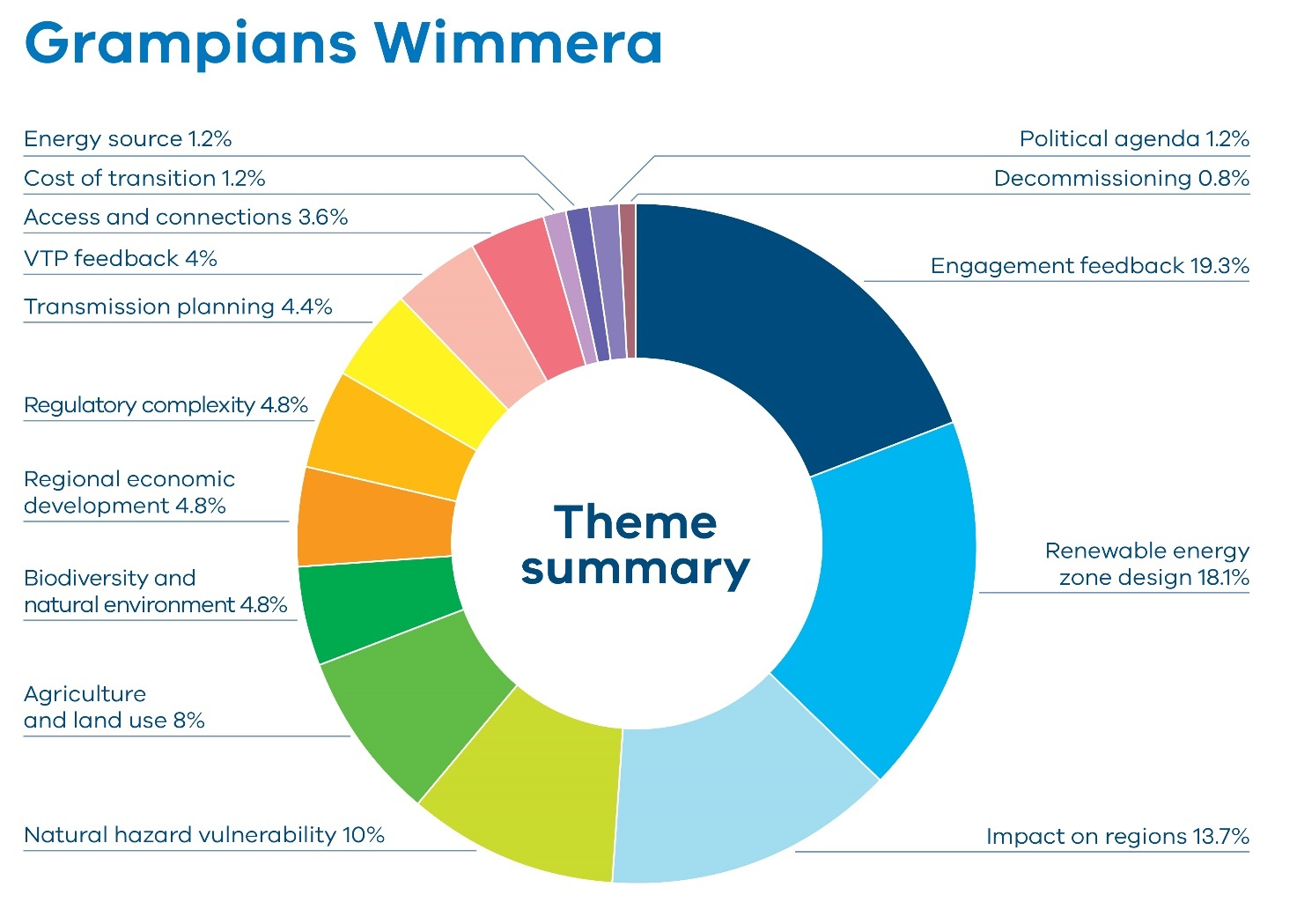
Table 5: Feedback by theme received by stakeholders in the Grampians Wimmera
Theme | Percentage
Engagement feedback | 19.3%
Renewable energy zone design | 18.1%
Impact on regions | 13.7%
Natural hazard vulnerability | 10%
Agriculture and land use | 8%
Biodiversity and natural environment | 4.8%
Regional economic development | 4.8%
Regulatory complexity | 4.8%
Transmission planning | 4.4%
VTP feedback | 4%
Access and connections | 3.6%
Cost of transition | 1.2%
Energy source | 1.2%
Political agenda | 1.2%
Decommissioning | 0.8%
The region around the draft proposed Grampians Wimmera Renewable Energy Zone is an area characterised by farmland, mining, areas of conservation and natural reserves, bordered by national parks. The region is reliant on dryland farming and broadacre cropping and grazing.
The region has been consistently involved across all VicGrid engagement opportunities, driven largely by mobilised interest groups. The interest group Farms for Food shared a community-led online map highlighting local land parcels where landholders do not wish to host renewable energy infrastructure.
During engagement on the draft 2025 VTP, the dominant theme was engagement feedback, with many community members expressing frustration that previous feedback opposing their region being included within a proposed renewable energy zone had not been reflected in the draft plan. There was also feedback about engagement fatigue as a result of many competing projects in the region, including renewable energy generation, transmission and mineral sands mining.
Example comment from respondent: “We are not against renewable energy or progress—but we are firmly against being placed within a REZ that we do not support, and we reject the process that has led to this point. The voices of rural communities like ours must carry weight. We are land stewards, food and fibre producers, and we deserve to have a genuine say in decisions that will shape our future.” – Quote from landholder, Grampians Wimmera.
Much of the feedback on renewable energy zone design said a large number of landowners in the area rejected the zone location. Some people, however, said they supported hosting generation in this region. There were concerns about the potential cumulative impacts of projects seeking to connect into the proposed Bulgana terminal station in the southern part of this draft proposed zone, particularly due to the proximity of the zone to the Grampians National Park (Gariwerd Cultural Landscape).
Example comment from respondents:
- “We have compiled data showing that over 70% of landowners in the mapped ‘Grampians’ REZ area do not support inclusion in the REZ. This is a resounding rejection and should serve as an unequivocal signal that community support does not exist for this proposal in its current form.” – Quote from Southern Wimmera Renewables Research Association.
- “The entire south eastern end of the REZ is proposed over extremely high levels of biodiversity, which according to the government’s own handbook for the development of renewable energy in Victoria should be avoided.” – Quote from individual, Grampians Wimmera.
There was a body of feedback relating to the impact on the region, particularly the emotional toll of the renewable energy zone proposal and other planned developments in the region. Many community members stated they felt stressed, anxious and powerless. There were also concerns about landscape change and impacts to rural lifestyles. Feedback also reflected sentiment that a disproportionate burden was being placed on rural communities by large-scale renewable energy infrastructure projects. People advocated for more equitable and community-sensitive planning processes. In addition, there was feedback from this region about the many competing demands from multiple projects, including transmission projects and mineral sands mining.
Example comment from respondent: “Your approach shows a clear lack of regard for the emotional strain, uncertainty, and distress you are causing everyday people – landowners, families and producers – who have done nothing to warrant this kind of disruption. The offer of mental health services to help communities “cope” with the anxiety caused by your project is not a solution – it is an admission of the harm your actions are causing.” – Quote from individual, Grampians Wimmera.
Natural hazard vulnerability, particularly fire risk, emerged as a critical concern about wind turbines and transmission infrastructure located near high- risk zones. Several pieces of feedback, including from Country Fire Authority (CFA) members, expressed the view that the local terrain and vegetation presented significant challenges to fighting fires. Some local CFA brigades reported they would not respond to fires on properties hosting renewable energy infrastructure. Feedback also reflected recent bushfire experiences.
Example comment from respondent: “The local CFA Brigades will not fight fires on any property that is hosting renewable energy infrastructure and this alone makes this area completely unsuitable for a REZ.” – Quote from individual, Grampians Wimmera.
Feedback revealed concern about the impact to agriculture which was an issue consistently raised by interest groups that have formed in response to the Victoria to New South Wales Interconnector West (VNI West) transmission project. This project aims to construct a high-capacity, double-circuit overhead transmission line connecting the Western Renewables Link (WRL) project at Bulgana, east of Stawell, to New South Wales.
Example comment from respondent: “We are producing food and fibre for Australia and the world with our prime agricultural land. It makes no sense to ruin the land that grows our food and cover it with infrastructure that is the absolute opposite of renewable.” – Quote from individual, Grampians Wimmera.
Agriculture was portrayed as the backbone of the region’s economy and identity, and many submissions commented on agriculture and land use, sharing opinions that large-scale renewable infrastructure was incompatible with productive farming. There was strong concern about the potential impacts on agricultural land, biosecurity, and the long-term viability of farming operations. There was also feedback about the pressures of competing mineral sands mining activity in the region.
Additionally, the renewable energy zone was said to include areas of high biodiversity and natural environment, including habitats for critically endangered species. The inclusion of conservation reserves and proximity to national parks was viewed as environmentally irresponsible and contradictory to government guidelines that recommend avoiding such areas.
Example comment from respondent: “The proposed south-eastern end of the REZ covers some of the highest quality areas of biodiversity in the state. Unbelievably the REZ is right up beside Kara Kara National Park and actually includes Morrl Morrl Conservation Reserve, Glynwylln Forest and a number of other reserves within the zone. It is also right beside Mount Bolangum Flora and Fauna Reserve, Big and Little Tottington Nature Conservation and Landsborough Hill Nature Conservation Reserve (which I believe is in the process of becoming a National Park).” – Quote from individual, Grampians Wimmera.
There was feedback expressing concern about the National Electricity Amendment (VicGrid Stage Reform) Bill 2025, specifically the provisions in the Bill to introduce authorised officers to oversee the enforcement of existing land access provisions. Some felt the powers granted under the Bill were an overreach and an infringement on landholders’ rights. The absence of a social licence was repeatedly cited, with communities asserting their right to reject infrastructure that affects their land, livelihoods and wellbeing. The perceived lack of meaningful community benefit initiatives and housing support further exacerbated feelings of disenfranchisement.
Example comment from respondent: “The recently announced National Electricity Amendment (VicGrid State Reform) Bill 2025 gives extraordinary powers to VicGrid to exercise within a REZ, which removes property rights and human rights, an abhorrent misuse of power for those within a REZ.” – Quote from individual, Grampians Wimmera.

Local government feedback
The Northern Grampians Shire Council expressed significant concerns regarding the draft 2025 VTP and the draft proposed Grampians Wimmera Renewable Energy Zone, opposing the zone in its current form. They viewed the 6-week consultation period as inadequate, especially during a peak farming season and regional challenges including drought and bushfire recovery. The council criticised the VTP’s assumptions about the VNI West and WRL, pointing out that these projects were treated as certainties despite pending approvals. The council emphasised the lack of social licence and unresolved community opposition, compounded by fears of compulsory land acquisition and absence of new community benefit initiatives. They also stressed that agriculture was a critical land use in the region, raising concerns about biosecurity and the impact on farmland. The council criticised the draft VTP for what it viewed as unrealistic capacity estimates, reliance on offshore wind targets without contingency plans, and lack of detailed technical justifications. The council also expressed the view that the plan was short-sighted, only extending to 2040.
Yarriambiack Shire Council’s submission highlighted concerns about the scale and location of renewable energy developments in the region, particularly those planned outside of the draft proposed Grampians Wimmera Renewable Energy Zone. They cited potential impacts of renewable energy infrastructure on community cohesion, agriculture, water resources and local amenity.

Wimmera Southern Mallee
Figure 6 shows the feedback received from stakeholders by theme in the Wimmera Southern Mallee region, and how often the themes were mentioned by percentage. Table 6 lists the themes and percentages in the chart.
Figure 6: Feedback by theme received by stakeholders in the Wimmera Southern Mallee region
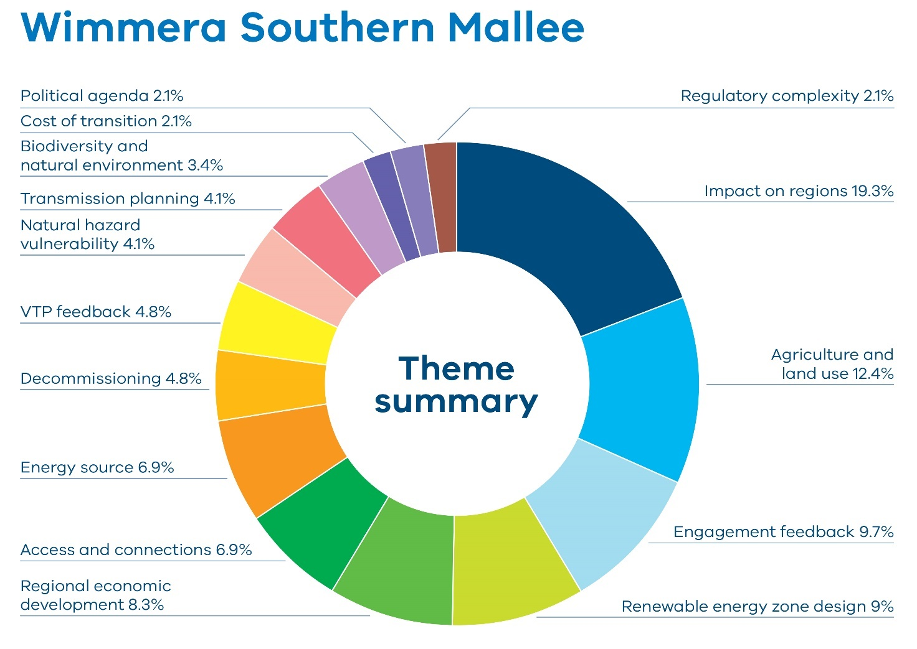
Table 6: Feedback by theme received by stakeholders in the Wimmera Southern Mallee region
Theme | Percentage
Impact on regions | 19.3%
Agriculture and land use | 12.4%
Engagement feedback | 9.7%
Renewable energy zone design | 9%
Regional economic development | 8.3%
Access and connections | 6.9%
Energy source | 6.9%
Decommissioning | 4.8%
VTP feedback | 4.8%
Natural hazard vulnerability | 4.1%
Transmission planning | 4.1%
Biodiversity and natural environment | 3.4%
Cost of transition | 2.1%
Political agenda | 2.1%
Regulatory complexity | 2.1%
The Wimmera Southern Mallee region is characterised by vast, flat plains, semi-arid climate, and strong reliance on dryland agriculture. The area is part of Victoria’s grain belt, producing significant volumes of wheat, barley, lentils and canola, alongside sheep grazing for wool and lamb.
With a long history of resilient farming and tight-knit rural communities, the region has also become a focal point for proposed large-scale renewable energy development, particularly wind. While some landholders and local councils have supported these developments – especially when economic benefits, lease payments, and local employment are clear – there is also concern about the cumulative impact of transmission lines, landscape changes and whether the benefits are equitably distributed. As with much of western Victoria, community sentiment is increasingly shaped by expectations of early, transparent consultation and genuine local benefit-sharing.
Feedback on the impact on regions highlighted concerns about the impact of renewable energy development on the social, environmental and economic fabric of the area. Communities reported feeling overwhelmed by the scale and pace of proposed projects, which were perceived to be concentrated in rural zones while offering limited local benefit. This was exacerbated by mineral sands mining activity in the region. The increasing amount of renewable energy infrastructure has raised fears about loss of the rural essence of the region. There was also concern about inadequate infrastructure to support temporary workforces, pressure on health and housing services, and the long-term burden of decommissioning and waste management. The visual impact of turbines, noise pollution and fire hazards were frequently mentioned, alongside fears of land devaluation, mental health stress and community division. Some called for exclusion zones around towns and nature reserves, and for buffer distances between turbines and dwellings to be increased to 2–5 km.
Example comment from respondents:
- “We do not consent to the degradation of our environment, landscapes, agricultural productivity. We do not consent to the diminishing of lifestyles with the introduction of fly in fly out workforce who live in accommodation camps. We do not consent to projects stretching and competing for the resources of our small communities and taking services away from current residents through the competitive pressure local business, health etc will be placed under as a result.” – Quote from individual, Wimmera Southern Mallee
- “I’m happy with the area proposed if anything it could be bigger there is huge potential and minimal environmental constraints out here. If done correctly the west could become a powerhouse with a diverse economy not reliant on the weather.” – Quote from landholder, Wimmera Southern Mallee.
Feedback from the region revealed concern about developer behaviour in the context of renewable energy projects. Many community members and councils reported that developers had engaged selectively and shared limited information, particularly during early project stages. This had led to feelings of betrayal and division within communities, especially where confidentiality clauses had prevented open discussion with neighbours. There was a strong perception that developers prioritised securing permits and approvals to increase project value for resale, with little regard for the lasting social, environmental and economic consequences for host regions. Concerns also included perceptions of inadequate consultation, lack of transparency, and the absence of binding commitments for decommissioning, waste management and community benefit contributions. The feedback called for stronger regulation, upfront financial bonds, and clearer planning frameworks to ensure developers were held accountable and that communities were not left with the burden once projects were sold or abandoned.
Example comment from respondent: “The public does not trust the process; the government or VicGrid due to the way successive projects have been pushed out. Background work has been happening for years with big consultancies and developers, but without the inclusion of communities. Support only from a tiny minority that will benefit from short term monetary gain and who have been sold into very risky arrangements with developers.” – Quote from individual, Wimmera Southern Mallee.
Agriculture and land use feedback reflected concern over the use of farmland for energy infrastructure. Many people - particularly landholders and rural residents - expressed strong opposition to wind and solar projects being sited on productive farmland, citing perceived risks to food security, biosecurity and long-established farming practices.
Example comment from respondent: “The Wimmera Southern Mallee zone is some of the best agricultural producing land in the state and when I look at the proposals surrounding Warracknabeal Curyo and Wilkur it seems an extreme amount of development in a very small and concentrated area. We would say, ok distribute around the state but we see no significant developments in or near the metropolitan areas where the highest usage is, place towers throughout the industrial area of Melbourne and Geelong. I do not agree with the concept of Zones at all, place the developments where they are needed, not in someone else’s back yard!” – Quote from landholder, Wimmera Southern Mallee.
Engagement feedback criticised consultation. Many felt the process lacked transparency, was rushed, and failed to meaningfully include local voices. Several submissions described the consultation as tokenistic and stated the view that decisions had already been made.
Example comment from respondent: “This engagement has come too little too late, with plans already in place to include the Wimmera Southern Mallee in a REZ”. – Quote from Wimmera Mallee Environmental and Agricultural Protection Association.
Feedback on renewable energy zone design included calls for a more strategic, transparent and locally responsive approach. Many felt that the design of the draft proposed zones was driven more by developer ambition than community feedback, biodiversity and land use factors. There were calls for rigorous impact assessments and a statewide framework to protect high-value agricultural land. There were concerns raised about the area surrounding the southern part of the zone, including cumulative impacts of projects seeking to connect into the proposed Bulgana terminal station.
There was also feedback about the proximity to Horsham and the Horsham airport. In addition, there were multiple calls from community to expand the zone to allow more landholders to benefit from the transition. Local councils did not support those calls.
Some feedback highlighted potential benefits related to regional economic development . Some landholders and community members expressed support for renewable projects that could diversify local economies, provide drought-proof income and stimulate employment. These people emphasised the importance of fair compensation, community benefit schemes and inclusive planning. Several submissions advocated for expanding the renewable energy zone boundaries to include more willing participants and projects with strong environmental and social credentials. Others noted that wind turbines could coexist with broadacre cropping, with minimal land loss and significant financial gain for hosts. Feedback highlighted the desire to locate renewable energy development further north to move away from areas and landscapes with significant environmental, cultural and community values.
Example comment from respondent: “I think constraining the REZ to the area between Warracknabeal and Horsham limits the potential for our region to be a renewable energy powerhouse for the state. We have low population density, an above average wind resource and towns crying out for employment non related to the agricultural sector which would all benefit from renewable energy development in our region. Landholders having to host transmission lines on their property need to be better compensated and there needs to be better communication about what the actual impact is on their farms. Currently misinformation is rife and its hard to determine fact from fiction given the spreading of non-factual information from groups with ulterior motives.” – Quote from individual, Wimmera Southern Mallee.

Local government feedback
The Yarriambiack Shire expressed concern over the scale and siting of renewable energy developments in the region, particularly in relation to the draft VTP. The council highlighted growing community division and unease about the impact of renewable energy on agriculture, water resources, and local amenity. They sought clarification about the status of large-scale projects such as the Curyo Windfarm and Wilkur Energy Park, which fall outside designated renewable energy zones and wishes to understand whether projects outside of the zone will be considered. The council urged the government to adhere strictly to zone boundaries to maintain credibility and planning certainty. It also opposed any increase in megawatt capacity beyond what is published for each zone and calls for planning reforms to reinstate buffer zones between turbines and neighbouring properties. Additional concerns included the lack of recognition of prime agricultural land in zone mapping and the potential landscape impacts of private transmission lines. The council requested clear, accessible communication materials for landholders outlining legal, operational, and environmental implications of hosting energy infrastructure, and stresses the need for cross-departmental coordination to support informed community engagement.
Horsham Rural City Council acknowledged the strategic importance of the VTP but expressed concern about the disproportionate burden placed on north-western Victoria, particularly the Wimmera Southern Mallee region, which hosts multiple renewable energy zones. The council identified three key issues: the protection of agricultural productivity, the need for transparent and inclusive planning and approvals processes, and the importance of a joined-up approach to economic development. The council also highlighted the importance of considering plans to expand the Horsham airport.
The council called for consistent statewide mapping of high-value agricultural land and rigorous impact assessments to ensure renewable energy projects do not compromise farming viability. It also highlighted the lack of visibility of zones in planning schemes and property transactions, recommending the creation of overlays or mandatory disclosures to inform landowners and buyers. The submission raised concerns about fast-tracked approvals and the potential erosion of community input, urging VicGrid to prioritise social cohesion and conflict resolution. The council supported the Renewable Energy Zone Community Energy Funds but stressed the need for strategies that address housing, skills, infrastructure, and long-term regional growth. The council advocated for coordinated investment across all levels of government to ensure that the benefits of renewable energy development are equitably distributed and support structural transformation in rural economies.
Buloke Shire Council’s submission to VicGrid on the draft 2025 VTP raised serious concerns about proposed energy infrastructure developments, particularly VNI West and WRL. They urged VicGrid to consider improving transparency, community engagement, and long-term planning to protect agriculture and local interests.

North West
Figure 7 shows the feedback received from stakeholders by theme in the North West region, and how often the themes were mentioned by percentage. Table 7 lists the themes and percentages in the chart.
Figure 7: Feedback by theme received by stakeholders in the North West region
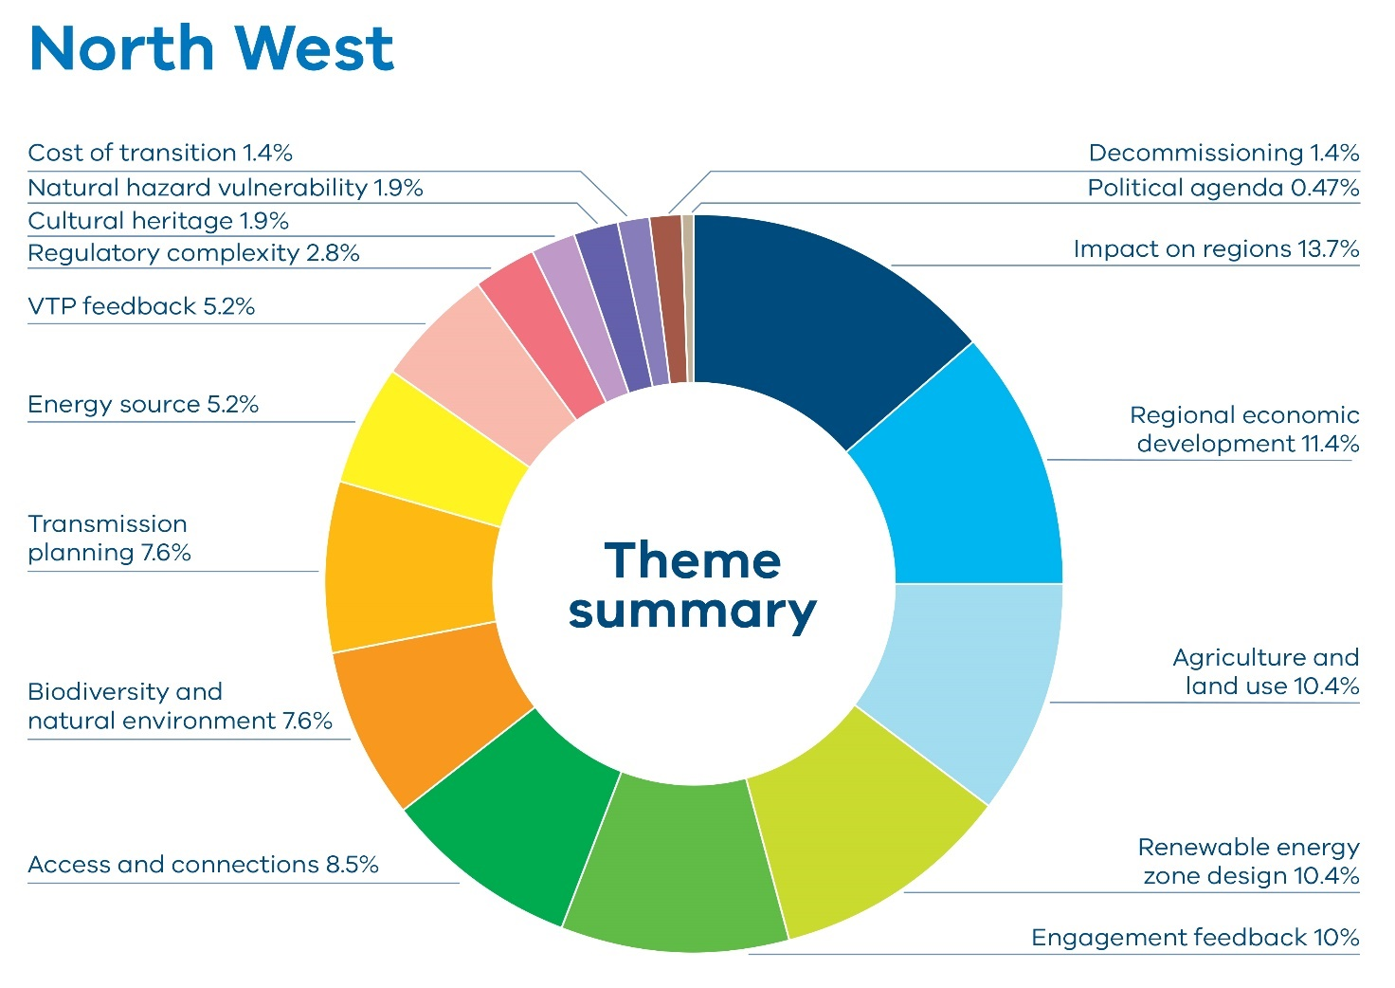
Table 7: Feedback by theme received by stakeholders in the North West region
Theme | Percentage
Impact on regions | 13.7%
Regional economic development | 11.4%
Agriculture and Land Use | 10.4%
Renewable energy zone design | 10.4%
Engagement feedback | 10%
Access and connections | 8.5%
Biodiversity and natural environment | 7.6%
Transmission planning | 7.6%
Energy source | 5.2%
VTP feedback | 5.2%
Regulatory complexity | 2.8%
Cultural heritage | 1.9%
Natural hazard vulnerability | 1.9%
Cost of transition | 1.4%
Decommissioning | 1.4%
Political agenda | 0.47%
The draft proposed North West Renewable Energy Zone is characterised by open plains, river systems and farmland with irrigation infrastructure. The region sits along the Loddon River and is part of the broader Murray-Darling Basin, which supports both dryland and irrigated agriculture. The area features a network of wetlands, which support significant wildlife and biodiversity. Fertile soils make the area well suited to a mix of farming enterprises. The region has also emerged as a significant hub for renewable energy development, particularly in solar power with the area’s flat terrain, high solar irradiance and proximity to grid infrastructure.
Feedback about the draft proposed North West Renewable Energy Zone echoed themes from across the state, citing the impact on regions, fears of industrialisation, impacts to property values and feelings of helplessness. Feedback raised significant concerns about the potential impact of the proposed Victoria to New South Wales Interconnector West (VNI West) transmission project, criticising the project’s approach to community consultation and its negative impact on community support. Citing prior experience with renewable energy projects, some community members and landholders reported feeling excluded from decision-making processes, particularly neighbours of proposed renewable energy projects. Feedback highlighted issues with developers prioritising private or non- disclosure agreements with host landowners without undertaking broader engagement with neighbours and the community. Several local governments, including Gannawarra, Northern Grampians and Buloke Shire councils, are opposed to the VNI West project and have emphasised the need for meaningful community benefits, such as reduced electricity costs for hosting infrastructure.
Example comment from respondent: “The installation of industrial-scale turbines and solar farms will significantly reduce property values for nearby landholders who receive no financial benefit, creating economic hardship.” – Quote from landholder, North West.
Some people reported instances of land banking, imposing restrictive caveats and misrepresenting community support. There was a strong demand for VicGrid to establish clear rules, enforce planning conditions, and monitor developer engagement practices. Some people emphasised the need for government-led oversight to restore integrity to the planning process and protect community interests. The community called for VicGrid to enforce minimum standards for consultation and to hold developers accountable for their conduct.
Example comment from respondent: “We have experienced a pattern of closed-door meetings, restrictive caveats on contracts and land titles, and tactics that have deliberately prevented broader community awareness or informed participation…The current model of early, private agreements between developers and host landholders undermines trust and transparency and has resulted in fractured community relations.” – Quote from landholder, North West.
While some feedback supported the renewable energy transition, there was a consensus that benefits must be equitably distributed to support regional economic development. Suggestions included expanding the proposed Renewable Energy Zone Community Energy Fund to support local infrastructure, housing and carbon reduction initiatives. Some people advocated for models such as community power hubs to manage these funds and ensure they reach both host and neighbouring communities. There were also calls to reduce energy costs for communities hosting infrastructure and to align transmission planning with local economic development goals.
Example comment from respondent: “Disbursement of Renewable Energy Community Benefit Funds should be managed through the successful community engagement model presented by the Community Power Hubs in Victoria in recent years. These were regional community groups who engaged with their communities and actively supported community energy projects that benefited those communities.” - Quote from Sustainability Network Loddon Mallee.
The proposed renewable energy zone includes irrigated and broadacre cropping areas. In terms of the impact to agriculture and land use, many people argued that renewable energy infrastructure should not be sited on farming land, which is essential for food and fibre production. Instead, they suggested locating projects on less productive or marginal land. Farmers expressed concern about potential property devaluation, disruption to agricultural operations, and the long-term viability of farming in the region. There was also frustration over what some saw as inadequate compensation and the lack of clarity around land use impacts and transmission infrastructure placement.
Example comment from respondent: “Council supports the need for ongoing communication and full consultation with our agricultural community to achieve a balance between energy projects and the need to continue to produce high quality food, which our municipality has proud tradition of doing so. Any potential use of food producing land should see the owner of that land adequately compensated and options to avoid any production loss to maintain Australia’s food security.” – Quote from Swan Hill Rural City Council.
In feedback on renewable energy zone design, several stakeholders proposed expanding the draft proposed North West Renewable Energy Zone to include areas with high solar and wind potential, such as Mildura and regions north and north-east of Kerang with many people claiming that these areas offered strong community support, less environmental constraints, and proximity to existing transmission corridors. People argued that zone boundaries should reflect actual resource potential and community readiness, rather than being retrofitted around existing projects. There was also concern that current zone planning underestimated the cumulative impact of multiple large-scale developments and failed to account for long-term sustainability.
Example comment from respondent: “The Ovens Murray REZ has disappeared, and the Central North REZ redrawn to exclude the Benalla and Glenrowan region, which is surprising given its solar farm activity and potential.” – Quote from individual, North West.
Biodiversity and natural environment feedback highlighted the ecological sensitivity of the North West region, particularly areas such as Lake Meran, Leaghur State Forest, and surrounding wetlands. These areas are home to endangered and migratory species, including the plains-wanderer, brolga and wedge-tailed eagle. Concerns were raised about the impact of wind turbines and battery energy storage systems (BESS) on biodiversity, fire risk and pollution. There was a strong call to exclude these high-value environmental assets from renewable energy zone boundaries and to implement significant buffer zones to protect them. Additionally, the region’s rich Aboriginal heritage – including scar trees, burial sites and middens – was seen as being inadequately considered in current planning.
Example comment from respondent: “Far from being environmentally friendly, these developments contribute to habitat destruction, disrupt wildlife (including birds and bats), and permanently alter the natural landscape. Their finite lifespan and resource demands further undermine their ‘renewable’ label.” - Quote from landholder, North West.

Local government feedback
The Swan Hill Rural City Council voiced support for Victoria’s transition to renewable energy and the establishment of renewable energy zones, particularly the draft proposed North West Renewable Energy Zone which affects the Swan Hill municipality. The council acknowledged the importance of sustainable energy development but emphasised the need for careful planning to avoid impacts on agricultural productivity, community wellbeing, and local infrastructure. It advocated for meaningful engagement with local government, First Nations communities, and residents throughout the planning and implementation phases. The council also highlighted the need for infrastructure upgrades, economic development opportunities, and mechanisms to ensure local benefits, including reduced energy costs and fair compensation for land use.
The Loddon Shire Council raised several key concerns regarding the draft VTP, particularly in relation to the North West Renewable Energy Zone and the proposed transmission line upgrade between Kerang and Bendigo. The council emphasised the inappropriateness of siting renewable energy projects on highly productive irrigated agricultural land, which is vital for food production and economic sustainability. The council raised the issue of cumulative impact on community wellbeing, with residents facing multiple stressors including recent floods, water buybacks, mineral sands exploration, and uncertainty around energy infrastructure. These pressures have diminished the community’s capacity to engage meaningfully with the VTP process. While acknowledging VicGrid’s improved engagement compared to previous planning efforts, the council called for more direct outreach to affected landowners. The council also advocated for meaningful community benefits from hosting renewable energy projects, suggesting long-term investments that support economic growth, energy reliability, and job creation and requests formal commitments to restore affected roads and fair compensation for landowners impacted by transmission upgrades. Although not included in the draft proposed North West Renewable Energy Zone, the Mildura Rural City Council strongly advocated for the inclusion of the Mildura region in the Victorian Transmission Plan’s zones. The council outlined Mildura’s exceptional solar resources, strong community and investor support, and existing infrastructure as compelling reasons for zone designation and argues that excluding Mildura from the renewable energy zone framework risks stalling renewable energy investment, undermining local economic development, and missing a strategic opportunity to support Victoria’s clean energy transition.
Buloke Shire Council’s submission to VicGrid on the Draft 2025 VTP expressed deep concern over proposed energy infrastructure developments, particularly the VNI West and Western Renewables Link WRL projects. The council highlighted the potential disruption to agriculture, the need for better community consultation, procedural fairness issues, and inadequate community benefits. It called for greater transparency, stronger decommissioning commitments, reform of the Payment in Lieu of Rates (PiLoR) scheme, and more detailed planning beyond 2040. The council urged VicGrid to engage genuinely with the community and provide clearer information on land access, project timelines, and biosecurity protections.

Central North
Figure 8 shows the feedback received from stakeholders by theme in the Central North region, and how often the themes were mentioned by percentage. Table 8 lists the themes and percentages in the chart.
Figure 8: Feedback by theme received by stakeholders in the Central North region
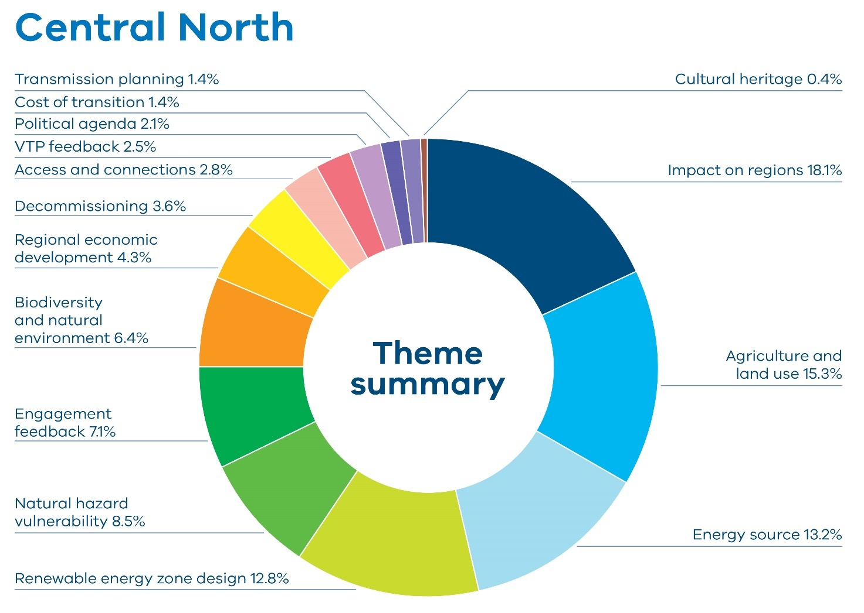
Table 8: Feedback by theme received by stakeholders in the Central North region
Theme | Percentage
Impact on regions | 18.1%
Agriculture and land use | 15.3%
Energy source | 13.2%
Renewable energy zone design | 12.8%
Natural hazard vulnerability | 8.5%
Engagement feedback | 7.1%
Biodiversity and natural environment | 6.4%
Regional economic development | 4.3%
Decommissioning | 3.6%
Access and connections | 2.8%
VTP feedback | 2.5%
Political agenda | 2.1%
Cost of transition | 1.4%
Transmission planning | 1.4%
Cultural heritage | 0.4%
The region is characterised by a mix of undulating and flat landscapes, fertile soils, and access to water via the Goulburn-Murray irrigation system. The area supports diverse and productive agricultural activity, including dairy farming, cropping (wheat, barley, canola), horticulture (tomatoes, stone fruit, olives and grapes), and livestock grazing, particularly sheep and beef cattle.
Historically, the area developed through gold mining (notably in Bendigo) and irrigation-based agriculture, contributing to a strong sense of rural identity and land stewardship. In terms of renewable energy development, the region has seen growing interest in solar, wind and battery projects, especially around Rushworth and Kyabram, due to high solar exposure and grid access.
However, community attitudes are mixed – while some farmers and councils support renewables as an opportunity for economic diversification, others express concern about land use conflicts, the visual and cumulative impact of energy infrastructure, and the fairness of consultation processes.
Feedback on the impact on regions included health concerns about noise, vibration and electromagnetic fields from turbines and transmission lines, with some community members reporting pre-existing conditions that could be worsened by proximity to infrastructure. Mental health impacts, particularly stress and anxiety related to uncertainty and loss of amenity, were also frequently mentioned.
Example comment from respondent: “Ongoing noise, vibration, and light pollution have not been sufficiently addressed. These impacts can degrade mental and physical health, particularly with wind farms and battery storage facilities near residences.”- Quote from individual, Central North.
There was criticism of the current planning and regulatory framework, which is viewed as favouring developers and lacking in enforceable protections for landholders. People called for reforms to planning laws, environmental assessments, and compensation mechanisms, and demand that renewable energy developers be held accountable for long-term impacts, including decommissioning.
Example comment from respondent: “A broader area with stricter planning criteria (e.g. mandatory setbacks, exclusion zones, better land classification filtering) would reduce community and environmental impacts. It would also allow infrastructure to be better integrated into the landscape.”- Quote from Individual, Central North.
There was also a perceived imbalance in the distribution of benefits and burdens. Many people argued that while a few landholders may profit from hosting infrastructure, the broader community bears the visual, environmental and social costs. This has led to calls for more equitable compensation frameworks, stronger regulatory protections for landholders and clearer planning guidelines. Several submissions referenced the Victorian Farmers Federation’s (VFF) policy recommendations, advocating for enforceable land access codes, agricultural impact assessments, and planning reforms to protect strategic farmland and irrigation zones.
Example comment from respondent: “The planning process has unintentionally set neighbour against neighbour. Landholders who receive payments to host infrastructure benefit, while adjacent landowners endure visual impacts, noise, and disruption with no compensation. This creates resentment and fractures once-close rural communities.” – Quote from individual, Central North.
Economic and tourism impacts were also raised, with concerns that the renewable energy zone might devalue land, disrupt tourism and reverse recent gains in rural development.
Agriculture and land use was a key theme throughout the feedback, with a focus on protecting farmland. Many community members raised concerns about the impact of renewable energy development on farmland which is described as vital for food security, economic sustainability, and community identity. People expressed the view that once this land is used for wind turbines, solar farms, and transmission lines, it cannot be reclaimed for farming. This concern was compounded by fears that the renewable energy zone will fragment agricultural operations, reduce land values, and undermine generational farming enterprises.
Example comment from respondent: “Including land with the best soils (Cambrian soil) in a proposed renewable energy zone is not acceptable and will decimate food production in the area, jobs, the township, tourism in the region etc. There are much more appropriate areas of land which are in the region that would make more sense, cause much less disruption and minimal impact to the land / people nearby.” - Quote from Individual, Central North.
While some people expressed support for renewable energy in principle, others expressed scepticism or opposition, favouring alternate energy sources.
Example comment from respondent: “I propose that gas and coal be given a new lease of life in Victoria. Upgrade the coalfired power stations. You say the coalfired power stations are becoming unreliable and closing down. Inject money into them. It provides a reliable & cheap form of power for our state and has for DECADES.” – Quote from landholder, Central North.
The scale and siting of the renewable energy zone was also raised in feedback on renewable energy zone design. Some argued the zone is poorly located, suggesting it be shifted to less densely populated, lower-value dryland farming areas. Others advocated for smaller, distributed renewable projects such as solar canals or community batteries that better align with local conditions and values. There were also calls to move the zone closer to Glenrowan, an area with multiple existing and pipeline projects and a higher social licence for renewable energy development, particularly solar.
Example comment from respondent: “While renewable energy development is important, the specific characteristics of the Central North REZ make it an unsuitable location for large-scale wind installations. An industrial wind farm may provide short-term economic benefits, but its long-term impact on our community’s environment, health, and infrastructure would be significant.” – Quote from Individual, Central North.
Feedback about natural hazard vulnerability focused predominantly on flood risk. Many community members highlighted that the draft proposed renewable energy zone includes land that is subject to flooding and inundation and raises concerns about the impact of and on renewable energy infrastructure.
Example comment from respondent: “This region is a known floodplain. Turbine construction—including access roads, crane pads, and foundations—will alter drainage patterns and increase the chance of future flood damage. We saw firsthand the consequences during the 2022 floods in Nanneella and Koyuga.” - Quote from individual, Central North”.
Engagement feedback included concerns about perceptions of inadequate consultation and community engagement. Some people said they felt blindsided by the renewable energy zone proposals and some questioned the engagement methods used and whether feedback would genuinely influence the outcome.
Example comment from respondent: “The planning process has not directly engaged with the small towns and farms that will be most affected, relying instead on hubs that aren’t located in the proposed zone, webinars, and online feedback methods that many rural residents may not hear about, have access to, or feel comfortable using — genuine consultation requires going to these communities in person and providing accessible, tailored opportunities for them to be heard.” – Quote from individual, Central North.
In terms of biodiversity and natural environment, people raised concerns about the potential impacts of wind turbines and solar farms on biodiversity, particularly in ecologically sensitive areas such as wetlands, native vegetation corridors, and habitats for raptors and other bird species including brolgas. The Mount Camel Range, Lake Cooper, and Whroo Forest were among the areas cited as needing protection. New data sets have also been received locating a brolga flocking ground in the Corop Wetlands.
Feedback on regional economic development included questions about community benefits and calls for local input into the use of the proposed community energy funds.
Example comment from respondent: “I see a major opportunity in supporting energy independence for residential households — not just large landowners. Stronger local infrastructure could enable community batteries, improved solar export, and better blackout protection. I encourage VicGrid to explore pilot programs for neighbourhood-level battery storage, especially in blackout-prone or rural towns.” – Quote from Individual, Central North.

Local government feedback
Campaspe Shire Council supported the transition to renewable energy and the intent of the Draft Victorian Transmission Plan to integrate environmental, land use, and community considerations early in the planning process. However, the council raised serious concerns about the proposed Central North Renewable Energy Zone, citing misalignment with local strategic plans, economic priorities—particularly in agriculture— and environmental and cultural values. The council called for reassessment of the zone boundaries, more detailed place-based evaluations, and stronger community involvement to ensure the region’s long-term sustainability is not compromised.
The City of Greater Bendigo expressed broad support for the proposed Central North Renewable Energy Zone as part of the 2025 Victorian Transmission Plan, recognising its potential to contribute to the state’s renewable energy goals. However, the submission emphasised the importance of protecting productive agricultural land, maintaining rural character, and ensuring meaningful local governance and community involvement. The city advocated for co-location opportunities, clearer planning guidelines, and strategic alignment with existing and future employment precincts. It also highlighted the need for community education and inclusive governance to maximize the benefits of renewable energy development.
Greater Shepparton City Council expressed support for the transition to renewable energy but raised several concerns about the clarity, inclusiveness, and long-term sustainability of the plan. The council emphasised the need for clearer zone boundaries, transparency around project approvals, and inclusion of previously proposed infrastructure upgrades. It also highlighted the importance of equitable community benefits, environmental protection, and agricultural viability. The submission called for deeper engagement with local government and communities to ensure a just and informed transition that aligns with regional priorities and values.

Gippsland
Figure 9 shows the feedback received from stakeholders by theme in the Gippsland region, and how often the themes were mentioned by percentage. Table 9 lists the themes and percentages in the chart.
Figure 9: Feedback by theme received by stakeholders in the Gippsland region
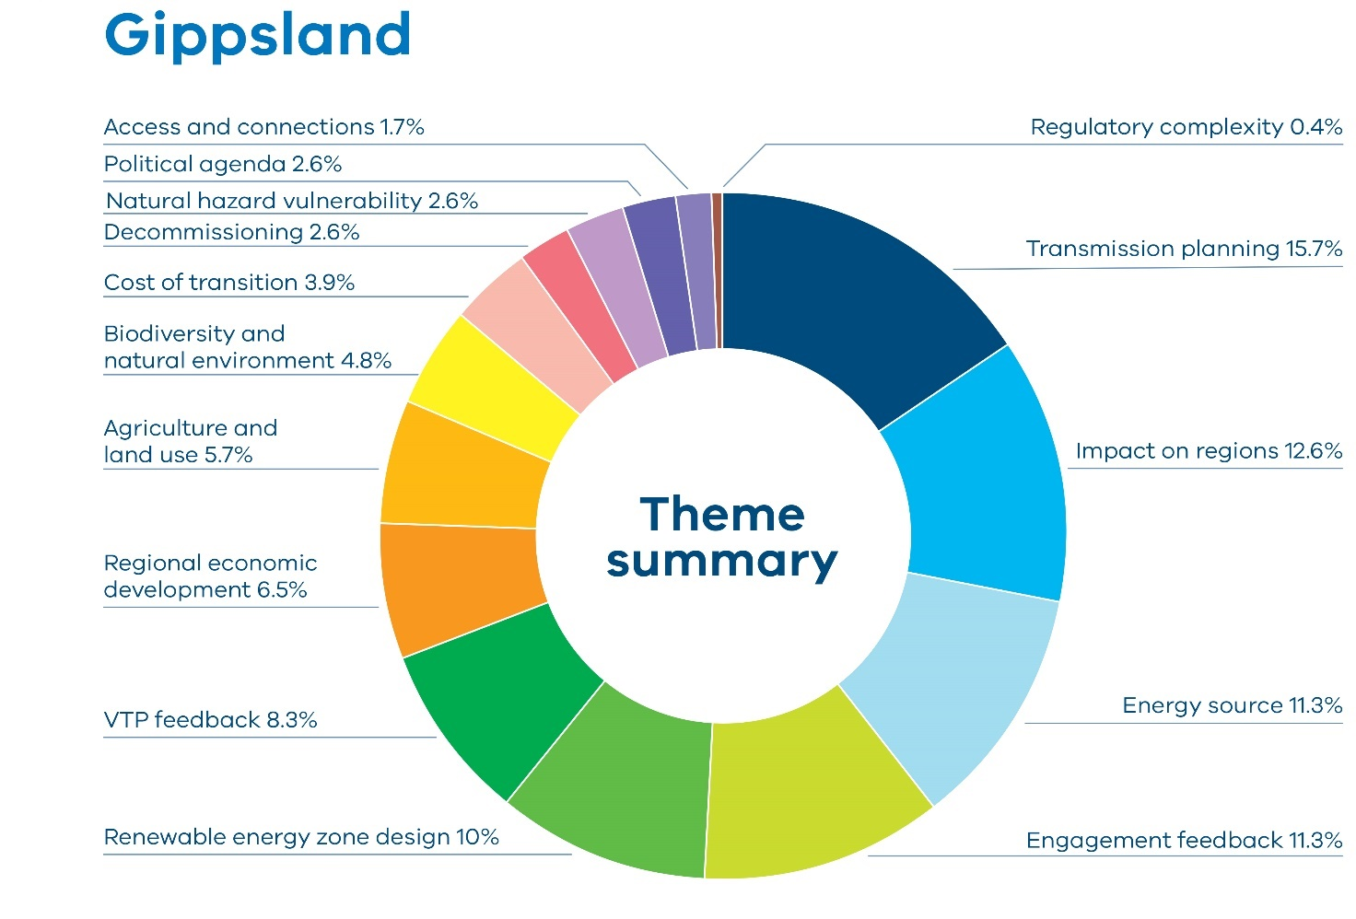
Table 9 Feedback by theme received by stakeholders in the Gippsland region
Theme | Percentage
Transmission planning | 15.7%
Impact on regions | 12.6%
Energy source | 11.3%
Engagement feedback | 11.3%
Renewable energy zone design | 10%
VTP feedback | 8.3%
Regional economic development | 6.5%
Agriculture and land use | 5.7%
Biodiversity and natural environment | 4.8%
Cost of transition | 3.9%
Decommissioning | 2.6%
Natural hazard vulnerability | 2.6%
Political agenda | 2.6%
Access and connections | 1.7%
Regulatory complexity | 0.4%
Gippsland, in south-east Victoria, has long been central to the state’s energy story, historically dominated by brown coal generation in the Latrobe Valley.
As Victoria transitions away from fossil fuels, Gippsland is emerging as a key region for renewable energy development, with strong momentum behind offshore wind, solar farms and battery storage projects. Its existing transmission infrastructure and skilled energy workforce make it well-positioned to support large-scale renewable investment. The region’s diverse landscape – ranging from forested hills to productive farmland and coastline – also brings environmental and community considerations to the forefront of planning and engagement efforts
Example comment from respondent: “Gippsland is accustomed to oil/gas/coal extraction, power generation and transmission. We are now generally comfortable in the transition to renewables as it is obvious that fossil fuels are passing into history. Other regions find the imposition of panels, turbines, batteries and towers are confronting, and will have a relatively short time to adjust to the necessity of RE infrastructure.”– Quote from individual, Gippsland.
Transmission infrastructure emerged as a particularly contentious issue under the transmission planning feedback theme. Many community members criticised the use of overhead transmission lines, citing perceived risks such as fire hazards, health concerns, GPS interference and biosecurity threats from contractors moving between farms. The physical footprint of transmission towers was seen as incompatible with farming operations and damaging to the landscape. There was a bulk of feedback advocating for underground transmission lines, arguing they would be safer, more durable and less disruptive to land use. Underground cabling was also viewed as a more respectful approach to landowners, with calls for fair compensation and long-term planning that prioritised community wellbeing over short-term cost savings.
Example comment from respondent: ““Surely the cons of overhead powerlines outweigh a much safer alternative in underground power lines. The ever changing climate for one, with higher fire risk in summer, the down time to having to turn the power off in the event of a fire. The increasing damaging wind storms. None of these effects the underground power. With new fibreoptic cabling you are able to see exactly where in the line a fault may be occurring.” – Quote from Individual, Gippsland.
Feedback about the impact on regions centred on the visual intrusion of wind turbines and solar farms being detrimental to the region’s natural beauty and tourism appeal.
Example comment from respondent: “The decrease in land value, the decrease in tourism which Gippsland is a prime tourist destination. People do not want to be looking at wind turbines, solar farms and power transmission lines.” – Quote from individual, Gippsland.
As in other areas of the state, many people questioned the reliability, cost-effectiveness and environmental sustainability of energy sources. People questioned the efficiency of renewables during peak demand periods, the recyclability of solar panels and the operational limitations of wind turbines in extreme weather. Several contributors emphasised the need for energy solutions that did not compromise agricultural productivity or rural aesthetics.
Example comment from respondent: “Wind farms also have proven to be costly and inefficient. They will not work during high winds they need to be turned off. As far as solar goes. It is also unreliable. Winter is the weakest time for solar and is the highest consumption of power.” – Quote from Landholder, Gippsland.
Despite opposition, there was support for the transition in general and the need to modernise energy systems and reduce reliance on fossil fuels. There was appreciation for VicGrid’s outreach efforts, with suggested improvements such as expanding electric vehicle charging networks, aligning renewable energy zone boundaries with property and council lines and ensuring equitable treatment across zones. There were also many suggestions to plan renewable projects in ways that preserved the region’s character and drive regional economic development
Example comment from respondent: “Renewable energy generation in Gippsland represents a significant economic opportunity, with over $100 billion in capital investment represented by projects currently in planning. Transmission infrastructure is critical to enabling these developments. If delivered strategically, it can ensure Gippsland continues to power Victoria, and position the region as a national leader in reliable clean energy generation. This transition would not only offset the impacts of coal power station closures but also create new jobs and deliver long-term benefits for Gippsland’s communities.” – Quote from Committee for Gippsland.
Gippsland communities have traditionally been strongly involved in VicGrid engagement, which continued during this round of engagement. Engagement feedback highlighted that the region was currently experiencing a particularly intense period of engagement and that the community was struggling to deal with the number of different plans and engagement opportunities across multiple sectors. There was also a body of feedback about engagement in general with reports ranging from a lack of awareness of engagement opportunities to feeling blindsided. Many expressed frustration with planning processes, feeling that rural voices were being ignored and that decisions were being made without adequate consultation. There were also concerns that longer-term planning did not provide the certainty the community was looking for about how the transition would impact them.
Example comment from respondent “While planning for energy needs into the future is welcome, I have major concerns with how this whole process in Gippsland is being proposed and communicated to residents like me. Not everyone is on social media or reads what limited local print media there is. Surely when something as important and impactful as this is being proposed, a letter could be sent to all rate payers in the affected areas?” – Quote from individual, Gippsland.
In terms of renewable energy zone design, some people advocated for an expansion of the draft proposed Gippsland Renewable Energy Zone, while there were also some concerns raised about the zone being able to meet its capacity with existing coal overlays.
Example comment from respondent: “Consider extending zone further east to maximise population growth and renewable energy capacity.” - Quote from individual, Gippsland.
VTP feedback was generally positive, with several people viewing it as an adequate starting point that reflected a broad range of perspectives. There were calls however for greater flexibility within the plan to accommodate an evolving energy landscape and potential shortfalls in offshore wind targets.
Example comment from respondent: “VicGrid has made lengthy efforts to accommodate a variety of opinions, define a broad route and illustrate some advantages of the new energy system.” – Quote from individual, Gippsland.
Feedback about the impact to agriculture and land use featured much less strongly in this round of engagement compared to engagement on the draft VTP Guidelines, reflecting efforts to avoid agricultural land when designing the draft proposed Gippsland Renewable Energy Zone. Community members did, however, highlight the potential impacts on prime agricultural land, disruption to traditional farming practices and potential impacts on property values. This feedback predominantly referenced areas across the Latrobe Valley.
Example comment from respondent: “Do not interfere with farming. Farmers have plenty of obstacles put in their way. They do not need above-ground transmission infrastructure, when underground cabling is eminently possible. Consider the effect of a collapsed transmission tower on the productivity of a farming property. Keeping farmers on-side should be a priority. Their numbers are decreasing as a result of frenetic residential development.” – Quote from landholder, Gippsland.

Local government feedback
The Wellington Shire Council highlighted several key concerns and priorities for the region. The council emphasised the importance of protecting productive agricultural land and ensuring that transmission infrastructure planning did not compromise local land use, environmental values or community wellbeing. The council advocated for transmission lines to be put underground as a preferred option, particularly in sensitive areas. This recommendation was framed within broader concerns about preserving landscape character, minimising disruption to agricultural land and ensuring that infrastructure development aligned with community expectations and environmental stewardship. The shire also highlighted that expansions to the Macalister Irrigation District did not appear to be accounted for in the draft VTP. It called for more direct engagement with affected landowners and better coordination with local government to manage the impacts of large-scale energy projects. The submission also stressed the need for fair compensation, robust planning processes and long-term community benefits, particularly in areas hosting renewable energy infrastructure. Wellington Shire Council advocated for a balanced approach that supported Victoria’s energy transition while safeguarding regional interests and sustainability.
South Gippsland Shire Council welcomed the draft 2025 VTP and supported the transition to renewable energy, particularly offshore wind. The council highlighted the region’s strategic importance due to its existing and proposed renewable energy projects and critical port infrastructure at Barry Beach and Port Anthony. While expressing in-principle support, the submission raised concerns about the lack of recognition for infrastructure outside designated renewable energy zones, the need for investment in land and infrastructure to support offshore wind, and the absence of clarity around community benefit mechanisms for areas outside zones. The council called for greater inclusion, planning support and formal recognition of its role in Victoria’s energy transition. Bass Coast Shire Council expressed general support for Victoria’s renewable energy transition, acknowledging the ambition and scale of the draft 2025 VTP. However, the council raised concerns about the lack of coordinated and continuous community engagement across transmission and renewable energy initiatives, particularly offshore wind and the Victorian Renewable Energy Terminal. The council warned that fragmented communication was causing confusion and fatigue among community members and called for a unified, well-resourced engagement strategy. The council also highlighted the need for integrated planning to manage growth pressures resulting from energy investment.
Bass Coast expected increased demand for housing, infrastructure and services, and urged VicGrid to provide targeted funding and support for structure planning, rezoning and transport upgrades to avoid delays and ensure regional benefits are realised. The council criticised the absence of enforceable commitments to net biodiversity gain and called for specific safeguards for Ramsar wetlands, marine parks and declared Distinctive Areas and Landscapes. It also advocated for the removal of redundant infrastructure to prevent long-term environmental degradation. Bass Coast council strongly supported underground transmission in sensitive landscape areas, particularly where tourism, amenity, were biodiversity are at risk. The council argued that cost should not be the sole factor determining project design and called for whole-of-life and community impact assessments.

Gippsland Shoreline
Figure 10 shows the feedback received from stakeholders by theme in the Gippsland Shoreline region, and how often the themes were mentioned by percentage. Table 10 lists the themes and percentages in the chart.
Figure 10: Feedback by theme received by stakeholders in the Gippsland Shoreline
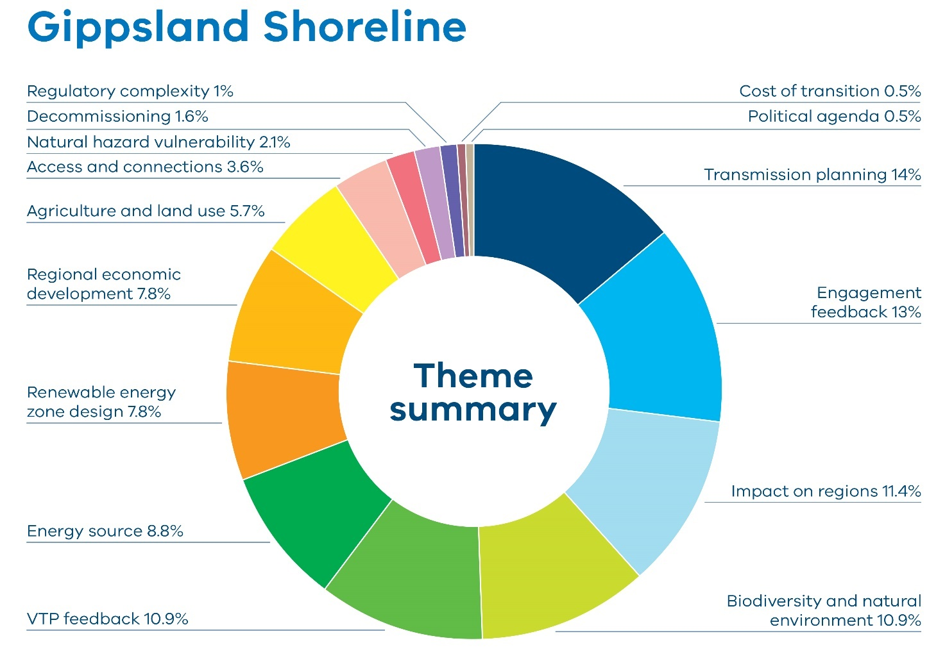
Table 10: Feedback by theme received by stakeholders in the Gippsland Shoreline
Theme | Percentage
Transmission planning | 14%
Engagement feedback | 13%
Impact on regions | 11.4%
Biodiversity and natural environment | 10.9%
VTP feedback | 10.9%
Energy source | 8.8%
Renewable energy zone design | 7.8%
Regional economic development | 7.8%
Agriculture and land use | 5.7%
Access and connections | 3.6%
Natural hazard vulnerability | 2.1%
Decommissioning | 1.6%
Regulatory complexity | 1%
Cost of transition | 0.5%
Political agenda | 0.5%
Transmission planning was a dominant theme in feedback about the Gippsland Shoreline Renewable Energy Zone, with a particular focus on strong opposition to above-ground transmission infrastructure. Landholders, councils and community members repeatedly advocated for underground transmission lines, citing reduced visual impact, improved safety and long-term cost efficiency. Above-ground lines were seen as outdated and incompatible with the environmental and agricultural sensitivity of the region. People stressed that underground was not just a technical preference but a community expectation, and they urged VicGrid to include it as a formal option in tenders and planning processes.
Example comment from respondent: “Ensure all transmission lines and renewables are forced to go underground to minimise impact to the people, community and the environment.” – Quote from Individual, Gippsland Shoreline.
Example comment from respondent: “Gippsland is a rich and productive agricultural area and above ground transmission will have significant adverse effects on the farmers impacted by the transmission corridor. In addition there will be a significant negative impact on land values. This is extremely unfair to the landowners affected by this infrastructure. Underground transmission lines for all new infrastructure should be mandated to improve safety, minimise maintenance and for longevity.” Quote from Individual, Gippsland Shoreline.
Engagement feedback underscored the importance of genuine engagement. Many felt the consultation process had been rushed with limited time to respond. There was a call for structured community co-design, better information dissemination and support for local advisory groups. The community feedback was clear: successful energy transition in Gippsland depended not only on technical infrastructure but on trust, transparency and respect for the people and landscapes it would affect.
Example comment from respondent: “I would like to take this opportunity to say that the timeframe for feedback on this draft Victorian Transmission Plan is completely unreasonable, especially given its importance, size of the document and the complexity for the ‘average Joe’ to read, comprehend and give feedback on!” – Quote from Individual, Gippsland Shoreline.
Social and economic impacts were also central to the feedback on impact on regions. Landholders expressed fears of impacts on property values, insurance premiums and farming practices. Mental health stress, loss of social cohesion and community division were cited as consequences of poorly planned infrastructure. Councils advocated for Payment in Lieu of Rates (PiLoR) to ensure sustainable revenue streams for local governments bearing the burden of development. There was also a strong push for community benefit schemes to be hyper-local, transparent and inclusive of both directly and indirectly affected residents.
Example comment from respondent: ““We support VicGrid’s intention to improve the community benefit frameworks and understand that this has been considered in a previous plan however we emphasise that benefits to community should be developed concurrently with transmission and not as a separate consideration. If you’re outlining the impacts, it’s equally important to explain the challenges and potential benefits for the communities affected. We urge greater transparency, consistency, and benchmarking in how these benefits are allocated, particularly in the new Gippsland Shoreline REZ.”– Quote from Gippsland Climate Change Network.
The feedback also highlighted significant concerns about biodiversity and natural environment. Many submissions pointed to the potential disruption of marine ecosystems, particularly lobster migration, and the impact on indigenous species such as koalas, gliders and endangered birds. Landcare corridors and restored habitats were seen as vulnerable to development of transmission and underground cables, prompting calls for drilling techniques and route adjustments to mitigate damage. The cumulative impact of overlapping projects – offshore wind, solar, hydrogen, and transmission – was a recurring concern, with stakeholders urging a regional framework to man
Example comment from respondent: ““The environmental effects are numerous: visual amenity of a beautiful coastal plain, destruction and compromise of significant Landcare projects and corridors linking the Mullungdung Forest and the Ninety Mile Beach, risks to wildlife habitat including that of the Southern Greater Glider and Strzelecki koala, and significant bird population too.”– Quote from Warrigal Creek Nominees.
Planning and technical clarity were repeatedly called for in VTP feedback. People said that there was a lack of detail in the draft 2025 VTP, particularly regarding the proposed transmission line between Woodside and Giffard. They requested clear timelines, capacity disclosures and coordination between VicGrid and developers to avoid misalignment and confusion. Concerns about system strength, fault levels and access fees were raised, with recommendations for early visibility and industry-wide guidelines to ensure fair and efficient grid integration.
Example comment from respondent: “Communities should be informed of the long-term infrastructure footprint, avoiding a piecemeal approach that erodes social licence and adds cumulative visual and land use burdens.” – Quote from Gippsland Climate Change Network.

Greater Melbourne
Figure 11 shows the feedback received from stakeholders by theme in the Greater Melbourne region, and how often the themes were mentioned by percentage. Table 11 lists the themes and percentages in the chart.
Figure 11: Feedback by theme received by stakeholders in the Greater Melbourne Region
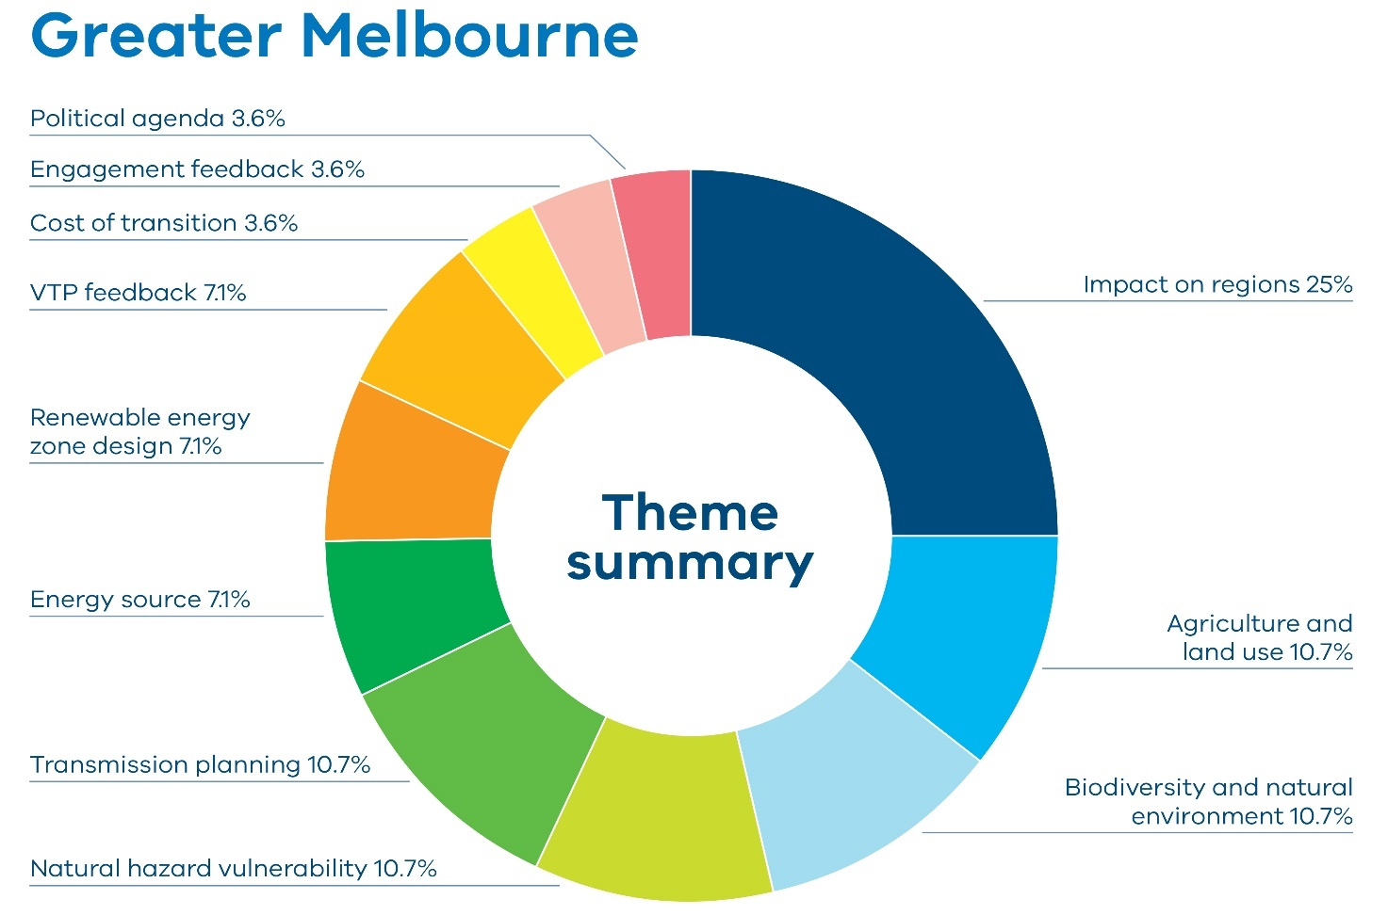
Table 11: Feedback by theme received by stakeholders in the Greater Melbourne Region
Theme | Percentage
Impact on Regions | 25%
Agriculture and Land Use | 10.7%
Biodiversity and Natural Environment | 10.7%
Natural Hazard Vulnerability | 10.7%
Transmission Planning | 10.7%
Energy Source | 7.1%
Renewable Energy Zone Design | 7.1%
VTP Feedback | 7.1%
Cost of Transition | 3.6%
Engagement Feedback | 3.6%
Political Agenda | 3.6%

There was significant feedback from the Greater Melbourne area, particularly within and around the Melton municipality.
In terms of impact on regions, many people strongly objected to the Western Renewables Link (WRL), which was a baseline input in the draft VTP. Concerns were raised about WRL’s potential impacts on visual and public amenity, land value, agriculture and other business operations, bushfire risk, aviation and the environment.
Example comment from respondent: “We are writing to formally object to the unacceptable impacts associated with the proposed Western Renewables Link (WRL), specifically the Melton section, which threatens both the safety and viability of our land, business, and broader community.” – Quote from Landholder, Greater Melbourne.
Example comment from respondent “As a member of the aviation community, I am concerned about the impact to Melton Airfield. I find it completely unacceptable that this plan is being pushed forward while ignoring the enormous safety risks it will create for aviation, and the potential loss of a community asset like Melton Airfield.” – Quote from Individual, Greater Melbourne.
People urged VicGrid to explore underground alternatives to WRL in transmission planning to avoid impacts on the community and environment. There were also recommendations to leverage new technologies that made better use of existing transmission infrastructure and minimised impacts on communities, such as reconductoring and line metering. Consideration for additional energy sources were also recommended, including battery storage and vehicle grid storage.
Example comment from respondent: “Underground HVDC lines eliminate fire ignition potential. They do not interfere with aerial firefighting. They avoid fragmenting farmland and follow existing road easements. They represent the best practice used across Europe and Asia for safe, modern transmission.” – Quote from Individual, Greater Melbourne.
In relation to the renewable energy zone design, there was feedback urging VicGrid to consider integrating renewable energy infrastructure into Victoria’s existing urban environments, to reduce the burden on regional communities, particularly given that metropolitan areas created the greatest demand.
Example comment from respondent: “Solar and wind energy (although not quite so efficient at only ~35% productivity) can be integrated into Australia’s existing urban environments and infrastructure, reducing reliance on farmland for renewable energy generation. This can be achieved through various methods, including rooftop solar panels, building-integrated photovoltaics (BIPV), repurposing existing infrastructure for wind turbines (like along highways or railways), and exploring floating solar farms on bodies of water in conjunction with improved battery storage and utilisation of sub-station location versus transmission lines.” – Quote from Landholder, Greater Melbourne.
Despite these concerns, Melton City Council’s submission to VicGrid expressed optimism about regional economic opportunities that new transmission infrastructure might bring, provided low-impact technologies were prioritised. They urged VicGrid to support the local electrical industry, and highlighted opportunities to provide targeted industry upskilling to address supply challenges and promote local production.
Example comment from respondent: “Council encourages VicGrid to nurture the electrical industry which produce lower impact technologies. This could include local production of underground HVDC and HVAC cabling to address supply challenges, targeted industry upskilling, and encouraging up-scaling of technologies.” – Quote from Melton City Council.
Melton City Council also stressed the importance of building community understanding and support in the area before implementing new transmission infrastructure. They called for an engagement approach that was meaningful and transparent, which had been lacking in many prior experiences with renewable energy developers.

Application of feedback on the draft Victorian Transmission Plan
When considering the feedback on the draft 2025 VTP, responses have also been taken into account in developing adjacent policies such as access and connections and community engagement expectations of developers.
Feedback on the draft 2025 VTP was categorised based on whether it related to overall system planning, a land use concern specific to a draft proposed renewable energy zone, the size or capacity of a draft proposed zone, planned projects, feedback about transmission projects or was broader contextual other key themes such as impact to agriculture, engagement feedback and the impact to regions. Feedback on overall system planning, land use concerns specific to a draft proposed renewable energy zone, feedback about draft proposed zone size or capacity, feedback about planned generation and transmission projects was individually considered with regard to stakeholder group, frequency of feedback and how it could be feasibly applied to the draft 2025 VTP. Details on changes made to specific zone design as a result of this feedback is detailed below.
Broader feedback on issues such as the impact to agriculture and impact on the regions was applied to provide further context for decision-making and to guide future efforts to address these concerns. Engagement feedback will be applied to future engagement efforts.
There was a significant body of feedback across all stakeholder groups on the design, capacity and f lexibility of the draft proposed renewable energy zones. This feedback broadly aligned with the following categories:
- Requests to alter zone boundaries or to include or exclude certain areas such as pipeline projects, specific parcels of land or according to biodiversity concerns
- Requests to increase the capacity of individual zones to accommodate pipeline projects or allow greater participation
- Requests to remove or change the location of a zone.
Industry feedback raised concerns about offshore wind targets, calling for contingencies should there be delays. Concerns were also raised about the limited capacity of renewable energy zones, with current configurations deemed too narrow and conservative to support the scale and diversity of renewable projects. There were concerns about potentials of stranded investments, especially for projects near zone boundaries or in zones with insufficient capacity. Many developers requested changes to zone design and capacity to accommodate ongoing projects.
There was also some feedback from community and local government to expand certain renewable energy zones to allow for more participation and to benefit from centralised planning, adherence to developer standards and access to shared community benefits.
The 2025 VTP is a long-term plan based on a future energy mix that responds to changing needs as coal-fired power stations close. It is designed to meet the growing energy demand from new sources such as data centres, clean fuel production and electric vehicles, while aligning with Victoria’s targets for renewable generation, storage and offshore wind. The draft 2025 VTP is based on scenarios identified in the VTP Guidelines published in 2024, and is designed to be flexible as the energy needs of Victorian homes and businesses change in the future.
However, we received clear feedback that there was misalignment between planned project capacity and modelled generation in the draft 2025 VTP. This impacts the viability of projects and in turn impacts investor confidence. Two goals of the Victorian Transmission Investment Framework (VTIF) are to foster community support and to foster investment. In order to meet the state’s renewable energy targets to deliver the power required to keep the lights on, it is vital to maintain investor confidence and support the planned projects that will help to supply power to the grid.
At the same time there was also a body of feedback about minimising the impacts on landholders, communities and the environment. Throughout the process of planning the 2025 VTP, efforts to balance the tension between the two goals of the VTIF has been ongoing.
While efforts to avoid high-value agricultural land, areas of high biodiversity and culturally significant sites in the design of draft proposed renewable energy zones have often been successful, feedback indicated that concerns remain. There are still issues being raised in relation to agriculture, biodiversity concerns and areas of cultural and local significance in some areas of the draft proposed zones. Current draft proposed zone design has also resulted in a degree of misalignment between pipeline project capacity and future energy needs.
To respond to this feedback, changes have been made to the size, shape and location of some of the proposed renewable energy zones. In a few cases, sections of the proposed zones have been removed or relocated to provide more flexibility and ensure the design accommodates a range of participants while meeting Victoria’s energy needs over the next 15 years. In other cases, it was considered necessary to expand both the size and capacity of proposed zones. However, expanding the footprint of proposed zones was often challenging due to land use constraints, biodiversity concerns and efforts to avoid farmland least suitable to colocation with renewable energy infrastructure. Where some feedback expressed support for zone expansion, and where land use constraints permitted, zone footprints have been expanded.
The area around the draft proposed Wimmera Southern Mallee Renewable Energy Zone offered opportunity to expand zone footprint and capacity due to lower land use constraints. While modest expansions have been made across other zones, the Wimmera Southern Mallee has seen the largest expansion. It is acknowledged that this includes agricultural land. VicGrid recognises agriculture’s crucial contribution to Victoria’s economy, regional and rural communities, food security and way of life. We remain committed to working collaboratively with the sector to understand how renewable energy infrastructure can co-exist with agriculture.
Research indicates that grazing and broadacre dryland cropping show the highest potential to be compatible with renewable energy infrastructure. However, given the diversity of individual farming operations, it is essential that planning and development is undertaken in a way that minimises disruption to agricultural productivity. Ensuring that farmers can continue to operate productive farms while unlocking economic opportunities for landholders and rural communities is critical to the success of the transition. It should also be noted that the decision to host renewable energy generation such as wind turbines, solar panels and batteries remains the choice of the individual landholder. When expanding the size of the draft proposed Wimmera Southern Mallee Renewable Energy Zone, the aim was to provide flexibility for all participants.
In addition to expanding the footprint of the draft proposed Wimmera Southern Mallee Renewable Energy Zone, it is also being combined with the draft proposed Grampians Wimmera Renewable Energy Zone to form one zone with 2 sections. has been re named as the proposed Western Renewable Energy Zone and is designed allow greater flexibility for all participants, landholders and renewable energy developers in the design and delivery of projects.
We now have 6 proposed renewable energy zones included in the 2025 VTP, with several of these zones split in 2 sections.

Application of community and industry feedback on the draft proposed renewable energy zones

Central Highlands
There were some requests from developers to expand the capacity and size of the draft proposed renewable energy zone to accommodate pipeline projects. While this was considered, any significant expansion in size was challenging due to land use constraints. An expansion to the north-east was considered but rejected due to the limited amount of new generation this would enable, distance to transmission and in response to feedback about overdevelopment in this region.
Community feedback on the cultural significance and natural beauty of the area around Mount Bolton and Mount Beckworth was also taken into account and the northern section has been removed from the proposed zone.
There was also a small parcel of land identified at the southern end, which has been added to the proposed zone to enable more flexibility.
There were concerns raised about the inclusion of horticultural land within the draft proposed renewable energy zone. Efforts were made to avoid horticultural land in the original draft proposed zone design. It is acknowledged that it has not been completely excluded in the proposed zone. It remains the choice of individual landholders to host renewable energy generation and this can be considered project by project. There was also a body of feedback from this region about Western Renewables Link (WRL) and its inclusion as an input in the draft 2025 VTP and calls to consider alternative proposals. The WRL project has a key role to play in securing Victoria’s energy future and supporting the transition from coal to renewables. The project is currently going through an Environment Effects Statement (EES) process and remains an input into the 2025 VTP. VicGrid acknowledges that the project has created concern in some sectors of the community, and that there is a need for continuous improvement in how the project proponent engages with communities.
Feedback also raised concerns about the potential impacts of energy infrastructure on mental health, physical health and social cohesion. VicGrid will continue to work with communities as the proposed renewable energy zones are developed to ensure impacts on communities are minimised while enhancing regional opportunities.
People were also concerned about potential disruptions to local flora and fauna. While it is acknowledged that there are still areas of biodiversity within the proposed Central Highlands Renewable Energy Zone, all planning and development is still subject to statutory planning and environmental approval processes under the Planning and Environment Act 1987 and Environment Effects Act 1978.

South West
Community members in the north-west section of the draft proposed South West Renewable Energy Zone were concerned about the inclusion of this region. The key reason was visual impact, but it was also noted that this area would require significant connection assets to connect to the grid across long distances. This area also has no known developer interest or any existing renewable energy projects.
There was also feedback that the draft proposed zone was in an area of higher agricultural productivity due to ground water access. While efforts have been made to avoid areas of agricultural productivity, including dairy operations, it is acknowledged that it has not been completely excluded in the proposed zone. It remains the choice of individual landholders to host renewable energy generation and potential impacts need to be considered project by project.
Community feedback said that there were some developers exploring possible projects in the region east of Coleraine, although noted the connection strategy to the declared shared network (DSN) was uncertain.
To address this feedback, the north-west section of the draft proposed renewable energy zone has been removed and replaced with a standalone section near Coleraine to explore opportunities for new and coordinated development.
We also heard concerns and received new data sets on brolga flocking grounds on the edge of the draft proposed renewable energy zone, which have subsequently been removed from the proposed zone.
Much of the feedback from this region also focused on the cumulative impact of development, the history of uncoordinated planning of connection assets and a preference for underground transmission. The draft proposed South West Renewable Energy Zone was originally designed to address this feedback. The Victorian Transmission Investment Framework (VTIF) reforms, including the establishment of zones, the new access regime and community benefits policies, provide clear signals to industry to support efficient and coordinated design of infrastructure while setting clear expectations for landholder, community and formally recognised Traditional Owner engagement and benefit sharing.
The 2025 VTP does not state whether new transmission infrastructure should be overhead or underground as every project is different and is considered case by case. This includes considerations such as cost, engineering, complexity and timing weighed against broader benefits.

Western
The draft proposed Grampians Wimmera and Wimmera Southern Mallee Renewable Energy Zones have been combined into one proposed zone with 2 standalone sections. This results in more flexibility for how and where renewable energy projects are delivered because modelled generation and access limits are now shared across the region. This allows for greater flexibility when selecting areas for renewable generation projects to better align landholder and developer interest and the potential to deliver tangible benefits for communities. Having 2 separate sections also allows for more connection options to make better use of transmission infrastructure.

Grampians Wimmera
Feedback from this region has consistently said that many people in the region do not support being involved in renewable energy development. This sentiment is often linked to from opposition to Victorian to New South Wales Interconnector West (VNI West). There are concerns that energy infrastructure may have a direct impact on agriculture and land use, and the habitats of critically endangered species. The region also reports concerns about the impact of the number of different projects and plans in the area including renewable generation projects, planned transmission projects and mineral sands mining. There are also concerns about potential fire risks and impacts to firefighting efforts posed by renewable energy infrastructure. There was feedback on engagement including about the duration of consultation and perceived lack of transparency. This feedback will help shape future engagement as VicGrid implements the 2025 VTP and future VTPs.
There has been no change to the footprint of this draft proposed renewable energy zone. However, it has now been combined with the draft proposed Wimmera Southern Mallee Renewable Energy Zone to form one proposed zone. This will allow for greater flexibility when citing projects in the wider region. VicGrid acknowledges the depth of community opposition voiced in this region. We also acknowledge that while efforts have been made to avoid prime farmland and biodiversity, these areas have not been completely excluded in the proposed renewable energy zone. The location of the proposed zone has been carefully considered as part of a broader statewide strategy to provide flexibility for all participants. This proposed zone is designed to work together with other proposed areas in the state as part of a long-term plan to meet Victoria’s energy needs. VicGrid remains committed to working with local communities to minimise impacts to the region and providing tangible benefits and regional development opportunities. At the same time, we will remain committed to implementing measures to promote a just and organised transition to renewables. It should also be noted that it remains the choice of individual landholders to host renewable generation infrastructure.
In terms of concerns about firefighting efforts, VicGrid remains committed to working with regional stakeholders and the Country Fire Authority (CFA) to respond to concerns about firefighting near renewable energy infrastructure. The CFA has advised that it has established operational procedures for response and continues to review and refine these to respond to emergencies at renewable energy facilities. The CFA works closely at a local level to ensure brigades and volunteers are familiar with any renewable energy development and given the training to support this. This includes renewable energy facilities such as solar farms, wind farms and battery energy storage solutions.
VicGrid is working closely with the Australian Energy Market Operator (AEMO) to support the delivery of VNI West to guard against early coal-fired power station closure. The Victorian Government has also announced that new arrangements to share the benefits of the energy transition more fairly will apply to VNI West. VicGrid acknowledges that this project has created concern in the region and work continues to improve the process and outcomes for communities.

Wimmera Southern Mallee
Feedback from this region highlights concerns about the impact of renewable energy development on the region with many reports of negative experiences with planned development, increased stress and fractured relationships.
There have also been concerns raised about the impact of renewable energy infrastructure to agriculture, with councils echoing calls to minimise disruption to farming and farm practices.
There was feedback about the need for integrated strategies that address housing, skills, infrastructure and long-term regional growth to ensure that the benefits of renewable energy development are equitably distributed and support structural transformation in rural economies.
There were calls from some in this region to expand the draft proposed renewable energy zone in both size and capacity to allow greater participation and benefits to landholders as well as calls from industry to include pipeline projects. Local councils did not support calls to expand draft proposed zone size or capacity.
In seeking to expand the total footprint of all renewable energy zones to allow more flexibility for participation for both landholders and project developers, the draft proposed Wimmera Southern Mallee Renewable Energy Zone offered opportunity for expansion due to relatively lower constraints compared to other areas of the state. This does, however, mean that more farmland will be included in the proposed zone. Broadacre dryland cropping and grazing has been identified as most suitable for potential co-location with renewable energy infrastructure. However, it is acknowledged that this decision will not be universally popular across the region and that farming and farm practices are individual and unique. We remain committed to working collaboratively with the sector to understand how renewable energy infrastructure can co-exist with agriculture and ensure the best outcome for all participants. It remains the choice of individual landholders to host renewable energy generation such as wind turbines, solar panels and batteries.
The draft proposed Wimmera Southern Mallee Renewable Energy Zone has now been combined with the draft proposed Grampians Wimmera Renewable Energy Zone to form the proposed Western Renewable Energy Zone. It is hoped that the expansion and combination of these of these zones will allow flexibility and choice when citing potential projects, while minimising impacts, centralising planning, implementing robust standards for developers and providing the region access to tangible and lasting community benefits.
Work on ensuring robust planning for community and regional economic benefits is currently under way and feedback about community and regional economic benefits will be integrated into that work.
People also urged VicGrid to realign engagement efforts, with many feeling that current consultation was rushed, lacked transparency and failed to meaningfully include local voices. VicGrid is committed to collaborating with local communities and councils throughout the implementation of the 2025 VTP and future VTPs. In addition, all feedback will be applied to enhance future engagement.

North West
Feedback from this region highlights the ecological sensitivity of areas such as Lake Meran, Leaghur State Forest and surrounding wetlands. It is acknowledged that this proposed renewable energy zone contains many rivers, lakes, wetland systems, parks and reserves. These will all require careful consideration when planning and designing projects. It should also be noted that this does not replace statutory planning and environmental approval processes, including approvals and engagement requirements under the Planning and Environment Act 1987 and Environment Effects Act 1978.
While there were concerns raised about the impact to farming in this region, there was also support for expanding the draft proposed renewable energy zone in both size and capacity to allow for greater participation. Efforts were made to expand the footprint of the proposed zone but it is located in an area, with many rivers and floodplains, broadacre dryland agriculture in the north-west section and irrigated farming in the east. As a result, it was very challenging to find areas for expansion. However, there has been a modest expansion running south along the Victorian to New South Wales Interconnector West (VNI West) corridor to allow access to the 500 kV network.
Although not within the draft proposed renewable energy zone, there was also a request from the Mildura Rural City Council to be included in a proposed zone. This request was also received during engagement on the draft VTP Guidelines and will continue to be considered in development of the 2027 VTP.
There was a body of feedback on prior interactions with developers and the impact that this has had on the region. Establishing renewable energy zones in conjunction with the new access regime and community benefits policies aims to promote coordinated development and deliver tangible benefits to local communities and guidelines for community engagement.

Central North
Feedback from this region focused on the impact of increased infrastructure development and the impact to farmland in the region. There were concerns raised about the potential impact of infrastructure on areas of high biodiversity including the Mount Camel Range, Lake Cooper, the Whroo Forest and the Corop Wetlands. In addition, new data sets identified a brolga flocking ground in the centre of the draft proposed renewable energy zone.
There were also multiple concerns raised about flood risk in the area, highlighting the impact of and on renewable energy infrastructure. There were limited calls to increase the size or capacity of the draft proposed renewable energy zone but there were calls to relocate the zone to Glenrowan, an area with multiple solar projects in development.
Due to significant biodiversity considerations identified within the draft proposed Central North Renewable Energy Zone, changes have been made to the proposed zone design. A substantial portion of the draft proposed zone has been removed from the proposed zone to minimise impacts on areas with high biodiversity value. A section of the draft proposed zone running along the 220 kV line has been retained in the proposed zone. In response to feedback from both community members and industry representatives, an additional area near Glenrowan has been incorporated in the proposed zone to compensate for the removed section.
Feedback also raised concerns about the broader implications of energy infrastructure on the region and insufficient community consultation to understand these potential impacts. VicGrid will continue to work with communities as the proposed renewable energy zones are developed to minimise impacts on communities while supporting regional opportunities.

Gippsland
Feedback on the draft proposed renewable energy zone highlighted issues in relation to transmission planning, with many advocating for underground transmission. Many people argued that cost should not be the sole factor determining project design and called for whole-of-life and community impact assessments.
There were suggestions to expand the draft proposed renewable energy zone boundary and concerns raised about the ability of the zone to meet its capacity given issues with coal overlays.
There were also calls to ensure that the region received tangible benefits that supported regional economic development, particularly in light of the imminent closure of major power stations and mines.
Options to expand the draft proposed renewable energy zone to the east to co-locate renewable energy infrastructure with plantation land was considered when designing the proposed zone, but issues arose with the proximity to the nearby Royal Australian Air Force (RAAF) base.
The 2025 VTP does not specify requirements for underground transmission as this is decided during detailed project design, taking into account complex and competing technical, economic, social, environmental and heritage factors.
Feedback also raised concerns regarding the lack of coordinated and continuous community engagement across transmission and renewable energy initiatives. VicGrid is committed to collaborating with local communities and councils throughout the implementation of the 2025 VTP and future VTPs. In addition, all feedback will be applied to enhance future engagement.
People also highlighted the potential loss of agricultural land and erosion of property values in the Latrobe Valley specifically. Efforts were made to avoid farmland in the draft proposed renewable energy zone design and it is acknowledged that it has not been completely excluded in the proposed zone. It remains the choice of individual landholders to host renewable energy generation and this can be considered on a project by project.

Gippsland Shoreline Renewable Energy Zone
Feedback on the draft proposed Gippsland Shoreline Renewable Energy Zone was largely focused on transmission planning. People strongly opposed above-ground transmission infrastructure, advocating instead for underground alternatives as a baseline expectation.
Genuine consultation was emphasised as essential to building the social licence required for a successful energy transition in the Gippsland region.
Feedback also raised concerns about the potential impacts of energy infrastructure on property values, insurance costs, farming practices, mental health and social cohesion. To mitigate these risks, people called for hyper-local community benefit schemes.
Biodiversity and natural environment concerns included potential disruptions to marine ecosystems, threats to indigenous species, and the cumulative impact of overlapping projects on land use and local ecology.
People urged greater planning and technical clarity in the 2025 VTP to prevent misalignment and confusion regarding new transmission infrastructure.
Minor changes have been made to the boundaries of the proposed shoreline renewable energy zone particularly along the coastline, to ensure all feasible shore crossing areas are contained within the boundaries of the zone.
The proposed Gippsland Shoreline Renewable Energy Zone is designed to help coordinate the infrastructure such as underground cables that offshore wind developers will build to connect to VicGrid’s onshore connection hubs.
In terms of biodiversity concerns, it should be noted that all planning and development is still subject to statutory planning and environmental approval processes, including approvals and engagement requirements under the Planning and Environment Act 1987 and Environment Effects Act 1978.
Feedback about community benefits for the proposed Gippsland Shoreline Renewable Energy Zone will be taken into consideration when designing the final community benefits plan. Communities impacted by the zone will receive new dedicated benefits, similar to our approach for onshore zones. These benefits will be in addition to any discretionary benefits paid by offshore wind developers.

Feedback on the impact to the regions, community benefits and access and connections
Throughout engagement on the draft VTP and also during previous engagement, there has been significant feedback on alleviating the impact of renewable energy generation on regional communities and ensuring access to tangible community benefits.
VicGrid has been consulting with community on potential new approaches to community benefits since 2021 and consulted on a draft Renewable Energy Zone Community Benefits Plan in 2024. We received a significant amount of valuable feedback from regional communities and other stakeholders about how benefits of the energy transition can be shared more fairly. This is an important reform that will leave a lasting legacy for regional Victoria over many decades and we want to get it right to ensure regional communities, landholders and formally recognised Traditional Owners can all share fairly in the benefits of the energy transition.
In addition, VicGrid is implementing new access and connections arrangements for projects inside and outside of renewable energy zones which focus on requirements for community and formally recognised Traditional Owner engagement and delivering social and economic benefits. This will mean there will be changes to the way access is allocated. VicGrid will also release for consultation a draft updated guide to community engagement and sharing economic and social benefits, setting out the government’s expectations for how developers engage with and create value for communities, Traditional Owners, landholders and neighbours. This will set the benchmark for our assessment of access applications by project developers. We will invite feedback from industry, landholders, Traditional Owners and communities. It should also be noted that landholders in renewable energy zones can choose whether or not to host new renewable energy infrastructure such as wind turbines, solar farms and batteries. It remains the choice of the individual landholder.
In addition, existing planning and environment controls will still apply. All proposed projects will continue to be subject to the planning and environmental approval process under the Planning and Environment Act 1987 and Environment Effect Act 1978.
Over time there will be more development of renewable energy generation and storage within renewable energy zones and VicGrid will work with developers to coordinate new development to minimise impacts on landscapes and the environment.
In response to calls for more information about what it means to host generation or transmission, VicGrid is currently working on landholder guides to clarify what to expect, what the process will be and what other resources are available.

Feedback on transmission planning
During engagement on the draft VTP, feedback about transmission planning and the priority transmission investment programs included concerns about transmission delivery, timelines and infrastructure coordination, as well as feedback about specific priority programs and the consideration of distribution networks.
The transmission programs have been refined through further power systems analysis and collaboration with energy industry stakeholders. The delivery timelines and costs have also been revised after taking on board the latest available information and carrying out robust industry benchmarking.
Feedback received regarding specific programs has been noted for consideration in detailed project assessments, development and delivery planning that will commence now. There will be further opportunities for consultation at each stage of the project planning process.

Feedback on storage
We heard concerns that the draft VTP underestimated storage needs and lacked clarity on long-duration storage, grid-forming batteries and system strength. The 2025 VTP includes additional committed batteries that have been identified in more recent data and provides further detail on the need for long-duration storage. Appendix A also outlines potential initiatives to address system strength. Further clarity on grid-forming batteries will be considered for the 2027 VTP.

Next steps
VicGrid is committed to ongoing engagement with communities and industry as we implement the 2025 VTP.
The feedback received on the draft VTP has been applied to the 2025 VTP and will continue to shape decisions as we refine the proposed renewable energy zones as part of the declaration process.
The proposed renewable energy zones in the 2025 VTP are not yet final. Once the 2025 VTP has been published, draft renewable energy zone Orders showing the proposed zones will be placed on public notice for a minimum of 6 weeks. During this time, community and industry will be able to provide further feedback on zone boundaries and the proposed hosting capacities. Feedback will be used to inform final renewable energy zone Orders, intended to be released in late 2025.
We will also consult with communities and industry as we implement the Renewable Energy Zone Community Energy Funds and access schemes. In addition, VicGrid will carry out targeted engagement with directly impacted First Peoples, landholders, neighbours and communities throughout the planning process for VTP transmission projects.
We will continue to seek to partner with First Peoples, work closely with local communities using a place-based engagement approach, and engage with industry in future design phases and updates to the VTP.

Appendix 1

Engagement events
The following tables outline the community engagement events including community events, Traditional Owner events, and Industry events.

Community events
The following table details the community events events by type, location and date.
Table 12 Community engagement events by type, location and date
Type | Location | When
Drop-in | Kerang | 20 May
Drop-in | Horsham | 20 May
Drop-in | Ballarat | 20 May
Drop-in | Glengarry | 20 May
Drop-in | Stawell | 21 May
Drop-in | Seaspray | 21 May
Drop-in | Rosedale | 22 May
Drop-in | Hamilton | 22 May
Drop-in | Kyabram | 22 May
Drop-in | Ballarat | 27 May
Drop-in | Horsham | 27 May
Drop-in | Kerang | 27 May
Drop-in | Glengarry | 27 May
Drop-in | Stawell | 28 May
Drop-in | Yarram | 28 May
Drop-in | Branxholme | 28 May
Drop-in | Rosedale | 29 May
Drop-in | Hamilton | 29 May
Drop-in | Kyabram | 29 May
Webinar | Statewide | 29 May
Drop-in | Mortlake | 30 May
Drop-in | Swan Hill | 2 June
Drop-in | Ballarat | 3 June
Drop-in | Horsham | 3 June
Drop-in | Kerang | 3 June
Webinar | Gippsland | 3 June
Webinar | North West and Central North | 3 June
Drop-in | Stawell | 4 June
Drop-in | Seaspray | 4 June
Drop-in | Koroit | 4 June
Webinar | South West | 4 June
Webinar | Central Highlands | 4 June
Drop-in | Rosedale | 5 June
Drop-in | Hamilton | 5 June
Drop-in | Kyabram | 5 June
Webinar | Grampians Wimmera and Wimmera Southern Mallee | 5 June
Drop-in | Mortlake | 6 June
Drop-in | Ballarat | 10 June
Drop-in | Horsham | 10 June
Drop-in | Kerang | 10 June
Drop-in | Stawell | 11 June
Drop-in | Yarram | 11 June
Drop-in | Penshurst | 11 June
Drop-in | Rosedale | 12 June
Drop-in | Hamilton | 12 June
Drop-in | Kyabram | 12 June
Drop-in | Rainbow | 12 June
Drop-in | Dimboola | 12 June
Drop-in | Hawkesdale | 13 June
Drop-in | Mirboo North | 16 June
Drop-in | Elaine | 16 June
Drop-in | Ballarat | 17 June
Drop-in | Horsham | 17 June
Drop-in | Kerang | 17 June
Drop-in | Rushworth | 17 June
Drop-in | Stawell | 18 June
Drop-in | Elmore | 18 June
Drop-in | Terang | 18 June
Drop-in | Rosedale | 19 June
Drop-in | Hamilton | 19 June
Drop-in | Kyabram | 19 June
Drop-in | Woodside | 23 June
Drop-in | Colbinabbin | 23 June

Traditional Owner events
The following table details the Traditional Owner events events by type, location and date.
Table 13 Traditional Owner events by type and group
Type | Group
Briefing | Barengi Gadjin Land Council
Briefing | Bunurong Land Council Aboriginal Corporation
Briefing | Dja Dja Wurrung Clans Aboriginal Corporation (DJAARA)
Briefing | Eastern Maar Aboriginal Corporation
Briefing | Gunaikurnai Land and Waters Aboriginal Corporation
Briefing | Gunditj Mirring Traditional Owners Aboriginal Corporation
Briefing | Taungurung Land and Waters Council Aboriginal Corporation
Briefing | Wadawurrung Traditional Owners Aboriginal Corporation
Briefing | Wamba Wemba Aboriginal Corporation
Briefing | Wurundjeri Woi Wurrung Cultural Heritage Aboriginal Corporation

Industry events
The following table details the Industry events events by type, location and date.
Table 14 Industry events by type and group
Type | Group
Briefing | AEMO executives
Briefing | AusNet executives
Briefing | CEC executives
Briefing | AEMO comms / corporate affairs
Briefing | AEMO staff
Webinar | Statewide
Briefing | AEC secretariat
Briefing | CEC members
Briefing | CEIG members
Briefing | CEFC staff
Briefing | OSW feasibility licence holders

Appendix 2
There were 214 public submissions from individuals.
We also received public submissions from the following organisations:
- ACEN
- AGL Energy
- Akaysha Energy
- AusNet
- Australian Energy Council
- Australian Energy Infrastructure Commissioner
- Bass Coast Shire Council
- Better Transmission Gippsland
- Buloke Shire Council
- Campaspe Shire Council
- Centre for New Energy Technologies
- City of Greater Bendigo
- Clean Energy Council
- Clean Energy Investor Group
- Coalition for Community Energy
- Committee for Gippsland
- Corangamite Catchment Management Authority
- Corangamite Shire Council
- Dairy Australia
- DeCarbonate Energy Pty Ltd
- Energy Australia
- Energy Grid Alliance
- Energy Users Association of Australia
- Engie
- Environment Victoria
- Euroa Environment Group
- Farmers for Climate Action
- Friends of the Earth
- GE Vernova
- GippsDairy
- Gippsland Climate Change Network
- Glenelg Shire Council
- Greater Shepparton City Council
- Hepburn Shire Council
- Horsham Rural City Council
- Hydro Tasmania
- Hydrostor
- Iberdrola Australia
- Jemena
- Kingston & District Power Alliance
- Kingston Agricultural Society
- Kingston Food and Wine Festival
- Kingston, Friends of the Avenue Inc
- Lismore Progress Association
- Loddon Shire Council
- Lumea
- Melton City Council
- Mildura Rural City Council
- Moorabool Shire Council
- Moyne Shire Council
- Neoen
- Nexa Advisory
- No BESS Learmonth Action Group
- Northern Grampians Shire
- Octopus Investments Australia
- Offshore Gippsland 12
- Origin Energy
- Pacific Blue
- Pentarch Offshore Solutions
- Powercor, Citipower, United Energy
- Pyrenees Shire Council
- RE-Alliance
- RWE Renewables
- Regional Cities Victoria
- SMA Australia
- South Gippsland Shire Council
- Southerly Ten
- Southern Wimmera Renewables Research Association
- Sustainability Network Loddon Mallee
- Swan Hill Rural City Council
- Swan Hill Sustainability Group
- Syncline Energy Pty Ltd
- Tesla
- Tilt Renewables
- Totally Renewable Yackandandah Inc
- Vestas
- Victoria Energy Policy Centre
- Victorian Farmers Federation
- Victorian National Parks Association
- Victorian TAFE Association
- Western Victorian Community Alliance
- Wellington Shire Council
- Wimmera Catchment Management Authority
- Wimmera Mallee Environmental and Agricultural Protection Association
- Wind Prospect
- Xatech International
- Yarriambiack Shire Council
- Zen Energy

Contact us
Phone: 1800 418 341
Email: vicgrid@deeca.vic.gov.au
Deaf, hearing or speech impaired? Please contact the National Relay Service on 133 677 or communications.gov.au/accesshub/nrs
Need an interpreter? Contact Translating and Interpreting Service (TIS) on 131 450 (within Australia) or visit www.tisnational.gov.au
ISBN 978-1-76176-471-4 (Print)
ISBN 978-1-76176-472-1 (pdf/online/MS word)
Disclaimer: The information in this document is current at the time of printing, may be subject to change and should not be relied upon. Please visit vicgrid.vic.gov.au for the latest updates

