DRAFT 2026 Victorian Transmission Plan Guidelines

Disclaimer
The publication of the 2026 Victorian Transmission Plan Guidelines is pursuant to amendments to the National Electricity (Victoria) Act 2005 passed in November 2025, which empowers VicGrid to develop a Victorian transmission plan.
The State of Victoria and its employees do not guarantee that the publication is without flaw of any kind or is wholly appropriate for your particular purposes and therefore disclaims all liability for any error, loss or other consequence which may arise from you relying on any information in this publication.
This publication does not include all of the information that an investor, participant or potential participant in the National Electricity Market might require and does not amount to a recommendation of any investment.
The information in this document is current at the time of printing and remains subject to change and should not be relied upon. Please visit the VicGrid webpage for the latest updates.

Contents
Contents 1
Acronyms 2
A message from VicGrid 3
Executive summary 4
1. The Victorian Transmission Plan 10
2. How VicGrid will develop the 2027 Victorian Transmission Plan 16
3. The future scenarios that VicGrid will consider 26
4. How VicGrid will partner with First Peoples 30
5. How VicGrid will consult with communities and industry to develop the plan 32

Acknowledgment of Traditional Owners
We acknowledge and respect Victoria’s Traditional Owners as the original custodians of Victoria’s land and waters, their unique ability to care for Country and deep spiritual connection to it. We honour Elders past and present whose knowledge and wisdom has ensured the continuation of culture and traditional practices.
We are committed to genuinely partnering and meaningfully engaging with Victoria’s Traditional Owners and First Peoples to support the protection of Country, the maintenance of spiritual and cultural practices and their broader aspirations in the 21st century and beyond.

Acronyms

Term | Definition
AEMO | Australian Energy Market Operator Limited
DNSP | Distribution Network Service Provider
ISP | Integrated System Plan
NEM | National Electricity Market
REZ | Renewable energy zone
VAPR | Victorian Annual Planning Report
VGPR | Victorian Gas Planning Report
VRET | Victorian Renewable Energy Target
VTP | Victorian Transmission Plan

A message from VicGrid
These guidelines outline how VicGrid will produce the 2027 Victorian Transmission Plan and will be updated over time and used for future Victorian Transmission Plans.
This document is a draft version of the guidelines for consultation. We are inviting submissions to understand community and industry views and help ensure the final guidelines are clear and effective. The final guidelines will be published by 31 August 2026.
VicGrid recognises consultation on renewable energy zones recently concluded in March 2026 and the release of these guidelines is occurring at the same time as VicGrid is providing an update on the new rules that manage the way projects gain access and connect to the grid.
By legislation, VicGrid was required to publish the first Victorian Transmission Plan in 2025, with a 15-year horizon. VicGrid is now required to refine the Victorian Transmission Plan through the publication of a second plan in 2027 with a 25-year horizon. This is to ensure the robustness of the plan.
The release of the draft guidelines is the first step in the development of the 2027 Victorian Transmission Plan. Subsequent plans will be published at least every four years.
We acknowledge that new policies and discussion on further change can have real impacts on people and community groups and that this evolving environment can be challenging, particularly for those directly affected.
At the same time, we must continue to plan proactively for the long-term and keep pace with growing demand for energy.
We are committed to balancing these priorities and progressing necessary planning while continuing to engage with and consider the impacts on communities.

Documents being released by VicGrid in mid-2026

Final renewable energy zone orders
The Minister for Energy and Resources is issuing a renewable energy zone order for five onshore renewable energy zones, setting the geographic boundary and indicative transmission hosting capacity for future renewable energy generation development.
The Minister is also issuing a renewable energy zone order for the Gippsland shoreline zone.

Community Engagement and Social Value Guidelines
An updated set of minimum expectations for how project developers engage landholders, neighbours, community and Traditional Owners, and create social value and economic benefits.

Victorian Access Regime update paper
An update on the development, timeframe and transition to the Victorian Access Regime – the new rules being introduced to manage how renewable energy projects access the grid.

Victorian Transmission Plan Guidelines (this document)
The 2026 Victorian Transmission Plan Guidelines will guide development of the 2027 Victorian Transmission Plan – the long-term strategic plan for renewable energy infrastructure and transmission development in Victoria.

Executive summary

The Victorian Transmission Plan
The Victorian Transmission Plan is a strategic long-term plan that identifies potential renewable energy zones and the transmission infrastructure needed to keep Victorians connected to reliable, affordable and sustainable power.
As the state’s ageing coal-fired power stations reach end of life and close down, Victoria’s electricity system must evolve to include a significant amount of new renewable energy generation, gas-powered generation and storage capacity.
As the state’s ageing coal-fired power stations reach end of life and close down, Victoria’s electricity system must evolve to include a significant amount of new renewable energy generation, gas-powered generation and storage capacity.
We must also plan for changing consumer demand as households, businesses and industry shift away from gas appliances, electric vehicle ownership increases and new sources of demand, such as data centres, emerge. These changes to generation, storage and demand must be supported by upgrades to the transmission network.
VicGrid produced the first Victorian Transmission Plan in 2025. It set out the transmission network upgrades needed to support new renewable energy sources over 15 years to 2040, enabling Victoria to plan the right infrastructure in the right places at the right time to meet demand.
The next Victorian Transmission Plan will be released in 2027. It will build on the outcomes from the 2025 plan to identify how much new renewable energy is needed over the next 25 years, the most suitable areas to generate that energy and the transmission upgrades and projects needed to support this generation.
As with the first Victorian Transmission Plan, VicGrid’s approach to developing the plan aims to balance the need for new energy infrastructure with a range of factors, including how to minimise impacts on communities, landholders, and Traditional Owners, agriculture, industry, the environment, cultural heritage and power bills.
Following the release of the 2027 Victorian Transmission Plan, the plan will be updated at least every four years. This is designed to continually extend the planning period and, if needed, allow the plan to respond to changes in circumstances.
These guidelines set out how VicGrid will develop the 2027 Victorian Transmission Plan and the role of community and industry feedback.
To do this, the guidelines will:
- Define a set of plausible, high-impact scenarios that consider different future conditions related to energy demand and supply, to establish the electricity system’s 25-year investment needs
- Outline methodologies, inputs, sensitivities and assumptions that will be used to make the Victorian Transmission Plan
- Describe how VicGrid will engage with communities, landholders, Traditional Owners and First Peoples, and industry in developing the Victorian Transmission Plan
- Set out a transmission planning standard that will be used to develop the plan

How the 2027 Victorian Transmission Plan will be different
The 2027 Victorian Transmission Plan will refine the 2025 plan. In addition to being developed for a longer planning period, the plan will build on renewable energy zone decisions that were made following the 2025 plan. In developing the 2027 Victorian Transmission Plan, VicGrid will also consider evolving energy market conditions as well as feedback from communities, landholders, industry and Traditional Owners. These guidelines include updates that address these changes.
The key changes that will impact the 2027 Victorian Transmission Plan are summarised in Figure 1.
Figure 1: How the 2027 Victorian Transmission Plan will be different from the 2025 plan
Legislative requirements | - The National Electricity (Victoria) Act 2005 requires a 25-year planning period for renewable energy zones and transmission projects. The requirement for the first Victorian Transmission Plan was for a shorter 15-year planning period.  - There are also a number of new requirements, including that the 2027 Victorian Transmission Plan must:  - Consider non-network solutions, such as battery storage, as alternatives to investment in transmission system assets including lines and substations.  - Include hosting capacity limits for renewable energy zones.  - Identify preferred transmission project areas of interest for renewable energy zone transmission projects to be developed in the first 10 years of the plan.
Previous and concurrent reforms underway for renewable energy zones and transmission projects | - The 2025 Victorian Transmission Plan proposed six onshore renewable energy zones, a shoreline zone in Gippsland and seven priority programs of transmission projects designed to meet Victoria’s needs over 15 years, to 2040. These zones and projects form the foundation for further analysis and provide the starting point for the 2027 plan.  - The 2027 Victorian Transmission Plan will also be developed in a way that takes into account VicGrid’s ongoing development work and engagement, including the Victorian Access Regime and renewable energy zone declaration process.
Changes in market outlook | - Energy market conditions are constantly evolving. The 2027 Victorian Transmission Plan will consider updated inputs and assumptions relating to project costs, the progress of generation, storage and transmission projects and forecast electricity demand. For example, demand assumptions will be updated to reflect anticipated data centre development.
Feedback and input from engagement with community, landholders, industry and Traditional Owners | - Feedback from communities, landholders, Traditional Owners and industry helped shape VicGrid’s approach to planning renewable energy zones and transmission projects in the 2025 Victorian Transmission Plan. The extensive feedback we have heard so far will continue to inform planning of renewable energy zones and transmission projects in the 2027 and future transmission plans.

How VicGrid will develop the 2027 Victorian Transmission Plan
The methodology for the 2027 Victorian Transmission Plan has been developed to build on the significant analysis already completed in the 2025 plan. The 2027 methodology considers the key changes outlined above and updates the analysis to meet additional needs for renewable energy generation and transmission over a longer period of 25 years.
To develop the 2027 Victorian Transmission Plan, VicGrid will:
- Update Victoria’s future energy needs: We will assess the extent to which the declared renewable energy zones can meet Victoria’s energy needs over the next 25 years across a range of potential future scenarios, and, if required, identify potential locations for new generation to meet additional demand.
- Revise the scale of generation and storage needs: We will identify how much energy and storage capacity is needed to meet demand across each future scenario, and where it is likely to be located. We will identify the mix of technologies needed to best meet demand, how much of each is required and when it will be needed.
- Identify what additional upgrades the transmission network needs: Building on existing and planned transmission projects from the 2025 Victorian Transmission Plan, we will identify combinations of potential transmission projects that can support the required generation and storage that is needed over time. Each combination of potential generation, storage and transmission projects is referred to as a development pathway.
- Assess and compare updated development pathways: We will assess the different development pathways and prepare a draft ‘optimal pathway’ aimed at delivering the greatest net benefits to Victoria while being the most robust to future uncertainties. As part of consultation on the draft 2027 Victorian Transmission Plan, we will consult with communities, industry, Traditional Owners and landholders on the draft optimal pathway for transmission projects. This includes potential locations for additional future renewable generation and storage and areas of interest for near-term transmission projects.
- Confirm any additional potential renewable energy zones and finalise the updated optimal development pathway: Drawing on the feedback received on the draft 2027 Victorian Transmission Plan, we will undertake a strategic review of the draft optimal pathway for transmission projects over the next 25 years to determine the final optimal development pathway. We will also confirm the potential areas of interest for transmission projects and the potential areas to be developed and declared as renewable energy zones through further investigation and consultation. Following publication of the final 2027 Victorian Transmission Plan, detailed design processes will commence to refine these transmission projects, which will involve further, more in-depth and targeted engagement with Traditional Owners, landholders, communities and industry. This process is already underway for projects identified in the 2025 Victorian Transmission Plan.

Figure 2: 2027 Victorian Transmission Plan development process
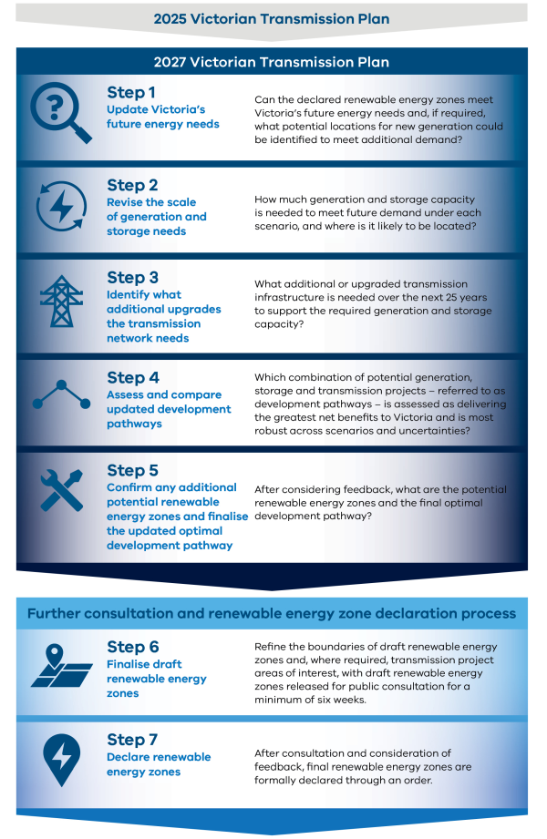

Scenarios
We will use scenarios to explore how different future conditions may affect how much generation, storage and transmission infrastructure Victoria will need. Three scenarios have been designed to represent a broad range of plausible future conditions.
The scenarios do not represent our view on how the energy transition will occur, nor are they an endorsement of one scenario over another. There are many plausible and different possible futures characterised by uncertainty. Scenarios are an important tool for planning and managing future risks and uncertainty to support robustness analysis.
These will be used to develop a 25-year plan that is robust to future uncertainties. The scenarios test the impact of factors such as energy demand, interconnection with other networks, government energy policies, pace of transition, renewable energy development, timing of existing power station closures, the potential growth of new large energy users such as data centres and the level of consumer energy resources such as rooftop solar, battery storage and electric vehicles, along with the extent to which these resources are integrated and coordinated.
The three scenarios build on those used by the Australian Energy Market Operator to develop the draft 2026 Integrated System Plan to meet Victoria’s needs – adapting and updating them with VicGrid data and analysis. The three scenarios are summarised in Table 1, with more detail included in Appendix B.
Table 1: Summary of the three scenarios for the 2027 Victorian Transmission Plan
 | Scenario 1 | Scenario 2 | Scenario 3
Summary | Victoria’s energy sector evolves in line with the Australian Energy Market Operator’s step change scenario, with updated data centre demand reflecting Victorian-specific forecasts. This scenario is considered the most likely. | Victoria’s energy sector evolves in line with the Australian Energy Market Operator’s accelerated transition scenario, with higher data centre demand than Scenario 1 to reflect Victorian-specific forecasts. | Victoria and the National Electricity Market face infrastructure delays. This scenario considers how VicGrid could respond to challenges in the energy transition driven by delays in key infrastructure builds, including gas supply challenges, uncoordinated data centre demand growth and consumer energy resources.
Demand | Moderate | High | Moderate
Consumer energy resources | High uptake, moderate coordination | Very high uptake, high coordination | High uptake, low coordination
Government targets | Scenarios achieve government generation and storage targets | Scenarios achieve government generation and storage targets | Scenario achieves government generation and storage targets but with some delays

Partnering with First Peoples to develop the 2027 Victorian Transmission Plan
Decisions about land, energy and infrastructure must be informed by Victorian Traditional Owners as the First Peoples of Victoria and the distinct rights holders to lands, seas and skies across the state. Genuine partnership means listening, learning and ensuring Traditional Owner voices and priorities inform how we plan, design and deliver energy infrastructure across Victoria.
Mapping and understanding different land uses across the Victorian region and engaging in dialogue with Traditional Owners will allow VicGrid to integrate Traditional Owner cultural values into planning and decision-making. Our engagement on the 2027 Victorian Transmission Plan and beyond will be responsive to the preferences of Traditional Owner groups, and we will seek to provide appropriate time for Traditional Owner groups to consider information, engage in an ongoing dialogue that provides a transparent view of decision-making, and better explain how input has been considered.
Traditional Owners have expressed the critical importance of protecting cultural heritage, values and landscapes through the transition to renewable energy, and the ongoing task of integrating cultural knowledge into transmission planning. We are prioritising activities to improve the quality and amount of data collected to understand and map different land uses and environmental features across the Victorian regions. This information will support integration of cultural knowledge into energy transition planning processes and to protect what is valuable to Traditional Owner communities.

Engaging with communities and industry to develop the 2027 Victorian Transmission Plan
VicGrid is embedding ongoing engagement across strategic planning, ensuring communities, landholders and industry have the opportunity to contribute to key decisions as approaches and plans evolve.
Since November 2023, we have actively engaged with community, industry, First Peoples and Traditional Owners at key stages in planning for renewable energy zones and supporting development and delivery of transmission projects for Victoria. In this time, VicGrid received more than 10,000 contributions through formal feedback mechanisms, conversations and events. These included:
- Formal written submissions
- Community, industry and Traditional Owner engagement activities such as briefings, workshops, roundtables, one-on-one meetings, webinars and drop-in sessions
- Direct enquiries via email and contact centres
- Surveys and interactive map pin drops
Insights from these ongoing conversations will continue to inform the assumptions and scenarios used in the analysis and be used to support the review of declared renewable energy zones.
Where we identify potential areas for hosting new renewable energy generation, storage or transmission infrastructure, we will undertake targeted consultation with the local community and industry on factors that could influence the suitability of the area for renewable energy and transmission infrastructure development.
This targeted consultation will provide the community and industry with the opportunity to provide input that helps:
- Identify and review areas suitable for renewable energy generation and transmission infrastructure development
- Manage environmental, land-use and community impacts
- Identify opportunities to create social value and economic benefits

In addition, VicGrid will undertake targeted industry engagement. This will build on the 2025 Victorian Transmission Plan, test planning assumptions and capture input from market participants, developers, peak bodies, and transmission and distribution network service providers.
We are committed to listening to and considering all feedback, while balancing this with the need to minimise costs for consumers while maintaining Victoria’s energy security.
Figure 3 illustrates the engagement opportunities and where feedback will support development of the 2027 Victorian Transmission Plan.
Figure 3: Community and industry engagement over the 2027 Victorian Transmission Plan process
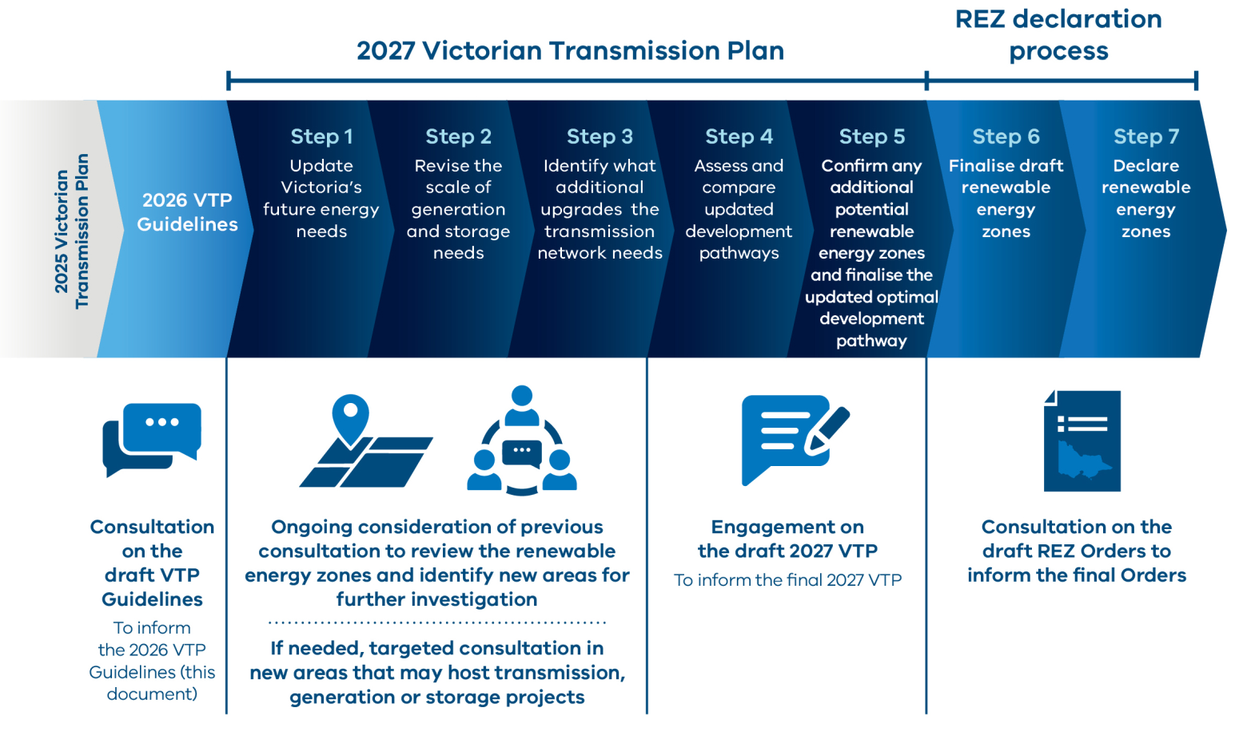

The Victorian Transmission Plan
The Victorian Transmission Plan (VTP) is a strategic long-term plan to support the energy transition. It is designed to be updated over time, to reflect current information on renewable energy development and energy demand.
Victoria’s energy system is rapidly changing as our aging coal-fired power stations are replaced with renewable energy such as wind and solar, as well as gas-powered generation and energy storage systems.
At the same time, consumer demand for electricity is shifting. Households are moving away from gas appliances, electric vehicles are becoming more common, and new sources of demand, such as data centres, are emerging. Global geopolitical events and the evolution of technology can also influence future energy supply and demand. In response to these changes, the electricity network must evolve through careful planning and timely investment to ensure its continued stability and reliability.
The VTP sets out renewable energy zones (REZs) and the transmission infrastructure needed to meet future demand and keep Victorians connected to reliable, affordable electricity as coal-fired power stations close.
VicGrid is developing the 2027 VTP, which will build on the first plan released in 2025.
The 2027 VTP will take a 25-year view of transmission infrastructure and REZ development.

1.1 Background to the Victorian Transmission Plan
VicGrid is responsible for planning and procuring transmission infrastructure in Victoria.
The Victorian Transmission Investment Framework, released in 2023, introduced a comprehensive set of reforms to support the state’s energy transition. The framework was designed to strengthen community engagement throughout the process of planning transmission and identifying REZs and to foster a strong investment environment for renewable energy infrastructure. As part of implementing this framework through legislation, VicGrid was given new roles and responsibilities, including new functions for undertaking transmission infrastructure planning, coordinating end-to-end engagement, and administering community benefits arrangements in Victoria. The framework also outlined the need to develop a new planning process, which aims to be achieved through the VTP.
The Victorian transmission planning objective (Figure 4), as set out in the National Electricity (Victoria) Act 2005 (the Act), underpins VicGrid’s functions. This objective incorporates greenhouse gas emission objectives and the state’s needs in response to the energy transition, and guides how transmission planning and investment decisions are made in Victoria.

Victorian transmission planning objective
The Victorian transmission planning objective is, in relation to Victoria:
a. To promote efficient investment in, and efficient operation and use of, electricity services for the long-term interests of consumers of electricity with respect to:
- Price, quality, safety and reliability and security of supply electricity
- The reliability, safety and security of the national electricity system
b. the delivery of transmission services consistent with a least-regrets development pathway; and
c. the achievement of targets set by Victorian legislation for reducing Victoria’s greenhouse gas emissions or that are likely to contribute to reducing Victoria’s greenhouse gas emissions.
Note: A least-regrets pathway means a process of selecting development pathways having regard to the risks associated with underinvestment or overinvestment in light of the uncertainties reflected across a range of scenarios.
Figure 4: Victorian transmission planning objective

1.2 The 2027 Victorian Transmission Plan
The 2027 VTP will build on the 2025 VTP, and will:
- Identify the scale and type of energy generation and storage required to meet Victoria’s future energy needs
- Determine the extent to which declared REZs can accommodate future demand, and if required, identify potential new locations for renewable energy generation
- Identify transmission projects, including non-network solutions, that are needed to support energy generation requirements over the next 25 years, balancing economic, social and environmental considerations across a range of future scenarios
- Identify areas of interest for preferred transmission projects to be developed in the first 10 years of the VTP

What the 2025 VTP included
In 2025, VicGrid released the first VTP, a strategic long-term plan that set a new approach to developing energy generation and transmission infrastructure to meet Victoria’s needs to 2040. This plan included:
- Six proposed REZs: Priority areas of the state with abundant renewable energy resources, such as wind and solar energy, that have the potential to host new electricity generation infrastructure while minimising impacts on communities and the environment. These geographic areas will be prioritised to meet Victoria’s needs for future renewable energy generation and storage development to 2040.
- A proposed shoreline REZ in Gippsland: This shoreline REZ is designed to host onshore connection infrastructure, such as underground cables, to link offshore wind generation with Victoria’s onshore transmission network.
- An optimal development pathway: The transmission projects that we will need to connect REZs and offshore wind to the grid until 2040, and proposed sequencing for these projects.
Figure 5: What the 2025 VTP included

1.2.1 Timing and sequencing of future transmission planning
Under the Act, VicGrid is required to publish the 2027 VTP by 31 July 2027. Following the release of the 2027 VTP, it will be updated at least every four years, with a requirement to publish it no later than 31 July in the fourth calendar year following the publication of the previous plan.
These periodic updates aim to balance the need to provide certainty for communities and industry, and flexibility for the plan to respond to evolving circumstances.
The National Electricity (Victoria) Act 2005 (the Act) allows the VTP to be reviewed and updated before release of the next one if there has been a material change to the key assumptions and forecasts underlying the plan. This provides some flexibility to react to changing circumstances.
This planning cycle allows for integration with existing electricity network planning documents produced by the Australian Energy Market Operator (AEMO) and VicGrid, including the:
- Integrated System Plan (ISP) – a national plan for the transition of the National Electricity Market power system over a 20-year development outlook, published every two years by AEMO. Where possible, the sequencing of the ISPs and future VTPs will allow them to inform one another to support consistency between national and Victorian transmission development. This will remain a priority for planning transmission developments across the national interconnected system.
- Victorian Annual Planning Report (VAPR) – The VAPR reviews how Victoria’s existing declared shared network performed over the previous 12 months, and considers planned transmission and the latest demand forecasts to analyse system performance and emerging risks over a 10-year planning period. The VAPR studies will be used to inform technical specifications for projects identified in the 2027 VTP and to improve and refine subsequent VTPs. The 2027 VTP and VAPR will be published concurrently.
The relationship between these transmission planning documents, as well as the Distribution Annual Planning Reports used by Distribution Network Service Providers (DNSPs) to plan the lower-voltage distribution system, are shown in Figure 6.

Figure 6: Relationship between electricity network planning documents in Victoria
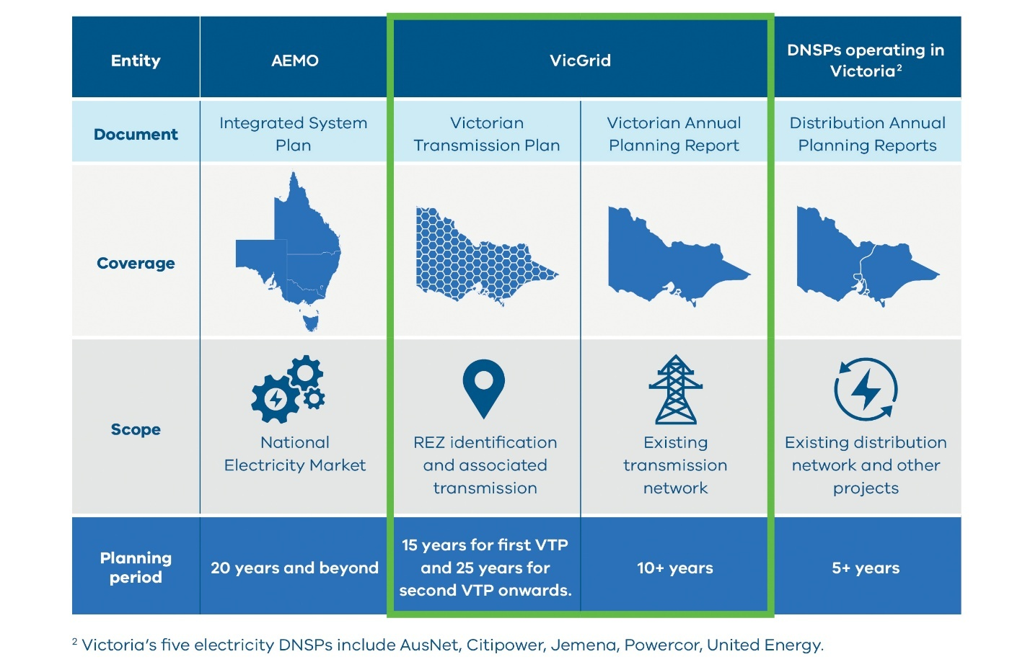

1.3 The Victorian Transmission Plan Guidelines
The Act requires VicGrid to prepare and publish a set of guidelines called the Victorian Transmission Plan Guidelines. The role of the guidelines is to define the framework and planning requirements that guide Victoria’s long-term transmission planning in the VTP. The Act sets the objectives and requirements of the guidelines in section 57. Figure 7 outlines the key objectives and requirements and where we address each in this document.

Figure 7: Guidelines document structure
Legislative requirement from section 57 of the Act | Guidelines Chapter
Legislative requirement from section 57 of the Act | 2 | 3 | 4 | 5
Legislative requirement from section 57 of the Act | How VicGrid will develop  the 2027 VTP | The future scenarios that VicGrid will consider | How VicGrid will partner with First Peoples | How VicGrid will consult with communities and industry
(1)(a) define a set of plausible, high-impact scenarios that establish the electricity system's 25-year investment needs consistent with Victorian energy policy objectives and market outlook |  | Yes
(1)(b) include key inputs, sensitivities, methodologies and assumptions that will be considered as part of the making of the Victorian transmission plan, including the geographical area that will be analysed in the plan | Yes | Yes
(1)(c) describe how VicGrid will consult stakeholders in the preparation of the Victorian transmission plan |  |  | Yes | Yes
(1)(d) specify a transmission planning standard that will provide for certain detailed aspects of the Victorian transmission plan. | Yes

1.4 How the 2027 Victorian Transmission Plan will be different
The 2027 VTP will address some key changes from the 2025 VTP. This includes planning for Victoria’s transmission needs for 25 years, instead of the 15-year period in the previous VTP. The second VTP also needs to take into consideration changes in energy market conditions and recommendations that were made following the 2025 VTP.
While largely consistent with those released in 2025, these guidelines include updates that address these changes. Figure 8 summarises the key changes that will impact the 2027 VTP.
Figure 8: Summary of key changes that will impact the 2027 VTP
Legislative requirements
The 2027 VTP must:
- Plan for a 25-year period, instead of the 15-year period for the 2025 VTP.
- Consider non-network solutions.
- Include hosting capacity limits for REZs.
- Identify preferred transmission project areas of interest for renewable energy zone transmission projects to be developed in the first 10 years of the VTP.
Declared REZs and transmission projects
- Proposed REZs from the 2025 VTP along with some transmission projects will form the foundation for further analysis.
- The requirements for additional generation and storage will build on declared REZs.
- The best location for additional future generation and storage will be informed by a refreshed statewide strategic land use assessment.
Changes in the energy market outlook
- The constantly evolving energy market requires updated assumptions about changes in demand for electricity and more generation being developed. These changes are reflected in the three scenarios.
- Demand forecasts are being re-evaluated to consider development of future data centres.
Feedback and input from ongoing engagement with community, industry and Traditional Owners
- Insights gathered from our ongoing conversations will continue to inform the 2027 VTP.
- We’re allowing more time for engagement with Traditional Owners and improving transparency on how inputs shape decisions.
- We will coordinate our engagement across all our activities, with clearer communication about how feedback influences decisions.
- A flexible and iterative engagement model will support targeted and meaningful consultation with impacted communities, Traditional Owners, landholders and industry as new information emerges.

How VicGrid will develop the 2027 Victorian Transmission Plan
The 2027 Victorian Transmission Plan (VTP) aims to ensure Victoria has the right transmission infrastructure in the right place at the right time to keep homes and businesses across the state connected to reliable, affordable power.
The 2027 VTP will set out the timing and scale of renewable energy and storage technologies needed to support Victoria’s future energy needs, as well as their potential locations. Based on this analysis and input from consultation with communities, landholders, Traditional Owners, industry and stakeholders, we will identify what transmission infrastructure is needed and when it should be developed.

Our approach adopts a transmission planning standard as outlined below to make sure that we have enough capacity in our transmission network to support our renewable energy generation without over-investing.The transmission planning standard
The transmission planning standard applied to the 2025 VTP remains unchanged and continues to apply to the 2027 VTP.
A transmission planning standard sets out the approach used to determine the level of transmission capacity required in a power system.
In line with the approach selected for the 2025 VTP, the 2027 VTP will continue to apply a probabilistic standard which determines transmission capacity through an economic cost-benefit analysis that compares the costs of transmission infrastructure with the impact that would be incurred in its absence.
This standard was assessed in 2024 as being able to deliver greater benefits to energy consumers and communities, through more cost-effective investment. This is considered to still be the case. Further, this approach is consistent with the National Electricity Law, which specifies that a probabilistic approach must be used to determine the benefits of a potential transmission augmentation.
This standard is reflected in the 2027 VTP methodology through an economic cost-benefit analysis which compares different combinations of generation and transmission investments to identify the combination that offers the greatest benefit from an economic, social and environmental perspective. This analysis also factors in the relative performance of these investment options across different future scenarios.
Appendix A provides further details on the transmission planning standard.
Figure 9: The transmission planning standard
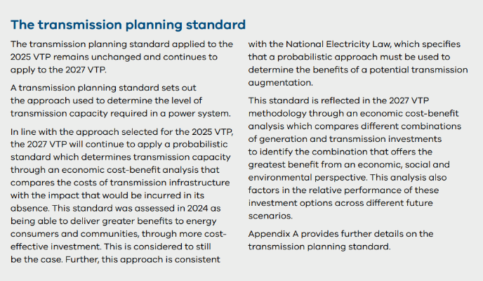
The methodology to develop the 2027 VTP builds on the approach developed for the 2025 VTP. The updated methodology is based on the latest inputs and assumptions, while also incorporating the declared renewable energy zones (REZs) as a starting point for further analysis.
Where available, inputs to the 2027 VTP will draw on decisions made through VicGrid’s broader development work including the Victorian Access Regime and REZ declaration process.

2.1 The process guiding development
The 2027 VTP will set out a long-term pathway for renewable generation, storage and transmission infrastructure over a 25-year planning period, with a focus on the transmission projects needed in the first 10 years.
At each stage of development, decisions will be guided by the Victorian transmission planning objective set out in the National Electricity (Victoria) Act 2005 (the Act). The methodology integrates strategic land use considerations, engagement with Traditional Owners, landholders and local communities, and the application of a planning standard to select a least-regrets pathway that supports transparency and investor confidence.

2.2 The steps of development for the VTP
Significant analysis has already been completed through the 2025 VTP. The methodology for the 2027 VTP uses declared REZs and transmission projects identified in the 2025 VTP as a starting point, reviews what has changed since 2025, and identifies additional needs for renewable energy generation and transmission over a longer period of 25 years.
Developing the 2027 VTP will be a five-step process designed to answer the following questions that allow us to build on the analysis from the 2025 VTP:
- Update Victoria’s future energy needs: Can the declared REZs meet Victoria’s future energy needs and, if required, what potential locations for new generation could be identified to meet additional demand?
- Revise the scale of generation and storage needs: How much generation and storage capacity is needed to meet future demand under each scenario, and where is it likely to be located?
- Identify what additional upgrades the transmission network needs: What additional or upgraded transmission infrastructure is needed over the next 25 years to support the required generation and storage capacity?
- Assess and compare updated development pathways: Which combination of potential generation, storage and transmission projects – referred to as development pathways – is assessed as delivering the greatest net benefits to Victoria and is most robust across scenarios and uncertainties?
- Confirm any additional potential renewable energy zones and finalise the updated optimal development pathway: After considering feedback, what are the potential REZs and the final optimal development pathway?
Table 2 describes the five steps of development and Figure 16 provides an illustration of the process.
Table 2: Summary of the five steps of developing the 2027 VTP
Key analytical steps | Description
Step 1 – Update Victoria’s future energy needs | The first step to develop the 2027 VTP involves a refresh of key inputs and assumptions and an assessment of how Victoria’s future energy needs have changed since the 2025 VTP. This includes refining the range of plausible future scenarios that consider future uncertainties (see Section 3) and updating the strategic land use assessment to reflect the latest information.  These updates will be used to inform a two-part process:  - We will undertake energy market modelling to assess how Victoria’s energy needs have changed since the 2025 VTP. This analysis will help identify any changes in the size, location and type of generation build and storage that Victoria requires to meet its future energy needs over the 25-year planning period.  - We will assess the extent to which declared REZs can meet Victoria’s future energy needs over the 25-year planning period and, if required, identify potential locations for new renewable generation. Using the declared REZs as the starting point, a multi-criteria analysis will be used to identify new areas where renewable generation could be considered to meet additional demand.  To support this analysis, we will use insights gathered from ongoing community, Traditional Owner and industry engagement, including in the assessment of declared REZs and the identification of potential locations for new renewable generation.  The outputs of Step 1 will form an input to further energy market modelling in Step 2. Insights and further analysis in subsequent steps of the methodology may result in refinements to the potential locations for new renewable generation. This reflects the dynamic, iterative planning process of the VTP.
Step 2 – Revise the scale of generation and storage needs | This step identifies how much generation and storage capacity is needed to meet demand over the 25-year planning period. This includes where it is likely to be located and by when it will be needed, under each future scenario.  Initial generation resource plans will be developed using energy market modelling, considering the outcomes of Step 1.  These generation resource plans identify indicative locations for the generation capacity needed to meet Victoria’s energy needs over the 25-year planning period under each scenario and will include:  - The technologies that are likely to be built based on cost-effectiveness  - How much capacity is likely to be built  - When this capacity should be built  The generation resource plan for each scenario will become the basis for network planning and candidate development pathway identification in Step 3.
Step 3 – Identify what additional upgrades the transmission network needs | Having identified the generation and storage needs under each scenario, we will undertake network planning and power system analysis to identify combinations of potential transmission projects, building on existing and planned transmission projects from the 2025 VTP, that could support the generation plans developed in Step 2.  To achieve this, the capacity of the existing and planned transmission network will be assessed against the additional generation identified for each scenario. Where constraints are identified, transmission planning will be undertaken to identify feasible project options, with the technical feasibility of these options assessed through power systems analysis. This will include consideration of non-network solutions, such as battery storage, as alternatives to investment in transmission system assets including power lines and substations.  These projects will be combined into a set of ‘candidate development pathways’ that identify which transmission projects are needed across the 25-year planning period to support the energy generation requirements.  The design and testing of candidate development pathways will apply adaptive planning principles.  Adaptive planning principles involve identifying and assessing pathways that provide more flexibility to respond to changing conditions – for example by changing the timing or scale of investment based on new information. The value of this increased flexibility will be considered when developing candidate development pathways.  Insights from this analysis will be used to review, and if necessary, refine the generation resource plan. This iterative approach across the REZ areas, generation resource plans and candidate development pathways will seek to collectively deliver the best overall outcome for Victoria.
Step 4 – Assess and compare updated development pathways | This step assesses and compares the candidate development pathways to identify the draft optimal pathway. Candidate development pathways will be assessed for their potential to meet future generation needs across a range of future scenarios using:  - Further energy market modelling across all scenarios to optimise the outcomes under each candidate development pathway.  - Cost-benefit analysis for each scenario to compare the costs and benefits of the candidate development pathways, taking into account capital and operating costs for both generation and transmission, as well as benefits from reduced carbon emissions and improved system reliability.  - Consumer bill impact assessment to analyse the impact of the candidate development pathways on the wholesale and transmission components of consumers’ electricity bills.  - Robustness analysis (also known as a least-regret analysis) to identify the pathway that minimises the net cost across all scenarios and is least sensitive to future uncertainties, with adaptive planning principles applied to account for the value of flexibility under uncertain future conditions. This forms the draft optimal pathway.  - Power system security and reliability check to confirm the technical feasibility of the draft optimal pathway.  The draft optimal pathway will be published in the draft 2027 VTP for consultation, alongside the potential areas for new generation and storage and the preferred areas of interest for any near-term transmission projects required to be built in the next 10 years following publication of the 2027 VTP. These draft areas of interest will provide broad initial investigation zones, defined by two proposed connection points to the declared shared network.
Step 5 – Confirm any additional potential renewable energy zones and finalise the updated optimal development pathway | This step finalises the optimal pathway based on feedback on the draft 2027 VTP.  Feedback received during consultation on the draft 2027 VTP will be used to undertake a strategic review of the draft optimal pathway for transmission development over the next 25 years to determine the final optimal pathway. This review will also be used to confirm and refine the potential areas for new generation and storage into potential REZs for the 2027 VTP. If needed, this allows additional locations for new REZs to be considered in more detail after the 2027 VTP, in consultation with Traditional Owners, local communities, councils, landholders, industry and stakeholders.  Once the final pathway has been confirmed, hosting capacity limits will be determined for the identified REZs and areas of interest will also be confirmed for transmission projects included in the first 10 years of the pathway.  Following publication of the final 2027 VTP, detailed design processes will commence to refine the transmission projects on the optimal pathway, which will involve further, more in-depth and targeted engagement with First Peoples, landholders, communities and industry.
Step 6 and 7 - REZ declaration process (after the VTP) | Any new potential REZs identified in the final 2027 VTP will be subject to the subsequent REZ declaration process.  This is a statutory process in which the Minister makes a declaration in a formal order (the Order) that includes REZ boundaries with maps and sets out engagement requirements and expectations of project proponents during project development. Where required, the Order will include the preferred transmission project areas of interest for the development of any major transmission infrastructure needed to enable generation and storage development within the zone.  In preparing the draft Orders, we will refine the boundaries of any new REZs set out in the 2027 VTP. The draft Orders will be made available for consultation for a minimum period of six weeks. After consultation and consideration of feedback, REZs may be formally declared by the Minister.

The strategic land use assessment
The strategic land use assessment is a core component of VicGrid’s approach to planning energy infrastructure and is used to support strategic decisions about how land use impacts are managed in renewable energy and transmission planning.
The assessment is used to identify areas that are suitable for hosting renewable energy infrastructure. This considers a range of land use factors, including environmental, ecological, cultural, social, economic and engineering characteristics and values.
A statewide strategic land use assessment was undertaken for the 2025 VTP, identifying the most suitable and least constrained areas for renewable energy and transmission development while highlighting sensitive areas to protect or avoid. This assessment included strategic mapping of land use constraints and opportunities for hosting renewable energy generation.
The strategic land use assessment undertaken for the 2025 VTP is a key starting point for the 2027 VTP and will be refreshed to reflect current information across environmental, biodiversity, cultural, social, land use, and engineering perspectives. The updated strategic land use assessment will form a critical input to both the energy market modelling and the multi-criteria analysis that will be used to assess the extent to which declared REZs can meet Victoria’s future energy needs over the 25-year planning period and, if required, identify potential locations for new generation.
Figure 10: The strategic land use assessment
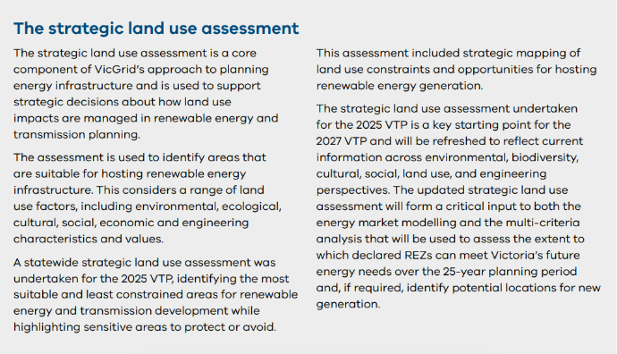

The multi-criteria analysis
Multi-criteria analysis provides a structured way to assess locations for renewable energy development by integrating economic, environmental, cultural and social considerations. It enables different types of information to be assessed together, including land-use constraints, the least-cost generation mix, regional economic impacts, generator interest and community and Traditional Owner feedback.
In the 2027 VTP, the multi-criteria analysis will be used to evaluate whether declared REZs can meet Victoria’s future energy needs and, if required, identify potential locations for new renewable generation. This supports planning decisions that align with Victoria’s future energy needs and broader planning objectives.
The multi-criteria analysis will also help refine the generation locations identified through energy market modelling by incorporating qualitative factors that modelling cannot adequately capture. By combining spatial constraints, engagement insights and regional development considerations, the multi-criteria analysis supports the identification of areas that balance system needs with community expectations and deliverability.
Figure 11: The multi-criteria analysis
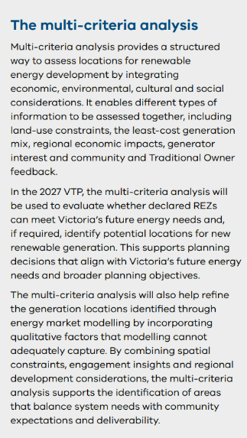

Energy market modelling
Energy market modelling is a method used to simulate and forecast how energy markets will behave in response to future changes. We will use energy market modelling software called PLEXOS that is widely used in the energy industry. It helps to analyse how different factors such as energy demand, consumer energy resource uptake, government policies, and generator capital and operating costs can influence the supply and demand of energy, and consequently the types and capacity of energy generation development in the future.
This type of modelling is crucial for understanding the future dynamics of the energy market and provides insights that assist stakeholders including policymakers, energy companies and investors in strategic decision-making. Through such models, we can forecast the impact of different transmission options on the future developer investment and operational decisions. We will use energy market modelling to identify the generation sector costs and inform the benefits quantified in the cost-benefit analysis.
Figure 12: Energy market modelling
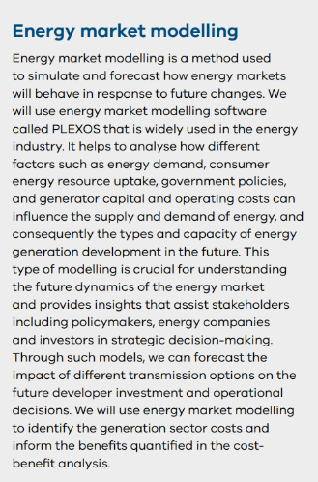

Power system modelling
Power system modelling is a specialised approach used to represent the intricate workings of electrical power systems through computer simulations. The method represents the power system at an appropriate aggregation level, including generation, transmission lines, substations and end-users of electricity. By using these models, we can assess reliability, plan upgrades, integrate renewable energy sources and predict how the system will behave under different conditions.
This process will help ensure that the power grid remains stable and efficient, minimise outages, and adapt to the evolving energy demands of Victoria. For the 2027 VTP, this modelling will be undertaken using an industry-standard power system simulation software (PSSE) that models the transmission network under a range of operating conditions.
Figure 13: Power system modelling
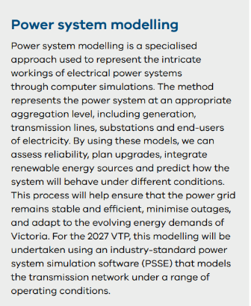

Cost-benefit analysis
Cost-benefit analysis is used to compare the economic costs and benefits of candidate development pathways for each system scenario against a counterfactual development path.
The cost-benefit analysis will consider the full spectrum of costs and benefits attributable to each candidate development pathway to determine its net market benefits. This approach builds on the Australian Energy Regulator’s cost-benefit analysis guidelines.
In addition to market benefits, the analysis adopts a holistic view by considering both quantitative and qualitative impacts, including environmental, economic and social outcomes. This approach ensures consistency with the Department of Treasury and Finance Economic Evaluation Technical Guidelines and infrastructure sector best practice.
Figure 14: Cost-benefit analysis
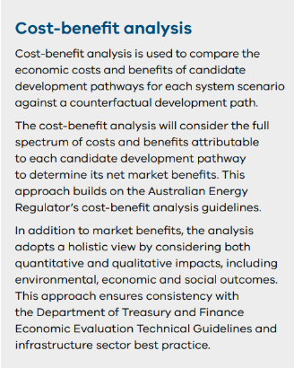
Figure 15: The five steps of 2027 VTP development
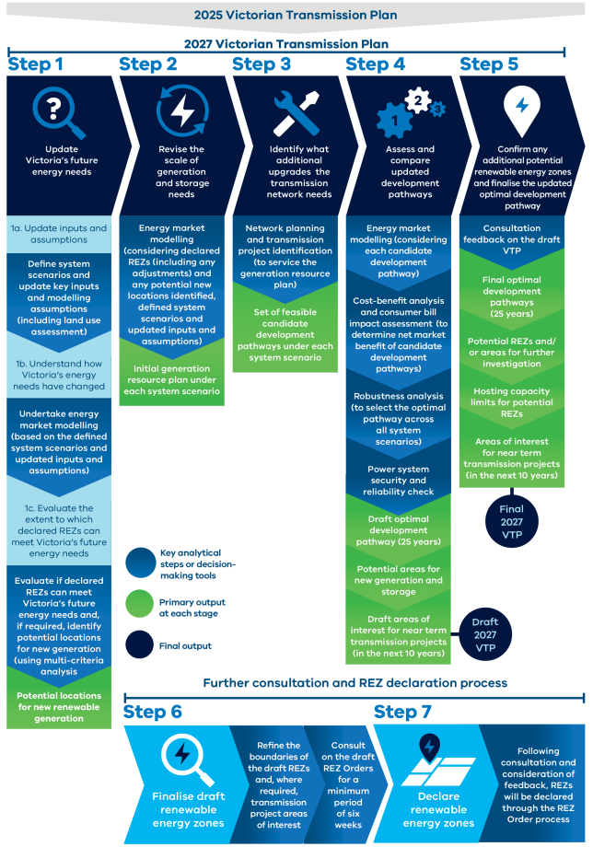

2.3 What has changed since the 2025 VTP
The methodology to develop the 2027 VTP has been refined from what was used for the 2025 VTP.
Updates have been made to reflect the extended planning period, declared REZs and proposed transmission projects, and a focus on improved clarity and adaptability. The approach remains scenario‑based and probabilistic, drawing on energy market modelling, power system analysis and strategic land‑use analysis.
A key change is the starting point. Rather than beginning with a broad study‑area assessment, the updated methodology now uses declared REZs and transmission projects identified in the 2025 VTP as a starting point. We are using energy market modelling with refreshed inputs and assumptions to understand how Victoria’s energy needs and locations for renewable generation may have shifted. We will evaluate if declared REZs can meet Victoria’s future energy needs, before the development of the generation resource plan. The latter stages comprise the identification and assessment of candidate development pathways and confirmation of an optimal pathway using established tools, with refinements informed by lessons learned.

Key methodology updates and why they have been made
The key updates to the methodology and the reasons for these changes are outlined below.
- The planning period will extend to 25 years, in line with the legislated requirement that all VTPs following the 2025 VTP adopt a 25‑year outlook.
- The 2027 VTP will build on the recommendation in the previous VTP to identify potential REZ areas and the transmission projects required to support them. A new broad study‑area assessment is therefore not required. This will avoid duplicating work and clarify how projects from the 2025 VTP and other transitional generation projects are incorporated into the 2027 VTP.
- Methodology assumptions and inputs will be updated so that analysis reflects current demand forecasts, policy settings and land‑use information.
- A structured assessment of current and future generation capacity in Victoria, building on the declared REZs, will be undertaken using energy market modelling and multi‑criteria analysis that considers economic, social, cultural and environmental factors. This analysis will evaluate whether declared REZs can meet Victoria’s future energy needs and, if required, identify potential locations for new generation.
- Where relevant, inputs to the analysis will align with other VicGrid processes, including the VAR and the REZ declaration process. These processes were not in place, or were still emerging, when the 2025 VTP was developed and now need to be reflected in the 2027 VTP.
- The methodology will incorporate adaptive planning to manage long‑term uncertainty associated with the 25‑year outlook, including potential triggers or thresholds that indicate when reassessment may be required.
- Once the optimal development pathway is confirmed and the potential 2027 VTP REZ boundaries are defined, the methodology will identify and confirm hosting capacity limits for each potential REZ. This will provide clear guidance on the level of REZ‑hosted generation assumed in the 2027 VTP and reflects practices adopted in the 2025 VTP.
- The methodology will incorporate additional analysis to identify areas of interest for near-term transmission projects (in the next 10 years), as required under the Act, and will also consider potential non‑network solutions as part of the optimal development pathway.
See Appendix A for further details on the methodology for developing the VTP.

The future scenarios that VicGrid will consider
We will use scenarios to identify potential renewable energy zones and transmission infrastructure that is most robust to future uncertainties.
Three scenarios have been designed to represent a broad range of plausible future conditions over the next 25 years. The scenarios take into account a range of parameters that could significantly impact when and where additional renewable energy generation and transmission may be required. These include:
- Energy demand: This refers to factors that can significantly alter energy demand, including electrification of households, businesses and industry, development of energy intensive data centres, and hydrogen generation.
- The level of consumer energy resources (CER), including rooftop solar, battery storage and electric vehicles, along with the extent to which these resources are integrated and coordinated.
- Generation and transmission development: This refers to potential changes in delivery timelines for electricity generation and/or transmission projects that are planned or expected.

3.1 The purpose of scenarios
The scenarios are not forecasts, but must be high-impact, plausible and establish the electricity system’s 25-year investment needs consistent with Victorian energy policy objectives and market outlook. The National Electricity (Victoria) Act 2005 also specifies that in preparing a Victorian Transmission Plan (VTP), VicGrid should have regard to the risks associated with under-investment and over-investment. VicGrid is required to manage these risks by considering a range of scenarios and developing a VTP that is robust to future uncertainties.
We have developed three scenarios that will help us determine the electricity system investment needs for the coming 25 years. All three of the scenarios build on the Australian Energy Market Operator’s (AEMO’s) scenarios that were used to develop the draft 2026 Integrated System Plan (ISP) and have been adapted and updated with more recent VicGrid data and analysis to meet Victoria’s needs. Where appropriate, aligning with AEMO’s scenarios supports consistency of assumptions with national planning bodies, avoids duplication, and acknowledges the thorough analysis and stakeholder management processes that informed the national scenarios.
The scenarios do not represent our view on how the energy transition will occur, nor are they an endorsement of one scenario over another. There are many plausible and different possible futures characterised by uncertainty. Scenarios are an important tool for planning and managing future risks and uncertainty.
Appendix B provides further details on the inputs, assumptions and scenarios that will be used in the development of the 2027 VTP.

3.2 The scenarios for the 2027 VTP
The three scenarios for the 2027 VTP are detailed below.
Scenario 1: If Victoria experiences a step-change in energy transition
This scenario is considered the most likely scenario and explores what may occur if Victoria’s energy transition goes according to plan and Victoria’s renewable energy targets, storage targets and offshore wind targets are met. It considers a potential future where the Victorian energy sector continues to evolve in line with AEMO’s national step change trends, adapted with VicGrid data and analysis to reflect the Victorian context, including updated data centre demand forecasts. AEMO defines this scenario as reflecting a pace of transition that supports Australia’s contribution to limit global temperature rise to less than 2°C, with consumer energy resources playing an important role in the transition.
Scenario 2: If Victoria’s energy transition accelerates
This scenario explores what may occur if Victoria’s energy transition accelerates, with high levels of electricity demand. Demand in this scenario builds on AEMO’s national accelerated transition forecasts, adapted for VicGrid data and analysis to consider a potential future with higher growth in data centre demand and new energy-intensive green industries. The scenario models a rapid decarbonisation pathway, high levels of consumer energy resources, including electric vehicles, and supportive social conditions.
Scenario 3: If Victoria and the national electricity market face delays in energy infrastructure This scenario explores what may occur if the national electricity market (NEM) and Victoria’s energy transition does not go to plan. It considers a potential future where new energy infrastructure across the NEM is delayed and there is reduced social acceptance, leading to delays of up to two years in the achievement of some government targets. Electricity demand in this scenario is similar to Scenario 1, however it also considers data centre demand that is concentrated geographically and consumer energy resources that are not integrated or coordinated.

The future scenarios VicGrid will consider
Parameters | Scenario 1:  If Victoria experiences a step-change in energy transition | Scenario 2:  If Victoria’s energy transition accelerates | Scenario 3:  If Victoria and the NEM face delays in energy infrastructure
 | Demand and demand-side parameters | Demand and demand-side parameters | Demand and demand-side parameters
Demand | Based on AEMO’s step-change, and VicGrid analysis | Based on AEMO’s accelerated transition, and VicGrid analysis | Based on AEMO’s step-change, and VicGrid analysis¹
Data centre load and location | Load: moderate  Location: distributed | Load: high  Location: distributed | Load: moderate  Location: concentrated
Consumer energy resources uptake and coordination (batteries, solar panels and electric vehicles) | Uptake: high  Coordination: moderate | Uptake: very high  Coordination: high | Uptake: high  Coordination: low
Energy efficiency | Moderate | High | Moderate
 | Additional parameters | Additional parameters | Additional parameters
Victorian Renewable Energy Targets (VRET) | Achieved | Achieved | Achieved but with delays of up to two years for interim 2030 target
Storage targets | Achieved | Achieved | Achieved
Offshore wind targets | Achieved | Achieved | Achieved but with delays of up to two years
Victoria’s Renewable Energy Transformation Agreement | Achieved | Achieved | Achieved but with potential delays of up to two years
Gas supply and infrastructure constraints | As per AEMO, supplemented with VicGrid analysis | As per AEMO, supplemented with VicGrid analysis | Increased gas supply and augmentation challenges
Timing of key transmission projects | As per AEMO and public announcements | As per AEMO and public announcements | Projects are delayed by up to two years
Victorian coal retirement | In line with Structured Transition Agreements and by 2035 at latest | In line with Structured Transition Agreements and by 2035 at latest | In line with Structured Transition Agreements and by 2035 at latest
Non-VIC coal retirement | As per AEMO’s ISP | As per AEMO’s ISP | As per AEMO’s ISP with delays of up to two years
Non-Victorian Government policies | Aligned with announcements | Aligned with announcements | Targets are delayed up to two years
Source: VicGrid and AEMO IASR 2025 and draft 2026 ISP

Scenario 1: If Victoria experiences a step-change in energy transition
This scenario considers a potential future where demand is aligned with the forecast in AEMO’s step-change scenario, with demand for data centres reflecting local conditions, and includes inputs and assumptions that are consistent with the achievement of state government targets across the NEM. By aligning with AEMO’s step-change scenario, Scenario 1 is based on well-understood and consulted-on inputs and assumptions and is considered the most likely.
Scenario 1 explores transmission needs if Victoria’s (and the NEM’s) energy transition goes according to plan and in line with national trends. It includes the continuation of policy settings and achievement of government targets, an energy transition that is well underway, and strong economy-wide electrification. In addition to government targets, the scenario is driven at the state level through the Gas Substitution Roadmap, the Zero Emissions Vehicle Roadmap and Solar Homes initiatives, supporting increased consumer appetite for consumer energy resources (such as solar panels, batteries and electric vehicles).
The scenario considers moderate growth in the global and domestic economy, additional growth in data centre demand and moderate hydrogen production supporting industries across Victoria. VicGrid will develop its own forecast for data centre demand in Victoria based on AEMO forecasts, connections enquiry data and other sources to ensure the VTP is designed with the most up-to-date information. Scenario 1 assumes that other states’ energy policies and targets are achieved as announced. Interconnection with other regions is assumed to be delivered on time, including the Victoria to New South Wales Interconnector West by 2030 and Marinus Link Stage 1 by 2030. Across the NEM, coal generation is assumed to retire in line with AEMO’s ISP and in Victoria, in line with structured transition agreements and by 2035 at the latest.
Appendix B provides additional detail on the inputs and parameters assumed for Scenario 1.

Scenario 2: If Victoria’s energy transition accelerates
This scenario considers a potential future where demand is aligned with the forecasts in AEMO’s accelerated transition scenario, adapted for Victoria, including for additional data centre demand.
Scenario 2 explores transmission needs if Victoria’s (and the NEM’s) energy transition accelerates. The Victorian Industry Policy, Renewable Hydrogen Industry Development Plan and Regional Economic Development strategies outline measures to support economic development as part of the energy transition. This scenario seeks to model the energy sector evolving in line with these policies, with increased demand resulting from the development of new energy-intensive green industries, including from hydrogen, commodities such as green steel, and data centres. Scenario 2 considers greater growth in the global and domestic economy, increased electrification and much higher consumer appetite for consumer energy resources (including solar panels, home batteries and electric vehicles) and their coordination into virtual power plants. Scenario 2 assumes that state government energy policies and targets are achieved as announced. Across the NEM, coal generation is assumed to retire in line with AEMO’s ISP and in Victoria, in line with structured transition agreements and by 2035 at the latest.
Appendix B provides additional detail on the inputs and parameters assumed for Scenario 2.

Scenario 3: If the NEM faces delays in energy infrastructure
This scenario considers a potential future where electricity sector infrastructure across the NEM and in Victoria is delayed. While demand is aligned with the forecasts in AEMO’s step change scenario, adapted for Victoria, this scenario is characterised by uncoordinated growth in data centre demand, resulting in a high concentration of data centres in the Melbourne area.
Scenario 3 explores transmission needs if the NEM, including Victoria, face delays in building the infrastructure it needs for the energy transition. The scenario considers potential delays of up to two years in the delivery of key transmission infrastructure across the NEM, including the Victoria to New South Wales Interconnector West, Western Renewables Link and Marinus Link Stage 1, with impacts on the roll-out of generation across Victoria. It also considers the potential for delays in the roll-out of offshore wind of up to two years. As a result, this scenario includes potential delays in the achievement of the 2030 VRET, while still achieving the 2035 VRET as coal retires in Victoria. Across the NEM, coal generation is assumed to retire in line with AEMO’s ISP, delayed by up to 2 years.
This scenario also considers lower social acceptance for the energy transition, leading to lower build-rates for renewable generation across the NEM and Victoria, and lower coordination of consumer energy resources impacting demand.
Appendix B provides additional detail on the inputs and parameters assumed for Scenario 3.

3.3 Sensitivity analysis
VicGrid will use sensitivity analysis to test the robustness of modelled outcomes results generated throughout the VTP methodology. Sensitivity analysis involves examining how a change to a single variable affects the analysis results, helping to identify any significant differences in transmission outcomes we need to consider, and the sensitivity of those outcomes to the variable being tested.
Sensitivity analysis is often used to complement a scenario-based planning approach. Relevant examples of sensitivity testing for transmission planning considered in the development of the 2027 VTP include for example potential changes in the scale and location of data centre demand, changes in electrification or electric vehicle uptake, or different infrastructure timing and coal retirement. Variations of these and other sensitivities will be considered as part of the VTP modelling with the final selection of sensitivity analysis reflecting key uncertainties identified throughout the analysis. Potential sensitivities are included in Appendix B.

3.4 Inputs and assumptions for the 2027 VTP
Many of the decision-making tools used in the 2027 VTP development process rely on inputs and assumptions, such as those relating to forecast demand and generation, existing and anticipated generation and transmission projects, the types of new generation and storage technology and the government policies that are modelled.
Modelling energy sector outcomes, and planning for them, is a complex process. For example, AEMO categorises key inputs and assumptions for its ISP across 13 categories. Despite this complexity, AEMO’s modelling and assumptions have been well consulted on and are generally well understood. VicGrid has aimed to base its inputs and assumptions on AEMO’s where appropriate, adapted for the Victorian context with additional inputs and assumptions that reflect Victorian policy and energy market context, particularly for data centre demand forecasts, gas supply and transmission project timing.
The energy market modelling and cost-benefit analysis includes inputs and assumptions relating to energy demand, costs of existing and new electricity generation, storage and fuel costs and renewable energy availability. These will be based on AEMO’s inputs and assumptions, supplemented by VicGrid’s own data and analysis. The multi-criteria analysis utilises significant Victorian-specific data and information, including land use, community and Traditional Owner feedback, regional development and environmental features. Transmission planning and power systems analysis will rely on AEMO inputs and assumptions, engineering standards and the National Electricity Rules.
The 2027 VTP will also seek to incorporate additional consumer energy resources export capacity from distribution network investment that was recently identified in AEMO’s 2026 draft ISP, supplemented with additional data and analysis where available.
The transmission and generation projects assumed to be the starting point for the updated plan are an important input to the power system engineering (PSSE) analysis and energy market modelling. As outlined in Appendix B, advanced transmission projects will be included as baseline inputs into the 2027 VTP. These include the Western Renewables Link, Victoria to New South Wales Interconnector West, Marinus Link Stage 1 and the transmission being developed to support the first 2 GW (gigawatts) of offshore wind. In addition, transmission projects confirmed in the 2025 VTP optimal development pathway will also be treated as baseline inputs unless there is a material change in circumstances. Between finalising these guidelines and developing the 2027 VTP, there may be other projects that will need to be progressed. These projects will also be treated as an input into the 2027 VTP where possible.
Generation projects that are ‘committed’ and ‘anticipated’ as defined by AEMO, are sufficiently advanced in development, or have an increased degree of certainty of being developed, will be treated as an input into the 2027 VTP where possible.
Appendix B contains further details on all inputs and assumptions.

How VicGrid will partner with First Peoples
As part of our commitment to partner with Victoria’s First Peoples and Traditional Owners, we will identify and consider key expectations and concerns relating to their rights and cultural responsibilities through the 2027 Victorian Transmission Plan (VTP).
These guidelines describe how we will deliver on this commitment through the 2027 VTP.

4.1 Our commitment to partnership
Our approach to developing the VTP recognises that decisions about land, energy and infrastructure must be informed by Traditional Owners as the First Peoples of Victoria and the distinct rights holders to lands, seas and skies across the state.
We are committed to working in partnership with Traditional Owners as distinct rights holders to Country and Sea Country. Traditional Owners are our partners who have rights that must be upheld as laid out under the Statewide Treaty Act 2025 (Vic), Charter of Human Rights and Responsibilities Act 2006 (Vic), the Traditional Owner Settlement Act 2010 (Vic), Aboriginal Heritage Act 2006 (Vic) and Native Title Act 1993 (Cth). Following the historic signing of Treaty with Victoria’s First Peoples in November 2025, we recognise the establishment of Gellung Warl to represent First Peoples and Traditional Owners in a renewed relationship with the State and in implementing statewide Treaty reforms. We acknowledge that Traditional Owners have legal rights and cultural responsibilities that will be recognised and supported through the renewable energy transition.
Genuine partnership means listening, learning and ensuring Traditional Owner voices and priorities are embedded at the centre of how we plan, design and deliver energy infrastructure across Victoria, and it means acknowledging that Traditional Owner groups will determine how they wish to participate in the VTP 2027.

4.2 Traditional Owners and the Victorian Transmission Plan
Through the 2025 VTP, we heard that Traditional Owners want to protect cultural heritage, minimise cumulative impacts to Country, protect biodiversity and the natural environment, and benefit from the economic development opportunities that the VTP will enable.
To help achieve those goals, we commit to listening to the concerns of Traditional Owners, providing opportunities to inform decision-making on matters that affect them, being transparent in how we balance competing factors and make decisions, and supporting their active participation through the development of the 2027 VTP.
Our engagement on the 2027 VTP will be responsive to the preferences of Traditional Owner groups. Importantly, we will seek to incorporate the lessons learned through the 2025 VTP by providing more time for Traditional Owner groups to consider information, engaging in an ongoing dialogue that provides a transparent view of decision-making, and better explaining how input has been considered. Where timeframes do not align between the development of the 2027 VTP and Traditional Owner decision-making processes, VicGrid will seek to communicate those constraints and explore alternative or future pathways for input into planning and decision-making.
VicGrid will engage in dialogue with Traditional Owners on key VTP outputs that may affect their rights and interests, including, but not limited to, transmission planning, renewable energy zone (REZ) planning and development and cumulative impacts management.

4.3 Improving how we integrate cultural knowledge into transmission planning
Traditional Owners have told us of the critical importance of protecting cultural heritage, values and landscapes through the transition to renewable energy. We understand that for Traditional Owners, all of Country is significant, and that within this broader cultural landscape there are areas and sites of particular cultural meaning and sensitivity.
Through our work delivering the 2025 VTP, we learned that our timeframes and processes need to better incorporate Traditional Owner ways of working in order to properly address their views and concerns. We also heard that there is an urgent need to map cultural heritage and values to minimise the impact of REZ and transmission development on Country.
As part of our ongoing partnership, we will collaborate with Traditional Owners to better understand, identify and protect these cultural and biocultural values. This requires us to deliver on our commitment to respecting Traditional Owner partnership protocols, and to improve upon how we collect and consider cultural heritage data and knowledge. Over the long-term and beyond the immediate requirements for planning the 2027 VTP, this means supporting Traditional Owners to undertake cultural heritage research on Country affected by the energy transition.
To support future plans, VicGrid has commenced a three-year program supporting Traditional Owner-led mapping of cultural or biocultural values. Through this program, we will collaborate with Traditional Owners to channel knowledge and advice (guided by Indigenous Cultural Intellectual Property (ICIP) protocols) into our planning processes. Guided by ICIP protocols, we will embed Indigenous Data Sovereignty principles into our partnership approach with Traditional Owners. We acknowledge the timelines to undertake this work extend well beyond the 2027 VTP. We will work openly with Traditional Owners to understand how best to integrate the outcomes of the biocultural values mapping program into ongoing transmission and REZ planning processes, including future VTPs.
In developing the 2027 VTP, VicGrid will seek to improve how cultural values are represented through decision making tools like the strategic land use assessment and the VTP process more broadly. We recognise the strategic land use assessment is informed by publicly available datasets, including the registered sites and protected areas under state, federal, and world heritage legislation. We acknowledge that these datasets are incomplete as they only represent areas of past surveys and areas of current protections of Country. In recognition of these gaps, we will seek to not only rely upon existing public datasets in our consideration of cultural values and in our decision making. We will work collaboratively with Traditional Owners to better understand their perspectives on areas of Country that are more or less suitable for development and to better represent cultural values across our decision-making process.
The strategic land use assessment does not replace regulatory requirements but aims to enhance understandings of Country through more detailed mapping and knowledge emergence. The Aboriginal Heritage Act 2006 (Vic) and the Heritage Act 2017 (Vic), along with other relevant state and Commonwealth legislation, still apply to any future works.

How VicGrid will consult with communities and industry to develop the plan
Meaningful engagement with communities and industry will continue to support us in planning and developing renewable energy zones and transmission infrastructure in ways that minimise impacts and maximise collective benefits.
Planning for Victoria’s renewable energy generation and transmission needs requires ongoing conversations with community, landholders and industry. We are committed to an ongoing and flexible engagement process as we develop the 2027 Victorian Transmission Plan (VTP). As new information emerges, we will engage with community, landholders and industry at key points to ensure their input helps shape our decisions.
This includes providing opportunities for early input into:
- Identifying and reviewing areas suitable for renewable energy and transmission infrastructure development
- Managing environmental, land-use and community impacts
- Identifying opportunities to create social value and economic benefits
We are committed to listening to and considering all feedback, while balancing this with the technical and financial requirements of planning the future transmission infrastructure needed to support Victoria’s energy security.

5.1 Community engagement model
VicGrid’s engagement approach aims to ensure communities have the capacity to understand and participate in decisions that impact them. Our engagement is guided by the Victorian Government’s Public Engagement Framework 2021-2025 and aligns with the values and principles set out by the International Association of Public Participation. These principles emphasise engagement that is meaningful, inclusive, transparent, informed, accountable and valuable for both community and government.
Our goal is to ensure regions and communities have the agency and opportunity to meaningfully participate in the planning and development of renewable energy zones, transmission projects and the benefits of the energy transition. To achieve this goal, we will seek to do the following:
- Increase awareness and understanding of VicGrid’s role in the energy transition, the role of renewable energy zones, and the need for new large-scale transmission to support the energy transition.
- Grow our visible presence in the regions where renewable energy zones and transmission infrastructure are being planned and delivered to support place-based and responsive engagement.
- Facilitate community input into key stages of planning and investment in renewable energy zones and state-procured transmission projects.
- Coordinate engagement across VicGrid’s activities to make it easier for communities to understand how different decisions and processes relate to one another, reduce duplication and ensure insights gathered through engagement activities can inform broader planning and decision-making where relevant.
We will seek to deliver on these objectives through a range of activities related to policy reforms, Victorian Transmission Plans and transmission project delivery.

5.2 Industry engagement
VicGrid remains committed to deeper, ongoing engagement with industry stakeholders throughout the development of the 2027 VTP and other policies.
Industry plays a crucial role in planning for the state’s renewable energy and transmission infrastructure needs. Industry stakeholders include developers of generation and storage projects, transmission owners and operators, existing generators and retailers, market and regulatory bodies, construction companies, investors and all businesses involved in the supply chain for new infrastructure.
We recognise that engagement is important for improving investor and developer confidence that Victoria is a good place to do business. This includes ensuring the transmission infrastructure needed to support renewable energy and storage connections in Victoria is developed in the right places at the right time.
We also recognise the criticality of providing certainty and a holistic, coordinated view of the future investment landscape for energy in Victoria. This document forms one component of that landscape, alongside the new policies, guidelines and approaches that make up the Victorian Access Regime and other aspects of the Victorian Transmission Investment Framework.
Our engagement with industry will build on the 2025 VTP, test planning assumptions and scenarios and capture input from market participants, developers, peak bodies, and transmission and distribution network service providers.

5.3 Embedding lessons learnt from past engagement
Over the past two years, VicGrid has been engaging community, landholders, industry, First Peoples and Traditional Owners on a range of issues. These include transmission planning, renewable energy zones, new access and connection processes, and projects in delivery. This engagement has provided valuable insights into community and industry priorities and reinforced the need for accessible, transparent and coordinated information.
While this feedback has helped shape our approach to planning renewable energy zones (REZs) and transmission projects, it's also helping us refine how we engage. We are working to better coordinate our engagement efforts across our activities and communicate clearly how feedback influences decisions. We’re also adopting a more flexible, iterative engagement model, enabling targeted consultation as new information emerges to enable impacted community and industry stakeholders to contribute meaningfully before decisions are finalised.
As we develop the 2027 VTP, we will continue to build community understanding of the need for new large-scale transmission infrastructure and Victoria’s transition to renewable energy. We will place greater emphasis on explaining REZs, including how they are designed to benefit regional communities, minimise impacts on land use and the environment, and how they relate to existing planning processes.

5.4 Opportunities for community and industry to input into the 2027 Victorian Transmission Plan
The following sections summarise the key opportunities for community and industry to provide input into the 2027 VTP.
Figure 16 illustrates the engagement opportunities and where engagement outputs will support the development of the 2027 VTP.
Figure 16: Summary of engagement opportunities

How past consultation will continue to shape our work
Since November 2023, we have actively engaged with community and industry at key stages in planning for REZs and supporting the planning and development of transmission projects for Victoria, including:
- Development of the statewide REZ study area
- The draft 2024 Guidelines
- Refinement of the study area to draft proposed REZs
- The draft 2025 VTP
- REZ declaration consultation
Alongside these consultation stages, we have also been engaging with the Department of Energy, Environment and Climate Action, and with the community and industry on the policy work relating to the new rules for how renewable energy projects gain access to the state’s transmission network and deliver benefits to community, landholders, neighbours and Traditional Owners.
Insights from these ongoing conversations will continue to shape and inform the 2027 VTP. Previous consultation will:
- Support the review of our assumptions and scenarios
- Support the review of declared REZs
- Help us identify new areas to investigate further for renewable energy development

Consultation on any new areas for further investigation
As part of Step 1 of developing the 2027 VTP, we will undertake further modelling to understand how Victoria’s energy needs have changed since 2025. Through this process, we may identify the need for new REZs.
Where we identify the need for new areas, we will undertake targeted consultation with the local community and industry on factors that could influence the suitability of the area for REZ and transmission infrastructure development.

Consultation on the draft 2027 Victorian Transmission Plan
The draft 2027 VTP will outline VicGrid’s proposed approach to consultation. This will include:
- How engagement with communities and industry to date has shaped the draft plan
- Further opportunities for communities and industry to provide feedback to inform the final 2027 VTP
Further details on the activities and opportunities to learn about the draft and provide feedback will be published on VicGrid’s website.
We will report back on what we heard and how community and industry engagement has informed the final 2027 VTP, which will be published by no later than 31 July 2027.

Renewable energy zone declaration consultation process
Before VicGrid can commence coordinating the development of renewable energy zones, the Minister for Energy and Resources must formally declare each zone. The Minister will only consider declaring zones that require development within 10 years.
This is a statutory process in which the Minister makes a declaration in a formal order (the Order). In preparing the draft Orders we will refine the boundaries of any new REZs set out in the 2027 VTP.
The process provides another opportunity for community and industry to provide feedback. The draft Order is made available for public consultation for a minimum of six weeks, enabling the community and industry to provide any comments and make submissions.
The Minister must consider any submissions when determining whether a renewable energy zone should be declared in an Order.
Appendix information and link
Appendix A: Victorian Transmission Plan Methodology
Appendix B: Inputs, Assumptions and Scenarios
To read the appendices, visit the Victorian Transmission Plan webpage.
Contact us
Phone: 1800 418 341
Email: enquiries@vicgrid.com.au
Deaf, hearing or speech impaired? Please contact the National Relay Service on 133 677 or on their webpage.
Need an interpreter? Contact Translating and Interpreting Service (TIS) on 131 450 (within Australia) or visit the TIS webpage.
Disclaimer: The information in this document is current at the time of printing, may be subject to change and should not be relied upon. For the latest updates please visit our webpage.

Consumer energy resources is a broad term that includes rooftop solar, battery storage, electric vehicles and controllable loads such as water heaters. In some cases, consumer energy resources can be ‘coordinated’ as part of Virtual Power Plants to support grid-scale demand.
On 1 November 2025, responsibility for the VAPR and associated declared network functions transferred from AEMO to VicGrid as the Victorian transmission network service provider.
VicGrid will also consider other national and state planning documents, including the Electricity Statement of Opportunities, the Gas Statement of Opportunities and the Victorian Gas Planning Report (VGPR). The VGPR assesses whether Victoria’s gas supply and transmission infrastructure can support forecasted annual consumption and peak day demand. The VGPR identifies risks including declining gas production, increased reliance on gas production during winter peak periods and storage depletion risks. The 2026 VGPR Update uses the most recent data from the 2026 Gas Statement of Opportunities to re-assess gas supply adequacy and emerging risks.
VicGrid analysis primarily refers to the development of Victorian-specific data centre demand forecasts, based on AEMO forecasts, VicGrid data and analysis and other sources.
Scenario 3 will consider a potential delay of up to two years in the achievement of the interim 2030 VRET because of infrastructure delay.

