Community summary:

Victoria’s renewable energy zones and what to expect
  - June 2026
Acknowledgment of Traditional Owners 1
Victoria’s energy future is taking shape 1
What’s in this summary? 2
Renewable energy zones 2
Draft 2026 Victorian Transmission Plan Guidelines 4
Community Engagement and Social Value Guidelines update 4
Victorian Access Regime update 5
Find out more 6
Contact us 6

Acknowledgment of Traditional Owners
We acknowledge and respect Victoria’s Traditional Owners as the original custodians of Victoria’s land and waters, their unique ability to care for Country and deep spiritual connection to it. We honour Elders past and present whose knowledge and wisdom has ensured the continuation of culture and traditional practices.
We are committed to genuinely partnering and meaningfully engaging with Victoria’s Traditional Owners and First Peoples to support the protection of Country, the maintenance of spiritual and cultural practices and their broader aspirations in the 21st century and beyond.

Victoria’s energy future is taking shape
The Victorian Government has formally declared six renewable energy zones as part of a long-term plan for the state’s energy system as coal-fired power stations reach their end of life and close.
Providing power to Victorian homes, businesses and essential services will require a significant amount of new renewable energy generation and large-scale batteries to store and release that energy as it’s needed.
Renewable energy zones will:
- Help coordinate renewable energy projects and reduce the need for unnecessary transmission infrastructure
- Enable VicGrid to set clearer rules around how projects gain access to the grid, including expectations for how developers engage with communities
- Provide more certainty about how and where renewable energy projects are developed
- Unlock new economic benefits for regional communities and Traditional Owners
VicGrid and the Department of Energy, Environment and Climate Action have also released the Community Engagement and Social Value Guidelines which set expectations for how project developers engage with communities, deliver local benefits and provide social value.
These changes are part of a new approach to planning energy infrastructure that considers impacts on communities, Traditional Owners, the environment and agriculture while ensuring all Victorians have access to reliable and affordable power.

What’s in this summary?

Renewable energy zone declarations
The Victorian Government has formally declared five onshore renewable energy zones and a Gippsland shoreline zone.

Draft 2026 Victorian Transmission Plan Guidelines
Draft guidelines that will shape the development of the 2027 Victorian Transmission Plan - Victoria’s 25-year plan for the state’s energy infrastructure.
Community Engagement and Social Value Guidelines update
Minimum expectations for how project developers engage with and create social value and economic benefits for landholders, communities and Traditional Owners.

Victorian Access Regime update
An update on the development, timeframe and transition to the Victorian Access Regime – the new rules being introduced to manage how renewable energy projects access the grid.

Renewable energy zones

Six renewable energy zones formally declared
The 2025 Victorian Transmission Plan proposed six onshore renewable energy zones, along with a Gippsland shoreline zone. The Victorian Government has now formally declared five of the onshore zones, as well as the shoreline zone.
The zone boundaries were finalised after three rounds of consultation with landholders, communities and Traditional Owners.
This is the first time Victoria has formally declared renewable energy zones. It allows VicGrid to begin detailed planning and coordination for the infrastructure needed to connect new renewable energy generation and large-scale battery projects to the grid.
The following zones have been formally declared:
- South West Renewable Energy Zone located south-west of Hamilton, between Macarthur and Darlington.
- Central Highlands Renewable Energy Zone in central west Victoria, located west and south of Ballarat.
- Gippsland Renewable Energy Zone in the Latrobe Valley, between Morwell and Sale.
- Western Renewable Energy Zone with two sections – the eastern section between Stawell and Donald, and the western section north of Horsham, between Dooen and Hopetoun.
- North West Renewable Energy Zone in north-western Victoria, located between Kerang and Swan Hill.
- Gippsland Shoreline Renewable Energy Zone located near Woodside and Giffard and between the coast and the South Gippsland Highway.
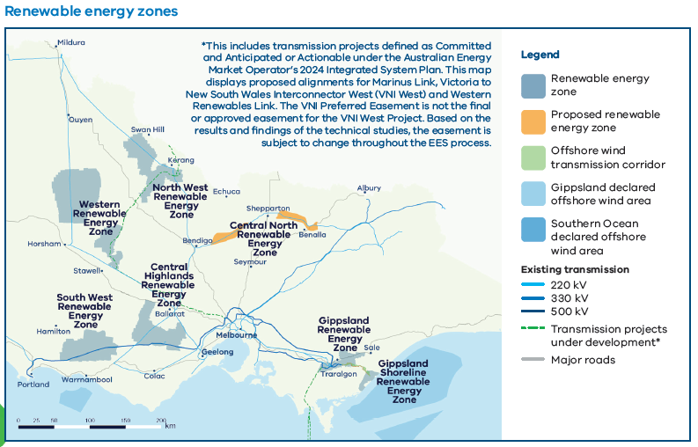
The Gippsland Shoreline Renewable Energy Zone is different from other renewable energy zones. It is not designed to facilitate onshore wind or solar farms. Instead, it is a defined planning area for offshore wind developers to run underground cables from the shoreline to the electricity grid.

What this means for

Communities
More co-ordinated planning of renewable energy generation and storage, such as wind farms, solar farms and batteries in renewable energy zones. Only a small proportion of land within each zone will be used for projects.

Landholders
Developers must talk to landholders to get permission to build renewable generation projects on their land. Landholders can choose whether or not to host a generation or storage project.

Traditional Owners
Better planning of where projects are located, with more consistent consideration of cultural values and heritage, helping avoid impacts to Country.

Industry
Zones give renewable energy project developers greater certainty to invest in renewable energy projects in Victoria, such as wind, solar and large-scale battery storage.

For more information about each renewable energy zone and the feedback that shaped them, visit our website.

Draft 2026 Victorian Transmission Plan Guidelines

Developing the 2027 Victorian Transmission Plan
VicGrid has started planning the next Victorian Transmission Plan by releasing the draft 2026 Victorian Transmission Plan Guidelines. This document will guide the development of the 2027 Victorian Transmission Plan, which will take a 25-year view of the state’s transmission and renewable energy generation needs.
The recently declared renewable energy zones will serve as a basis for the 2027 plan. As planning continues, VicGrid will assess whether the declared zones can meet Victoria’s future energy needs and – if required – identify potential locations for further zones.
We are inviting submissions on the draft guidelines to help us understand community and industry views and ensure the final guidelines are clear and effective.
We recognise renewable energy zones proposed in the 2025 Victorian Transmission Plan are only now being formally declared, and that this evolving process can feel challenging or uncertain, particularly for those directly affected.
At the same time, we must continue to plan for the long term and keep pace with growing demand.
The next Victorian Transmission Plan is due to be released in mid-2027. Before the plan is finalised, we will publish a draft version and consult landholders, communities and Traditional Owners on any new areas identified as potential renewable energy zones.
You can view the draft 2026 Victorian Transmission Plan Guidelines and learn more on our Engage Victoria webpage.

Community Engagement and Social Value Guidelines update

Clear expectations for project developers
VicGrid and the Department of Energy, Environment and Climate Action have released the Community Engagement and Social Value Guidelines, which set the Victorian Government’s expectations for how project developers engage with communities, create social value and deliver economic benefits.
Developers are expected to:
- Engage early and meaningfully with host landholders, neighbouring and nearby landholders, communities and Traditional Owners
- Consider feedback from these groups when designing their projects
- Support local economic investment and deliver community benefits, while recognising impacts on communities
- Establish clear processes for complaints and dispute resolution
VicGrid is asking renewable energy project developers seeking to connect to the network to follow these guidelines. VicGrid will also work with developers to identify areas for improvement.
From 2027- when the Victorian Access Regime comes into effect - project developers seeking to connect to the state’s transmission network will need to meet these expectations.
To learn more about the expectations in the Community Engagement and Social Value guidelines and how they will be implemented, visit our website.

What this will mean

Communities can expect:
- To have a say in shaping how the energy transition impacts and benefits them
- More transparency about when and how they can influence decisions

Landholders can expect:
- Project developers to engage them and neighbours earlier and more transparently about how the energy transition impacts and benefits them
- To be free to discuss project details with other community members without contractual restrictions

Traditional Owners can expect:
- More projects to engage earlier on agreement-making that reflects self-determined expectations
- Greater consideration of cultural heritage and values in project planning and decision-making

Industry can expect:
- Greater clarity of government expectations for community and Traditional Owner engagement and creating social value and economic benefits
- Increased accountability to deliver on commitments

Victorian Access Regime update
VicGrid is developing the Victorian Access Regime – the new set of rules to manage how renewable energy projects gain access to the state’s electricity network (both inside and outside renewable energy zones).
These rules will help address a current problem where too many projects are competing for the same part of the network. They will also help ensure developers genuinely engage with and deliver economic and social benefits for landholders, communities and Traditional Owners as part of the process to secure space on the network.
It is essential for Victoria’s energy system that we get the rules right, and we’re taking the time to make sure we do that properly.
We have received significant feedback on the proposed Victorian Access Regime, both during the formal consultation period and in ongoing conversations with communities and stakeholders.
The new Victorian Access Regime is now expected to start in mid-2027. Until then, the current open access arrangements under the National Electricity Rules will continue to apply.

Find out more
These changes reflect a new approach to planning energy infrastructure – one that considers community, environmental, cultural and technical factors and interests, while helping ensure all Victorian communities and businesses have access to reliable and affordable power.
To find out more about VicGrid and these updates, visit the following web pages:
- VicGrid overview
- Renewable energy zones
- Community Engagement and Social Value Guidelines:
- Draft 2026 Victorian Transmission Plan Guidelines
- Victorian Access Regime

Contact us
Phone: 1800 418 341
Email: enquiries@vicgrid.com.au
Deaf, hearing or speech impaired? Please contact the National Relay Service on 133 677 or vist their website.
Need an interpreter? Contact Translating and Interpreting Service (TIS) on 131 450 (within Australia) or visit their website.
Disclaimer: The information in this document is current at the time of printing, may be subject to change and should not be relied upon. Please visit our website for the latest updates.

