Draft 2026 Victorian Transmission Plan Guidelines
May 2026
Appendix A: Victorian Transmission Plan Methodology
Purpose
This is Appendix A to the 2026 Victorian Transmission Plan Guidelines.
Contents

Acronyms 4
Appendix A: VTP methodology – content summary 5
A.1 Overview of the Victorian Transmission Plan methodology 6
A.2 The methodology reflects a probabilistic transmission planning standard 8
A.3 Key decision-making tools for the 2027 Victorian Transmission Plan 10
A.4 Step 1 – Update Victoria’s future energy needs 13
A.5 Step 2 – Revise the scale of generation and storage needs 16
A.6 Step 3 – Identify what additional upgrades the transmission network needs 16
A.7 Step 4 – Assess and compare updated development pathways 17
A.8 Step 5 – Confirm any additional potential renewable energy zones and finalise the updated optimal development pathway 20

Acronyms
Term | Definition
AER | Australian Energy Regulator
CBA | Cost-benefit analysis
LT | Long-term capacity expansion energy market modelling
REZ | Renewable Energy Zone
VTP | Victorian Transmission Plan

Appendix A: VTP methodology – content summary
This appendix details the proposed methodology for developing the 2027 Victorian Transmission Plan, which involves the following five steps:
- Assess Victoria’s future energy needs
- Identify the scale of generation and storage needs
- Identify what upgrades the transmission network needs
- Assess and compare development pathways
- Confirm the potential renewable energy zones and finalise the optimal development pathway
This appendix describes how each step will be completed, including brief descriptions of the tools and models we will use.
- Overview of the Victorian Transmission Plan methodology
The Victorian Transmission Plan (VTP) methodology has been developed as a five-step process designed to answer the following questions that allow us to build on the analysis from the 2025 VTP:
- Update Victoria’s future energy needs: Can the declared renewable energy zones (REZ) meet Victoria’s future energy needs and, if required, what potential locations for new generation could be identified to meet additional demand?
- Revise the scale of generation and storage needs: How much generation and storage capacity are needed to meet future demand under each scenario, and where and when is it likely to be built?
- Identify what additional upgrades the transmission network needs: What additional or upgraded transmission infrastructure is needed over the next 25 years to support the required generation and storage capacity?
- Assess and compare updated development pathways: Which combination of potential generation, storage and transmission projects – referred to as development pathways – is assessed as delivering the greatest net benefits to Victoria and is most robust across scenarios and uncertainties?
- Confirm any additional potential renewable energy zones and finalise the updated optimal development pathway: After considering feedback, what are the potential REZs and the final optimal development pathway?
Figure A-1 summarises the VTP methodology, including the key analysis activities, decision-making tools and outputs for each step. The steps shown in this figure are described in further detail in Sections A.4 to A.8.
To provide a high-level overview of the methodology, Figure A-1 illustrates these steps as sequential, however, in practice, a number of these activities will be iterative and/or occur in parallel with various interdependencies.
Box 1: What has changed since the 2025 VTP
The methodology to develop the 2027 VTP has been refined from what was used for the 2025 VTP.
Updates have been made to reflect the extended planning period, declared REZs and proposed transmission projects, and a focus on improved clarity and adaptability. The approach remains scenario‑based and probabilistic, drawing on energy market modelling, power system analysis and strategic land‑use analysis. See Section 2.3 of the Draft 2027 Guidelines for further detailed regarding what has changed since the 2025 VTP.
Figure A-1: Summary of the 2027 VTP methodology
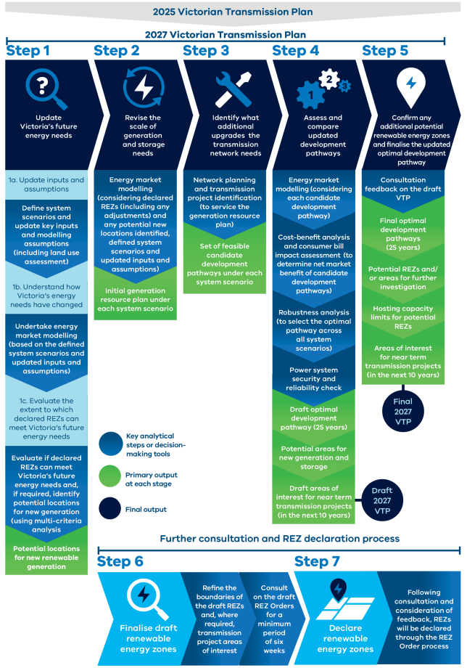
- The methodology reflects a probabilistic transmission planning standard
The transmission planning standard applied to the 2025 VTP remains unchanged and continues to apply to the 2027 VTP.
The standard provides the basis for determining how much transmission capacity should be provided under different inputs and assumptions, supporting the development of a reliable, efficient and economic transmission system over the long-term.
- What is a transmission planning standard?
A transmission planning standard sets out the approach used to determine the level of transmission capacity required in a power system.
The aim of transmission planning is to develop an efficient power system that delivers the energy customers need at the lowest cost possible, consistent with maintaining a high level of reliability and security while achieving government’s targets for decarbonisation and renewable energy. This involves planning for a transmission system that supports the optimal mix and location of generation across Victoria.
Any standard needs to balance maintaining reliable supply with the cost of achieving that reliability. The value of reliable supply will only increase with a greater role for electricity in a zero-emissions future.
In general, transmission planning standards can be defined as either probabilistic or deterministic:
- A probabilistic standard determines the level of transmission capacity through an economic cost-benefit analysis (CBA) that compares the costs of transmission infrastructure against the costs that would be incurred in the absence of that infrastructure. This approach therefore determines when and how much money could be spent on upgrades to the system to meet customer demand. This approach is consistent with the National Electricity Law, which specifies that a probabilistic approach must be used to determine the benefits of a potential transmission augmentation.
- A deterministic standard applies fixed technical requirements and contingency tests. It specifies the level of redundancy and performance that must be maintained under prescribed conditions. Application of a deterministic transmission planning standard involves evaluating the outcomes of a predetermined set of contingencies, without reference to their probability of occurrence. In general, a deterministic planning standard is easier to administer but may lead to a higher level of capital expenditure and higher network charges. The basic weaknesses of this approach are that it does not consider the likelihood and consequences of failures in the transmission system and the variable pattern of renewable generation supply, consumer demand, weather and other variables affecting supply and demand.
The 2024 Guidelines applied a probabilistic transmission planning standard based on a desktop review of transmission planning standards across six countries. This review considered factors such as economic efficiency, investor confidence, boundary issues and equity for generators. This standard was used in preparing the 2025 VTP.
- What is applied in the 2027 VTP?
Based on the review underpinning the selection of the probabilistic transmission standard used for the 2025 VTP, the 2027 VTP will continue to apply a probabilistic, economic planning approach. This approach also consistent with the National Electricity Law. Applying a probabilistic planning standard helps ensure that transmission development is efficient, timely and proportionate to system needs.
While probabilistic planning is more complicated to plan and administer than deterministic approaches, in general it offers greater benefits to energy consumers and communities across the state, including lower costs and less infrastructure. For Traditional Owners and communities, this means greater clarity about why and when transmission is required, fewer unnecessary projects and improved transparency about how decisions are made. For industry, it provides clearer expectations about when transmission capacity will be available to support renewable energy investment and how planning decisions align with long‑term system requirements.
This standard is reflected in the VTP methodology through the use of a probabilistic CBA that assesses combinations of generation, storage and transmission investments across weighted future system scenarios, as well as testing the sensitivity of the results to specific inputs. This will enable the VTP to accommodate future uncertainty by enabling decisions to be adjusted as conditions evolve.
Figure A-2 provides a high-level overview of how the probabilistic planning standard is applied to each key stage of the VTP methodology.
Figure A-2: Application of probabilistic planning standard in the 2027 VTP methodology
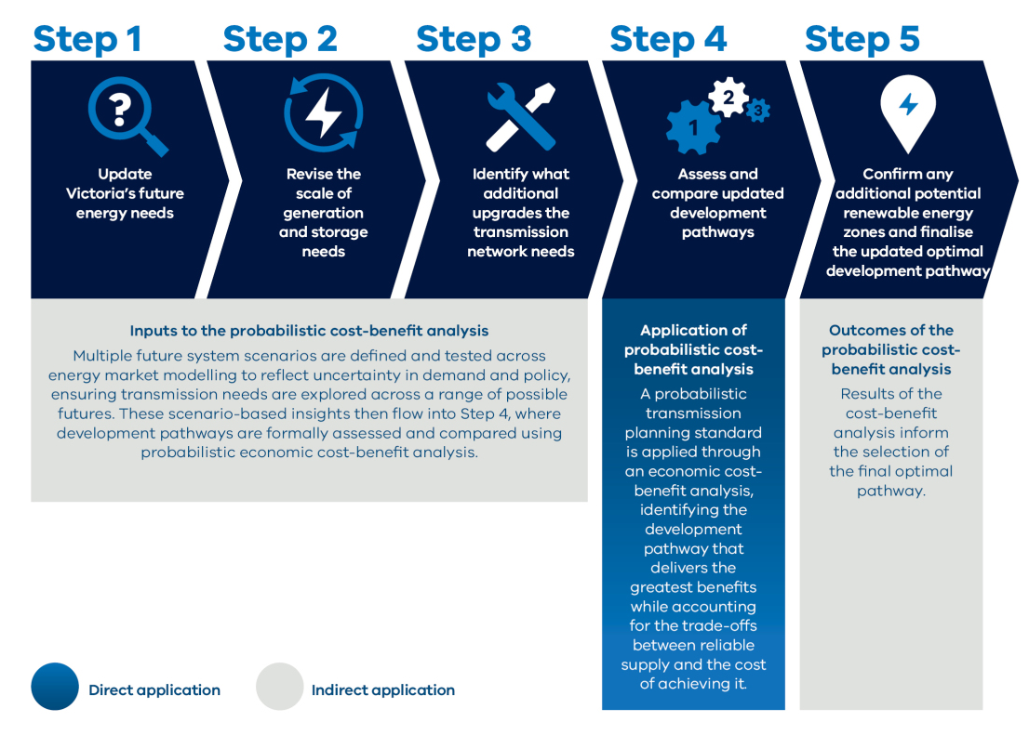
By assessing and comparing development pathways across scenarios, the standard supports selection of a least‑regrets development pathway that is most robust over the 25‑year outlook.
- Key decision-making tools for the 2027 Victorian Transmission Plan
Many of the methodological steps are underpinned by key decision-making tools and analysis to improve the quality and evidence-basis of the methodology. This section explains the role of these analyses and the approaches that will be taken.
- Strategic land use assessment
The strategic land use assessment is a core component of the Victorian Transmission Investment Framework and is used to identify suitable areas for siting infrastructure based on a range of technical, environmental, cultural, social and economic factors.
The objectives of the strategic land use assessment are to:
- Support the protection of key landscape and land use values and areas and minimise potential land use impacts and land use conflicts from REZ development.
- To provide early, authoritative and credible information and insights in relation to land use across Victoria to support decision-making and consideration of key trade-offs in where renewable energy development is focused.
- To provide communities, Traditional Owners, and regional and industry stakeholders clear and early indication of the suitability of different areas for REZ development and the risks, complexities and opportunities associated with different land use values.
The strategic land use assessment produces a range of geographic information system outputs that provide strategic information on areas that can minimise land use conflicts, support strategic investment opportunities, and highlight planning and environmental risks and complexities for development. The outputs of the assessment provide rich insights around land use that can be considered alongside other technical and qualitative factors in developing the VTP.
Box 2: Strategic land use assessment model and methodology
The strategic land use assessment utilises a spatial multi-criteria analysis methodology to map and understand existing land uses and landscape values across Victoria, using a range of data inputs across multiple value themes.
A spatial multi-criteria analysis is a decision-making tool which brings together a number of datasets across environmental, ecological, cultural, social, economic and engineering themes into an integrated assessment. Spatial datasets contribute to distinct criteria and are scored. A spatial model processes the data using a multi-criteria analysis scoring framework that aggregates criteria across different value themes to produce maps for detailed analysis, testing and refinement. The analysis also identifies avoidance areas as locations to protect for development where there are no acceptable trade-offs, such as national parks and world heritage sites. The resulting constraint maps bring together a large number of considerations and datasets into a strategic output in a logical and consistent way.
A high-level process flow that will be undertaken for the constraints assessment multi-criteria analysis is outlined in Figure A-3 below.
Figure A-3: Strategic land use assessment spatial multi-criteria analysis process
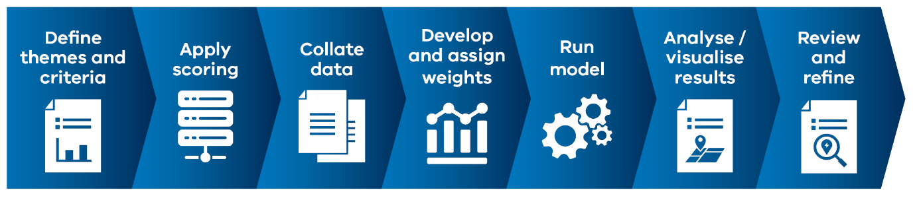
In addition to the core constraints multi-criteria analysis, the strategic land use assessment will consider a range of additional overlays to help decision-making around land use conflicts and opportunities. These overlays are additional factors that are not appropriate to include in the multi-criteria analysis trade-off analysis but are better dealt with as supplementary inputs to the constraints mapping outputs, such as the presence of existing infrastructure, administrative boundaries or value-specific analysis.
For the 2025 VTP, the strategic land use assessment included a statewide assessment of land use constraints and opportunities, which then resulted in the development of a REZ areas for investigation published in the 2024 Guidelines. The REZ area for investigation formed the starting point of the 2025 VTP, and the underlying analysis and insights supported decision-making in identification of the declared REZs.
For the 2027 VTP, the strategic land use assessment scope will be updated to focus on statewide land use constraints analysis, building on the constraints assessment undertaken for the 2025 VTP. This will inform areas identified for new potential REZs. Refer to Section A.4.1 for further detail.
- Multi-criteria analysis
A multi-criteria analysis provides a structured way to assess locations for renewable energy development by integrating economic, environmental, cultural and social considerations. It enables different types of information to be assessed together, including Victoria’s future energy needs, land-use constraints, regional economic impacts, generator interest, and community and Traditional Owner feedback.
In the 2027 VTP, the multi-criteria analysis will be used to evaluate whether declared REZs can meet Victoria’s future energy needs and, if required, identify potential locations for new renewable generation. This supports planning decisions that align with Victoria’s future energy needs and broader planning objectives.
The multi-criteria analysis will also help refine the generation locations identified through energy market modelling by incorporating qualitative factors that modelling cannot adequately capture. By combining spatial constraints, engagement insights and regional development considerations, the multi-criteria analysis supports the identification of areas that balance system needs with community expectations and deliverability.
- Energy market modelling
Energy market modelling will inform decisions by assessing future whole-of-system outcomes under different future scenarios and testing sensitivity of results to different inputs and assumptions This involves comparing types of costs to determine the least-cost path to meet demand and policy objectives as the energy system evolves.
We will undertake two main modelling phases as part of the methodology:
- Long-term capacity expansion modelling (LT): LT determines the least-cost generation mix under a high-level network topology while meeting demand, policy objectives and assumed retirement of coal-fired power stations. Long-term modelling will identify suitable locations for new generation and provide the basis for network and transmission planning to connect these areas to the existing system.
- Short-term modelling (ST): ST uses the new entrant profile and transmission build path from the previous stage and considers additional network constraints to optimise the dispatch of electricity at half-hourly intervals. In this methodology, short-term modelling will be used to validate investment determined by the long-term modelling and as the interface with power system modelling.
All market modelling will be undertaken with PLEXOS, an energy market modelling software that is widely used in industry. PLEXOS enables economic, policy and technical constraints to be overlaid on the standard electricity dispatch formulation. It also allows optimisation parameters, granularity and horizon to be selected.
Figure A-4 illustrates the process flow.
Figure A-4: Energy market modelling process flow
- Power systems analysis
Power system analysis is a specialised approach used to represent the intricate workings of electrical power systems through computational simulations. For the 2027 VTP, this analysis will be undertaken using industry-standard power system simulation software that models the transmission network under a range of operating conditions.
Power system simulation tools provide a comprehensive environment for network planning and assessment, including load‑flow studies, stability analysis, short‑circuit analysis and other functions essential to maintaining system reliability and efficiency. These tools are widely used across the electricity sector to assess how the transmission network performs under both normal and contingent conditions.
Power system analysis is particularly valuable for its ability to model the complex behaviours of power systems with precision and flexibility. It can handle large-scale power networks and simulate how changes in the system, such as the introduction of new generators or loads, or modifications to the network configuration, will impact overall system performance. Through its extensive library of component models and the ability to customise and extend these models, it supports detailed analysis of system response to various operating scenarios.
This process is crucial for ensuring that the power grid remains stable, efficient, minimises outages, and adapts to the evolving demands of energy consumers. Power system modelling serves as a foundational tool for designing and operating electricity networks that are both resilient and sustainable.
- Step 1 – Update Victoria’s future energy needs
Step 1 of the methodology establishes the foundation for the 2027 VTP. This step involves a refresh of the key inputs and assumptions, and an assessment of how Victoria’s future energy needs have changed since the previous VTP. These activities ground the 2027 VTP in up-to-date inputs and assumptions and the current view of Victoria’s future energy needs.

- Update inputs and assumptions
The first step to develop the 2027 VTP involves a refresh of key inputs and assumptions. This includes defining the system scenarios and refreshing the datasets that inform generation and transmission planning.
To ensure land‑use considerations are current and consistently applied, the strategic land use assessment from the previous VTP will be updated using the latest environmental, biodiversity, cultural, social and land‑use information.
The refreshed strategic land use assessment forms a critical input into subsequent steps in the methodology, including the energy market modelling and the evaluation of declared REZs, which includes identifying new REZ areas where additional support is needed.
Box 3: Strategic land use assessment in the 2027 VTP
Strategic land use assessment in the 2027 VTP
The focus of the strategic land use assessment for the 2027 VTP is on refining the understanding of land use constraints for REZs as strategic locations for coordination energy development. The analysis scope is limited to relevant wind and solar constraints, focused on strategic statewide and regional issues.
The strategic land use assessment will not include analysis of:
- Individual renewable energy projects
- Property-level, siting or technology-specific decisions relevant to project level planning and environmental assessments and approvals
- Pumped hydro, battery energy storage systems, or other forms of storage, with respect to land use constraints
The strategic land use assessment may consider additional variability in input criteria between wind and solar land use requirements, and between different Victorian regions, to support decision-making through the 2027 VTP.
Updates to constraints mapping from the 2025 VTP
The strategic land use assessment constraints analysis will build on the model developed and published with the 2024 Guidelines, with updates and changes to address assessment gaps and incorporate up-to-date input data for the assessment criteria. Additional inputs for new or existing criteria will align to the overall analysis scope outlined above and seek to address key information gaps identified from consultation to date, aiming to support evaluation of declared and future REZ areas.
For the 2027 VTP, VicGrid is proposing a slight revision to the constraints multi-criteria analysis theme structure to reflect stakeholder and community feedback from the development of the 2025 VTP, aiming to better categorise existing input criteria into distinct value themes. The main change to the multi-criteria analysis structure is proposed to establish Agriculture as a stand-alone theme from other land use criteria, allowing more targeted analysis of agricultural inputs. A summary of the proposed themes is provided in Table A-1 below.
Table A-1: Strategic land use assessment themes
Theme | Objective
Biodiversity | Protect and/or minimise potential impacts on areas of significant environmental and biodiversity value.
Cultural heritage | Protect and/or minimise potential impacts on areas that have cultural heritage significance and/or sensitivity.
Community | Protect and/or minimise potential impacts on areas that have community and public importance, including community infrastructure
Agriculture | Protect and/or minimise potential impacts to agricultural land use and farming activities.
Resource and Industry | Protect and/or minimise potential impacts to resources and industrial land uses, including strategic extractive areas.
Natural hazards and Terrain | Minimise risks to the power system’s vulnerability to natural hazards and climate change and reduce engineering complexities.
Traditional owner input and cultural heritage
The strategic land use assessment is a key decision support tool to ensure appropriate representation of cultural values in transmission and REZ planning. We acknowledge that existing cultural heritage datasets are incomplete, as some parts of Victoria have not undergone detailed heritage assessments. As part of our ongoing partnership with Traditional Owners, we will work with them to improve how cultural values are represented in the strategic land use assessment and develop our understanding of Traditional Owner perspectives on what areas of Country are more or less suitable for development. We will collaborate with Traditional Owners to channel knowledge, with consent, so that cultural values can be better understood, identified and protected.
The refreshed inputs and assumptions provide an updated evidence base for the VTP, ensuring that the modelling and analysis undertaken is grounded in current policy, market and land‑use settings.
- Understand how Victoria’s energy needs have changed
Energy market modelling will be used to assess how Victoria’s energy needs have changed since the 2025 VTP. Using the defined system scenarios and updated inputs and assumptions, the modelling will identify any changes in the size, location, type of generation build and what storage is required over the 25-year planning period.
This purpose of this phase of energy market modelling is to inform the evaluation of declared REZs and the multi-criteria analysis in the subsequent step. This modelling will seek to understand how the refreshed view of Victoria’s future energy needs may impact generation planning across declared REZs. The modelling will also identify other locations across the state that are well-suited to the development of generation.
- Evaluate the extent to which declared REZs can meet Victoria’s future energy needs
The declared REZs form the starting point for analysis in the 2027 VTP. This step of the methodology will assess the extent to which declared REZs can meet Victoria’s future energy needs over the 25-year planning period and, if required, identify potential locations for new renewable generation.
A multi-criteria analysis will be undertaken to evaluate if declared REZs can meet Victoria’s future energy needs (across the longer planning period of 25 years) across a range of economic, social, cultural and environmental factors. The multi-criteria analysis will also use this broad range of inputs, alongside energy market modelling outputs from the previous activity, to identify potential locations for new renewable generation (if required).
This assessment will ensure the REZs continue to align with Victoria’s long-term generation requirements and broader economic, social and environmental considerations.
The factors considered in the multi-criteria analysis are outlined below:
- Land use constraints and considerations, through detailed land-use information from the strategic land use assessment
- Energy market modelling outputs
- Stakeholder views collated from VicGrid engagement (to date and ongoing) with Traditional Owner groups; local communities through drop-in sessions, feedback form responses and submissions; and local councils and industry bodies through briefings and submissions.
- Cumulative economic, social and environmental impacts and regional equity, including assessing the size and location of in-service and committed generation projects
- Transmission network design and utilisation, including feasibility of network augmentation, community acceptance and overall deliverability of the plan
- Generator/developer interest
- Alignment with regional and local economic development strategies
If potential locations for new renewable generation are required, VicGrid will engage with communities, Traditional Owners, industry and stakeholders on the potential locations identified to gain a better understanding of the associated social, cultural, economic and environmental impacts.
The declared REZs (including any adjustments) and any potential new locations identified will form an input to further energy market modelling, with insights from that modelling potentially informing refinements to REZ considerations as part of a dynamic and iterative planning process.
- Step 2 – Revise the scale of generation and storage needs
Step 2 of the methodology focuses on identifying how much energy generation and storage capacity is needed to meet demand over the 25-year planning period, and where it is likely to be located under each future system scenario.
Initial generation resource plans will be developed for each future system scenario through further energy market modelling, which will integrate the declared REZs and any potential locations for new renewable generation from the previous step. The initial generation resource plans will outline what generation and storage to build, where it is likely to be located and when it will be needed under each system scenario.
For each defined system scenario designed to represent high-impact but plausible future developments in demand and supply conditions in the Victorian energy sector over the next 25-year period, the generation resource plans will include:
- Which technologies are likely to be built based on cost-effectiveness (including storage)
- How much capacity is likely to be built
- When this capacity should be built
The resulting generation resource plans will outline an initial view of the expected sequence of generation, and storage builds across the 25-year planning period, as well as a more informed understanding of the areas designated for REZ development.
The generation resource plan for each scenario will serve as the foundation for transmission network planning in Step 3, where candidate transmission projects and pathways will be identified and tested to enable the forecast generation development under each scenario.
- Step 3 – Identify what additional upgrades the transmission network needs
Potential transmission projects required to enable the generation resource plans from Step 2 will be identified through network planning supported by power systems analysis, building on existing and planned transmission projects from the 2025 VTP. The capacity of the existing transmission network will be evaluated against the additional generation identified in each scenario. Where constraints are identified, transmission planning will develop feasible project options to connect new generation and augment the grid. The technical feasibility of these options will be analysed through power systems analysis to ensure the secure and reliable operation of the network under a range of conditions.
In developing the 2027 VTP, VicGrid will consider the impact of distribution network opportunities by including these as an input to the energy market modelling. The 2027 VTP will also consider non-network solutions, such as battery storage, as alternatives to investment in transmission system assets including lines and substations.
Over the 25-year planning period, a range of feasible project options will be developed to form a set of ‘candidate development pathways for each scenario. These pathways will identify the potential transmission projects required and indicate when they will be needed to ensure the secure operation of the power system, meet supply requirements and deliver reliable power to Victorian homes and businesses.
The design and testing of candidate development pathways will adopt adaptive planning principles to help plan for uncertainty in Victoria’s future energy needs. Adaptive planning is an approach that helps plan for uncertainty by identifying and assessing pathways that consider changes (to timing or scale of investments) in response to evolving conditions. Importantly, this means that the value of flexibility (option value) is part of the decision-making process for both short-term and longer-term investment planning within candidate development pathways.
Where necessary, insights from this analysis will be used to review, and if necessary, refine the generation resource plan. This iterative approach across the REZ areas, generation resource plans and candidate development pathways will seek to collectively deliver the best overall outcome for Victoria.
The primary outputs from Step 3 are a set of technically feasible and cost-informed candidate development pathways for each scenario. These outputs will include indicative project scope and timing across the 25-year period. The pathways, along with supporting technical assumptions and cost inputs, will then progress to Step 4, where they will undergo comparative assessment through further energy market modelling, CBA, and robustness testing to determine the draft optimal pathway.
- Step 4 – Assess and compare updated development pathways
Step 4 assesses and compares the candidate development pathways to determine the draft optimal pathway, which represents the combination of generation and transmission projects that minimises net costs across scenarios and is most robust to future uncertainties. This assessment draws on several decision‑making tools to compare pathway performance, test technical feasibility and identify the pathway that is both economically efficient and robust to a wide range of future outcomes. The key output from this step is the draft optimal pathway, which will be published in the draft 2027 VTP for consultation.
As part of this step, sensitivity analysis will be undertaken to test the robustness of results generated across the assessment and to understand how variations in key assumptions may influence the relative performance of candidate development pathways. The sensitivity analysis will focus on uncertainties relevant to transmission planning, including potential changes in electricity demand characteristics, the timing and delivery of major generation and transmission projects, the retirement of existing generation, and key financial parameters. Variations of these sensitivities will be considered as part of the modelling and assessment to support identification of a draft optimal pathway that remains robust to uncertainty.
- Energy market modelling
Further energy market modelling will be undertaken to assess the performance of each candidate development pathway under all system scenarios. This modelling will follow the same approach applied in Step 2 but will incorporate the candidate development pathways as exogenous inputs in place of generic transmission augmentation assumptions. Doing so allows the modelling to reflect the hosting capacity and transfer capability associated with each pathway.
The market modelling will re‑optimise generation investment and dispatch outcomes under each candidate pathway, producing a set of outputs such as generation capital and operating costs, unserved energy and emissions outcomes. These outputs will form key inputs to the CBA and the robustness analysis undertaken in later parts of this step.
- Cost-benefit analysis
A CBA will be used to systematically compare the costs and benefits of the candidate pathways for each system scenario against a counterfactual development path for the same respective system scenario. The CBA will determine the net market benefits associated with each candidate pathway, which will form a key input into the robustness analysis.
The counterfactual development path serves as the reference point for the economic analysis and represents a future with no network augmentation other than committed and anticipated projects, or small intra-regional augmentations and replacement expenditure projects.
The CBA will consider the full spectrum of impacts (costs and benefits) attributable to each candidate pathway to determine the net market benefits. The CBA in the 2027 VTP builds on the Australian Energy Regulator’s (AER) CBA guidelines. In addition to the benefits described in the AER guidance (which denotes market benefits accruing to those who consume, produce and transport electricity in the market), the VTP CBA will consider a holistic view of benefits, both qualitative and quantitative (to the extent possible). This will enable non-market benefits to be considered, including environmental, economic and social impacts. This will ensure that the VTP CBA is consistent with the Department of Treasury and Finance Economic Evaluation Technical Guidelines and best practice within the infrastructure sector.
In terms of costs, this CBA will consider:
- Costs incurred in constructing or providing the projects within each candidate pathway
- Operating and maintenance costs in respect of projects within each candidate pathway
In terms of benefits, the 2027 VTP will clearly set out and justify the range of benefit and cost categories (and quantification approach) used within the CBA. As an example, the range of benefit categories is likely to be similar to the 2025 VTP and include (but not be limited to):
- Avoided generation variable costs
- Avoided generation capital expenditure
- Avoided generation operating and maintenance expenditure
- Improved reliability
- Avoided emissions
- Capital expenditure savings.

- Consumer bill impact assessment
A consumer bill impact assessment will be undertaken to analyse the impact of candidate development pathways on the wholesale and transmission components of Victorian consumers’ electricity bills.
The assessment will examine how candidate development pathways are expected to influence electricity market outcomes, as well as the costs associated with delivering the necessary transmission infrastructure. It will provide insights into how changes in the generation mix, enabled by transmission development, may place downward pressure on wholesale electricity prices, while recognising that increased investment in transmission infrastructure may lead to higher network costs.
The assessment will form part of the comparison of candidate development pathways and will consider impacts on consumer bills over the long term. It will inform the consideration of the optimal development pathway, alongside the cost-benefit analysis and robustness analysis.
- Robustness analysis
A robustness analysis will be undertaken for the candidate pathways across all system scenarios to identify the draft optimal pathway. This will be the most robust candidate pathway under all scenarios and uncertainties, minimising potential costs while maintaining electricity security and reliability for Victorian consumers.
The robustness analysis determines ‘regrets’ (or benefits foregone) for each candidate pathway option across each scenario, with the most robust option being the one that has the lowest amount of regret in any one scenario. The ‘regrets’ determined through this analysis are reflective of the benefits and costs considered through the CBA.
Table A-2 and Table A-3 shows an illustrative example of the robustness analysis. In this example, three system scenarios with weightings have been modelled and three candidate pathways are assessed against these scenarios. The conceptual net market benefits of each candidate pathway are shown in Table A-2, which would have been computed through a hypothetical CBA. The candidate pathway with the highest net market benefit under the range of scenarios is shown in bold.
Table A-2: Conceptual example – net market benefits ($m)
Scenario | Scenario 1 | Scenario 2 | Scenario 3
Weighting | 50% | 10% | 40%
Candidate pathway 1 | $200M | $180M | $220M
Candidate pathway 2 | $150M | $200M | $240M
Candidate pathway 3 | $150M | $300M | $200M
Maximum net market benefits for each scenario | $200M | $300M | $240M

Table A-3 shows the ‘regrets’ associated with each of the candidate pathways under each scenario. The regret for each candidate pathway is the difference between its net market benefits and the optimal pathway for that scenario (i.e. the maximum net market benefits for each scenario).
The worst regret for each candidate pathway is shown in bold. In this conceptual example, the candidate pathway with the least-worst regret prior to consideration of scenario weightings is candidate pathway 3 (with a worst regrets of $50M). However, when scenario weightings are incorporated, candidate pathway 2 is seen to have the least-worst regrets. This candidate pathway is therefore deemed the optimal candidate pathway, exhibiting the lowest level of regret and thus most resilient in the face of uncertainty (based on the assigned scenario weightings).
Table A-3: Conceptual example – regrets analysis ($m)
Scenario | Scenario 1 | Scenario 2 | Scenario 3 | Worst regret | Weighted worst regret
Weighting | 50% | 10% | 40% | Worst regret | Weighted worst regret
Candidate pathway 1 | $0M | $120M | $20M | $120M | $12M
Candidate pathway 2 | $50M | $100M | $0M | $100M | $10M
Candidate pathway 3 | $50M | $0M | $40M | $50M | $25M

The primary output from Step 4 is the draft optimal pathway for the next 25 years. This will be published in the Draft 2027 VTP, and feedback will be sought to inform the development of the final optimal pathway in Step 5.
- Power systems analysis
Further power systems analysis will be undertaken to confirm the technical feasibility of the draft optimal pathway identified through the economic assessment. This analysis will test whether the pathway maintains secure and reliable operation of the power system under a range of operating conditions and will identify any network constraints or performance issues that may require updates to the pathway.
The technical assessment will draw on power flow, stability and fault‑level studies, and will be used to verify that the draft optimal pathway meets power system security requirements. Where the power systems analysis identifies issues that materially affect feasibility, the results will be fed back into the market modelling and pathway assessment to refine the draft optimal pathway before consultation.
The key output from this analysis is confirmation that the draft optimal pathway is technically feasible and capable of supporting secure system operation.
- Development of draft areas of interest for near term transmission projects
The draft optimal pathway will identify the preferred areas of interest for any near-term transmission projects required to be built in the next 10 years following publication of the 2027 VTP. These draft areas of interest will provide broad initial investigation zones, defined by two proposed connection points to the declared shared network. This will include consideration of non-network solutions as outlined in Step 3. The draft areas of interest will be included in the draft 2027 VTP.
- Step 5 – Confirm any additional potential renewable energy zones and finalise the updated optimal development pathway
Step 5 confirms the potential REZs and finalises the optimal development pathway based on feedback received on the draft 2027 VTP. As part of the consultation process, stakeholder input will be reviewed and incorporated where appropriate to confirm the final optimal pathway. This pathway will detail the transmission infrastructure projects required to support REZ development and enable Victoria’s energy transition over the next 25 years.
The key outputs from this step include the potential REZs and the identification of areas for further investigation, the final optimal pathway, determination of hosting capacity limits for potential REZs, and areas of interest for near term transmission projects (for the next 10 years).
- Development of the final optimal pathway
The draft optimal pathway will be refined to incorporate relevant stakeholder feedback and outcomes from additional technical assessments. The final optimal pathway will define the transmission infrastructure required over the 25-year planning period, including the indicative timing and sequencing of projects. This pathway will provide a clear framework for the investments necessary to maintain system security and reliability, while aligning with the broader objectives of Victoria’s energy transition.

- Potential REZs and identification of areas for further investigation
As part of the development of the final optimal pathway, declared REZs will be confirmed where appropriate, and additional areas for further investigation may be identified. Recognising that some future generation may be located outside the boundaries of current REZs, a structured approach will be applied to assess and consider such opportunities. These decisions will be informed by stakeholder feedback, the multi-criteria analysis and land-use considerations integrated throughout the methodology.
- Determining hosting capacity limits for potential REZs
Once the potential REZs and final optimal pathway are in place, hosting capacity limits will be established for each REZ. These limits will account for updated land use considerations, power system performance and project deliverability. Hosting capacity limits will ensure that generation needs are met, and that power system security, reliability and land use constraints are appropriately balanced.
By finalising the optimal pathway and confirming the parameters for REZ development, Step 5 ensures that Victoria has a clear and actionable plan to enable a secure, reliable and sustainable energy future.
- Development of the areas of interest for near term transmission projects
The optimal pathway will identify the preferred areas of interest for any near-term transmission projects required to be built in the next 10 years following publication of the 2027 VTP. This will take into account consultation feedback received on the draft areas of interest included in the draft 2027 VTP.

This includes, for example, the cost to build and connect new generation, operate generation infrastructure (including fixed, variable and fuel costs) and the cost of unserved energy.

