VicGrid
Renewable energy zones and transmission projects proposed in Gippsland
  - August 2025
VicGrid, the government body responsible for planning and developing new renewable energy zones and transmission infrastructure, has released the 2025 Victorian Transmission Plan.
The plan marks a significant step in the state’s renewable energy transition and sets out the new energy infrastructure we need to keep Victoria’s lights on as coal-fired power stations close.
It outlines how much more wind and solar energy Victoria is expected to need over the next 15 years. It identifies the most suitable locations for renewable energy zones and the transmission projects needed to keep costs down and the lights on.
This summary outlines what is proposed in Gippsland.

Gippsland’s role in the energy transition
Gippsland has some of the strongest and most consistent winds in Australia, both onshore and in the declared offshore wind zone. Wind energy is set to play a significant role in replacing coal-fired power, keeping the lights on and driving investment back into the region.
The region also has significant existing transmission infrastructure, built to connect coal-fired power in the Latrobe Valley to metropolitan Melbourne and other parts of Victoria.
VicGrid is already developing a new transmission line from Giffard to the Latrobe Valley to connect the first 2 gigawatts (GW) of offshore wind energy to the grid. We are speaking with landholders and communities in Gippsland to identify the most suitable route for this new transmission line.
As part of the 2025 Victorian Transmission Plan, we’ve identified a suitable area for additional onshore wind energy generation in Gippsland and the additional transmission infrastructure needed to support approximately 7 GW of offshore wind in Gippsland.

What does the 2025 Victorian Transmission Plan mean for Gippsland?
The 2025 Victoria Transmission Plan seeks to provide greater clarity and certainty about the extent of renewable energy generation in Gippsland and the transmission needed to connect additional onshore and offshore wind generation.

It’s your choice
Developers must talk to landholders to get permission to build renewable generation projects (such as wind turbines, large scale solar farms or batteries) on their land. Landholders can choose whether or not to host a project.
Landholders who do host renewable generation projects will receive financial payments and benefits that they negotiate with the developer. Dedicated community benefits will also apply to projects developed in renewable energy zones. This ensures the whole community benefits from development.

Have your say
The proposed Gippsland Renewable Energy Zone and Gippsland Shoreline Renewable Energy Zone will soon be placed on public notice for 6 weeks to provide the opportunity for comments and submissions. The Minister for Energy and Resources must consider any submissions when determining whether the renewable energy zone should be official declared.
For more information, please see ‘Next steps’ below.

What’s proposed in Gippsland

Planning currently under way
VicGrid is currently planning the Gippsland offshore wind transmission stage 1 project. This project includes a connection hub near Giffard and a 500 kilovolt (kV) transmission line that will connect the first 2 gigawatts (GW) of offshore wind energy to the grid in the Latrobe Valley.
You can learn more about this project on the VicGrid website.
What’s included in the 2025 Victorian Transmission Plan
- A proposed Gippsland Renewable Energy Zone in between Morwell and Sale. For more details, see section ‘The proposed Gippsland Shoreline Renewable Energy Zone’.
- A proposed Gippsland Shoreline Renewable Energy Zone between Morwell and Sale the Gippsland coast and South Gippsland Highway. This zone is not designed to host onshore wind or solar projects. For more details, see section ‘The proposed Gippsland Shoreline Renewable Energy Zone’.
- A Gippsland offshore wind transmission stage 2 project, which includes a new 500 kV transmission line from the existing transmission network near Driffield to Woodside, and a new 500 kV line from Woodside to Giffard. New terminal stations will be needed at Driffield and Woodside. For more details, see section ‘The additional transmission needed to connect both offshore and onshore wind in Gippsland’.
- A second Hazelwood to Yallourn 220 kV transmission line, approximately 10 km long. We will investigate following the route of the existing transmission easement, but this will be subject to further technical work. For more details, see section ‘The additional transmission needed to connect both offshore and onshore wind in Gippsland’.

The proposed Gippsland Renewable Energy Zone
The proposed Gippsland Renewable Energy Zone is located between Morwell and Sale and includes parts of the local government areas of Wellington and Latrobe. Small sections of Baw Baw and South Gippsland local government areas are also in the zone. It sits within the Registered Aboriginal Party boundary of the Gunaikurnai Land and Waters Aboriginal Corporation.
When identifying this zone, we have aimed to balance complex land use issues across the region with the pressing need to position renewable energy zones with the best access to wind and solar energy. We sought to coordinate access to existing transmission infrastructure to avoid the need to build more transmission lines for onshore renewable energy generation.
Australia’s first declared offshore wind area is located off the coast of Gippsland and VicGrid is coordinating development of the transmission that will bring offshore wind energy from the coast to the Latrobe Valley. Part of the proposed Gippsland Renewable Energy Zone overlaps the offshore wind transmission study area.

How much new energy are we planning for in the Gippsland Renewable Energy Zone?
Once renewable energy zones are declared, VicGrid proposes to run a competitive allocation process to decide which projects in each zone have the authority to connect the energy they produce to the grid.
We will consider:
- the amount of electricity Victoria needs to generate to meet expected demand as outlined in the Victorian Transmission Plan
- ensuring the level of development inside each zone can be supported by available transmission lines
- the density of projects within each renewable energy zone
- how development can be coordinated to avoid the ‘spaghetti effect’ of many powerlines crossing the landscape
- whether developers are meeting expectations for landholder, community and Traditional Owner engagement and benefits.
This will ensure we ultimately produce enough energy to meet demand while also considering the impact on communities, Traditional Owners, agriculture and the environment.
We are proposing to set access limits for each zone at the maximum amount that can be managed by the planned build-out of the transmission network.
This is not the level of development people should expect in each zone but is the maximum that the transmission network could support within the zone.
How to read the map
The map (see Figure 1) shows the proposed Gippsland Renewable Energy Zone, proposed Gippsland Shoreline Renewable Energy Zone and the general area of new transmission lines and terminal stations proposed for Gippsland.
The specific locations of proposed transmission projects will be determined through consultation with communities, landholders, Traditional Owners and First Peoples.
The map also includes some of the significant land use and landscape values that have influenced the shape and size of the draft proposed Gippsland Renewable Energy Zone. The identified land use and landscape values in the region are a sub-set only and are not exhaustive of the values present.
For more information about the factors that informed the draft proposed Gippsland Shoreline Renewable Energy Zone, see section, ‘Feedback about the proposed Gippsland Shoreline Renewable Energy Zone’.
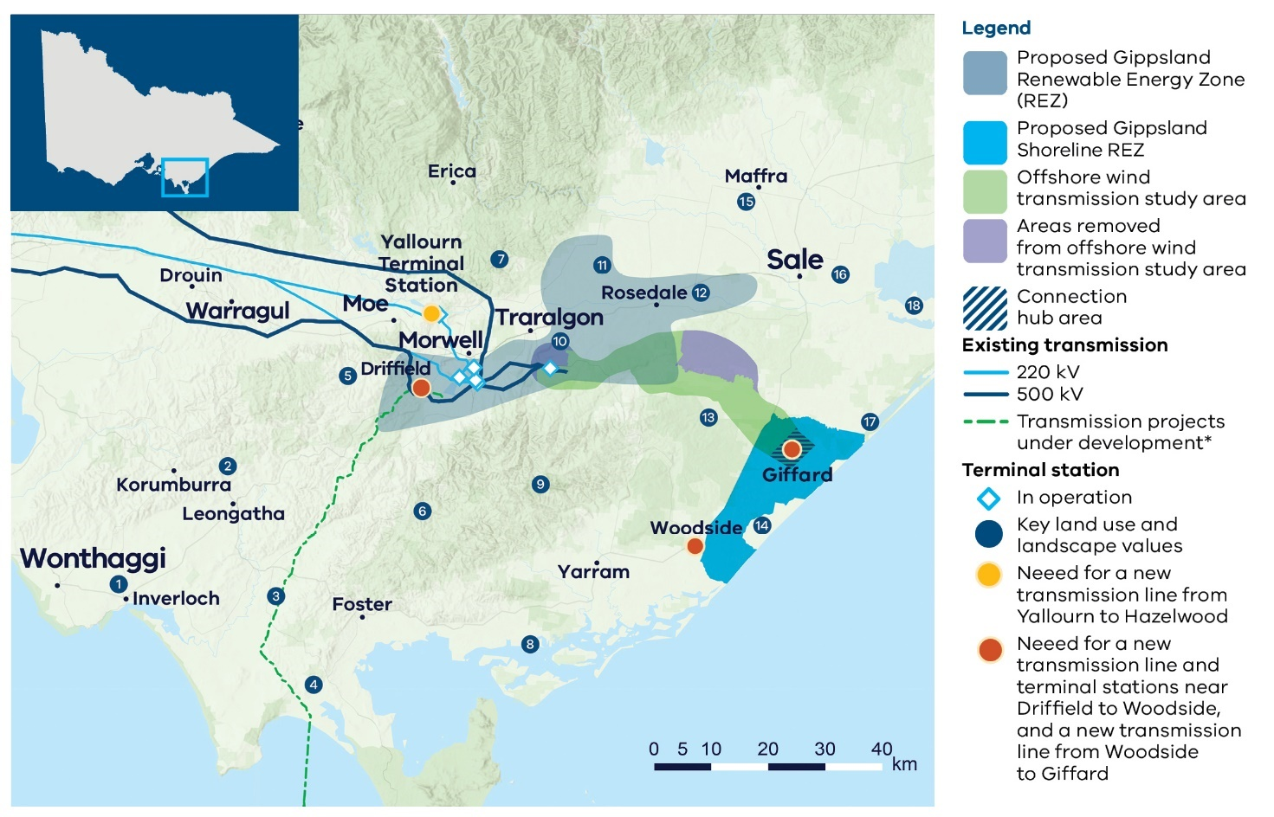
Figure 1 The planned and proposed areas for Gippsland
Key land use and landscape values
- Community: Bass Coast Distinctive Area Landscape and wind farm prohibition area (Victorian Planning Provisions)
- Community: Area of higher aggregated dwelling density in west and southwest Gippsland
- Agriculture: Medium to high productivity agriculture across southwest Gippsland, particularly dairy farming
- Biodiversity/cultural/ community: Wilsons Promontory and surrounding significant and sensitive landscape
- Agriculture: High agricultural productivity area and lower compatibility with renewables around Thorpdale, particularly horticulture farming
- Land use: Restrictedand non-restricted use plantation land across the Strzelecki ranges and broader region. Note: restricted plantation land refers to plantations subject to the Victorian Plantations Corporation Act 1993 (Vic) represent areas of existing productive land use for growing large-scale crops with existing legislative restrictions around co-location with other land uses such as renewable energy generation.
- Biodiversity: State parks and forests, home to native flora and fauna
- Biodiversity: Corner Inlet Ramsar-listed wetlands
- Biodiversity/cultural/ community: Strzelecki Ranges including Tarra-Bulga National Park and surrounding parks and forests, home to native flora and fauna
- Mining: Active mine site
- Agriculture: Medium to high agricultural productivity area adjacent to the Macalister Irrigation District
- Biodiversity/cultural: Latrobe River and surrounding areas of sensitivity
- Biodiversity/cultural: Mullungdung State Forest and Stradbroke Flora and Fauna Reserve, home to native flora and fauna
- Biodiversity/cultural: Coastal wetlands and protected biodiversity area for native flora and fauna
- Agriculture: High agricultural productivity area within the Macalister Irrigation District, including dairy farming
- Land use: Height restrictions associated with the Royal Australian Air Force base
- Biodiversity/cultural: Gippsland Lakes Coastal Park and Ramsar-listed wetlands
- Biodiversity/cultural: Lake Wellington and surrounding sensitive areas
Note: The map shows transmission projects under development including transmission projects defined as Committed and Anticipated or Actionable under the Australian Energy Market Operator’s 2024 Integrated System Plan. This map displays the proposed alignment for Marinus Link.

Acting on community feedback
Community and industry views have been crucial to the design of the 2025 Victorian Transmission Plan.
VicGrid’s role is to balance the need for new renewable projects that will deliver reliable and affordable power as coal closes with a range of other factors, including how we minimise impacts on landholders, communities, agriculture, the environment and power bills.
Not all community or industry requests have been adopted. The Victorian Transmission Plan reflects difficult choices, made by weighing up many factors to deliver a plan that best serves all Victorians.
We have used the feedback received during engagement on the renewable energy zone study area and draft Victorian Transmission Plan Guidelines in 2024 and again during engagement on the draft Victorian Transmission Plan in 2025 to shape the size and location of the proposed renewable energy zone.

Feedback about the proposed Gippsland Renewable Energy Zone

What we heard
- Preserve biodiversity and the natural environment, including the giant Gippsland earthworm, Wilsons Promontory, areas along the Bass Coast, the Strzelecki Ranges and coastal reserves and wetlands.
- Minimise impacts on agriculture, including dairy farms in South and West Gippsland, along the coast and in the Macalister Irrigation District.
- Consider South Gippsland’s high dwelling density when assessing the area’s suitability for wind energy projects.
- Use existing transmission infrastructure in the Latrobe Valley where possible, and underground transmission where new infrastructure is required.
- Explore co-location opportunities with plantation land.
- Avoid the airspace used by the Royal Australian Air Force (RAAF) base in East Sale

What we did
- Worked to avoid agricultural areas, particularly dairy farms in the south and west and Macalister Irrigation District.
- We avoided areas with higher dwelling densities in South Gippsland.
- We avoided the habitat of the giant earthworm.
- We sought to protect significant landscapes along the Bass Coast, Wilsons Promontory, the Strzelecki Ranges, coastal reserves and wetlands.
- We located the proposed renewable energy zone near the existing 500 kilovolt (kV) transmission network around Loy Yang.
- We included some freehold plantation land.
- We considered options to expand the proposed zone further east and south east, including further use of plantation land. However, these options were not progressed due to complexities with the proximity to the nearby RAAF base and low-flying aircraft, as well as potential impacts on biodiversity and cultural heritage in nearby parks.

What will it be like living in a renewable energy zone?
If you live in or near a renewable energy zone, over time you will see more development of renewable energy generation and storage. The Victorian Transmission Plan does not change existing consent processes. You can choose whether or not to host new renewable energy such as wind turbines, solar farms or batteries on your property. It’s your decision and we encourage you to talk to your neighbours about it.
Existing planning and environment controls will still apply. All proposed projects will continue to be subject to the planning and environmental approval processes under the Planning and Environment Act 1987 and Environment Effects Act 1978.
VicGrid will work with developers to coordinate new development and associated transmission to minimise impacts on landscapes and the environment. Only a small proportion of land in a renewable energy zone will be needed for development.
You will also see new community and regional economic benefits delivered over time as part of the Victorian Government’s new Renewable Energy Zone Community Benefits Plan.
This new approach will feature:
- the introduction of new Renewable Energy Zone Community Energy Funds to benefit regional and rural communities
- payments for landholders who host new transmission
- guidance for payments for significantly impacted neighbours of new transmission
- a commitment to co-design a new approach to economic benefits for Traditional Owners.
Renewable Energy Zone Community Energy Funds are an opportunity to invest directly in projects that improve local outcomes and create other benefits for communities in regions hosting energy infrastructure.
Local decision-making that responds to local needs and priorities will be a cornerstone of these funds and decisions about investments will be made in consultation with regional community reference groups with broad community and industry representation.
In addition to government initiatives, developers of projects will be required to implement their own community benefits programs.
The final Renewable Energy Zone Community Benefits Plan is set to be released in coming months. Learn more on the VicGrid website.

It’s your choice
Developers must talk to landholders to get permission to build renewable energy projects on their land, and landholders can choose whether or not to host a project. Those who agree to allow development will receive financial payments and benefits that they negotiate with the developer.

The proposed Gippsland Shoreline Renewable Energy Zone
The proposed Gippsland Shoreline Renewable Energy Zone is located in the region’s south, near the towns of Woodside and Giffard, and between the coastline and the South Gippsland Highway. It sits within the boundaries of the Gunaikurnai Land and Waters Aboriginal Corporation and the Wellington Shire local government area.
The proposed location of the zone has been developed as part of our work to identify a transmission study area and in consultation with prospective offshore wind developers.
There will be designated areas within the zone where offshore wind export cables are allowed to cross the shore.
VicGrid is coordinating further work to identify suitable shore crossing locations for offshore wind projects, which will facilitate greater protection of environmentally and culturally sensitive areas along the coast.

Designed for connections not generation
Unlike the other proposed renewable energy zones, this zone is not designed to host onshore wind or solar projects.
Instead, it is a limited area where offshore wind developers will need to locate the infrastructure such as underground cables to connect offshore wind turbines to the grid.
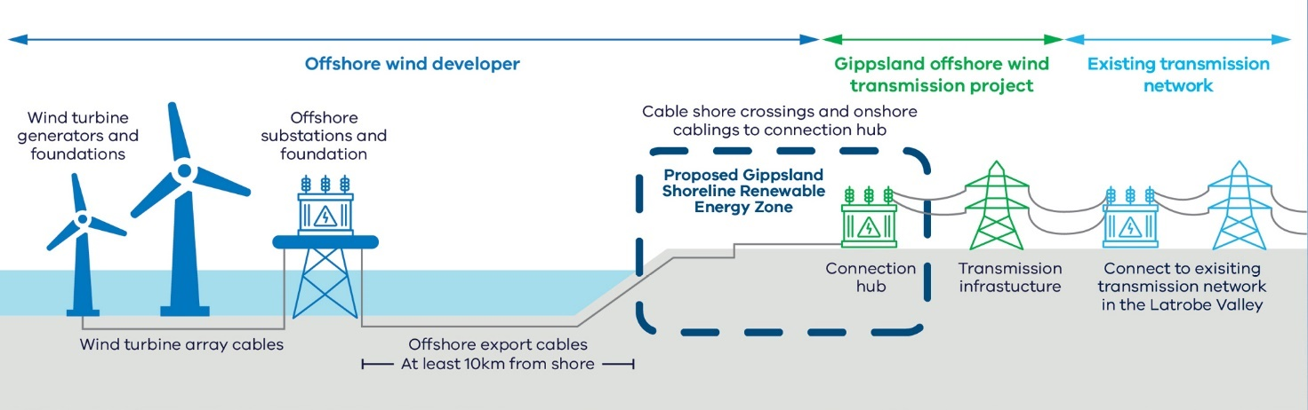
Offshore wind developers will need to consult with landholders as they plan the connections, and VicGrid is playing a coordination role to support landholders in this area
Figure 2 Figure 2 Offshore wind infrastructure in Gippsland

Feedback about the proposed Gippsland Shoreline Renewable Energy Zone

What we heard
- Mixed feedback from different stakeholder groups on the size of the proposed Gippsland Shoreline Renewable Energy Zone. Some called for a reduction in the size of the zone to minimise impacts on community and landholders while others called for an increase to allow greater flexibility for determining onshore cable routes for offshore wind development.
- Requests to ensure the Gippsland Shoreline Renewable Energy Zone captured the full extent of feasible shore crossing areas.
- Concerns raised about the management of overlapping onshore cable corridors within the Gippsland Shoreline Renewable Energy Zone.
- Concerns over the proximity of the proposed zone to key ecological and culturally sensitive sites such as Ramsar wetlands and other coastal reserves.
- Requests to expand the zone to include viable onshore wind areas near Giffard and Darriman.

What we did
- We made minor amendments to the boundaries of the Gippsland Shoreline Renewable Energy Zone, particularly along the coastline, to ensure that all feasible shore crossing areas were contained within the boundaries of the zone. This provides offshore wind developers with the opportunity to fully explore the range of appropriate potential shore crossing sites.

What landholders in the proposed Gippsland Shoreline Renewable Energy Zone can expect
Offshore wind developers are already talking with landholders in this area and will need to continue consulting with communities about their projects.
All proposed projects will continue to be subject to the planning and environmental approval processes under the Planning and Environment Act 1987 and Environment Effects Act 1978.
Communities impacted by the proposed Gippsland Shoreline Renewable Energy Zone will receive new dedicated benefits similar to our approach for onshore renewable energy zones. These benefits will be in addition to any discretionary benefits paid for by offshore wind developers.

The additional transmission needed to connect both offshore and onshore wind in Gippsland
The 2025 Victorian Transmission Plan identifies the need for new transmission lines in Gippsland to support both the proposed Gippsland Renewable Energy Zone and approximately 7 GW of offshore wind by 2040.
The location where each transmission line will be built has not yet been identified. To deliver these projects by the proposed dates, we will need to start the detailed planning process within 3 years following the release of the 2025 Victorian Transmission Plan.
The first step in the planning process will be to consult with communities, landholders, Traditional Owners, First Peoples, and industry, and carry out technical investigations, to help determine a study area for the new transmission. Then, we will work to narrow the study area to a corridor, then a route, then an easement. At each step of the process, consultation with landholders, community, industry, Traditional Owners and First Peoples will provide important feedback to help shape decisions.

A second Hazelwood to Yallourn 220 kV double circuit line in Gippsland
Planning suggests this infrastructure will be needed by 2028.
This project is needed to ensure energy from the proposed Gippsland Renewable Energy Zone and Gippsland offshore wind area can flow to consumers across the state.
The length of this project is about 10 km. The specific location of this line is yet to be identified. We will investigate following the route of the existing transmission easement, but this will be subject to further technical work.
Figure 3 A second Hazelwood to Yallourn 220 kV double circuit line in Gippsland
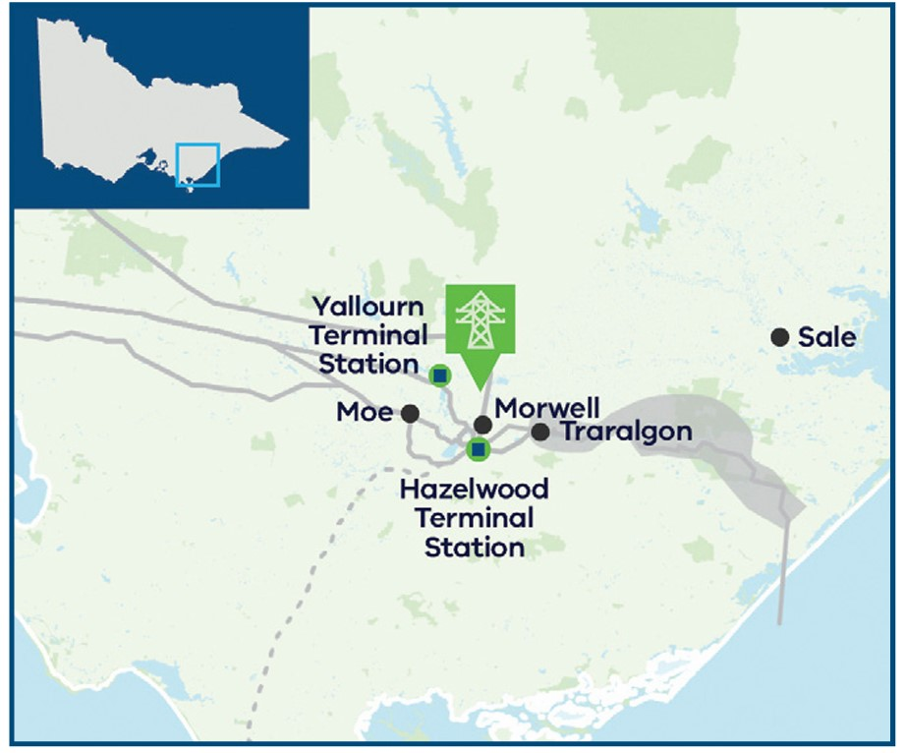

The Gippsland offshore wind transmission stage 2 program
Planning suggests this infrastructure will be needed between 2033 and 2038.
The program includes a new 500 kV transmission line from the existing transmission network near Driffield running to Woodside, and a new line between Woodside and Giffard. New terminal stations will be needed at Driffield and Woodside.
These lines combined with the stage 1 project currently in development for the first 2 GW of offshore wind will create a loop that can accommodate approximately 7 GW of offshore wind energy.
Figure 4 The Gippsland offshore wind transmission stage 2 program
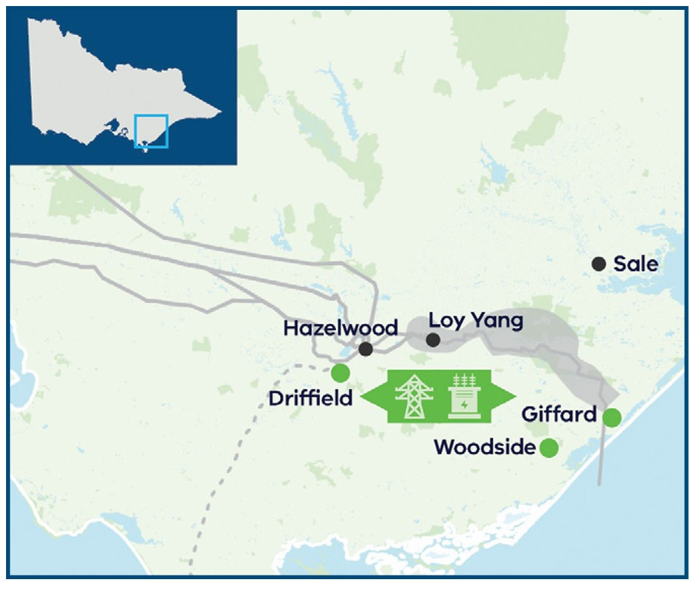
VicGrid is already speaking with landholders and communities to identify the most suitable route for the Gippsland offshore wind transmission stage 1 project. This project has been factored in as an input to the 2025 Victorian Transmission Plan and is being progressed. It includes a new transmission line from a connection hub near Giffard to the Latrobe Valley (Loy Yang) to connect the first 2 GW of offshore wind energy to the grid by 2032.

Typical stages of identifying a transmission line route

Study area
A broad geographic area that we will progressively narrow over time as we undertake detailed studies and consultation with landholders, First Peoples, Traditional Owners, community and stakeholders.

Corridor
One or more geographic areas narrowed down from the Study Area that are considered suitable for transmission infrastructure. There is flexibility within a corridor to undertake site-specific consultation with landholders to identify suitable routes.

Route
A route is narrower again and is the final stage before an easement is selected. This still allows flexibility for locating (or micrositing) of towers to minimise impacts on landholders and landholder operations.

Easement
An easement is a legally secured right-of-way for the transmission infrastructure to be built and maintained.

Introducing new benefits for landholders hosting new major transmission lines and neighbours
We are introducing mandatory payments to landholders who host new transmission lines, above and beyond the compensation paid for impacts on land value and business operations. We’re also introducing guidance for payments for significantly impacted neighbours of new transmission lines.
These new benefits will be in addition to existing compensation arrangements under the Land Acquisition and Compensation Act 1986, Traditional Owner Settlement Act 2010 and the Native Title Act 1993 (Cth), as well as any discretionary payments made by transmission project developers.
You can learn more about these payments in the draft Renewable Energy Zone Community Benefits Plan on our website.

Next steps
Communities within proposed renewable energy zones can continue to provide feedback and seek more information about renewable energy zones, including through face-to-face meetings with VicGrid.
We will invite formal feedback about the proposed Gippsland and Gippsland Shoreline Renewable Energy Zones as part of the official declaration process. There will be 6 weeks of consultation, to begin in coming weeks, which will give landholders, communities and Traditional Owners another opportunity to provide feedback and shape decision-making.

Email updates
To stay up to date about the renewable energy zone declaration process and VicGrid’s work, subscribe for our email updates at vicgrid.vic.gov.au

Call or email us
Call us on 1800 418 341 or email vicgrid@deeca.vic.gov.au

Contact us
Phone: 1800 418 341
Email: vicgrid@deeca.vic.gov.au
Deaf, hearing or speech impaired? Please contact the National Relay Service on 133 677 or communications.gov.au/accesshub/nrs
Need an interpreter? Contact Translating and Interpreting Service (TIS) on 131 450 (within Australia) or visit www.tisnational.gov.au
ISBN 978-1-76176-457-8 (Print)
ISBN 978-1-76176-457-5 (pdf/online/MS word)
Disclaimer: The information in this document is current at the time of printing, may be subject to change and should not be relied upon. Please visit our wesbite for the latest updates.

