2025 Victorian Transmission Plan Appendix B: Energy market modelling
  - August 2025

Disclaimer
This 2025 Victorian Transmission Plan is published by the State of Victoria pursuant to amendments to the National Electricity (Victoria) Act 2005, which implement the first stage of Victorian Transmission Investment Framework reforms and empowers the CEO VicGrid to develop a Victorian Transmission Plan. It has been prepared for the purposes of consultation and comment, in connection with the 2024 Victorian Transmission Plan Guidelines.
While the State of Victoria has made reasonable efforts to ensure the quality and accuracy of the information in this publication, the State of Victoria and its employees do not guarantee that the publication is without flaw of any kind or is wholly appropriate for your particular purposes and therefore, to the extent permitted by law, disclaims all liability for any error, loss or other consequence which may arise from you relying on any information in this publication.
This publication does not include all of the information that an investor, participant or potential participant in the National Electricity Market might require, and does not amount to a recommendation of any investment. The modelling work included herein inherently requires assumptions about future behaviours and market interactions. Anyone proposing to utilise this publication should note that there may be differences between estimated and actual results which may be material.
Anyone proposing to use the information in this publication (which includes information and forecasts from third parties) should independently verify its accuracy, completeness and suitability for purpose, and obtain independent and specific advice from appropriate experts.
Please visit vicgrid.vic.gov.au for the latest updates.

Copyright
© The State of Victoria Department of Energy, Environment and Climate Action 2025

Contents
Disclaimer 1
Copyright 1
Contents 2
Acronyms 3
Glossary 3
Appendix B Energy market modelling 5
B.1 What is energy market modelling? 6
B.2 Energy market modelling overview 6
B.3 Where energy market modelling was used in the development of the 2025 VTP 8
B.4 Inputs and assumptions 9
B.5 Modelling results 10
B.6 Sensitivity analysis 16
Contact us 17

Acronyms
Term | Definition
AEMO | Australian Energy Market Operator
CER | Consumer energy resources
CIS | Capacity Investment Scheme
ESOO | Electricity Statement of Opportunities
EV | Electric vehicles
GPG | Gas-powered generation
GW | Gigawatt (one million kilowatts)
ISP | Integrated System Plan
LT | Long-term capacity expansion
MW | Megawatt (one thousand kilowatts)
NEM | National Electricity Market
REZ | Renewable energy zone
SLUA | Strategic land use assessment
TW | Terawatt (one billion kilowatts)
TWh | Terawatt hour (one billion kilowatt hours)
VER | Value of emissions reduction
VNI | Victoria to New South Wales Interconnector
VRET | Victorian Renewable Energy Targets
VTP | Victorian Transmission Plan

Glossary
This glossary has been prepared as a quick guide to help readers understand terms used in this document. Words and phrases defined in the National Electricity (Victoria) Act 2005 and other Victorian legislation have the meaning given to them in legislation.
Term | Definition
Candidate development pathway | A set of possible transmission projects and proposed timings to upgrade the Declared Shared Network, needed to accommodate the development of new generation and storage capacity in REZs.
Committed | Generation and storage projects are considered committed if they have reached a sufficiently advanced stage of planning and development. Projects have been considered committed for the purposes of energy market modelling in the VTP if they meet any of the following criteria:  - it was classified as Committed or In Commissioning by AEMO as at April 2025, or it is completed or in the construction phase as identified in AEMO Victorian Planning’s Connections Portfolio list as at May 2025, or  - it was successful in CIS auction results released in or before December 2024, or it was successful in the VRET2 auction results.
Declared Shared Network | The Victorian interconnected high-voltage power lines and shared terminal stations that transport large amounts of electricity from where it is generated to where it is needed across the state. It allows multiple electricity providers to share the infrastructure for transporting electricity. Sometimes wind and solar developments need to build their own private lines to connect their project to the shared network.
Firming | Firming infrastructure includes facilities that can supply electricity during times when the network experiences a shortfall of surplus generation. Battery storage, gas-fired generation and long duration energy storage schemes can provide the desired firming.
Generation resource plan | A spatial plan that identifies indicative locations for the new generation capacity needed to meet Victoria’s energy needs under different future scenarios. The plan is developed based on a multicriteria analysis and, alongside the results of a strategic land use assessment, is used to inform potential REZ candidate areas. The generation resource plan includes possible amounts, types and timing of new generation build across different locations in Victoria.
Integrated System Plan | An integrated 20-year plan for the efficient development of the National Electricity Market (NEM), prepared every 2 years by the Australian Energy Market Operator.
Multi-criteria analysis | A methodology for evaluating qualitative economic, social, cultural and environmental factors as part of a process for determining where, when and how Victoria’s electricity transmission network should develop.
The optimal development pathway | The optimal mix of transmission projects needed to connect REZs with Victoria’s Declared Shared Network over the next 15 years, taking into account economic cost-benefit and robustness analysis across different scenarios, as well as power system security and reliability. For the 2025 VTP, the optimal development pathway sets out proposed projects and sequencing over the next 15 years. Future VTPs will take a 25-year timeframe.
Proposed REZs | The areas proposed to be considered for REZ declaration. These are presented in the 2025 VTP (this document) and, over time, may be declared by the Minister for Energy as REZs.
Renewable energy zone (REZ) | An area declared in a renewable energy zone Order where a REZ access scheme and special benefits arrangements will apply.
REZ access scheme | A scheme, under the proposed Victorian Access Regime, declared by the Minister for Energy and Resources which sets out arrangements governing network connections for new renewable generation and storage projects located in a REZ. These arrangements include access limits for each type of renewable generation, access fees, access conditions, and the process for allocating access.
REZ candidate areas | More refined areas within the study area that are assessed as being most suitable for renewable energy generation through energy market modelling and community and industry consultation. .
REZ study area | A broad geographic area suitable for further investigation in planning for future renewable energy zones, based on the results of a strategic land use assessment and consultation feedback.
Robustness analysis | Robustness analysis is undertaken on all candidate development pathways to select the one that performs best (i.e., can adapt with minimal cost) across all scenarios. This approach, often called ‘least worst regrets’, is used to determine the optimal development pathway and seeks to minimise the risks of over- and under-investment.
Scenarios | Scenarios are a collection of assumptions that describe how the future may unfold. Scenario-based planning is useful in highly uncertain environments, and can help assess future risks, opportunities, and development needs in the energy industry.
Strategic land use assessment | An assessment that identifies suitable areas for siting infrastructure based on a range of social, cultural, technical, environmental, and economic factors.
Traditional Owner | A member of a Traditional Owner group, having the meaning set out in the Traditional Owner Settlement Act 2010. Traditional Owners have rights that must be upheld as laid out under the Charter of Human Rights and Responsibilities Act 2006, the Traditional Owner Settlement Act 2010, Aboriginal Heritage Act 2006 and Native Title Act 1993 (Cth).
Victorian Access Regime | The proposed set of new rules, to be defined under the National Electricity (Victoria) Act 2005, for how new generation projects can connect to the Declared Shared Network, both within and outside of REZs. Under the Victorian Access Regime, the Minister will declare REZ access schemes, and all new generation projects outside of REZs will be subject to a Grid Impact Assessment to reduce the risk of curtailment for REZ generators.
Victorian Transmission Investment Framework | A set of reforms being implemented to transmission planning in Victoria, including: a new transmission planning objective; a new planning process through the Victorian Transmission Plan; the Victorian Access Regime; new community and Traditional Owner benefit arrangements; and new approaches to procuring transmission infrastructure.
Victorian transmission plan | A document setting out an optimal set of transmission projects that address the planning and development needs over the following periods related to new major electricity transmission infrastructure to facilitate connection of renewable energy zones to the declared shared network:  (a) 15 years for the first Victorian transmission plan;  (b) 25 years for each subsequent Victorian transmission plan.

- Energy market modelling
Appendix B: Energy market modelling – summary
This appendix describes what energy market modelling is and how it has been used to inform the identification of the proposed renewable energy zones (REZs) and transmission needs in the 2025 Victorian Transmission Plan (VTP).
The Appendix covers:
- What energy market modelling is and how it is used to forecast the type, location and capacity of new energy generation investments in the future.
- How energy market modelling has informed different steps in the development of the 2025 VTP, including:
  - Step 2: Developing proposed REZs
  - Step 4: Assessing candidate development pathways. Note: These 2 steps form part of the VTP development process that involve energy market modelling, as described in Section 2.4 of the VTP. See Figure B-2 for an overview of the 5-step methodology.
- Specific inputs and assumptions used in addition to those detailed in the 2024 VTP Guidelines – Appendix D: Inputs, Assumptions and Scenarios (with some modifications as outlined in the statement on departures from the guidelines).
- Key energy market modelling results for each scenario, including:
  - modelled energy generation by technology type (essentially a forecast of anticipated generation if generation were to locate optimally to meet demand, based on the constraints included the model)
  - modelled locations of new generation, which is one of the inputs for the multi-criteria analysis to identify REZ candidate areas
  - anticipated cost of generation and storage to support cost benefit analysis
  - the results of initial sensitivity testing and analysis.
  - What is energy market modelling?
Energy market modelling is a method used to simulate and forecast how energy markets will behave in response to future changes. It helps us predict behaviours relating to energy generation investment and meeting electricity demand in real-time.
We have used energy market modelling software, PLEXOS, which is widely used in the industry. It helps analyse how different factors such as energy demand, consumer energy resource uptake, government policies and generator capital and operating costs can influence the supply and demand of energy and, consequently, the type, location, and capacity of energy generation development in the future.
The model allows us to forecast the impact of different transmission options on future developer investment and operational decisions. We also use it to determine the capital and operating costs for generation for use in the VTP cost-benefit analysis (see Appendix D).
This type of modelling is crucial for understanding the future dynamics of the energy market. It provides insights that assist stakeholders in strategic decision-making, including policymakers, energy companies, and investors.
  - Energy market modelling overview
Energy market modelling assesses future whole-of-system outcomes under different scenarios. It involves comparing different types of costs to determine the least-cost path to meet demand and policy objectives as the energy system evolves. The types of costs considered include the cost of building and connecting new generation, the cost of operating generation infrastructure (including fixed, variable and fuel costs) and the cost of unserved energy (unserved energy is energy demand that cannot be met due to generation or transmission capacity limitations).
We have undertaken 2 main modelling modules as part of the methodology:
- Long-term capacity expansion modelling: Long-term modelling determines the least-cost generation mix for the transmission network, in order to meet demand, policy objectives and assumed retirement of coal-fired power plants. Long-term modelling helps to identify suitable locations for new generation infrastructure, to inform the network and transmission planning needed to connect these areas to the grid.
- Short-term modelling: Short-term modelling uses the output of the long-term modelling, such as the new entrant generation profile and transmission build path. It identifies the best way to meet energy demand (known as dispatch) at half-hourly resolution given a more detailed view of the transmission network. Short-term modelling is used to validate investment determined by the long-term modelling and produce detailed plant dispatch outcomes used for power system modelling (see Appendix C).
Figure B-1below is a graphic overview of the energy market modelling approach. The figure shows the inputs (demand, costs, generation options and policies), the module (long term capacity expansion and short term dispatch) and the key outputs (investment path, and price and dispatch). Table B-1 provides a transcription of Figure B-1 Overview of energy market modelling approach
Figure B-1 Overview of energy market modelling approach (Notes: The ‘Key Outputs’ inform the power systems modelling (refer Appendix C) and the VTP economic and robustness analysis (refer Appendix D).)
Table B-1 Overview of energy market modelling approach
Input | Modules | Key outputs
Demand  Annual consumption  Consumer energy resources  Hydrogen consumption | Long term capacity expansion (LT)  Least-cost based modelling to identify transmission and generation development opportunities | Investment path  New generation and storage build  New transmission flow path and REZ development
Costs  Fuel costs and capital expenditure  Transmission costs  Weighted average cost of capital | Short term dispatch  Half hourly detailed dispatch  Assess the feasibility of LT run and reliability risks | Price and dispatch  Price outcomes in each region  Dispatch and storage operation
Generation options
Existing and committed developments
New generation build options
Policies  Federal and state policies | NA | NS
The long-term capacity expansion modelling ensures that a level of resiliency is built into the capacity expansion path. This capacity expansion pathway then meets reliability requirements under the assumptions modelled in the short-term dispatch modelling.
Figure B1 illustrates the energy market modelling approach, including the inputs, the 2 modelling modules and the key outputs.
  - Where energy market modelling was used in the development of the 2025 VTP
Section 2 of the 2025 VTP documents the comprehensive approach taken to developing the transmission plan across a 5-step methodology, summarised in Figure B-2. Energy market modelling supported several steps in the 2025 VTP methodology. This section details where we used energy market modelling and how its results informed decisions.
Table B-2 is a transcription of Figure B-2, the 5-step VTP methodology.
Figure B-2 The 5-step VTP methodology
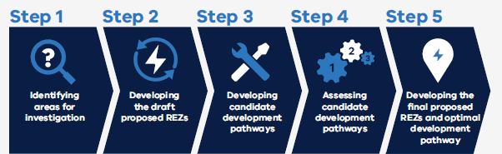

Table B-2 The 5-step VTP methodology
Step 1 | Step 2 | Step 3 | Step 4 | Step 5
Identifying areas for investigation | Developing the draft proposed REZs | Developing candidate development pathways | Assessing candidate development pathways | Developing the final proposed REZs and optimal development pathway
    - Step 2: Developing the proposed REZs
In this step, energy market modelling was used to inform the development of an initial generation resource plan for each VTP hypothetical scenario. This was one of the main inputs to identify REZ candidate areas.
The energy market modelling determined the generation and storage infrastructure required to meet Victoria’s energy needs from a least-cost perspective. For each scenario, the modelling results outlined:
- which technologies to build – both generation and storage
- how much capacity to build
- when to build new capacity
- the location of the new generation build.
The modelled generation locations were also an input to later steps and provided the starting point to identify detailed transmission needs.
The model used in this step optimised both new generation and transmission investment by allowing the (linearised) expansion of transmission capacity beyond its existing and committed level. The model also allowed us to consider the ability to co-locate batteries with wind and solar to reduce the need for transmission upgrades. Assumptions for transmission costs are discussed in Section B.4.4 below.
    - Step 4: Assessing candidate development pathways
Following Step 2, the candidate development pathways were developed in Step 3 (refer to Appendix A and C). In Step 4, energy market modelling assessed energy system costs in each scenario, for each candidate development pathway. System costs included generation capital and operational expenditure, unserved energy, and emissions outcomes. These outputs were then used to inform the cost-benefit analysis (refer to Appendix D).
In Step 4, the modelling approach was similar to that in Step 2 with the key difference being that the candidate development pathways, including the impact on REZ hosting capacity and transfer capacity, were included as an exogenous input rather than a modelled output, in place of the linearised transmission augmentation.
  - Inputs and assumptions
Section 2 of the 2025 VTP and Appendix D in the 2024 VTP Guidelines detail the inputs and assumptions used in VTP methodology. This section provides further detail on selected inputs and assumptions used in the energy market modelling.
    - Gas-powered generation
As outlined in the 2024 VTP Guidelines, the modelling included constraints on gas-powered generation (GPG) to reflect the limitations on the physical gas system (e.g. new import terminals, pipelines, plant and storage). The model applied a daily GPG usage limit in the southern part of the National Electricity Market (NEM) (i.e., excluding Queensland) based on the level in AEMO’s 2024 final Integrated System Plan (ISP) models.
New GPG capacity was also limited to that outlined in AEMO’s 2024 ISP. This is consistent with the overall approach for the first VTP (aligning with AEMO’s ISP, adapted for Victoria where possible). The model adopted a 3.6 GW limit for scenario 1 and 3, and a 4.4 GW limit for scenario 2 on the total capacity of Victorian GPG plants, which is consistent with the maximum modelled GPG capacity in Victoria in the 2024 ISP across its scenarios.
    - Offshore wind
VicGrid’s modelling assumed that 9 GW of offshore wind will be built in line with the Victorian Government’s legislated targets. Consistent with the VTP Guidelines, the location and volume of offshore wind were an assumed input based on government legislation. The model therefore factored in 2 GW of offshore wind by 2032, 4 GW by 2035 and 9 GW by 2040. For the purposes of the modelling, we assumed the initial 2 GW is built off the coast of Gippsland by 2032, 1.5 GW is built in the Southern Ocean offshore wind declared area by 2040 and the remaining 5.5 GW is built off the coast of Gippsland between 2032 and 2040.
    - Transmission costs
In Step 2, the market modelling considered transmission costs, including the cost of expanding the transmission network, when making location decisions about new generation capacity. Transmission costs were sourced from AEMO’S ISP 2024 linearised ($/MW) REZ augmentation costs.
In Step 4, the transmission projects are taken as an output from Step 3 and are considered fixed. As a result, no transmission cost is incorporated at this step. However, transmission costs underpinning these projects are accounted for in the cost-benefit analysis (which is described in Appendix D).
    - Land use availability
The market modelling considered the results of the strategic land use assessment (SLUA) used to determine the renewable energy zone study area. The study area identified the parts of Victoria that have the potential to host new energy generation, storage and transmission infrastructure. For modelling purposes within PLEXOS, we used Tiers 1, 2 and 3 of the study area, as well as technology-specific land use limits, to determine the total amount of potential wind and solar generation at different locations within the state. Chapter 2 of the VTP and the VTP Guidelines outline further details on the strategic land use assessment undertaken as part of the VTP.
    - Value of emissions reduction
The value of emissions reduction (VER) was not directly included as an input in the optimisation but was used post-modelling to assess the cost of emissions from the modelling output. For further detail, see Appendix D.
  - Modelling results
The energy market modelling results provided an important input into the generation resource plan, as well as the transmission development for the VTP. Note that a wider range of assessment criteria, including the modelling results, has been considered in the renewable energy infrastructure development in the VTP.
The results in this section have been derived from Step 4 modelling, which incorporated the candidate development pathways.
    - Victorian capacity and generation mix
Figure B-3 shows three different scenarios over the years 2025 to 2040 for the Installed Capacity by Giga Watts for coal, gas, hydro, offshore wind, distributed storage, utility storage, solar and wind.
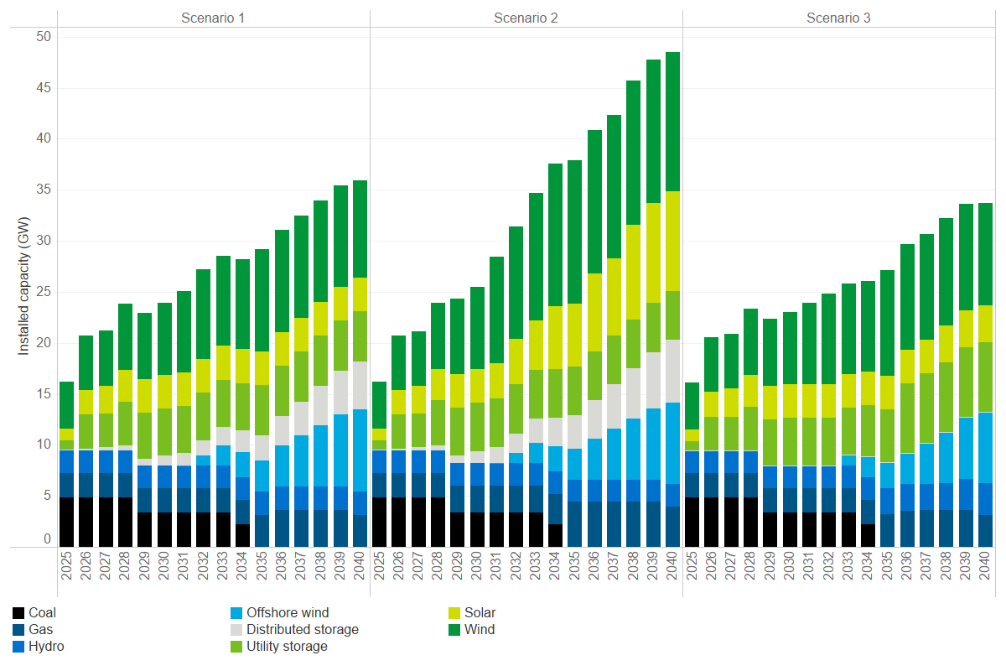
Figure B-3 Forecast Victorian capacity mix – utility scale
The results shown in Figure B-3 are based on the ‘core’ candidate development pathway for each scenario. That is, scenario 1 using candidate development pathway 1, scenario 2 using candidate development pathway 2 and scenario 3 using candidate development pathway 3. See Appendix D for more information on the core scenarios.
Figure B-3 highlights that, across all 3 scenarios, Victoria’s renewable generation capacity increases to accommodate demand growth and address the exit of coal-fired power, as Victoria progresses towards its renewable energy targets. Generation development in the short term (by 2030) is driven by these government targets, including the Victorian Renewable Energy Target (VRET) and Victorian storage target, as well as the Commonwealth’s Capacity Investment Scheme (CIS) targets. In the medium term, offshore wind is built in alignment with the Victorian offshore wind target – noting that scenario 3 considers a potential future where offshore wind build-out is delayed by one year.
Figure B-3 also highlights an increase in firming capacity across all 3 scenarios to meet increased demand and supplement renewable generation during low wind and solar availability periods. Firming capacity refers to generation that can be directly controlled. GPG will play a small but important role in Victoria’s generation mix, particularly in periods of low renewable energy generation following 2035.
Between scenarios, scenario 2 sees a greater generation build than scenario 1 and scenario 3, due to the underlying assumptions of higher electricity demand and greater hydrogen production in this scenario. This increased build requirement in scenario 2 includes a greater requirement for gas-powered firming to service the higher demand. In scenario 3, lower coordinated distributed storage is modelled in line with the assumptions for this scenario. This results in a need for additional utility storage of approximately 2 GW by 2035.
Figure B-4 below shows the new utility storage build by duration from 2025 to 2040 in Victoria across three scenarios.
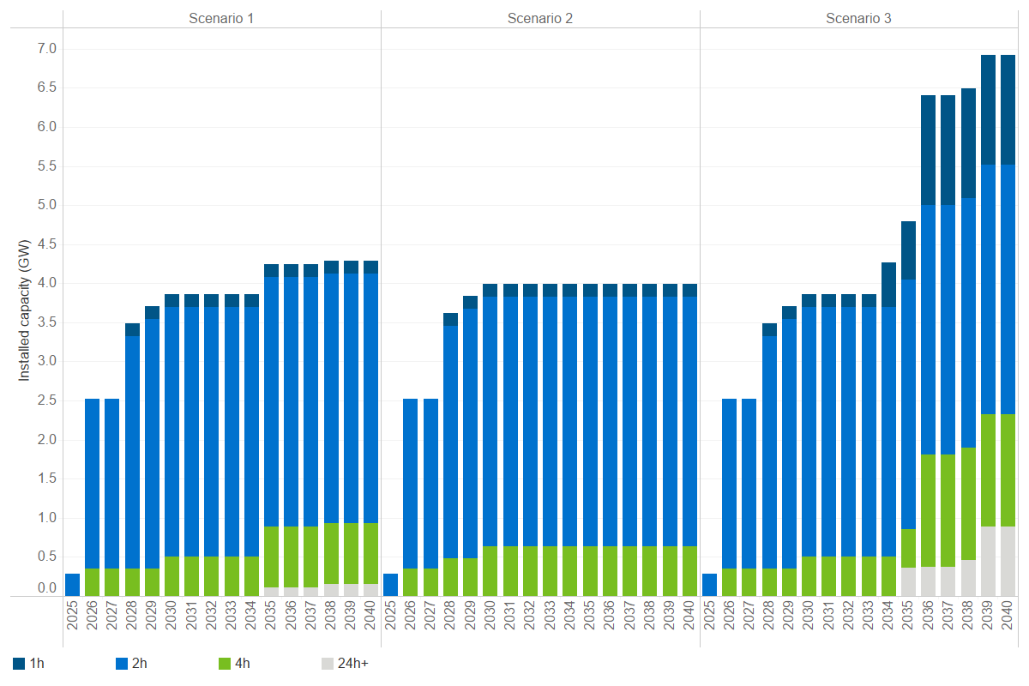
Figure B-4 New utility storage build by duration out to 2040, Victoria
More storage capacity will be required to support wind and solar generation as coal-fired power stations retire over time. Figure B-4 shows the committed and new utility storage requirement in Victoria by duration until 2040 for each scenario. In the early years, most of the storage investments have relatively shorter durations (2 hours). After 2030, longer duration storage will start to enter the market as renewables make up more of the generation mix. Storage with more than 24-hour duration will be needed after 2035, primarily in Scenario 3 due to the lack of Marinus Link cable 2 which would otherwise provide additional firming to Victoria.
Scenario 2 does not include 24-hour duration storage before 2040 despite higher demand. This is partly due to the higher level of modelled gas peaking capacity which provides an alternative source of long-duration firming. Scenario 2 also has a higher level of hydrogen load, the majority of which is assumed to be flexible in the model and can be met when renewable energy is abundant.
Figure B-5 illustrates the following annual generation mix outcomes and trends across the scenarios (in each case using the core candidate development pathway for each scenario). The generation from rooftop and small-scale solar are included as they also contribute to the VRET target.

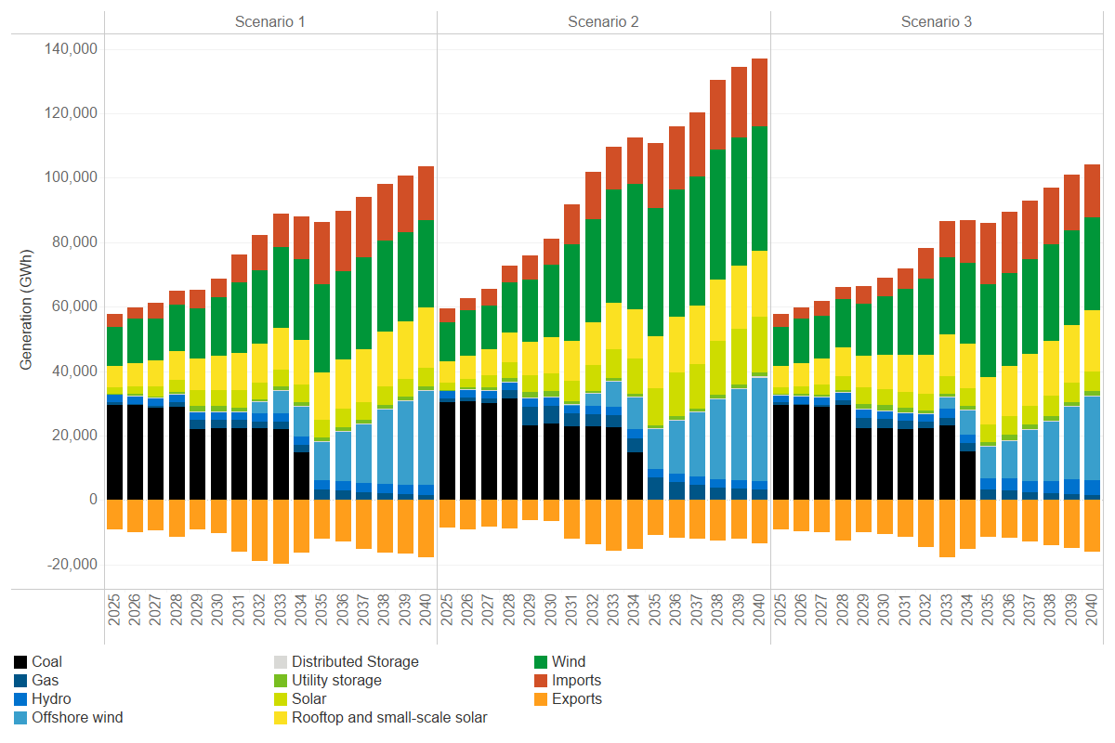
Figure B-5 Forecast Victorian annual generation mix
All 3 scenarios see Victoria’s renewable energy output increase while coal-fired power output reduces as Victoria progresses towards the 65% (2030) and 95% (2035) renewable energy targets. From 2035 on, the generation provided by offshore wind and other onshore renewables, firmed by storage and gas-powered generation, supports Victorian electricity needs.
Solar plays a bigger role in scenario 2 than scenarios 1 and 3, driven by higher hydrogen production and the relatively lower capital cost of this technology in the long-term.
Over the modelling period to 2040, Victoria will see increased utilisation of interconnectors with higher levels of imports and exports.
Figure B-6 shows Victoria’s average time-of-day generation mix for 2025 and 2040 in scenario 1. Negative values show Victorian exports or charging of storage. In 2025 coal-fired generation supports the majority of Victoria’s daily electricity needs, particularly in the evening and overnight. Coal-fired generation is reduced during the middle of the day when existing utility storage and (not pictured) rooftop solar panels contribute to a growing proportion of Victoria’s daily energy needs.
By 2040, the large increase in renewable generation, including 9 GW of offshore wind renewable generation, will support Victoria’s electricity needs throughout the day. There will be a greater role for batteries, long duration storage, and gas-powered peaking generation in the evening and overnight.
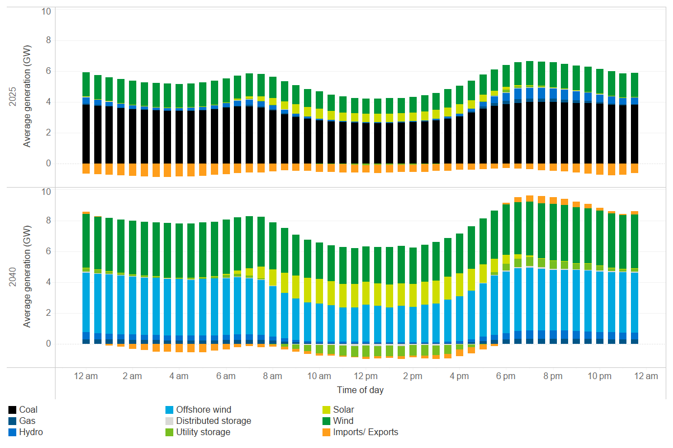
Figure B-6 Forecast Victorian time of day generation mix, scenario 1 and candidate development pathway 1, FY2025 vs FY2040

    - Location of new generation in Victoria
Table B-3 and Table B-4 show how the proposed REZs will support the new (committed and new entrant) onshore wind and solar capacity in Victoria in 2030, 2035 and 2040. Note, Table B-3 and Table B-4 provide indicative additional generation capacities across each of the 6 proposed REZs by 2040. This includes the existing pipeline of committed generation projects, as well as the additional capacity that we are planning for beyond the current project pipeline. The values indicate the likely scale of new generation within each REZ based on our modelling.Numbers have been rounded.
In the short term, the modelling shows significant onshore wind investments in the Central Highlands and South West proposed REZs. In the medium to longer term, onshore wind investments diversify across the proposed REZs, with the bulk of solar investment in the Central North proposed REZ for scenario 1 and scenario 3. Spreading the resources more widely in Victoria provides diversity benefits due to different generation profiles at different locations.
Compared to scenario 1 and scenario 3, scenario 2 also sees significant onshore wind investment in the Western proposed REZ. Scenario 2 also sees additional solar development between 2030 and 2040 in both the Central Highlands and Gippsland proposed REZs due to their proximity to assumed hydrogen production in these locations. Scenario 2 also sees batteries co-located with renewables in the Central Highland proposed REZs. The co-location of batteries helps to reduce transmission needs by using them to soak up higher levels of renewable generation (e.g. midday with solar output) which can then be sent to the load centres when renewable generation is lower (e.g. overnight without solar).
Table B-3 Committed and new entrant build by proposed REZ, Victoria, scenario 1
Proposed REZ | Generation build capacity (MW) | Generation build capacity (MW) | Generation build capacity (MW) | Generation build capacity (MW) | Generation build capacity (MW) | Generation build capacity (MW)
 | FY30 | FY30 | FY35 | FY35 | FY40 | FY40
 | Wind | Solar | Wind | Solar | Wind | Solar
Central Highlands | 1,460 | 130 | 1,930 | 130 | 1,930 | 130
Central North | NA | 920 | NA | 920 | NA | 920
Gippsland | 400 | 160 | 400 | 160 | 400 | 160
North West | NA | NA | 400 | NA | 400 | NA
South West | NA | NA | 1,330 | NA | 1,330 | NA
Western | NA | NA | 800 | NA | 800 | NA

Table B-4 Committed and new entrant build by proposed REZ, Victoria, scenario 2 and scenario 3
 | Generation build capacity (MW) | Generation build capacity (MW) | Generation build capacity (MW) | Generation build capacity (MW) | Generation build capacity (MW) | Generation build capacity (MW)
Proposed REZ | FY30 | FY30 | FY35 | FY35 | FY40 | FY40
 | Wind | Solar | Wind | Solar | Wind | Solar
Scenario 2 | Scenario 2 | Scenario 2 | Scenario 2 | Scenario 2 | Scenario 2 | Scenario 2
Central Highlands | 1,460 | 130 | 1,930 | 130 | 1,930 | 1,690
Central North | 860 | 920 | 1,370 | 1,300 | 1,470 | 1,850
Gippsland | 400 | 160 | 400 | 160 | 400 | 900
North West | NA | NA | 400 | 1,520 | 400 | 1,520
South West | 70 | NA | 2,010 | NA | 2,050 | NA
Western | NA | NA | 2,790 | 950 | 2,790 | 1,730
Scenario 3 | Scenario 3 | Scenario 3 | Scenario 3 | Scenario 3 | Scenario 3 | Scenario 3
Central Highlands | 1,310 | 130 | 1,930 | 130 | 1,930 | 130
Central North | 140 | 920 | 140 | 920 | 140 | 920
Gippsland | 400 | 160 | 400 | 160 | 400 | 160
North West | NA | NA | 400 | NA | 400 | 310
South West | NA | NA | 1,550 | NA | 1,700 | NA
Western | NA | NA | 800 | NA | 800 | NA

    - Victorian analysis of periods of low renewable energy generation
Wind and solar generation are inherently variable, and it is not uncommon to experience periods when there is little wind and sunshine. This is most likely in winter when energy demand is also high to provide heating during cold weather.
The risk of limited periods of low renewable energy generation is an important planning consideration for modern electricity networks. In Victoria, this risk will become more pronounced in the late 2030s, following the retirement of coal-fired power plants.
The energy market model includes limited periods of low renewable energy generation based on AEMO’s half-hourly wind and solar availability trace inputs. For example, the modelling highlights the potential for such a period in scenario 1 during late June in 2040. During this period, both onshore and offshore wind availability is expected to be very low relative to total installed capacity, coupled with low solar output in Victoria’s winter. Further, while there is sufficient utility storage capacity in Victoria to meet demand, this storage is unable to be used effectively due to the lack of renewable energy generation to charge them. The model shows the risk of energy supply shortages and the potential for large levels of unserved energy during this period, which could see households, businesses and industry not being able to access the energy they need. VicGrid will continue to assess the impacts and costs of potential unserved energy along with the costs and benefits of additional generation and transmission infrastructure.
The modelling outcomes demonstrate the importance of Victoria’s own hydro resources, appropriate levels of firming capacity, including gas, and interconnection with other states and regions. Our analysis suggests that Victoria to New South Wales Interconnector (VNI)-East and VNI-West, as well as transmission to Victoria’s Ovens-Murray region where Victoria’s hydro plants are located, are particularly important.
There are well-documented examples of periods of low renewable energy generation in Australia, Europe and the United States, and we will take learnings from these examples. VicGrid will continue to assess the mix of generation, transmission and interconnection to ensure reliable energy supply for Victoria in limited periods of renewable energy generation.
  - Sensitivity analysis
We have also undertaken several high-level sensitivity model tests to analyse the impact of alternative input assumptions on the modelling results. These are discussed below.
Impact of low demand (based on AEMO Electricity Statement of Opportunities (ESOO) 2024)
The market modelling tested the impact of lower demand based on the 2024 ESOO forecast. Compared to the final 2024 ISP Step Change, the 2024 ESOO Central demand is lower by approximately 1.5 TWh in Victoria (15 TWh NEM-wide) in 2030 and 8.5 TWh in Victoria (30 TWh NEM-wide) in 2040.
Lower demand leads to lower renewable and firming investment in Victoria and the NEM. In scenario 1, very little additional onshore wind and solar investment is needed in Victoria post-2030 after meeting the VRET and CIS targets due to limited demand growth and the assumed uptake of offshore wind.
Other state governments targets not met
The market modelling tested a sensitivity that assumes renewable policies in other states, such as the New South Wales Infrastructure Roadmap and Queensland’s Renewable Energy Target, are not met. However, it is assumed that all Victorian policy targets are still delivered on time.
The results show that Victorian renewable and firming investments in scenario 1 remain largely unchanged due to various Victorian renewable policy objectives such as Victorian storage target, VRET, CIS targets and the Victorian offshore wind targets. In other words, the renewable and the associated transmission infrastructure need in Victoria is largely independent of the delivery of other state targets.
Constrained interconnectors
This sensitivity tested the impact of constrained interconnectors between Victoria and New South Wales, South Australia and Tasmania. The test applies a 50% derating on the capacity of all the relevant interconnectors, which reduces Victoria’s import capacity by approximately 2.5 GW once the additional capacity under VNI West and the Marinus Link cables are accounted for.
The results show that if Victoria cannot rely as much on importing from other regions, it will need approximately 8 GW of additional solar and 1 GW of long-duration storage (and 0.8 GW of utility storage) to help meet demand during winter periods of low wind generation. This is because Victoria would normally rely on inter-state supplies over these periods. If interconnector capacity is constrained, gas and hydro resources will be insufficient to meet demand. As a result, additional solar would be installed to provide energy, and more storage capacity would be needed to ensure solar energy can be transported from midday to overnight periods.
Reduced consumer energy resources (CER) coordination
This sensitivity tested the impact of reduced CER coordination from the Step Change level to the Reduced CER sensitivity level in the final 2024 ISP. This included reducing the uptake of behind-the-meter storage, including vehicle-to-grid charging from electric vehicles (EVs), as well as reducing the level of EV coordination (i.e. more concentrated charging during evening peak and overnight periods).
Less coordination from CER means there would be greater demand placed on the utility energy sector during evening peak and overnight periods, which leads to more firming investment in storage NEM-wide. Victoria would also rely on more peaking gas investments in other NEM regions, beyond the modelled Victorian limit on gas powered generation. The increased utility storage investment would also lead to higher utility solar uptake, given these technologies complement each other.
Increased data centre load
The main modelling assumes moderate demand growth from data centres in Victoria. There is currently quite a lot of interest in data centres, with a large amount of uncertainty surrounding the electricity load they will require in the future.
Adding 1,500 MW of additional data centre load, assumed to be a flat load operating 24 hours a day, significantly increases annual electricity demand. In addition, this flat load will be much more difficult to supply in winter than summer, when Victoria typically experiences a period of stillness, reducing wind output and solar output is naturally reduced in winter. There will need to be approximately 2 GW of additional solar built in Victoria, alongside 1.3 GW of long-duration storage by 2040 to meet the increased daily energy need and ensure demand during overnight periods is met.

Contact us
Phone: 1800 418 341
Email: vicgrid@deeca.vic.gov.au
Deaf, hearing or speech impaired? Please contact the National Relay Service on 133 677 or communications.gov.au/accesshub/nrs
Need an interpreter? Contact Translating and Interpreting Service (TIS) on 131 450 (within Australia) or visit www.tisnational.gov.au
ISBN 978-1-76176-423-3 (Print)
ISBN 978-1-76176-424-0 (pdf/online/MS word)
Disclaimer: The information in this document is current at the time of printing, may be subject to change and should not be relied upon. Please visit vicgrid.vic.gov.au for the latest updates.

