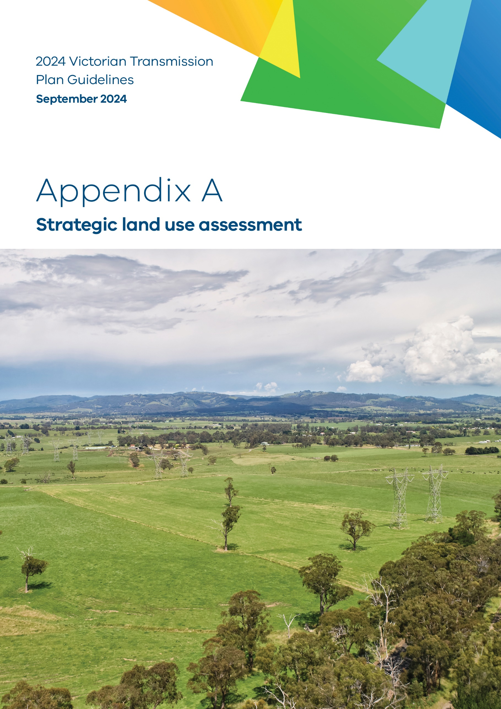

- Strategic land use assessment

Purpose
This is Appendix A to the 2024 Victorian Transmission Plan Guidelines (2024 VTP Guidelines) originally published as a draft on 22 July 2024.
VicGrid is changing the way energy infrastructure is delivered in Victoria. We are putting in place a long-term strategic plan – the Victorian Transmission Plan (VTP) – to ensure we have the right infrastructure in the right place at the right time to support the energy transition.
As set out in the amendments to the National Electricity (Victoria) Act 2005 (the Act) passed in May 2024, we are required to develop and release the inaugural VTP, the 2025 VTP, by 31 July 2025. This will guide Victoria’s smooth transition to renewable energy as coal-fired power stations retire in the following decade.
We are required to prepare and publish a set of guidelines called the 2024 Victorian Transmission Plan Guidelines (this document), which outline how the 2025 VTP will be developed. This appendix provides further technical details on the content included in the main guidelines.
Disclaimer
The publication of the 2024 VTP Guidelines is pursuant to amendments to the National Electricity (Victoria) Act 2005 passed in May 2024, which implement the first stage of the Victorian Transmission Investment Framework reforms and empower the CEO VicGrid to develop a Victorian transmission plan.
The State of Victoria and its employees do not guarantee that the publication is without flaw of any kind or is wholly appropriate for your particular purposes and therefore disclaims all liability for any error, loss or other consequence which may arise from you relying on any information in this publication.
This publication does not include all of the information that an investor, participant or potential participant in the National Electricity Market might require, and does not amount to a recommendation of any investment.
The information in this document is current at the time of printing, and remains subject to change and should not be relied upon. Please visit vicgrid.vic.gov.au for the latest updates.
Copyright
© The State of Victoria Department of Energy, Environment and Climate Action 2024

Contents
Appendix A Strategic land use assessment 1
A.1 Background 5
A.1.1 Overview 5
A.1.2 A phased approach 6
A.1.3 Strategic land use assessment phase 1 scope and limitations 6
A.1.4 Objectives and principles 7
A.1.5 Whole of government approach 7
A.2 Methodology overview 8
A.2.1 Spatial multi-criteria analysis methodology 9
A.2.1.1 Defining the themes and criteria 9
A.2.1.2 Applying scores 10
A.2.1.3 Collating the data 11
A.2.1.4 Develop and assign weights 13
A.2.1.5 Aggregation methodology 14
A.2.2 Methodology to identify the renewable energy zone study area 14
A.3 Community and stakeholder engagement 16
A.3.1.1 Renewable Energy Planning Survey 16
A.3.1.2 Interactive map on community values 19
A.4 Partnering with Traditional Owners and First Peoples 21
A.5 Constraints assessment 23
A.5.1 Themes, criteria and weightings 23
A.5.2 Results 30
A.5.3 Additional constraints criteria 31
A.6 Wind and solar opportunity assessments 32
A.6.1 Solar criteria and weightings 33
A.6.2 Wind criteria and weightings 33
A.6.3 Results 34
A.6.4 Other criteria considered 36
A.7 The renewable energy zone study area 38
A.8 Next steps 42
A.8.1 How will the study area evolve as part of the 2025 Victorian Transmission Plan? 42
A.9 Identifying an area for future transmission projects (strategic land use assessment phase 2) 43


Acronyms
Term | Definition
AEMO | Australian Energy Market Operator
CER | Consumer energy resources
EV | Electric vehicles
GW | Gigawatt (one million kilowatts)
GWh | Gigawatt hour (one million kilowatt hours)
IAP2 | International Association of Public Participation
IASR | Inputs, Assumptions and Scenarios Report
IEC | International Electrotechnical Commission
IEEE | Institute of Electrical and Electronics Engineers
ISP | Integrated System Plan
MCA | Multi-criteria analysis
MW | Megawatt (one thousand kilowatts)
MWh | Megawatt hour (one thousand kilowatt hours)
NCC | National Construction Code
NEM | National Electricity Market
NER | National Electricity Rules
NEVA | National Electricity (Victoria) Act 2005
ODP | Optimal development pathway
PSS/E | Power system simulation for engineering
PV | Photovoltaic solar
RAP | Registered Aboriginal Parties
REZ | Renewable energy zone
RRN | Regional reference node
TW | Terawatt (one billion kilowatts)
TWh | Terawatt hour (one billion kilowatt hours)
VAPR | Victorian Annual Planning Report
VCR | Value of Customer Reliability
VEU | Victorian Energy Upgrades
VPP | Virtual Power Plant
VRET | Victorian Renewable Energy Targets
VTIF | Victorian Transmission Investment Framework
VTP | Victorian Transmission Plan
WACC | Weighted average cost of capital

Appendix A: Strategic land use assessment – content summary
VicGrid has undertaken a statewide strategic land use assessment to identify parts of Victoria that are suitable for investigation for potential future renewable energy development. This assessment aims to provide early information on the areas being considered in the development of the 2025 Victorian Transmission Plan. These areas have been identified to minimise land use conflicts, make the most of high-quality renewable energy resources, and protect significant values. This appendix summarises the assessment methodology and outcomes, and how it will support planning for renewable energy zones.
- Background
    - Overview
As part of the Victorian Transmission Investment Framework (VTIF) 3 new planning tools will be integrated into the transmission planning process to deliver the best outcomes for Victoria and directly respond to existing and emerging challenges. The strategic land use assessment is one of these new planning tools.
In the past, considerations related to land use, environmental, cultural and social impacts from transmission and renewable energy development have not been well integrated into power system planning. These impacts have been dealt with project by project and late in the planning and approvals process, rather than early enough to inform strategic planning and system design. This has resulted in a lack of coordination and consistency in how the location of new energy infrastructure is determined.
In response to these challenges, we have undertaken a bespoke strategic land use assessment to bring together multiple land use factors and community perspectives in a single assessment to identify areas for potential renewable energy generation. It seeks to identify areas that can minimise the overall impacts of development to land use and landscape values, while also keeping the costs of energy low and attracting renewable energy and transmission investment. The assessment aims to proactively assess and consult early to ensure new energy infrastructure development is planned in a way that avoids important regional and rural assets, values and landscapes and manages a range of relevant competing land uses. This helps guide the engineering and design work needed to plan our state’s future power system away from inappropriate locations, supporting more streamlined investment into areas with fewer land use, cultural and environmental concerns.
We have tailored the strategic land use assessment to the needs of the 2025 Victorian Transmission Plan (VTP) to identify parts of Victoria for further study for potential future renewable energy and transmission development. This strategic land use assessment used a spatial multi-criteria analysis (spatial MCA) methodology combined with geographic information system (GIS) tools. This method provides a way of understanding existing land uses and landscape features across the state from several perspectives using a range of spatial datasets.
As a result of this assessment, we have produced a renewable energy zone study area (study area) that shows the parts of Victoria that have potential to host a renewable energy zone (REZ), which would coordinate new energy system infrastructure, such as wind and solar generation, as well as supporting transmission lines. The study area generally contains a mix of high-quality renewable energy resources and relatively lower land use constraints. Importantly, it identifies areas to deprioritise and avoid so we can focus early investigations away from significant environmental, cultural and community landscapes, such as national parks, wetlands and world heritage sites.
This study area will ultimately be narrowed to proposed renewable energy zones (REZs) as part of developing the 2025 VTP. REZs will be areas with high potential for renewable energy generation, such as wind and solar, while also being appropriate for development from a land and environment perspective. They are geographies for coordinating large-scale generation, storage and transmission infrastructure to support the transition from coal-fired power to renewables. The statewide constraints analysis detailed in this appendix, alongside Traditional Owner, landholder, local community and regional stakeholder feedback, will support the identification of proposed REZs.
- A phased approach
The strategic land use assessment will be applied in 2 distinct phases, which will support multiple outcomes across the 2025 VTP and proposed REZ refinement process.
- Phase 1: Supporting the identification of appropriate locations for proposed REZs, which will coordinate renewable generation and storage. This phase will be delivered across several steps, starting with a statewide analysis to identify the study area for the 2025 VTP, then supporting the refinement of this area into individual proposed REZs (detailed in the final 2025 VTP).
- Phase 2: Identifying an area of interest for any new transmission project needed to connect proposed REZs to the Victorian electricity network. The areas of interest will be included in the 2025 VTP. Corridor refinement for identified transmission projects will occur following the 2025 VTP as part of project development.
This document is focused on the phase 1 methodology, in particular, the approach and results for the statewide assessment to commence the VTP process. This methodology will provide the foundation for further analysis under phase 1 of the strategic land use assessment to support development of the 2025 VTP.
The method will also be a starting point for phase 2, which can commence once candidate areas for renewable energy zones and transmission projects are identified for the 2025 VTP. At this point we will consider how the criteria, approach and spatial tools from phase 1 need to evolve to reflect the specific needs in identifying appropriate areas for transmission infrastructure.
- Strategic land use assessment phase 1 scope and limitations
The strategic land use assessment phase 1 includes all areas within the state of Victoria in a desktop assessment at a very broad and strategic scale. Phase 1 is currently focused on identifying a study area for renewable energy generation, focusing on wind and solar, to support the long-term planning for new transmission infrastructure in Victoria.
The statewide analysis identifies larger areas to avoid and deprioritise across the state while also providing an initial view on smaller areas to protect that may ultimately fall inside the boundaries of a future REZ.
The following important factors are outside the scope of phase 1:
- This assessment does not assess or make decisions about individual projects, including whether a project would be appropriate in a specific location inside or outside the study area.
- Transmission infrastructure will be assessed during phase 2. However, many factors related to siting wind and solar generation overlap with requirements for siting transmission.
- This statewide assessment is limited to wind and solar generation technologies, as these are currently the most commercially viable and scalable technology types.
- Pumped hydro and other forms of mechanical energy storage are not considered because of the different land use and engineering features of pumped hydro that require separate analysis.
- Other technologies, such as pumped hydro storage, might be appropriate outside the study area, but would be subject to other detailed assessments.
- Battery energy storage systems (BESS) have also not been explicitly considered, however they generally have fewer specific land and environment requirements than wind and solar and are likely to overlap with most factors covered in this state-level assessment.
- A detailed assessment of technologies, impacts or issues related to planning and environmental approvals is not included.
- This statewide assessment does not assess or make decisions with respect to local or property-level issues or designate specific areas or parcels of land where future infrastructure would be sited.
- Assessments of issues relating to technology, planning and environmental approvals, and property-level issues would be undertaken as part of detailed project designs.
The analysis uses information made available to the project team and obtained from stakeholders and other sources during the development of the statewide assessment. While we consider this to provide robust coverage of the relevant issues at a statewide scale in identifying the study area, it is not exhaustive and does not intend to capture the breadth of issues related to siting individual energy infrastructure projects. Additional information, datasets and analysis will be required by project proponents in understanding the feasibility of specific projects within a REZ, over time.
The analysis undertaken to produce the study area used the latest data available and was current at the time of its capture. Data was updated as of 15 May 2024, prior to the preparation of the draft VTP Guidelines, to minimise risks to completeness of data due to data currency.
    - Objectives and principles
Table A-1 details the overarching objective and key guiding principles for strategic land use assessment phase 1. Holistically, these guide the identification of areas that can minimise impacts from development, protect significant areas and landscapes, and prioritise areas with opportunities for renewables investment.
The overarching objective and guiding principles have underpinned decision-making across the assessment phases, including the development of the spatial MCA models, the application of scores and weightings, and the analysis and prioritisation of the study area.
Table A-1: Strategic land use assessment phase 1 objectives and guiding principles
Objective | Description
Overarching objective | To identify parts of Victoria that are suitable for further study for potential future renewable energy development, as the starting point to identify proposed REZs.
Guiding principles | - Prioritise areas that support sufficient, timely investment in renewable energy generation to inform the 2025 VTP.  - Identify potential areas for REZs that meet the electricity system planning requirements under the 2025 VTP.  - Protect and/or minimise impacts to highly significant or sensitive areas that have high environmental, social, cultural or economic land use value.
Spatial MCA objective | To evaluate the location and relationships of various criteria from a spatial aspect and alternative options through a systematic process that considers a range of land use and landscapes values.
    - Whole of government approach
An internal government reference group was established to support this strategic land use assessment. This reference group included representatives from various Victorian Government portfolio areas across multiple departments to ensure interdepartmental views and expertise could help develop the spatial MCA. This group provided project governance and oversight in addition to giving feedback on the model and assessment approach. Targeted engagement was also undertaken with departments in relevant policy areas, in addition to data-holders for critical inputs.
- Methodology overview
There are 2 key stages of the methodology we have used to develop the study area. These are described below and illustrated in Figure A-1.
- The spatial multi-criteria analysis (MCA) to identify and understand existing constraints on and opportunities for renewable energy development from a range of land use, environmental, cultural and social considerations.
- Assessment of areas for inclusion in the study area, to bring together the results from the opportunities and constraints assessments to identify the most appropriate areas to investigate for renewable energy generation development.
The assessment brings together several sub-level spatial MCAs in an integrated framework, covering 2 general areas of analysis:
- A constraints assessment: To understand and identify potential areas to focus generation and transmission development that would minimise overall impacts (detailed in section A.5).
- Opportunity assessments: To identify areas across Victoria that seek to maximise the viability of solar and wind generation projects (detailed in section A.6).
These spatial MCAs are the foundation of the assessment and produce maps, which are analysed to understand the balance of potential impacts and opportunities in locating areas for the development of potential generation and transmission projects across the state.
To determine the study area, we then brought together the outputs from each assessment to identify areas for investigation that offer high opportunities and lower overall constraints for renewable energy and transmission development. This second step applied an additional level of analysis where the results across the constraints and opportunities assessments could be easily combined, to focus on the areas that perform best across the results and deprioritise or avoid the areas with highly significant and sensitive values.
Figure A-1: How we will identify the study area combining constraints and opportunities assessments
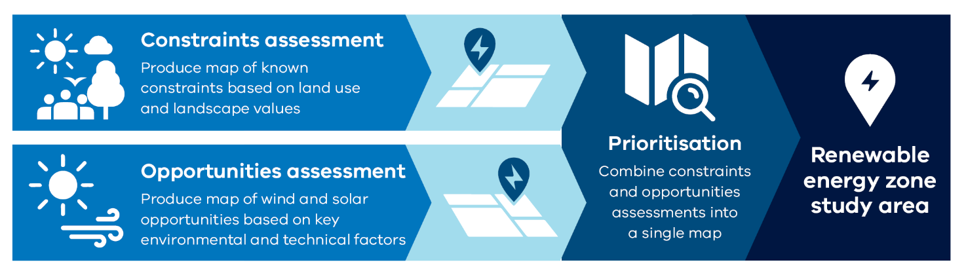

What is a spatial multi-criteria analysis?
A multi-criteria analysis (MCA) is a commonly used decision-making tool that enables multiple factors to be considered in an integrated assessment. A spatial MCA is a variant of an MCA that incorporates geographic information. This brings spatial relationships into the decision-making process to compare and evaluate criteria and trade-offs.

- Spatial multi-criteria analysis methodology
Figure A-2 illustrates the high-level process flow for preparing and undertaking the spatial MCAs for the constraint and opportunities assessments. These steps are described in the following sections, noting any significant differences between the structure or methodology of the MCAs.
The spatial MCAs bring together more than 60 spatial datasets in total across environmental, cultural, land use and engineering themes. These datasets contribute distinct criteria and are scored in each MCA. Weights are applied at the theme level in the constraints assessment and at criteria level in the opportunities assessment.
A spatial model then processes the data using the MCA framework to generate a series of raster maps (cells on a grid) for more detailed analysis. These maps are then analysed, tested and refined through an iterative process to ensure the results bring together the available data in a logical and consistent way.
For the strategic land use assessment spatial MCA we used a raster pixel, or spatial grid cell, of 225 metres to align with the resolution of some criteria inputs at the statewide scale.
Figure A-2: The spatial MCA high level process flow
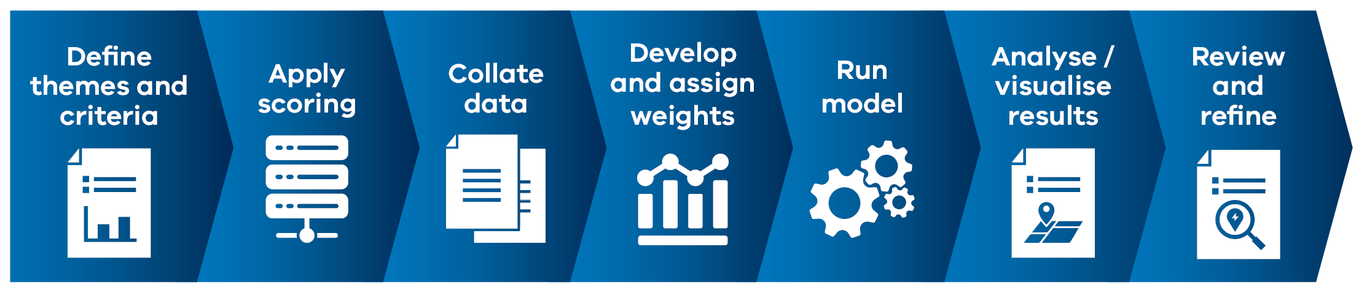
We have developed a bespoke GIS-based tool to undertake the analysis, with the intention that this will serve future needs as the strategic land use assessment evolves.
      - Defining the themes and criteria
The constraints and opportunities assessments adopt slightly different MCA structures and methods to accommodate the criteria and concerns in each assessment.
Because more than 50 criteria have been considered in the constraints MCA, they have been grouped into 5 themes to reflect distinct land use constraint perspectives. Each theme contains a set of criteria that have been grouped to reflect a distinct policy area or constraint type. The themes and criteria have been defined by subject matter specialists and engagement with government stakeholders and informed by feedback received during community engagement activities described in section A.3. See section A.5 for details on the constraints assessment themes and criteria.
For the opportunities assessment, a limited number of criteria were selected based on advice from wind and solar energy specialists as well as discussions with the Australian Energy Market Operator (AEMO). This focused on factors relevant to investment in wind or solar generation at a state scale. Themes were not required to capture distinct perspectives. See section A.6 for details on the opportunities assessments themes and criteria.
      - Applying scores
Subject matter experts in the relevant policy area qualitatively assessed each criterion within a theme and scored them on a scale of 1-9 for constraints (shown in Figure A-3) and opportunities (shown in Figure A-4). The 1-9 scale is relatively simple and easy to use with many stakeholders while also providing a degree of nuance to represent the relative importance of different factors. For the constraints assessment, 9 was considered most constrained and 1 least constrained. For the opportunities assessment, an inverted 1-9 scale was used, with 9 being most suitable for development and 1 being least suitable.
Input from a range of government stakeholders and insights from community feedback was used to ensure the scores were appropriate at the statewide scale and to reflect the overarching objective and principles. Scores were assigned based on the significance of the criterion to the objective of the theme and/or MCA assessment, as well as the overall accuracy or completeness of the data. Consideration was given to the scale of the analysis and the overall equivalence of scores across different themes.
The MCA scores reflect a mix of strategic policy priorities, technical requirements, high-level planning, and approvals requirements. The scores relate to the relative level of constraint or opportunity for each criterion in regard to the development of an entire REZ. They do not represent a view on individual projects or a government view on overall land use values.
A distinct score of 999 outside the 1-9 scale is used for Avoidance areas when there are no acceptable trade-offs (e.g., Defence properties or national parks). This scoring removes the sites/areas from the analysis.
Figure A-3: Constraints assessment scoring framework
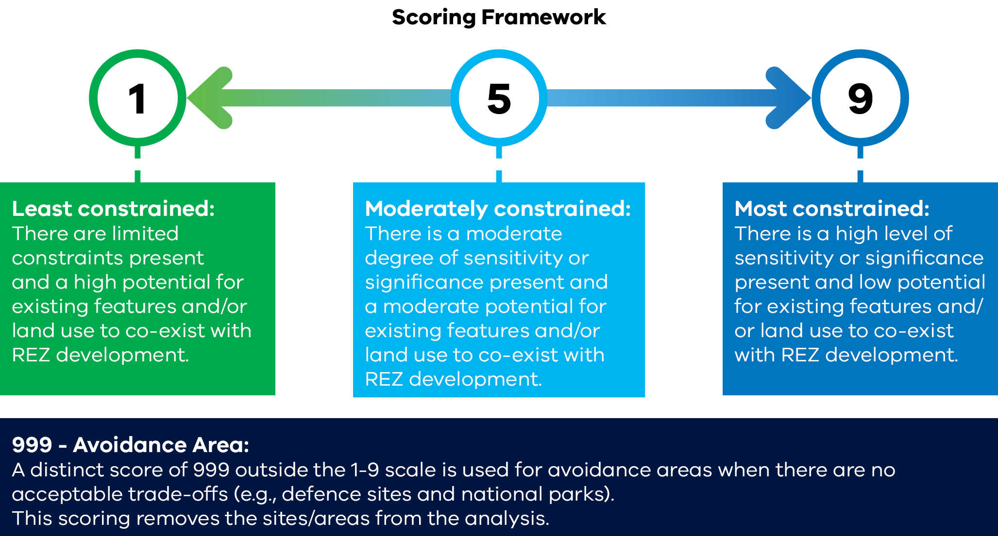
Figure A-4: Opportunity assessments scoring framework
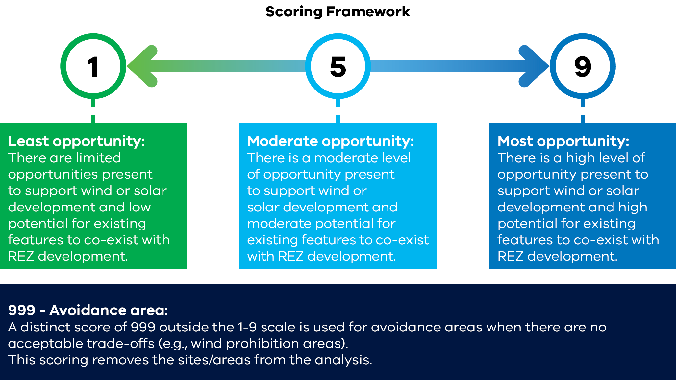
      - Collating the data
To ensure inputs were fit for purpose and consistent with VicGrid’s needs, technical advice was sought from subject matter specialists, government stakeholders and data-holders on appropriate datasets to use for the statewide strategic land use assessment. Datasets that were included in the assessment were required to be authoritative and complete, meaning they were sourced from official sources to ensure that data was captured and recorded using endorsed processes and methodologies.
For the constraints assessment, subject matter specialists provided modelled data inputs for biodiversity, agriculture and bushfire. This approach was considered the most accurate and effective option for these areas, which were among the highest priorities highlighted by Victorian communities.
Modelled data inputs for statewide land use assessment
Agriculture
VicGrid recognises that renewable energy and transmission infrastructure can impact agricultural land use. The VTP needs to balance meeting the state’s energy needs with ensuring food security. This includes protecting important agricultural land and minimising land use impacts on various farming practices.
In relation to agriculture data inputs for the current statewide assessment, VicGrid worked with specialist agriculture consultancy RMCG to develop a bespoke model combining several statewide datasets to understand the relative performance or significance of agricultural land. The agricultural land model brought together available statewide datasets, including the Victorian Government’s updated Victorian Land Use Information System (VLUIS) 2022 dataset, to create a performance potential measure for agricultural land. This measure considers farmgate output, biophysical land capability (e.g., soil quality and rainfall), access to irrigation, and farm infrastructure investment. The combined dataset – termed agricultural performance potential – identifies higher-value agricultural land across Victoria that may be less favourable for hosting renewable energy development.
A summary of the agricultural model developed with RMCG is provided below.
Agricultural performance theme | Dataset | Description
Farm output value | Victorian Land Use Information System 2022  ABS 2021-22, Estimated Value of Agricultural Operations (EVAO) by ANSZIC industry classification  ABS 2020-21, Agricultural Commodities Census | Provides a relative measure of agricultural output (gross income $/ha), based on agricultural industry statistics, reflecting land use, irrigation or rainfall inputs and the land's inherent capability to support agriculture (e.g., soil type, landform).
Access to irrigation water | Victorian – Land Use Information System 2022 (land parcels) | Irrigation access, indicated by water licences (including active v. non-active licences and water usage), is an indicator of agricultural production potential and provides drought resilience.
Land capability | Victorian Government - Land Systems Victoria 2000 | Maps the biophysical foundation of farmland as an indicator of long-term sustainable production, based on key metrics including soils, terrain, landform, rainfall and susceptibility to degradation.
Infrastructure investment | Victorian – Land Use Information System 2022 (land parcels) | Assessment of (fixed) infrastructure investment to conduct farming activities specific to agriculture industry type.

A key part of the agricultural performance potential model is access to, and active use of, irrigation infrastructure, such as in the Goulburn Murray Irrigation District and other declared irrigation districts that have been the subject of significant Victorian Government investment. Consideration of the impacts on agricultural land, including declared irrigation districts, will continue as the strategic land use assessment is applied into the future.
Development of this agricultural model included bilateral and group consultation with agriculture industry representatives and Agriculture Victoria. The model was tested and validated with subject-matter experts in RMCG to ensure it was an appropriate representation of agricultural performance for the purpose of guiding further investigation for power system planning.
As an additional component, RMCG also considered the compatibility of wind, solar, transmission and BESS technologies with different types of farming. This work will be refined further, working with industry stakeholders, with a view to incorporating it at a more regional level of analysis.
Biodiversity
In relation to biodiversity, VicGrid worked directly with the Department of Energy, Environment and Climate Action’s (DEECA’s) Biodiversity Division and the Arthur Rylah Institute to include a newly updated model for representing biodiversity values at a statewide scale. Habitat Value 2023 is a new, statewide spatial dataset ranking biodiversity values in Victoria, where each 75m² pixel across Victoria is assigned a ranking from 0-100. The analysis is produced by Zonation software utilising Habitat Distribution Models as inputs. Habitat Value is an update of the Strategic Biodiversity Value (SBV) dataset currently published by DEECA and includes all modelled species rather than the previous subset of threatened species. This updated dataset is a statewide map showing key habitat for native wildlife. It supports planners and developers to locate infrastructure in areas that would have the least impact on wildlife. The assessment also included National Reserve System Protected Areas and sites in the Collaborative Australian Protected Areas database 2022.
VicGrid will continue to work with DEECA’s Biodiversity Division on how additional and more regionally specific datasets on biodiversity values and species (e.g., brolga) could be included to support the ongoing analysis to identify REZs and transmission projects.
Bushfire risk
VicGrid has worked with DEECA’s Bushfire Risk, Engagement and Predictive Services team to assess and quantify bushfire hazard and bushfire risk using a sophisticated modelling framework called Risk 2.0.
Risk 2.0 brings together datasets covering fire histories, ecological vegetation classes, climate, digital elevation and terrain models, fire ignition, fire behaviour and fire simulations. The modelling framework is designed to provide strong evidence to support strategic bushfire management decision-making.
The strategic land use assessment includes a bushfire intensity model, supported by Risk 2.0 data. This model identified the relative hazard of bushfires in different locations and highlighted the relative risk of bushfire exposure to energy infrastructure.
This model has been used instead of existing planning layers such as the Bushfire Management Overlay (BMO) and Bushfire Prone Areas (BPA) datasets because it provides a more detailed view of bushfire risk to understand areas of higher risk within areas subject to the BMO or BPO layers. This dataset models the likelihood of suppression success from a first attack perspective, based on the energy output from bushfire given fuel, weather and topography.
This dataset was considered a more appropriate and nuanced representation of bushfire risk at a statewide level.

      - Develop and assign weights
For the constraints assessment, MCA themes were weighted to reflect the relative importance of each theme in supporting the strategic land use assessment objectives and principles. The weighting value was assigned to each theme independent of the level of constraint or suitability.
Weightings were assigned based on a series of internal workshops, which also incorporated community values derived from the statewide Renewable Energy Planning Survey. Results from the land use section of the survey were aggregated to understand community preferences towards theme weights. See section A.8 for more information on the survey.
Criteria within each constraint theme were not weighted on the basis that the scoring reflected the relative importance of different features. Assigning weights at the criteria level would risk introducing additional subjectivity and complexity to the model and the potential for double counting.
For the opportunities assessments, weightings were determined for each of the criteria in the solar and wind opportunity models, reflecting the relative importance of each criterion in siting wind and solar projects and the overall viability of investment in REZs. Weightings were assigned based on specialist advice for each of the wind and solar models.
      - Aggregation methodology
Within each of the constraints and opportunities assessments we used an aggregation method to bring the scored criteria and/or themes into an overall constraints result and an overall opportunities result. There are some differences in the aggregation method across the assessments. These are described below.
Constraints assessment aggregation
The constraints assessment model adopts a maximum cell value method to bring the criteria together within each theme. This means the highest constraint score is taken at each 225m² raster cell. This method is an effective way to represent the level of constraint at each cell location in the state. In particular:
- It avoids challenges where multiple land values are layered up in a single location and can cause other cells with fewer scores to appear relatively low in constraint, whereas this may not be the case.
- This approach is appropriate within themes because the criteria are broadly aligned to a particular policy area, type of land value or use. This means the most constrained value can ‘stand in’ for the others.
To combine themes together, scores were weighted, summed and then normalised to scale results back to the 1 to 9 scale. This approach is appropriate across themes because at this level of the MCA scores represent different categories of land constraint that need to be balanced.
Opportunity assessments aggregation
The opportunity assessments for wind and solar differed from the constraints assessment. Due to the simpler scope of considerations in the wind and solar assessments, criteria were accumulated directly to the overall result using a weighted sum method.
- Methodology to identify the renewable energy zone study area
The assessment to identify the study area for the 2025 VTP brought together the opportunities and constraints assessments to identify the most appropriate areas to investigate for potential future renewable energy zones. A method was designed to identify and map a study area reflecting a combination of high opportunities and lower overall constraints, while avoiding larger areas with high sensitivity and significance.
It is important to acknowledge that the renewable energy zone study area includes areas that are sensitive or hold significance for communities or stakeholders. It is not possible to avoid all such areas in a statewide analysis. Sensitive and significant areas will be considered through a series of stages, as planning moves from statewide considerations to regional considerations and eventually down to individual project proposals.
The process to identify the study area involved 4 steps. It used a hexagon mesh overlay to combine and analyse the constraints and opportunities results, described below.
Step 1: Developing a regular hexagon mesh map
A regular hexagon mesh was overlayed on the opportunities and constraints output maps to break Victoria into distinct hexagon areas for analysis (approximately 4,200 hectares in size). This overlay provided a standard reporting unit across the assessment results, to analyse the relative level of constraint and opportunity for each hexagon, alongside other attributes including proximity to the transmission network. The hexagon mesh was aligned to the geographic boundary of Victoria with some hexagons extending beyond the border to ensure completeness of each hexagon.
Step 2: Analyse constraints and opportunities results
We then analysed each hexagon to determine:
- Constraints score
- Opportunities score
- Operability (percentage of Avoidance present)
- Distance to 500kV transmission, including planned major augmentations
- Distance to important terminal stations (network connection points).

Step 3: Identify the total study area
We then determined a broad study area by deprioritising or avoiding areas with a high density of significant and sensitive values or where development of a REZ was not likely to be feasible (i.e., excluding them from the study area). This step involved selecting hexagons for the study area that met a threshold of having relatively higher opportunities and low-moderate constraint scores. Hexagons were not included in the study area if there were high constraints or limited opportunities for development, reflecting areas to deprioritise, or if there was a high proportion of land designated as an Avoidance area. Isolated hexagons surrounded by hexagons covered entirely by Avoidance area were removed from the study area as those locations would not be feasible for a REZ.
Step 4: Break the study area into tiers
The total study area was then broken into tiers to help understand which areas within the study area to prioritise for further investigation as part of 2025 VTP development. This prioritisation process identified 3 tiers reflecting the relative potential of each hexagon across the constraints and opportunities results.
- Tier 1: Most suitable for further investigation for a renewable energy zone. Hexagons that were in the lowest band of constraint scores and highest opportunity scores were allocated to tier 1. Areas in tier 1 were required to also have a low percentage of Avoidance area.
- Tiers 2 and 3: Suitable and available for further investigation. Hexagons with relatively higher constraint scores and lower opportunity scores were allocated to tiers 2 and then 3.
An adjustment to the tiers was then made based on factors relevant to transmission planning on the Victorian network, to understand which areas might be strategically more or less important in planning a least-cost power system through the 2025 VTP. Specifically, this included:
- de-prioritising (re-classifying) areas that are a significant distance from the existing 500kV network; and
- prioritising areas proximate to key terminal stations on the Victorian high-voltage transmission network.
This adjustment process could not result in identifying any new tier 1 areas to ensure that areas prioritised for further investigation had strong opportunities and relatively low land use constraints.
The results of this process and summary of the resulting tiers available for further investigation are shown section A.7.
- Community and stakeholder engagement
To provide early information about community values and preferences related to the strategic land use assessment we undertook the following activities between November 2023 and February 2024:
- The Renewable Energy Planning Survey to gain an understanding of diverse community views and values towards renewable energy and transmission development across Victoria.
- An interactive mapping activity to seek community views on important land use and landscape values in their area.
While these surveys provide an important initial understanding of local community values, concerns and preferences, they are a starting point for further and deeper engagement as the REZ development process continues.
      - Renewable Energy Planning Survey
The Renewable Energy Planning Survey was a text-based survey designed to measure community attitudes towards REZs, transmission development, and VicGrid as an organisation. While the Renewable Energy Planning Survey captured specific insights to support the statewide assessment it also provided feedback that will be considered across VicGrid’s work program and subsequent stages of developing the 2025 VTP.
The survey was conducted as face-to-face interviews in regional centres and was available online via Engage Victoria. The survey was also available to be completed at pop-up events held in regional communities during December 2023 and February 2024. The survey was advertised on local and regional radio stations and newspapers.
We ran a series of community workshops and drop-in sessions during May and June 2024 to discuss the results of the survey with communities.
In total, 2,015 responses were received across Victoria (see Table A-2). This was a robust and demographically diverse sample at the state and regional level. It is a baseline sample across Victorian regions that is a starting point for understanding views and values towards renewable energy and transmission infrastructure, across a range of topics.
Table A-2: Renewable Energy Planning Survey sample summary
Region | Number of participants
Central North | 237
Ovens Murray | 294
Gippsland | 244
South West | 303
Western Victoria | 265
Murray River | 237
Greater Melbourne | 435
Total | 2,015

In the land use section of the survey, we asked participants to rate the importance of 4 overarching factors when choosing suitable areas of Victoria for hosting renewable energy and transmission infrastructure. Participants also ranked a list of 10 relevant issues relating to land use planning for renewable energy and transmission infrastructure. Participants were also asked to identify additional landscape values they considered important and why.
These results provide insight at a statewide level on the values and issues most important to communities. Across Victoria, respondents indicated that protecting Victoria’s natural environment and ecosystems was the most important factor, followed by minimising land use conflicts. Engineering and technical factors were considered least important in choosing areas for renewable energy development, although keeping power bills down was still of moderate importance.
The survey results highlighted a clear and consistent message about the significance communities place on protecting Victoria’s natural environment, parks, water systems (rivers and lakes), and biodiversity. The need to consider impacts on agricultural land and farming communities was also highlighted as a key concern when thinking about what areas of Victoria can co-exist with renewable energy infrastructure.
The results of this section of the survey are shown in Figure A-5 and Figure A-6.
The survey did not seek views on protecting and conserving Victoria's Aboriginal and historical cultural heritage. We are partnering with Traditional Owners and First Peoples to gather this information.
Figure A-5: Renewable Energy Planning Survey results – land use themes
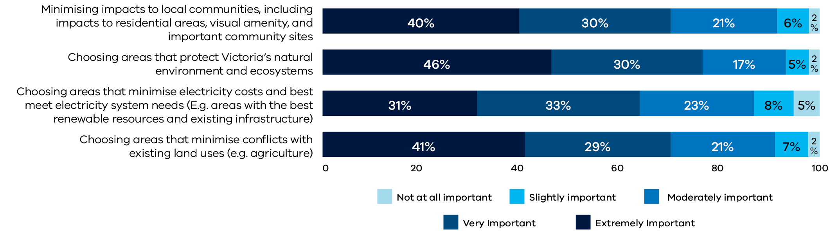

Figure A-6: Renewable Energy Planning Survey results – land use sub-themes (rankings)
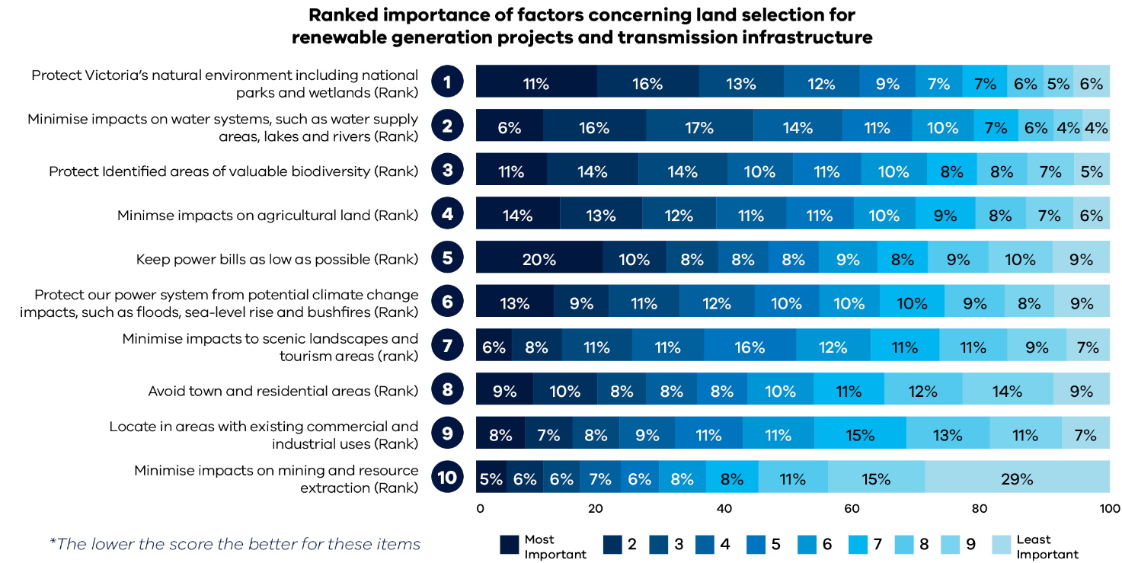

These insights were used to support decision-making through the development of theme-level weights in the statewide constraints assessment spatial MCA that reflected local community preferences. They also helped VicGrid to validate inputs into the MCA models, including how criteria were scored.
For example, a range of natural environment features, including rivers, lakes, national and state parks and wetlands were treated as Avoidance areas. Communities also highlighted a preference for minimising disturbance of vegetated areas and aligning with areas close to existing infrastructure. These issues were reflected in the assessment framework and approach. Recognising the importance of improving the understanding of strategic agricultural land, we undertook work with RMCG to develop a combined dataset on agricultural performance potential that could help identify areas of strategic importance that may be less suited to hosting energy infrastructure.
      - Interactive map on community values
We undertook a participatory mapping exercise to understand the areas and landscapes important to communities across Victoria, hosted on Engage Victoria. We asked participants to drop a pin on an area or landscape important to them and describe why it was important. Pins could be dropped in the following categories:
- Agriculture and resources
- Appropriate areas for renewable energy zone development
- Cultural heritage
- Natural environment and biodiversity
- Scenic landscapes
- Social aspects (e.g. tourism and recreation).
A total of 2,465 pins were placed on the map, covering a range of issues and areas. A breakdown of the total pins is provided in Table A-3.
Table A-3: Interactive map pin count
Topic | Count of pins
Agriculture and resources | 1,249
Appropriate area for REZ development | 58
Cultural heritage | 73
Natural environment and biodiversity | 616
Scenic landscape | 169
Social (e.g. tourism and recreation) | 179
Other | 121
Total | 2,465

The mapped comments were analysed to identify main themes at both statewide and regional levels. Insights were collected through visual analysis of the map by the project team. Themes were also analysed within each pin category. This provided a greater understanding at a statewide level of common issues raised among community members. Table A-4 summarises the key insights for each pin category.
Table A-4: Interactive map results summary
Pin category | Key statewide insights
Agriculture and resources | Participants highlighted areas of prime agricultural value and emphasised the value of irrigation infrastructure and water sources. Many comments noted the importance of agricultural land in terms of food and fibre production and raised concerns about the co-location of energy infrastructure in those areas.  Concerns were highlighted across the state about contamination and bushfire risk due to the presence of energy infrastructure, particularly batteries.
Appropriate area for REZ development | Participants highlighted a clear preference for identifying appropriate areas for REZ development in an area of existing infrastructure (including non-energy infrastructure) that already had disturbance to the landscape.  Many comments also highlighted that some communities and regions were suited to hosting renewable energy infrastructure due to available compatible land and noted the ability to capitalise on the economic benefits available to local communities.
Cultural heritage | Participants highlighted areas with historical sites, buildings and values. For example, areas with gold mining history were identified as having various historical landmarks and buildings that the community wished to preserve. Participants also identified some areas of high significance to First Peoples.
Natural environment and biodiversity | Participants highlighted areas of high biodiversity value, such as threatened and vulnerable species (e.g. birds) which could be impacted by REZ development. These areas were highlighted in parks and reserves. The importance of rivers and lakes to local communities was also reflected across the state.  Submissions raised concerns about clearing trees, and expressed a desire to leave nature ‘untouched’ and avoid areas that were vegetated.  Concern about the impacts to wildlife was particularly strong in coastal areas.
Scenic landscape | Participants identified areas with natural beauty and concerns about the impact of REZ development on natural amenity. Comments highlighted the visual amenity of water systems (coastal and inland) as being valued and needing protection from energy development.
Social (e.g. tourism and recreation) | Participants identified areas of high tourism value and identified concerns about how energy infrastructure may impact tourism attraction to an area. The feedback was focused on areas with natural assets, such as coastal and inland waters or mountains. Recreational activities such as fishing were regularly referenced with respect to waterways.  Many comments highlighted the important social values and identities associated with farming communities.
Other | Comments covered a diverse range of topics related to renewable energy and transmission development, including both impacts from development, such as noise/air pollution, and health and safety concerns. Many comments also highlighted the need to consider bushfire and flood-prone land and areas of lower suitability for development due to the topography and soil type.

This information provides VicGrid with further, spatially explicit information about key community values and concerns to test the statewide assessment framework and spatial MCA. The spatial information from the interactive map was also used as a view layer to cross-reference community values against existing spatial datasets and areas considered more and less appropriate for REZ development. This information will continue to be relevant in identifying significant landscape and land use values as we investigate the study area.
It is important to note that the responses covered a range of topics, including issues not necessarily within the immediate scope of the phase 1 strategic land use assessment or representative of specific land use or landscape values. Concerns about the broader impact of transmission and generation development on local communities will continue to inform further analysis to refine the study area into proposed REZs through the development of the 2025 VTP.
- Partnering with Traditional Owners and First Peoples
Cultural heritage and cultural values are key considerations in the development of the strategic land use assessment. VicGrid’s commitment to partnering with Traditional Owners and First Peoples’ communities is outlined in chapter 5 of the 2024 VTP Guidelines. Under principles of self-determination, we are committed to forming true partnerships with Traditional Owners to identify expectations, concerns and opportunities that align to their rights and cultural responsibilities, and provide for the protection of Country in line with the broader aspirations of First Peoples impacted by the energy transition.
This is the first time VicGrid has undertaken a strategic land use assessment exercise and we recognise the need to evolve the assessment model and method over time in line with these commitments and our engagement with Traditional Owners and First Peoples. Phase 1 of the strategic land use assessment currently includes only publicly available datasets for Aboriginal and historical cultural heritage. As such, the data relating to Aboriginal cultural heritage is limited and does not capture all known heritage values. Some parts of Victoria have not undergone detailed heritage assessments, and the lack of data simply reflects the lack of assessment, not a lack of heritage values.
Intangible Aboriginal cultural heritage values have been included in this version of the strategic land use assessment in a limited way. Intangible heritage values can only be identified through consultation with Traditional Owners. However, landforms that are publicly known to be of cultural significance have been included within this iteration, where possible.
VicGrid is committed to supporting and empowering Registered Aboriginal Parties (RAPs) and Traditional Owner groups to assist in mapping and assessments. This could include through providing funding and other capacity-building support to RAPs, so they can resource and run their own renewable energy engagement programs aligned with self-determination principles.
We will work collaboratively with Victoria’s Traditional Owners including RAPs and the Victorian Aboriginal Heritage Council, as well as First Peoples State Relations, to evolve the strategic land use assessment to support the VTP. We will also supplement the publicly available data with culturally appropriate information Traditional Owners are willing to provide throughout the lifecycle of the strategic land use assessment.
Feedback from First Peoples and Traditional Owners on renewable energy and transmission development will be vital in this process, so we can understand and protect Country. This will enable the model to progressively include relevant tangible and intangible Aboriginal and historical cultural values to help avoid places of cultural significance. This will be done in conjunction with the more detailed assessments for proposed REZs and any new transmission projects for the 2025 VTP, and processes following publication of the 2025 VTP.
No assessment of impact, or the potential for impacts to occur to any heritage values, is included within this report. Additionally, the strategic land use assessment does not replace regulatory requirements. The Aboriginal Heritage Act 2006 (Vic) and the Heritage Act 2017 (Vic), along with other relevant State and Commonwealth legislation, still applies to any future works.
- Constraints assessment
The constraints assessment sought to understand and identify potential areas to focus renewable generation development that would minimise overall impacts. It sought to understand constraints to development at a statewide level rather than specific sites. The following section details the final framework elements and the results.
- Themes, criteria and weightings
Figure A-7 illustrates the themes and groups included in the constraints assessment. Table A-5 explains the objective of each theme, the weighting value assigned to each theme and the rationale for the weighting value.
The relative weight of natural environment factors were assigned collectively between the 2 natural environment themes given the overlap between the areas and issues identified in each theme.
Table A-6 details the criteria included in each group, by theme.
Figure A-7: Statewide constraints assessment model
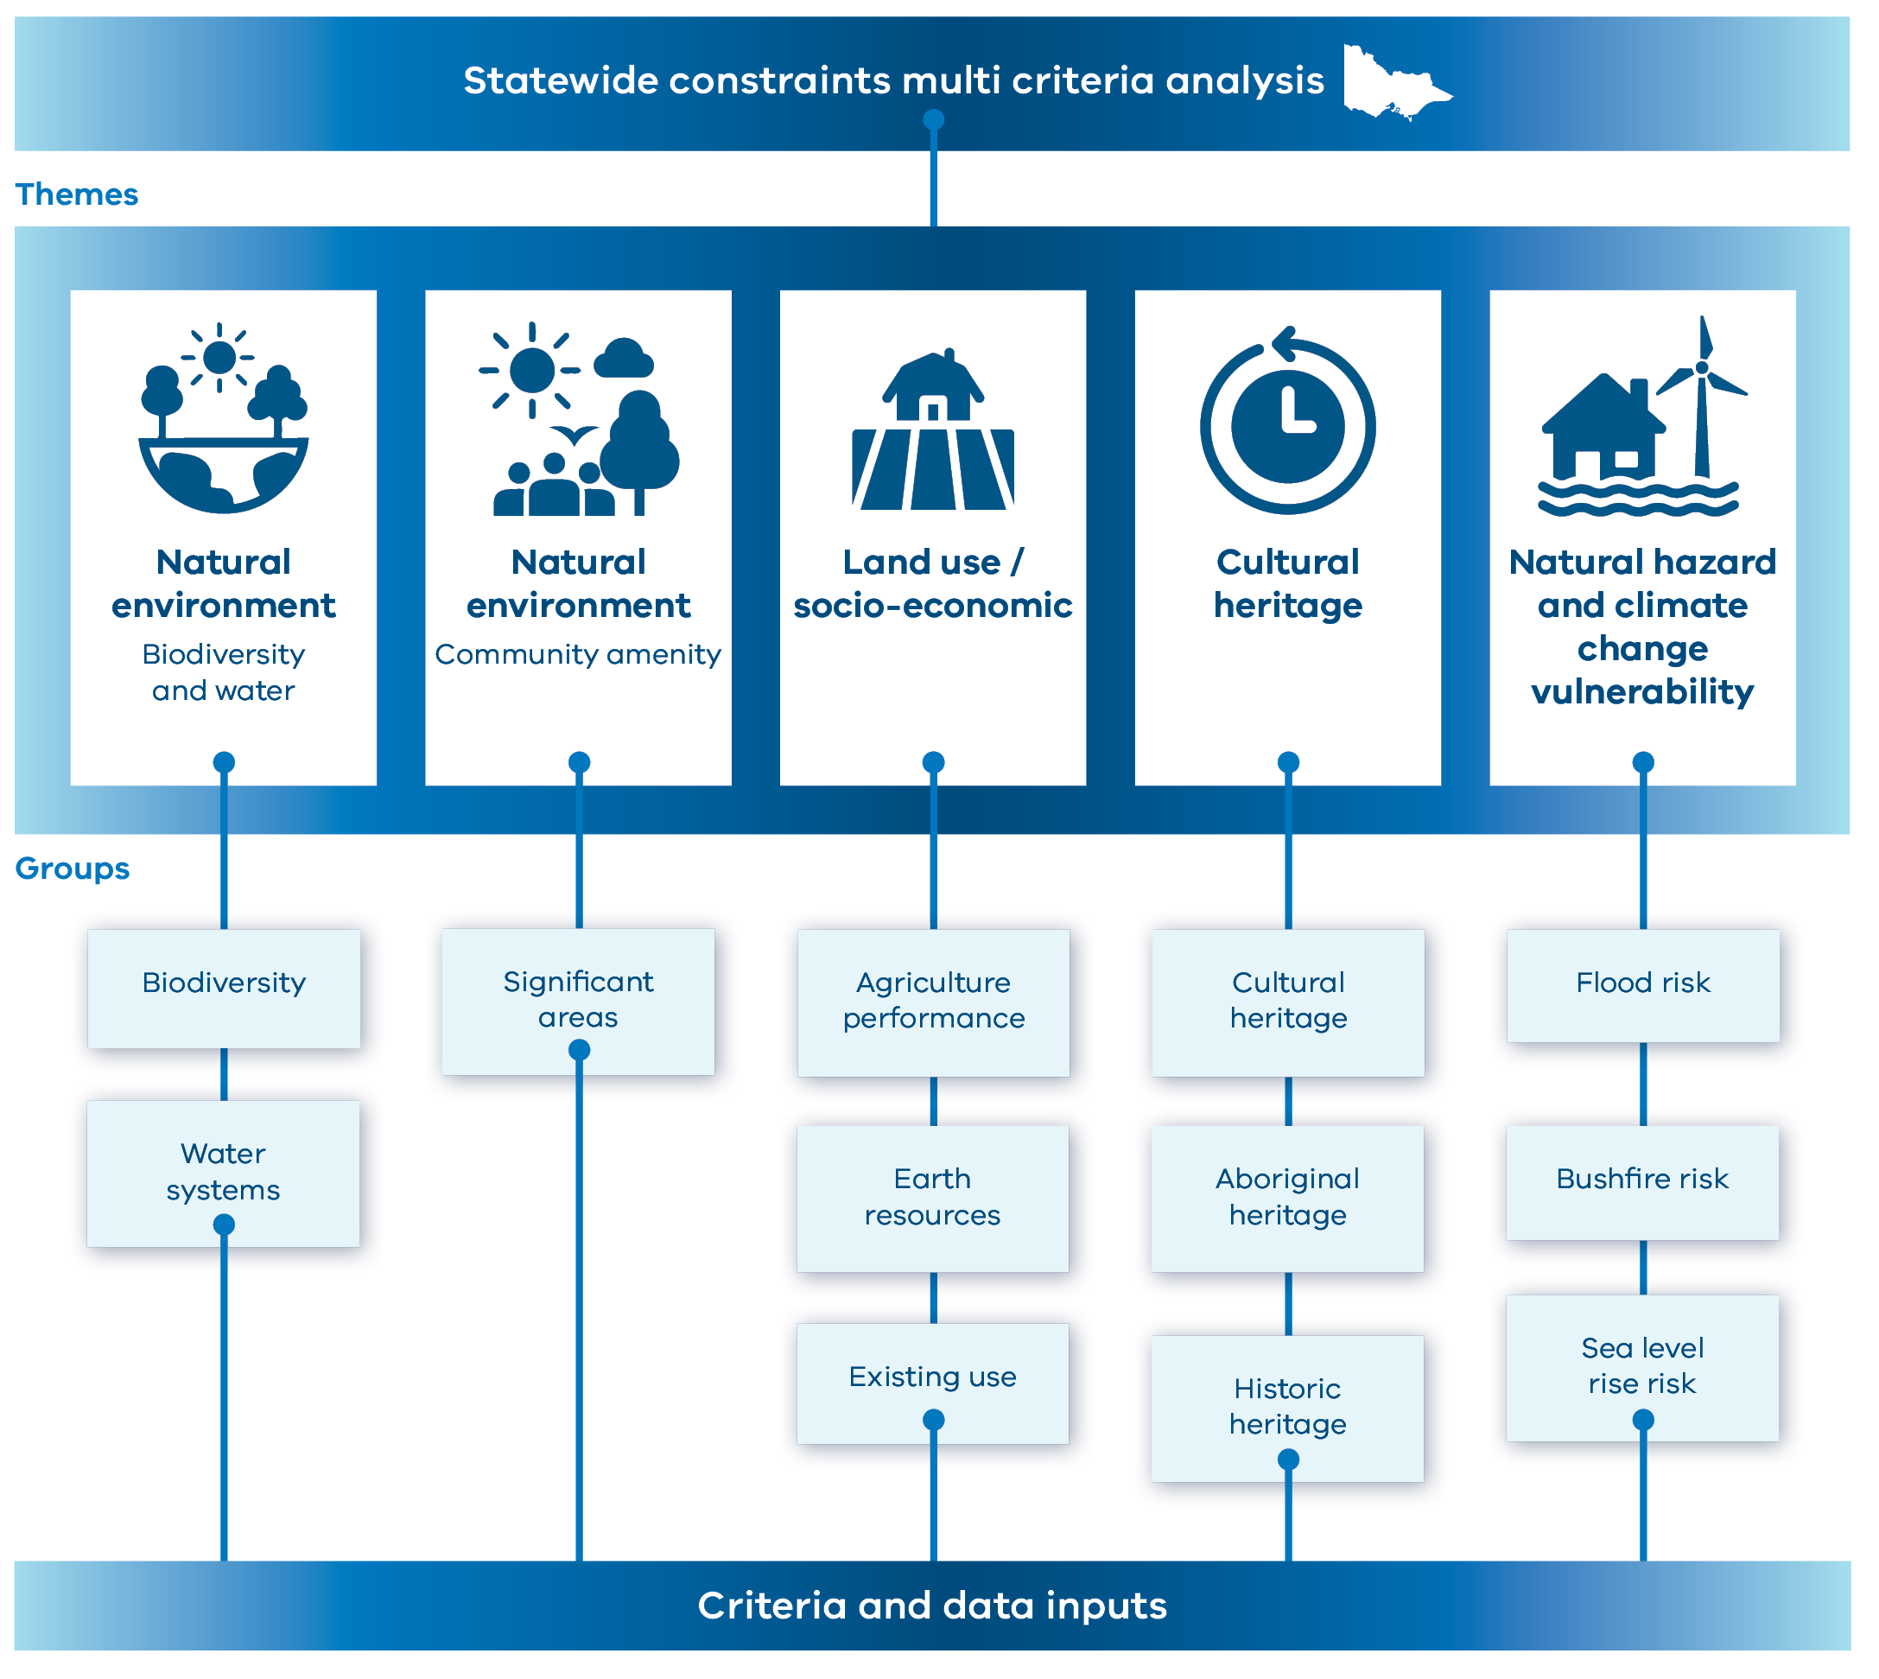
Table A-5: Themes, objectives and weighting values of the constraints assessment
Theme | Objective | Weighting | Rationale
Natural hazards and climate vulnerability | Minimise the risk to the power system’s vulnerability to natural hazards and climate change. | 10% | This theme was considered less important overall as many coastal and forested areas are classed as Avoidance or are highly constrained due to values in other themes. Other technical constraints can be managed/mitigated at individual project level where that hazard exists. This theme was considered low-medium importance in the Renewable Energy Planning Survey.
Natural environment – biodiversity and water systems | Minimise the impact of wind/solar development on areas of significant environmental and biodiversity value. | 30% | Protecting the natural environment and biodiversity values is a key policy driver for REZ development and supported by various state policies and legislation. This theme was the highest ranked value in the Renewable Energy Planning Survey.
Natural environment – community amenity | Minimise the impact of wind/solar development on areas that have community amenity from the natural environment. | 10% | Weighting for this theme is lower because to a high degree the locations overlap with locations protected through the natural environment and cultural heritage themes as well as the limited criteria and datasets available with state coverage. The weighting was considered alongside those assigned to the other natural environment theme
Land use / socio-economic | Minimise the impact of wind/solar development on valued social and economic uses of land. | 25% | Protecting high value, strategic areas for agriculture, strategic resource extraction and rural residential areas is a high priority for REZ development. Protecting prime agricultural land was of high importance in the Renewable Energy Planning Survey and interactive map exercise.
Cultural heritage | Protect and/or minimise the future potential impact on areas that have cultural heritage significance and/or sensitivity. | 25% | Protecting cultural heritage is a high priority for REZ development and state government policy. This theme was weighted relatively lower given the available datasets for the current version of the statewide MCA model.
Table A-6: Constraints assessment criteria and description, by theme and group
Group | Criteria | Description
Natural hazards and climate vulnerability
Flood risk | Land subject to flooding (planning overlays) | Areas identified as at risk of flooding. Identifies moderate-high constraints that present a risk to energy infrastructure.
Flood risk | Urban Floodway Zone | Areas identified as at risk of flooding that are subject to planning controls. Identifies moderate-high constraints that present a risk to energy infrastructure.
Bushfire risk | Bushfire intensity | Modelled intensity of bushfires across Victoria, prepared by DEECA providing an indication of potential fire behaviour and suppression effectiveness under the direst circumstances (maximum modelled radiant heat energy (kW/m)). However, easement clearing, or other mitigations can manage risks. This criterion captures a range of areas from least constrained to moderately-most constrained.
Sea level rise risk | Sea level rise storm surge in 2040, 2070 and 2100 | Sea level rise and the increased impact of storm surges pose a risk to coastal infrastructure. 2100 and 2070 storm surges were scored from least-moderately constrained and moderately-most constrained, respectively, given the time range is at or beyond the design life of most energy infrastructure. 2040 storm surge was considered avoidance given the risk to coastal infrastructure and values, and is within the design life of energy infrastructure.
Natural environment – biodiversity and water systems
Biodiversity | Habitat biodiversity value | The habitat biodiversity value criteria was re-classified on a 1-9 scale for the statewide strategic land use assessment and converted to 225 m pixels. This modelled dataset represents the potential importance of habitat and biodiversity values across Victoria and includes all modelled species, not just threatened species.  The habitat biodiversity value MCA dataset identifies areas of high to low constraint reflecting the relative importance of an area to biodiversity values.
Biodiversity | National Protected Area Reserve System | The National Protected Area Reserve System provides a national perspective of the conservation of biodiversity in protected areas. It also allows Australia to report on the status of protected areas to meet international obligations such as those under the Convention on Biological Diversity. These areas are of high significance and sensitivity and considered Avoidance.
Water systems | Water supply protection areas | Management areas used as a high-level indicator of healthy water assets that may require protection in the future. These are least-moderately constrained.
Water systems | Designated water supply catchments | Management areas used to designate assets that may require protection. These are moderately constrained.
Water systems | Major waterways | Major waterways and rivers that are significant at a statewide scale and require protection. These are moderately constrained in this theme as waterways values are represented in the habitat biodiversity value dataset and also represented in the cultural heritage theme, including some that are highly constrained.
Water systems | Waterbodies | Large waterbodies, such as lakes, which require protection and are incompatible with energy infrastructure. These areas are to be avoided at the statewide level.
Water systems | Wetlands | Wetlands have high environmental, cultural and social value and should be protected as Avoidance areas.
Water systems | Ramsar listed wetlands | Ramsar wetlands are internationally recognised as rare or unique wetlands, and are important for conserving biological diversity. Ramsar wetlands are protected under the Commonwealth Environment Protection and Biodiversity Conservation Act 1999 (EPBC Act) and international treaties and considered Avoidance.
Natural environment – community amenity
Significant areas | Significant Landscape Overlay | The Significant Landscape Overlay is used to identify landscapes that have been recognised for their natural value and community significance, adding planning controls that limit certain types of development. These areas are moderately constrained.
Significant areas | Conservation and Recreation Zone | Public land that has been identified as conservation areas or set aside for recreational use, with the purpose of protecting and enhancing the natural environment. These areas are moderately-most constrained.
Significant areas | Parks and reserves | Public land that has been identified as parks and reserves, including national and state parks. These areas have prohibited and restricted uses and offer significant environmental and community value and are considered Avoidance.
Land use/socioeconomic
Agriculture | Agricultural performance potential | Agricultural performance potential is based on modelling of factors related to agricultural production including land capability, irrigation and farmgate output. The model provides a range of least to most constrained areas based on the modelled performance potential across these factors. For further information see Section 2.1.3.
Earth resources | Extractive Industry Interest Areas (EIIAs) | Represent potential areas for the supply of extractives materials, such as for construction activities. These areas are most constrained.
Earth resources | State Resources Overlay including Strategic Extractive Resource Areas | Planning control representing areas for supply of extractive resources that have been identified for protection, such as quarries. These areas are most constrained.
Earth resources | Minerals and extractives tenements | Areas with current or applications for various levels of licences relating to mineral or extractive resources, which may restrict the co-existence with renewable energy. These areas include a range of constraint values from least to most constrained depending on the status of the licence, with specific extractive areas to be avoided.
Earth resources | Special Use Zone 1 (SUZ1) | The Special Use Zone 1 is a sub-set of the Special Use Zone. In some local government areas, this is applied to areas that are committed for extractive or energy resource use and impose planning controls on competing land uses. Given planning restrictions related to competing uses these areas are most constrained.
Earth resources | Heavy minerals sands | Locations for supply of mineral sands resources that have been identified. Heavy mineral sands provide material used to build wind turbines and batteries and are most constrained.
Existing use | Plantations – protected by VPC Act 1993 | Plantations subject to the Victorian Plantations Corporation Act 1993 (Vic) represent areas of existing productive land use for growing large-scale crops with limited to no opportunity for co-location due to legislation constrains around alternative uses. These areas are most constrained.
Existing use | Public land | The transition of public land from one land use to another is complex, requiring graduated approvals depending on the significance of current land use.  Specific types of public land that are relatively more complex are accounted for separately in the MCA (see conservation and recreation, parks and reserves, and Commonwealth land – defence). The remainder of public land is moderately constrained.
Existing use | Industrial zones | These areas typically have existing industrial use that is not suitable for large-scale infrastructure, and are typically located near urban areas. However, there may be opportunities for colocation in some circumstances. These areas are moderately constrained.
Existing use | Commercial zones | These areas typically have existing commercial use that is not suitable for large-scale infrastructure, and are typically located near urban areas. These areas are most constrained.
Existing use | Residential areas / residences / township adjacent | Residential and similar planning zones, and adjacent areas in close proximity to residential areas, which present a risk of potential impacts to landowners, land use, land values and visual amenity. These areas are most constrained.
Existing use | Urban centres and localities | Areas of concentrated urban development with populations of 200 people or more. These areas of urban development are primarily identified using objective dwelling and population density criteria using data from the 2016 Census. These areas are to be avoided.
Existing use | Commonwealth land - Defence | Defence sites and areas of height restrictions are to be avoided.
Cultural heritage
Aboriginal heritage | Areas of Cultural Heritage Sensitivity (CHS) | Areas of CHS are associated with registered Aboriginal Places, and/or landforms or land categories that are considered likely to contain Aboriginal cultural heritage. Areas of CHS are defined under the Aboriginal Heritage Regulations 2018. Not all areas of CHS are mapped. A moderate score was used for CHS at the statewide scale to reflect the range of scientific significance associated with these areas (low to very high).
Aboriginal heritage | Unnamed natural waterways | These locations are not areas of CHS in accordance with the Aboriginal Heritage Regulations 2018; however, they represent landforms that are known to have an increased potential for Aboriginal places to be present. These areas are least-moderately constrained given their spread across Victoria.
Aboriginal heritage | Unnamed natural water bodies | These locations are not areas of CHS in accordance with the Aboriginal Heritage Regulations 2018; however, these represent landforms that are known to have an increased potential for Aboriginal Places to be present.
Aboriginal heritage | Inland lakes | These landforms are known to frequently be of high cultural significance to First Peoples and Traditional Owner groups and have the potential to contain Aboriginal Ancestral Remains. These areas are moderately-most constrained.
Aboriginal heritage | Significant rivers (named) | Major waterways are significant landmarks in Aboriginal culture and highly sensitive. These areas along the rivers are most constrained.
Aboriginal heritage | Aboriginal heritage – landforms of high significance | These landforms are known to contain locations of high cultural significance to First Peoples and Traditional Owner groups. Landforms included in this criterion are known to be highly constrained.
Historical heritage | Victorian Heritage Register | The Victorian Heritage Register provides protection for places, objects, relics or shipwrecks assessed as being of outstanding cultural significance within the State of Victoria. These areas are moderately-most constrained.
Historical heritage | Victorian Heritage Inventory (VHI) | The VHI is a register for known historical archaeological sites. It also includes sites that may not meet the current threshold criteria for VHI-listing. These areas are moderately constrained.
Cultural heritage | Heritage Overlay | Places listed on local government areas’ Planning Schemes (on the Heritage Overlay) are generally of local significance, but also include places of State significance (which are also typically listed on the VHR). These areas are least-moderately constrained.
Cultural heritage | Register of National Estate (RNE) | The RNE was formerly compiled as a record of Australia’s natural, cultural, and Aboriginal heritage places worth keeping for the future. The RNE was frozen in 2007 and many places have since been listed on appropriate statutory registers, however, is a good indicator that there may be something of cultural heritage value in the area. As such, these areas are least constrained.
Cultural heritage | Commonwealth Heritage List | The Commonwealth Heritage List is established under the Environment Protection and Biodiversity Conservation Act 1999 (Cth) (EPBC Act). Includes Historical, Indigenous and/or Natural places identified on land controlled or owned by the Australian Government. Significant impacts to CHL places may require an EPBC Act referral. These areas are moderately constrained.
Aboriginal heritage | Aboriginal heritage - landforms of very high significance | These landforms are known to contain locations of particularly high cultural significance to First Peoples and Traditional Owner groups. These areas are to be avoided.
Aboriginal / historical / cultural heritage | National Heritage List | The National Heritage List (Historical, Indigenous and/or Natural) includes places of significance to the nation of Australia and is administered under the EPBC Act. National Heritage Listed places are considered a Matter of National Environmental Significance (MNES) and any significant impact to these places will trigger an EPBC Act Referral. These areas are to be avoided.
Aboriginal / historical / cultural heritage | UNESCO World Heritage List | World Heritage Listed places are places of international significance for their Historical, Indigenous and/or Natural values. These areas are to be avoided.

- Results
The results of the constraints assessment are shown in Figure A-8. The map highlights particular characteristics of the criteria considered in the constraints assessment. In particular:
- North-west: With the exception of Murray-Sunset National Park, Wyperfeld National Park and adjacent land, this region is relatively less constrained. This reflects the combination of comparatively lower biodiversity, natural hazard and agriculture performance potential from the datasets used. However, there are known limitations in the available data at the statewide level that may impact this region.
- East: This region is generally more highly constrained, with significant biodiversity, community amenity such as the Alpine National Park and surrounds, and natural hazard scores, including the correlation between forests and high maximum bushfire hazard. Additionally, there are a number of highly constrained and Avoidance areas for heritage.
- Southern coastline: Across both the Gippsland and south-west coastlines, there is a mix of relatively low and highly constrained land including a number of Avoidance areas such as Budj Bim World Heritage Site, Great Otway National Park and Wilsons Promontory. The south-west also features a significant number of wetlands. There are also more highly constrained agricultural production areas in parts of these regions.
The results highlight the need for region-level assessments to refine the study area, which will happen during development of the 2025 VTP.
Figure A-8: Constraints assessment result
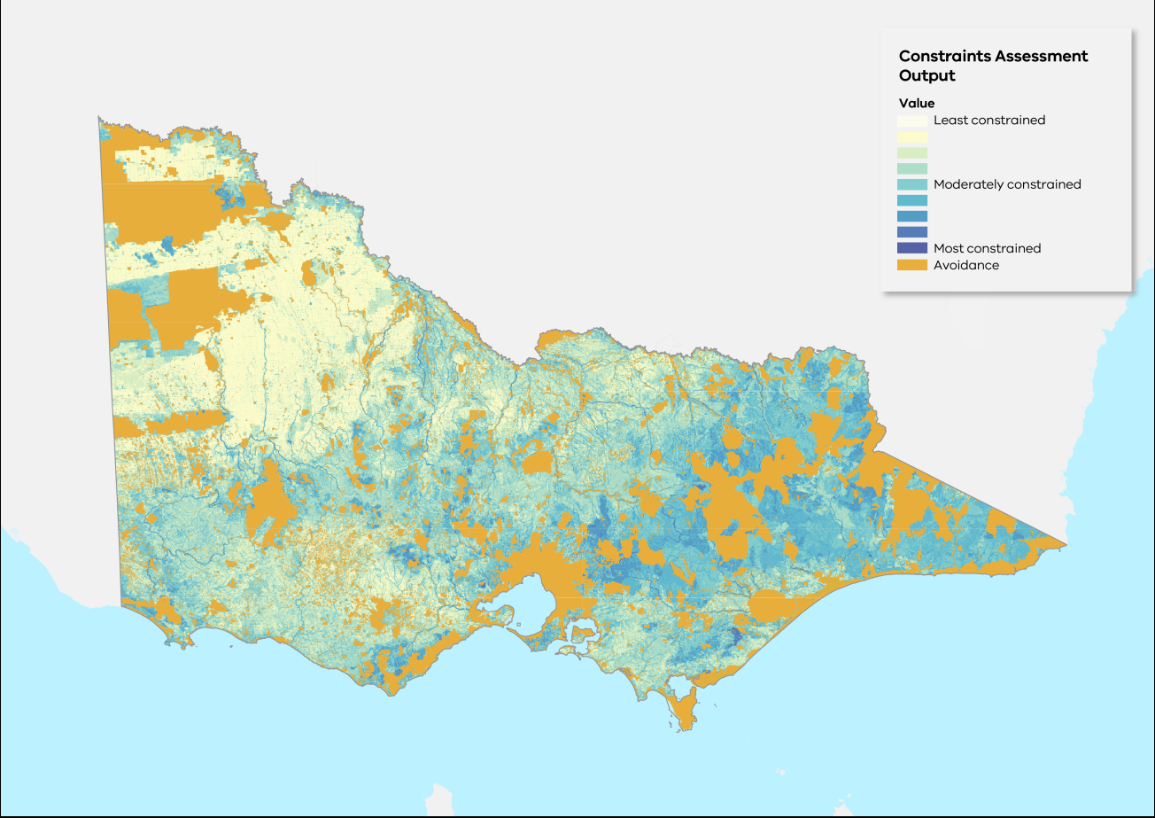

- Additional constraints criteria
Additional criteria may be used to support further refinement of the study area into proposed REZs during development of the 2025 VTP where the datasets are relevant and useful at a regional level. These potential additional criteria include:
- Agricultural compatibility – VicGrid is working to develop a methodology to consider the compatibility of different farming practices with renewable energy infrastructure. Feedback from stakeholders will help shape this work, and enable compatibility to be assessed at a regional level, where greater emphasis on relevant farming types can be made.
- Viewsheds (visual amenity) – the identification of viewpoints for wind and solar is highly specific to location and is best addressed at a regional level given available data.
- Land parcel size – parcel size is a relevant consideration for wind and solar development and is best addressed at a regional rather than statewide level so data can be analysed in more detail.
- Tourism – while protecting key tourism locations is an important consideration for REZ development, the completeness and reliability of spatial tourism data are highly variable at the statewide level. Tourism is better addressed at a regional scale where a more focused review of data and key considerations can occur.
Other criteria may be considered for further strategic land use assessments to support the refinement of the study area into smaller geographies.
- Wind and solar opportunity assessments
An opportunities assessment was undertaken to analyse areas across Victoria for viability to host solar and wind generation projects. This assessment considered key environmental and technical factors at a state level. The following section outlines the elements of and results for each opportunity assessment.
Figure A-9 illustrates the criteria included in the wind and solar opportunity assessments. Table A-7 explains the criteria and weightings for the solar opportunities assessment, and Table A-8 explains the criteria and weightings for the wind opportunities assessment.
Figure A-9: Statewide opportunities assessments model
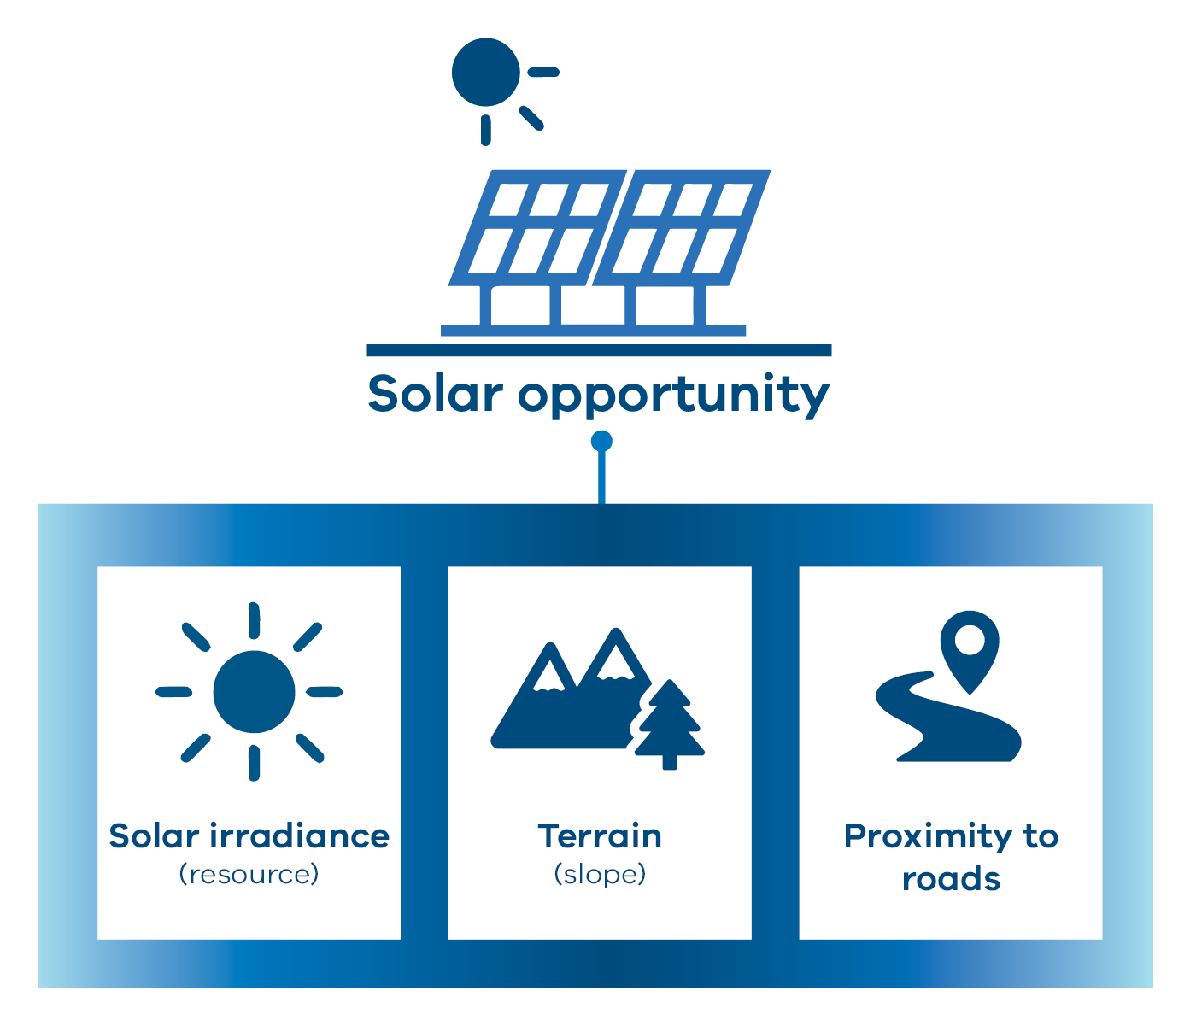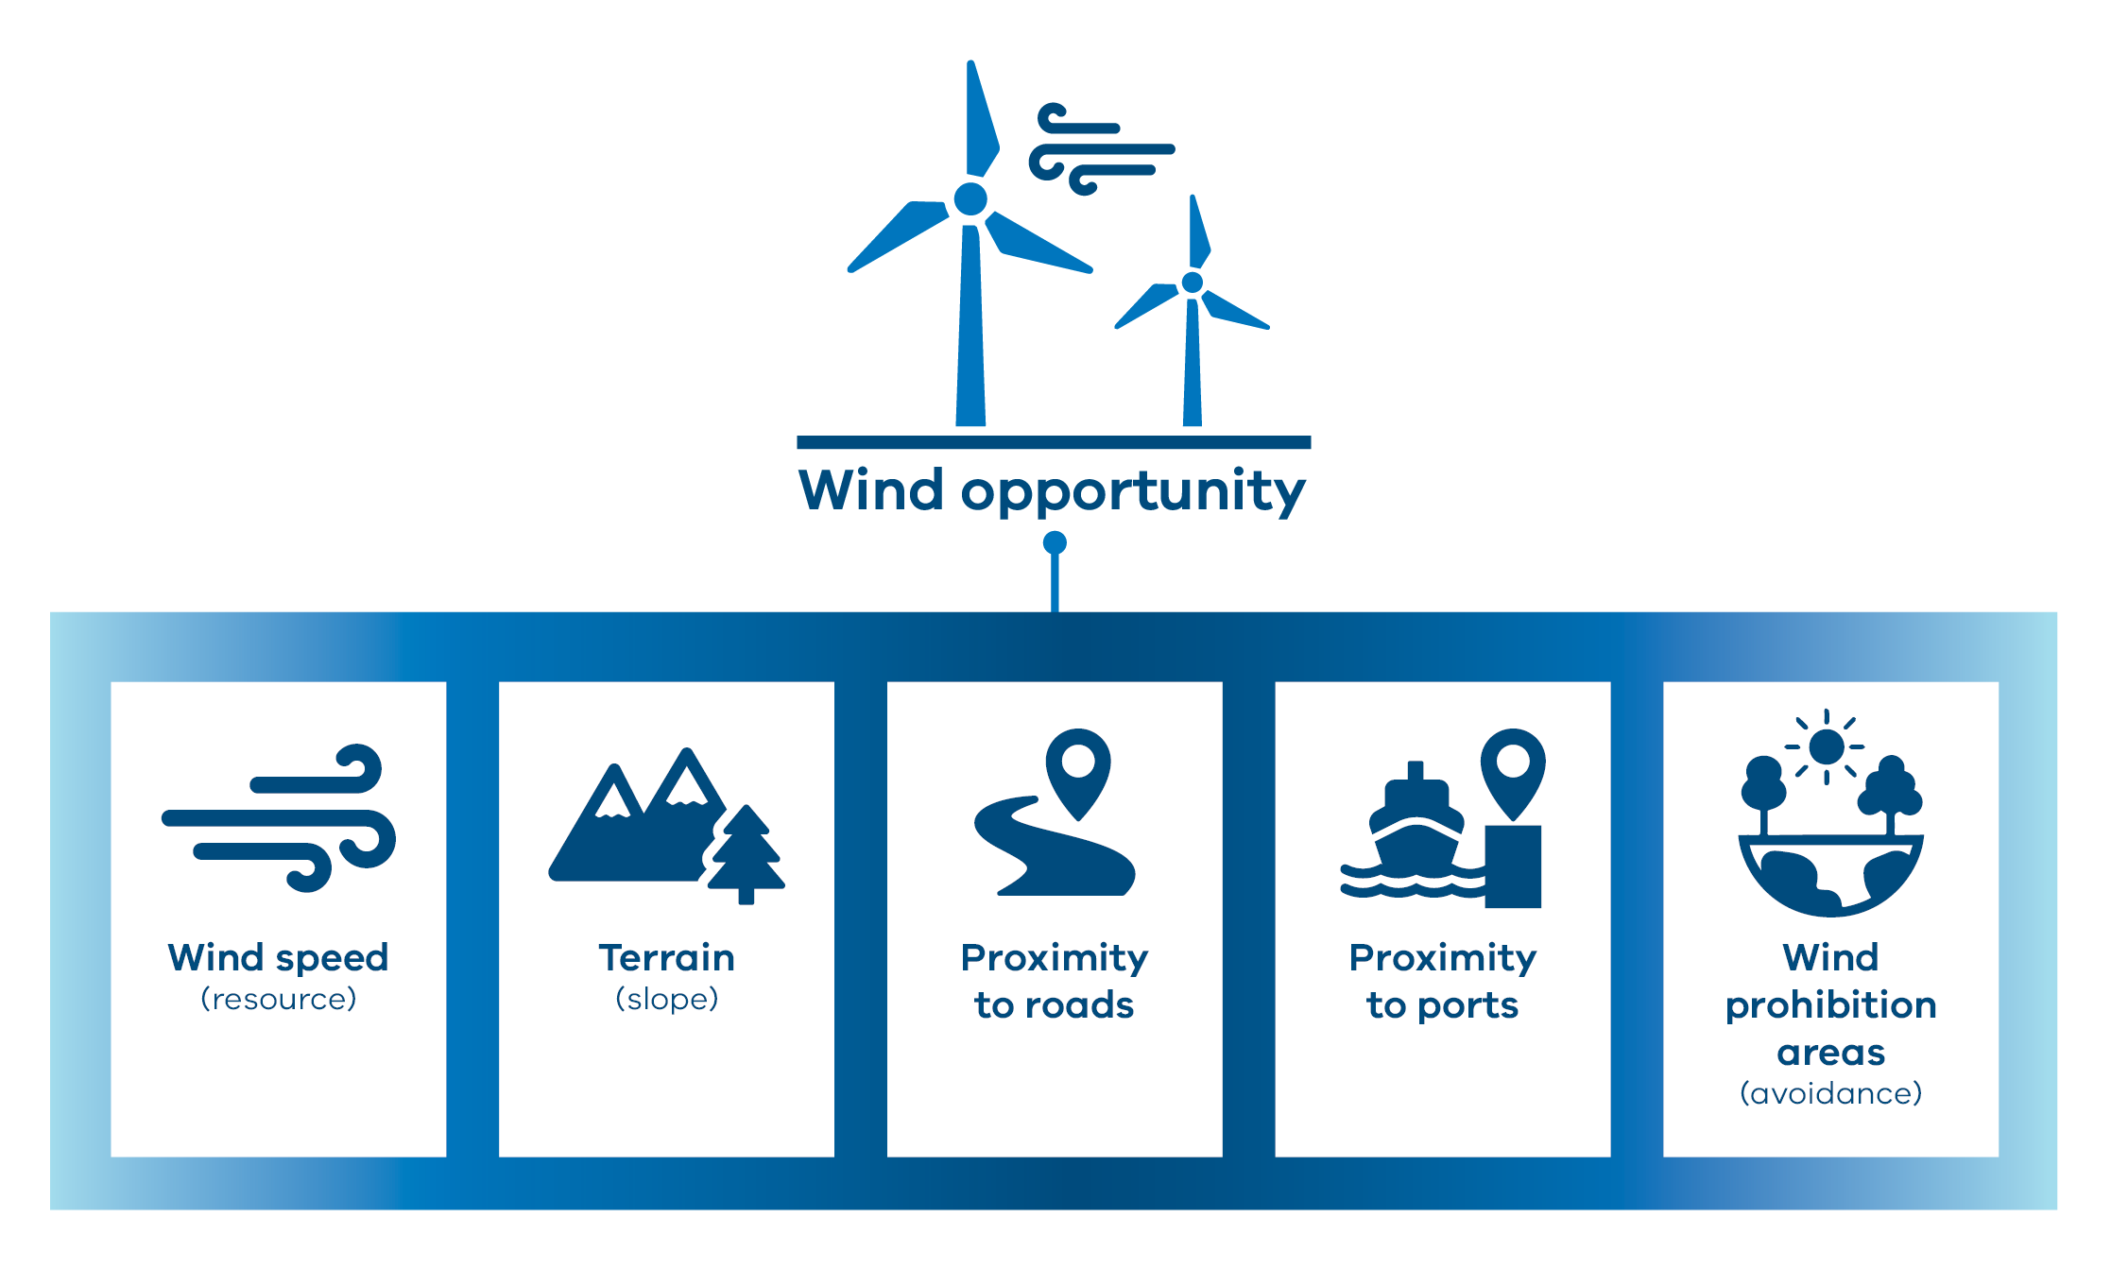
    - Solar criteria and weightings
Table A-7: Solar opportunities assessment framework
Criteria | Rationale | Weight
Solar global horizontal irradiance (GHI) (resource quality) | Solar resource was mapped on a 5 km x 5 km grid across Victoria using the Global Solar Atlas dataset, which measures the long-term yearly average global horizontal irradiance (GHI) in kWh/m2.  Solar GHI has been scored in intervals starting with a minimum of 1,300 kWh/m² as moderate opportunity, stepping up to higher intervals as most opportunity. Solar resource quality is a critical factor for siting solar generation facilities and is weighted as highest importance overall. | 60%
Slope ≤15% | Measures the level of terrain slope. Ideal topography for solar is less than 15% slope north-south. Slope greater than 15% is not supported by current tracking technology for solar installation. This criteria is scored highly as most opportunity, but is weighted as relatively low importance overall. | 15%
Proximity to Roads | Measures the distance to linear major road networks. Proximity to existing road infrastructure can introduce cost savings if roads do not have to be upgraded to carry heavy vehicles. This criteria is scored as least-moderate opportunity, but weighted as relatively moderate importance overall. | 25%

    - Wind criteria and weightings
Table A-8: Wind opportunities assessment framework
Criteria | Rationale | Weight
Wind speed (resource quality) | Wind speed was mapped on a 3 km x 3 km grid across Victoria using the Global Wind Atlas wind resource dataset. Wind resource quality (speed) is a critical factor for siting wind generation facilities.  Wind speed was measured at a height of 150 m and has been scored in intervals starting with a minimum of 6 m/sec as moderate opportunity, stepping up to most opportunity. Wind speed is weighted as highest importance overall. | 60%
Slope  - 25 – 50%  - 20 – 25%  - 0 – 20% | Measures the level of terrain slope. It is more expensive to access and construct wind farms on terrain with greater slope. This feature is spread across the opportunity range but is weighted as relatively lower importance overall. | 20%
Proximity to major roads  (0 – 5 km) | Measures the distance to major road network. Proximity to existing major road infrastructure supports project viability and cost savings and provides moderate opportunity, but is weighed as relatively lower importance overall. | 20%
Proximity to ports  - >100 km  - 50 – 100 km  - 0 – 50 km | Measures proximity to the nearest port, where wind-farm components arrive for distribution. Proximity to existing port infrastructure can introduce cost savings and minimise construction complexities and provides least-moderate opportunities, but is weighted as relatively lower importance overall. | 20%
Wind Prohibition Areas | The Victorian Planning Provisions and Planning Schemes prohibit the development of wind generation in specific locations of Victoria due to high landscape or environmental values. These prohibition areas were introduced into the Victorian Planning Provisions in 2012 and include the Yarra Valley and Dandenong Ranges, Mornington and Bellarine Peninsulas, Macedon and McHarg Ranges, and land within 5 km of the Great Ocean Road, Bass Coast and the coast east of Warrnambool. Areas in the Victorian Planning Provisions covering a large area extent were included as avoidance for wind in the statewide assessment. | Avoidance

    - Results
The results of the opportunity assessments are shown in Figure A-10 (solar) and Figure A-11 (wind).
The solar opportunity result is predominantly driven by the resource quality across the state, with potential greatest in the north and north-west and generally less in southern areas of Victoria. There are generally more limited opportunities for solar development in the east and north-east of the state because of slope constraints.
The wind opportunity result is predominantly driven by the wind resource across the state as well as access to critical infrastructure. The assessment result shows the greatest opportunities for wind development are in the west and south-west of Victoria, as well as South Gippsland. Comparatively poorer wind resource and slope constraints result in more limited opportunities for wind development in the east and north-east of the state.
Wind prohibition areas in the Victorian Planning Provisions are highlighted in yellow as Avoidance areas.

Figure A-10: Solar opportunity map
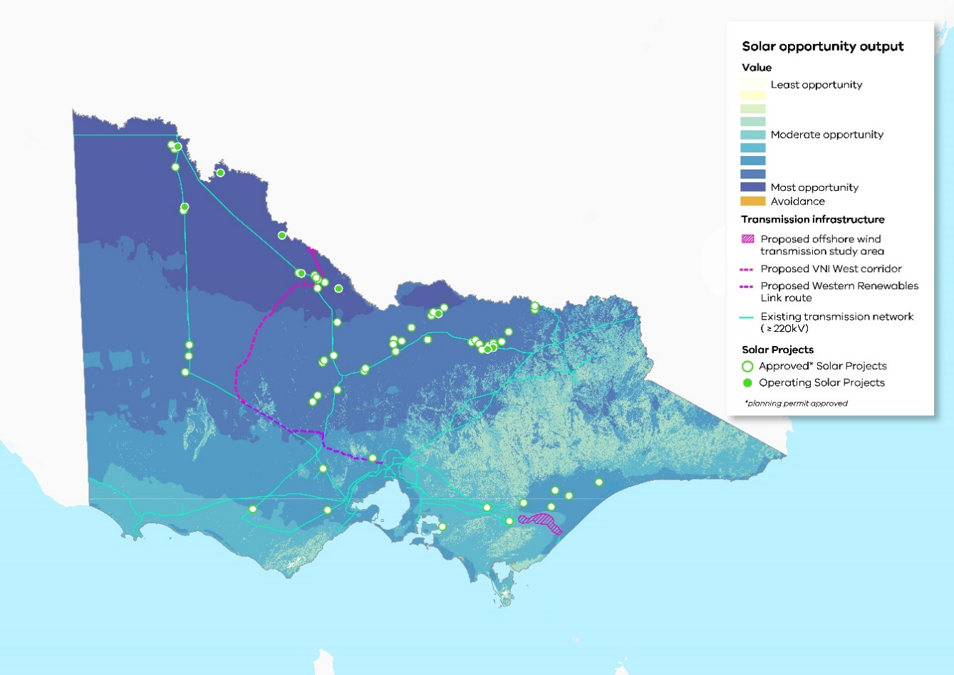
Solar project locations were sourced from the Department of Transport and Planning on 15 May 2024.
Figure A-11: Wind opportunity map
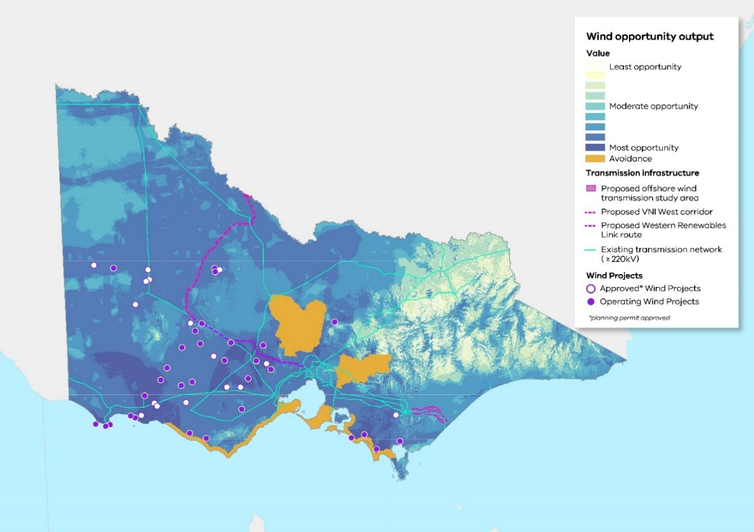
Wind project locations were sourced from the Department of Transport and Planning on 15 May 2024.

- Other criteria considered
Additional network and market factors were considered for the opportunities assessment but were not included in the spatial assessment as they were considered to be better addressed separately when identifying and refining the study area. This ensured a view of wind and solar opportunity at a state level independent of the transmission network. In particular:
- As a result of consultation with AEMO, proximity to existing and planned transmission network was removed as criteria in the opportunities MCA. Instead, proximity to the existing and planned transmission network was brought in as factor in prioritising areas within the study area.
- Marginal loss factors (the losses experienced by generators as energy is transmitted from the generation source to load centres where it is used) and network congestion (an indicator of the carrying capacity of the network to transmit energy to load centres) were considered important factors for wind and solar projects but better addressed through power system and market modelling as part of the 2025 VTP development.

- The renewable energy zone study area
The study area we are investigating for future renewable energy zones is shown in Figure A.
The study area shows the parts of Victoria that have the potential to host energy generation. It helps early in the planning process to highlight areas to protect and avoid where there are significant sensitive land use and landscape values. It will focus our further investigations on areas that have high opportunity for solar and wind generation with low constraints.
The study area brings together a number of smaller areas (the hexagons used in the analysis stage) across the state into an aggregated area. The study area is made up of tiers 1-3, shown in blue, which represents the areas being considered in development of the 2025 VTP. The darker blue areas represent more suitable areas that will generally be higher priority for investigation.
Areas shown in yellow and white on the study area map reflect areas to be respectively deprioritised or avoided because they are more sensitive or contain values not appropriate or feasible for development.
The study area boundaries are indicative and should be seen as a guide for further analysis. As part of refining the study area, there may be cases where deprioritised areas are identified as being appropriate for REZ development through closer analysis and engagement. VicGrid will consider this on a case-by-case basis through the development of the VTP.
Avoidance areas identified in the detailed constraints and opportunities assessments still apply within the proposed study area as areas to avoid. Those Avoidance areas, and any additional avoidance areas identified through consultation, will be used to support further analysis to identify proposed REZs within the broad study area.
The study area in Figure A reflects the opportunities and constraints assessments, highlighting areas for further investigation particularly in the south-west, north-west, central north and areas of Gippsland. A breakdown of each tier and area type are described in Table A-9.
Figure A-12: Renewable energy zone study area
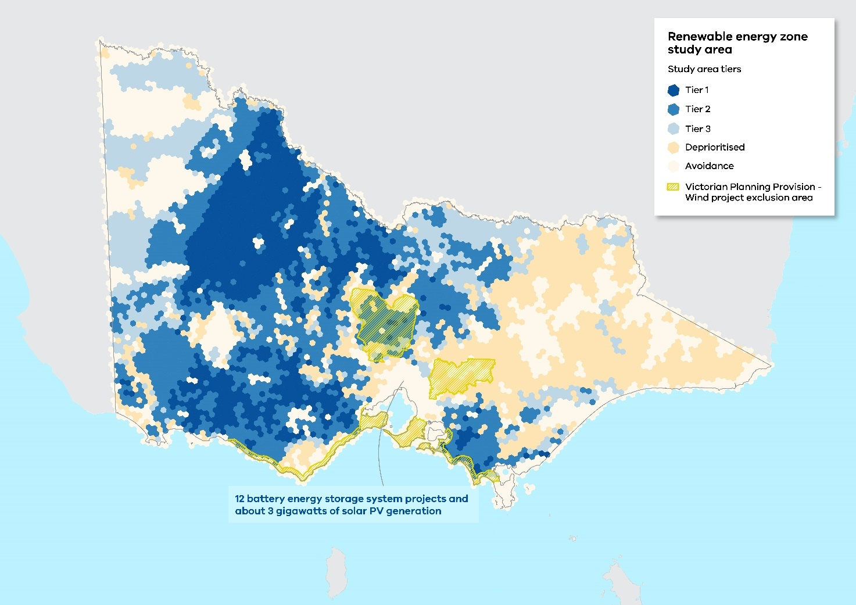
Table A-9: Renewable energy zone study area characteristics
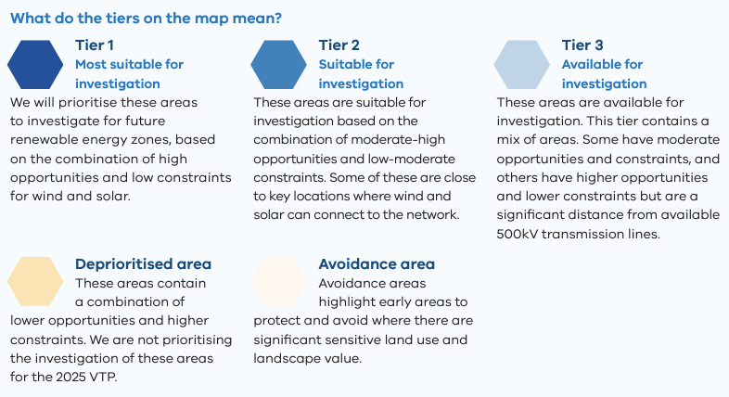
The statewide assessment considers proximity to the existing and planned 500kV transmission network, shown in Figure A-13. The results highlight areas for further study and analysis near to network infrastructure. Lower priority areas often are further away from the existing and planned 500kV network.
To validate the analysis, the study area map was reviewed against approved and operating generation projects. Figure A-14 shows wind, solar and battery projects in Victoria and highlights that the study area aligns with areas that developers have assessed as attractive for investment. No changes were made to the study area as a result of this review. Further information relating to potential REZ projects will be sought from developers through the generator survey and further industry engagement.
Please note that Figure A-13 shows a proposed alignment for Western Renewables Link, VNI West and offshore wind transmission as of the date of publication. These alignments have not completed necessary planning and environmental approvals and therefore should be considered indicative only at this time.
A more detailed map of the renewable energy zone study area including key geographical features and towns is available on https://engage.vic.gov.au/vicgrid.

Figure A-13: Renewable energy zone study area and Victorian transmission network (existing + proposed)
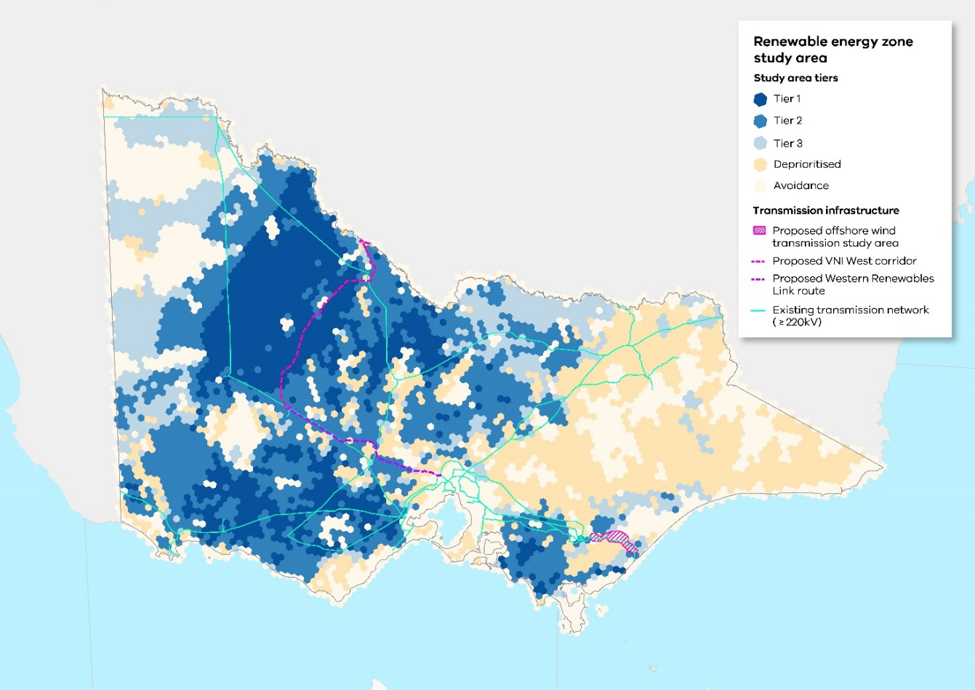
Figure A-14: Renewable energy zone study area and approved and operating renewable generation projects
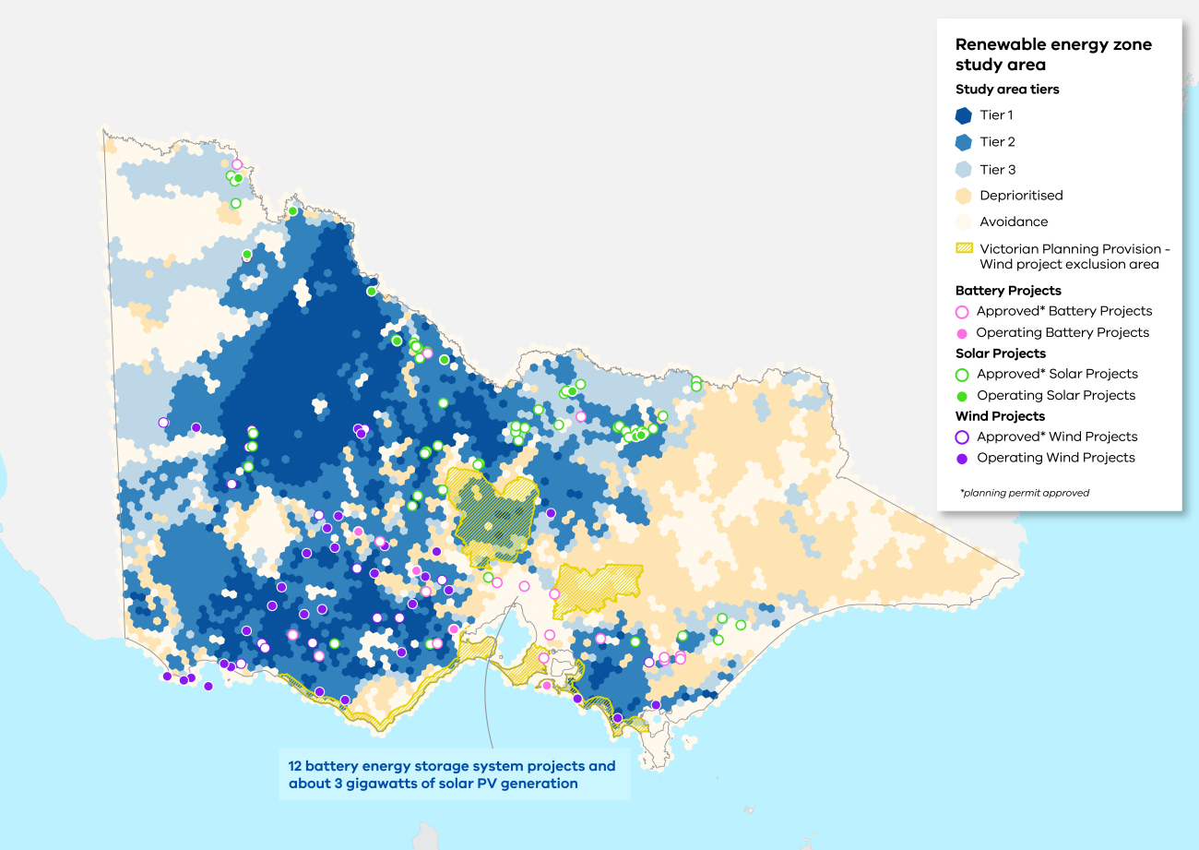
Battery, solar and wind project locations were sourced from the Department of Transport and Planning on 15 May 2024.

- Next steps
The following section explains some of the key steps we will take to refine the study area to REZs. It also outlines the phase 2 strategic land use assessment process to identify areas of interest for future transmission projects.
- How will the study area evolve as part of the 2025 Victorian Transmission Plan?
As part of developing the 2025 VTP, we will undertake further investigations to refine the study area to candidate areas for renewable energy zones. We will prioritise our investigations using the tier system described in A.7.
Ultimately, only a proportion of the study area will be needed to host new energy infrastructure. The land eventually proposed for REZs needs to protect significant areas and sites, minimise impacts on land, communities, water and biodiversity, and also keep the total cost of infrastructure low, to keep power bills down.
The study area identifies areas for further investigation and prioritisation for REZs. It does not lock in development in any region or prevent individual projects inside or outside the study area, including other technologies which might be appropriate in geographies outside the study area, such as pumped hydro storage. All proposed projects (both within and outside REZ areas) will continue to be assessed case by case, and will be subject to relevant planning and environmental approvals in Victoria. However, the Victorian declared REZs will provide benefits for communities and energy developers by improving coordination of infrastructure projects to minimise social and environmental impacts. Victoria’s new network access arrangements seek to coordinate generation into REZs to provide more certainty to communities and investors. Generators seeking to connect to the transmission network from outside a REZ will be subject to a grid impact assessment to ensure those projects do not negatively impact investment in REZs. This framework is designed to preserve the integrity of the REZ as the most appropriate location for coordinated development.
The following points summarise the levels of refinement through the 2025 VTP development:
- Study area: Broad geographical area that shows the parts of Victoria that have the potential to host a REZ.
- Candidate areas: More refined areas within the study area that are assessed as being most suitable for renewable energy generation through energy market modelling and community and industry consultation.
- Draft proposed REZs: The priority candidate areas that we propose for renewable energy generation development in the coming 15 years. These will be presented in the draft 2025 VTP.
- Proposed REZs: The priority candidate areas that we finalise following industry and community consultation. These will be presented in the final 2025 VTP and, over time, may be declared by the Minister as REZs.
To support the identification of the candidate areas and proposed REZs for the 2025 VTP, further analysis will be undertaken on the statewide constraints assessment. VicGrid will continue to work through feedback on the study area as part of this refinement including from Traditional Owners, landholders, local communities, and regional stakeholders. This feedback will enable VicGrid to consider regional and local issues, including understanding regional preferences and areas of significance. VicGrid will consider additional criteria and datasets that may be relevant in supporting the identification of REZs over time, such as in relation to agricultural land, biodiversity and cultural heritage.
Further and more detailed assessments of land use, environmental and cultural values would be undertaken for project approvals and assessments and are outside the scope of the strategic land use assessment.
Following the final 2025 VTP, the Minister can commence the REZ declaration process. The Minister will consider the proposed REZs that require development within 10 years. The REZ declaration process will include:
- Draft REZs: Each draft REZ that requires development will be specified in a draft Order prepared by the Minister for consultation.
- REZs: Each declared REZ included in formal Orders made by the Minister.
Figure A-15 illustrates the refinement process. For more detail on each step involved in the refinement process as part of developing the 2025 VTP, see Appendix B to the 2024 VTP Guidelines.
Figure A-15: The evolution of the REZ identification process through the 2025 VTP and REZ declaration
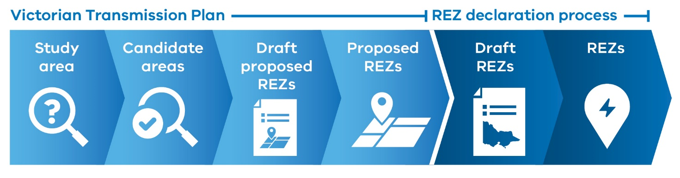
- Identifying an area for future transmission projects (strategic land use assessment phase 2)
In addition to supporting identification of proposed REZs, the strategic land use assessment will also support the identification of areas of interest for future transmission projects needed within the next 10 years. This analysis will be undertaken for proposed projects identified in the draft 2025 VTP.
The approach to identifying the transmission areas of interest will build on the statewide strategic land use assessment framework and model. Specific adjustments to the process will focus on issues relevant to transmission infrastructure. This could include adding additional, regionally specific and transmission-specific datasets where appropriate to augment or change the statewide strategic land use assessment model.
Each proposed transmission project’s area of interest will be published in a map in the draft 2025 VTP, and be subject to feedback.
These areas will ultimately be refined to transmission corridors and included as part of each REZ declaration.
This process will include more targeted engagement and analysis to ensure local values and perspectives from First Peoples, communities and stakeholders are appropriately considered.
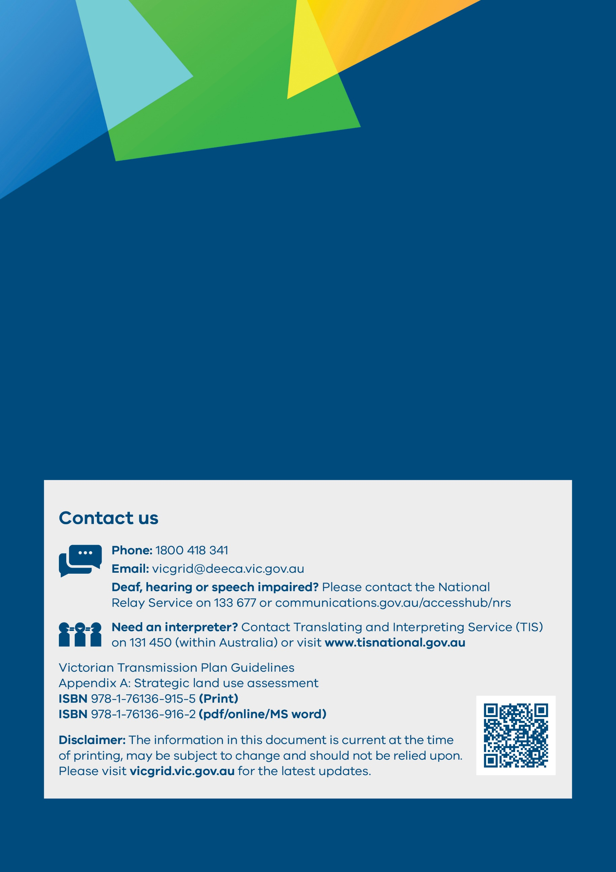

The land’s immediate potential is based on existing knowledge and practices and does not cover projected changes in technologies, climate or adaptation measures. Assessing future performance potential was found to be problematic due to a lack of a consistent dataset or method to objectively quantify future use or productive capacity.
Development of solar energy facilities in the Goulburn Murray Irrigation District are currently subject to the Solar Energy Facilities Design and Development Guidelines, which seek to protect land serviced by irrigation infrastructure: Solar energy facilities (planning.vic.gov.au).
A notable limitation at this stage is that the aggregation of datasets at the pixel resolution of the assessment may mitigate or compound any errors in datasets. Similarly, converting vector source data to raster analysis data requires the data to be transformed, which modifies the spatial representation of the data.
VicGrid selected the hexagon size to support the strategic selection of a study area to meet VTP requirements. Hexagons were selected based on those that intersect with the geometry of the Victorian state.
Participate | Developing the first Victorian Transmission Plan | Engage Victoria.
Pop-ups were held in Ballan, Benalla, Maffra, Mildura, Mortlake, Natimuk, Stawell, Warrnambool and Yarram.
‘Regions’ for the REZ Planning Survey were selected broadly based on the geographies of the Australian Energy Market Operator’s 6 REZs as published in the Integrated System Plan.
The term ‘cultural heritage’ refers to both tangible and intangible values. Tangible cultural values relate to physical objects, places, or landscapes, whereas intangible heritage values can range from social and spiritual values, to oral traditions, artistic practices, skills, and knowledge. They can be associated with physical places and objects, but can also occur separately from these (UNESCO Intangible Cultural Heritage 2024).
Within the cultural heritage theme, the criteria have been collated within sub-themes, which were defined based on legislative pathways or the types of heritage present. Aboriginal cultural heritage includes heritage that has predominantly Aboriginal heritage values or that would require approval under the Aboriginal Heritage Act 2006 (Vic). Historical heritage includes heritage values that date to the contact or post-contact period or that would require approval under the Heritage Act 2017 (Vic). Cultural heritage is for heritage that has more than one type of heritage present.
Approved and operating solar project locations are provided as a visual guide only. Those shown were sourced on 15 May 2024, and do not represent the complete dataset of in-service and committed generation projects that will be considered in the VTP methodology, as outlined in Appendix B.
Approved and operating wind project locations are provided as a visual guide only. Those shown were sourced on 15 May 2024, and do not represent the complete dataset of in-service and committed generation projects that will be considered in the VTP methodology, as outlined in Appendix B.
This decision was due to capacity constraints on the existing Victorian network which limits available capacity for hosting new renewables projects beyond the projects already in the state’s pipeline. This ensured the wind and solar opportunity models could provide a view on areas of high potential for renewable energy development independent of the transmission network including in areas that could be unlocked through future augmentations under the VTP.
Project locations are provided as a visual guide only. Those shown were sourced on 15 May 2024, and do not represent the complete dataset of in-service and committed generation projects that will be considered in the VTP methodology, as outlined in Appendix B.

