Gippsland offshore wind2 GW transmission project
Study area refinement report
  - October 2026

Acknowledgment of Traditional Owners
We acknowledge and respect Victoria’s Traditional Owners as the original custodians of Victoria’s land and waters, their unique ability to care for Country and deep spiritual connection to it. We honour Elders past and present whose knowledge and wisdom has ensured the continuation of culture and traditional practices.
We are committed to genuinely partnering and meaningfully engaging with Victoria’s Traditional Owners and First Peoples to support the protection of Country, the maintenance of spiritual and cultural practices and their broader aspirations
in the 21st century and beyond.
Acknowledgment of Traditional Owners 1
Executive summary 3
About this report 3
The preferred route 4
What happens next 4
Gippsland offshore wind 2 GW transmission project 4
Offshore wind energy transmission 4
VicGrid’s guiding principles 5
VicGrid and the development partner: roles and responsibilities 5
How we identified the study area 5
Refining the study area to a preferred route 7
Phase 1: Identifying areas not suitable to host transmission 8
Phase 2: Identifying a corridor 11
Phase 3: Identifying a route 30
Identifying the easement 51

Executive summary

About this report
This report explains how VicGrid identified the Gippsland offshore wind 2 GW (gigawatt) transmission project’s preferred route.
We recognise a project of this scale will bring significant change for people who live and work in the area. This report explains how we narrowed the study area, what informed our decisions and why we chose the preferred route.
We started with an initial study area identified through the options assessment method. More information about how we identified this area is available in the Gippsland Options Assessment Report, published in March 2024.
From there, we progressively narrowed a broad study area – between 3 and 12 km wide – to a corridor, draft preferred route and finally a preferred route around 200 m wide.
At each stage, we used environmental, land use and technical criteria – based on our guiding principles – to compare options and identify where a transmission line could be located with the fewest impacts.
We combined desktop assessments, field investigations and preliminary engineering with feedback from landholders, Traditional Owners and the community. This feedback informed our decisions and led to changes to the route.
At the same time, we have been preparing an Environment Effects Statement (EES), which will assess the project’s potential environmental, social, cultural and economic impacts in detail. The EES is planned for public exhibition in 2027.
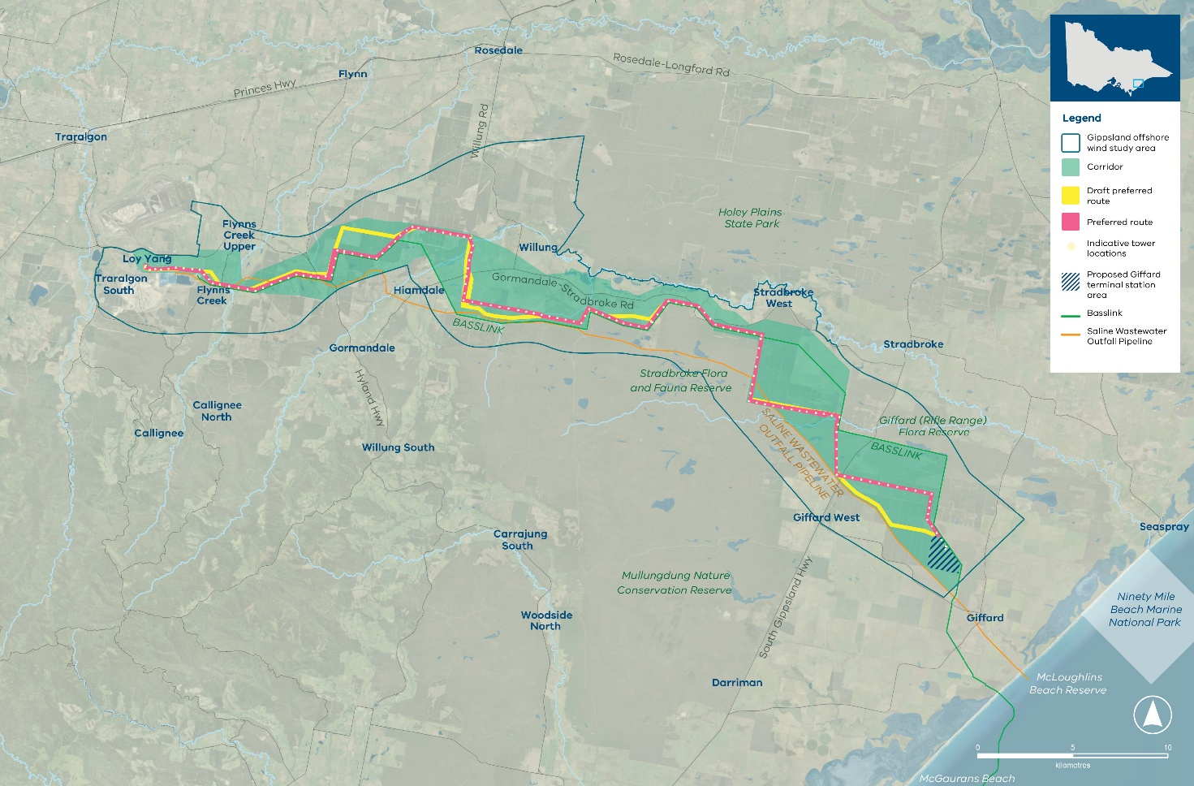

The preferred route
The preferred route is about 60 km long and 200 m wide, running from a proposed terminal station at Giffard in the east to the Loy Yang Power Station switchyard in the west.
Where practical, we have aligned the route with Basslink to follow existing transmission infrastructure.
Landholder feedback informed several changes to the draft preferred route. These changes helped us to:
- Follow Basslink and property boundaries more closely
- Reduce visual impacts for nearby homes
- Minimise property fragmentation
- Limit disruption to existing plantation operations

What happens next
The preferred route will be assessed through the EES. Within this route, we have developed a reference design and an indicative easement to assess the project’s potential impacts.
The indicative easement is 70 m wide in most areas and up to 170 m wide at two locations where additional width is needed to reduce electrical interference with Basslink.
The reference design and indicative easement are not final. We developed them for assessment purposes. Once appointed, a development partner will work alongside VicGrid to confirm the final easement, exact tower locations and other details.
To find out more about the reference design and what it could mean for your area or property, read our Preferred route and reference design summary.
If you would like to talk to us about your land, contact us at enquiries@vicgrid.com.au or speak directly with your landholder engagement advisor.

Gippsland offshore wind 2 GW transmission project

Offshore wind energy transmission
VicGrid is planning and delivering the shared transmission infrastructure needed to connect future offshore wind energy projects off the Gippsland coast to the electricity grid.
A shared transmission line will avoid the ‘spaghetti effect’ of many private transmission lines and minimise environmental impacts.
Offshore wind energy project developers are responsible for planning and delivering the connection of their offshore infrastructure to a new terminal station at Giffard.
We are designing the Gippsland offshore wind
2 GW transmission project to meet the Victorian Government target of 2 GW of offshore wind generation capacity by 2032.
Victoria will need additional transmission infrastructure for offshore wind generation beyond the first 2 GW of capacity in Gippsland. The 2025 Victorian Transmission Plan identified this need.
Further work will identify an appropriate route for this additional infrastructure so it can support Victoria’s offshore wind energy targets.

VicGrid’s guiding principles
VicGrid first established the guiding principles for deciding where the transmission line should go through an options assessment method, following consultation with communities in 2023. We then tested the principles through further engagement and community attitudes research.
We have used these principles throughout the refinement process to guide decisions about where the transmission line should go.

VicGrid’s guiding principles
- Minimise impact on host landholders and communities, including visual amenity
- Minimise impact on the environment
- Minimise impact on First Peoples’ cultural values and aspirations
- Minimise impact on existing and future land use
- Minimise cost impacts to energy consumers and generators
- Limit engineering complexities during construction and impacts on existing infrastructure

VicGrid and the development partner: roles and responsibilities
VicGrid’s role in deciding where the transmission line goes has included:
- Working with an initial area of interest identified in Offshore Wind Implementation Statement 1, where the transmission line could feasibly be located to support generation in the Gippsland offshore wind declared areas
- Establishing the options assessment method to assess possible corridor options and define a study area
- Developing a refinement approach to narrow the study area to a corridor, and then to a preferred route and reference design for assessment in the Environment Effects Statement (EES)
VicGrid will appoint a development partner to help prepare the project for delivery. The development partner will work alongside VicGrid, and within the preferred route, to:
- Confirm the final easement (expected to be around 70 m wide in most areas and up to 170 m wide in two locations)
- Confirm exact locations of transmission towers and other infrastructure
- Work with landholders on the agreements, compensation and payments for hosting infrastructure
VicGrid will stay involved throughout this process. The decisions and commitments we have made carry through to this stage, and we will keep working directly with landholders as the design is finalised.

How we identified the study area
In March 2024, VicGrid identified an initial study area for the transmission line using the options assessment method. This structured process compared different options against a common set of criteria – drawing on community feedback, desktop analysis and technical advice.
We started with a long list of 12 possible transmission corridors. We mapped existing land uses, features, values and areas of sensitivity between the Gippsland coast and the existing electricity grid, then compared the options at a high level to understand their key differences.
The assessment gave equal weight to maximising the benefits of each option and minimising its impacts. We built the guiding principles into this process and continued to apply them through the refinement work that followed.
The assessment identified the best-performing option because it:
- Was shorter, with fewer engineering complexities, which helps to reduce construction costs and time
- Avoids major residential areas and sensitive community assets
- Offered opportunities to align with other infrastructure, including roads and the existing Basslink transmission line
- Balanced different land uses, interacting with a lower proportion of agricultural land and a higher proportion of public and plantation land
- Was centrally located to the offshore wind declared area
From this option, VicGrid defined a broad study area between 3 and 12 km wide for further refinement through the phases described in this report.
A more detailed explanation of this phase is available in the Gippsland Options Assessment Report, published in March 2024.
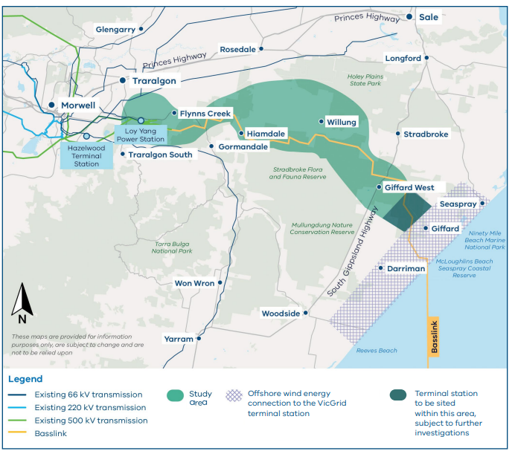
Study area and indicative terminal station location
Source: engage.vic.gov.au/project/offshore-wind-transmission/page/document-library

Refining the study area to a preferred route

Our approach to refinement
To refine the study area, we applied environmental, land use and technical criteria to understand,
compare and assess the potential impacts of different options, and identify land most suitable to
host transmission infrastructure.
VicGrid’s guiding principles, industry expertise, community feedback and engagement informed the criteria.
This process narrowed the investigation from a broad study area 3–12 km wide to a corridor, then to a draft preferred route and, finally, a preferred route around 200 m wide. The development partner will work alongside VicGrid to confirm the final easement.
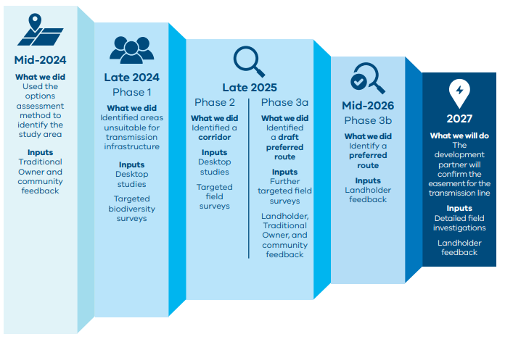

Phase 1: Identifying areas not suitable to host transmission

Developing the Phase 1 refinement criteria
We began Phase 1 by setting criteria to help identify whether areas were more or less suitable to host transmission infrastructure.
Table 1 summarises these criteria and gives examples of how we applied them. We continued to use the Phase 1 criteria throughout subsequent refinement phases.
Table 1: Phase 1 refinement criteria
Phase 1  refinement criteria | Examples of areas that were less suitable for further investigation | Examples of areas that were more suitable for investigation
Scenic places and visual amenity | Land closer to homes, heritage places or scenic lookouts. | Land further from dwellings, in open landscapes or screened by vegetation.
Land uses and zones | Areas closer to homes, schools and recreation areas, and land zoned for rural living, recreation, conservation or environmental significance. | Land already zoned for utilities and infrastructure or used for livestock grazing or grain growing.
Land size | Smaller parcels of land which would be detrimentally fragmented by transmission infrastructure. | Larger parcels where transmission infrastructure could be located along a boundary to minimise fragmentation and impacts on neighbouring land.
Biodiversity | Land with mostly native flora and fauna and a higher likelihood of, or confirmed presence of, threatened species. | Land with little or no native flora and fauna.
Waterways | Areas where impacts on waterway flow and the effects of flooding might be greater. | Areas less likely to be affected by flow changes or flooding.
Cultural heritage | Areas of high Aboriginal cultural heritage significance, where ancestral remains, songlines or ceremonial sites may be found. | Land already disturbed by other infrastructure or industry.
Buildings and other infrastructure | Areas with more buildings or infrastructure, particularly active irrigation, dams and homes. | Land with fewer buildings or less critical infrastructure.
Technical constructability | Land featuring mountainous terrain, large water bodies, regular flooding, contamination or swampy areas which would present greater construction complexity and cost. | Less mountainous land that would not require long spans between towers or sharp turns in the transmission alignment.

Areas identified as unsuitable to host transmission infrastructure
In Phase 1, VicGrid assessed every land parcel within the study area to identify places where a transmission line would cause unavoidable and unacceptable impacts. We initially used existing
data and mapping for this early desktop assessment, before carrying out targeted field surveys in
selected areas.
Parcels were sorted into two groups:
- Suitable for further investigation – places that could potentially host transmission, but where more information was needed in later phases to understand the constraints.
- Not suitable for further investigation – places identified as unable to host transmission, which were removed from the study area.
Being marked ‘suitable’ at this stage did not mean a parcel would host transmission. It meant the parcel warranted a closer look in later phases.
Because this was an early desktop-based step, we did not rule out a parcel simply because a constraint might be present. Instead, we considered how likely and how significant each constraint was.
For example, a biodiversity constraint could be avoided later through further investigation and by carefully positioning (micro-siting) infrastructure – so its presence alone did not make a parcel unsuitable.
Two criteria presented the most constraints in this phase and had the greatest influence on which areas we ruled out: biodiversity and technical constructability.

Biodiversity
We assessed biodiversity values using information from the Victorian Biodiversity Atlas (VBA), the Commonwealth Predicted Matters Tool and the Habitat Values dataset prepared by the Department of Energy, Environment and Climate Action (DEECA).
VicGrid reviewed records of threatened species listed under the Environment Protection and Biodiversity Conservation Act 1999 (Cth) (EPBC Act) and the Flora and Fauna Guarantee Act 1988 (Vic) (FFG Act) to identify those most at risk and where offsets may be unavailable or difficult to secure.
We also carried out targeted field surveys to map and assess native vegetation, fauna habitat and
the potential presence of threatened species
and communities.
This assessment determined that Holey Plains State Park was not suitable for further investigation, as it was unlikely that unacceptable impacts could
be avoided.

Technical constructability
We also tested whether it would be practical to build transmission infrastructure on parcels identified
as suitable.
We ruled out areas where, for example, parcels were too small to host transmission infrastructure, would become ‘landlocked’ between other constraints, or would force the line to backtrack.
This test ruled out land to the west of Loy Yang Power Station because the transmission line must approach the Loy Yang connection point from the east. Some parcels would also have required the transmission line to span the Loy Yang open-cut mine, which would not be technically feasible.
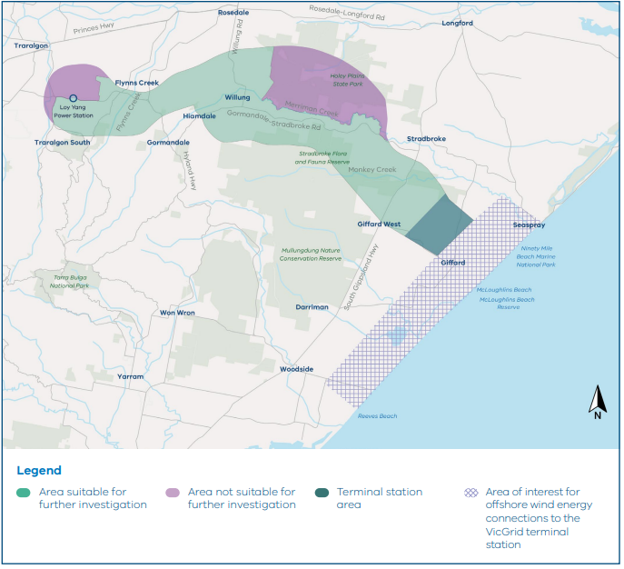
Refining the study area
Source: engage.vic.gov.au/project/offshore-wind-transmission/page/document-library

Phase 2: Identifying a corridor
Phase 2 identified a corridor – or area of connected land – based on environmental, land use and engineering factors.
We completed targeted field surveys and investigations, mapped environmental values
and consulted with landholders to learn about
the study area.
To identify the corridor, we:
- Mapped homes, environmental values and areas with technical challenges
- Identified possible pathways for the transmission line
- Applied the refinement criteria to compare and assess these pathways
- Identified a corridor with the fewest constraints
During this phase, we assessed technical constraints, land use types, biodiversity and Aboriginal cultural heritage. We considered these values first because they had more influence on the project location.
We also mapped constraints relating to visual amenity, contamination, hydrology and bushfire risk.
Areas where constructing the transmission line was not technically feasible were ruled out.
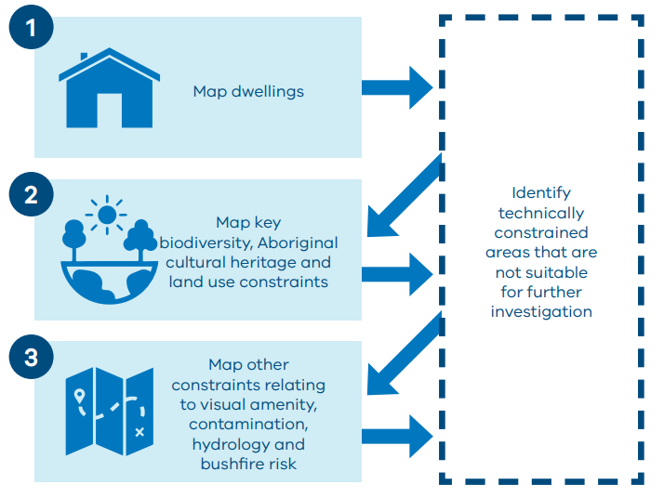

Identifying areas with constraints
We used heat maps to identify the concentration of different environmental and social values.
These maps helped identify which areas had multiple significant values and where new transmission infrastructure may result in higher impact.
We prepared the heat maps using spatial mapping data and other datasets.

Technically constrained areas
We applied a 300 m buffer around homes, following the Australian Energy Infrastructure Commissioner’s recommendation for a minimum 300 m setback from 500 kV (kilovolt) transmission lines wherever possible, unless otherwise agreed through consultation with the relevant landholder.
We mapped all homes in the study area to identify constraints. This required some on-the-ground investigations to ensure all housing and structures were mapped correctly.
Other technical constraints included:
- Areas where the 300 m buffers around two or more homes overlapped, or where there was less than 70 m clearance between two homes. These areas could not accommodate a 70 m easement.
- Areas where the transmission line would need to backtrack along the route, increasing route length and potential impacts.
- Areas where the new transmission line would not be able to cross the existing Basslink transmission line due to limited space.
- Areas within the Loy Yang Power Station overburden dump, which contains mining
waste material unsuitable for transmission
tower foundations.
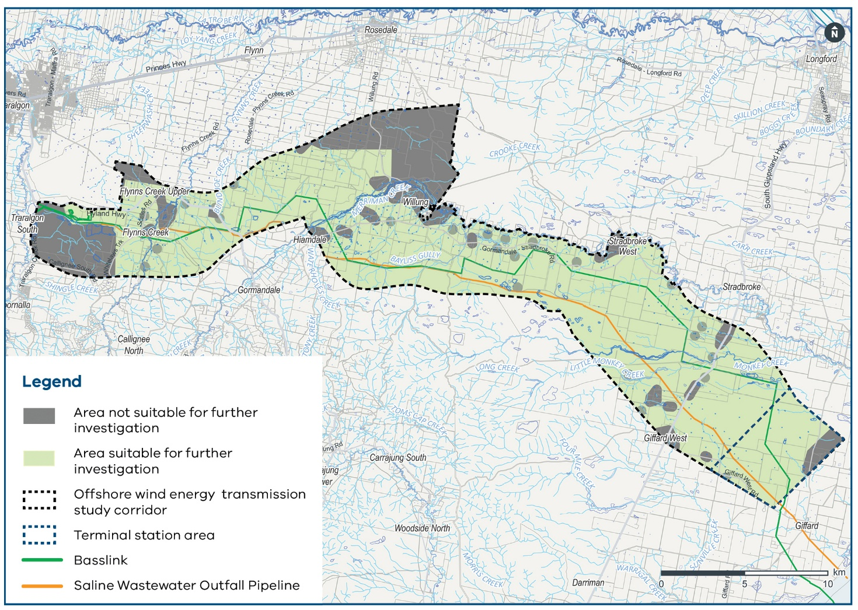

Biodiversity
We mapped biodiversity constraints by layering different datasets and preparing a heat map. The heat map showed areas with higher biodiversity values, including habitat for threatened species, known locations of threatened flora and fauna, threatened ecological communities, and waterways.
Table 2: Datasets used to map biodiversity values
Environmental value | Data source
Habitat value | Habitat Value Map (DEECA)
Ecological vegetation class (EVC) conservation status and native vegetation extent | Extant (2005) EVC mapping (DEECA)  Native Vegetation Extent (2017)
Threatened ecological community (TEC) | Extant (2005) EVC mapping (DEECA)
Known locations of threatened flora and fauna | Victorian Biodiversity Atlas  DEECA Spatial Data  Targeted field surveys (2024)
Habitat for a threatened species for which offsets are not readily available | Habitat Importance Map
Landscape score | Landscape score (DEECA)
Waterways and current wetlands | Vicmap Hydrology  Index of Stream Condition 2010 scores  Current Wetlands (DEECA)
Protected public land | Public Land Management (DEECA)

This work identified several areas with important native vegetation and wildlife values, including:
- Giffard (Rifle Range) Flora Reserve
- Mullungdung State Forest
- Stradbroke Flora and Fauna Reserve
- Merrimans Creek Flora Reserve
- Gormandale Flora Reserve
- Callignee State Forest

Aboriginal cultural heritage
We developed a predictive model to map areas where tangible Aboriginal cultural heritage is more likely to be present, based on different landforms and features. For example, higher and drier landforms, and areas near water, are more likely to have supported past habitation or provided access to resources.
The predictive model provided an important starting point but does not replace the need for more detailed assessments. Further consultation and on-the-ground surveys with Gunaikurnai Land and Waters Aboriginal Corporation (GLaWAC) are ongoing to ensure Aboriginal cultural heritage is properly identified, respected and protected.
The results indicated a very high level of constraint near waterways including Merriman Creek, Bayliss Gully Creek, Monkey Creek and Flynns Creek, and on elevated land, including areas within the Callignee State Forest.

Land use compatibility
We assessed how existing and planned land uses interact with transmission infrastructure. For example, some farming types are more compatible with transmission infrastructure than others.
Transmission infrastructure has impacts on every type of land use. The purpose of this assessment was to consider which land uses would be more or less compatible.
The assessment considered:
- Agricultural activities: intensive farming activities, such as dairy farming and pivot irrigation, are less compatible with transmission infrastructure, while livestock grazing and other dryland cropping activities are more compatible.
- Mining and extractive industries: active mining operations are less compatible with transmission lines. Exploration licences may also constrain the development of transmission lines.
- Informal recreational parkland: parkland is important to the community, particularly areas containing native vegetation.
- Aviation: the proximity of airstrips and aircraft operations to transmission lines creates aviation safety risks.
- Existing approvals: land with an existing development approval was assessed as having a high expected level of constraint.
- Restrictive covenants: legal covenants permanently protect land and are considered a significant constraint on the development of transmission infrastructure.
The assessment found that much of the investigation area had a high level of land use constraint.

Visual amenity
We assessed how the project might affect the views of people in the area.
Private homes have the highest level of sensitivity, followed by recognised scenic places such as Holey Plains State Park.
We rated constraint levels based on a dwelling’s proximity to proposed transmission infrastructure.
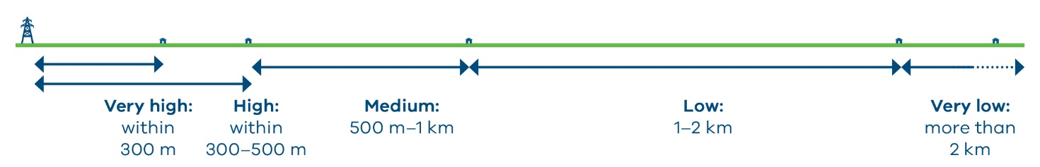

Contamination
We assessed the likelihood of contaminated land in the area. Contamination can present risks to construction, the environment and community safety if not managed properly.
The assessment found constraints in the Loy Yang precinct, as it has two rural country fire service facilities and a landfill site. Fire service facilities may have contaminated land due to historical use of per-fluoroalkyl and polyfluoroalkyl substances (PFAS) in firefighting foam.

Hydrology
We mapped hydrology across the investigation area using existing datasets, including:
- Land Subject to Inundation Overlay: land that may flood during a 1-in-100-year flood event
- Flood Overlay: land where floodwaters are likely to flow quickly and with high force
These desktop reviews identified approximately 10 major waterways and 260 km of minor waterways in the investigation area.

Bushfire
Like most of rural Gippsland, the whole investigation area is designated as bushfire prone under the Building Act 1993 (Vic). This means the land is at risk of being affected by bushfires.
We take this seriously. In mapping constraints, we applied the Bushfire Management Overlay (BMO) – the planning control used for land most significantly affected by extreme bushfire – as the highest level
of constraint.
The BMO relies on broad-scale mapping, which may not fully reflect factors that change over time, such as vegetation growth, climate change and seasonal conditions. These factors can increase or decrease risk.
Bushfire risk is examined in much greater detail in the Bushfire Impact Assessment, which forms part of the Environment Effects Statement (EES). VicGrid will continue to work with the Country Fire Authority and with landholders to plan for and manage bushfire risk.
For more information, see our bushfire risk fact sheet vicgrid.com.au/__data/assets/pdf_file/0037/794467/Transmission,-renewables-and-fire-safety-factsheet.pdf

Combined heat map and constraints
We layered the heat maps to identify the least-constrained areas. For example, an area could have fewer biodiversity constrains but greater land use or cultural heritage constraints. Comparing these differences helped up identify sensitive places and select the most suitable corridor for further investigation.
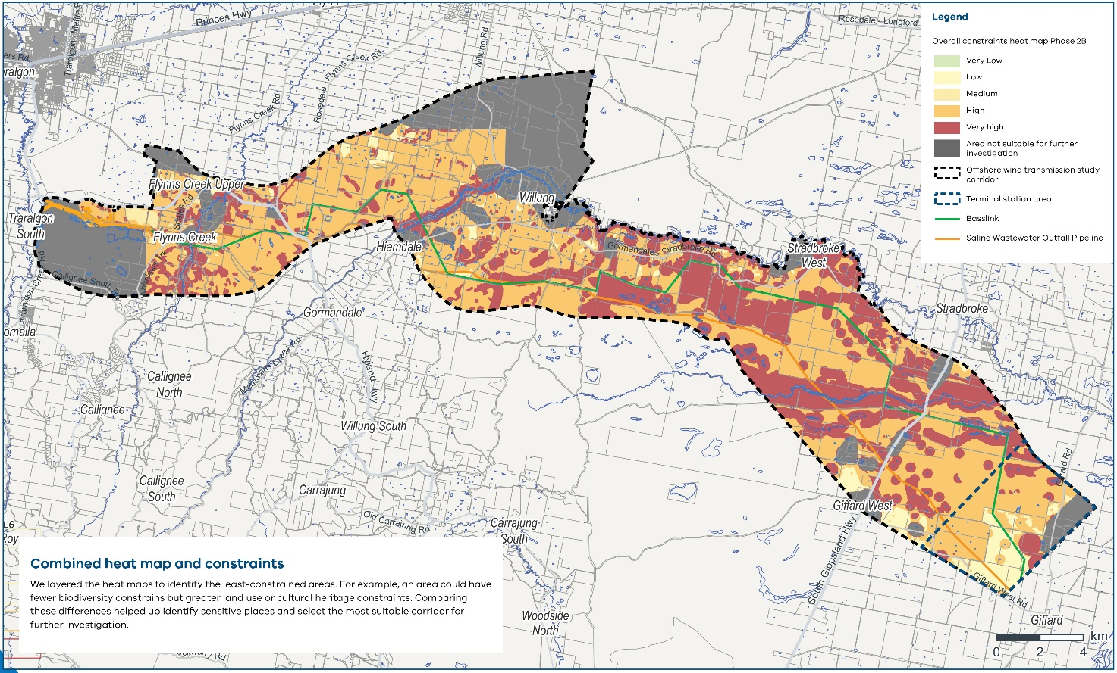
Combined heat map and constraints

Identifying possible transmission line pathways
We used the heat maps to identify possible pathways that avoid homes, technically constrained areas and places with important biodiversity and cultural heritage values.
We applied Phase two criteria to make sure each pathway was logical and technically feasible. Our aims included:
- Avoiding areas of ‘very high’ impact on important values where possible.
- Crossing waterways at about 90 degrees to reduce the required transmission line span length, minimise vegetation impacts, and maintain safety clearances from the waterway.
- Aligning with property boundaries or roads where possible.
- Exploring co-locating with existing transmission infrastructure where possible.
- Limiting transmission line spans to 400–500 m (span lengths are the distance the lines cover between each tower).
- Maximising straight sections where possible and ensure the transmission line can progress in a forward direction, avoiding the need to backtrack.
- Limiting transmission line angles to 90 degrees and avoid changing angles over short distances. Using acute angles to change direction may need larger towers, increasing the complexity of the structure and the visual impact. Acute angles can also present issues with electrical clearance (the minimum safe distance between two energised lines).
- Minimise the number of crossings of Basslink to maintain electrical clearances and reduce electromagnetic interference. Where a crossing of Basslink is required, cross at approximately 90 degrees to minimise the footprint and reduce impacts.
We identified 37 possible pathway segments through this process, resulting in a total of 302 potential end-to-end pathways.
We divided the investigation area into five sections to simplify the assessment and to compare pathway options within each section based on desktop studies and information captured through the heat mapping phase.
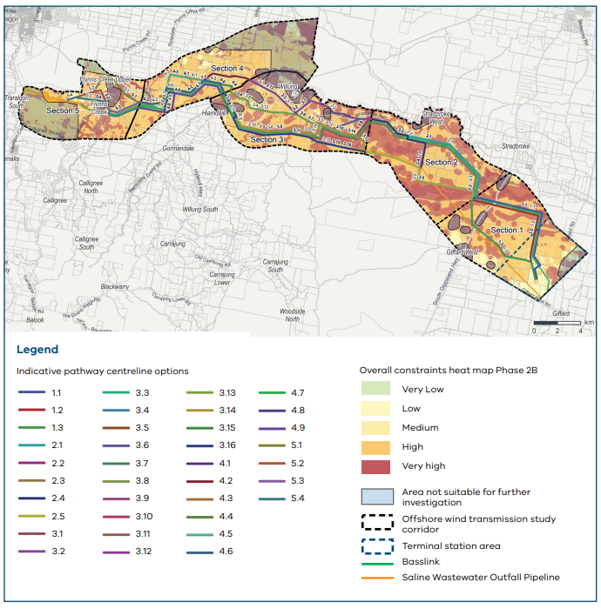
Map of possible pathways identified

Options assessment

Section 1: Giffard to Stradbroke
This section includes farmland in the east, sections of Giffard Plantation and Mullungdung State Forest. We identified three options:
- Option 1.1 follows the Basslink corridor, set back slightly to the east and north.
- Option 1.2 follows the Basslink corridor, set back slightly to the west and south.
- Option 1.3 follows the Saline Wastewater Outfall Pipeline (SWOP) for part of the section, then angles north to cross the narrowest part of Mullungdung State Forest (a highly constrained biodiversity area).
Options 1.1 and 1.3 could be co-located with existing infrastructure to reduce impacts but would present technical challenges. Further investigation was needed during later refinement phases to confirm required distances from Basslink and the SWOP.
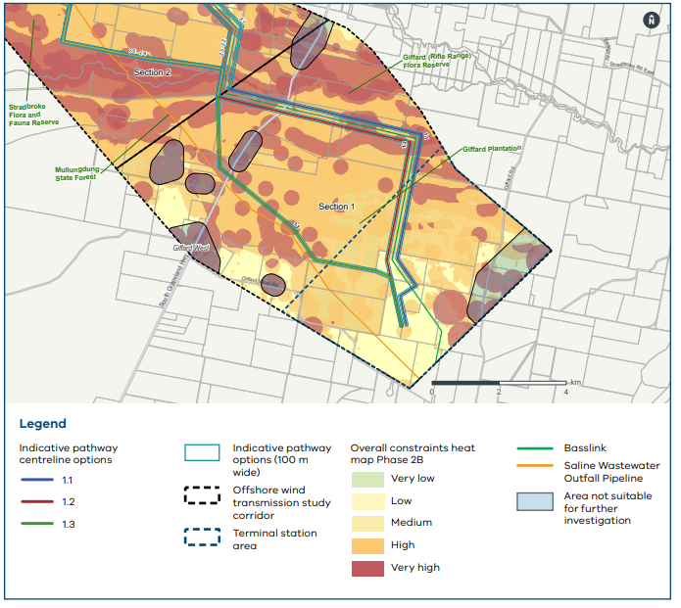
Map of Giffard to Stradbroke options

Assessment key
For each section of the investigation area, we conducted further analysis to understand the level of constraint.
We tested the pathway options in each section against our Phase 1 criteria. We looked at the proportion of each option that would have ‘high’ or ‘very high’ levels of constraint.
If an option contain no or very few areas with a ‘very high’ level of constraint for a criterion, we marked it bright green. If there were many areas in the option with very high constraints, this was marked bright yellow.
Table 3: Study corridor Section 1 pathway options, key constraints analysis
Criteria | Expected level of constraint | Option 1.1 | Option 1.2 | Option 1.3
Total area (ha) |  | 121.09 | 115.07 | 99.41
Biodiversity | Very high | Moderate | Moderate | Low
Biodiversity | High | Moderate | Moderate | Moderate
Aboriginal cultural heritage | Very high | Moderate | Moderate | Moderate
Aboriginal cultural heritage | High | High | Moderate | Moderate
Based on the comparison, option 1.1 was assessed as unsuitable because transmission in these areas would significantly impact native vegetation through the Giffard (Rifle Range) Flora Reserve. Land south of the SWOP was not suitable for further investigation due to constraints with crossing the SWOP and impacts on homes in Giffard West.
Pathway options 1.2 and 1.3, and the land between them, were considered suitable for further investigation.

Section 2: Stradbroke to Willung
The eastern part of the corridor between Stradbroke and Willung is mostly public reserves and farmland, including plantation areas. There are some homes in the northern part of this section, closer to Merriman Creek.
In this area, two main approaches were tested: following Basslink as much as possible or locating pathways near plantation and reserve boundaries. Using these approaches, five different options were identified:
- Option 2.1 follows Basslink to the north (the northernmost option).
- Option 2.2 follows Basslink to the south but shifts northward to avoid the Stradbroke Flora and
Fauna Reserve.
- Option 2.3 follows Basslink to the south.
- Option 2.4 runs west through plantation land, then turns north to cross Basslink.
- Option 2.5 follows the SWOP and passes through the Stradbroke Flora and Fauna Reserve.
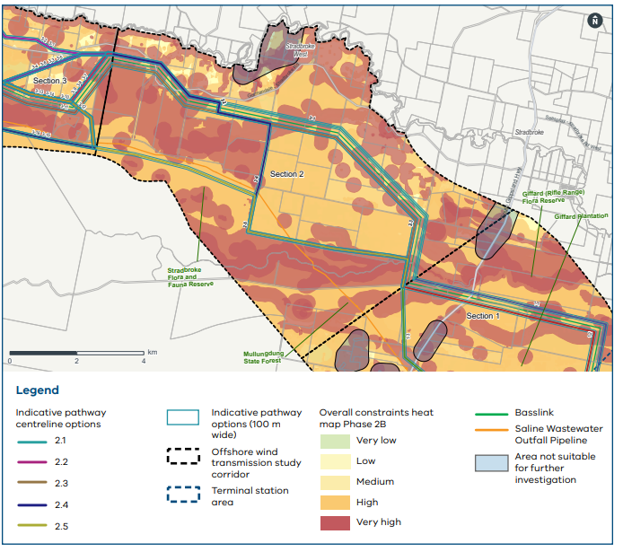
Map of Stradbroke to Willung options
Table 4: Study corridor Section 2 pathway options, key constraints analysis
Criteria | Expected level of constraint | Option 2.1 | Option 2.2 | Option 2.3 | Option 2.4 | Option 2.5
Total area (ha) |  | 129.57 | 130.37 | 127.32 | 145.46 | 117.49
Biodiversity | Very high | Low | Low | Low | Low | Low
Biodiversity | High | Low | Low | Low | Low | High
Aboriginal cultural heritage | Very high | High | Very High | Moderate | Moderate | Moderate
Aboriginal cultural heritage | High | Moderate | Moderate | High | High | High
Land use | High | High | High | High | Very High | Very High
Areas in the western section south of Basslink and the option to follow the SWOP were identified as unsuitable. A transmission line in this area would require significant clearing of native vegetation through the Stradbroke Flora and Fauna Reserve.

Section 3: Willung to Hiamdale
This section of the corridor was complex because it had:
- Many nearby homes
- Sensitive biodiversity values
- The need to cross Merriman Creek
- An existing Trust for Nature conservation covenant
We identified 16 potential options in this section, some of which shared short overlapping segments. None of the 16 options had clearly fewer impacts than the other when assessed against the Phase 1 criteria.
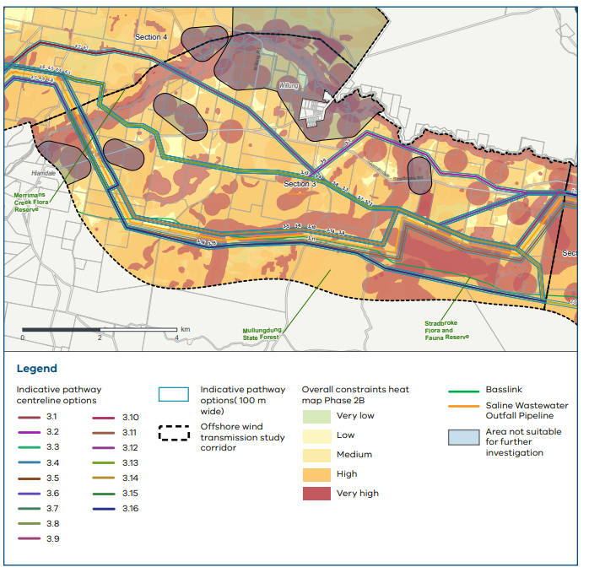
Map of Willung to Hiamdale options

Table 5: Study corridor section 3 pathway options, key constraints analysis
Criteria | Expected level of constraint | Options
Criteria | Expected level of constraint | 3.1 | 3.2 | 3.3 | 3.4 | 3.5 | 3.6 | 3.7 | 3.8 | 3.9 | 3.10 | 3.11 | 3.12 | 3.13 | 3.14 | 3.15 | 3.16
Total area (ha) |  | 122 | 138.1 | 119.3 | 134.2 | 153 | 155.9 | 125.9 | 140.8 | 159.6 | 162.7 | 163.5 | 123.4 | 138.3 | 157.1 | 145.1 | 148
Crosses Basslink |  | N | N | N | N | N | N | N | N | N | N | N | N | N | N | N | N
Biodiversity | Very high | Low | Low | Low | Low | Low | Low | Low | Low | Low | Low | Moderate | Low | Low | Low | Low | Low
Biodiversity | High | Low | Low | Low | Low | Low | Low | Moderate | Moderate | Low | Low | Moderate | Moderate | Moderate | Low | Low | Low
Aboriginal cultural heritage | Very high | Low | Low | Moderate | Moderate | Moderate | Moderate | Moderate | Moderate | Moderate | Moderate | Moderate | Moderate | Moderate | Moderate | Low | Low
Aboriginal cultural heritage | High | Very high | High | High | High | Moderate | Moderate | High | High | Moderate | Moderate | High | High | High | High | High | High
Land use | High | Low | Moderate | Moderate | Moderate | High | High | Moderate | Moderate | High | High | Very high | Moderate | High | Very high | Very high | Very high
Land use | Existing covenant registered on title | Low | Low | High | High | High | High | High | High | High | High | Low | High | High | High | Low | Low
Landscape and visual | High | Moderate | Moderate | Moderate | Low | Low | Low | Low | Low | Low | Low | Low | Low | Low | Low | Low | Low

Most of the options intersect part of the Trust for Nature conservation covenant in the central east part of this section.
Densely populated areas near Merton Vale Road were identified as unsuitable for hosting transmission infrastructure due to small property sizes and the concentration of homes.
We also considered following the SWOP. Building a transmission line in this area would have impacts on high value native vegetation in the Stradbroke Flora and Fauna Reserve and was therefore ruled out.

Section 4: Hiamdale to Flynns Creek
Land between Hiamdale and Flynns Creek is mostly plantation land.
Nine potential pathway options were assessed in this section. All options run parallel to Basslink in
some areas.
- Option 4.1 is the northernmost option in the corridor and only aligns with Basslink for about 2 km on the western side.
- Options 4.3 and 4.5 align with Basslink for a short distance on the eastern side of the section and then mirror option 4-1 through the northern portion of the corridor until running parallel with Basslink on the western side.
- Options 4.2, 4.4 and 4.6 generally follow the northern side of Basslink.
- Options 4.7, 4.8 and 4.9 follow the south of Basslink, with potential for co-location with the SWOP in the western part of the section.
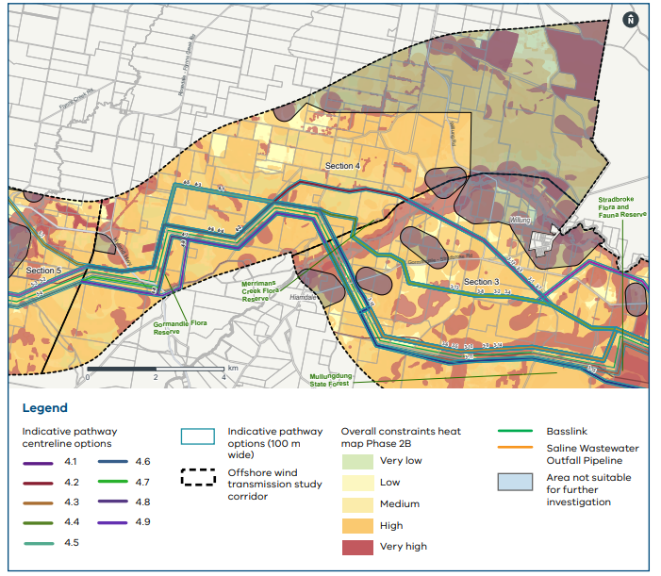
Map of Hiamdale to Flynns Creek options
Table 6: Study corridor Section 4 pathway options, key constraints analysis
Criteria | Expected level of constraint | Options
Criteria | Expected level of constraint | 4.1 | 4.2 | 4.3 | 4.4 | 4.5 | 4.6 | 4.7 | 4.8 | 4.9
Total area (ha) |  | 115.54 | 110.62 | 101.50 | 96.57 | 96.64 | 91.71 | 92.33 | 93.76 | 92.87
Biodiversity | Very high | Low | Low | Low | Low | Low | Low | Low | Low | Low
Biodiversity | High | Low | Low | Low | Low | Low | Low | Low | Low | Low
Aboriginal cultural heritage | Very high | Low | Low | Low | Low | Low | Low | Low | Low | Low
Aboriginal cultural heritage | High | Moderate | Moderate | High | High | High | High | High | Very high | High
Land use | High | Very high | Very high | Very high | Very high | Very high | Very high | Very high | Very high | Very high

In this section, all options had similar levels of constraint against the criteria.
During this assessment, we also engaged with commercial landholders. Their input helped us consider land use, access routes and how transmission infrastructure could work alongside ongoing business operations.
Areas in the northern part of the study area near Rosedale were identified as unsuitable for transmission infrastructure, as there would be a significant detour from the most direct path. The resulting longer transmission line through this area would have more impacts on people and places, and higher costs.

Section 5: Flynns Creek to Loy Yang Power Station
This section extends from the western edge of plantation land to the Loy Yang Power Station.
Four pathway options were identified. All options approach the Loy Yang switchyard from the north to avoid constraints in this section.
- Option 5.1 departs from Basslink, heading northwest through the Flynns Creek before turning southwest toward Loy Yang.
- Options 5.2 and 5.3 follow Basslink to the north for around 2.7 km before branching away to avoid homes and other buildings.
- Option 5.4 follows Basslink to the south before crossing to the north to enter the switchyard.
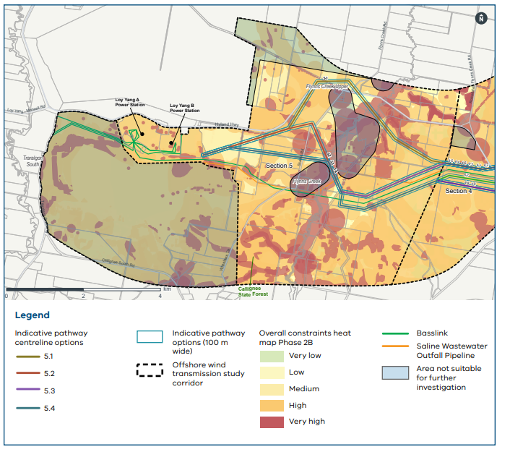
Map of Flynns Creek to Loy Yang Power Station options
Table 7: Study corridor Section 5 pathway options, key constraints analysis
Criteria | Expected level of constraint | Option 5.1 | Option 5.2 | Option 5.3 | Option 5.4
Total area (ha) |  | 115.54 | 110.62 | 101.50 | 96.57
Biodiversity | Very high | Low | Low | Low | Low
Biodiversity | High | Low | Low | Low | Low
Aboriginal cultural heritage | Very high | Low | Low | Low | Low
Aboriginal cultural heritage | High | High | Moderate | Moderate | High
Land use | High | High | High | Moderate | Moderate
Landscape and visual | High | Moderate | Moderate | Moderate | Moderate
Landscape and visual | Moderate | Moderate | Moderate | Moderate | Moderate
Contamination | Very High | Moderate | Moderate | Moderate | Moderate
In this section, all options had similar levels of constraint across the criteria.
The transmission line must pass to the north of Basslink as it nears the Loy Yang Power Station. This is because ground conditions to the south, together with the existing overhead transmission lines and easements, limit the available entry points to the switchyard.
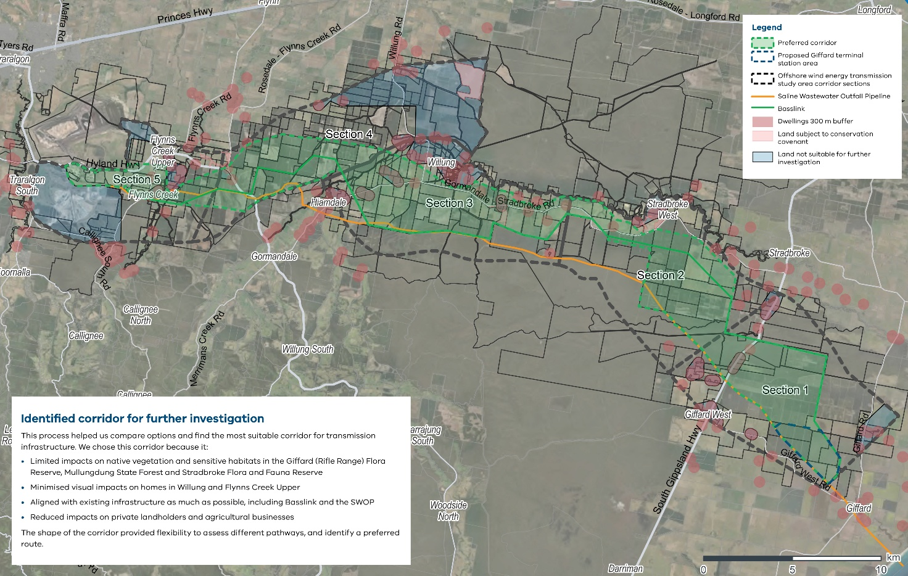
A corridor closer to Flynns Creek was identified as unsuitable due to the density of homes and sensitive viewpoints.

Identified corridor for further investigation
This process helped us compare options and find the most suitable corridor for transmission infrastructure. We chose this corridor because it:
- Limited impacts on native vegetation and sensitive habitats in the Giffard (Rifle Range) Flora Reserve, Mullungdung State Forest and Stradbroke Flora and Fauna Reserve
- Minimised visual impacts on homes in Willung and Flynns Creek Upper
- Aligned with existing infrastructure as much as possible, including Basslink and the SWOP
- Reduced impacts on private landholders and agricultural businesses
The shape of the corridor provided flexibility to assess different pathways and identify a preferred route.

Phase 3: Identifying a route
This refinement phase was carried out in two sub-phases:
- Phase 3A – refinement of a corridor to a draft preferred route (around 200 m wide)
- Phase 3B – refinement of the draft preferred route to a preferred route based on the outcomes of consultation with landholders and stakeholders

Key terms
Some of the technical terms related to Phase 3 include:
Parallelism: the extent to which the transmission line will run alongside Basslink
Transposition: transmission lines can experience electromagnetic interference when placed near
each other.
To operate the new transmission line safely near Basslink, we need to allow enough space in two locations for transposition, which involves swapping the positions of the conductors of a transmission line. This is essential for reducing electrical interference.
For this project, transposition involves using two towers side by side to change the positions of the three phases and reduce electrical interference.
As a result, the easement in these locations will be up to 170 m wide – compared with about 70 m elsewhere.
The two proposed locations are near Willung South and Gormandale, ensuring even spacing along
the line.
The final locations and design will be decided during the detailed design phase, with input from landholders and Basslink’s operator.

Phase 3A: Draft preferred route
This refinement phase built on the desktop work from Phase 2. It focused on field work to confirm assumptions and address uncertainties.
It included:
- On-the-ground surveys and investigations
- Site visits to confirm the location of homes and buildings and surrounding land uses
- Landholder and community meetings
- Conceptual design and engineering work for the Loy Yang Power Station switchyard and Giffard terminal station site
We also held a series of multidisciplinary workshops with technical experts, landholder engagement advisers and environmental specialists to identify where further information or investigation would be needed.
At this stage, we needed more detailed criteria to refine the draft preferred route. We drew on the criteria from refinement Phases 1 and 2, and considered feedback from landholders and asset owners – including plantation operators – and reviewed our previous work.
The final criteria used in Phase 3 incorporated all of these inputs.
Table 8: The final criteria used in Phase 3
Tier | Criteria
Primary decision-making criteria  Based on Phase 1 criteria | - The draft preferred route must be set back 300 m from residential homes unless otherwise agreed through consultation with the landholder.  - Where possible, avoid areas categorised as having a high or very high level of constraint under Phase 1 criteria (biodiversity, Aboriginal cultural heritage and land use compatibility).  - Where possible, avoid areas of concern categorised under other criteria (including landscape character, visual amenity, contamination, acid sulfate soils and hydrology).  - Where possible, avoid buildings.
Secondary decision-making criteria  Based on Phase 2 criteria | - Avoid doubling back and ensure that changes in direction of the transmission line are no greater than 90 degrees.  - Consider the technical and construction constraints in the Basslink crossing area.  - Where possible, follow existing infrastructure easements.  - Consider crossing waterways at approximately 90 degrees to minimise transmission line span lengths, reduce vegetation impacts and maintain safety clearances from the waterway.  - Avoid doubling back and maintain a maximum deviation angle of no more than 90 degrees.
Tertiary decision-making criteria | - Where possible, align with existing property boundaries or roads.  - Avoid changing angles over short spans and keep pathway centrelines straight for as long as possible.  - Consider other technical and construction constraints, as well as program and cost implications.

Targeted field surveys
A range of field investigations was carried out to verify, clarify and refine the information gathered through earlier phases. These investigations focused on locations with significant constraints, uncertainty or complexity, as well as areas where more information was needed.

Biodiversity
Biodiversity investigations focused on areas where high-value ecological features are known to occur and where more information would help to make decisions.
The surveys tested assumptions made during earlier refinement phases and confirmed that the heat map was as a reliable and appropriate tool.

Aboriginal cultural heritage
The assumptions in the heat maps were tested through walkover surveys conducted by heritage advisors and representatives from Gunaikurnai Land and Waters Aboriginal Corporation (GLaWAC). These walkovers validated assumptions made during the earlier refinement phases.
This increased confidence in our approach to avoiding and mitigating impacts on Country.

Landscape character and visual impacts
We used a three-dimensional terrain modelling tool to assess views from homes and lookouts. This helped us understand where different terrain and ridgelines might screen transmission infrastructure and reduce visual impacts.
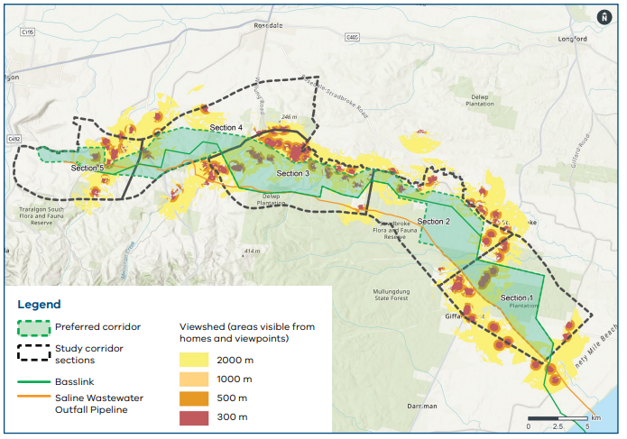
Map of viewsheds along the corridor

Technical considerations
A key challenge during route refinement was determining where the transmission line could cross Basslink. Crossing a high-voltage transmission line is complex because the new line must maintain the required horizontal and vertical safety clearances from the existing line.
High-voltage transmission lines generate electromagnetic fields that can interfere with one another where the lines are too close. We conducted detailed studies to determine how close the new line could be to existing Basslink infrastructure while ensuring both lines operate safely.

Key constraint points
During this refinement phase, we identified points along the corridor where there was limited flexibility to position transmission infrastructure. We called these ‘key constraint points.’
We assessed these key constraint points by comparing options against the refinement criteria. At this stage we needed to narrow down our options to determine the most suitable path for the transmission line that minimised impacts as much as possible.
In some instances, a decision at one key constraint point influenced where the transmission line could
feasibly be placed at another key constraint point. We compared and assessed these options to find
the most suitable path.

Assessing options to identify the draft preferred route
The draft preferred route was the option with the fewest constraints and lowest overall potential impact. Feedback from landholders during Phase 3B helped us finalise the preferred route.

Section 1: Giffard to Stradbroke
This section of the draft preferred route includes agriculture land around the proposed Giffard terminal station area and Mullungdung State Forest and Stradbroke Flora and Fauna reserve in the north west section. Most of this section goes through plantation land. A review of technical, environmental and land use constraints identified two key constraint points:

S1-KC1: the connection point with the Giffard terminal station
Key constraints here included technical connection requirements, such as the location, design, land use and configuration of the Giffard terminal station. We considered northern and southern options following the SWOP.
For S1-KC1, the northern option was adopted because it provided greater opportunities to avoid land use compatibility issues, minimise visual impacts on nearby homes, and align with existing boundaries within plantation land.

S1-KC2: crossing South Gippsland Highway
Key constraints included homes along the highway and associated visual impacts, as well as biodiversity values west of the highway. We considered a northern option aligned with Basslink and a
southern option aligned with the SWOP.
Both options for S1-KC2 had comparable evaluation outcomes. The southern option was adopted because it could run alongside the existing
SWOP easement.
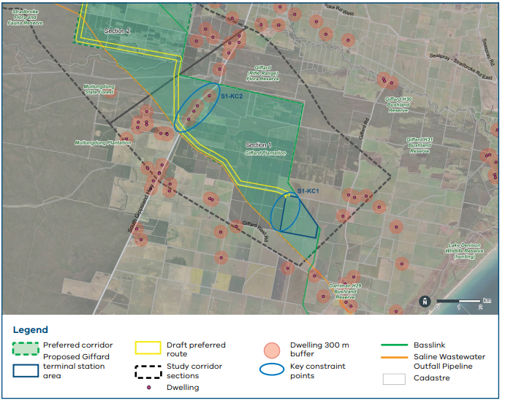
Map of Section 1: Giffard to Stradbroke

Section 2: Stradbroke to Willung
Gormandale-Stradbroke Road crosses this section, with some homes in the western part. The transmission line would be most visible from properties at the eastern and western ends.
A review of technical, environmental and land use constraints across the section identified two key
constraint points:

S2-KC1: Stradbroke Flora and Fauna Reserve/Mullungdung State Forest
Both Mullungdung State Forest and the Stradbroke Flora and Fauna Reserve are characterised by native vegetation with high biodiversity value. We considered a northern option aligning to Basslink and a southern option aligning to SWOP.
We chose the northern option because it required a shorter route through high-value vegetation.

S2-KC2: narrow section of Gormandale-Stradbroke Road
Key constraints included homes located off Gormandale-Stradbroke Road and the potential visual impacts from those homes. We considered options aligned with the northern and southern edges of the corridor to increase the distance from homes.
We chose the southern option because it minimised the fragmentation of properties by aligning with the existing Basslink easement and property boundaries as much as possible.
The transmission line also needed to cross Basslink in this section. Crossing here would help to reduce impacts in areas further along the route, where homes and important biodiversity habitat created greater constraints.
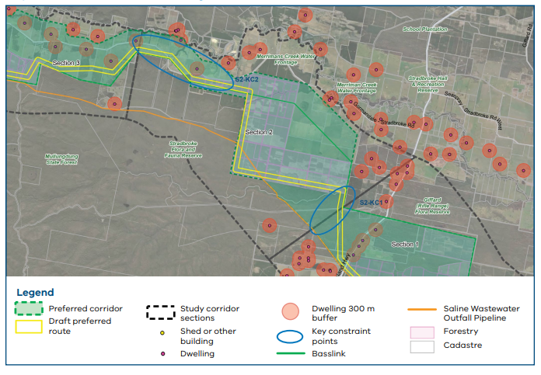
Map of Section 2: Stradbroke to Willung

Section 3: Willung to Hiamdale
The northern boundary of this section was designed to avoid Merriman Creek and properties around Willung are just to the north of this section. We reviewed technical, environmental and land use constraints across this section and identified four key constraint points:

S3-KC1: the narrow eastern part of this section, close to Gormandale-Stradbroke Road
We considered a northern option that passed through private properties containing homes, as well as southern options aligned with Basslink.
We chose the southern option because it was further from homes, reducing the visual impact of the transmission line.

S3-KC2: land near the Trust for Nature covenant site
The corridor was relatively narrow at this location and highly constrained by the presence of homes. We considered a northern option through a property north of Gormandale-Stradbroke Road and across Bayliss Gully, and a southern option aligned with Basslink through the southern part of the land protected by the Trust for Nature covenant.
We chose the southern option aligning with Basslink because it avoided the high biodiversity habitat to the north of the Trust for Nature covenant.

S3-KC3: at the crossing of Gormandale-Stradbroke Road near Hiamdale
We considered northern, southern and central options for crossing Gormandale-Stradbroke Road.
We chose the S3-KC3 central option because it resulted in fewer visual impacts to homes and allowed for a crossing at Merriman Creek (S3-KC4 – north option) that reduced biodiversity impacts.

S3-KC4: at the crossing of Merriman Creek
Merriman Creek and its riparian zone (the narrow strip of land that forms a transition area between the creek and drier land) is characterised by high-quality vegetation and high biodiversity values. Waterways and surrounding land may also have Aboriginal cultural heritage and archaeological significance and are protected under Victorian cultural heritage legislation. Evidence of past Aboriginal cultural activity is more likely to be found near waterways and other water bodies.
We considered three Merriman Creek crossing options at north, south and central locations.
We chose the north option because it had fewer biodiversity impacts and was further away from homes.
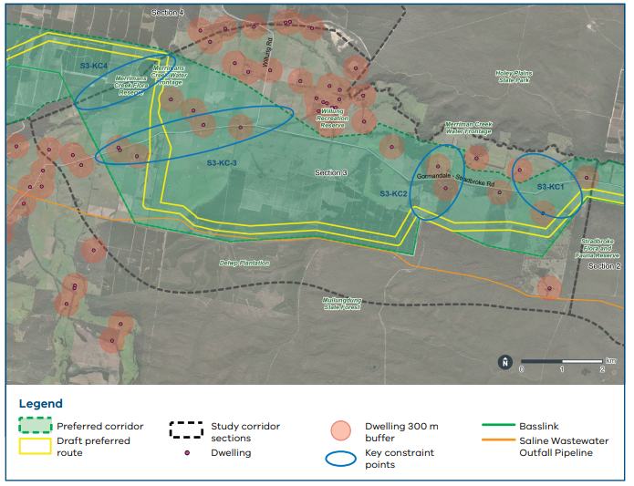
Map of Section 3: Willung to Hiamdale

Section 4: Hiamdale to Flynns Creek
Most of the land in this section is used for existing plantation operations, with some homes.
A review of technical, environmental and land use constraints across this section identified one key
constraint point:

S4-KC1: crossing Hyland Highway
Key constraints included homes along the highway, as well as the location of Basslink and the Gormandale Flora Reserve.
We identified only one viable option to cross the highway, near the centre of the corridor. Other options further north would be too close to homes. Options further south would require the transmission line to
cross Basslink twice more before approaching the Loy Yang Power Station switchyard from the northern
side of Basslink.
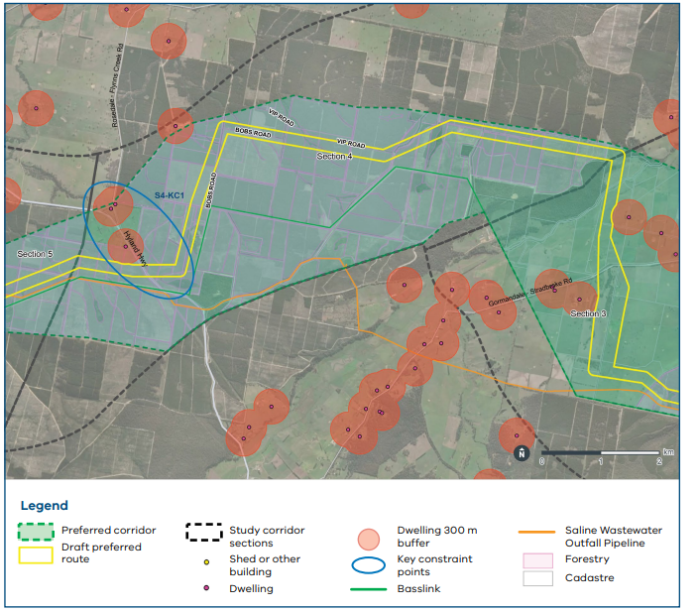
Map of Section 4: Hiamdale to Flynns Creek

Section 5: Flynns Creek to Loy Yang Power Station
We reviewed technical, environmental and land use constraints across the section and identified two key constraint points:

S5-KC1: near the Traralgon Field and Game site and Bobs Road
This key constraint point is within a relatively narrow part of the corridor containing homes and the Traralgon Field and Game site. Basslink also borders this part of the corridor. We considered a northern option along the corridor’s northern boundary and a southern option aligned with Basslink.
We adopted the southern option because following the existing Basslink easement where practical would minimise land use impacts.

S5-KC2: Loy Yang Power Station site and adjacent land
This point is constrained by the presence of power generation and transmission infrastructure, geotechnical considerations and the potential for
soil contamination from historical land uses and ground disturbance.
The preferred route through this area was developed in close consultation with the power station’s operator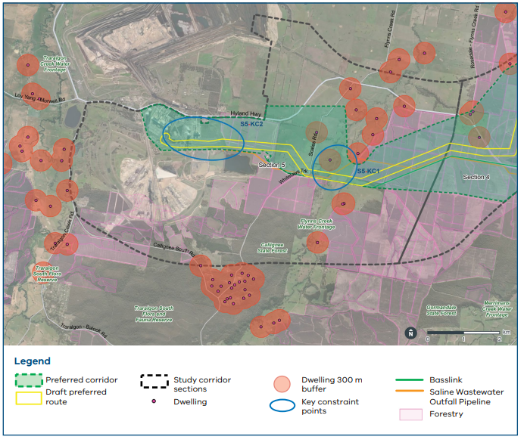
Map of Section 5: Flynns Creek to Loy Yang Power Station

Phase 3B: Finalising the preferred route
In the final refinement phase, we used feedback from landholders and other stakeholders, together with a draft technical design, to refine the draft preferred route into the preferred route.

Transmission line technical design
We assessed whether the draft preferred route could accommodate a workable transmission line.
This work identified constraints at the Merriman Creek crossing because of environmental values along the creek and the tight angle proposed for the transmission line.
We widened this section slightly on both the southern and northern sides of the creek to provide greater design flexibility and minimise environmental impacts.

Feedback from landholders and community
Feedback from landholders whose properties were within the draft preferred route was the primary driver for changes. This included feedback from private landholders, as well as plantation operators who will host a significant portion of the transmission line.
In some sections, we undertook a more detailed evaluation using the full list of refinement criteria to determine the preferred route alignment.
A summary of feedback received is included in the following sections.

Section 1: Giffard to Stradbroke Between Giffard and the South Gippsland Highway
Based on feedback, we changed the route in this area to minimise the fragmentation of plantation land, follow existing plantation access roads where possible, and align with the existing Basslink transmission line north of the proposed terminal station at Giffard.
Landholders also told us they were concerned about how visible the transmission line would be from properties north of the South Gippsland Highway. There are limited options to move the route in this area because of nearby homes, and other crossing locations had already been ruled out during earlier assessments. We will continue to look for ways to reduce visual impacts as the detailed design is developed.
Landholders also raised other issues in this area, including:
- Possible conflicts with the existing maintenance program for the SWOP
- The potential effect on land values
- Access for emergency services to a nearby dam
We understand these are important concerns. The project’s EES will propose a range of mitigation measures to effectively manage impacts on properties. We will work with the development partner to continue engaging with landholders as the detailed design – including the final easement and tower locations – is developed. Compensation for impacts on land value and access arrangements will be worked through directly with each affected landholder.
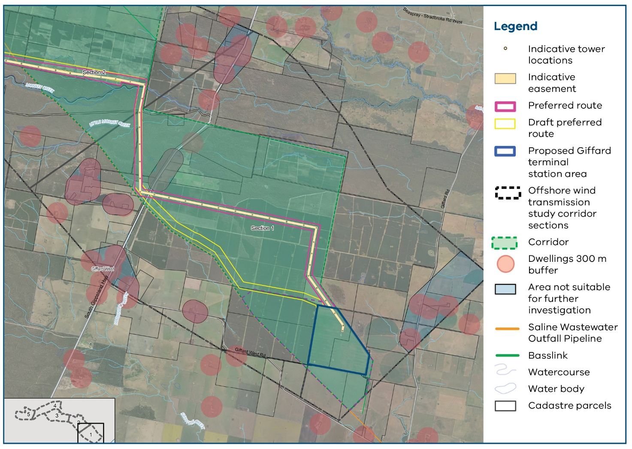
Map of Section 1: Giffard to Stradbroke

Section 2: Stradbroke to Willung

Near Stradbroke Flora and Fauna Reserve
In response to landholder feedback, this section of the route was widened slightly to align more closely with the boundary between plantation land and the Stradbroke Flora and Fauna Reserve. This will avoid fragmenting plantation land.
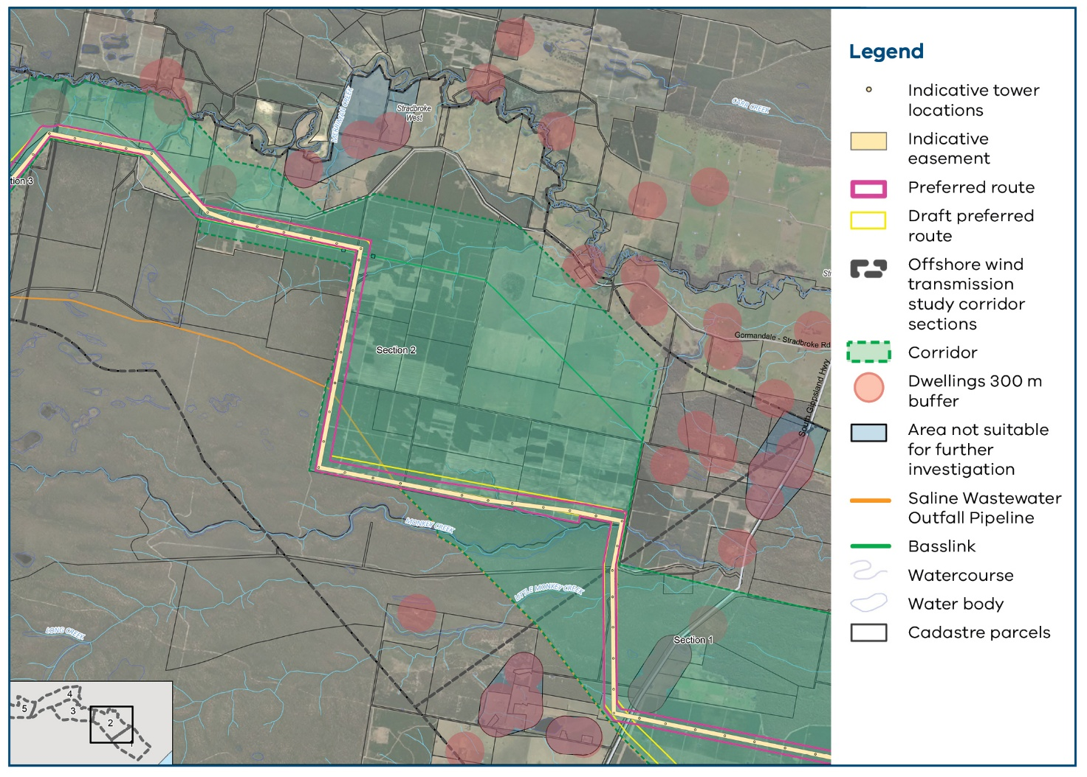
Map of Section 2: Stradbroke to Willung

Section 3: Willung to Hiamdale

Areas south of Willung
Landholders in this area told us they wanted the transmission line to be aligned as closely as possible with Basslink while remaining away from homes. However, closer alignment of the transmission line would increase the extent of parallelism with Basslink (refer to page 36 for an explanation of why this may be a problem). It would create additional technical complexity, including the need for transposition in other areas along the preferred route. This option may also require an increase in native vegetation clearing.
We compared the draft preferred route with the alternative suggested by landholders.
The southern option would have had greater biodiversity impacts, but it also offered important benefits. It would reduce land use and visual impacts, and follow the existing Basslink transmission line more closely. After considering these trade-offs, we selected this option as the preferred route.

Realignment near Bayliss Gully
We realigned the route near Bayliss Gully towards Flemings Road. This option avoided fragmenting plantation land and reduced vegetation impacts around Bayliss Gully.
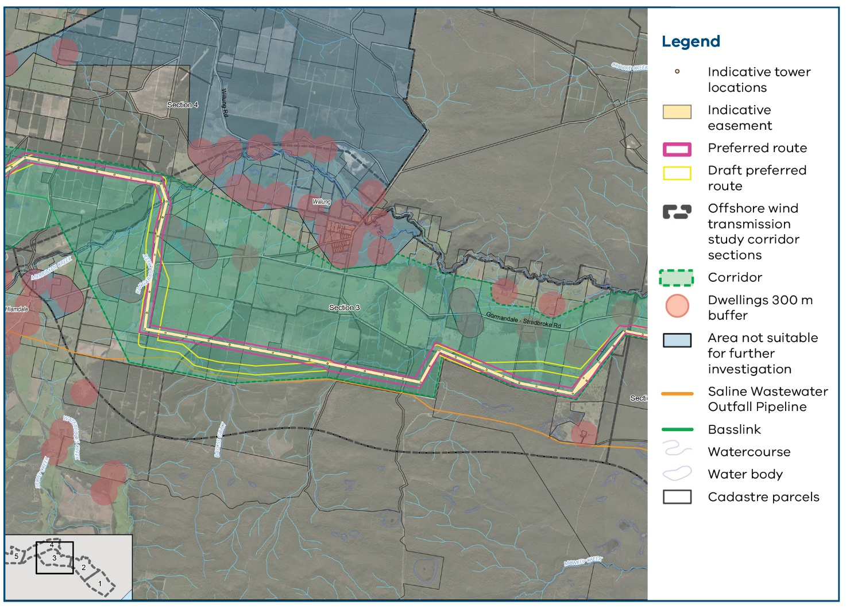
Map of Section 3: Willung to Hiamdale
Table 9: Southern alternative performance against criteria
Criteria | Draft preferred route | Southern alternative
Primary decision-making criteria
300 m from residential dwellings | Yes | Yes
Avoid areas of high or very high constraint (biodiversity, Aboriginal cultural heritage and land use compatibility) | Performs better (biodiversity)  Fewer biodiversity constraints, with greater potential to avoid impacts through design. | Performs worse (biodiversity)  Greater biodiversity constraints, with some potential for avoidance through design.
 | Performs worse (land use)  This route would bisect and fragment land. | Performs better (land use)  This alternative would generally avoid land fragmentation by aligning closely to land boundaries.
Avoid areas of other concern (landscape character and visual, contamination, acid sulfate soils, hydrology) | Performs worse (visual)  This alternative would be slightly more visually prominent from homes. | Performs better (visual)  This alternative would be slightly less visually prominent from homes.
Avoid buildings | Yes | Yes
Secondary decision-making criteria
Minimise number of Basslink crossings | Not applicable | Not applicable
Technical and construction constraints in the Basslink crossing area | Not applicable | Not applicable
Follow existing infrastructure easements | Performs worse  This alternative would only align with the Basslink easement for part of its length. | Performs better  This alternative would allow for alignment adjacent or near the Basslink easement.
Cross waterways at approximately 90 degrees | Comparable  This alternative crosses two drainage lines at approximately 90 degrees | Comparable  This alternative crosses two drainage lines at approximately 90 degrees.
Avoid doubling back and ensure that changes in direction of the transmission line are no greater than 90 degrees | Yes | Yes
Tertiary decision-making criteria
Align with existing property boundaries or roads | Performs worse  This route bisects properties and aligns with property boundaries for only part of its length. | Performs better  This alternative aligns with eastern and southern boundaries of two properties for approximately 2.7 km
Avoid changing angles over short spans, make centrelines straight | Yes | Yes
Other technical and construction constraints | None | Basslink parallelism  This alternative introduces an additional 2.7 km of parallelism with Basslink.  Stringing pad location  The change in direction at the southeast corner would require a tower designed to accommodate a 90-degree turn. This could result in a stringing pad that encroaches on the Basslink easement and may require a bespoke tower design.  Transmission line length  This alternative would be approximately  300 m longer than the draft preferred route, resulting in additional capital and maintenance costs.  However, these additional costs may not be material given the total length of the transmission line (around 60 km).

Preferred alignment consideration along Flemings Road
Landholders shared feedback about potential impacts on farming operations, the use and movement of farm machinery, biodiversity, visual impacts and significant trees located along property boundaries.
We considered moving the route slightly east or west of Flemings Road. We selected the option on the western side of Flemings Road for the preferred route, in consultation with landholders.
Table 10: Western alternative performance against criteria
Criteria | Eastern alternative | Western alternative
Primary decision-making criteria
300 m from residential dwellings | Yes | Yes
Avoid areas of high or very high constraint (biodiversity, Aboriginal cultural heritage and land use compatibility) | Performs better (biodiversity)  Fewer biodiversity constraints. Both alternatives offer comparable potential to avoid these constraints through design. | Performs worse (biodiversity)  More biodiversity constraints. However,  these could be avoided through design.
 | Performs worse (land use)  This alternative would bisect and fragment land. | Performs better (land use)  This alternative would generally avoid  land fragmentation by aligning closely  to land boundaries
Avoid areas of other concern (landscape character and visual, contamination, acid sulfate soils, hydrology) | Performs better (visual)  Less visually prominent from the nearest homes. | Performs worse (visual)  More visually prominent from the  nearest homes.
Avoid buildings | No  There are cattle sheds and structures in this alternative, although these could be avoided through design. | Yes
Secondary decision-making criteria
Minimise number of Basslink crossings | Not applicable | Not applicable
Technical and construction constraints in the Basslink crossing area | Not applicable | Not applicable
Follow existing infrastructure easements | Not applicable | Not applicable
Cross waterways at approximately 90 degrees | Yes  Crosses a minor waterway at approximately 90 degrees. | Yes  Crosses a minor waterway at approximately 90 degrees.  Runs near and parallel to Kangaroo Creek.
Avoid doubling back and ensure that changes in direction of the transmission line are no greater than 90 degrees | Yes | Yes
Tertiary decision-making criteria
Align with existing property boundaries or roads | Yes  Aligns with Flemings Road, although roadside vegetation constrains the available alignment. | Yes  Aligns with Flemings Road, although roadside vegetation constrains the available alignment.
Avoid changing angles over short spans, make centrelines straight | Yes  Centreline may need to deviate to avoid biodiversity constraints. | Yes  Centreline may need to deviate to avoid biodiversity constraints.
Other technical and construction constraints | None | Kangaroo Creek  A bespoke transmission tower foundation may be required near Kangaroo Creek, depending on geotechnical conditions.

Preferred alignment consideration south of Merriman Creek
Landholders raised several concerns and suggestions to refine the preferred route to avoid unsuitable ground conditions along the creek line, shift the route further away from dwellings and avoid more productive land.
We considered three options in more detail to determine the most suitable option: retaining the draft preferred route, an eastern alternative and a central alternative.
We selected the eastern option because it has fewer biodiversity constraints, fewer land use impacts and is only slightly more visually prominent than the other options.
This option encroaches on the 300 m dwelling buffer on one property and was selected in consultation with the landholder. This is the only location along the preferred route that is less than 300 m from a dwelling.
We also widened the preferred route on both sides of Merriman Creek to allow for design flexibility and avoid environmental constraints along the creek line.
Table 11: Eastern and central alternatives performance against criteria
Criteria |  | Draft preferred route |  | Eastern alternative | Central alternative
Primary decision-making criteria
300 m from residential dwellings |  | Yes |  | No  Intersects the 300 m buffer around the dwelling on one land parcel. | No  Intersects the 300 m buffer around the dwelling on one land parcel.
Avoid areas of high or very high constraint (biodiversity, Aboriginal cultural heritage and land use compatibility) |  | Performs worse (biodiversity)  More biodiversity constraints, particularly when considering native vegetation. The draft preferred route also contains more large trees than alternatives, but these may be avoided through micro-siting of transmission towers. |  | Performs better (biodiversity)  Fewer biodiversity constraints than the draft preferred route, and similar to the central alternative. | Performs better (biodiversity)  Fewer biodiversity constraints than the draft preferred route, and similar to the eastern alternative.
 |  | Performs worse (land use)  The draft preferred route would fragment land parcels more than alternatives and would have more land use impacts for landholders. |  | Performs best (land use)  Performs best out of the alternatives. It minimises fragmentation of land and avoids impacts to land use. | Performs better (land use)  Less fragmentation of land compared to the draft preferred route. However, this option would have more land use impacts for landholders.
Avoid areas of other concern (landscape character and visual, contamination, acid sulfate soils, hydrology) |  | Performs better (visual)  The draft preferred route is less visible from nearby homes. |  | Performs worse (visual)  This alternative is slightly more visible from nearby homes. It is comparable to the central alternative. | Performs worse (visual)  This alternative is slightly more visible from nearby homes. It is comparable to the eastern alternative.
Avoid buildings |  | Yes |  | No  Intersects the 300 m buffer around the home on one land parcel. | No  Intersects the 300 m buffer around the home on one land parcel.
Secondary decision-making criteria
Minimise number of Basslink crossings | Not applicable |  | Not applicable |  |  | Not applicable
Technical and construction constraints in the Basslink crossing area | Not applicable |  | Not applicable |  |  | Not applicable
Follow existing infrastructure easements | Not applicable |  | Not applicable |  |  | Not applicable
Cross waterways at approximately 90 degrees | Yes |  | Yes |  |  | Yes
Avoid doubling back and ensure that changes in direction of the transmission line are no greater than 90 degrees | Yes |  | Yes |  |  | Yes
Tertiary decision-making criteria
Align with existing property boundaries or roads | Performs worse  The draft preferred route does not follow property boundaries or roads. |  | Performs better  Follows property boundaries for approximately 470 m. |  |  | Performs better  Follows property boundaries for approximately 470 m.
Avoid changing angles over short spans, make centrelines straight | No  Includes sharp angles in the 70 m easement based on the highly constrained environment in this part of the preferred corridor. |  | No  Includes sharp angles in the 70 m easement based on the highly constrained environment in this part of the preferred corridor.  Includes more sharp angles than the draft preferred route. |  |  | No  Includes sharp angles in the 70 m easement based on the highly constrained environment in this part of the preferred corridor.  Includes more sharp angles than the draft preferred route.
Other technical and construction constraints | None |  | None |  |  | None

Section 4: Hiamdale to Flynns Creek
In this section, the preferred route runs entirely through plantation land and mostly follows Basslink.

Realignment near Bobs Road and Fish Dam Road
We realigned this route near Bobs Road and Fish Dam Road to minimise fragmentation of plantation land and disruption to plantation operations.
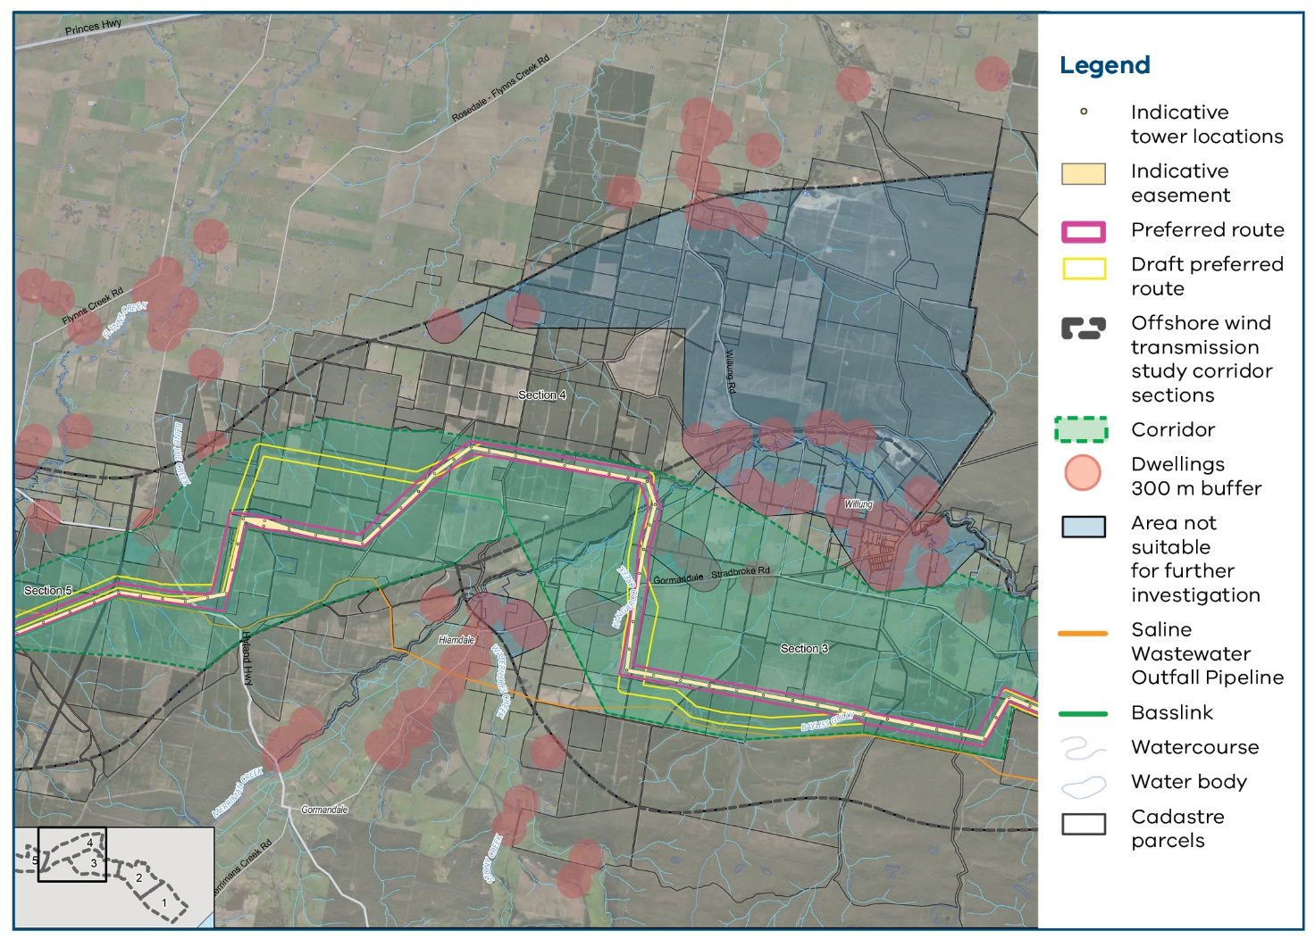
Map of Section 4: Hiamdale to Flynns Creek

Section 5: Flynns Creek to Loy Yang

Realignment closer to the Basslink converter station
Landholders asked us to align the route more closely with the existing Basslink easement and the property’s southern boundary, and reduce land fragmentation.
We found that this option (western option) was more suitable because it fewer impacts on land use, was less visually prominent and was better aligned with existing infrastructure and land boundaries.
The western option had greater potential biodiversity impacts, but careful micro-siting of transmission towers could help minimise these impacts.
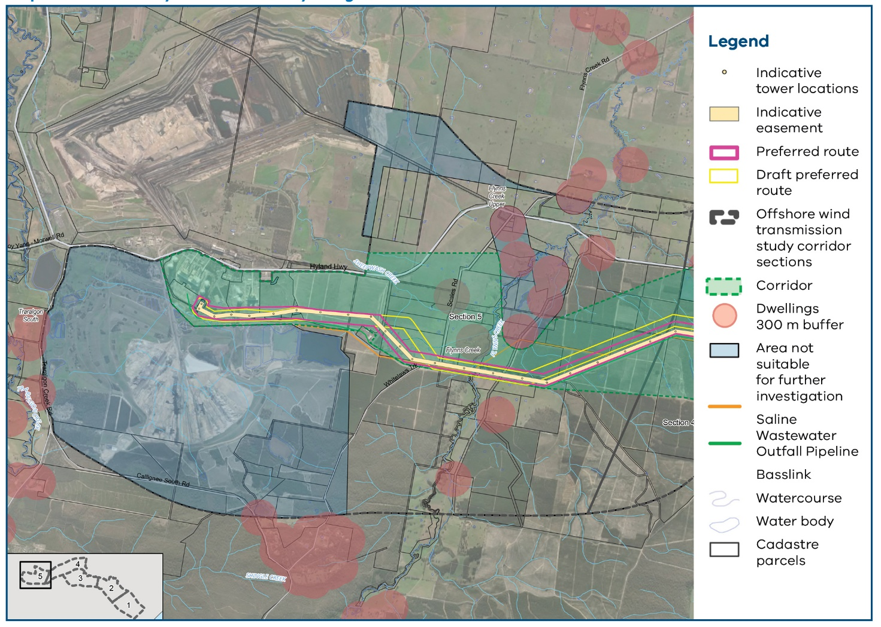
Map of Section 5: Flynns Creek to Loy Yang Power Station
Table 12: Western alternative performance against criteria
Criteria | Draft preferred route | Western alternative
Primary decision-making criteria
300 m from residential dwellings | Yes | Yes
Avoid areas of high or very high constraint (biodiversity, Aboriginal cultural heritage and land-use compatibility) | Performs better (biodiversity)  Fewer biodiversity constraints, with greater potential to avoid impacts through design. | Performs worse (biodiversity)  Biodiversity constraints are approximately double those of the draft preferred route. There is some potential to avoid impacts through design, but complete avoidance of impacts is unlikely.
 | Performs worse (land use)  As noted by the landholder, the draft preferred route would bisect and fragment the land. | Performs better (land use)  The western alternative would result in less land fragmentation.
Avoid areas of other concern (landscape character and visual, contamination, acid sulfate soils, hydrology) | Performs worse (visual)  Slightly more visible from nearby homes. | Performs better (visual)  Slightly less visible from nearby homes.
Avoid buildings | Yes | Yes
Secondary decision-making criteria
Minimise number of Basslink crossings | Not applicable | Not applicable
Technical and construction constraints in the Basslink crossing area | Not applicable | Not applicable
Follow existing infrastructure easements | Performs worse  The draft preferred route does not align with existing infrastructure easements. | Performs better  This alternative would run adjacent or near  the Basslink easement for approximately  500–550 m more than the draft preferred route.
Cross waterways at approximately 90 degrees | Comparable  The draft preferred route crosses one drainage line at more than 90 degrees. | Comparable  This alternative crosses two drainage lines at more than 90 degrees.
Avoid doubling back and ensure that changes in direction of the transmission line are no greater than 90 degrees | Yes | Yes
Tertiary decision-making criteria
Align with existing property boundaries or roads | Performs worse  The draft preferred route bisects a land parcel and is not closely aligned with land boundaries or roads. | Performs better  This alternative aligns with the southern boundary of one property for approximately  500–550 m.
Avoid changing angles over short spans, make centrelines straight | Yes | Yes
Other technical and construction constraints | None | Basslink parallelism  This alternative introduces an additional  500–550 m of parallelism with Basslink.  Basslink secondary access road  This alternative poses a more challenging crossing of the Basslink secondary access road (which diverges from the main access road). This may require more towers and associated additional capital costs.

Identifying the easement
We have identified a preferred route, which will now be assessed through the Environment Effects Statement (EES) process. Within this route, we have developed a reference design and indicative easement to help assess the project’s potential impacts.
The reference design and indicative easement are for assessment purposes only. They are not the final
design or easement.
When we appoint a development partner, we will work together to finalise the easement, tower locations, and the project’s detailed design and construction approach. Further technical studies and ongoing discussions with landholders, Traditional Owners and the community will inform this work.
Permanent transmission infrastructure is expected to remain within the preferred route assessed through the EES. If any permanent infrastructure is needed outside the preferred route, this would be subject to further planning and environmental approval requirements.
Most construction impacts will be temporary and will occur during the construction period. They will mostly occur within or close to the preferred route, however some temporary facilities – such as laydown areas or worker accommodation – may sit outside the route.
The project must complete the EES process and receive all required Commonwealth and Victorian Government approvals before construction can begin.
To read more about the reference design, see our Preferred route and reference design community summary: vicgrid.com.au/__data/assets/pdf_file/0022/801427/Community-summary-preferred-route-and-reference-design.pdf

Contact us
Phone: 1800 418 341
Email: enquiries@vicgrid.com.au
Deaf, hearing or speech impaired? Please contact the National
Relay Service on 133 677 or communications.gov.au/accesshub/nrs
Need an interpreter? Contact Translating and Interpreting Service
(TIS) on 131 450 (within Australia) or visit www.tisnational.gov.au
Disclaimer: The information in this document is current at the time
of printing, may be subject to change and should not be relied upon.
Please visit vicgrid.com.au for the latest updates.

