2025 Victorian Transmission Plan Appendix C: Power system modelling
  - August 2025

Disclaimer
This 2025 Victorian Transmission Plan is published by the State of Victoria pursuant to amendments to the National Electricity (Victoria) Act 2005, which implement the first stage of Victorian Transmission Investment Framework reforms and empowers the CEO VicGrid to develop a Victorian Transmission Plan. It has been prepared for the purposes of consultation and comment, in connection with the 2024 Victorian Transmission Plan Guidelines.
While the State of Victoria has made reasonable efforts to ensure the quality and accuracy of the information in this publication, the State of Victoria and its employees do not guarantee that the publication is without flaw of any kind or is wholly appropriate for your particular purposes and therefore, to the extent permitted by law, disclaims all liability for any error, loss or other consequence which may arise from you relying on any information in this publication.
This publication does not include all of the information that an investor, participant or potential participant in the National Electricity Market might require, and does not amount to a recommendation of any investment. The modelling work included herein inherently requires assumptions about future behaviours and market interactions. Anyone proposing to utilise this publication should note that there may be differences between estimated and actual results which may be material.
Anyone proposing to use the information in this publication (which includes information and forecasts from third parties) should independently verify its accuracy, completeness and suitability for purpose, and obtain independent and specific advice from appropriate experts.
Please visit vicgrid.vic.gov.au for the latest updates.

Copyright
© The State of Victoria Department of Energy, Environment and Climate Action 2025

Contents
Disclaimer 1
Copyright 1
Contents 1
Acronyms 2
Glossary 2
Appendix C: Power system modelling 3
C.1 Power system modelling overview 4
C.2 PSS/E 2025 VTP model 6
C.3 Power system modelling scope, inputs and assumptions 6
C.4 Methodology 8
C.5 Regional network summaries 11
C.6 Limitations and next steps 23

Acronyms
Term | Definition
AEMO | Australian Energy Market Operator
AVP | AEMO Victoria Planning
GW | Gigawatt (one million kilowatts)
ISP | Integrated System Plan
MVA | Megavolt-ampere
MW | Megawatt (one thousand kilowatts)
NER | National Electricity Rules
PSS/E | Power system simulation for engineering
REZ | Renewable energy zone
SOCS | System Overload Control Scheme
VAPR | Victorian Annual Planning Report
VNI | Victoria to New South Wales Interconnector
VTP | Victorian Transmission Plan
WRL | Western Renewables Link

Glossary
This glossary has been prepared as a quick guide to help readers understand terms used in this document. Words and phrases defined in the National Electricity (Victoria) Act 2005 and other Victorian legislation have the meaning given to them in legislation.
Term | Definition
Augmentations | These are improvements or additions made to the existing electricity transmission network to increase its capacity, efficiency, or reliability. This can involve upgrading current infrastructure or building new components to handle increased demand or integrate new generation sources.
Candidate development pathway | A set of possible transmission projects and proposed timings to upgrade the Declared Shared Network, needed to accommodate the development of new generation and storage capacity in REZs.
Curtailment | A situation where energy generators are required to limit their energy supply into the market due to capacity limitations on the grid and corresponding market signals.
Declared Shared Network | The Victorian interconnected high-voltage power lines and shared terminal stations that transport large amounts of electricity from where it is generated to where it is needed across the state. It allows multiple electricity providers to share the infrastructure for transporting electricity. Sometimes wind and solar developments need to build their own private lines to connect their project to the shared network.
Easement | This is a legal right allowing someone to use another person’s land for a specified purpose. For transmission lines, easements typically include the land parcels where both overhead and underground lines are situated, along with an adjacent buffer zone to ensure safe operation. Common uses of easements also include routes for drainage, sewage, and roadways.
Integrated System Plan | An integrated 20-year plan for the efficient development of the National Electricity Market (NEM), prepared every 2 years by the Australian Energy Market Operator.
Proposed REZs | The areas proposed to be considered for REZ declaration. These are presented in the 2025 VTP (this document) and, over time, may be declared by the Minister for Energy as REZs.
Renewable energy zone (REZ) | An area declared in a renewable energy zone Order where a REZ access scheme and special benefits arrangements will apply.
REZ access scheme | A scheme, under the proposed Victorian Access Regime, declared by the Minister for Energy and Resources which sets out arrangements governing network connections for new renewable generation and storage projects located in a REZ. These arrangements include access limits for each type of renewable generation, access fees, access conditions, and the process for allocating access.
Scenarios | Scenarios are a collection of assumptions that describe how the future may unfold. Scenario-based planning is useful in highly uncertain environments, and can help assess future risks, opportunities, and development needs in the energy industry.
Strategic land use assessment | An assessment that identifies suitable areas for siting infrastructure based on a range of social, cultural, technical, environmental, and economic factors.
System strength | This describes the ability of the power system to maintain and control the voltage waveform at a given location, both during steady state operation and following a disturbance. System strength is often approximated by the amount of electrical current available during a network fault (fault level), however the concept also encompasses a collection of broader electrical characteristics and power system interactions.
Traditional Owner | A member of a Traditional Owner group, having the meaning set out in the Traditional Owner Settlement Act 2010. Traditional Owners have rights that must be upheld as laid out under the Charter of Human Rights and Responsibilities Act 2006, the Traditional Owner Settlement Act 2010, Aboriginal Heritage Act 2006 and Native Title Act 1993 (Cth).
Victorian Access Regime | The proposed set of new rules, to be defined under the National Electricity (Victoria) Act 2005, for how new generation projects can connect to the Declared Shared Network, both within and outside of REZs. Under the Victorian Access Regime, the Minister will declare REZ access schemes, and all new generation projects outside of REZs will be subject to a Grid Impact Assessment to reduce the risk of curtailment for REZ generators.
Victorian Transmission Investment Framework | A set of reforms being implemented to transmission planning in Victoria, including: a new transmission planning objective; a new planning process through the Victorian Transmission Plan; the Victorian Access Regime; new community and Traditional Owner benefit arrangements; and new approaches to procuring transmission infrastructure.
Victorian transmission plan | A document setting out an optimal set of transmission projects that address the planning and development needs over the following periods related to new major electricity transmission infrastructure to facilitate connection of renewable energy zones to the declared shared network:  (a) 15 years for the first Victorian transmission plan;  (b) 25 years for each subsequent Victorian transmission plan.
- Power system modelling
Appendix C: Power system modelling – summary
This appendix provides additional detail on how VicGrid has used power system modelling to inform development of the 2025 Victorian Transmission Plan (VTP).
The appendix documents:
- What power system modelling is and how it has informed the 2025 VTP
- A description of the power system model we used, Power system simulation for engineering (PSS/E) Victorian Annual Planning Report (VAPR) 2024
- Key inputs, assumptions and modelling parameters used in the model
- Our methodology for applying PSS/E VAPR 2024 to undertake relevant power system analysis
- A discussion of power system modelling results across different Victorian regions, including transmission network constraints and an overview of the transmission project needs identified to address these constraints. Detailed project information is presented in Appendix A.
  - Power system modelling overview
Power system modelling is a specialised approach used to represent the intricate workings of electrical power systems through computer simulations. Power system modelling is a foundational tool for designing and operating resilient and sustainable electricity networks.
Section 2 of the 2025 VTP documents the comprehensive approach to developing the transmission plan across a 5-step methodology. Power system modelling and analysis was used in Step 3 to identify and develop candidate development pathways.
Table C-1 is a transcription of Figure C-1, the 5-step VTP methodology.
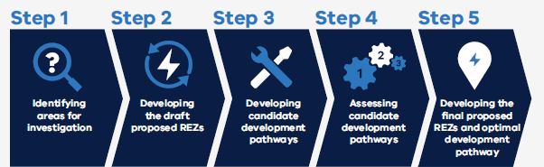
Figure C-1 The 5 The 5-step VTP methodology

Table C-2 The 5 The 5-step VTP methodology
Step 1 | Step 2 | Step 3 | Step 4 | Step 5
Identifying areas for investigation | Developing the draft proposed REZs | Developing candidate development pathways | Assessing candidate development pathways | Developing the final proposed REZs and optimal development pathway
The main purpose of the power system modelling for the VTP is to identify the transfer limits from different areas of the power system (which incorporates the proposed REZs) to the metropolitan Melbourne area. This task was critical as it identified the network element(s) causing the transfer limit and the solutions to improve it. The constraints considered were thermal, voltage ranges and stability constraints.
These solutions were then further studied to ensure the network would operate securely and reliably across a range of operating conditions.
As part of Step 3, the study method described below was undertaken to identify indicative transfer limits that could be achieved from various transmission augmentations. The most effective of these network augmentations that met the forecast demand projections were selected to form the proposed candidate development pathways.
AEMO’s Power System Model Guidelines specify requirements for information and models that various market participants must prepare as specified in the National Electricity Rules (NER). To align with the Power System Model Guidelines, VicGrid has adopted PSS/E as the preferred software for power system analysis. PSS/E is a software application that simulates the transmission network under various conditions, including assessing the impact that different generation scenarios from the 2025 VTP would have on network reliability. PSS/E provides a comprehensive environment for system planning and operation, including network thermal assessment, contingency analysis and network voltage support assessment, and other functions essential for testing and identifying network reliability and efficiency.
Key steps of the power system modelling approach adopted for the 2025 VTP are outlined below:
- In line with the inputs, assumptions and scenarios outlined in the VTP Guidelines, the network scenarios were modelled and mapped in the PSS/E model for demand and generation, through market modelling and major loads (data centres and hydrogen production). These were identified through a range of steps including strategic land use assessment and generation planting
- The PSS/E VAPR 2024 model provided by AEMO Victoria Planning (AVP) was used as a base case for the VTP power system modelling
- We identified relevant inputs, assumptions and modelling parameters to extend the PSS/E VAPR model for use in the VTP and these were discussed with various stakeholders at the outset of PSS/E modelling
- We updated the PSS/E model with the proposed transmission projects (see Appendix A) and consulted with industry stakeholders
- The updated PSS/E model was then used for undertaking relevant power system analysis to assess risks that network alteration of any new or additional equipment to the network could impose on network capability, power system security or inter-regional power transfer capability
- The outcome of the power system analysis identified constraints in the network. These were then assessed to understand how they could be remedied in order to meet overall network needs as specified in the NER and other relevant standards, guidelines and good engineering and industry practice
- The findings of the power systems analysis helped us identify indicative power transfer limits within the Victorian transmission network supplying power to load centres.
This process is crucial for ensuring that the transmission solutions identified in the 2025 VTP maintain network performance, provide a stable and efficient power grid, minimise the effects of outages, and adapt to evolving energy demand, whilst meeting required network performance standards.
For the 2025 VTP, comprehensive power system modelling and assessment has been limited to scenario 1 and scenario 2, and in turn candidate development pathway 1 and candidate development pathway 2. Scenario 3 was evaluated by the extension of scenario 1 modelling results and in workshops with stakeholders.
  - C.2 PSS/E 2025 VTP model
Currently, AVP maintains the PSS/E power system model for the Victorian transmission network. This model includes all the transmission lines, terminal stations, other related network elements, compensation devices and generation in Victoria and is updated annually.
The most recent PSS/E model for the Victorian transmission network (referred to as VAPR 2024 model hereafter) was sourced from AVP and used as the building block for developing the 2025 VTP PSS/E model. The VAPR 2024 model was modified to include the generation profile created through market modelling that included the 2025 VTP inputs and assumptions. Candidate transmission projects and Integrated System Plan (ISP) projects were also included in the power system model, along with anticipated network compensation equipment to prepare the base case which was used for undertaking the VTP power system analysis.
  - Power system modelling scope, inputs and assumptions
    - Scope of modelling for the 2025 VTP
Power system modelling is being undertaken for the 3 VTP hypothetical scenarios outlined in the 2024 VTP Guidelines. These 3 scenarios reflect 3 different potential futures for Victorian energy demand.
Scenario 1 reflects the current trajectory of Victoria’s energy transition. The bulk of this appendix relates to the power system studies undertaken for this scenario.
Scenario 2 builds on scenario 1 and represents a higher load and generation scenario reflecting significant growth in green industries. To support this growth, additional transmission projects were identified through strategic planning workshops with industry stakeholders, and assessed through power system studies.
The basis for scenario 3 is the same as scenario 1, as they both have a similar load and generation profile. However, scenario 3 reflects a potential future where there are delays in building new energy infrastructure across the National Electricity Market, including for Western Renewables Link (WRL), Victoria to New South Wales Interconnector (VNI) West and Marinus Link. Given the similarities across the scenario where the same transmission projects for scenario 1 were utilised for scenario 3, the power system modelling for scenario 1 was also used to assess scenario 3.
    - Existing transmission network
The transmission planning and subsequent power systems analysis for different demand projection scenarios shows that Victoria could face significant constraints, with ageing and existing infrastructure struggling to meet projected energy demands.
To ensure a stable and secure power supply with more renewable energy, the Victorian network will require augmentations (enhancements to existing infrastructure). These include upgrades to key transmission lines, substations, and switching stations, as well as integrating more flexible, resilient technology solutions to accommodate new energy generation sources.
Table C-3 outlines the existing network capacity of the Victorian regional network areas. These have been used as a starting point for planning and analysing augmentations as part of Steps 2, 3 and 4.
Table C- 3 Existing Network Capacity
Network area | Assumed existing network capacity limit (MW)¹
South West Victoria | 1,850 MW²
Western Victoria | 450-780 MW3 (North West of Ballarat)⁴  6003 (South East of Ballarat)⁴
North West Victoria | 400-450 MW3,⁴
South East Victoria | 6,000 MW5
Central North Victoria | 600-650 MW3
Notes:
- Network capacity is primarily provided under Summer Peak conditions and is valid under specific network conditions and can vary based on generation, load, interconnector flow
- Based on AEMO 2024 ISP, Appendix A5; this value does not consider the impact of Mortlake turn in
- The upper value provided is based on AEMO 2023 Transmission Expansion Options Report
- The network capacity in Western Victoria and North-West Victoria is highly dependent on the regional load, generation mix and location of the generation
- Based on AEMO 2023 Transmission Expansion Options Report and represents the network capacity available on the 500kV network at Latrobe Valley.

C.3.3 Basis of transfer limit
The transfer limit is considered as the physical limit of a network to transfer energy from a generation connection point to major load centres, primarily metropolitan Melbourne. There are multiple factors impacting on the transfer limits.
While the transfer capability varies throughout the day with generation dispatch, load, and weather conditions, the transfer limit is the maximum generation that the REZ or generators within a network region can host under high stress conditions before network assets exceed their post contingent (N-1) rating. These high stress conditions typically occur during maximum demand, on the hottest days in Victoria. Hot conditions negatively affect the transfer limit, as transmission infrastructure needs to be operated at its most restrictive 45°C rating.
The transfer limit is based on the most binding technical limitations within the power system, which are the thermal limit, voltage stability limit, transient stability and oscillatory stability limit. These factors are detailed in Table C - 4.
For the 2025 VTP, thermal assessment was undertaken for a limited set of operating conditions. This assumption is made to allow for maximum utilisation of the physical transmission assets, where the transfer limit should ideally be constrained by the thermal limits of those assets, with all other limits having been designed not to restrict the thermal capability. However, this does not always occur due to the network topology and their interaction or sharing with other network elements. Where relatively low-cost augmentation can be applied, i.e. reactive plant installed at terminal stations to address reactive and/ or voltage stability compensation concerns, fault mitigation equipment or system strength equipment, these are assumed to have been installed. Additionally other factors, such as network security and operational factors are also considered when determining the transfer limit.
Table C-4 below shows the factors impacting the transfer limit.
Table C-4 Factors impacting the transfer limit
Factors | Impact on the transfer limit
Thermal limit | The thermal limit is the maximum capability of a transmission line to carry electricity. It is established by identifying the equipment (e.g. transformer, transmission lines, droppers, etc.) with the lowest rating in the electricity path, under the most severe N-1 conditions.  Thermal limits can be increased by implementing control mechanisms that will offload the limiting equipment, augmenting existing assets or building new assets to provide additional flow capacity or pathways. Depending on the limiting piece of equipment, the capital costs and social impacts can be very high.
Voltage stability limit | Long term voltage stability is the maximum loading allowed within a region or in a local area to maintain a healthy voltage range under different network operating scenarios before experiencing voltage collapse. The voltage stability limit can be improved through the installation of static and/or dynamic reactive compensation (e.g. reactors, capacitors, static var compensators, etc.).  Preliminary steady state voltage studies were conducted to determine satisfactory voltage performance under system normal and under contingency conditions. The analysis identified that pre and post contingent voltages were within a healthy and allowable voltage range.
Transient stability and oscillatory stability limit | Transient stability is the power system’s ability to maintain voltage levels and return to steady state after a disturbance. Oscillatory stability relates to damping of generator rotor angles. These studies are complex and require a wide range of dynamic power system studies to be conducted across a range of operating scenarios, as well as joint planning with other jurisdictions and stakeholders. Given the level of complexity involved, these studies have not been conducted for the 2025 VTP.

  - Methodology
In the 2025 VTP, power system analysis is limited to power flow, contingency analysis, in the PSS/E environment. These are essential for evaluating the performance and reliability of power systems. To identify the future transfer limit for the various network areas of the power system the following approach was adopted:
- Model Building the power system model, based on the VAPR 2024 model, was updated with the Victorian load and generation build developed for the 2025 VTP. Proposed projects in the candidate development pathways were included in the model together with reactive compensating equipment identified in various RIT-T assessments as required to obtain stable network operation.
- Power flow analysis was undertaken to determine the steady-state operation of the power system under maximum demand conditions. Power flow results focussed on reviewing bus voltages, power flows on transmission lines, network losses, steady state generation adequacy, transfer capacity and reactive power balance across the network. Load flow findings were analysed and any constraints were recorded for further network remediation assessment.
- Contingency analysis was undertaken to assess the power system's ability to withstand component failures (e.g. transmission outages or generator failures) without violating operational limits. Contingency analysis findings were analysed to assess existing network redundancies and robustness of the system in response to contingencies. Network constraints in the form of voltage violations, transmission line overloads, or other performance issues in the network were recorded for further network assessment.
The above analysis used the base input and analytical assumptions outlined in Table C-5.
Table C-5 Base inputs and assumptions in the PSS/E model
 | Base inputs and assumptions
Ambient temperature | The VAPR 2024 maximum demand model was used as the base building block for the 2025 VTP model. This model considers 45°C temperature ratings for all circuits. For this final VTP, 3 reference conditions were assessed, with transfer limits typically higher at lower temperature ratings:  Summer Peak: Considers 45°C temperature ratings for all circuits  Summer Typical: Considers 30°C temperature ratings for all circuits  Winter Typical: Considers 10°C temperature ratings for all circuits
Limit of assessment | The power system studies were limited to the assessment of Victoria only, considering the transmission system with voltage at and above 220 kV only. The assessment was also limited to the boundary of the Greater Melbourne Metropolitan area and the interconnectors with other regions.
Contingency assessment | Contingency analysis was limited to N-1 contingency events for transmission lines and critical transformers across the Victorian network. No N-2 or N-1-1 contingencies have been considered for the 2025 VTP. These would normally be examined during a more detailed planning stage for project development.  Under normal and contingency events we assessed voltage at the relevant buses to ensure they are kept within 90% to 110% range of the nominal voltage of the equipment.
Electrical parameters for new transmission equipment | New transmission equipment was assumed to have the following thermal ratings at the various reference conditions. These are consistent with the existing equipment currently installed on the Victorian transmission system and reflects the already understood operation, maintenance practices and spare parts holdings applied in Victoria:  500 kV Transmission Line:  Summer Peak: 2700 MVA for Normal/Emergency ratings  Summer Typical: 3105 MVA for Normal/Emergency ratings  Winter Typical: 3645 MVA for Normal/Emergency ratings.  330 kV Transmission Line:  Summer Peak: 1200 MVA for Normal/Emergency ratings  Summer Typical: 1380 MVA for Normal/Emergency ratings  Winter Typical: 1620 MVA for Normal/Emergency ratings.  220 kV Transmission Line:  Summer Peak: 800 MVA for Normal/Emergency ratings  Summer Typical: 920 MVA for Normal/Emergency ratings  Winter Typical: 1080 MVA for Normal/Emergency ratings.  500/220 kV Transformers: 1000 MVA Normal, 1500 MVA (150%) for Emergency ratings (where operating conditions permit). These ratings are applicable at all reference conditions.
  - Regional network summaries

C.5.1 South West Victoria
      - Existing network topology and network constraints
The South West Victorian transmission network travels through areas including Heywood, Mortlake, Moorabool, Terang, and Sydenham and is shown in Figure C-2. It includes a mix of 220 kV and 500 kV transmission assets and supports a significant amount of existing onshore wind generation. This network also forms an interconnection between Victoria and South Australia via the Heywood Terminal Station, and incorporates the South West and Central Highlands proposed REZs.
Figure C-2 shows map of Victoria with the existing network in the South West area.
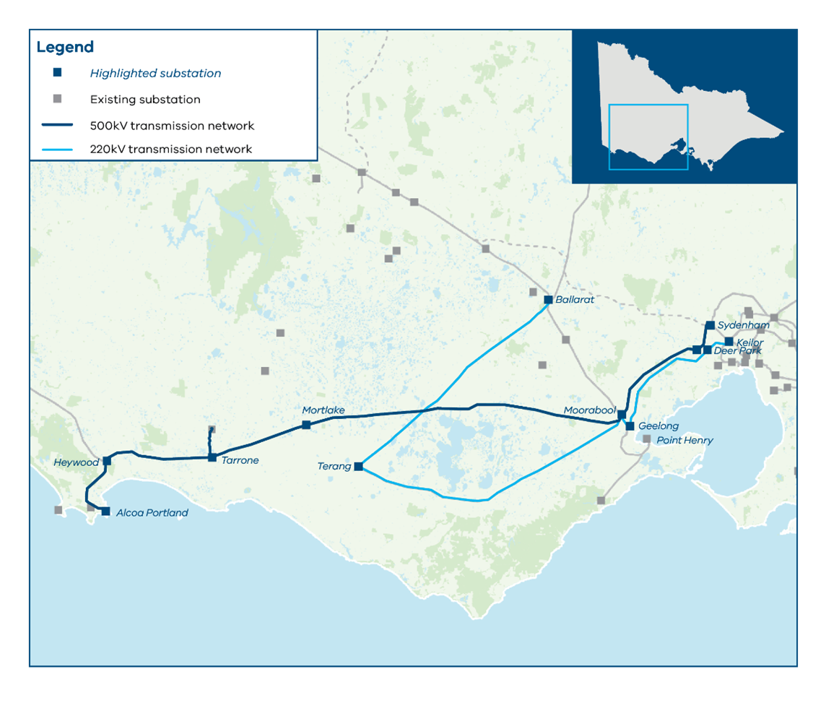
Figure C-2 Existing Transmission Network Topology for South West Victoria
The majority of the onshore wind generation located in this region is connected to the 500 kV network which connects the Heywood Terminal Station to the South Morang and Keilor Terminal Stations via Mortlake, Cressy, Moorabool and Sydenham. The main constraint for this generation is due to voltage stability issues and limits the existing transfer capacity to 1,850 MW (AEMO, 2024). The completion of the Mortlake turn-in project and other minor augmentations will address this stability limit. Once these are complete, the thermal constraint of the Cressy to Moorabool 500 kV line will be the main constraint in this part of the network.
The 220 kV network faces a different issue due to the close correlation between the wind generation from South West Victoria and Western Victoria. This can cause the 220 kV network to be overloaded, particularly the Moorabool to Geelong transmission line, which can restrict generation from this part of the network.
      - Candidate development pathway 1 projects required by 2031
- The following projects from the Western Victoria reinforcement program assist in resolving network constraints in South West Victoria. Further project details are presented in Appendix A.
- Project 1.1 Increase the rating of the Moorabool to Geelong 220 kV circuits (No.1 and No.2) by upgrading station plant (e.g. GTS 220kV isolators) and enabling system overload control scheme (SOCS)
- Project 1.4 Switch the existing Geelong to Keilor circuits into Deer Park (No.1 and No.3). Operate the 3 Deer Park to Keilor 220 kV circuits as normally open, effectively resulting in the supply to Deer Park being provided from Moorabool via Geelong
- Project 1.5 Undertake a 1000 MVA replacement of the A2, A3 and A4 500/220 kV transformers at Keilor.
- These projects alleviate the 220 kV constraints and create a radial flow path from Geelong to Deer Park, allowing excess generation on the 220 kV network to flow into the 500 kV network via the Moorabool 500/220 kV transformers.
      - Candidate development pathway 1 projects required prior to 2040
The South West expansion program outlined below and detailed in Appendix A, facilitates the increase in the transfer limit for South West Victoria. This program includes the following projects:
- Project 4.1 Install a new 500/220 kV terminal station at Truganina and 2 220 kV lines from Truganina to Deer Park
- Project 4.2 Install a new 500 kV double circuit line from Tarrone to Mortlake to Moorabool and Tarrone 500 kV turn in
- Project 4.3 Install a new 500 kV double circuit from Moorabool to Truganina and single circuit from Truganina to Sydenham
- Project 4.4 Rebuild the 3 existing transmission lines between Deer Park and Keilor with new high-capacity double circuit lines, with a normally open point between Deer Park and Geelong. Note that the circuits from Geelong to Deer Park remain unchanged, retaining their existing capacity.
This program provides significant additional network capacity in South West Victoria by creating 4 500 kV circuits (2 existing circuits and 2 new circuits) from South West Victoria to metropolitan Melbourne, mirroring the existing arrangement in South East Victoria from the Latrobe Valley. The transfer limit will be increased to the security limit of approximately 7,500 MW (subject to network conditions).
Once these projects are completed, the thermal constraint will likely be the Moorabool to Truganina 500 kV line or Moorabool to Cressy 500 kV line for trip of the parallel circuit. Generation from both South West Victoria and Western Victoria could result in significant amounts of power flowing through Moorabool or Sydenham Terminal Stations and a network security transfer limit of 7,500 MW being applied, which is applicable under all reference conditions. This limit is subject to further investigation and will continue to be assessed by VicGrid.
Part of the South West expansion program creates an alternative 220 kV flow path from Truganina to Deer Park to Keilor, which can alleviate the system security constraint at Sydenham. Further investigation is likely required to address any operational constraints at Moorabool.

C.5.1.4 Candidate development pathway 2 projects required by 2031
Candidate development pathway 2 builds from the projects already considered in candidate development pathway 1. By 2030, the only additional project required is
- Project 10.1: Install a new 220 kV single circuit from Moorabool to Geelong.
Post Deer Park cut-in (Project 1.4), this project is driven by the increase in demand in Scenario 2, which results in higher load at both Geelong and Deer Park, which could see the Moorabool to Geelong 220kV transmission line overloaded for trip of the parallel circuit across the various reference conditions. Ultimately, the need of this project is driven by the load increase in Scenario 2 and as such, should be monitored as the load increases in Victoria.
      - Candidate development pathway 2 projects required prior to 2040
Candidate development pathway 2 builds from the projects already considered in candidate development pathway 1. By 2040, the additional projects considered for this network area are:
- Project 4.5: Install a new 500 kV double circuit line from Heywood to Tarrone
- Project 8.1: Install a new 500 kV single circuit from Sydenham to Keilor
- Project 10.3: Install a new 500 kV double circuit from Mortlake to Bulgana.
Due to the close correlation between wind generation in South West Victoria and Western Victoria, generation within these areas are likely to occur at the same time, often leading to these generators competing for the same transmission capacity to supply the metropolitan Melbourne area. After WRL and the Western Victoria reinforcement program are complete, they will share the following key exit corridors:
Moorabool Terminal Station and Moorabool to Sydenham 500 kV Lines
- A proportion of generation from Western Victoria will flow along the Ballarat to Moorabool 220 kV corridor and will flow onto the 500 kV network between Moorabool to Sydenham via the Moorabool 500/220 kV transformers, which competes with generation connected to the Heywood to Mortlake to Moorabool 500 kV corridor.
Sydenham Terminal Station
- Generation from South West Victoria flowing on the Heywood to Mortlake to Moorabool to Sydenham 500 kV corridor competes with generation from Western Victoria flowing on the 500 kV circuits from Bulgana to Sydenham.
By sharing these key exit corridors, operational scenarios exist where generation in South West Victoria could restrict generation in Western Victoria and vice-versa, in particular for Scenario 2, given the increase in demand and increased generation from South West and Western Victoria. Projects 8.1 and 10.3 alleviate this constraint by:
Creating a parallel flow path to metropolitan Melbourne
- The proposed 500 kV double circuit from Mortlake to Bulgana establishes 2 parallel flow paths for generation to supply metropolitan Melbourne. One path follows Mortlake – Bulgana – Sydenham, consisting of 2 500 kV circuits, while the other follows Mortlake – Moorabool – Truganina flow path, consisting of 4 500 kV circuits to Truganina, and then 3 500kV circuits to Sydenham, with an additional 220kV flow path to Keilor via Deer Park and Truganina
- This additional flow path can help ‘bypass’ the operational limitation at Moorabool and thereby increasing the overall transfer capacity from this network area. However, the amount of additional capacity that could be unlocked is dependent on network conditions, including the amount and mix of generation from this area, due to the close correlation between wind generation in South West Victoria and Western Victoria. The key network constraints that are observed are:
- Overload of the Cressy to Moorabool 500 kV for trip of parallel circuit
- Operational limitations at Moorabool
- Operational limitations at Sydenham.
Increasing the 500kV supply capacity to metropolitan Melbourne
Sydenham Terminal Station is a key exit corridor for generation in South West Victoria and Western Victoria. Its ability to supply the load in metropolitan Melbourne is dependent on the downstream circuits, which consist of 2 500 kV circuits from Sydenham to South Morang and one 500 kV circuit from Sydenham to Keilor. During Summer Peak conditions, the Sydenham to Keilor circuit for trip of one Sydenham to South Morang circuit becomes the limiting constraint, which then shifts to Sydenham to South Morang for trip of Sydenham to Keilor at other reference conditions due to the lower rating on the Sydenham to South Morang circuits
To alleviate this constraint for the load growth in scenario 2, a second Sydenham to Keilor 500 kV circuit is proposed. This increases the 500 kV supply capacity from South West and Western Victoria to metropolitan Melbourne, with the critical contingency becoming Sydenham to Keilor circuit for trip of the parallel circuit. However, depending on network conditions, operational limitations at Sydenham may bind first.

C.5.1.6 Other issues and sensitivities
Additional issues that were identified during the power system modelling are presented below. Further assessment of these issues or sensitivities and their impact on the overall transfer limit will continue to be assessed.
Connecting the Southern Ocean offshore wind area
The modelling has assumed that 1.5 GW of offshore wind will be connecting to the existing Portland – Heywood 500 kV corridor. While the line has a thermal rating of 2,500 MVA (at 45°C), the equipment within the substations is rated much lower, causing the capacity to be limited to 1,400 MVA. Uprating this equipment should allow the full 2 GW of offshore wind to flow through the Portland – Heywood 500 kV line. This project has been identified in Program 7 – Offshore Wind upgrade and included in all 3 candidate development pathways.
The need for a new double circuit 500 kV line extending from Tarrone to Heywood (Project 4.5) to help facilitate the connection of offshore wind will be driven by the amount of renewable generation connecting west of the Tarrone Terminal Station and the level of network curtailment experienced by these generators. Project 4.5 has been included in candidate development pathway 2 reflecting the higher need for onshore generation in this scenario and will continue to be assessed in the future.
Ballarat to Terang to Moorabool 220 kV Loop
South West Victoria also consists of a low capacity (200-390 MVA at 45°C) 220 kV single circuit line between Ballarat and Moorabool Terminal Station, consisting of the Terang and Berrybank Terminal Stations, which currently hosts some renewable generation. Due to the low rating of these circuits, the assessment did not consider additional generation connecting to this 220 kV loop as it was anticipated that new generation hosted in the South West and Central Highlands would seek to connect to the 500 kV circuits in South West Victoria or connect to the nearby 220 kV network in Western Victoria between Ballarat to Moorabool.
Regional loads in South West Victoria
South West Victoria consists of large regional loads such as Geelong, as well as large industrial loads such as the Portland smelter. These loads typically assist generators located within South West Victoria as the localised generation can supply these loads and limit the loading on the critical transmission assets closer towards the metropolitan Melbourne area. Reduction of the key existing or forecasted loads with overall generation dispatch may shift the critical constraint to Sydenham to Keilor 500 kV for trip of a Sydenham to South Morang 500 kV circuit (for candidate development pathway 1 only) or Truganina to Sydenham 500 kV for trip of the parallel circuit (for all candidate development pathways). This may bind earlier than other constraints that have previously been identified. This may require additional transmission augmentations to resolve.
    - Western and North West Victoria
      - Existing network topology and network constraints
The network in Western and North West Victoria covers the 220 kV rhombus, consisting of Red Cliffs – Bendigo to Ballarat to Horsham Terminal Stations. Historically, solar generation has connected to the northern section of the rhombus, and wind generation to the southern section of the rhombus. This network incorporates the proposed Western REZ, North West REZ and Central Highlands REZ.
Figure C-3 below is a map of Victoria that shows the existing transmission network for the Western and North West Victoria.
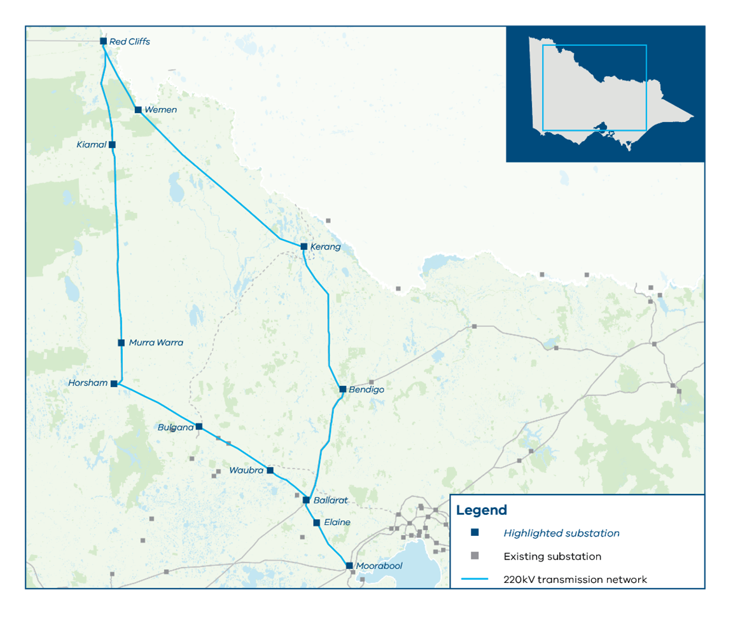
Figure C-3 Existing transmission network topology for Western and North West Victoria
Western Victoria, which covers the southern section of the rhombus, consists of the 220 kV transmission network from Murra Warra Terminal Station to Ballarat Terminal Station – via Bulgana, Crowlands, Ararat and Waubra Terminal Stations. It also consists of Elaine Terminal Station, which is between Ballarat and Moorabool terminal stations.
North West Victoria, which covers the northern section of the rhombus, consists of the 220 kV transmission network from Red Cliffs through to Bendigo, via Wemen, and Kerang Terminal Stations. It also includes the Kiamal Terminal Station which connects between Red Cliffs and Murra Warra Terminal Stations.
For both Western and North West Victoria, the key exit corridor to supply the metropolitan Melbourne area, is through the Ballarat - Moorabool – Geelong – Deer Park – Keilor 220 kV transmission lines.
Both Western and North West Victoria share the same existing thermal constraints, which is that they both compete for capacity in the rhombus under N-1 conditions, as all 220 kV transmission lines are only single circuit. In addition to the thermal constraints, this network (in particular North West Victoria), experiences voltage oscillation and voltage collapse issues, for a number of different outage conditions. The network in this area is supported by a number of control systems which enable greater utilisation of the assets whereby generation is curtailed when triggered by defined network events.
This area of the network is particularly prone to oscillatory performance issues that requires rigorous analysis to ensure any new connection is able to operate satisfactorily on the network.
      - Candidate development pathway 1 projects required by 2031
Projects already in development, including WRL and VNI West and the VTP projects in the Western Victoria reinforcement program assist in alleviating the existing constraints in this region.
Key additional projects identified in this VTP include those in the Western Victoria reinforcement program (see Appendix A for further detail):
- Project 1.1 Increase the rating of the Moorabool to Geelong 220 kV circuits (No.1 and No.2) by reassessing the SOCS scheme operating in the area to determine whether it can be modified to increase capacity, or otherwise establish a new SOCS scheme, as well as upgrading station plant (e.g. Geelong 220 kV isolators)
- Project 1.3 Rebuild the existing transmission line between Ballarat and Moorabool into a 220 kV high-capacity double circuit transmission line with higher capacity per circuit
- Project 1.4 Switch the existing Geelong to Keilor circuits into Deer Park (No.1 and No.3). Operate the 3 Deer Park to Keilor 220 kV circuits as normally-open, effectively resulting in the supply to Deer Park Terminal Station being provided from Geelong Terminal Station.
These projects significantly change the transfer capacity of key exit corridors to supply the Greater Melbourne Metropolitan area by:
- Creating a new exit corridor via WRL and the new 500 kV transmission line from Bulgana to Sydenham
- The projects result in Geelong and Deer Park becoming a radial network, which allows excess generation from this area on the 220 kV network to flow into the 500 kV network via the Moorabool 500/220 kV transformers. This results in Western and North West Victoria competing for the same 500 kV transmission capacity from Moorabool to Sydenham with South West Victoria.
These projects significantly increase the transfer limit from this area. As a result of implementing these projects, the key thermal constraints that are observed depending on network location and other network conditions are:
Western Victoria
- Overload of the Ballarat to Elaine or Elaine to Moorabool 220 kV for trip of parallel circuit or trip of Ballarat – Moorabool 220 kV, with these constraints applicable across all reference conditions
- Overload of Waubra to Ballarat 220 kV for trip of one circuit of Bulgana to Sydenham 500 kV, with these constraints applicable across all reference conditions.
North Western Victoria
- Overload of Bendigo to Kerang 220 kV line for trip of Kerang to Bulgana 500 kV line or Bulgana to Sydenham 500 kV line, where this constraint is observed under Summer Peak and Summer Typical conditions
- Overload of Kerang to Bulgana 500 kV line for trip of the parallel circuit, where this constraint is observed under Winter Typical conditions
- At this reference condition, the Bendigo to Kerang 220 kV is sufficiently rated for the Bendigo load and, as such, the critical contingency shifts to the Kerang to Bulgana 500 kV line
- Overload of Red Cliffs – Wemen - Kerang 220kV for trip of various contingencies, with this constraint generally observed under Summer Peak and Summer Typical conditions. However, depending on other network conditions, this constraint could also bind during Winter Typical conditions.
      - Candidate development pathway 1 projects required prior to 2040
The North West strengthening program provides additional network capacity by strengthening the existing 220 kV rhombus. This program includes:
- Project 3.1 Replace the existing transmission line between Murra Warra, Horsham and Ballarat with a high-capacity double circuit line
- Project 3.3 Rebuild the existing transmission line between New Kerang and Bendigo into a high-capacity double circuit line.
Converting the northern section of the rhombus (New Kerang to Bendigo) and the southern section of the rhombus (Murra Warra to Ballarat) from single circuit to high-capacity double circuit 220 kV transmission lines would increase the transfer limit substantially depending on network conditions, location of new generation and overall interconnector flow. Some of the key thermal constraints that are observed are detailed below:
Western Victoria
- Overload of the Ballarat to Elaine or Elaine to Moorabool 220 kV for trip of parallel circuit or trip of Ballarat – Moorabool 220 kV, with these constraints applicable across all reference conditions
- Overload of Waubra to Ballarat 220 kV for trip of parallel, with these constraints applicable across all reference conditions
- Overload of Horsham to Murra Warra 220 kV for trip of parallel, with these constraints applicable across all reference conditions, and primarily driven by the amount of generation along the Horsham – Murra Warra – Red Cliffs corridor
- Overload of Bulgana to Sydenham 500 kV line for trip of parallel circuit, with this constraint more likely to bind during Summer Typical and Winter Typical conditions.
North Western Victoria
- Overload of Bendigo to Fosterville for trip of one circuit on Bulgana to Sydenham 500 kV, with this constraint more likely to bind during Summer Peak and Summer Typical conditions
- Overload of Kerang to Bulgana 500kV line for trip of parallel circuit, with this constraint applicable across all reference conditions
- Overload of Red Cliffs to Wemen to Kerang 220kV for trip of various contingencies, with this constraint applicable across all reference conditions
      - Candidate development pathway 2 projects required by 2031
By 2031, candidate development pathway 2 has the same projects as candidate development pathway 1 for this network area. Refer to Section C.5.2.2.
      - Candidate development pathway 2 projects required prior to 2040
Candidate development pathway 2 builds from the projects already considered in candidate development pathway 1. By 2040, the additional projects considered for this network area are:
- Project 3.2 Rebuild the existing transmission line between Red Cliffs and New Kerang into a high-capacity double circuit line
- Project 8.1 Install a new 500 kV single circuit from Sydenham to Keilor
- Project 10.3 Install a new 500 kV double circuit from Mortlake to Bulgana.
Projects 8.1 and 10.3 create a robust 500 kV backbone, providing a strong link with South West Victoria and increasing the supply capacity into metropolitan Melbourne. Due to the close correlation between wind generation in South West Victoria and Western Victoria, generation within these areas are likely to occur at the same time and thereby share similar constraints, which has been discussed in more detail in Section C.5.1.5.
Project 3.2 addresses the constraint identified in candidate development pathway 1 (overload of Red Cliffs to Wemen to Kerang 220kV for trip of various contingencies), which at times could limit generation in this area. This project would help uplift the capacity in this network area, thereby allowing more generation and load to connect in this network area and also help facilitate exports to New South Wales via Buronga under scenario 2.
      - Other issues and sensitivities
Due to the network complexity of these regions, as well as the multiple interconnection points with New South Wales and South Australia, the network constraints are heavily dependent on network operating conditions such as interconnector flow, generation mix, demand and where future generation connects to the network. The following issues have been identified for further assessment.
Overload of Ballarat to Bendigo 220 kV line
When low solar generation in North West Victoria coincides with low New South Wales import (or New South Wales export) under peak summer demand conditions, there may be an issue on the Ballarat to Bendigo 220 kV line for trip of Bendigo to New Kerang 220 kV line, due to the regional load located at Bendigo and surrounding regions such as Fosterville, with this constraint likely to bind under Summer Peak and Summer Typical conditions due to the existing lower thermal rating of the circuit. This overload could be managed through control schemes or other non-network solutions, such as a localised generation closer to Bendigo.
Overload of Bendigo to Fosterville/Shepparton 220 kV line
Similar to the Ballarat to Bendigo line overload, when there is low solar generation in North West Victoria as well as Central North Victoria, coinciding with low New South Wales import (or New South Wales export) under peak summer demand conditions, we may observe an issue on the Bendigo to Fosterville/Shepparton 220 kV line for trip of Bendigo to New Kerang 220 kV line or Bulgana to Sydenham 500 kV line due to the regional load located at Bendigo and surrounding regions. This overload could be managed through similar schemes as detailed above or by rebuilding the Bendigo to Shepparton 220 kV transmission line to a higher capacity.
Overload of Red Cliffs – Wemen – Bendigo 220 kV line
Due to the low capacity of this circuit (134 MVA at 45°C line ratings), there are a variety of network operating conditions that can overload this circuit. For example, the 2024 VAPR notes that at times of high demand, this line is forecast to exceed its 45°C rating under system normal conditions due to the increased supply from New South Wales and South Australia via Red Cliffs post Yallourn retirement. This risk is unlikely to be completely alleviated post VNI West. Additionally, when export through Buronga coincides with high regional demand, generation from the proposed North West REZ may overload this circuit under system normal conditions across the various reference conditions. While options to alleviate this constraint have been investigated, such as rebuilding this circuit to a higher capacity double circuit line, this project has only been included in candidate development pathway 2 to facilitate the increased load and generation proposed in scenario 2. VicGrid will continue to monitor this constraint in the future.

C.5.4 South East Victoria and Gippsland

C.5.4.1 Existing network topology and network constraints
The South East Victoria transmission network consists of areas including Hazelwood, Yallourn and Loy Yang, which has traditionally been the synchronous generation hub of Victoria as well as the interconnection with Tasmania through Basslink. The network consists of 4 500 kV circuits to supply the metropolitan Melbourne area from Hazelwood Terminal Station to Rowville, Cranbourne and South Morang terminal stations. It also consists of 6 220 kV transmission lines from Hazelwood Power Station and Yallourn Power Station to Rowville Terminal Station.
The Gippsland offshore wind transmission will connect to the South East Victorian transmission network, with the first radial line being included as a model base assumption. The area also includes the proposed connection for Marinus Link, increasing interconnection with Tasmania.
Prior to the retirement of Yallourn Power Station, there is expected to be 6,000 MW of transfer capacity on the 500 kV network (AEMO, 2023).
Figure C-4 below shows a map of Victoria with the existing transmission network for the South East Victoria.
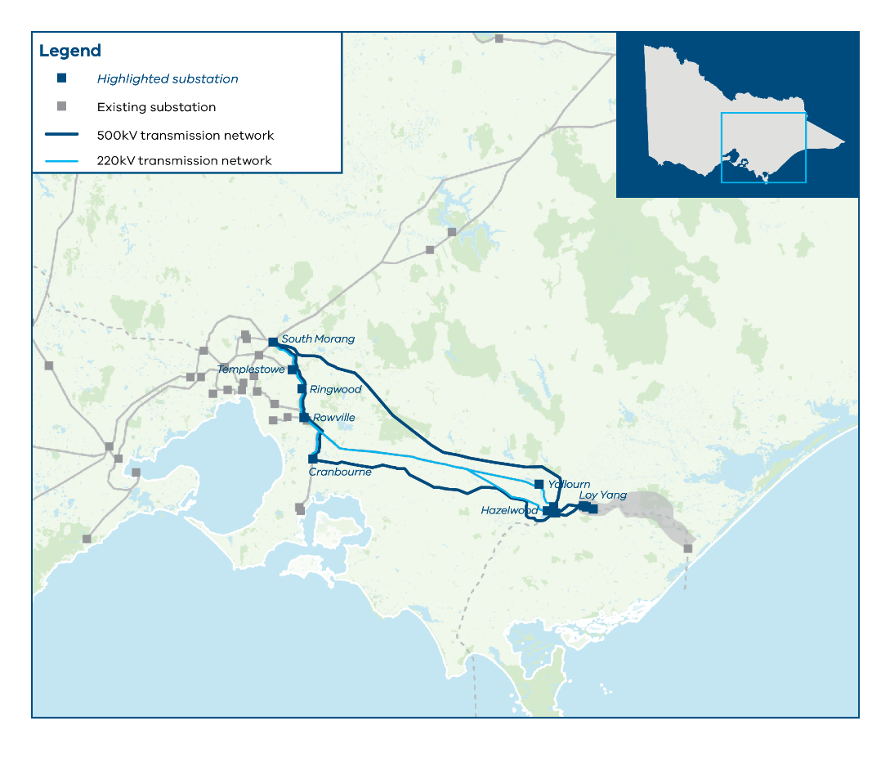
Figure C-4 Existing transmission network topology for South East Victoria
After Yallourn’s retirement, the network in Latrobe Valley will change from a radial configuration to the modified parallel arrangement with an inter-trip scheme that is being assessed by AVP. This will assess tripping certain Yallourn to Rowville 220 kV lines to prevent overloading on the remaining Hazelwood to Yallourn circuits and/or Hazelwood 500/220 kV transformers. While this is expected to provide better network utilisation between the 220 kV and 500 kV network in South East Victoria, the transfer capacity remains sufficient to address the forecast generation in the region. As Gippsland offshore wind generation increases, further works on the 220 kV and 500 kV will be required. Further details are available in VAPR 2024.
      - Candidate development pathway 1 projects required by 2031
The following projects from the Eastern Victoria reinforcement program assist in alleviating the existing constraints in this region:
- Project 2.1 Install a second Hazelwood to Yallourn double circuit line. Widen existing Hazelwood to Yallourn 220 kV (No.1 and No.2) easement and install approximately 10 km for a second Hazelwood to Yallourn double circuit line (new No.3 and No.4)
- Project 2.2 Install a second 500/220 kV transformer at Cranbourne and tie in the existing Hazelwood to Rowville 500 kV (No.3) circuit at Cranbourne.
The key constraint observed is the overload of the Hazelwood 500/220 kV transformer for trip of a parallel transformer across all reference conditions, resulting in a similar transfer limit across these conditions. This transfer limit could be increased by having a third Hazelwood 500/220 kV transformer in parallel or through other operational means. This may be investigated in the future if it is determined that there is a need to increase this transfer limit by 2031 for the various scenarios.
      - Candidate development pathway 1 projects required after 2031
The Latrobe Valley strengthening program facilitates the increase in transfer limit from this region and supports the integration of offshore wind projected to be located in Gippsland. Meanwhile, the Gippsland offshore wind transmission stage 2 program is designed to connect offshore wind to the network. These programs include the following projects (further detailed in Appendix A):
- Project 5.1 Install a second Gippsland 500 kV double circuit radial line and tie-in loop. A new 500 kV double circuit line linking new terminal stations near Driffield and Woodside (locations to be determined), and a new 500 kV double circuit tie-in loop between the new terminal station near Woodside and the proposed new terminal station at Giffard. This forms a 500 kV loop for Gippsland offshore wind generation
- Project 6.1 Install power flow controllers at Hazelwood
- Project 6.2 Install an additional transformer at Cranbourne or Rowville.
These projects, when combined with having 3 500/220 kV transformers in parallel at Hazelwood, increase the total transfer limit in the range of 7,000 – 7,500 MW, subject to assessment on fault levels and any remediation. This is primarily driven by the proposed power flow controllers, which allow the 220 kV and 500 kV network to be optimally utilised. The key constraints are on the 500 kV network, which may be limited to 6,000 MW (the same as the existing network). This constraint is to manage the existing transient stability and voltage stability constraints on the network, which are primarily driven by the existing synchronous generation in the Latrobe Valley. Once these units are retired, these stability constraints may be improved (subject to further analysis), which could impact the transfer limit.
It is expected that 7.5 GW or more of offshore wind will be connecting to the Victorian network in Gippsland by 2040, which is supported by Project 5.1.
      - Candidate development pathway 2 projects required by 2031
By 2031, candidate development pathway 2 has the same projects as candidate development pathway 1 for this network area. Refer to Section C.5.4.2.

C.5.4.5 Candidate development pathway 2 projects required prior to 2040
Prior to 2040, candidate development pathway 2 has the same projects as candidate development pathway 1 for this network area. Refer to Section C.5.4.3.
      - Other issues and sensitivities
No further key issues and sensitivities have been identified at this stage.
    - Central North
      - Existing network topology and network constraints
The Central North transmission network consists of areas between Bendigo, Shepparton and Dederang and incorporates the proposed Central North REZ. The network consists of a 220 kV single circuit line between Bendigo and Shepparton Terminal Stations that includes Fosterville Terminal Station. It also consists of 3 220 kV circuits from Shepparton Terminal Station to Dederang Terminal Station, with 2 of those circuits connected to Glenrowan, which is located in between Shepparton and Dederang. Historically this region has hosted solar generation between Shepparton and Dederang.
Figure C-5 below shows the existing transmission network topology for Central North Victoria.
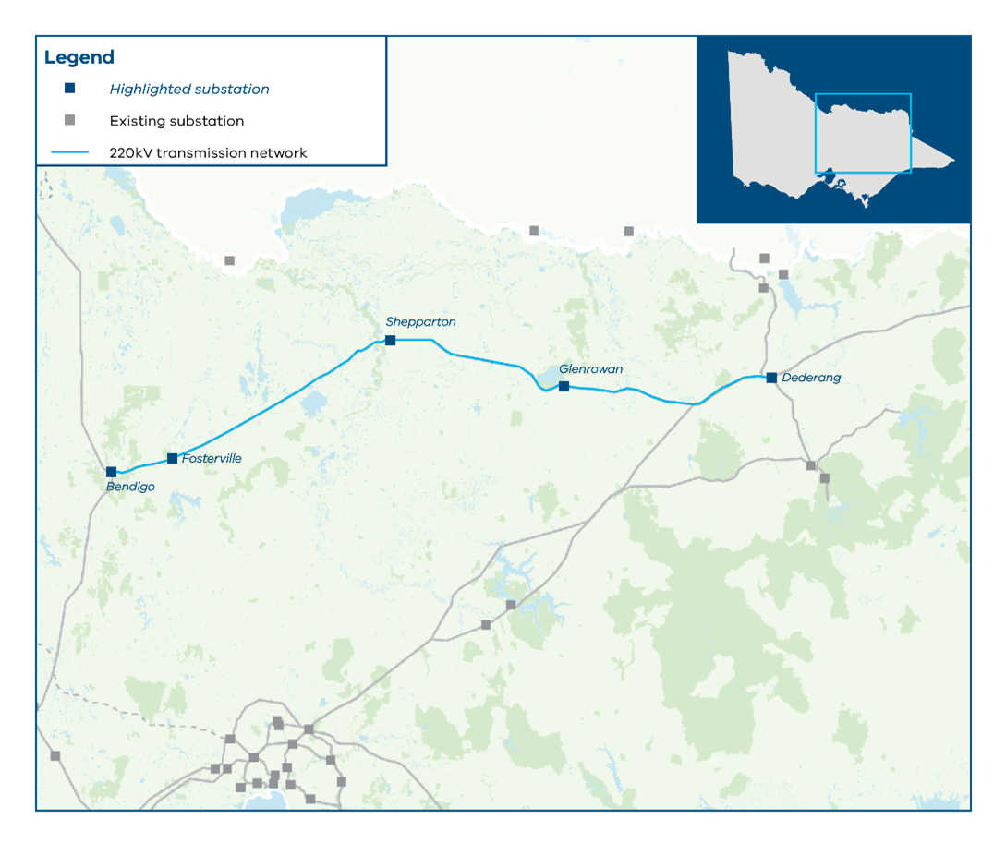
Figure C - 5 Existing transmission network topology for Central North Victoria
The Central North region contains 3 key exit corridors through which generation can supply the metropolitan Melbourne area:
Power flowing west through the Shepparton to Bendigo 220 kV, after which it will follow the same flow paths and exit corridors as Western and North West Victoria and competes for the same transmission capacity
Power flowing east through the 3 220 kV circuits from Shepparton to Dederang. At Dederang there are 2 exit corridors, where network conditions determine which exit is primarily used:
- Via the 220 kV lines from Dederang to Mount Beauty to Eildon to Thomastown, where generation from Central North will compete with the hydro generators connecting at Mount Beauty and Eildon
- Via the 3 220/330 kV transformers at Dederang and along the 330 kV double circuit line between Dederang and South Morang. Generation from Central North will compete for transmission capacity with New South Wales import and the Murray hydro generation.
Due to the network complexity of this region, the existing transfer limit ranges from approximately 700 MW in Summer Peak conditions to approximately 1,100 MW in Winter typical conditions, which assumes that new generation will primarily connect on the Shepparton to Dederang corridor. The key thermal constraints that are observed, depending on network location and other network conditions are:
- Overload of Dederang to Shepparton 220 kV for trip of Bendigo to Shepparton 220kV, which is observed under Summer Peak conditions
- Overload of Glenrowan to Dederang 220 kV for trip of parallel circuit, which is observed under Summer Peak and Summer Typical conditions
- Overload of Dederang 330/220 kV transformer for trip of Bendigo to Shepparton 220kV, which is observed under Winter Typical conditions.
      - Candidate development pathway 1 projects required by 2031
No candidate development pathway 1 projects have been identified for this region. Network characteristics together with forecast load and new generation in this region has not projected a material need for any augmentation projects at this stage.
      - Candidate development pathway 1 projects required prior to 2040
No candidate development pathway 1 projects have been identified for this region. Network characteristics together with forecast load and new generation in this region has not projected a material need for any augmentation projects at this stage.
      - Candidate development pathway 2 projects required by 2031
No candidate development pathway 2 projects for delivery by 2031 have been identified for this region. Network characteristics together with forecast load and new generation in this region has not projected a material need for any augmentation projects at this stage.
      - Candidate development pathway 2 projects required prior to 2040
The Central North strengthening program facilitates the increase in transfer limit from this region. These programs include the following projects (further detailed in Appendix A):
- Project 9.1 Rebuild the 220 kV single circuit between Shepparton and Dederang as a double circuit
- Project 9.2 Add a fourth 330/220 kV transformer at Dederang
- Project 9.3 Rebuild the existing 220kV transmission line between Shepparton and Bendigo as a double circuit.
Projects 9.1 and 9.2 facilitate an increase in transfer capacity in the East, by having 2 high capacity 220 kV circuits alongside 2 existing 220 kV capacity circuits coming into Dederang, as well as an additional 330/220 kV transformer at Dederang, which facilitates additional generation supplying metropolitan Melbourne via the 330 kV double circuit line between Dederang and South Morang. Project 9.3 facilitates an increase in transfer capacity in the West, by having 2 high capacity 220 kV circuits from Shepparton to Bendigo. As a result of implementing these projects, the key thermal constraints that are observed depending on network location and other network conditions are:
- Overload of the existing Dederang to Glenrowan 220 kV No.1 or No.2 circuits for trip of parallel circuit
- Overload of Dederang 330/220 kV transformer for trip of parallel transformer or trip of Eildon to South Morang 220 kV circuit.

C.5.5.6 Other issues and sensitivities
Additional issues that were identified during the power system modelling are presented below. Further assessment of these issues or sensitivities and their impact on the overall transfer limit will continue to be undertaken.
Interdependence of Victorian hydro generation, New South Wales imports and North West generation
The network in this region is complex, and there are significant interdependencies with Victorian hydro generation located in Ovens Murray, New South Wales import and North West Victorian generation, with various protection schemes in place to optimise existing network capacity, such as the VNI Systems Integrity Protection Scheme and Dederang bus scheme. VicGrid will continue to monitor this network area and its impact on the various generation sources and interconnector flow.
  - Limitations and next steps

C.6.1 Key limitations
Considering the scope and approach adopted in the 2025 VTP, the following elements are identified as key limitations to be considered over coming months and in future VTPs.
Assessment limited to the Greater Melbourne metropolitan area
The power system modelling is limited to the network between the regional networks (including the proposed REZs) to the boundary of the Greater Melbourne metropolitan area, mainly consisting of the outer 500 kV ring (Keilor – Sydenham – South Morang – Rowville - Cranbourne). While network constraints around and within Melbourne metropolitan region are critical, and could potentially constrain generation from REZs, these constraints will be managed through other Victorian planning processes such as the VAPR released annually. Additionally, resolving these constraints in Greater Melbourne metropolitan area would require joint planning with the distribution businesses to ensure customer demand is met and that any remediations are carefully coordinated.
Assessment does not consider transient stability constraints
Transient stability constraints require a specific range of dynamic power system studies to be conducted to identify and develop transient stability constraint equations covering the feasible operating conditions of the network. These stability constraints currently exist for a number of operating conditions and will bind on the network as identified in the 2024 VAPR.
As the network evolves, principally due to the proposed network augmentations altering the topology of the grid and the changing technology of the generators with higher response speeds, the impact of transient stability will change. The degree of influence from transient stability is yet to be analysed and will be undertaken as project design evolves and key data becomes more certain.
The network as it presently operates is exposed to transient stability limitations, and it would not be unreasonable to expect that future network operation would also be constrained by transient stability limits.
Assessment does not consider system strength impacts
System strength and the ability to maintain and control the voltage waveform at any given location is a critical parameter for the evolving power system. As synchronous generation starts to retire, along with the increase in inverter-based resources, system strength (and the corresponding minimum fault levels) will start to decrease over time, which requires remediation to ensure a stable power system. While the assessment of system strength has not been undertaken in this VTP, it is anticipated that system strength remediation will be required in the wider Victorian network. Further details are outlined in Appendix A.

Contact us
Phone: 1800 418 341
Email: vicgrid@deeca.vic.gov.au
Deaf, hearing or speech impaired? Please contact the National Relay Service on 133 677 or communications.gov.au/accesshub/nrs
Need an interpreter? Contact Translating and Interpreting Service (TIS) on 131 450 (within Australia) or visit www.tisnational.gov.au
ISBN 978-1-76176-425-7 (Print)
ISBN 978-1-76176-426-4 (pdf/online/MS word)
Disclaimer: The information in this document is current at the time of printing, may be subject to change and should not be relied upon. Please visit vicgrid.vic.gov.au for the latest updates.

