VicGrid

Renewable energy zones and transmission projects proposed in Gippsland
  - Updated May 2026
VicGrid is planning and developing new renewable energy zones and transmission to keep Victorians connected to reliable, affordable power.
Following the release of the 2025 Victorian Transmission Plan, Victoria’s transition to renewable energy is taking an important step forward with the declaration of renewable energy zones.
The 2025 Victorian Transmission Plan proposed six onshore renewable energy zones, along with a Gippsland shoreline zone. The Victorian Government has now formally declared five of the onshore zones, as well as the shoreline zone. You can learn more about each of the renewable energy zones on our webpage.
This summary provides an update on the onshore and shoreline zones in Gippsland, along with the supporting transmission projects.

What’s planned for Gippsland
Gippsland has some of the strongest and most consistent winds in Australia, both onshore and in the declared offshore wind zone. Wind energy is set to play a significant role in replacing coal-fired power, keeping the lights on and driving investment into the region.
The region also has significant existing transmission infrastructure, built to connect coal-fired power in the Latrobe Valley to metropolitan Melbourne and other parts of Victoria.
VicGrid is already developing a new transmission line from Giffard to the Latrobe Valley to connect the first two gigawatts (GW) of offshore wind energy to the grid (the Gippsland offshore wind transmission stage 1 project). We are speaking with landholders and communities in Gippsland to finalise the preferred route for this new transmission line.
The 2025 Victorian Transmission Plan identified:
The Gippsland Renewable Energy Zone – an area suitable for additional onshore wind energy in Gippsland.
The Gippsland Shoreline Renewable Energy Zone – a defined planning area where offshore wind farm developers will run underground cables from the shoreline to the electricity grid.
Two future proposed transmission projects – including a Gippsland offshore wind transmission stage 2 project from Driffield to Woodside to Giffard, and a proposed second 220 kilovolt (kV) line from Hazelwood to Yallourn.
The Minister for Energy and Resources has formally declared both the Gippsland Renewable Energy Zone and the Gippsland Shoreline Renewable Energy Zone.

What is a renewable energy zone?
Renewable energy zones are areas identified as the best places to host wind, solar and battery storage projects.
Renewable energy zones will:
Help coordinate renewable energy projects and reduce the need for unnecessary transmission infrastructure
Enable VicGrid to set clearer rules around how projects gain access to the grid, including expectations for how developers engage with communities
Provide more certainty about how and where renewable energy projects are developed
Unlock new economic benefits for regional communities and Traditional Owners
The Gippsland Shoreline Renewable Energy Zone is different from the other renewable energy zones. It is a defined planning area where offshore wind developers will run underground cables from the shoreline to the electricity grid. You can learn more about what this means on page 9.
The introduction of renewable energy zones doesn’t alter what is allowed to occur on land under existing land use zones or overlays, such as the Farming Zone or Rural Activity Zone.
All proposed projects will continue to be subject to existing planning and environmental controls, including approval processes under the Planning and Environment Act 1987 and Environment Effects Act 1978.
Renewable energy project developers must talk to landholders to get permission to build renewable generation projects on their land. Landholders can choose whether or not to host a wind, solar or battery project.
Landholders who choose to host projects will receive financial payments and other benefits negotiated directly with the developer.
Project developers will also work with neighbouring properties to address impacts and negotiate financial benefits.

Gippsland Renewable Energy Zone
The declared Gippsland Renewable Energy Zone is located between Morwell and Sale. It includes parts of the local government areas of Wellington Shire, Latrobe City and South Gippsland. The zone is within the Registered Aboriginal Party boundary of the Gunaikurnai Land and Waters Aboriginal Corporation.
When identifying this zone, we aimed to balance complex land use issues across the region with the pressing need to position renewable energy zones with the best access to wind and solar energy. We looked to coordinate access to existing transmission infrastructure to avoid the need for more transmission lines for onshore renewable energy generation.

How decisions will be made about new renewable energy projects in this zone
The Victorian Government is setting new rules to manage how renewable energy projects, such as wind and solar farms, gain access to the state’s transmission network.
Under the current open access regime, developers can connect their projects almost anywhere on the transmission network, as long as they meet technical and environmental planning requirements.
Under the new approach, known as the Victorian Access Regime, developers will apply for access and VicGrid will oversee a competitive process to decide which projects can connect within each zone.
Each zone will have a set limit on how much new renewable energy can be connected. We are proposing to set access limits that reflect how much electricity the network can carry at a given time, based on current infrastructure and planned upgrades.
In determining how much of the access limit is allocated, we will consider:
The amount of electricity Victoria needs to generate to meet increasing demand
The size of the zone and the density of projects
Whether developers are meeting expectations for landholder, community and Traditional Owner engagement, and adding social value through initiatives and economic development
This process will ensure Victoria produces energy to meet demand, while minimising the impact on communities, Traditional Owners, agriculture and the environment.

How to read the map
The map in Figure 1 shows the Gippsland Renewable Energy Zone, Gippsland Shoreline Renewable Energy Zone and the general area of new transmission lines and terminal stations proposed for Gippsland.
The map also includes some of the significant land use and landscape values that have influenced the shape and size of the Gippsland Renewable Energy Zone. The identified land use and landscape values in the region are a sub-set only and do not represent all of the values present.
You can view the areas in more detail through our interactive map via our webpage.
For more information about the factors that informed the Gippsland Shoreline Renewable Energy Zone, see the Gippsland Shoreline Renewable Energy Zone factsheet on our webpage.

Figure 1: Renewable energy zones and transmission planned for Gippsland
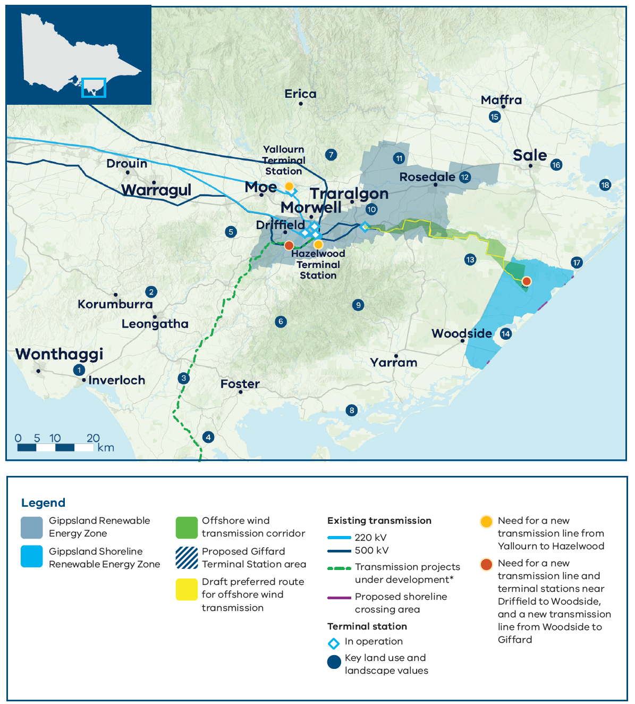
Map disclaimer: The map shows transmission projects under development, including transmission projects defined as ‘Committed and Anticipated’ or ‘Actionable’ under the Australian Energy Market Operator’s 2024 Integrated System Plan. This map displays the proposed alignment for Marinus Link.

Key land use and landscape values
- Community: Bass Coast Distinctive Area Landscape and wind farm prohibition area (Victorian Planning Provisions)
- Community: Area of higher aggregated dwelling density in west and southwest Gippsland
- Agriculture: Medium to high productivity agriculture across southwest Gippsland, particularly dairy farming
- Biodiversity/cultural/community: Wilsons Promontory and surrounding significant and sensitive landscape
- Agriculture: High agricultural productivity area and lower compatibility with renewables around Thorpdale, particularly horticulture farming
- Land use: Restricted and non-restricted use plantation land across the Strzelecki Ranges and broader region
- Biodiversity: State parks and forests, home to native flora and fauna
- Biodiversity: Corner Inlet Ramsar-listed wetlands
- Biodiversity/cultural/community: Strzelecki Ranges including Tarra-Bulga National Park and surrounding parks and forests, home to native flora and fauna
- Mining: Active mine site
- Agriculture: Medium to high agricultural productivity area adjacent to the Macalister Irrigation District
- Biodiversity/cultural: Latrobe River and surrounding areas of sensitivity
- Biodiversity/cultural: Mullungdung State Forest and Stradbroke Flora and Fauna Reserve, home to native flora and fauna
- Biodiversity/cultural: Coastal wetlands and protected biodiversity area for native flora and fauna
- Agriculture: High agricultural productivity area within the Macalister Irrigation District, including dairy farming
- Land use: Height restrictions associated with the Royal Australian Air Force base
- Biodiversity/cultural: Gippsland Lakes Coastal Park and Ramsar-listed wetlands
- Biodiversity/cultural: Lake Wellington and surrounding sensitive areas

How feedback shaped the Gippsland Renewable Energy Zone
We carefully considered all feedback, but not all community or industry requests have been acted on. The 2025 Victorian Transmission Plan and the renewable energy zone declarations reflect difficult choices, made by weighing up many factors to deliver a plan that best serves all Victorians. These decisions balance energy needs, land use, environmental impacts and community concerns.
To shape the Gippsland Renewable Energy Zone, we undertook engagement as part of the 2025 Victorian Transmission Plan development. This commenced in 2023 and was delivered across multiple consultation phases. Further engagement was then carried out as part of the renewable energy zone declaration process, between November 2025 and March 2026.
Renewable energy zones are broad strategic areas identified for potential development. We recognise that the declared zone includes sensitive areas that are not appropriate for development. These will be carefully considered in future project level planning, design and environmental assessment and planning approvals.
Below is a summary of previous consultation findings and how we responded by refining the zone. You can learn more on our webpage.

Feedback so far about the Gippsland Renewable Energy Zone

Preparing for the 2025 Victorian Transmission Plan

What we heard
Preserve biodiversity and the natural environment, including the Giant Gippsland Earthworm, Wilsons Promontory, areas along the Bass Coast, the Strzelecki Ranges, and coastal reserves and wetlands
Minimise impacts on agriculture, including dairy farms in South and West Gippsland, along the coast and in the Macalister Irrigation District
Consider South Gippsland’s high dwelling density when assessing the area’s suitability for wind energy projects
Use existing transmission infrastructure in the Latrobe Valley where possible, and underground transmission where new infrastructure is required
Explore opportunities to locate renewable energy infrastructure on land used for plantations
Avoid the airspace used by the Royal Australian Air Force (RAAF) base in East Sale

What we did
Avoided agricultural areas potentially less compatible with renewable energy infrastructure, particularly dairy farms and the Macalister Irrigation District
Avoided areas with higher dwelling densities in South Gippsland
Avoided the habitat of the Giant Gippsland Earthworm
Avoided significant landscapes along the Bass Coast, Wilsons Promontory, the Strzelecki Ranges, coastal reserves and wetlands
Located the proposed renewable energy zone near the existing 500 kV transmission network around Loy Yang
Included some plantation land where co-location with renewable energy infrastructure may be suitable
Explored options to expand the proposed zone further east and south-east, but this was not progressed due to constraints with the RAAF base, and potential biodiversity and cultural heritage impacts

As part of the renewable energy zone declaration consultation

What we heard
Continued concerns about the impacts of generation and transmission infrastructure on high-value agriculture
Prevent potential impacts on the region’s character and tourism, and the community’s wellbeing
Prevent potential loss and fragmentation of native vegetation and habitats
Consider impacts on bushfire risk and emergency response
Consideration is needed for projects outside the zones, including cumulative impacts and the need for clear boundaries

What we did
Defined the boundaries using a standard approach to align them with existing administrative and planning features, such as roads and local government boundaries, which resulted in the removal of the small area overlapping with Baw Baw Shire
Detailed assessment of concerns relating to environment, agricultural, bushfire and social impacts will occur at the project level through consultation, planning, design and environmental assessment and approvals.
In response to proposed projects outside the zone, we are designing an assessment process to ensure they don’t disrupt generation supplied from renewable energy zones and that they are subject to the same community engagement standards. Learn more on our webpage.

What will it be like living in a renewable energy zone?
If you live in or near a renewable energy zone, you can expect to see the development of renewable energy infrastructure over time, including wind, solar and battery projects.
The development of projects is limited by the available space on the transmission network and only a small proportion of land is expected to be used. The vast majority of land will continue to support existing uses such as farming.
VicGrid will coordinate development of projects to reduce impacts on communities, landscapes and the environment, while all projects will still need to meet existing planning and environmental approval requirements.

Engagement and the delivery of social and economic value
Renewable energy zones will drive economic development in regional Victoria and enable new economic benefits over time through the Victorian Government’s Renewable Energy Zone Community Benefits Plan.
The introduction of new Renewable Energy Zone Community Energy Funds will support initiatives that create benefits from the energy transition and improve energy and biodiversity outcomes in regions hosting renewable energy zones and new transmission infrastructure. These benefits will be in addition to any benefits provided directly by renewable energy developers.
Local decision-making that responds to local needs and priorities will be a cornerstone of these funds. Decisions about investments will be made in consultation with regional community reference groups, with broad community and industry representation.
The Renewable Energy Zone Community Benefits Plan is being developed and will be released once finalised. Learn more on our webpage.
The Victorian Government will soon release the Community Engagement and Social Value Guidelines. The guidelines set out the minimum expectations of developers in how they engage with communities, and create social value and economic benefits.
Developers will be expected to engage early and meaningfully with host landholders, neighbouring and nearby landholders, Traditional Owners and communities surrounding their project.
Developers will be expected to integrate feedback received from these groups into project design, including initiatives that support economic investment in the region, recognise impacts on communities and deliver community benefits.
You can learn more about the guidelines and how we are implementing them on our webpage.

Gippsland Shoreline Renewable Energy Zone
The Gippsland Shoreline Renewable Energy Zone is located in the south of Gippsland, near Woodside, Giffard and Seaspray. It sits within the boundaries of the Gunaikurnai Land and Waters Aboriginal Corporation and the Wellington Shire local government area.

Shoreline crossing areas
The zone includes four specific shoreline crossing areas, where underground cables can come ashore:
Reeves Beach
McGauran Beach
South-west of Merriman Creek
Seaspray Beach
These areas were selected to avoid the coast’s most environmentally and culturally sensitive locations, and to minimise technical challenges.
Offshore wind developers must locate their cables within one of these areas. Only developers who are successful in the Victorian Government’s auction process and the Commonwealth licensing process, and who obtain all required planning, environmental and regulatory approvals, will be able to proceed to construction.
You can learn more about the shoreline crossings in the Shoreline crossing technical summary on our webpage.

Onshore infrastructure requirements
All onshore connection infrastructure, from the shoreline to the proposed terminal station near Giffard, must be located within the zone.
This infrastructure must be installed underground, except where access points are required for operation and maintenance, or where specific conditions apply under relevant government approvals and regulations, such as safety requirements.
You can learn more about the shoreline zone on our webpage.

What communities in the shoreline zone can expect

If you own land in or near the zone
Offshore wind developers may contact landholders in or near the zone to discuss voluntary, early-stage access for surveys and investigations. VicGrid is developing clear access and compensation arrangements to support this process.
Developers are expected to engage early and honestly, explain what access is needed and why, and offer fair compensation.

For the broader community
All proposed projects must go through existing planning and environmental approval processes, which include further community consultation.
Communities in and near the Gippsland Shoreline zone will receive new dedicated economic benefits, including a Renewable Energy Zone Community Energy Fund, similar to our approach for onshore renewable energy zones. These benefits will be in addition to any benefits provided directly by offshore wind developers.

Designed for connections not generation
The Gippsland Shoreline Renewable Energy Zone is different from other renewable energy zones, which are designed to facilitate onshore wind, solar and battery storage projects. The shoreline zone is not designed to facilitate onshore wind, solar or battery storage projects. Instead, it’s a defined planning area for offshore wind developers to run underground cables from the shoreline to the electricity grid.
The zone does not restrict onshore wind, solar or large-scale battery storage projects from seeking to develop in the area. Once the Victorian Access Regime is in place, developers of any proposed projects will be required to apply for a grid impact authority and demonstrate that their projects are unlikely to disrupt generation supplied by the offshore wind projects and projects within the Gippsland Renewable Energy Zone. Learn more about the Victorian Access Regime and the Grid Impact Assessment process on our webpage.
Figure 2: How offshore wind energy gets to the electricity grid
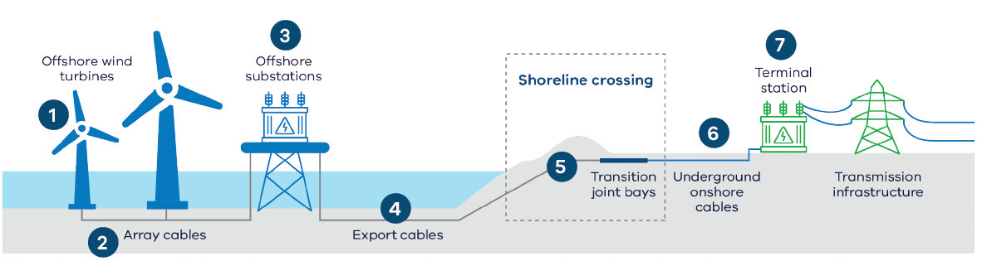

Transmission projects
The 2025 Victorian Transmission Plan identifies the need for new transmission lines in Gippsland to support both the Gippsland Renewable Energy Zone and approximately seven gigawatts (GW) of offshore wind energy by 2040.
While the 2025 plan identifies the need for these projects, the locations of new transmission lines have not yet been identified. VicGrid will carry out extensive consultation and technical investigations to help determine the location of the new transmission lines. For each project, this includes narrowing the study area to a corridor, then to a route and finally to an easement.

A second Hazelwood to Yallourn 220 kV double circuit line in Gippsland
The 2025 Victorian Transmission Plan suggests this infrastructure will be needed by 2028.
This project is needed to ensure energy from the Gippsland Renewable Energy Zone and Gippsland offshore wind area can flow to consumers across the state.
The length of this project is about 10 km. The specific location of this line is yet to be identified. We will investigate following the route of the existing transmission easement, but this will be subject to further technical work.
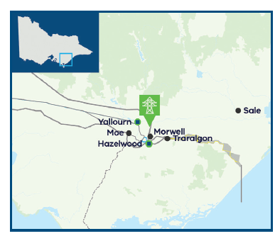

The Gippsland offshore wind transmission stage 2 project
The 2025 Victorian Transmission Plan suggests this infrastructure will be needed between 2033 and 2038.
The program includes a new 500 kV transmission line from the existing transmission network near Driffield running to Woodside, and a new line between Woodside and Giffard. New terminal stations will be needed at Driffield and Woodside.
These lines, combined with the stage 1 project – currently under development for the first two GW of offshore wind energy – will create a loop capable of accommodating approximately seven GW of offshore wind energy.
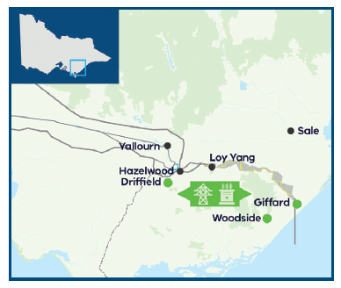

Gippsland offshore wind transmission stage 1 project
VicGrid is currently working with landholders and communities to finalise the preferred route for the Gippsland offshore wind transmission stage 1 project. It includes a new transmission line from a terminal station near Giffard to the Latrobe Valley (Loy Yang), connecting the first two GW of offshore wind energy to the grid by 2032.

What happens next
Declaring renewable energy zones is not the end of the process. Over the next 12 to 24 months, VicGrid will do the following:
- Finalise the rules that renewable energy and storage projects must follow to develop within a zone, including the requirement to meet the expectations that will be outlined in the Community Engagement and Social Values Guidelines.
- Set limits on how much new renewable energy generation can connect to the network within each zone.
Work with existing projects seeking connection to the network to meet community expectations.
- Monitor the performance of projects who gain access and review if they are meeting the conditions of their connection agreement.
- Support the creation of community energy funds and work with communities on how those funds are spent.
- Continue planning the necessary transmission projects and work with generation and storage projects to coordinate their infrastructure and minimise environmental and community impacts.
Throughout these steps, we will continue to engage with communities, landholders, Traditional Owners, industry and local government. The feedback captured to date will continue to help shape these processes as Victoria progresses towards a coordinated and fair energy transition.
You can learn more about the new rules and guidelines that will enable this work on our webpage.

Contact us
Phone: 1800 418 341
Email: enquiries@vicgrid.com.au
Deaf, hearing or speech impaired? Please contact the National Relay Service on 133 677 or their webpage.
Need an interpreter? Contact Translating and Interpreting Service (TIS) on 131 450 (within Australia) or visit their webpage.
Disclaimer: The information in this document is current at the time of printing, may be subject to change and should not be relied upon. Please visit the VicGrid website for the latest updates.

Restricted plantation land refers to plantations subject to the Victorian Plantations Corporation Act 1993. This represents areas of existing productive land use for growing large-scale crops with existing legislative restrictions around co-location with other land uses such as renewable energy generation.

