VicGrid

South West Renewable Energy Zone
  - Updated May 2026
The Minister for Energy and Resources has formally declared the South West Renewable Energy Zone which is located south-east of Hamilton, between Macarthur and Darlington.
The 2025 Victorian Transmission Plan proposed a renewable energy zone with two sections in south west Victoria, the one outlined above, and a second section between Casterton and Balmoral (known to the community as the Dundas Tablelands).
The Minister for Energy and Resources has chosen to formally declare only the southern section of the zone.
When deciding not to declare the area known as the Dundas Tablelands, the Minister acknowledged the need to understand in more detail and consult further on concerns raised by local communities regarding environmental and biodiversity values, land use constraints, and potential complexities for projects.
Figure 1: South West Renewable Energy Zone location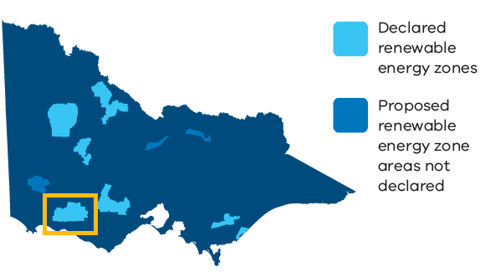

What is a renewable energy zone?
Renewable energy zones are areas identified as the best places to host wind, solar and battery storage projects.
Renewable energy zones will:
- Help coordinate renewable energy projects and reduce the need for unnecessary transmission infrastructure
- Enable VicGrid to set clearer rules around how projects gain access to the grid, including expectations for how developers engage with communities
- Provide more certainty about how and where renewable energy projects are developed
- Unlock new economic benefits for regional communities and Traditional Owners
The 2025 Victorian Transmission Plan proposed six renewable energy zones in regional Victoria. The Victorian Government has now declared five of these zones, with some changes to proposed boundaries.
You can learn more about each of the renewable energy zones on our webpage.
The introduction of renewable energy zones doesn’t alter what is allowed to occur on land under existing land use zones or overlays, such as the Farming Zone or Rural Activity Zone.
All proposed projects will continue to be subject to existing planning and environmental controls, including approval processes under the Planning and Environment Act 1987 and Environment Effects Act 1978.

The South West Renewable Energy Zone
The declared South West Renewable Energy Zone includes parts of the Moyne local government area. Small parts of the zone also sit within the Southern Grampians and Corangamite local government areas.
The zone is within the Registered Aboriginal Party boundaries of Eastern Maar Aboriginal Corporation and Gunditj Mirring Traditional Owners Aboriginal Corporation.
As a result of the renewable energy zone declaration process, the Dundas Tablelands area has been removed from the South West Renewable Energy Zone.
Find out more in the Dundas Tablelands factsheet on our webpage.

How decisions about new renewable energy projects will be made in this zone
The Victorian Government is setting new rules to manage how renewable energy projects, such as wind and solar farms, gain access to the state’s transmission network.
Under the current open access regime, developers can connect their projects almost anywhere on the transmission network, as long as they meet technical and environmental planning requirements.
Under the new approach, known as the Victorian Access Regime, developers will apply for access and VicGrid will oversee a competitive process to decide which projects can connect within each zone.
Each zone will have a set access limit for how much new renewable energy can be connected. We are proposing to set access limits that reflect how much electricity the network can carry at a given time, based on current infrastructure and planned upgrades.
In determining how much of the access limit is allocated, we will consider:
- The amount of electricity Victoria needs to generate to meet increasing demand
- The size of the zone and the density of projects
- Whether developers are meeting expectations for landholder, community and Traditional Owner engagement and adding social value through initiatives and economic development
This process will ensure Victoria produces enough energy to meet demand, while minimising the impact on communities, Traditional Owners, agriculture and the environment.
Renewable energy project developers must talk to landholders to get permission to build renewable generation projects on their land. Landholders can choose whether or not to host a wind, solar or battery project.
Landholders who choose to host projects will receive financial payments and other benefits negotiated directly with the developer.
Project developers will also work with neighbouring properties to address impacts and negotiate financial benefits.

How to read the map
The map in Figure 2 shows the South West Renewable Energy Zone, including some of the significant land use and landscape values that influenced its location, size and shape. The identified values in the region are a sub-set only and do not represent all of the values present.
Figure 2: The South West Renewable Energy Zone
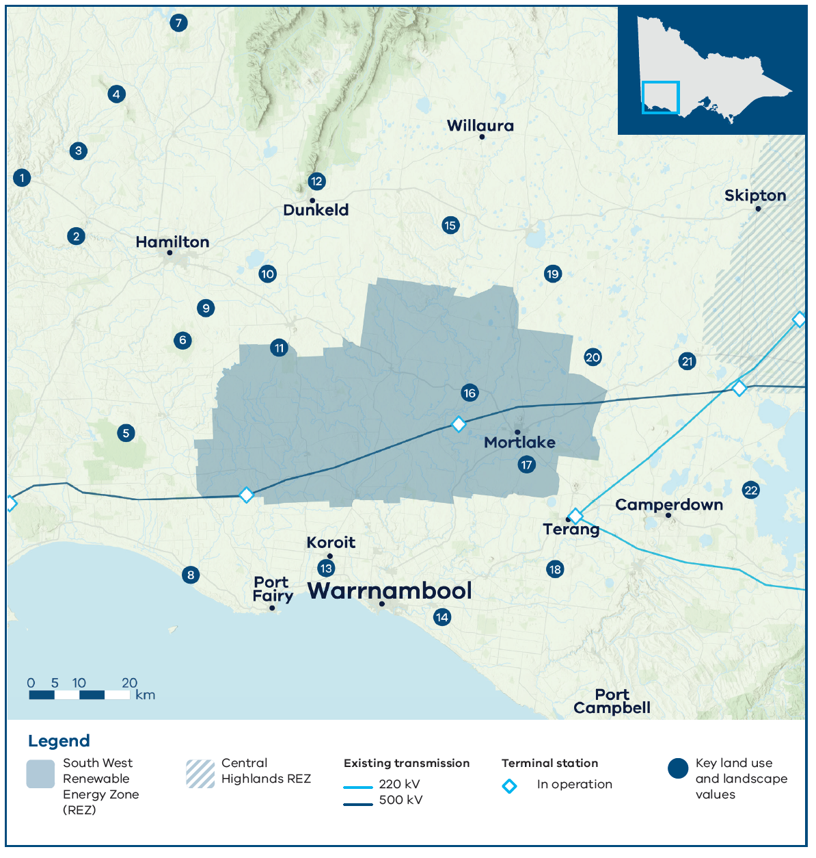

Key land use and landscape values
- Community/agriculture: Area of higher aggregated dwelling density around Coleraine, with a high proportion of cropping surrounding the south of Coleraine
- Biodiversity/cultural: Wannon River and surrounding areas of sensitivity, including scattered protected biodiversity areas
- Biodiversity/cultural: Higher value biodiversity and cultural values associated with waterways (creeks)
- Biodiversity/cultural/community: Dundas Range Scenic Reserve, including protected biodiversity area for native flora and fauna
- Cultural heritage: Budj Bim World Heritage Cultural Landscape
- Biodiversity/cultural: Mount Napier State Park, including protected biodiversity areas
- Biodiversity/cultural: Multiple state forests, home to native flora and fauna
- Community/biodiversity/cultural: Coastal parks, reserves and tourism sites
- Biodiversity: Public Conservation and Resource Zone Area
- Biodiversity/cultural: Lake Linlithgow and surrounding lakes, home to native flora and fauna including Brolga flocking area
- Cultural: Western volcanic cones and lava flows from Mount Rouse
- Cultural/biodiversity/community: The Grampians (Gariwerd Cultural Landscape) – significant landform and landscape with high cultural, community and biodiversity values, including significant viewpoints of the region
- Biodiversity/cultural: Tower Hill Wildlife Reserve, home to native flora and fauna
- Land use: Wind farm prohibition area within 5 km of the coast east of Warrnambool (Victorian Planning Provisions)
- Mining: Retention licence
- Biodiversity/cultural: Hopkins River and surrounding areas of sensitivity
- Agriculture: High agricultural productivity dairy farming area with relatively lower compatibility with renewables
- Agriculture: High productivity dairy farming area with relatively lower compatibility with renewables
- Biodiversity/cultural: Lake Bolac and surrounding wetlands and reserves, home to native flora and fauna including Brolgas
- Biodiversity: Brolga flocking area
- Biodiversity/cultural: Wetlands and volcanic landscape around Mount Elephant
- Biodiversity/cultural: Western District Lakes Ramsar-listed wetlands, home to native flora and fauna including Brolgas

How feedback shaped the zone
We carefully considered all feedback, but not all community or industry requests have been acted on. The 2025 Victorian Transmission Plan and the renewable energy zone declarations reflect difficult choices, made by weighing up many factors to deliver a plan that best serves all Victorians. These decisions balance energy needs, land use, environmental impacts and community concerns.
To shape the South West Renewable Energy Zone, we undertook engagement as part of the 2025 Victorian Transmission Plan development. This commenced in 2023 and delivered across multiple consultation phases. Further engagement was then carried out as part of the renewable energy zone declaration process, between November 2025 and March 2026.
Renewable energy zones are broad strategic areas identified for potential development. However, we recognise that the declared zone includes sensitive areas that are not appropriate for development. These will be carefully considered in future project level planning, design and environmental assessment and planning approvals.
Below is a summary of previous consultation findings and how we have responded through the zone refinement. Learn more at our webpage.

Preparing for the 2025 Victorian Transmission Plan

What we heard
- The region has played a significant role in Victoria’s energy transition so far, with many renewable projects already underway or proposed – with no overarching coordination until now
- Minimise the cumulative impacts of wind projects, particularly on visual amenity and on how overdevelopment affects people’s sense of place and way of life
- Minimise impacts on agriculture, particularly dairy farmland, in recognition of the sector’s contribution to the local economy and food security
- Protect biodiversity, including the Brolga and Southern Bent-wing Bat
- Avoid the areas with good groundwater access and agricultural productivity south-west of Hamilton
- Consider including land near Coleraine in the zone

What we did
- Avoided agricultural land, including concentrated dairy farming areas and areas with good access to groundwater
- Avoided significant landscapes and landforms, including Budj Bim World Heritage Site, the Grampians (Gariwerd) National Park, Lake Corangamite, Great Otway National Park and coastal areas
- Avoided the habitat of species such as the Brolga, especially in areas with high concentrations of wetlands
- Added the northern section (known as the Dundas Tablelands), which offers stronger wind resources than areas previously considered in this region

As part of the renewable energy zone declaration consultation

What we heard

Northern section (known as Dundas Tablelands)
- Consultation on the proposed northern section was late, unclear and insufficient
- The Dundas Tablelands and surrounds are among Victoria’s most ecologically significant landscapes
- Protect threatened and endangered species and the region’s remnant red gums
- Greater consideration is needed regarding the feasibility of connection the northern section to the transmission network

Southern section
- Continued concerns were raised about the impacts on agricultural land uses, biodiversity and the cumulative impacts of development in the region
- Minimise impacts on the Mount Rouse lava flow and stony rises, which are considered as geomorphologically unique
- The area is highly prone to bushfires, with limited ground access and strong reliance on aerial firefighting

What we did

Northern section (known as Dundas Tablelands)
- Removed the northern section of the zone in response to concerns about limited engagement opportunities, environmental and biodiversity values, land use constraints and potential project complexities for projects

Southern section
- Defined the boundaries using a standard approach to align them to existing administrative and planning features – such as roads and local government boundaries
Detailed assessment of concerns relating to environment, agricultural, bushfire and social impacts will be considered at the project level through consultation, planning, design and environmental assessment and approvals.

What will it be like living in a renewable energy zone?
If you live in or near a renewable energy zone, you can expect to see the development of renewable energy infrastructure over time, including wind, solar and battery projects.
The development of projects is limited by the available space on the transmission network and only a small proportion of land is expected to be used. The vast majority of land will continue to support existing uses such as farming.
VicGrid will coordinate development of projects to reduce impacts on communities, landscapes and the environment, while all projects will still need to meet existing planning and environmental approval requirements.

Engagement and the delivery of social and economic value
Renewable energy zones will drive economic development in regional Victoria and enable new economic benefits over time through the Victorian Government’s draft Renewable Energy Zone Community Benefits Plan.
The introduction of new Renewable Energy Zone Community Energy Funds will support initiatives that create benefits from the energy transition and improve energy and biodiversity outcomes in regions hosting renewable energy zones and new transmission infrastructure. These benefits will be in addition to any benefits provided directly by renewable energy developers.
Local decision-making that responds to local needs and priorities will be a cornerstone of these funds. Decisions about investments will be made in consultation with regional community reference groups, with broad community and industry representation.
The Renewable Energy Zone Community Benefits Plan is being developed and will be released once finalised. Learn more at our webpage.
The Victorian Government has also released the Community Engagement and Social Value Guidelines. The guidelines set out the minimum expectations of developers in how they engage with communities and create social value and economic benefits.
Developers are expected to engage early and meaningfully with host landholders, neighbouring and nearby landholders, Traditional Owners and communities surrounding their project.
Developers are also expected to integrate feedback received from these groups into project design, including initiatives that support economic investment in the region, recognise impacts on communities and deliver community benefits.
You can learn more about the guidelines and how we are implementing them at our webpage.

What happens next
Declaring renewable energy zones is not the end of the process. Over the next 12 to 24 months, VicGrid will do the following:
- Finalise the rules that renewable energy and storage projects must follow to develop within a zone, including the requirement to meet the expectations outlined in the Community Engagement and Social Values Guidelines
- Set limits on how much new renewable energy generation can connect to the network within each zone
- Work with existing projects seeking connection to the network to meet community expectations
- Monitor the performance of projects who gain access and review if they are meeting the conditions of their connection agreement
- Support the creation of community energy funds and work with communities on how those funds are spent.
- Continue planning the necessary transmission projects and work with generation and storage projects to coordinate their infrastructure and minimise environmental and community impacts
Throughout these steps, we will continue to engage with communities, landholders, Traditional Owners, industry and local government. The feedback captured to date will continue to help shape these processes as Victoria progresses towards a coordinated and fair energy transition.
You can learn more about the new rules and guidelines that will enable this work on our webpage.

Contact us
Phone: 1800 418 341
Email: enquiries@vicgrid.com.au
Deaf, hearing or speech impaired? Please contact the National Relay Service on 133 677 or their webpage.
Need an interpreter? Contact Translating and Interpreting Service (TIS) on 131 450 (within Australia) or visit their webpage.
Disclaimer: The information in this document is current at the time of printing, may be subject to change and should not be relied upon. Please visit the VicGrid website for the latest updates.

The Brolga is listed as an endangered species under the Flora and Fauna Guarantee Act 1998 (Vic) and is at high risk of extinction in Victoria. Brolga flocking areas are areas mapped by DEECA which provide important Brolga habitat for Brolgas to drink, roost and feed during drier months until breeding. The Victorian Government’s Handbook for the Development of Renewable Energy in Victoria includes specific guidance for wind facilities and the Victorian Brolga, including avoiding Brolga flocking areas.

