Transmission Connection Point Forecasts for Victoria

Purpose
AEMO prepared this summary to provide information about its transmission connection point forecasts for Victoria, in line with its previous Victorian Declared Shared Network (DSN) responsibilities, which transferred to VicGrid on 1 November 2025.

Disclaimer
AEMO has made reasonable efforts to ensure the quality of the information in this publication but cannot guarantee that information, forecasts and assumptions are accurate, complete or appropriate for all circumstances. Anyone proposing to use the information should independently verify and check its accuracy and suitability for purpose and obtain independent expert advice. To the maximum extent permitted by law, AEMO and its officers, employees and consultants involved in the preparation of this publication:
- make no representation or warranty, express or implied, as to the currency, accuracy, reliability or completeness of the information in this publication; and
- are not liable (whether by reason of negligence or otherwise) for any statements, opinions, information or matters contained in or derived from this publication, or any omissions from it, or for any use of the information.

Published: April 2025
Please note: These forecasts are based on information available to AEMO as at 1 November 2024, although AEMO has endeavoured to incorporate more recent information where practical. This page uses many terms with meanings defined in the NER. The NER meanings are adopted unless otherwise specified. The AEMO Connection Point Forecasting Methodology provides a summary of the modelling approach undertaken.

Acknowledgement
AEMO acknowledges, in alphabetical order, AusNet Services, CitiPower, Jemena, Powercor, and United Energy, for their support, cooperation, and contribution in providing data and information used in these forecasts.

Background
The connection point forecasting methodology directly incorporates the effects on demand due to population growth and consumer energy resources (CER) such as photovoltaics (PV), batteries, and electric vehicles.
Forecasts of maximum and minimum demand are produced for each connection point independently (described as non-coincident forecasts), and also at times of regional maximum and minimum demand (described as coincident forecasts). The non-coincident forecasts presented here are reconciled to the latest regional forecasts from AEMO’s Electricity Statement of Opportunities (ESOO).
Forecasts for CER are included in the modelling inputs consistent with the forecasts underpinning the latest ESOO regional forecasts, alongside population growth projections.

2024 connection point results and insights
Refer to the dynamic interface for detailed information on individual connection points. In the following figures and tables, some large industrial loads directly connected to the transmission network are excluded to maintain confidentiality.
Figures 1 and 2 show the average annual growth in maximum operational demand for summer and winter over the 10-year forecast period in Victoria (2025 to 2034). Growth is shown as a percentage of the latest actual seasonal maximum operational demand (in 2023-24), after adjusting for outages. Figures 3 and 4 show the average annual growth in minimum operational demand for summer and shoulder seasons, on the same basis as Figures 1 and 2. (The shoulder season represents spring and autumn periods when demand troughs typically occur).
Figures 1 and 2 indicate that most Victorian transmission connection points are expected to experience growth in their maximum demand over the next decade.
In summer, nearly all connection points show positive growth rates, reflecting broad-based increases in peak demand (due to factors such as population growth, electrification of heating and transport, and air-conditioning uptake). Notably, many connection points in metropolitan Melbourne and growing regional centres exhibit average annual summer demand growth above 2% of their 2023-24 peak. By contrast, only a few connection points show declining summer peak demand, typically due to specific local factors (detailed in Table 1).
Winter maximum demand growth is also widespread, with many sites exceeding the 2% annual growth threshold. This difference reflects the influence of electric heating (which adds to winter peaks) versus cooling (which dominates summer peaks) and the varying impact of distributed PV (which has little effect on both summer and winter peaks).

Figure 1: Forecast average annual growth in maximum operational demand for summer (10% probability of exceedance [POE]) as percentage of actual maximum operational demand in 2023-24.
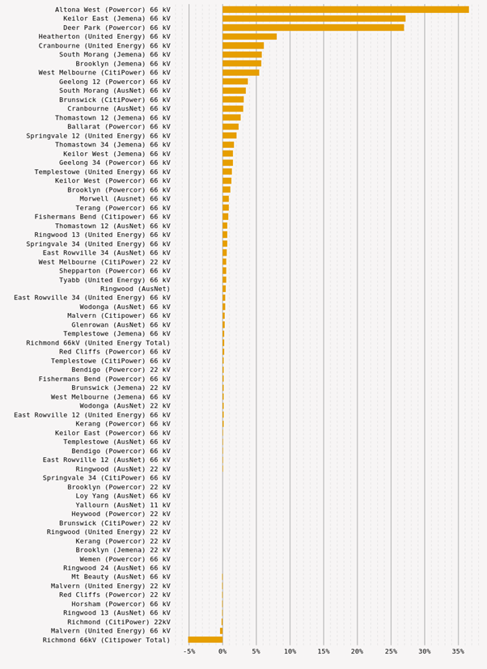
Figure 2: Forecast average annual growth in maximum operational demand for winter (10% POE) as percentage of actual maximum operational demand in 2023-24.
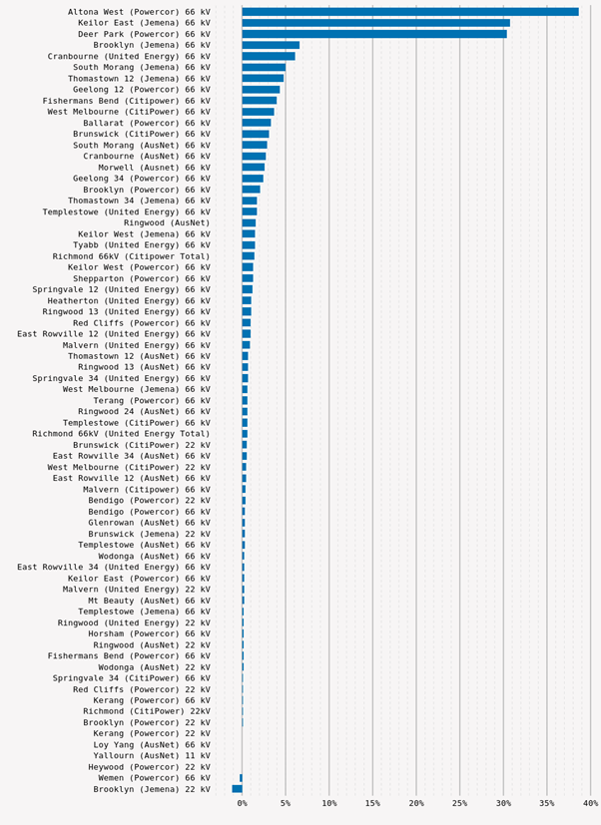
Figure 3: Forecast average annual growth in minimum operational demand for summer (90% POE) as percentage of actual minimum operational demand in 2023-24.
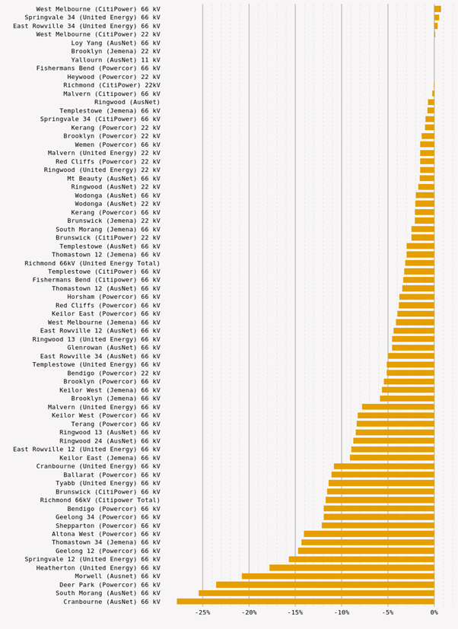
Figure 4: Forecast average annual growth in minimum operational demand for shoulder season (90% POE) as percentage of actual maximum operational demand in 2023-24.
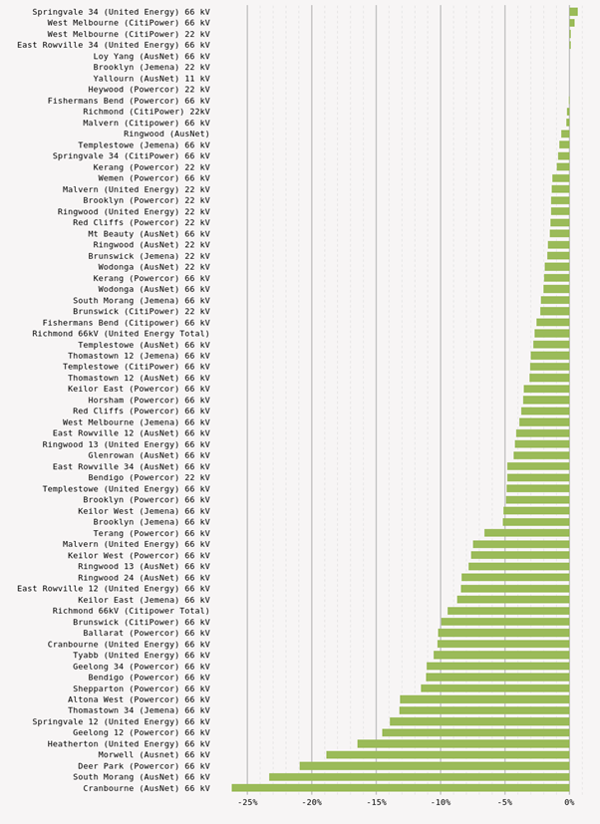
Figures 3 and 4 highlight the significant reduction in minimum demand levels over the forecast period, influenced significantly by the operation of consumers’ distributed PV. Across most of Victoria, minimum demand at the transmission connection point level is forecast to decline substantially (negative growth) over the coming decade. In many locations, midday demand in mild seasons is falling as PV generation reduces the net load drawn from the grid. Only very few connection points – typically those with relatively low PV penetration and growth in continuous or off-peak loads – are projected to have rising minimum demand. The vast majority are expected to see their minimum demand continue to decrease each year.
Table 1 lists the drivers of large changes in operational maximum demand over the 10-year forecast period. Changes are considered “large” if the average annual change exceeds 2% of the actual maximum operational demand in 2023-24 (approximately 2% per year of the base-year peak demand). Table 1 covers maximum demand (peak load) increases or decreases above this threshold.
Table 1: Drivers at connection points with average annual change in maximum operational demand (10% POE) exceeding 2% of actual maximum operational demand in 2022-23.

Season | Forecast maximum demand increase greater than threshold | Forecast maximum demand decrease greater than threshold
Summer | 14 connection points exceed threshold. The most significant changes are forecast for:  Altona West (Powercor): Strong demand growth driven by high population expansion in Melbourne’s outer west and booming commercial/industrial developments. This is resulting in a robust rise in summer peak demand. (In 2023-24, Altona West peaked at ~237 megawatts (MW) and is forecast to keep growing due to ongoing housing developments and increasing large customer connections.)  Keilor East (Jemena): Significant new load connections and urban growth in the north-west Melbourne suburbs supplied by Keilor Terminal Station are boosting forecast demand. New large commercial and industrial customers in the area are expected to drive strong load growth over the next decade. (For example, expansion around Melbourne Airport and nearby business precincts, as well as growing suburbs like Tullamarine and Airport West, contribute to the rising summer peak.)  Deer Park (Powercor): Rapid load growth in Melbourne’s western suburbs, coupled with recent load transfers from other stations, leads to a high forecast demand increase at Deer Park Terminal Station. The station supplies booming areas like Truganina, Tarneit, and Caroline Springs. Additionally, multiple zone substations (Laverton North, Laverton, Werribee) have been or are being shifted onto Deer Park to relieve adjacent terminals, further boosting Deer Park’s summer peak. (By 2034, the 10% POE summer demand at Deer Park is projected to more than double, reflecting west Melbourne’s growth and these load transfers.)  Heatherton (United Energy): Ongoing growth in southern Melbourne (Brighton through to Edithvale) underpins rising demand at Heatherton. The area is largely built-out but increasing infill development and incremental load growth are pushing the summer peak upward (2024 peak ~360 MW). Moreover, government-led infrastructure projects planned in this supply area (such as the Suburban Rail Loop stabling yard in Heatherton) are expected to further increase demand at Heatherton Terminal Station. (These major projects are not yet in the base forecast until details firm up, but they signal additional future load on top of steady residential/commercial growth.) | One connection point exceeds threshold.  Richmond (CitiPower): The Richmond Terminal Station (TS) forecast peak demand is decreasing, largely due to load redistribution and local generation. In late 2020, a significant was transferred from Richmond TS to Brunswick TS, causing a step down in Richmond’s peak demand. This, along with mild recent summers and the uptake of rooftop PV in its inner-city catchment (over 20 MW of PV across CitiPower/UE at Richmond by 2021), means Richmond’s summer maximum demand is now projected to decline. Additionally, some large customers in the area have adopted on-site generation (Richmond 66 kilovolts [kV] peaked around 393 MW in 2021 before the load transfer; afterward the load has trended down.)
Winter | 17 connection points exceed threshold. The most significant changes are forecast for:  Altona West (Powercor): High population growth and industrial expansion in Melbourne’s outer-west (Werribee, Tarneit, Laverton North, etc.) are driving strong demand increases at Altona West. This terminal supplies ~96,000 customers (including a large industrial customer) and ongoing urban development continues to push winter peaks upward.  Keilor East (Jemena): Rapid development in Melbourne’s north-west is boosting winter demand at Keilor East. Jemena’s supply in this area is impacted by greenfield growth on the urban fringe (Sunbury, Sydenham with ~7–8% annual maximum demand growth) and higher-density infill around Essendon Airport (for example, North Essendon ~5% p.a.), alongside new infrastructure like the planned Keilor East rail station – all contributing to above-threshold winter load increases.  Deer Park (Powercor): This connection point covers the western growth corridor, and its winter demand is surging accordingly. Deer Park TS (commissioned in 2017) was built to relieve nearby supply points (Keilor and Altona) and has picked up major load transfers – for example, around 30 MW shifted from Laverton and Werribee zones – to support new suburbs like Tarneit, Truganina, Caroline Springs and Melton. Combined with ongoing housing and industrial developments in these areas, Deer Park’s winter peak growth exceeds the planning threshold. | No connection points exceed threshold.

While no connection point shows an increase in minimum demand exceeding the 2% threshold (in either summer or shoulder seasons), 83% of connection points exceed this threshold in terms of decreases in minimum demand during both periods.
This widespread decline is driven by significant growth in rooftop PV capacity over the 10-year outlook, leading to substantial reductions in daytime minimum demand at most connection points. Continued strong uptake of rooftop PV — supported by the Victorian Government’s Solar Homes program and other incentives — is reflected in the projections developed for the 2024 ESOO. As a result, midday summer demand is declining at the majority of locations, as local PV generation increasingly offsets demand that would otherwise be met by the grid.
Supplementary information
Dynamic interface | An Excel workbook with the following information for each transmission connection point:  - Historical and forecast maximum demand, including 10% POE and 50% POE, for active power.  - Historical and forecast minimum demand, including 90% POE and 50% POE, for active power.  - Coincident and non-coincident values.  - High-level commentary and summary plots.
Reactive power system forecast spreadsheet | Separate spreadsheet for reactive power forecasts at each transmission connection point, providing complementary information for power system studies. Values are provided for reactive power at connection point maximum demand. AEMO plans to extend the methodology to forecast reactive power at connection point minimum demand.
Transmission Connection Point Forecasting Methodology Overview 2020 | The current AEMO transmission connection point forecasting methodology outlines the process through which the forecasts were developed.

The 2024 ESOO used CER assumptions from the 2024 Forecasting Assumptions Update. AEMO is also consulting with stakeholders on updated assumptions in the Draft 2025 Inputs, Assumptions and Scenarios Report, however as these are available only in a draft state and are not applied to the regional demand forecasts of the 2024 ESOO, these have not been applied.
The connection point forecast is published on a seasonal basis, covering the period from summer 2024-25 to summer 2033-34. Summer refers to 1 November to 31 March, and winter refers to 1 June to 31 August.

