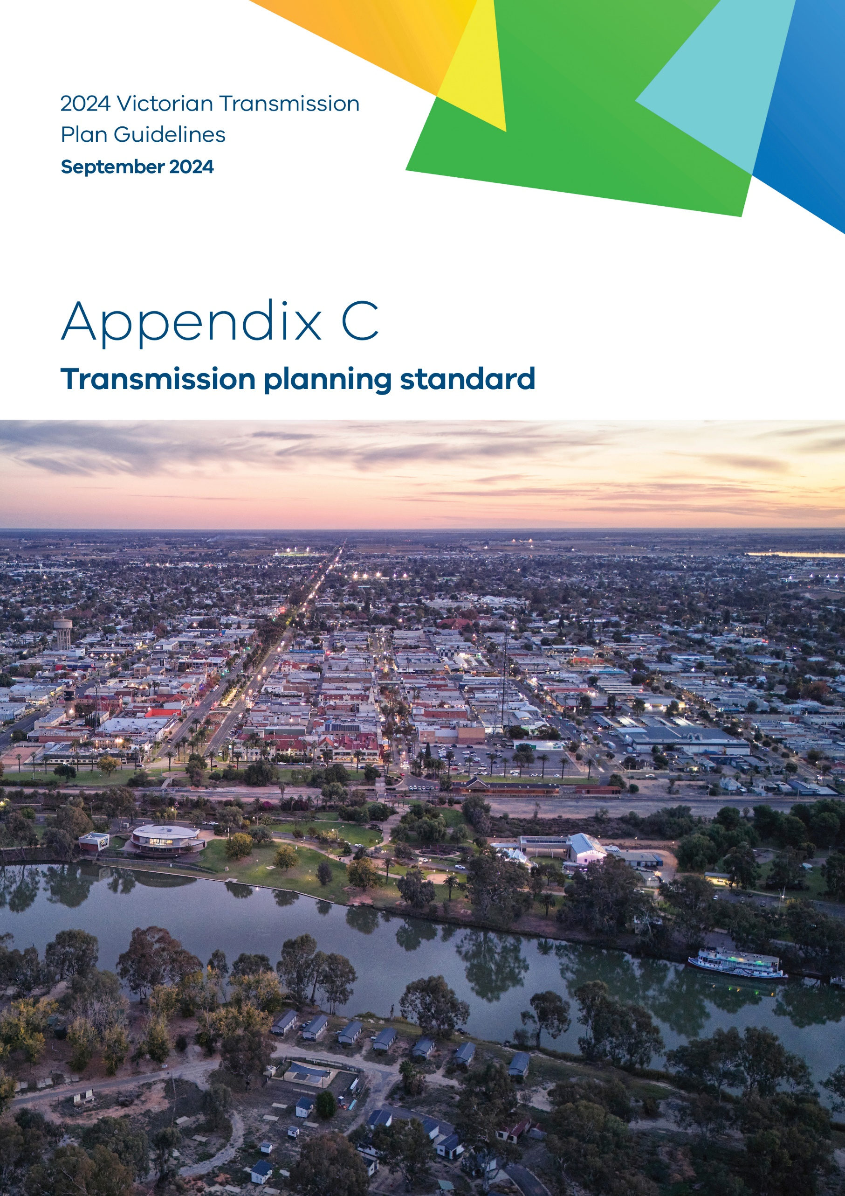

- Transmission planning standard

Purpose
This is Appendix C to the 2024 Victorian Transmission Plan Guidelines (2024 VTP Guidelines) originally published as a draft on 22 July 2024.
VicGrid is changing the way energy infrastructure is delivered in Victoria. We are putting in place a long-term strategic plan – the Victorian Transmission Plan (VTP) – to ensure we have the right infrastructure in the right place at the right time to support the energy transition.
As set out in the amendments to the National Electricity (Victoria) Act 2005 (the Act) passed in May 2024, we are required to develop and release the inaugural VTP, the 2025 VTP, by 31 July 2025. This will guide Victoria’s smooth transition to renewable energy as coal-fired power stations retire in the following decade.
VicGrid is required to prepare and publish a set of guidelines called the 2024 Victorian Transmission Plan Guidelines (this document), which outline how the 2025 VTP will be developed. This appendix provides further technical details on the content included in the main guidelines.
Disclaimer
The publication of the 2024 VTP Guidelines is pursuant to amendments to the National Electricity (Victoria) Act 2005 passed in May 2024, which implement the first stage of Victorian Transmission Investment Framework reforms and empower the CEO VicGrid to develop a Victorian transmission plan.
The State of Victoria and its employees do not guarantee that the publication is without flaw of any kind or is wholly appropriate for your particular purposes and therefore disclaims all liability for any error, loss or other consequence which may arise from you relying on any information in this publication.
This publication does not include all of the information that an investor, participant or potential participant in the National Electricity Market might require, and does not amount to a recommendation of any investment.
The information in this document is current at the time of printing, and remains subject to change and should not be relied upon. Please visit vicgrid.vic.gov.au for the latest updates.
Copyright
© The State of Victoria Department of Energy, Environment and Climate Action 2024

Contents
Appendix C Transmission planning standard 1
C.1 Background 5
C.2 Comparison of transmission planning standards 6
C.3 Incorporation of multi-criteria analysis into network augmentation 7
C.4 Selected transmission planning standard 7

Acronyms
Term | Definition
AEMO | Australian Energy Market Operator
CER | Consumer energy resources
EV | Electric vehicles
GW | Gigawatt (one million kilowatts)
GWh | Gigawatt hour (one million kilowatt hours)
IAP2 | International Association of Public Participation
IASR | Inputs, Assumptions and Scenarios Report
IEC | International Electrotechnical Commission
IEEE | Institute of Electrical and Electronics Engineers
ISP | Integrated System Plan
MCA | Multi-criteria analysis
MW | Megawatt (one thousand kilowatts)
MWh | Megawatt hour (one thousand kilowatt hours)
NCC | National Construction Code
NEM | National Electricity Market
NER | National Electricity Rules
NEVA | National Electricity (Victoria) Act 2005
ODP | Optimal development pathway
PSS/E | Power system simulation for engineering
PV | Photovoltaic solar
RAP | Registered Aboriginal Parties
REZ | Renewable energy zone
RRN | Regional reference node
TW | Terawatt (one billion kilowatts)
TWh | Terawatt hour (one billion kilowatt hours)
VAPR | Victorian Annual Planning Report
VCR | Value of Customer Reliability
VEU | Victorian Energy Upgrades
VPP | Virtual Power Plant
VRET | Victorian Renewable Energy Targets
VTIF | Victorian Transmission Investment Framework
VTP | Victorian Transmission Plan
WACC | Weighted average cost of capital


Appendix C: Transmission planning standard – content summary
This appendix explains the rationale for the adoption of a probabilistic transmission planning standard in Victorian renewable energy zones (REZs), consistent with the approach taken to transmission planning in Victoria more generally.
- Background
A transmission planning standard is a set of criteria and guidelines that aims to ensure the development and maintenance of a reliable, efficient and sustainable transmission system to meet current and future electricity demands, in this case for the transmission system in Victoria.
The objective of transmission planning is to develop an efficient power system that delivers the energy customers need at the lowest cost possible, consistent with maintaining a high level of reliability and security while achieving Government targets for decarbonisation and renewable energy. The efficient power system will then contain the right mix and location of generation across Victoria and the transmission system to support that.
The objective of reliability immediately raises the question of what the standard for reliability is, noting that any standard needs to balance the value of reliable supply, which will only increase with a greater role for electricity in a zero-emissions future, with the cost of achieving that. The need for investment in large-scale renewable generation to drive low-cost, reliable and low-emission supply also raises the issue of what level of reliability should be provided to generators.
In broad terms, transmission planning standards can be defined in either deterministic or probabilistic terms. A deterministic standard defines a specific technical outcome that the relevant transmission planner needs to consider when designing the power system, often a level of redundancy that must be provided. Application of a deterministic transmission planning standard involves evaluating the outcomes of a predetermined set of contingencies, without reference to their probability of occurrence.
In contrast, a probabilistic assessment considers both the impact of a contingency event and the probability of its occurrence. Consequently, the amount of transmission capacity provided under a probabilistic approach will depend on an economic cost-benefit assessment comparing the costs of transmission infrastructure with the costs that would be incurred in the absence of that infrastructure.
In general, a deterministic planning standard may lead to a higher level of capital expenditure and higher network charges, but it is easier to administer and report on current and future status. The basic weaknesses of this approach are that it does not consider the likelihood and consequences of failures in the transmission system and the variable pattern of renewable generation supply, consumer demand, weather and other variables affecting supply and demand. In contrast, probabilistic planning strives to consider all these aspects and to determine when and how much money should be spent on upgrades to the system to meet customer demand.
Different jurisdictions take varying approaches to transmission planning standards. In NSW, the approach to planning renewable energy zones (REZs) is to adopt a deterministic curtailment target within the REZs with easy administration and tracking, but to have it determined by probabilistic modelling of the REZ.
VicGrid has recently analysed the impacts of applying a new transmission planning standard across Victoria’s transmission network planning and REZ development.
The analysis included a desktop review of worldwide practices in this area and a market analysis of 2 alternative standards:
- Applying an approach based on economic probabilistic cost-benefit analysis (CBA), and
- Applying a deterministic curtailment limit (CL) which is set by economic CBA over an extended period.
The findings of this analysis are summarised in Section C.2.
- Comparison of transmission planning standards
The analysis was based on information on planning standards used overseas across markets in 6 countries. The planning standards used for REZs were as follows:
- South Africa uses a deterministic approach without mention of a CBA;
- Texas (United States) uses a CL, which is derived by CBA like NSW; and
- mainland US (interconnections except Texas), the United Kingdom, India and the Philippines use a probabilistic CBA standard.
Access limits may be applied in various ways to partly manage curtailment risk for generators.
It is expected that a number of REZs in Victoria will be unlike the Central-West Orana (CWO) REZ in NSW, which is radial and consists of only renewable generation initially. To the extent that Victorian REZs are more meshed, transmission augmentation within them will have the potential to impact other neighbouring REZs and, potentially, interconnectors.
Table C-1 provides a comparison of the 2 planning standards assessed.
Table C-1: Comparison of transmission planning standards
Aspect of outcome | Cost-benefit analysis standard | Curtailment limit standard
Economic efficiency | Better assesses the impact of curtailment on the total cost of electricity in Victoria, thereby considering the most cost-effective way of meeting reliability and renewable targets overall (i.e. is it more cost effective to provide more capacity within a particular REZ or to make an alternative investment in generation and/or transmission?). | Uses an annual average curtailment in a REZ, which does not consider the value of the curtailed energy or its other characteristics such as peak value. An improvement could be to use a curtailment lost revenue limit, which would at least value the curtailment based on market price. In practice, curtailment will not be evenly spread, as the National Electricity Market’s (NEM’s) dispatch algorithm will dispatch in order of constraint coefficients (i.e. impact of each generator on network congestion), even when differences are very small.
Investor confidence | Investors may be sceptical of market model results other than their own. Investor confidence could be raised by providing the forecast average curtailment from the CBA analysis and through the intended application of an access scheme to protect the ability of generators in REZs to get dispatched. | Gives investors confidence that a network upgrade may be provided if curtailment reaches or exceeds the target level. The NSW access scheme sets the curtailment limit for network congestion only within REZ, so there is no promise about curtailment due to deeper network constraints.
Scope of standard | Statewide application as there are no interface or boundary issues. | Would need to be within REZs only, which could create boundary issues.
Provides clear and bankable results for investors | If curtailment information was provided as above, then this would assist the investors. | Yes, but subject to the issues raised above.
Adaptable for changing augmentation and technology costs | Yes, can be included at any time. | No, the extended period where the fixed curtailment limit applies may cause less or more than optimum economic network investment.
Boundary issues | No, as the same standard would be applied across the transmission network. | Yes, as the two different standards would create an interface issue and potentially push the curtailment issue from the REZ into the backbone network.
Equity for generators | Modelling showed that cross-REZ benefits of augmentation are captured under the CBA approach. | The REZs will require different curtailment limits depending on the cost of augmentations. Cross-REZ benefits of an augmentation would not be captured because of the fixed nature of the CL standard.
- Incorporation of multi-criteria analysis into network augmentation
Consistent with VicGrid’s obligations in transmission planning, consideration of network augmentation to deliver improved access to generators will integrate ‘economic, social and environmental factors including least-cost system design, technical system requirements, strategic land use assessment and wider factors considered through a multi-criteria analysis.’
- Selected transmission planning standard
The analysis presented above demonstrates that, while probabilistic planning is more complicated to plan and administer than deterministic approaches, in general it offers greater benefits to energy consumers and host communities, including lower costs and less infrastructure. In addition, there is a long track record of using probabilistic planning for transmission network planning in Victoria.
For these reasons, VicGrid will undertake transmission planning for the purposes of developing the Victorian Transmission Plan (VTP) on a probabilistic, economic basis, consistent with the probabilistic transmission planning standard used up until now across the rest of the transmission system in Victoria, while also considering other factors outlined above
This approach is reflected in the VTP methodology through the use of a probabilistic cost-benefit assessment of alternative coherent sets of optimised projects (candidate pathways) across various scenarios and sensitivities. The optimal candidate pathway will then be selected on an economic basis using the least-regret analysis relating to the probability of each scenario.
The transmission planning process will be complemented by an access regime that aims to ensure the optimum amount of wind and solar generation is matched with the REZ hosting capability, and which will contain a mechanism to protect REZ generators from other new connections outside of REZs degrading their expected level of access.



NSW sets the curtailment limit for an initial 20 years and it is 4.37% for Central-West Orana REZ and 3.86% for the South West REZ.
In NSW, there does not appear to be any obligation on EnergyCo to augment the network should the curtailment limit be exceeded but it cannot allow any further connections.
National Electricity (Victoria) Act 2005 as amended 15 May 2024

