Victorian Annual Planning Report
October 2025
  - Published by AEMO Victorian Planning under its declared network functions in Victoria

 | We acknowledge the Traditional Custodians of the land, seas and waters across Australia. We honour the wisdom of Aboriginal and Torres Strait Islander Elders past and present and embrace future generations.  We acknowledge that, wherever we work, we do so on Aboriginal and Torres Strait Islander lands. We pay respect to the world's oldest continuing culture and First Nations peoples' deep and continuing connection to Country; and hope that our work can benefit both people and Country.  'Journey of unity: AEMO's Reconciliation Path' by Lani Balzan  AEMO Group is proud to have launched its first Reconciliation Action Plan in May 2024. 'Journey of unity: AEMO's Reconciliation Path' was created by Wiradjuri artist Lani Balzan to visually narrate our ongoing journey towards reconciliation – a collaborative endeavour that honours First Nations cultures, fosters mutual understanding, and paves the way for a brighter, more inclusive future.
Important notice
Purpose
The purpose of this publication is to provide information relating to electricity supply, demand, network capability, and development for Victoria’s electricity transmission declared shared network.
AEMO Victorian Planning (AVP) publishes the Victorian Annual Planning Report (VAPR) in accordance with clause 5.12 of the National Electricity Rules. This publication is generally based on information available to AVP as at 30 June 2025, although AVP has incorporated more recent information where practical.
Disclaimer
AEMO has made reasonable efforts to ensure the quality of the information in this publication, but cannot guarantee that information, forecasts, and assumptions are accurate, complete or appropriate for your circumstances.
Modelling work performed as part of preparing this publication inherently requires assumptions about future behaviours and market interactions, which may result in forecasts that deviate from future conditions. There will usually be differences between estimated and actual results, because events and circumstances frequently do not occur as expected, and those differences may be material.
This publication does not include all of the information that an investor, participant, or potential participant in the National Electricity Market might require and does not amount to a recommendation of any investment. Anyone proposing to use the information in this publication (which includes information and forecasts from third parties) should independently verify its accuracy, completeness and suitability for purpose, and obtain independent and specific advice from appropriate experts.
Accordingly, to the maximum extent permitted by law, AEMO and its officers, employees and consultants involved in the preparation of this document:
- make no representation or warranty, express or implied, as to the currency, accuracy, reliability or completeness of the information in this document; and
- are not liable (whether by reason of negligence or otherwise) for any statements or representations in this document, or any omissions from it, or for any use or reliance on the information in it.
Copyright
© 2025 Australian Energy Market Operator Limited. The material in this publication may be used in accordance with the copyright permissions on AEMO’s website.

Executive summary
The 2025 Victorian Annual Planning Report (VAPR) presents AEMO Victorian Planning’s (AVP’s) annual 10-year Transmission Development Plan for Victoria. The VAPR complements VicGrid’s Victorian Transmission Plan (VTP) by providing more frequent updates in the shorter 10-year planning horizon to address changes in the network between VTP publications. The VAPR also takes inputs from the reform from the Victorian Transmission Investment Framework (VTIF) and reflects them annually in the Transmission Development Plan for Victoria.
The 2025 plan reiterates the need to progress key transmission projects to deliver the necessary infrastructure to enable the energy transition and maximise benefits to Victorian household and business consumers. Planned network investments – including projects in delivery or development that unlock lower-cost generation supplies – enhance competition, increase power system resilience, and improve the efficiency of resource sharing between Victoria and neighbouring regions in the National Electricity Market (NEM).
The rapid changes in Victoria’s energy landscape are driven by consumer choices, energy market participant choices, and state and federal government policies and regulations. These key changes are shaping Victoria’s transmission needs over the next decade:
- The geographic location of supply continues to diversify. Historically, Victoria’s electricity largely came from large brown coal generators in the Latrobe Valley, in the east of the state. Now, and increasingly in future, supply comes from renewable resources and interconnectors throughout Victoria.
- The latest forecasts, like previous forecasts, show growth in electricity maximum demand for the next five years, driven by homes and businesses switching from gas to electricity and electrification of transport like electric vehicles (EVs), then further growth in the 5-10 year maximum demand forecast driven by the connection of data centres.
- Minimum demand from the grid continues to decline, but more slowly than previously forecast. As consumers’ distributed photovoltaic (PV) investments keep growing and meeting more of their energy needs, their grid demand falls, but this decline is forecast to be offset by increased electrification and data centre loads. Careful planning is needed for secure operation of the power system with very low levels of demand from the transmission network.
The 2025 VAPR and Transmission Development Plan for Victoria are largely consistent with last year’s assessment, reinforcing that continued progress on a suite of projects across the state is critically important to alleviate constraints in Victoria’s Declared Shared Network (DSN) and deliver consumer benefits. These projects include:
- Western Renewables Link (WRL), Victoria – New South Wales Interconnector West (VNI West), and Renewable Energy Zone (REZ) Development Plan (RDP) Stage 1, which are all advancing to detailed design and delivery stages,
- Metropolitan Melbourne voltage management, Victorian system strength requirements, and reconfiguration of the Latrobe Valley, for which a cost-benefit assessment or regulatory investment tests for transmission (RIT-T) were completed since the 2024 VAPR and are now progressing through procurement processes, and
- planned projects which are still undergoing a cost-benefit assessment or RIT-T, including eastern Victoria grid reinforcement and western metropolitan Melbourne reinforcement, and the Red Cliffs – Wemen – Kerang 220 kilovolts (kV) transmission line transfer capacity assessment.
AVP continues to progress these projects, so they can be delivered in a timely manner to manage power system security and provide Victorian consumers with reliable energy at the lowest cost.
The 2025 VAPR demonstrates the importance of delivering key infrastructure projects to manage Victoria’s reliability and system security risks
Victoria’s transmission planning is driven by the context of rapid changes in the energy landscape, network developments and federal and state government policy:
- Continued growth of renewable energy generation, consumer energy resources (CER) and storage systems across Victoria – in both the transmission and distribution networks – is making power flow bi-directional and altering traditional flow patterns.
- Investment remains strong. Victoria’s total installed large generation capacity (on 30 August 2024) is 17 gigawatts (GW), consisting of 9.5 GW of large-scale renewable generation (wind, solar, storage and hydro) and 7.5 GW of large-scale conventional thermal generation (coal and gas).
  - New large-scale renewable generation and storage projects totalling 1.4 GW have connected in Victoria over the past year, and another 840 megawatts (MW) is committed to connect.
  - Over 10 GW of large-scale renewable generation and 8 GW of battery energy storage projects have submitted connection enquiries, of which 9 GW are currently going through either the optional pre-application process or the formal application stage.
- The transmission network has a critical role in a robust power system during the transition towards a future with fewer large synchronous generators, due to reduced availability or retirement. This includes Victoria’s Yallourn W Power Station (YWPS, scheduled to retire in 2028), Loy Yang A (2035) and Loy Yang B (2047).
- As household and business consumers continue to install their own distributed PV generation and storage systems, Victoria’s levels of minimum operational demand continue to decline, requiring additional market-based solutions (like coordinated storage and EV charging, scheduled loads such as pumping load, and demand response) and other investments to support power system security. Victoria’s minimum operational demand is anticipated to decline to zero by 2029 and reach -1.6 GW by 2035-36.
- The latest regional electricity demand forecasts indicate Victoria’s summer peaking maximum demand continuing to steadily increase over the next decade, but at a higher rate than projected last year. On average, 1% year-on-year growth is projected in the 10% probability of exceedance (POE) forecast, reaching 12.4 GW in 2035-36:
  - For later years in the planning horizon, the 10% POE maximum demand forecast demonstrates faster growth than last year’s forecast, mainly due to the projected increase in large data centre load connections. Over the past 18 months, AVP has received over 18 GW of data centre connection inquiries. As part of the 2025 Annual Planning Review, AVP has performed scenario analysis for different levels of data centre connection rates and the possible augmentations that would be required to facilitate these connections.
The Victorian DSN remained secure in 2024-25, as AEMO operated the system to manage the challenges of record low minimum demand, rapidly growing levels of variable renewable energy (VRE) generation, and non-credible incidents due to severe weather conditions. Notable network performance observations include:
- The annual peak Victorian operational demand in 2024-25 was 9,851 MW on 16 January 2025 (compared to the peak of 9,184 MW in 2023-24). Although higher than the previous year, this peak remained low compared to the historical summer maximum demand of 10,576 MW in 2008-09, before Victorian consumers’ substantial uptake of distributed PV.
- Victoria recorded its all-time lowest minimum operational demand of 1,504 MW on 1 January 2025. This was 60 MW lower than the previous record set last year, and the sixth consecutive year that the record has been broken. At the time of the record minimum demand, more than 3.5 GW of distributed PV supplied the majority of Victoria’s underlying demand.
- Due to existing network constraints, curtailment of VRE generation was predominately observed in the Western Victoria and Murray River corridors during 2024-25 and curtailment levels across Victoria were overall less than in 2023-24.

Progress is being made on projects in AVP’s Transmission Development Plan
Two projects have been delivered since the last VAPR:
- The new 220 kV Golden Plains Terminal Station (GPTS), constructed as part of the connection of Golden Plains Wind Farm, was energised in August 2024. GPTS is currently connected in a radial transmission arrangement Cressy Terminal Station (CRTS) with a number of connections for the Golden Plain energy precinct to tie back to CRTS with GPTS.
- The new 220 kV Koorangie Terminal Station (KOTS) was completed between the existing Kerang Terminal Station (KGTS) and Wemen Terminal Station (WETS). This terminal station was established to facilitate the connection for the Koorangie battery energy storage system (KESS). KOTS was energised in November 2024 and KESS was completed in June 2025.
The following critically important projects are in the delivery stage and are expected to alleviate the constraints identified in this and previous VAPRs:
- WRL – this aims to unlock renewable energy resources, reduce network congestion, and improve utilisation of existing assets in Western Victoria. The scope includes a double-circuit 500 kV overhead transmission line from Sydenham to Joel Joel (near Bulgana) with a 220 kV connection into the existing Bulgana 220 kV Terminal Station, and the project is planned to be completed in late 2029.
- VNI West – this proposed new interconnector between Victoria and New South Wales consists of a high capacity 500 kV double-circuit overhead transmission line to carry energy from the Murray River and Western Victoria REZs and increase export and import capability. In October 2024, Transmission Company Victoria (TCV) published a preferred easement for the line route and based on landholder feedback is currently undergoing planning and environmental assessments. The project is planned to be energised in late 2030 and fully operational by the end of 2031.
- RDP Stage 1 projects – directed by the Victorian Government, this includes three system strength projects including turn-in of the Haunted Gully to Tarrone 500 kV line at Mortlake (completed July 2025), and nine minor network augmentations. These projects support the connection of more low-cost renewable generation in regional Victoria and are progressing towards being finalised in late 2025.
- EnergyConnect – this interconnector between South Australia and New South Wales, with connection to Victoria at Red Cliffs, will have a transfer capacity of 800 MW. The project is aimed at reducing the cost of providing secure and reliable electricity across the NEM. Commissioning of Stage 1 and inter-network testing was completed in April 2025, enabling an initial transfer capacity of 150 MW. Stage 2 is planned to be completed in late 2026.
- Project Marinus – this proposed underground and undersea electricity transmission project is comprised of two 750 MW high voltage direct current (HVDC) links to further connect Tasmania and Victoria. The project is proceeding with early works required and in August 2025 the Final Investment Decision (FID) for Stage 1 was endorsed, enabling commissioning of the first cable in 2030.
The following RIT-Ts have progressed since the 2024 VAPR:
- Metropolitan Melbourne Voltage Management – addressing the previously identified network limitation on managing the voltages in the metropolitan Melbourne area during high and low demand times. AVP published the Project Assessment Conclusions Report (PACR) in December 2024, which presented the preferred option, to progressively install, and contract services from, new reactive power assets.
- Victorian System Strength requirements – addressing the system strength requirements set out in AEMO’s 2024 System Strength Report. AVP published the PACR in August 2025, which presented the preferred options portfolio that will consist of a range of system strength services agreements with new and existing synchronous unit proponents and grid-forming (GFM) battery energy storage system (BESS) proponents.
- Eastern Victoria Grid Reinforcement – addressing priority limitations identified in the 2023 VAPR in Victoria’s eastern 220 kV ring, including Rowville A1 500/220 kV transformer overloads. AVP published the Project Specification Consultation Report (PSCR) in November 2024, outlining credible network options and technical characteristics required from non-network options to meet the identified need, being to support the forecast demand growth in the eastern metropolitan area.
- Western Metropolitan Melbourne Reinforcement – addressing priority limitations identified in the 2023 VAPR for the 220 kV corridor between Moorabool and Keilor. AVP published the PSCR in March 2025, outlining credible network options and technical characteristics required from non-network options to meet the identified need, being to support forecast loads to the western metropolitan Melbourne load centres in Geelong and Deer Park.
One feasibility study has progressed since the 2024 VAPR:
- Red Cliffs – Wemen – Kerang Transfer Capacity – AVP has commenced feasibility studies to investigate credible network options and technical characteristics required from non-network options to meet the identified need, being to manage thermal loading on the line, particularly following retirement of Yallourn as power flow increases from New South Wales into Victoria at Red Cliffs during periods of high demand. These studies will determine the need for, and form input to, a RIT-T.
Other projects that are currently undergoing scoping and development include:
- Latrobe Valley reconfiguration – since the 2024 VAPR, AVP has continued working with relevant asset owners to deliver the works to transition to modified parallel operating mode when YWPS retires. The Latrobe Valley modified parallel configuration will continue to utilise the Yallourn Power Station switchyard (YPS) connections to Hazelwood Power Stations switchyard (HWPS) to enable the 220 kV lines connected to both switchyards to continue to supply consumers.
- Offshore wind transmission project – AVP is working closely with VicGrid in developing the declared shared transmission infrastructure from a hub on the Gippsland coast to the 500 kV Loy Yang Power Station (LYPS) switchyard to facilitate the Victorian Government’s initial 2 GW target for offshore wind generation by 2032. Offshore Wind Energy Victoria (OWEV) is seeking bids from developers to provide support packages for its offshore wind energy projects. The Gippsland Offshore wind zone has drawn significant interest and OWEV has indicated the first 2 GW tranche in Gippsland will be the first capacity auction for offshore wind development.
Figure 1 and Figure 2 present AVP’s Transmission Development Plan for Victoria, illustrating respectively the infrastructure projects that have been delivered in the past 12 months, and those that are currently in progress.
- Newly completed/approaching completion Transmission Development Plan projects for Victoria
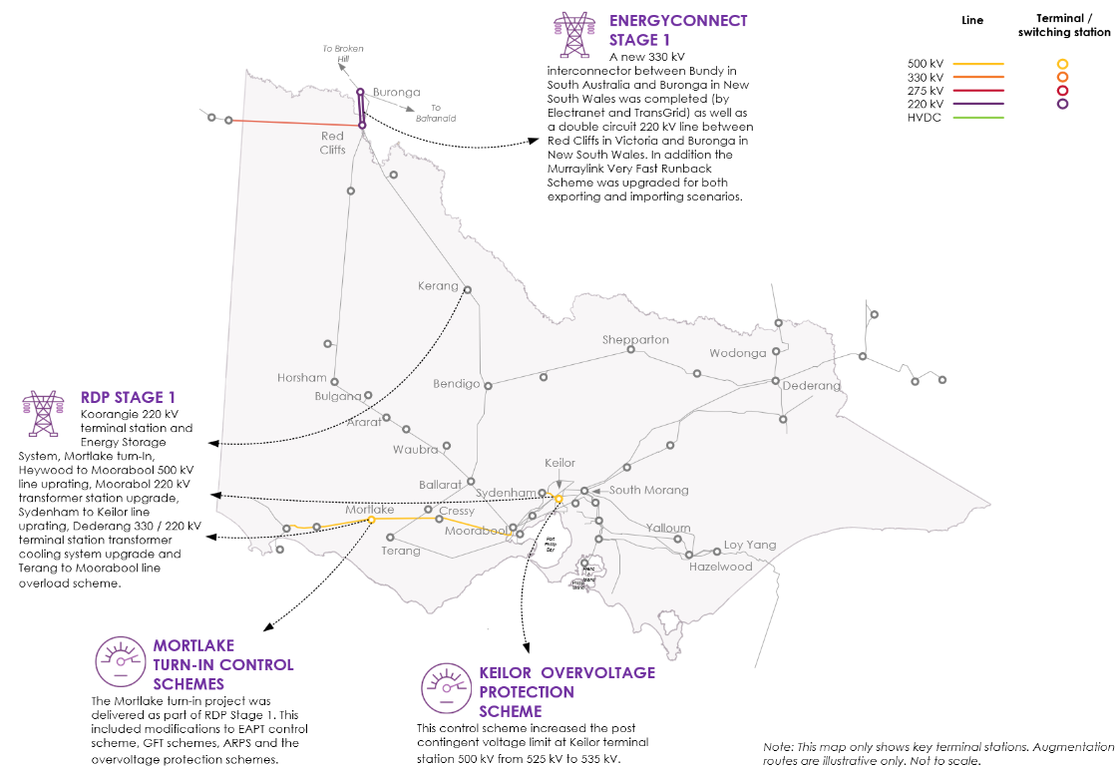
EAPT: Emergency Alcoa Potline Trip. GFT: Generator Fast Trip. ARPS: Anti Resonance Protection Scheme.
- In progress Transmission Development Plan projects for Victoria
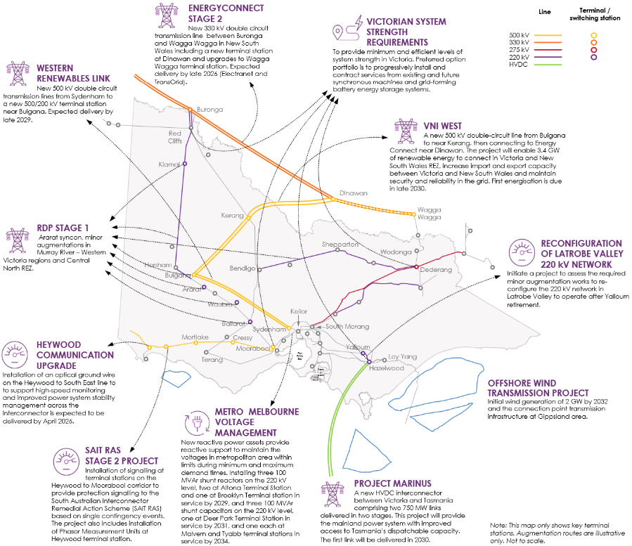
Syncon: synchronous condenser. SAIT RAS: South Australia Interconnector Trip Remedial Action Scheme. MVAr: megavolt amperes reactive.

The future outlook of the 2025 VAPR reiterates the need to progress with regulatory tests to address previously identified network limitations
AVP’s annual planning review for Victoria assesses the current and forecast supply, demand, and operational challenges to identify potential new network limitations. For new limitations identified in the review, efficient investment options are proposed that also consider the benefits from unlocking lower-cost generation supply, increasing power system resilience, and improving the efficiency of resource sharing between Victoria and its neighbouring regions in the NEM.
The key messages from the 2025 VAPR are:
- This assessment, like those published in the last two VAPRs, consistently demonstrates emerging network limitations and the urgency of delivering previously identified augmentation projects.
- The latest assessment is consistent with the 2024 VAPR – the projection of network limitations and their impact on the performance of the DSN is largely consistent with the 2024 assessment.
- AVP has classified one new priority limitation – Keilor A2 and A4 500/220 kV transformer thermal capacity limitation. Thermal loading on the Keilor 500/220 kV transformers A2 and A4 has been identified as a priority limitation at times of maximum demand. The primary driver behind this limitation is increasing demand in the western metropolitan area. It is anticipated that remediation of this limitation can be included in either the Ausnet transformer replacement RIT-T for these transformers or the existing AEMO RIT-T for the Western Metropolitan Grid Reinforcement.
- It is critically important to progress the transmission projects in Victoria’s network development plan, to ensure supply reliability and deliver consumer benefits – the future outlook of the 2025 VAPR highlights the importance of moving forward with the already commenced regulatory tests and approvals of the planned projects initiated by the previous VAPRs to deliver consumer benefits in a timely manner and maintain the reliability of electricity supply in Victoria.
- Proactive engagement is needed between AVP and Victoria’s Declared Transmission System Operators (DTSOs) and distribution businesses (DBs) to identify the optimal solutions for asset replacement projects and manage operational challenges:
  - AVP continues timely and effective joint planning with AusNet Services to identify the optimal solutions to key replacement projects including (but not limited to):
    - South Morang Terminal Station 500/330 kV and 330/220 kV transformers,
    - Keilor 500/220 kV transformers, and
    - tower replacement on the Heywood to Alcoa Portland 500 kV line.
  - AVP continues to work with other DTSOs and DBs to identify credible and cost-effective solutions to the emerging challenges caused by increased fault levels across the DSN, due to the growing generation portfolio, and managing system security at times of low demand.
  - AVP continues to work with VicGrid on the programs identified by the VTP and has assessed these programs and identified no new limitations will be created, while some limitations will be addressed by these programs.

Contents
Executive summary 3
1 Introduction 14
1.1 Purpose and scope of the 2025 VAPR 14
1.2 Roles and responsibilities 15
1.3 Structure of the 2025 VAPR 17
1.4 AVP is seeking feedback on the value of information in this report 17
1.5 Supporting material 17
2 Drivers of the energy transition in Victoria 19
2.1 Evolving energy consumption and supply 20
2.2 Growth in renewable energy sources allowing orderly exit of coal power plants 21
2.3 The critical role of the transmission network in a robust power system 23
2.4 Government policies and initiatives supporting the energy transition 24
2.5 Supply changes – continuing investments in grid-scale renewable generation and storage 25
2.6 Electricity consumption and demand trends and forecasts 29
3 Transmission Development Plan for Victoria 38
3.1 Major projects in the Transmission Development Plan 43
4 Future outlook of the DSN 70
4.1 Annual Planning Review methodology 72
4.2 Projection of network limitations in the planning horizon 74
4.3 System security planning for the DSN 83
4.4 Control schemes in the DSN 89
4.5 General Power System Risk Review – planned activities 92
4.6 Joint planning activities to maintain the DSN 94
4.7 Proposed updates to the Transmission Development Plan 105
A1. Government policies and initiatives 107
A2. Approach to network limitation review 109
A3. Input assumptions for VAPR models 111
A3.1 New generation, transmission and system strength projects 111
A3.2 VicGrid network augmentation projects 113
A4. DSN limitations detail 114
A4.1 Central North Victoria corridor 115
A4.2 Eastern Victoria Corridor 115
A4.3 Northern Victoria corridor 116
A4.4 Murray River corridor 118
A4.5 South West Victoria corridor 119
A4.6 Greater Melbourne and Geelong 120
A4.7 Western Victoria corridor 123
A4.8 Victoria system-wide 123
Abbreviations 124

Tables
Table 1 2025 VAPR supporting resources 18
Table 2 Newly committed large-scale renewable projects since 2024 VAPR 28
Table 3 Newly commissioned large-scale renewable projects since 2024 VAPR 28
Table 4 Newly commissioned storage projects since 2024 VAPR 28
Table 5 Newly committed hybrid and storage projects since 2024 VAPR 28
Table 6 RDP Stage 1 system strengthening projects underway 45
Table 7 Summary of RDP Stage 1 minor augmentation projects still in progress – all projects aimed at relieving thermal constraints 46
Table 8 Victorian System Strength Requirement RIT-T – Option portfolio 3 – Summary of components 51
Table 9 Impact of planned projects on existing limitations – Western Victoria and Murray River corridors 62
Table 10 Impact of planned projects on existing limitations – south-west corridor 63
Table 11 Impact of planned projects on existing limitations – Eastern Victoria, Victoria – New South Wales Interconnector and Latrobe Valley 64
Table 12 Priority limitations from 2024 VAPR 74
Table 13 New priority limitation from 2025 VAPR 75
Table 14 Demand groups that influence augmentation options 81
Table 15 Forecast of post-contingent available fault level at significant Victorian nodes in each financial year, 2025-26 to 2034-35 (MVA) 86
Table 16 System strength locational factors 87
Table 17 Victoria inertia requirements and projections 87
Table 18 Network needs assessment results 98
Table 19 Asset retirements in the DSN 100
Table 20 DNSP preferred connection modifications 105
Table 21 Committed generation, transmission augmentation and system stability projects 111
Table 22 VicGrid network augmentation projects 113
Table 23 Limitations in the Central North Victoria corridor 115
Table 24 Limitations in the Eastern Victoria corridor 115
Table 25 Limitations in the Northern Victoria corridor 116
Table 26 Limitations in the Murray River corridor 118
Table 27 Limitations in the South West Victoria corridor 119
Table 28 Limitations in Greater Melbourne and Geelong 120
Table 29 Limitations in Western Victoria corridor 123
Table 30 Limitations in the Victorian system 123

Figures
Figure 1 Newly completed/approaching completion Transmission Development Plan projects for Victoria 7
Figure 2 In progress Transmission Development Plan projects for Victoria 8
Figure 3 Bi-directional flow paths in modern-day power systems 20
Figure 4 Actual and forecast Victorian coal power generation retirements, 2009-10 to 2049-50 (GW) 22
Figure 5 Generation capacity in the NEM, 2024 ISP Step Change scenario, 2009-10 to 2049-50 (GW) 23
Figure 6 Summary of existing generation capacity and connections pipeline in Victoria 26
Figure 7 Total maximum capacity (MW) by count of projects by category 27
Figure 8 Forecast Victorian electricity annual operational (sent out) consumption, 2025 ESOO Central scenario, 2026-27 to 2055-56 30
Figure 9 Forecast Victorian electricity annual operational (sent out) consumption for data centres, 2025 ESOO Central scenario, 2026-27 to 2054-55 31
Figure 10 Forecast EV consumption versus distributed PV generation, 2025 ESOO Central scenario, 2026-27 to 2054-55 32
Figure 11 Comparison for 2029-30 between the 2024 and 2025 ESOO Victorian consumption forecasts, Central – Step Change scenario 33
Figure 12 Comparison for 2034-35 between the 2024 and 2025 ESOO Victorian consumption forecasts, Central – Step Change scenario 34
Figure 13 Actual and 10% POE forecast maximum demand for Victoria in 2024 and 2025 ESOO Central (Step Change) scenario, operational sent out), 2021-22 to 2035-36 (MW) 35
Figure 14 Actual and 50% POE forecast maximum demand for Victoria in 2024 and 2025 ESOO Central (Step Change) scenario, operational sent out, 2021-22 to 2035-36 (MW) 36
Figure 15 Actual and 90% POE forecast minimum demand for Victoria in 2024 and 2025 ESOO Central (Step Change) scenario, operational sent out, 2020-21 to 2035-36 (MW) 37
Figure 16 Newly completed/approaching completion Transmission Development Plan projects for Victoria 40
Figure 17 In progress Transmission Development Plan projects for Victoria 41
Figure 18 Timeline of Transmission Development Plan projects for Victoria 42
Figure 19 Project overview map of WRL 47
Figure 20 Project overview map of VNI West 50
Figure 21 Latrobe Valley high demand radial mode 53
Figure 22 Latrobe Valley modified parallel mode 54
Figure 23 Renewable energy zones defined in the 2025 VTP 55
Figure 24 Map of new priority programs in the 2025 VTP 56
Figure 25 Study area and indicative connection hub for offshore wind generator connections 58
Figure 26 Regulatory tests and feasibility studies in progress 66
Figure 27 Identification of network limitations – the planning cycle 72
Figure 28 Priority limitations under investigation 73
Figure 29 Thermal overloading of Keilor 500/220 kV A2 and A4 transformers 76
Figure 30 Monitored limitations 77
Figure 31 Impact of VicGrid VTP programs on existing limitations 80
Figure 32 Possible transmission augmentations to meet needs of large load connections 82

Introduction
This section outlines the purpose and summarises the content of the 2025 VAPR.

Purpose and scope of the 2025 VAPR
The 2025 VAPR provides useful information to stakeholders about the Victorian electricity transmission DSN. It assesses the adequacy of the DSN over a 10-year planning horizon to ensure the DSN meets network performance requirements to supply electricity to Victorian consumers in a secure and reliable manner. The VAPR compliments the VTP (which focuses on developing REZs over a 25-year period) by providing more frequent updates in the shorter 10-year planning horizon to address changes in the network between VTP publications. The VAPR also takes inputs from the reforms coming from the VTIF and reflects them annually in the Transmission Development Plan for Victoria.
The VAPR presents the Transmission Development Plan for Victoria while identifying network limitations for further investigation.
To assess the adequacy of the DSN over the 10-year planning horizon, the VAPR takes into account:
- the most recent demand forecasts (2024 AEMO Connection Point demand forecast and 2025 Electricity Statement of Opportunities (ESOO) regional demand forecasts),
- generation plant and retirement information using the July 2025 update on AEMO’s Generation Information web page, Register of Large Generators Victoria, and AVP Internal connections project information,
- committed, anticipated and future Integrated System Plan (ISP) projects (from AEMO’s Transmission Augmentation Information page),
- projects from the final 2025 VTP and other network/non-network projects initiated by VicGrid,
- committed distribution augmentations identified in the 2024 Transmission Connection Planning Report prepared by the Victorian distribution network service providers (DNSPs), and
- committed asset retirements and deratings as per the 2025 DSTOs’ Asset Renewal Plans.
With this assessment, AVP updates its Transmission Development Plan for Victoria, which outlines the strategy for Victoria to provide a transmission system which best meets the needs of the DSN’s stakeholders.
This plan builds on the national plan developed through AEMO’s ISP and VicGrid’s VTP. The VAPR provides insights relating to the DSN’s performance, supply and demand changes and forecasts for the next decade, emerging DSN changes to address network needs, and the AVP’s Transmission Development Plan for the DSN, with a particular focus on developments most likely to deliver positive net economic benefits to energy consumers, to facilitate the establishment of REZs or where corrective action is required to keep the DSN reliable and secure.
The Annual Planning Review undertaken by AVP and presented in this report has considered the policy initiatives and directives of the Federal Government and Victorian Government (see Section 2.4) in identifying network limitations for the next 10 years and proposing solutions to those limitations in the Transmission Development Plan for Victoria.

Roles and responsibilities

AEMO Victorian Planning (AVP)
AVP currently holds the role of transmission network service provider (TNSP) planner in the jurisdiction of Victoria. While there are multiple DTSOs in Victoria, AVP is responsible for planning and directing augmentation of the DSN in Victoria.
The National Electricity Rules (NER) require all jurisdictional planning bodies of the NEM to undertake an Annual Planning Review followed by publishing a Transmission Annual Planning Report (TAPR) by 31 October each year, as outlined in NER 5.12.1 and 5.12.2 respectively.
Other obligations and responsibilities that AVP holds as the Jurisdictional Planning Body for Victoria include:
- initiating network investment for cost-effective solutions for consumers, including conducting RIT-Ts on potential transmission network and non-network projects, and
- undertaking joint planning with Victorian DTSOs and DNSPs, AEMO National Planning and neighbouring TNSPs.

VicGrid
VicGrid is a Victorian government agency established under the State Owned Enterprises Act (1992) that was initially established as part of the Department of Energy Environment and Climate Action (DEECA) to coordinate the overarching planning and development of Victorian REZs.
In May 2024, an amendment to the National Electricity (Victoria) Act 2005 (NEVA) legislated the establishment of VicGrid as a statutory authority with the following responsibilities:
- coordinating the planning and development of REZ infrastructure,
- investing in projects to strengthen and modernise Victoria’s energy grid,
- changing the planning and development framework of the electricity transmission infrastructure in Victoria to ensure it benefits all Victorians, through the VTIF,
- coordinating the delivery of the transmission required to connect new offshore wind resources to the grid,
- working with AVP to deliver major infrastructure upgrades, and
- providing information to communities.
In September 2025, the National Electricity (Victoria) Amendment (VicGrid Stage 2 Reform) Bill 2025 received royal assent, which will make the necessary changes to the NEVA to transfer the Victorian network declared functions from AEMO to VicGrid. These functions include:
- to plan, authorise, contract for, and direct, augmentation of the DSN,
- to provide information about the planning processes for augmentation of the DSN,
- to provide information and other services to facilitate decisions for investment and the use of resources in the adoptive jurisdiction's electricity industry,
- to provide shared transmission services by means of, or in connection with, the DSN,
- any other functions, related to the declared transmission system or electricity network services provided by means of or in connection with the declared transmission system, conferred on it under the National Electricity Law (NEL), and
- any other functions, related to the declared transmission system or electricity network services provided by means of or in connection with the declared transmission system, conferred on it under a law of the adoptive jurisdiction.
It is anticipated that transfer of Victorian network declared functions from AEMO to VicGrid will occur on 1 November 2025 and that this VAPR will be the final VAPR published by AEMO as the TNSP planner in Victoria.

Victorian Transmission Investment Framework (VTIF)
In March 2024, the Victorian Government finalised legislation introducing the VTIF, a new regulatory framework with a comprehensive set of reforms to support the state’s energy transition. VTIF is an integrated approach for planning and delivering electricity transmission infrastructure on a coordinated basis that will support development of REZs across Victoria.

Victorian Transmission Plan (VTP)
Under the new VTIF framework, VicGrid will develop the VTP as a 25-year comprehensive strategic plan for Victorian transmission and REZ development. VicGrid published the 2024 VTP Guidelines in September 2024. In May 2025, VicGrid published the first draft VTP, which allowed for public consultation before the 2025 VTP was published in August 2025.
The first VTP covered a planning horizon of 15 years, with future VTP publications covering the full 25-year planning horizon. The VTP offers a new approach to planning that considers important factors including land use, environmental impacts and community views much earlier in the process. This aims to minimise impacts to regional communities, landholders and rights holders, keep costs low for consumers, and give industry the certainty it needs to invest in the renewable energy Victoria requires for the future.

Structure of the 2025 VAPR
The 2025 VAPR consists of three main sections and is supported by a number of documents as listed in Section 1.5:
- Section 2 – Drivers of the energy transition in Victoria outlines the overall context for this review of the Victorian DSN, including the changing nature of supply and demand, the need for resilience in the power system, and policy and regulatory updates.
- Section 3 – Victoria’s Transmission Network Development Plan provides an update on network development activities and regulatory investment tests that have progressed since the 2024 VAPR.
- Section 4 – Future outlook of the Victorian DSN provides a forecast of DSN limitations for the planning horizon and proposes potential solutions. This section also contains information about ongoing activities for system security planning, control schemes required to manage DSN performance, and joint planning activities with other network service providers (NSPs).
- Appendix A1 outlines the government policies and initiatives that have been considered in the VAPR.
- Appendix A2 summarises AVP’s approach to the network limitation review.
- Appendix A3 summarises the forecast changes to the network that have been considered in identifying future limitations.
- Appendix A4 provides details of DSN limitations, as an outcome of this review.

AVP is seeking feedback on the value of information in this report
AVP welcomes stakeholder submissions on the usefulness of the 2025 VAPR, and on potential improvements or additional information sources that would be valuable to stakeholders in future VAPRs. Submissions will be shared with VicGrid to inform its 2026 Victorian Annual Planning Report.
Send your written submissions to VIC.Planning@aemo.com.au by 31 December 2025.

Supporting material
Table 1 lists a suite of electronic resources published by AEMO to support the content in this report. Unless otherwise indicated, these resources are published alongside the VAPR on VicGrid’s website.

- 2025 VAPR supporting resources
Resource | Description
Victorian Network Performance and Insights Report (VNPIR) | Formerly a chapter of the VAPR, this report provides an overview and key insights of the performance of the DSN during financial year 2024-25 and reviews the capabilities and challenges of the present-day network to inform the VAPR.
Historical DSN rating and loading workbook | Ratings and loadings for the 2024-25 maximum demand and high export periods presented in Section 4 of the VNPIR.
AusNet Services 2025 asset renewal plan | AusNet Services’ transmission asset renewal process provides a list of planned asset renewal projects, including asset retirements and de-ratings for the next 10-year period, including changes since last year and the options considered.
Asset related datasets | - Transmission connection point data for each transmission terminal station where primary station assets are associated with an actual or forecast emerging network limitation.  - Transmission line segment data for each transmission line between terminal stations that are associated with a historical or emerging line capacity limitation.  - Aggregated generation connection data for each connection application or new (completed over the last 12 months) connection agreement at terminal stations or areas where the connections could affect existing or emerging network limitations.
2024 Victorian Connections Point Demand Forecast | AEMO’s internal maximum and minimum demand forecasts for the Victorian connection points.
System security reports | AEMO’s system strength, inertia and network support and control ancillary services (NSCAS) assessments, collectively known as the System Security Reports under NER 5.20. At https://aemo.com.au/energy-systems/‌electricity/national-electricity-market-nem/nem-forecasting-and-planning/system-security-planning.
Eastern Victoria Grid Reinforcement RIT-T PSCR | The first publication in the Eastern Victoria Grid Reinforcement RIT-T process, at https://www.aemo.com.au/initiatives/major-programs/eastern-victoria-grid-reinforcement.
Metropolitan Melbourne Voltage Management RIT-T PACR | The third and final publication in the Metropolitan Melbourne Voltage Management RIT-T process, at https://www.aemo.com.au/initiatives/major-programs/metropolitan-melbourne-voltage-management-regulatory-investment-test-for-transmission.
Victorian System Strength Requirement RIT-T PACR | The third and final publication in the Victorian System Strength Requirement RIT-T process, at https://www.aemo.com.au/initiatives/major-programs/victorian-system-strength-requirement-regulatory-investment-test-for-transmission.
Western Metropolitan Melbourne Reinforcement RIT-T PSCR | The first publication in the Western Metropolitan Melbourne Reinforcement RIT-T process, at https://www.aemo.com.au/initiatives/major-programs/western-metropolitan-melbourne-reinforcement.
General Power System Risk Review (GPSRR) | An integrated, periodic review of major power system frequency risks associated with non-credible contingency events in the NEM (previously the Power System Frequency Risk Review). At https://www.aemo.com.au/energy-systems/electricity/national-electricity-market-nem/system-operations/general-power-system-risk-review.
Enhanced Locational Information (ELI) Report | Provides a consolidated set of locational information to inform decisions about where to locate projects in the NEM. At https://aemo.com.au/energy-systems/electricity/national-electricity-market-nem/nem-forecasting-and-planning/forecasting-and-planning-data/enhanced-locational-information.
Electricity Network Options Report | Provides the electricity network options including transmission and distribution in the NEM to inform the development of the ISP. At https://www.aemo.com.au/consultations/current-and-closed-consultations/2025-electricity-network-options-report-consultation.
ESOO | Provides technical and market data for the NEM over a 10-year period to inform the planning and decision-making of market participants, new investors, and jurisdictional bodies. At https://www.aemo.com.au/energy-systems/electricity/national-electricity-market-nem/nem-forecasting-and-planning/forecasting-and-reliability/nem-electricity-statement-of-opportunities-esoo.
2024 ISP | A roadmap for the transition of the NEM power system to meet both consumer needs and government energy and emissions targets between now and 2050. It outlines the mix of generation, storage and network investments required meet the targets. At https://www.aemo.com.au/energy-systems/major-publications/integrated-system-plan-isp/2024-integrated-system-plan-isp.

Drivers of the energy transition in Victoria
This section outlines information about the changing energy landscape in Victoria that is relevant for transmission planning. This includes a summary of key changes in energy consumption and supply patterns and government policies, updated generation and storage projects since the publication of the 2024 VAPR, and insights from the latest demand and energy consumption forecasts for Victoria.
Key insights
- Victoria’s rapid energy transition is being driven by large-scale renewable energy generation, so far mostly developed in the west of the state, and strong uptake of distributed generation by consumers.
- Victoria recorded its all-time lowest minimum operational demand of 1,504 MW on Sunday 1 January 2025. This was 60 MW lower than the previous record set last financial year. This minimum demand occurred during the daytime due to high output from distributed PV generation.
- Government policies and incentive schemes, increasing industry commitment to large-scale investments in renewable energy generation, fast-growing consumer investment in distributed renewable resources, and the application of new technologies are reshaping how Victorians use the transmission network.
- New generation/storage commitments since the 2024 VAPR total 840 MW of solar and wind generation, while another 997 MW of wind and solar generation connected to the DSN. Investment remains strong, particularly in BESS in the South-west, Murray River and Central Northern regions of Victoria. A total of 350 MW of BESS projects reached the committed stage since the 2024 VAPR.
- The maximum installed large generation capacity, together with committed generation, in the Victorian DSN as of July 2025, is 17.1 GW, consisting of:
  - renewable generation capacity of 9.6 GW – 8.9 GW of large-scale wind, solar generation, and battery storage, and 0.7 GW of hydro generation, and
  - thermal generation capacity of 7.5 GW – 5.1 GW of coal generation, of which 3.9 GW is announced to be retired in the next 10 years, and 2.4 GW of gas generation.
- Maximum demand in Victoria is projected to grow steadily through to 2030, supported by gradual increases in forecast consumption from data centres, large industrial loads (LILs), and electrification. From 2030 onwards, demand growth accelerates, primarily driven by a substantial uplift in projected data centre consumption. This results in a change from the 2024 ESOO, with 50% POE maximum operational demand reaching 11.3 GW by 2034-35, approximately 723 MW higher than the corresponding forecast in the 2024 ESOO.
- Minimum demand is forecast to decline rapidly, reaching 0 GW by 2029 and -2.6 GW by the end of the planning horizon.

Evolving energy consumption and supply
Traditional energy consumption has changed in Australian households and businesses, with the growth of non-conventional and smarter electricity usage patterns throughout the day. The energy efficiency of cooking, heating, and cooling is rising due to consumer choices and behavioural shifts. Consumers are managing energy in new ways through their CER, including EVs, domestic and small-scale energy storage systems, and adjustments to the operating cycles of appliances like heat pumps, air-conditioners, and hot water heaters.
Figure 3 shows that the generation supply has become more distributed, in a change from traditional centralised generation, with generation now diversified on both the supply and user sides, and energy increasingly flowing both ways, from and towards consumers.
- Bi-directional flow paths in modern-day power systems
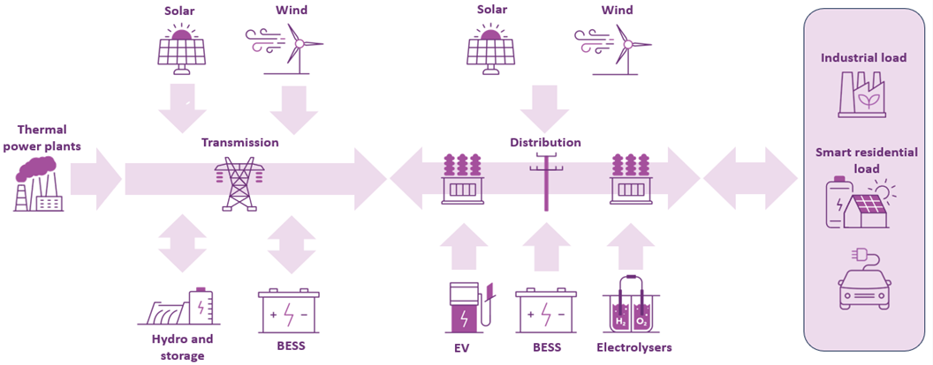

The future power system will have changes in energy supply and consumption patterns at different levels of the power system. These are the key changes observed in the transition towards a modern power system, including in Victoria and across the Australia’s energy markets:
- There is ongoing growth in CER, including distributed PV generation, BESS and EVs.
- Multiple elements have the opportunity to be coordinated including through virtual power plants (VPPs) which can aggregate CER assets into larger systems, trading energy between them and the grid, and providing broader system benefits from these resources depending on financial incentives, technology and communication standards, customer preferences, and market or policy arrangements.
- Operational challenges to maintain system security and meet consumer requirements in the broader power system during low and negative demand daytime periods are growing, driven by the high levels of distributed PV relative to underlying demand. In Victoria, reverse power flows have occurred at a number of terminal stations, which were mainly built to supply customer loads, as a result of an increasing number of distributed generators (including distributed PV) connected at the distribution level. In 2024-25, the total hours of reverse power flows increased by 11% compared to 2023-24. More co-ordinated approaches with DNSPs will be required to manage the operational challenges resulting from these reverse power flows.
- Victoria recorded its all-time lowest minimum operational demand of 1,504 MW on 1 January 2025. This was 60 MW lower than the previous record set last financial year. Minimum demand is now occurring during the daytime because of the effect of distributed PV generation. At the time of minimum demand on 1 January 2025, 3.5 GW of distributed PV generation was observed.
- There is increased potential for large inverter-based block loads like data centres and hydrogen electrolysers connecting to the network.
Victoria’s transition from fossil fuels to clean energy sources, to deliver low cost and reliable energy to households and businesses via a secure power system, is well underway as consumers, investors and governments continue to develop renewable generation and storage.
The main load centres in Victoria are in metropolitan Melbourne and the Geelong area, where the bulk of the state’s energy is consumed by households or businesses.
Changes in the energy landscape mean that careful and proactive coordination is required to plan and operate the power system. The growing proportion of CER generating energy in the distribution network, the bi-directional power flow at terminal stations, and the occurrence of minimum system load (MSL) conditions are creating additional operational challenges as well as the need for proactive planning measures.

Growth in renewable energy sources allowing orderly exit of coal power plants
Historically, Victoria’s power generation was predominantly based on brown coal power plants in the Latrobe Valley, and some gas generation units used to firm up demand during peaking times. Hazelwood Power Station retired in 2017, and the remaining coal fleet, which is aging, is planned to retire in 10-20 years.
YWPS’s owner, EnergyAustralia, announced in 2021 its intention to retire YWPS early due to carbon neutral targets, the net plant’s reliability, and rising operational costs. With YWPS’ retirement, the Victorian network will find alternative supplies from interconnectors and other generators (existing and future) to cover the 1,600 MW generation (roughly 20% of Victoria’s electricity demand) it was providing. As discussed in the 2025 VTP, Victoria’s generation landscape is expected to change from the current dominant supply source of coal generation in the Latrobe Valley to a mix of wind and solar generation predominantly located in Western Victoria and offshore wind in Gippsland. The services provided by these existing coal-fired generators – such as inertia and frequency control, and supply or absorption ability of reactive power – will be fulfilled by other sources and technologies inclusive of sources shared from neighboring regions.
Figure 4 illustrates the coal generation capacity in Victoria, and how it is projected to decrease over the next two decades based on announced coal plant retirement plans, as well as the reduction in coal capacity forecast in the 2024 ISP Step Change scenario, which shows all Victoria’s coal fleet is forecast to retire by 2033-34.
- Actual and forecast Victorian coal power generation retirements, 2009-10 to 2049-50 (GW)
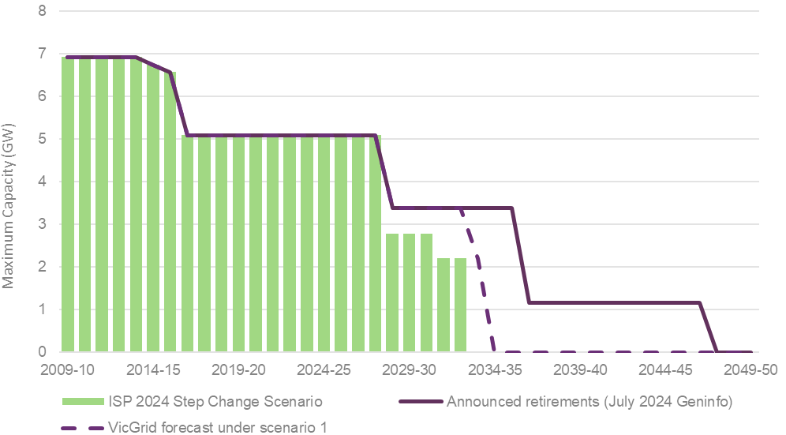
Notes: Geninfo is AEMO’s Generation Information webpage, at https://www.aemo.com.au/energy-systems/electricity/national-electricity-market-nem/nem-forecasting-and-planning/forecasting-and-planning-data/generation-information. VicGrid forecast is at https://www.vicgrid.com.au/__data/assets/pdf_file/0032/761396/2025-victorian-transmission-plan.pdf.
The 2024 ISP identified that renewable energy connected by transmission and distribution, firmed with storage and backed up by gas-fired generation, will be the lowest-cost way to supply electricity to homes and businesses as Australia transitions to a net zero economy.
Figure 5 shows expected generation capacity across the NEM to 2050 in the optimal development path of the 2024 ISP Step Change scenario. It highlights that, as coal generation retires, supply adequacy needs to be balanced with growth in renewable generation, with about 6 GW of additional generation capacity needing to be added to the NEM every year.
- Generation capacity in the NEM, 2024 ISP Step Change scenario, 2009-10 to 2049-50 (GW)
Notes: Flexible gas includes gas-powered generation and potential hydrogen capacity. CER storage means CER such as batteries and EVs. Projections for rooftop solar and other distributed solar and CER storage were based on unit costs, consumer trends and assumptions about payments received to participate in the electricity market.

The critical role of the transmission network in a robust power system
A key element of a robust power system is its ability to maintain system security and reliability during extreme operating conditions driven by factors such as high or low demand levels, lack of system strength and/or inertia, and extreme climate events.
System strength and inertia are critical characteristics that enable the power system to recover from sudden disturbances and maintain stability. Reduced availability (due to displacement or orderly retirement) of conventional generation units online can lead to shortfalls in these characteristics.
Maintaining the resilience of the DSN through these challenges is critical. The future power system will be more complex with the continuing growth of renewable inverter-based resources (IBR) on the supply side as well as large inverter-based loads (IBL), and ongoing rapid uptake in renewable energy-based sources diversified across both transmission and distribution networks. As such, planning the power system is essential to ensure it continues to operate reliably to meet consumer needs.
The transmission network continues to play a critical role in maintaining a resilient power system, as the backbone or primary corridor of the power system to transfer the energy sourced from renewable generation across Victoria and neighboring regions into Victoria’s large load centres.
The 2024 ISP’s optimal development path identified over 10,000 km of transmission projects by 2050 across the NEM, under the Step Change scenario, including major augmentation projects that have been identified as committed/anticipated or actionable for Victoria to enable the optimal development path. The development of these projects is critical to ensure the resilience of the overall power system in Victoria.

Government policies and initiatives supporting the energy transition
The Victorian Government has made a range of commitments and policy announcements to enable the energy transition and support the connection of renewable generation. These commitments and policies have significant impact on the drivers for, and economics of, investment opportunities in the Victorian electricity network. These are recent major government policies or initiatives:
- VTIF and VTP – see Section 1.2.2 for details.
- VTP – VicGrid’s 2025 VTP offers a new approach to planning that considers important factors including land use, environmental impacts and community views much earlier in the process. This aims to minimise negative impacts to regional communities, landholders and rights holders, keep costs low for consumers and give industry the certainty it needs to invest in the renewable energy Victoria requires for the future.
- Victorian transmission planning objectives – with the new functions of VicGrid, a new Victorian transmission planning objective, as set out in amendments to the NEVA, passed in May 2024. The new objective incorporates environmental objectives and the state’s needs in response to the energy transition and will guide how transmission planning and investment decisions are made in Victoria.
- RDP – as outlined in the RDP Directions Paper, AEMO worked with the Victorian Government to develop the RDP Stage 1 projects to provide short- to medium-term solutions to strengthen the existing network and accelerate REZs. In 2022, the Victorian Government issued the Third RDP Stage 1 NEVA Order directing AEMO to enter contracts with the declared transmission system operators for the network augmentations identified in RDP Stage 1²³. For progress of the delivery of the projects since 2024 VAPR, see Section 3.1.2.
- Offshore wind targets – the Victorian Government has set generation capacity targets of at least 2 GW by 2032, 4 GW by 2035 and 9 GW by 2040. VicGrid is leading a coordinated approach to transmission development for offshore wind generation in Gippsland and the declared Southern Ocean area. See Section 2.5 for more details about planned offshore wind development activities.
Appendix A1 lists all government policies and initiatives taken into consideration in this plan.

Supply changes – continuing investments in grid-scale renewable generation and storage
Enabling the energy transition requires timely investment and delivery of new DSN and connections projects. This will ensure the benefits of these projects unlock renewable potential and deliver benefits to consumers and communities.
Victoria’s transition is driven by investment in large-scale renewable energy generation, primarily concentrated in the state’s Northern, Western, and Southwestern corridors and in the Gippsland Offshore zone. Victoria is also seeing an influx of BESS interest in all regions including the metropolitan Melbourne area which is generally a difficult location for other large renewable projects. Government policies and initiatives driven by Victoria’s renewable energy targets (see
Section 2.4), such as Victorian Renewable Energy Target 1 (VRET1) and VRET2, have enabled a total of approximately 1.6 GW of new renewable energy generation capacity and up to 365 MW/600 megawatt hours (MWh) of new energy storage that is planned to be online in Victoria by 2025. Victoria’s off shore wind policy development policy has drawn significant interest, particularly in the Gippsland offshore wind zone where the first capacity auction for offshore wind development will occur.
AVP defines projects by the following definitions:
- Proposed – projects that proponents have proposed, that have not yet met commitment criteria,
- Committed – projects where Connection Agreements have been executed and the project is unconditional, and
- Commissioned – projects where all Hold Point testing has been completed and AEMO has approved the generator for output at full capacity.
Figure 6 shows the high investment interest for renewable generation and storage in Victoria across existing projects and the pipeline for new connections in the outlook period. It summarises the installed capacity of existing and projected generation/storage connections on the DSN exceeding 30 MW:
- The total large generator installed capacity plus committed generation and storage projects in Victoria as of 30 August 2025 is 17.1 GW. Renewable generation capacity is 9.6 GW:
  - 8.9 GW of large-scale wind, solar generation, and battery storage, and
  - 0.7 GW of hydro generation.
- Current thermal generation capacity 7.5 GW:
  - 5.1 GW of coal generation remains after 1.9 GW retired between 2014 and 2017, and
  - 2.4 GW of gas generation.

- Summary of existing generation capacity and connections pipeline in Victoria
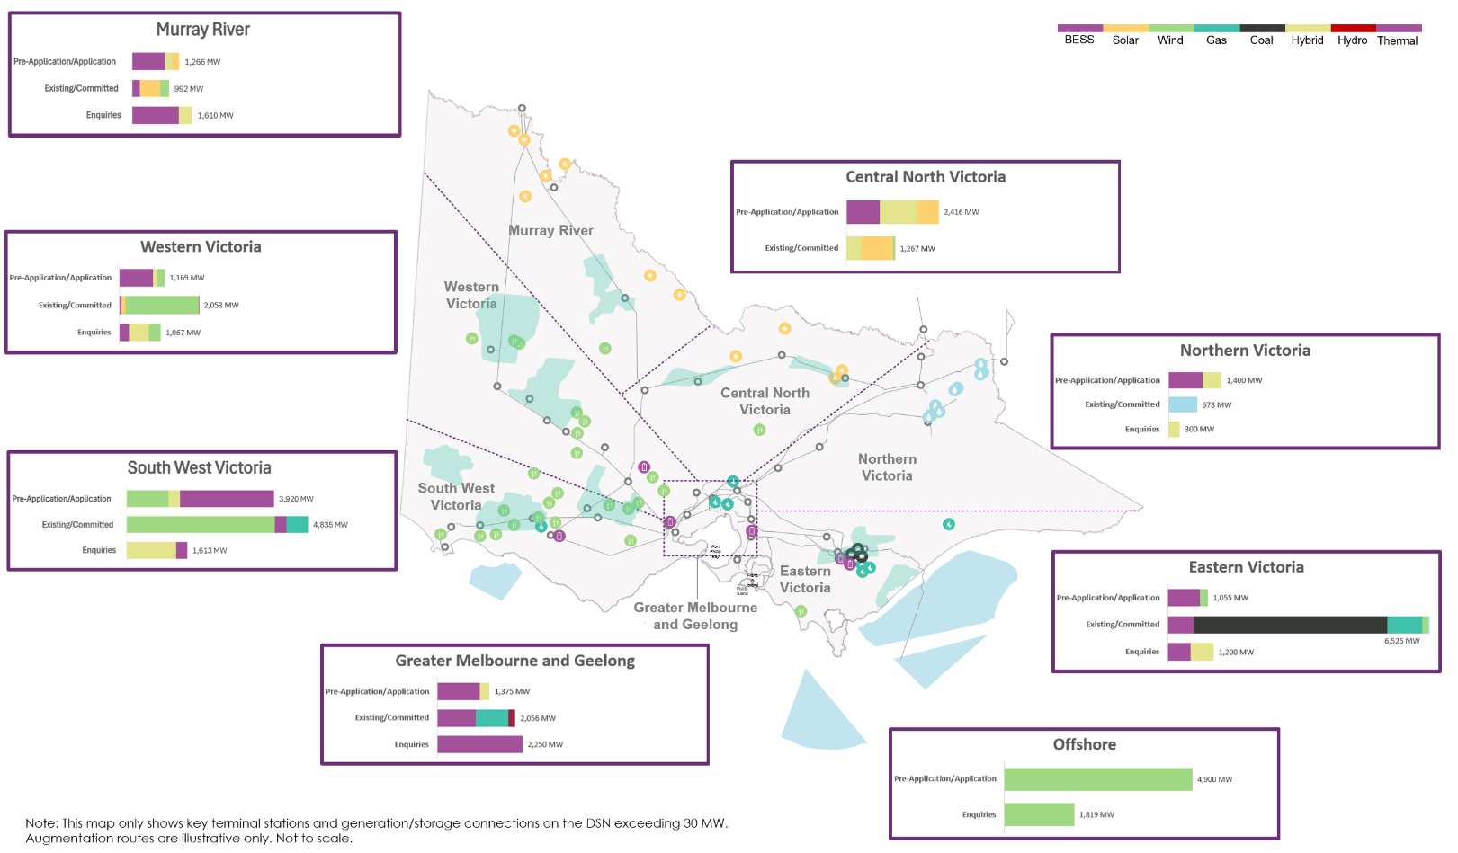

There is a substantial pipeline of additional projects currently classed as proposed. Figure 7 shows new and existing generation and storage projects from the last 12 months, grouped by the stage in the connection process projects are at.
- Total maximum capacity (MW) by count of projects by category
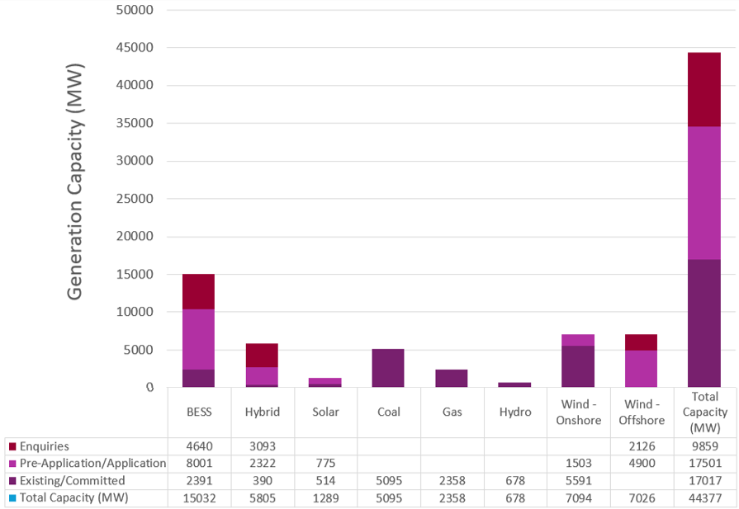

Growing investments in renewable energy highlight challenges in Victoria’s traditional transmission network​
As Victoria decarbonises its energy system, the geographic location of supply has diversified. Additional solar and wind generation is being developed in the west of the state while large brown coal generators in the Latrobe Valley are approaching their planned closure dates (mid-2028 for Yallourn Power Station and Loy Yang A in 2035). Solar and wind generation sources, including offshore wind, are also expected to develop in the east to take advantage of existing transmission infrastructure.
Both east and west generation developments will be needed to meet the needs of Victorian consumers. While the network to the east is expected to largely accommodate generation developments replacing coal in the next decade, the network to the west does not yet have capacity to transfer large quantities of the power from the renewable energy sources expected to connect in that area (see Section 3.2.1 in the 2025 Victorian Network Performance and Insights Report [VNPIR]).

Generation and storage update since the 2024 VAPR​
Interest in wind and utility-scale solar projects continues, however there is an increasing uptake of committed BESS projects including hybrid applications of IBR incorporating storage.
Table 2 lists newly committed large-scale renewable energy projects, currently in the commissioning phase, since the publication of the 2024 VAPR, adding 320.5 MW of capacity and 1,740 MWh of storage.
- Newly committed large-scale renewable projects since 2024 VAPR
Source | Project | Connecting terminal station | Connection voltage (kV) | Maximum capacity (MW) | Storage capacity (MWh)
Solar | Winton North Solar Farm | GNTS – Glenrowan | 220 | 100
BESS | Wooreen BESS | JLTS – Jeeralang | 220 |  | 1,400
BESS | Axedale Solar Farm and BESS | ADTS – Axedale | 220 | 140 | 100
BESS | Fosterville Solar Farm and BESS | ADTS – Axedale | 220 | 80.5 | 240

As Table 3 shows, three large-scale renewable projects have been commissioned in the DSN in the past year, adding 1,028 MW of capacity.
- Newly commissioned large-scale renewable projects since 2024 VAPR
Source | Project | Connecting terminal station | Connection voltage (kV) | Maximum capacity (MW)
Wind | Golden Plains Wind Farm | CRTS – Cressy | 220 | 733
Wind | Ryan Corner Wind Farm | TGTS – Terang | 132 | 205
Wind | Hawkesdale Wind Farm | TGTS – Terang | 132 | 90

In Victoria, two storage projects totalling 770 MWh have recently been commissioned (see Table 4). This will further reinforce the continuity of supply and firming of VRE sources.
- Newly commissioned storage projects since 2024 VAPR
Source | Project | Connecting terminal station | Connection voltage (kV) | Storage capacity (MWh)
BESS | Koorangie Energy Storage System | KOTS – Koorangie | 220 | 370
BESS | Rangebank BESS (Cranbourne 220 kV) | CBTS – Cranbourne | 220 | 400

In addition to the recently connected storage projects, a further two hybrid projects incorporating BESS and a standalone BESS project totalling 220.5 MW of generation and 1,740 MWh of BESS projects reached commitment status in the past year, as shown in Table 5.
- Newly committed hybrid and storage projects since 2024 VAPR
Source | Project | Connecting Terminal station | Connection Voltage (kV) | Maximum capacity (MW) | Storage capacity (MWh)
BESS | Wooreen BESS | JLTS – Jeeralang | 220 |  | 1,400
Hybrid | Axedale Solar Farm and BESS | ADTS – Axedale | 220 | 140 | 100
Hybrid | Fosterville Solar Farm and BESS | ADTS – Axedale | 220 | 80.5 | 240

Electricity consumption and demand trends and forecasts
The regional demand forecasts used for the 2025 Annual Planning Review are the Victorian components of AEMO’s 2025 ESOO Central (Step Change) scenario forecasts. Forecasts are sent out, meaning energy delivered from the transmission system to household and business consumers plus expected losses in transmission and distribution networks:
- Operational consumption is defined as energy usage over a year, supplied through the transmission network and measured in megawatt hours (MWh).
- Operational demand is defined as the level of electricity drawn from the transmission network, measured in megawatts (MW), averaged from the power system in half-hour intervals.
- Underlying consumption/demand means all the energy used, including that supplied by distributed PV.
Part of this section will cover analysis and explanation of how the 2025 forecasts compare to the 2024 forecasts. Consumption and demand forecasts are updated using the latest data on economic and population drivers as well as trends in behaviour by household and business consumers, including electrification impacts. The forecasts factor in projections for energy efficiency measures and growth in CER, including distributed PV generation, BESS and EVs, which all impact how much energy needs to be supplied from the transmission network.
For context, the VNPIR has details about Victoria’s operational consumption and demand in 2024-25:
- The maximum demand for Victoria was 9,851 MW and occurred on 16 December 2024, compared to the peak of 9,294 MW in 2023-24.
- Victoria recorded its all-time lowest minimum operational demand of 1,504 MW on Wednesday 1 January 2025. This was 60 MW lower than the previous record set last year.

Annual operational consumption forecast
Figure 8 shows Victoria’s component forecasts containing operational consumption, small-scale generation and energy efficiency that make up the operational (sent out) consumption under the 2025 ESOO Central (Step Change) scenario for the next 30 years.
Under this scenario, AEMO projects the following:
- Operational consumption increases gradually over the next 10 years due to business mass market (BMM), LIL and residential grid demand growth, with low contributions from EVs, business and residential electrification.
- From years 10 to 20, operational consumption increases significantly, driven by rapid growth in data centres and EV load, supported by consistent energy consumption from BMM. EV adoption continues to increase throughout the forecast period but increases more slowly than in the 2024 ESOO.
- From years 11 to 30, consumption continues to grow, driven by electrification in the residential and business sector, EV adoption, and the growth of data centres and domestic hydrogen production, offset by energy efficiencies and PV uptake. Starting from 2040-41, residential energy consumption is forecast to become negative, driven by the continued growth of distributed PV generation from households installing larger PV systems, along with improvements in energy efficiency.
- Forecast Victorian electricity annual operational (sent out) consumption, 2025 ESOO Central scenario, 2026-27 to 2055-56
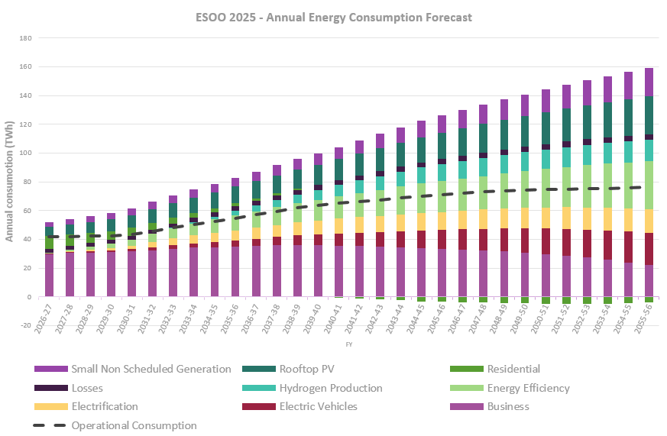

Data centre connections
In the 2025 ESOO, data centres were a separate segment, under the business category, due to their growth patterns being fundamentally different from other business customers. In 2024-25, data centres consumed around 4 terawatt hours (TWh) of electricity across the NEM, accounting for around 2% of grid-delivered supply. The ESOO 2025 forecast a substantial rise in the numbers of data centres and hence energy usage in Victoria, suggesting that while plateauing after Year 10 (2034-35), data centres will remain a significant consumer of grid power.
- Forecast Victorian electricity annual operational (sent out) consumption for data centres, 2025 ESOO Central scenario, 2026-27 to 2054-55
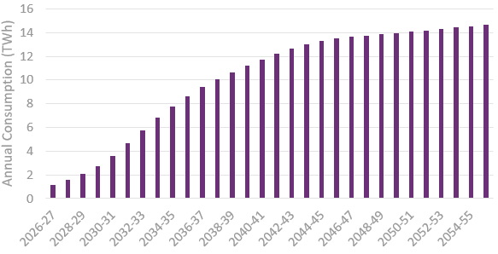
Source: AEMO Forecasting Portal, at https://www.aemo.com.au/energy-systems/electricity/national-electricity-market-nem/nem-forecasting-and-planning/forecasting-and-planning-data/electricity-forecasting-data-portal.

Changes in the forecast driven by consumer behaviour
There are a combination of factors influencing the uptake of EVs and its contribution to residential electricity consumption. Australian policy measures designed to support decarbonisation and electrification are projected to significantly influence electricity consumption across multiple sectors. For example, the New Vehicle Efficiency Standard (NVES) is fostering increased adoption of EVs, while Victoria’s Gas Substitution Roadmap is facilitating the transition from gas to electricity within residential and commercial domains.
In addition to the Gas Substitution Roadmap, new electrification and efficiency standards and regulations are making new domestic and commercial builds all electric, making incentives available through the Victorian Energy Upgrades (VEU) program, to new or existing homeowners and property developers.
It should be noted that compared to the 2024 ESOO, the 2025 ESOO forecast showed a short-term uplift in new connections of residential developments, encouraged by state and federal incentives to improve housing affordability. This is anticipated to be a short-term boost until 2040 with residential connections returning to align with economic factors. Regardless, the 2025 ESOO anticipated a steady increase in the uptake of distributed PV, driven by anticipated electrification and efficiency regulations and consumers wanting to spend less on fuel bills, including charging up their EVs. This is illustrated in Figure 10.
- Forecast EV consumption versus distributed PV generation, 2025 ESOO Central scenario, 2026-27 to 2054-55
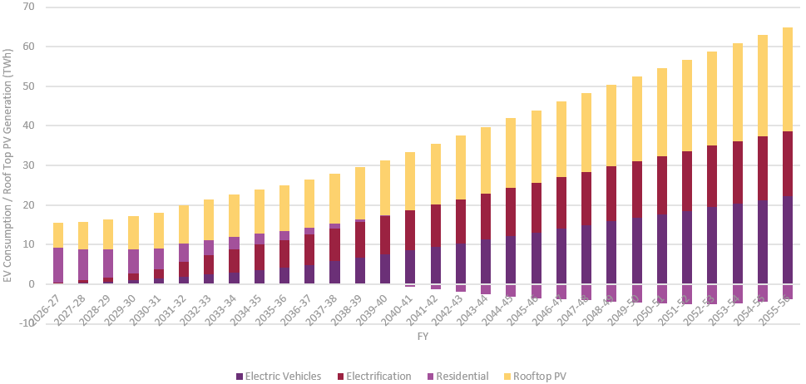
Source: AEMO Forecasting Data Portal, at https://www.aemo.com.au/energy-systems/electricity/national-electricity-market-nem/nem-forecasting-and-planning/forecasting-and-planning-data/electricity-forecasting-data-portal.

Factors influencing changes between 2024 and 2025 consumption forecasts
As the 2025 ESOO reported, under the Step Change scenario, operational consumption is forecast to increase from 178 TWh in 2024-25 to around 229 TWh by 2034 in Victoria. This is attributed to the potential rapid expansion of data centre projects and accelerated business electrification, which is expected to pick up momentum through the 2030s and exceed levels in the 2024 ESOO.
This upward trend is predicted to be partially offset by the continued adoption of distributed PV systems, which reduce grid demand. This is anticipated from 2045-46 to 2054-55, where the forecast pace of growth in consumption begins to moderate, with slowing growth in data centres and sustained uptake of rooftop PV and PV non-scheduled generation (PVNSG), while EVs and hydrogen production remain key contributors to the overall growth during this period.
Using the 2024 and 2025 ESOO consumption forecasts, Figure 11 illustrates the key factors driving the changes in Victorian consumption projections for 2029-30:
- Increases in LILs (including data centres in the chart) are primarily due to the growth of data centres in Victoria. AEMO’s 2025 Inputs, Assumptions and Scenarios Report (IASR) forecast that under the Step Change scenario, data centre energy consumption will increase by an average of 25% year-on-year, reaching around 12 TWh by 2029-20, an equivalent of 6% of the NEM’s grid-supplied electricity.
- A weaker economic forecast has reduced projected growth in the BMM sector.
- The Federal Government’s revised NVES provides flexible emission reductions for non-EVs and reduced zero emission targets beyond 2029. This amendment has led to increased EV uptake projections,.
- Updated PV forecasts reflect a trend towards larger rooftop systems for businesses and more efficient PV panels for residences. Schemes such as the $2.3 billion federal Cheaper Home Batteries Program are likely to increase household uptake of PV and batteries. While PV systems significantly offset both residential and business consumption, the impact on peak demand is only marginally reduced.
- Comparison for 2029-30 between the 2024 and 2025 ESOO Victorian consumption forecasts, Central – Step Change scenario
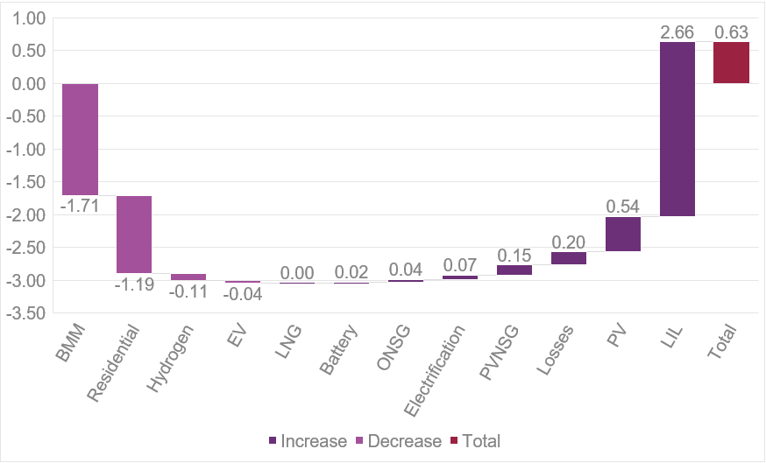

Figure 12 illustrates the factors influencing the revised ESOO consumption forecasts under the ESOO Central scenario for 2034-35 for Victoria, which are significantly lower than the 2024 ESOO forecasts, primarily due to:
- BMM growth plateauing due to slow economic growth,
- the continued adoption of larger PV systems, which is projected to partly offset consumption growth in the 2030s,
- accelerated growth of data centres, and
- electrification of homes and businesses also showing a slow but gradual increase from year 10 onwards.
EV adoption is still set to increase electricity consumption, despite a lower forecast due to slower car sales and the Federal Government’s NVES.
- Comparison for 2034-35 between the 2024 and 2025 ESOO Victorian consumption forecasts, Central – Step Change scenario
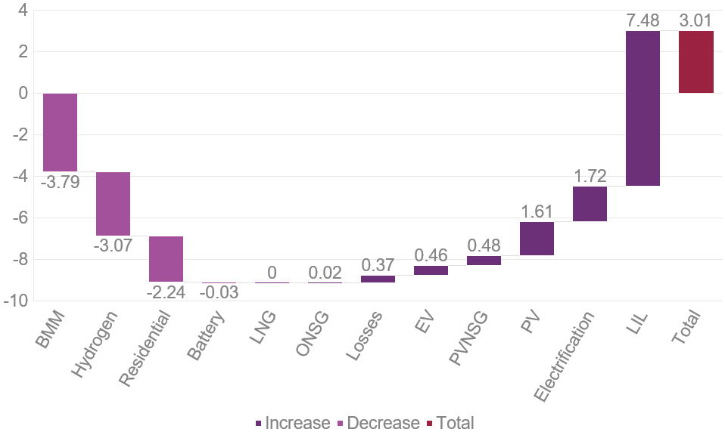

Operational demand forecasts
Maximum and minimum operational demand means the highest and lowest level of electricity sent out from the transmission system, measured, and averaged in half-hour intervals in either summer (November to March) or winter (June to August).
Maximum and minimum operational demand forecasts can be presented with:
- a 50% POE, meaning they are expected statistically to be met or exceeded one year in two, and are based on average weather conditions (also called one-in-two-year), or
- a 10% POE (for maximum demand) or 90% POE (for minimum demand), based on more extreme conditions that are expected to be exceeded on average one year in 10 (also called one-in-10-year).

Maximum demand forecast is steadily increasing, but at a lower rate than projected last year
The latest (2025 ESOO) 10% POE and 50% POE maximum demand forecasts for Victoria are shown in Figure 13 and
Figure 14 respectively, and compared to equivalent forecasts in the 2024 ESOO. The primary influences on maximum operational demand forecast trends are residential and business drivers. In comparison with the 2024 ESOO, the 2025 ESOO forecast a steeper growth trajectory, particularly in the medium- to long-term horizon. Stronger projected growth in electrification in the business sector contributed a key uplift in the maximum operational demand forecast for Victoria.
Key insights are:
- For the next decade, both 10% and 50% POE demand forecasts are summer peaking.
- For the first five years, maximum demand forecasts increase steadily in alignment with the 2024 ESOO forecast.
- During the second five years, demand growth accelerates, primarily driven by a substantial uplift in projected data centre demand compared to the 2024 ESOO forecast.
- Actual and 10% POE forecast maximum demand for Victoria in 2024 and 2025 ESOO Central (Step Change) scenario, operational sent out), 2021-22 to 2035-36 (MW)
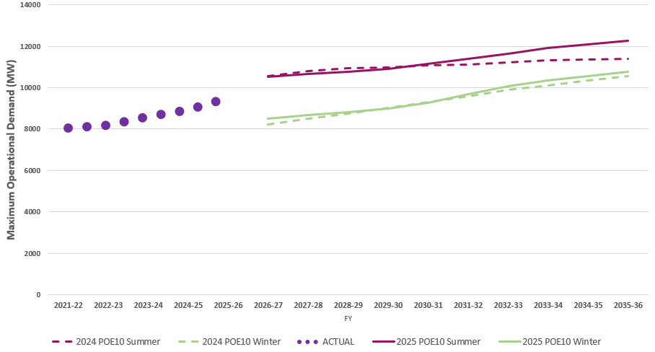
- Actual and 50% POE forecast maximum demand for Victoria in 2024 and 2025 ESOO Central (Step Change) scenario, operational sent out, 2021-22 to 2035-36 (MW)
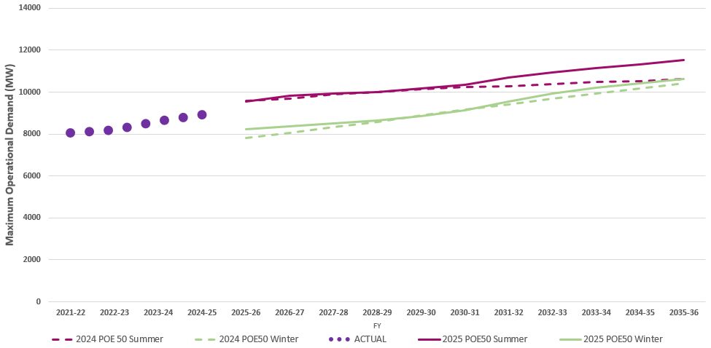

Minimum demand forecast is declining, and is projected to be lower than forecast last year
Minimum operational demand is strongly correlated to PV capacity, with minimums often occurring during daytime
hours. The 2025 ESOO demand forecasts have been revised to account for the upward trend in population, electrification, appliance uptake and economic activity which has resulted in increased minimum demand compared to the 2024 ESOO forecast.
Figure 15 shows the 90% POE minimum demand forecasts, which continue in a downward trend that is projected at a slower rate compared to 2024 due to stronger economic conditions and increases in data centre load.
Under the ESOO Central scenario at the 90% POE forecast, key insights for Victoria are:
- Minimum demand is anticipated to fall below zero by 2029-30.
- Between 2025-26 and 2035-36, minimum demand will drop an average of 292 MW at 90% POE, year-on-year.
- By 2035-36, minimum demand is anticipated to fall below -2.1 GW.
- Actual and 90% POE forecast minimum demand for Victoria in 2024 and 2025 ESOO Central (Step Change) scenario, operational sent out, 2020-21 to 2035-36 (MW)
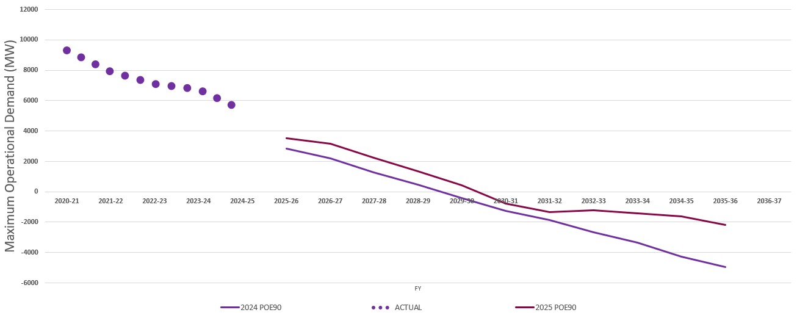

Transmission Development Plan for Victoria
This section outlines AVP’s updated 10-year Transmission Development Plan to support reliable, secure, and affordable electricity for Victoria, provides information about key network developments underway and planned for the Victorian DSN as part of the Transmission Development Plan, and discusses plan changes since the 2024 VAPR.
Key insights
- The Transmission Development Plan for Victoria is designed to deliver security and reliability objectives in the context of Victorian Government policy and regulatory settings. The investment projects presented in the plan have been identified as efficient investment solutions that consider the benefits from unlocking lower-cost generation supplies, maintain the reliability of the electricity supply to the Victorian consumers while ensuring power system resilience, and improve the efficiency of resource sharing between neighbouring regions. As such, timely delivery of these investments is critically important to meet Victoria’s energy reliability and security requirements.
- The majority of the network and non-network developments currently being progressed in Victoria through its Transmission Development Plan – such as RDP Stage 1 projects, WRL and VNI West – serve to reduce congestion and improve DSN system strength to harness renewable generation developments for consumers.
- Regulatory tests and feasibility studies recently completed or currently underway include the following:
  - To manage the voltages in metropolitan Melbourne during high and low demand conditions, AVP published the PACR of the Melbourne Metropolitan Voltage Management Regulatory Investment Test in December 2024.
  - To maintain required system strength services across the DSN under the revised system strength rules, AVP published the PACR in August 2025.
  - To reinforce the 220 kV ring in eastern and western metropolitan Melbourne DSN, AVP published the PSCR for the Eastern Victoria Reinforcement RIT-T in November 2024 and the Western Metropolitan Melbourne Reinforcement RIT-T in March 2025.
  - To increase the transfer capacity of the 220 kV Red Cliffs – Wemen – Kerang transmission line, AVP has commenced feasibility studies to investigate credible network and non-network options that will determine the need for, and may form input to, a future RIT-T.
- Together these projects target key thermal, stability, voltage control, system strength, and REZ expansion limits across the state and interconnector transfer limits with neighbouring states.
- The Transmission Development Plan is updated annually after undertaking the Annual Planning Review presented in Section 4.
AVP’s annual 10-year Transmission Development Plan consists of network augmentation projects identified as part of annual transmission planning process and additional augmentations and operational arrangements initiated by the government via NEVA orders and market investors as part of large generator/storage or load connections.
This plan is reviewed and updated each year as part of the VAPR. Over the 10-year outlook, these projects will facilitate the connection of new generation, increase network capacity to transfer power between new supply centres and demand, and manage emerging operational challenges. Combined, these projects help efficiently deliver network performance as outlined in the NER, maintain supply reliability, and put downward pressure on costs to consumers in the context of Victorian Government policy and regulatory settings.
As the jurisdictional planner for the DSN in Victoria, AVP is committed to reviewing and improving the development plan for the DSN to deliver reliable, secure and affordable energy to consumers while enabling the energy transition.
To address emerging operational challenges and deliver a system capable of facilitating the supply and demand changes highlighted in Section 2, AVP has been progressing a suite of transmission development projects.
Figure 16 and Figure 17 show the projects included in the updated Transmission Development Plan for Victoria. Figure 18 illustrates the in-progress projects in the Transmission Development Plan in a timeline.
These projects are either:
- completed projects – projects that have completed the delivery stage since the publication of 2024 VAPR,
- projects in delivery stage – projects that have completed regulatory tests or other planning approvals and have progressed to detailed scoping and design stage, or
- other planned projects – all committed and anticipated projects according to the ISP commitment criteria in the ISP Methodology, as well as transmission projects initiated by VicGrid as part of the VTP.
AVP’s Transmission Development Plan for Victoria assesses limitations identified in the Annual Planning Review and is designed to meet security and reliability objectives in an efficient way over the coming decade. This means it is not necessarily designed to remove all network limitations, particularly where generation investments occur in weaker parts of the grid, resulting in generation curtailment, or where the costs of augmentation outweigh the benefits to consumers.
In parallel to AVP’s Transmission Development Plan for Victoria, VicGrid develops the VTP, which is a long-term strategic plan for REZs and transmission infrastructure required to enable an orderly energy transition.
AVP proactively identifies and monitors future limitations through its planning and connection functions as well as interfaces with AEMO and DTSO operational teams, which could trigger further investigations under specific system changes or generator investment patterns.
The VAPR uses detailed analysis to capture the nature, timing, impact, and triggers associated with potential limitations, which identify the need for network investment and inform the subsequent ISP. The focus of this work is on identifying projects that are likely to deliver net positive economic benefits under the current regulatory framework, or where corrective action is required to keep the DSN reliable and secure.
Section 3.1 of the VAPR provides more detail about projects, including high-level scope and progress since the 2024 VAPR.
- Newly completed/approaching completion Transmission Development Plan projects for Victoria
- In progress Transmission Development Plan projects for Victoria
- Timeline of Transmission Development Plan projects for Victoria
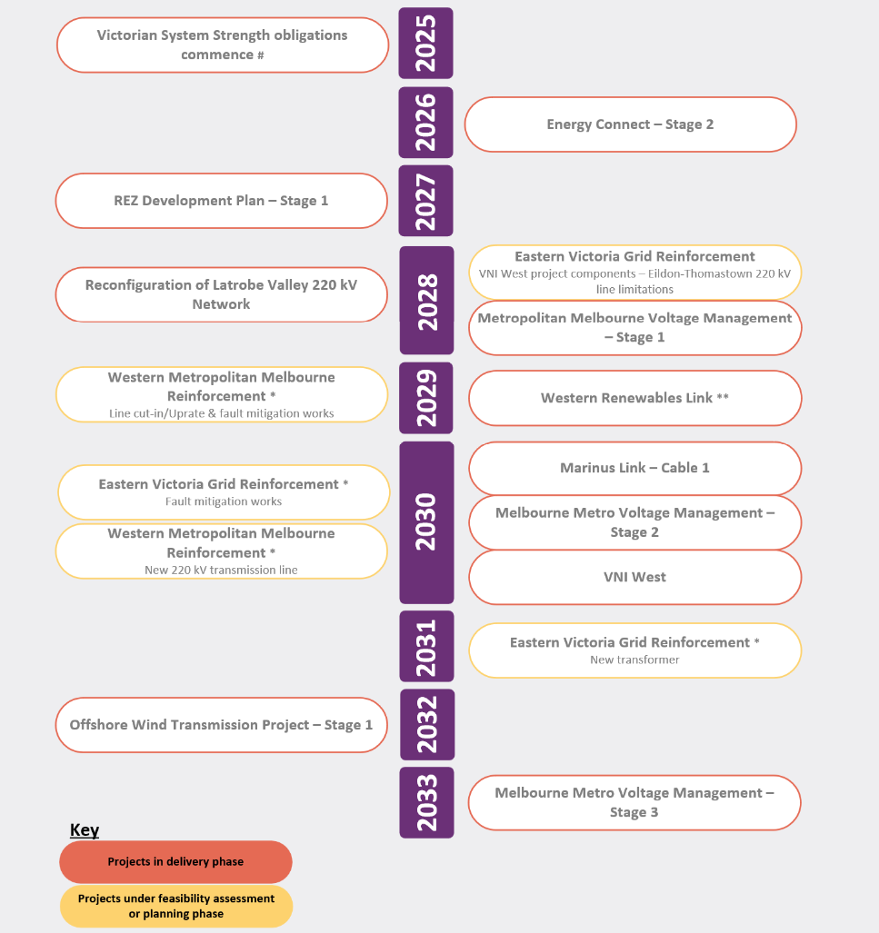
Note: Projects that appear in both the Transmission Development Plan and VicGrid’s VTP may have different timelines due to different inputs and assumptions. As these projects become committed, the timelines will align in future publications.
# Provision of system strength services occurs progressively in the planning horizon. Refer to VAPR Section 3.1.2 for specific details of the preferred option portfolio.
* Western Metropolitan Melbourne Reinforcement and Eastern Victoria Grid Reinforcement options and timings are based on published PSCRs and are subject to change as each RIT-T progresses that will confirm preferred options and timing.
** WRL was originally anticipated to be completed in mid-2027 as shown in previous VAPR publications, however the anticipated completion date has now shifted to having first energisation in late 2029.

Major projects in the Transmission Development Plan

Completed projects since 2024 VAPR
The following projects have completed construction works and been delivered since the 2024 VAPR.

New terminal stations in the DSN
- New 220 kV GPTS, owned and operated by AusNet Services, includes both new CRTS to GPTS 220 kV transmission lines that were energised in August 2024, which facilitated the Golden Plain Wind Farm transmission connections. GPTS is currently a radial transmission arrangement with a number of connections for the Golden Plain energy precinct to tie back to CRTS.
- New 220 kV KOTS, owned and operated by AusNet Services, was completed between KGTS and WETS. Establishment of this shared terminal station was initiated to facilitate a transmission connection for the KESS. The terminal station was energised in November 2024. The existing Kerang – Wemen – Red Cliffs 220 kV line is now known as Kerang – Koorangie 220 kV line and Koorangie – Wemen – Red Cliffs 220 kV lines.
- New 500 kV Plumpton Terminal Station (PRTS) and 500 kV cable, owned and operated by TransGrid through Lumea, is currently being energised (July 2025) as part of the Melbourne Renewable Energy Hub project. The new 500 kV cable has been installed to connect this terminal station to the existing Sydenham Terminal Station (SYTS).

REZ Development Plan (RDP) Stage 1 projects
Six of the RDP Stage 1 projects were completed since the 2024 VAPR, as detailed below. Six projects remain in delivery as detailed in Section 3.1.2.
- The Mortlake turn-in project was completed in July 2025, connecting the existing Haunted Gully to Tarrone 500 kV circuit, of the Moorabool to Heywood 500 kV double-circuit line, into Mortlake Power Station to establish a Haunted Gully to Mortlake 500 kV circuit and a Mortlake to Tarrone 500 kV circuit. This project improves voltage stability in the South West REZ to increase the potential for connection of up to 1,500 MW of additional renewable generation on optimal conditions and 1,100 MW on a peak summer demand periods. As part of this project, updates were also made to existing control schemes across the South West Victoria corridor to support the new network configuration. Further details on these control scheme updates are provided in the Control Schemes section below.
- The KESS was completed in June 2025, establishing a new:
  - Koorangie 220 kV Terminal Station connecting into the existing, Kerang – Wemen 220 kV line as mentioned in the previous section, and
  - a 185 MW/370 MWh BESS with GFM inverters.
A portion of the KESS, with the support of its GFM technology, will provide system strength services for 20 years as part of the service agreement with AEMO in Murray River REZ to increase the potential for connection of up to 300 MW of renewable generation.
- Three projects were delivered in the South West REZ with the aim to relieve thermal constraints:
  - the Ballarat Terminal Station (BATS) – Terang Terminal Station – Moorabool Terminal Station thermal loading control scheme, as detailed in the control schemes section below,
  - Sydenham to Keilor line uprating (station upgrade), and
  - Moorabool 220 kV transformer (MLTS) station upgrade.
- The Central North REZ augmentation project – Dederang Terminal Station 330/220 kV transformer (secondary cooling system), as detailed in the control schemes section below.

Control schemes
- Mortlake Turn-In project – delivered as part of RDP1, AVP upgraded existing control schemes in South Western Victoria due to the changed topological conditions in the South West 500 kV corridor. These updates included enhancements to wind farm Generator Fast Trips (GFTs) in the South West corridor, Emergency Alcoa Potline Trip (EAPT), Anti Resonance Protection Scheme (ARPS) and a number of Overvoltage Protection Schemes (OVPS).
- Keilor Overvoltage Protection Scheme (KOVPS) – with a continuous drop in both historical minimum demand and Victorian regional minimum demand forecast, high voltages in areas around Keilor have become a system security concern, as the voltage at Keilor Terminal Station (KTS) 500 kV could exceed the short-term rating of the 500/220 kV transformers post contingency. The updated control scheme will increase the short-term high voltage rating at KTS 500 kV bus from 525 kV to 535 kV to address this potential violation, and was commissioned in January 2025.
- Interconnector Emergency Control Scheme (IECS) – a review found insufficient load available for the scheme’s load shedding sequences as a result of reduced net loads, primarily due to increased distributed PV. The updated scheme includes additional loads and was commissioned in December 2024.
- Murraylink Very Fast Runback (VFRB) Scheme – the existing Murraylink VFRB scheme was modified to include monitoring of the newly commissioned Red Cliffs – Wemen – Koorangie and Koorangie – Kerang 220 kV lines, supporting the Koorangie Energy Storage Project. The updated scheme was commissioned in November 2024.
- AVP developed a new thermal loading control scheme for the Ballarat Terminal Station – Terang Terminal Station – Moorabool Terminal Station corridor as part of South West REZ augmentation and RDP1 project. The scheme was designed to manage thermal overloading on the Moorabool – Terang 220 kV line following a contingency on the Ballarat – Berrybank 220 kV line. The scheme was commissioned in November 2024.
- AVP completed the Dederang Terminal Station 330/220 kV transformer (secondary cooling system) project as part of the Central North REZ augmentation and RDP1 project. This initiative automated the cooling control system for the H3 330/220 kV transformer at Dederang Terminal Station, enabling an increased short-term rating. To support the upgraded rating, settings within the Dederang Bus Split Scheme (DBUSS) Transformer control scheme were updated in August 2025.

Transmission augmentation projects already underway

Projects in delivery stage ​
The following sections describe transmission augmentation projects already in delivery stage to alleviate the previously identified network constraints in the DSN.

REZ Development Plan (RDP) Stage 1 projects
The Victorian Government’s RDP Directions Paper published in February 2021 identified potential network augmentations that would relieve existing constraints on the Victorian DSN and facilitate the connection of future generators.
In late 2021, the Victorian Government directed AVP to progress procurement activities for three contestable projects for services to strengthen the system, as well as three sets (totalling nine projects) of non-contestable minor network augmentations
In 2022, the Victorian Government also directed AVP via REZ Stage 1 NEVA Orders to progress procurement activities and enter into contracts with the declared transmission system operator. This directive was for the network augmentations identified during the procurement process for turn-in of the Haunted Gully to Tarrone 500 kV line at Mortlake.
Table 6 summarises major projects currently being delivered under the RDP Stage 1 to provide system strength to the existing DSN to enable additional renewable generation connections.
- RDP Stage 1 system strengthening projects underway
Project | REZ | Purpose | Description and scope
Ararat synchronous condenser   | V3 – Western Victoria | Improving the system strength in Western REZ and providing dynamic voltage and reactive power control capability.  Ararat synchronous condenser is expected to allow the stable connection of up to 600 MW of additional renewable generation. | - Installation of a 250 megavolt amperes (MVA) (+250/-172 megavolt amperes reactive [MVAr]) synchronous condenser and the associated primary and secondary equipment at existing Ararat Terminal Station.  - Planned completion date of the project is early 2026 with a 20-year service agreement^{A}.
A. See https://aemo.com.au/en/newsroom/media-release/aemo-awards-contract-to-improve-system-security-in-western-victoria-rez
Table 7 below provides a summary of the minor augmentations to be carried out in West Murray, South West and Central North REZs in Victoria as part of RDP Stage 1. The purpose of these minor augmentations is to alleviate the existing thermal constraints to allow additional low-cost renewable generation in regional Victoria to connect to the NEM.
- Summary of RDP Stage 1 minor augmentation projects still in progress – all projects aimed at relieving thermal constraints
Project | ISP REZ | Description and scope of work | Status
Heywood to Moorabool 500 kV line uprating (substation/ auxiliary upgrade and dynamic line rating) | V3 – Western Victoria | - Upgrade interplant limitations (such as switch to circuit breaker conductor sections) within the Moorabool and/or Heywood terminal station/s to increase the Heywood to Moorabool 500 kV line rating. | Works complete.  Expect full implementation and practical completion November 2025.
Red Cliffs – Kiamal – Murra Warra – Horsham– Bulgana thermal loading control scheme | V2 – Murray River  V3 – Western Victoria | - Install a generator runback/tripping scheme to quickly reduce the output of local generators to avoid overload of the Red Cliffs – Kiamal– Murra Warra – Horsham– Bulgana 220 kV lines.  - This scheme is planned to operate to prevent overload following trip of either Bendigo – Kerang 220 kV line or Red Cliffs – Wemen– Kerang 220 kV line. | Undergoing project benefits review.
Red Cliffs – Kiamal – Murra Warra – Horsham – Bulgana thermal overloading control scheme with Murraylink VFRB for Murraylink import conditions | V2 – Murray River | - Implementation of a new control scheme to manage thermal overloading on the 220 kV network between Red Cliffs, Kiamal, Murra Warra, Horsham, and Bulgana.  - This will enable Murraylink to run back during import conditions into Victoria and was commissioned in August 2025. | Works complete.  Expect full implementation and practical completion November 2025.
Ararat, Waubra, Ballarat, Bulgana and Kiamal terminal station interplant upgrades | V2 – Murray River  V3 – Western Victoria | - Upgrade interplant limitations at Ararat, Waubra, Ballarat, Bulgana, Crowlands, Horsham and Kiamal to allow full utilisation of the 220 kV line ratings. | Works in progress.  Expect practical completion December 2025.
Dederang – Glenrowan– Shepparton – Bendigo circuit thermal loading control scheme | V1 and V6 | - Development of an automatic generator runback scheme designed to manage thermal loading on Ballarat – Bendigo and future Axedale – Fosterville – Bendigo 220 kV network. This scheme aims to dynamically reduce generator output in response to line loading conditions, helping maintain network reliability and prevent thermal overloads. | In progress.  Delayed by construction of Axedale Terminal Station. Planned completion early 2027.

Western Renewables Link (WRL)
In July 2019, AVP completed the Western Victoria Transmission Network Project RIT-T to unlock renewable energy resources, reduce network congestion, and improve utilisation of existing assets in western Victoria. AusNet Services was then awarded a contract to develop the project and seek planning approvals in order to build, own, operate and maintain the contestable parts (primarily 500 kV lines new 500/220kV terminal station near Bulgana) of the preferred transmission augmentations identified for WRL by the RIT-T.
In May 2023, following investigations in relation to the VNI West transmission project and the provision of the draft VNI West PACR, the Victorian Minister for Energy and Resources Issued order S 267, 27 May 2023 (May NEVA Order) in relation to WRL and VNI West. The effect of the May NEVA Order is to allow the WRL Project to proceed based on a modified scope including the construction of a new 500 kV double-circuit transmission line from Sydenham to Bulgana (referred to as the uprate). The order explains why such a course is justified and directs AVP to proceed with an uprated scope for the project. Subject to project assessment and approvals, WRL is planned for ‘first energisation’ in late 2029.
- Project overview map of WRL
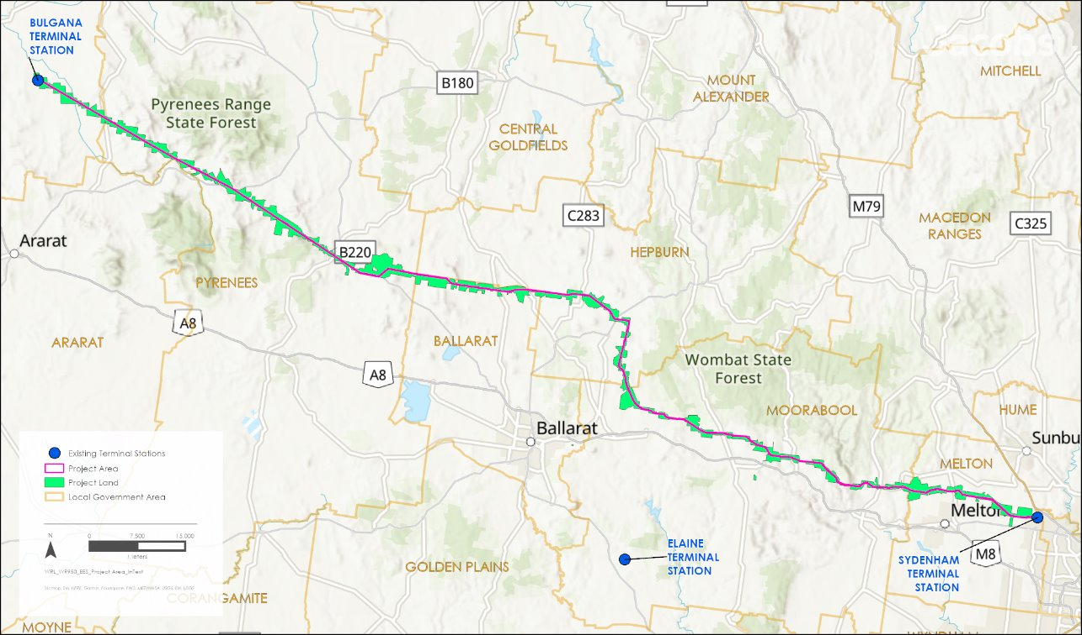

The updated scope of WRL consists of:
- extension of the 500 kV SYTS by two breaker-and-a-half switched bays, including an additional 500 kV switched bus connected reactor sized approximately 100 megavolt amperes reactive (MVAr), and two 70 MVAr line reactors,
- establishment of a new 500/220 kV Joel Joel Terminal Station (JJTS), formally referred to as ‘near Bulgana’ or ‘BXTS’ located near the existing 220 kV Bulgana Terminal Station (BGTS), including a 500 kV switchyard comprising of four double switched bays (with provision for extension), two 1,000 megavolt amperes (MVA) 500/220 kV transformers, two 70 MVAr line reactors, and provision for the future development of a 220 kV switchyard,
- construction of a new 500 kV double-circuit transmission line from SYTS to JJTS with approximate length of 190 km,
- redevelopment of the existing 220 kV BGTS, including the expansion of the existing single busbar 220 kV switchyard to a two busbar breaker-and-a-half (and double switched) switching arrangement, changed bay terminations for the existing BGTS- Horsham Terminal Station (HOTS), BGTS-CWTS (Crowlands) 220 kV transmission lines and the Bulgana Wind Farm transformer connections,
- construction of a new 220 kV double-circuit transmission line from BGTS to JJTS, with approximate length of 2.5 km,
- the addition of two physically independent route communication links between BGTS and JJTS, and between JJTS and SYTS,
- interface activities at various existing terminal stations including, but not limited to:
  - protection and control system updates, new panel installation, direct current (DC) systems, Substation Control and Information System (SCIMS), and
  - minor augmentations at existing terminal stations (unless mentioned above) impacted by the above works, and
- works at new and existing terminal stations to implement special control schemes for the WRL project.
The VNI West transmission line(s) will connect into the new JJTS near Bulgana. Network augmentation for the WRL project can function independently and is not dependent on the completion of VNI West.
AusNet Services has been engaging with landholders along the transmission route to conduct early works such as geotechnical investigation and field surveys. The location and configuration of the new JJTS at Joel Joel has been confirmed for this project.
The Environmental Effect Statement (EES) for the project was out for public exhibition from 30 June 2025 to 22 August 2025. The EES panel inquiry, which includes a public hearing, will take place throughout 2025.
The latest project information is available on AusNet Services’ dedicated project website.

Victoria – New South Wales Interconnector West (VNI West)
VNI West is a proposed new high capacity 500 kV double-circuit overhead transmission line, which will deliver vital new transmission infrastructure to:
- harness forecast of 3.4 GW of clean electricity from REZs in New South Wales and Victoria, in particular the wind and solar-rich regions of the North West REZ and the Grampians Wimmera REZ,
- add forecast 1.93 GW of electricity export capacity from Victoria to New South Wales, and 1.67 GW of electricity import capacity from New South Wales to Victoria, and
- maintain security and reliability in the electricity network as coal-fired power stations retire.
In May 2023, AVP and Transgrid released the PACR which identified the preferred network option for VNI West, charting a broad corridor that connects it to WRL at a new terminal station at or near Bulgana, and crosses the Murray River north of Kerang to connect it to EnergyConnect in New South Wales at the new Dinawan substation. The preferred network option in the PACR is known as Option 5A.
TCV has been established to undertake early works in Victoria, including community, landholders and Traditional Owner consultations, and ongoing investigations into the corridor and ultimate route. A major component of this was the refinement of the PACR Area of Interest into the Draft Corridor, as documented in the Draft Corridor Report, published 6 October 2023, which proposed a narrowed draft corridor for Victoria that is roughly 2 km wide on average. The draft corridor was then further refined through desktop and field environmental assessments, and discussion with landholders and communities, to arrive at a preferred easement, which was published in October 2024. Then, as a result of landholder feedback and Technical Reference Group input, the preferred easement was shaped into a project easement, which is now undergoing planning and environmental assessments. Subject to project assessment and approvals, VNI West is planned for ‘first energisation’ in late 2030 and planned to be fully operational (with inter-network testing complete, subject to market conditions) in late 2031.
The scope of VNI West in Victoria and New South Wales consists of:
- establishing new Tragowel Terminal Station with two 500/220 kV 1,000 MVA transformers,
- 220 kV connections from the new Tragowel Terminal Station to the existing 220 kV lines near Kerang,
- a new 192 km 500 kV double-circuit overhead line from near Bulgana to Tragowel, including 50% series compensation on the line at Tragowel and 90 MVAr line shunt reactors at each end of each line,
- a new 500 kV double-circuit overhead line from Tragowel to locality of Dinawan, including 120 MVAr line shunt reactors at each end of each line,
- establishing Dinawan 500 kV switchyard with two 500/330 kV 1,500 MVA transformers,
- upgrading Dinawan – Gugaa double-circuit line from 330 kV to 500 kV operation (lines build at 500 kV as part of EnergyConnect) including the installation of 80 MVAr line shunt reactors at each end of each line68,
- terminating Lower Tumut – Wagga 330 kV single-circuit overhead line (line TL51) at Gugga 330 kV68,
- building 330 kV double-circuit overhead line between Gugga and Wagga, using the Line TL51 easement68,
- cutting in the Eildon to Thomastown 220 kV circuits at South Morang, in place of previously proposed modular power flow controllers, to prevent overloading on the 220 kV line between Eildon and Thomastown,
- up to +/- 400 MVAr dynamic reactive compensation at the new 220 kV Tragowel Terminal Station, and
- installing two 120 MVAr reactors at Wagga 330 kV substation for voltage support.
- Project overview map of VNI West
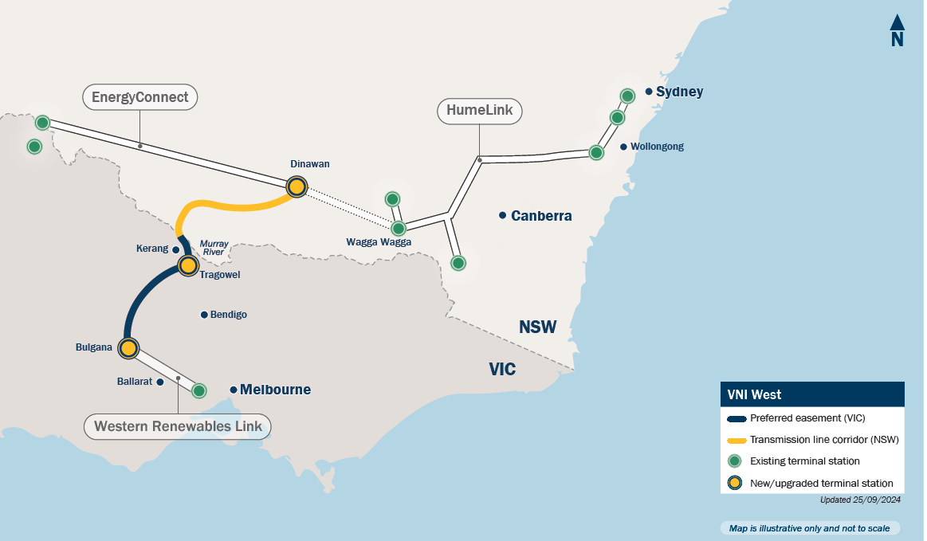

Metropolitan Melbourne Voltage Management
Investment is required to maintain Victorian DSN voltages in the metropolitan Melbourne region within operational and design limits in a more efficient and cost-effective manner. This investment need is driven by forecast changes in the DSN and the east coast’s broader power system, which are resulting in a need for voltage management support in Metropolitan Melbourne area of Victoria such that voltages can be maintained above lower limits during high demand periods and below upper limits during low demand periods.
In December 2024, AVP published the Metropolitan Melbourne Voltage Management RIT-T PACR, which is the final report of this RIT-T. The PACR presents the preferred option, which is to progressively install, and contract services from, reactive power assets, including:
- three 100 MVAr shunt reactors on the 220 kV level, two at Altona Terminal Station (ATS) and one at Brooklyn Terminal Station (BLTS), to be in service by 2029,
- one 100 MVAr shunt capacitor on the 220 kV level at Deer Park Terminal Station, to be in service by 2031, and
- two 100 MVAr shunt capacitors on the 220 kV level, one each at Malvern and Tyabb terminal stations, to be in service by 2034.
The proposed investments have a total estimated capital cost of $47.5 million (in present value terms) and are forecast to deliver a net present value (NPV) economic benefit of approximately $255.1 million.

Victorian System Strength Provision
In October 2021, the Australian Energy Market Commission (AEMC) made its final rule determination on Efficient Management of System Strength on the Power System, which introduced new obligations for System Strength Service Providers (SSSPs). Under NER S5.1.14(b), AVP as the SSSP for Victoria is responsible for proactive provision of system strength services to maintain power system stability and to facilitate efficient IBR connections, as forecast by AEMO in its annual System Strength Report.
In August 2025, AVP published the Victorian System Strength Requirement RIT-T PACR, which is the final report of this RIT-T. The PACR confirmed the proposed preferred option portfolio identified in the PADR, which is to progressively install and contract services from existing and future synchronous machines and GFM BESS, as shown in Table 8.
- Victorian System Strength Requirement RIT-T – Option portfolio 3 – Summary of components
Financial year | Minimum fault levels | Efficient level
2025-26 | Existing generators, including conversion of some units to be capable of operating in synchronous condenser mode  1 x Existing synchronous condenser at the Red Cliffs system strength node (SSN) | Covered by minimum fault level requirements
2026-27 |  | Covered by minimum fault level requirements
2027-28 |  | 900 MW GFM BESS Moorabool SSN
2028-29 | Same as 2028 +  2 x synchronous condensers Hazelwood SSN | Same as 2028 +  350 MW grid-following (GFL) to GFM BESS Hazelwood SSN
2029-30 | Same as 2028 +  2 x synchronous condensers Hazelwood SSN
2030-31 | Same as 2030 +  1 x synchronous condenser Hazelwood SSN
2031-32 | Same as 2030 +  1 x synchronous condenser Hazelwood SSN | Same as 2031 +  500 MW GFL to GFM BESS Hazelwood SSN  350 MW GFL to GFM BESS Moorabool SSN  400 MW ISP forecast GFM BESS Hazelwood SSN
2032-33 | Same as 2030 +  1 x synchronous condenser Hazelwood SSN | Same as 2032 +  300 MW GFL to GFM BESS Moorabool SSN
2033-34 | Same as 2033 +  1 x synchronous condenser Hazelwood SSN | Same as 2032 +  300 MW GFL to GFM BESS Moorabool SSN
2034-35 |  | Same as 2034 +  65 MW GFM BESS Red Cliffs SSN +  1 x 500 kV synchronous condenser Giffard (Gippsland) Offshore Wind Hub
2035-36
Notes:
- As specified in Table 2, AVP, 2025 Victorian System Strength Requirement PACR, at https://aemo.com.au/initiatives/major-programs/victorian-system-strength-requirement-regulatory-investment-test-for-transmission
- Option portfolio 3 (as well as all other option portfolios) also assumes two synchronous condensers at Buronga in each of 2026 and 2027 as part of EnergyConnect Stage 1 and Stage 2, respectively. These four synchronous condensers have not been shown in the table above since, while the portfolio options rely on them as an interstate contribution, AVP is not proposing to contract them and they form part of the assumed interstate contribution (which has been factored into the options portfolio development process).
- ‘Same as 2028’ (and this language used with reference to other years in this table) refers to the same components as that year but, where the use of existing synchronous generation is included in this, it does not imply the same operation of these units between years.
The proposed investments have a total estimated capital cost of $689.5 million (in 2024 dollars) and are forecast to deliver a NPV economic benefit of approximately $3.85 billion.
AVP has commenced procurement activities for service agreements in line with the PACR preferred option.
AVP has summarised system security requirements at Section 4.3.2.

Committed new terminal stations
New shared terminal stations are planned, designed and constructed with provisions for future connections for interested parties. The following new shared terminal stations are currently in construction or committed as part of new transmission connection to the DSN:
- Carwarp Terminal Station (CPTS), owned and operated by AusNet Services, is planned to be energised by November 2025. The terminal station is being established to facilitate the Carwarp Energy Park project and will be cut into the existing Kiamal – Red Cliffs 220 kV line.
- Pine Lodge Terminal Station (PLTS), owned and operated by AusNet Services, is planned to be energised by January 2026. This shared station is being established for the committed Pine Lodge BESS projects and will cut into the existing Glenrowan – Shepparton 220 kV line.
- Goorambat East Terminal Station (GETS), owned and operated by AusNet Services, is planned to be energised by May 2026. This shared station is established to facilitate the Goorambat East Solar Farm project and will be cut into the existing Dederang – Shepparton 220 kV line.
- Gnarwarre Terminal Station (GWTS), owned and operated by Australian Energy Operations (formerly known as Transmission Operations Australia), is planned to be energised by November 2026. This shared station is being established to facilitate the Gnarwarre BESS project and will be cut into the existing Moorabool – Terang 220 kV line.
- Axedale Terminal Station (ADTS), owned and operated by AusNet Services, is planned to be energised by December 2026. This shared station is being established for the committed Axedale Solar Farm and Fosterville Solar Farm projects and will cut into the existing Bendigo – Fosterville – Shepparton 220 kV line.

Other planned projects

Reconfiguration of Latrobe Valley 220 kV network
The Latrobe Valley reconfiguration project was identified in the 2023 VAPR to enhance the utilisation of 220 kV network between Latrobe Valley and Melbourne and reduce reliability risks after retirement of YWPS. It involves rearrangement of existing infrastructure to minimise risks of overloading transformers and lines at times of high demand post the retirement of YWPS.
At times of high demand while YWPS is in service (Figure 21), the 220 kV and 500 kV networks share the supply to Rowville from the Latrobe Valley, which minimises risks on the 500/220 kV transformers and on the 220 kV lines connected to Rowville. When YWPS retires, the 220 kV lines from the Latrobe Valley to Rowville become unused, and at times of maximum demand the 500/220 kV A1 transformer at Rowville is forecast to be overloaded under system normal operation if no actions are taken.
- Latrobe Valley high demand radial mode
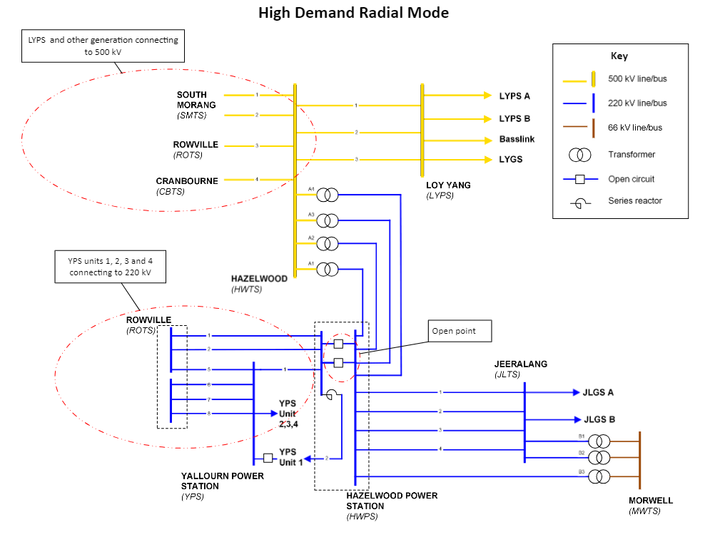

In the 2023 VAPR, AVP assessed options to reduce the risk on the Rowville A1 transformer after YWPS retires and recommended changing to a modified parallel mode (Figure 22) as the best option.
- Latrobe Valley modified parallel mode
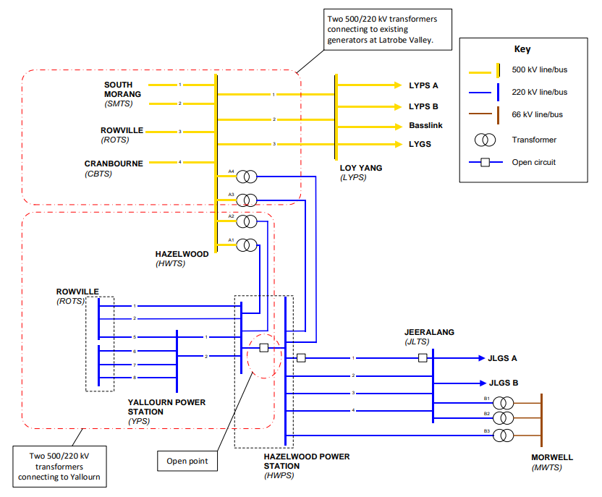

Since the 2023 VAPR, AVP has commenced works with the relevant asset owners to ensure the works will be completed to transition to modified parallel operating mode when YWPS retires. These works include:
- minor works on the Hazelwood – Yallourn #1 and #2 220 kV lines to increase short-term line ratings,
- bypassing the series reactor at Hazelwood 220 kV bus 6,
- switching operations at Hazelwood, Jeeralang and Yallourn to achieve the bus groups shown in Figure 22, and
- installing overload protection schemes on the Hazelwood – Yallourn 220 kV lines and on the Hazelwood 500/220 kV transformers to prevent overloads under contingencies (see Section 4.4.5 for more details).
Since the 2024 VAPR, AVP has completed a cost-benefit assessment justifying the proposed reconfiguration works, continued to work with the relevant asset owners on the scope, and has now developed a detailed scope of works for the project. Discussions with asset owners continue to indicate that this project cost will be below the $8 million RIT-T cost threshold, therefore a RIT-T is not required and will not be undertaken. It is anticipated that contracts for the works will be in place by the end of 2025 with delivery planned before the closure of YWPS.

Victorian Transmission Plan priority programs
The VicGrid 2025 VTP published in August 2025 is a plan for developing Victoria’s REZs and the transmission infrastructure required to enable that development. The 2025 VTP retained the two existing offshore REZs and announced six new REZs (Figure 23) with a plan to connect 21.8-35.2 GW of wind, solar and BESS resources by 2040.
- Renewable energy zones defined in the 2025 VTP
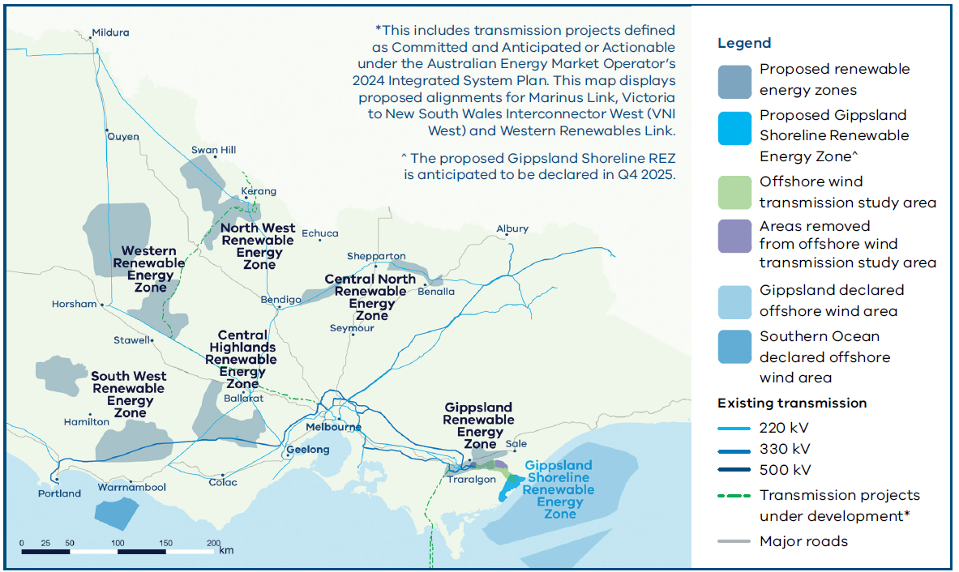
Source: https://www.vicgrid.com.au/__data/assets/pdf_file/0032/761396/2025-victorian-transmission-plan.pdf
To enable the connection of the additional energy resources, VicGrid has analysed multiple candidate development pathways (CDPs) and as identified in the preferred CDP referred to as the optimal development pathway (ODP) has announced seven new priority programs (Figure 24) required, over and above existing transmission projects that are already under development across Victoria to enable delivery energy resource connections. Some of these priority programs involve projects to address limitations currently being considered in RIT-Ts being progressed by AVP, and VicGrid and AVP will coordinate next steps on these proposed projects.
- Map of new priority programs in the 2025 VTP
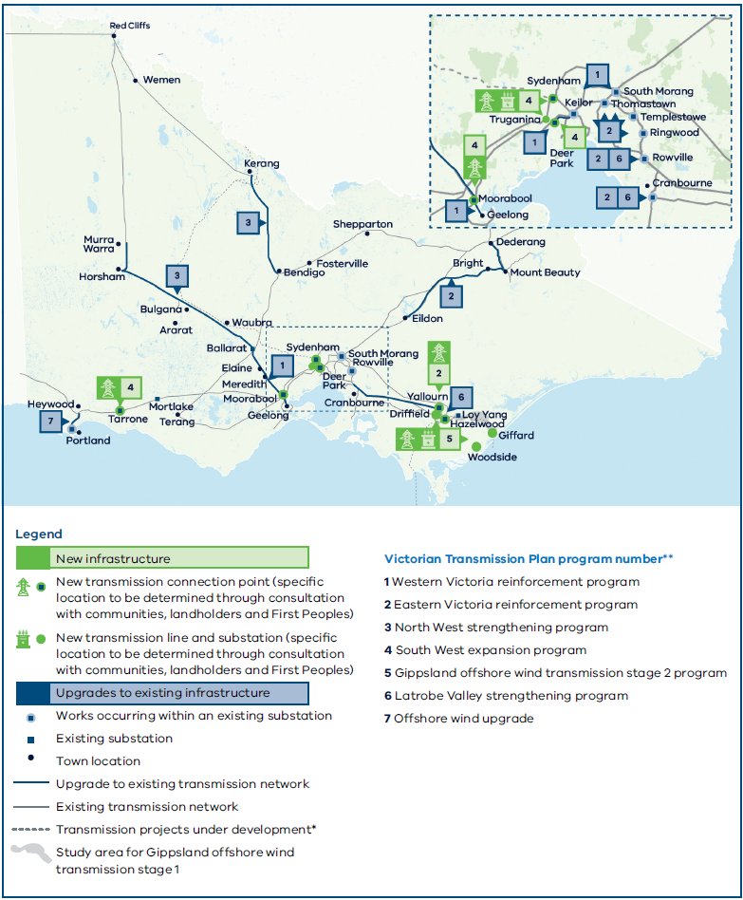
Source: https://www.vicgrid.com.au/__data/assets/pdf_file/0032/761396/2025-victorian-transmission-plan.pdf
AVP has assessed the impact of these programs on existing limitations in the DSN as part of the 2025 VAPR, and details of the results are in Section 4.2.

Offshore wind transmission project
The Victorian Government has set offshore wind energy generation capacity targets of:
- at least 2 GW by 2032,
- 4 GW by 2035, and
- 9 GW by 2040.
OWEV is seeking bids from developers to provide support packages for their offshore wind energy projects. OWEV is targeting the completion of this process for the first 2 GW tranche at Gippsland by late 2026.
VicGrid will continue to lead the coordinated approach for new shared transmission infrastructure to connect the proposed offshore wind generation in the Gippsland Offshore REZ and Southern Ocean Offshore REZs.
For the Gippsland Shoreline REZ, it is proposed to extend the transmission network to an offshore connection hub at Giffard, as shown in Figure 25. An Expression of Interest has been released to the industry for a development partner. Shoreline crossing areas have also been identified through the transmission study area. Community engagement and negotiations on the transmission route between Giffard and the existing Loy Yang Power Station are in progress.
The Southern Ocean REZ, which currently is not part of the initial 2 GW target, will be required to connect into the existing South-West transmission network. No shore crossings have been identified for this area and is likely to be addressed by the offshore wind developer or developers.
- Study area and indicative connection hub for offshore wind generator connections
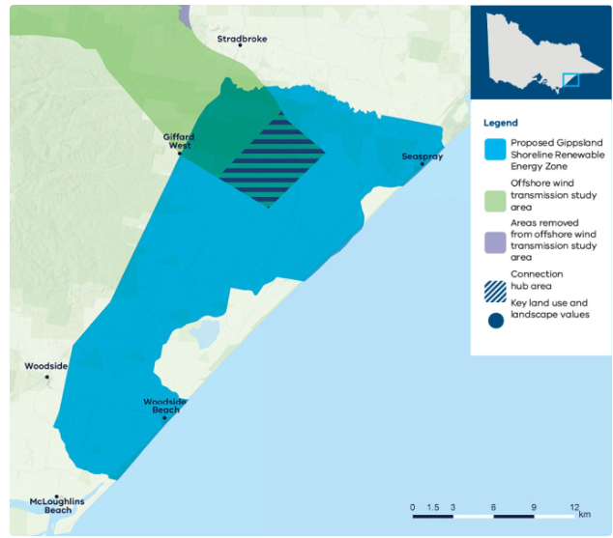
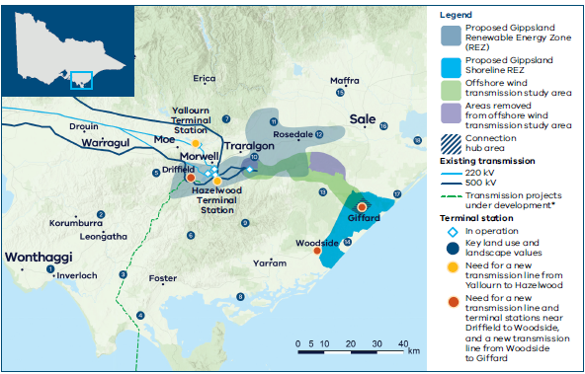
Sources: https://www.vicgrid.com.au/transmission-planning/renewable-energy-zones/gippsland-shoreline-renewable-energy-zone and
https://www.vicgrid.com.au/__data/assets/pdf_file/0028/761392/2025-victorian-transmission-plan-gippsland-summary.pdf

Projects in neighbouring regions

EnergyConnect
EnergyConnect is a committed interconnector between South Australia and New South Wales, with connection to Victoria at Red Cliffs, with a transfer limit of 800 MW. The project is aimed at reducing the cost of providing secure and reliable electricity across the NEM, while facilitating a longer-term transition to low emission energy sources in Northern South Australia and Southern New South Wales. The completion of EnergyConnect will provide increased transfer between Victoria and New South Wales via the upgraded Red Cliffs to Buronga 220 kV connection.
EnergyConnect will be commissioned in two stages:
- Stage 1 (complete) – a new 275 kV and 330 kV double-circuit interconnector has been built from Robertstown in mid-north South Australia to Buronga in south-west New South Wales, via a new 275/330 kV substation at Bundey in South Australia. A new 220 kV double-circuit line has been built between Buronga and Red Cliffs in Victoria, replacing the existing single-circuit line, and increasing the line thermal capacity to 800 MVA per circuit. Commissioning of EnergyConnect Stage 1 and inter-network testing was completed in April 2025. The transfer capacity of the new South Australia – New South Wales interconnector (SNI) following Stage 1 completion is 150 MW.
  - The Heywood interconnector (HIC) between Victoria and South Australia was upgraded in 2016 with an increased design transfer capacity of 650 MW in both directions, however due to stability limits identified following the South Australian black system event in 2016 the interconnector has been limited to 550 MW for South Australian export and 600 MW for South Australian import. Inter network testing is currently progressing, with the aim of assessing conditions for potential release of the full design capacity.
  - The Murraylink VFRB Scheme for Victoria to South Australian exporting conditions was also upgraded in EnergyConnect Stage 1 to accommodate for the double-circuit contingency of the new 220 kV double-circuit line between Buronga and Red Cliffs in Victoria. This upgrade was completed in August 2024.
- Stage 2 – a new 330 kV double-circuit transmission line (540 km) will be built between Buronga and Wagga Wagga in New South Wales, a new substation will be constructed at Dinawan in New South Wales, and the existing substation at Wagga Wagga will be upgraded. The section between Dinawan and Wagga Wagga will be constructed to 500 kV but operated initially at 330 kV in anticipation of the VNI West double-circuit line connecting at Dinawan at 500 kV. Stage 2 is planned to be completed in late 2026.
This project includes the South Australia Interconnector Trip Remedial Action Scheme (SAIT RAS). The SAIT RAS was designed to cater for the separation of South Australia from either HIC or 500 kV Victorian network under high power transfer conditions that could result in transient instability in South Australia. This scheme includes a Victorian component to detect any loss of both 500 kV lines between Heywood and Moorabool in Victoria, which result in an effective separation of South Australia from South West Victoria, either due to a credible contingency during a prior outage or non-credible event. ElectraNet has commissioned Stage 1 of the scheme, including its Victorian component delivered by AVP, and is progressing additional works for Stage 2 of the scheme with AusNet.
These additional works under Stage 2 include:
- SAIT RAS (Stage 2) – Ausnet is undertaking works at terminal stations along the Heywood to Moorabool corridor to provide protection signalling to the SAIT RAS scheme based on single contingency events. The project also includes installation of Phasor Measurement Units (PMUs) at Heywood Terminal Station.
- South East Switching Station to Heywood Optical Ground Wire (OPGW) – ElectraNet and AusNet are undertaking upgrades between Heywood and the South East Substation, a critical node within the HIC corridor linking Victoria and South Australia. The works include installing OPGW to enhance real-time data exchange and grid protection capabilities, supporting high-speed monitoring and improved power system stability management across the interconnector.
- As a separate project, AVP is proposing to add an additional new scheme, Heywood Interconnector Remedial Action Scheme (HIC RAS), to trip load and generation connected to the south-west Victorian corridor, to better manage transient stability post non-credible separation of South Australia from the 500 kV Victorian network. Refer to Section 1.4.2 for more details.

Marinus Link
Marinus Link is a proposed underground and undersea electricity transmission project, comprising two 750 MW HVDC links to further connect Tasmania and Victoria.
This project will provide the mainland power system with improved access to Tasmania’s dispatchable capacity (including deep storages) and high quality VRE opportunities, helping reduce the scale of investment needed on the mainland. The characteristics of customer demand, generation, and storage resources vary significantly between Tasmania and the rest of the NEM, and improved access between Tasmania and the mainland will allow the NEM to capitalise on this diversity.
This project will be delivered in two stages, initially as a 750 MW project (Stage 1), with a second 750 MW link to follow at a later date (Stage 2). In August 2025 Marinus Link reached the FID milestone and Stage 1 construction is anticipated to commence in 2026 with a planned completion in 2030.

Progression of AVP’s Transmission Development Plan since 2024 VAPR​
The following changes have been made to AVP’s Transmission Development Plan since the 2024 VAPR:
- Feasibility studies for the Red Cliffs – Wemen – Kerang 220 kV transmission line limitation and the voltage stability limitations in the area have commenced (see Section 3.1.2 for more information).
- A RIT-T for Eastern Victoria Grid Reinforcement has progressed with publication of the PSCR on 13 November 2024. The PSCR consultation period ended on 7 February 2025 and AVP is progressing next steps in the cost-benefit assessment process (see Section 3.1.5 for more information).
- A RIT-T for Western Metropolitan Melbourne Reinforcement has progressed with publication of the PSCR on 11 March 2025. The PSCR consultation period ended on 6 June 2025 and AVP is progressing next steps in the cost-benefit assessment process (see Section 3.1.5 for more information).
- A RIT-T for Metropolitan Melbourne Voltage Management concluded with publication of the PACR on 13 December 2024 (see Section 3.1.2 for details).
- A RIT-T for Victorian System Strength Requirement concluded with publication of the PACR on 1 August 2025 (see Section 3.1.2 for details).

Reducing constraints with projects already underway
The on-time delivery of these major augmentation projects is critically important to unlock the network opportunities and enable consumer benefits via renewable energy sources.
As discussed in the VNPIR, during 2024-25 there were 18 high impact constraints meeting the limits of over 20 binding hours and over $60,000 of binding market impact. Among the top 18 Victorian transmission constraints in 2024-25, 11 are from the Western Victoria and Murray River corridors. The number of top-listed constraints from these corridors is reasonably consistent with previous years (past 10 years). Furthermore, 13.4% and 3.4% of curtailment in VRE generation was observed in Murray River and Western Victoria corridors throughout 2024-25, which is a slight reduction compared to last year where 16.7% and 3.1% curtailment was observed.
Many of the constraints listed are expected to be relieved by the completion of major augmentation projects such as WRL and VNI West, with these two projects expected to reduce the impact of six of the nine constraints listed.
The tables below summarise existing Victorian transmission network constraints where there are projects underway that are expected to reduce the impact of those constraints. The constraints are ranked by their impact on generation dispatch during 2024-25. Where there are currently no planned projects to address network constraints, AVP will continue to monitor those constraints and raise suitable projects when options with positive net market benefits are identified. The full list of high impact constraints including those with no planned projects are in the VNPIR.
Table 9 contains the existing constraints in the Western and Murray River corridors, which are the areas where dispatch was constrained the most during 2024-25, and the impact of the planned projects on these constraints.
Table 10 contains the existing constraints in the South West corridors and the impact of planned and ongoing projects on these constraints.
Table 11 contains the remaining constrained areas of Eastern Victoria, the Victoria – New South Wales Interconnector (VNI) and the Latrobe Valley, and the impact of planned projects on them.

- Impact of planned projects on existing limitations – Western Victoria and Murray River corridors
Rank | Equation(s) | Description of constraint | Upcoming projects | Planned completion date
1 | North-west Victoria voltage oscillations (prior outage) | This represents a set of the network constraint equations associated with voltage oscillation during a range of prior outage conditions.  More outages have occurred in 2024-25 compared to 2023-24, particularly related to commissioning of EnergyConnect, and due to this, these constraints have bound more.  AEMO is continuously reviewing these constraints as revised models are obtained and based on upcoming outage schedule. | System strength improvement projects such as Ararat Synchronous Condenser (Syncon) being delivered as a part of the Victorian Government’s RDP are expected to reduce the impact of this constraint. | FY 2025-26
2 | Kerang voltage collapse  V^^V_NIL_KGTS  V^^V_NIL_KGTS_2 | To avoid voltage collapse at Kerang due to the loss of Horsham – Murra Warra – Kiamal 220 kV line considering Murraylink VFRB scheme disabled. | EnergyConnect, Ararat Syncon and the connection of KESS are expected to reduce the impact of these constraints. | FY 2027-28
3 | Waubra to Ballarat thermal  V>>NIL_WBBA_RCWEKG, V>>NIL_WBBA_KGBE, V>NIL_WBBA_KMRC,  V>>NIL_WBBA_RCBSS | To avoid overloading Waubra to Ballarat 220 kV line on trip of the Red Cliffs – Wemen – Kerang 220 kV line or Kiamal to Red Cliffs 220 kV line or Kerang to Bendigo 220 kV line or Red Cliffs to Buronga 220 kV line. | Minor augmentations as part of the Victorian Government’s RDP Stage 1 projects and the WRL project increase the thermal capability of the Ballarat – Waubra– Ararat – Crowlands – Bulgana – Horsham– Murra Warra – Kiamal 220 kV corridor to reduce the impact of this limitation. | FY 2030-31
5 | Wemen to Kerang voltage collapse  V^^V_MLNK_KGTS | To avoid voltage collapse at Kerang due to the loss of Horsham – Murra Warra – Kiamal 220 kV line during an outage of Murraylink. | EnergyConnect, Ararat Syncon and the connection of KESS are expected to reduce the impact of these constraints. | FY 2027-28
9 | Red Cliffs voltage stability  V^SML_HORC_3,  V^SML_KGRC_4,  V^^SML_ARWBBA_1,  V^SML_BUDP_3,  V^SML_BESH_2,  V^SML_HOMR_3, V^SML_BEKG_4 | These are the outage constraints to avoid voltage collapse at Red Cliffs. Outages are of Horsham to Red Cliffs through Murra Warra 220 kV, Kerang to Red Cliffs through Wemen 220 kV, Ararat to Waubra 220 kV lines.  V^SML_BUDP_3 is to avoid voltage collapse for loss of Bendigo to Kerang 220 kV line. This is also an outage constraint at the time of Buronga to Balranald (X3) or Balranald to Darlington Pt (X5) outage. | EnergyConnect, Ararat Syncon and the connection of KESS are expected to reduce the impact of these constraints. | FY 2027-28
10 | Red Cliffs voltage collapse  V^^SML_NIL_3  V^^SML_NSWRB_2 | To avoid voltage collapse at Red Cliffs for the loss of Bendigo to Kerang 220 kV, Darlington Point to Balranald (X5) or Balranald to Buronga (X3) 220 kV lines when the New South Wales Murraylink runback scheme is unavailable. | EnergyConnect, Ararat Syncon and the connection of KESS are expected to reduce the impact of these constraints. | FY 2027-28
14 | Red Cliff – Wemen – Kerang thermal  V>>NIL_WEKG_HOMRKM  V>>NIL_RCWE_HOMRKM | To avoid overloading the Red Cliff – Wemen – Kerang 220 kV line for the loss of Horsham – Bulgana – Crowlands 220 kV line or Horsham – Murra Warra – Kiamal 220 kV line. | AVP has commenced detailed feasibility studies of options to address this constraint. The VicGrid VTP has proposed a project to replace sections of the existing single-circuit transmission with a new high capacity double-circuit lines in north-west Victoria as part of CDP2 (not preferred) which would be expected to reduce the impact of these constraints. | FY 2035-36
16 | Kerang voltage collapse  V^^V_BDBU_KGTS  V^^V_BDBU_KGTS_2 | To avoid voltage collapse at Kerang due to the loss of Horsham – Murra Warra – Kiamal 220 kV line during an outage of the Bundey to Buronga line. | EnergyConnect and the connection of KESS are expected to reduce the impact of these constraints. | FY 2027-28
18 | Ballarat to Bendigo thermal  V>>NIL_BABE_HOMRKM, V>>NIL_BABE_KMRC, V>>NIL_BABE_RCWEKO | To avoid overloading Ballarat to Bendigo for loss of Horsham – Murra Warra – Kiamal 220 kV or Kiamal to Red Cliffs 220 kV lines. | WRL and VNI West are expected to reduce the impact of these constraints. | FY 2031-32
- Impact of planned projects on existing limitations – south-west corridor
Rank | Equation | Description | Upcoming projects | Planned completion date
8 | Elaine to Moorabool thermal  V>>NIL_ELML_BAML2 | To avoid overloading Elaine to Moorabool 220 kV line on trip of Ballarat to Moorabool No. 2 220 kV line. | The WRL project will reduce the impact of this constraint. | FY 2030-31
12 | Haunted Gully to Moorabool  And Mortlake to Moorabool Voltage collapse  V^^V_NIL_SWVIC | To manage flow towards Moorabool across Haunted Gully to Moorabool and Mortlake to Moorabool 500 kV lines due to the loss of Haunted Gully to Moorabool 500 kV line and both Alcoa Portland (APD) potlines. | Mortlake Power Station (MOPS) turn-in project, as a part of the Victorian Government’s RDP and the new terminal station at Cressy, will reduce the impact of this constraint. | Completed July 2025
13 | Moorabool to Geelong thermal  V>>XGTML2_KTTX2_1_R2 | This is a multiple outage thermal constraint. Outages are of Geelong to Moorabool No. 2 220 kV line and Keilor A2 500/220 kV transformer. This constraint is formulated to avoid overloading on the remaining Moorabool to Geelong 220 kV line on trip of Sydenham to Keilor 500 kV line. | The Western Metropolitan Melbourne Reinforcement project is expected to reduce the impact of this constraint. In the VicGrid VTP, there is a proposed project to increase the rating of these lines which is expected to reduce the impact of this constraint. | RIT-T in progress, refer to Section 3.1.5
- Impact of planned projects on existing limitations – Eastern Victoria, Victoria – New South Wales Interconnector and Latrobe Valley
Rank | Equation | Description | Upcoming projects | Planned completion date
4 | VNI export voltage collapse during outages  V^^N_xxx | Avoid voltage collapse around Murray for loss of all APD potlines during planned transmission equipment outages.  These constraints each behave similarly to their system normal counterpart V^^N_NIL_1.  These constraints are invoked during outages of any line in, or connecting to, the 330 kV corridor between Victorian and New South Wales capital city load centres. Outages of other significant lines including 500 kV Latrobe Valley lines in Victoria and 220 kV lines in south-west new South Wales also may require such constraints to be invoked. | Completion of VNI West is expected to reduce the impact of this constraint. | FY 2031-32
11 | VNI voltage collapse  V^^N_NIL_1 | To avoid voltage collapse in northern Victoria and southern New South Wales for loss of APD potlines following fault on one of the 500 kV lines in Southwest Victoria. | AVP is investigating the possible causes of APD tripping due to failure to ride through 500 kV faults and is exploring options to avoid tripping.  Completion of EnergyConnect Stage 2, WRL and VNI West is expected to reduce the impact of this constraint. | FY 2031-32
15 | VNI export transient stability during outages  V::N_xxx | Prevent transient instability for fault and trip of Hazelwood to South Morang line during planned transmission equipment outages. | AVP is investigating the possible causes of APD tripping due to failure to ride through 500 kV faults and is exploring options to avoid tripping.  Completion of EnergyConnect Stage 2, WRL and VNI West is expected to reduce the impact of this constraint. | FY 2031-32

Ongoing regulatory tests and feasibility studies for future developments

What is a regulatory investment test?

Purpose of a RIT-T
Strategic planning of the power system is crucial to making informed decisions in the long-term interests of Australian energy consumers. Under the NEL, AVP is responsible for planning and directing augmentation for the Victorian electricity transmission DSN.
The RIT-T process is a regulatory mechanism under the NER that applies an economic cost-benefit test on proposed investments for the shared transmission network of the NEM. It is designed to identify the most economically efficient investment to all those that produce, consume or transport electricity in the NEM, including for changes in Australia’s greenhouse gas emissions, whether or not the net benefit of changes in emissions is to those that produce, consume or transport electricity in the NEM.
As the RIT-T proponent, AVP follows one of two RIT-T processes outlined in the NER, depending on the nature of the investment. Where the investment is not an Actionable ISP Project the process of NER 5.16 applies, and for an ISP Actionable Project the RIT-T process of NER 5.16A applies.

Stages involved in a RIT-T
The RIT-T process generally has three stages and requires transmission network planners considering significant investment for the transmission network to publish a report at each stage:
- Project Specification Consultation Report (PSCR) – the first report seeks feedback and advice on the identified need for investment as well as credible options that look at both network and non-network solutions to address the identified need. The consultation period for the PSCR is a minimum of 12 weeks from the publication date of the PSCR. Where a proposed investment is an Actionable ISP project, the PSCR stage is not required, as consultation is managed through the ISP publication.
- Project Assessment Draft Report (PADR) – the second report of the process considers feedback on the PSCR and identifies and seeks feedback on the proposed preferred option and assessment methodology. The PADR must be published within 12 months of the end of the consultation period for the corresponding PSCR, unless an extension is requested and granted by the Australian Energy Regulator (AER). The consultation period must not be less than six weeks from the publication date of the PADR.
- Project Assessment Conclusions Report (PACR) – the final report of the RIT-T considers feedback on the PADR and presents the transmission planner’s recommended solution (preferred option) to deliver the highest net economic benefit and intended course of action. The PACR must be published as soon as practical after the end date of the consultation period for the corresponding PADR.
The end-to-end timing for undertaking a RIT-T can vary significantly depending on the complexity of potential credible options and the drivers of the identified need, but typically takes between 12 and 18 months from publication of the PSCR to completion of the PACR.
AVP is currently working on the RIT-Ts outlined in the sections below.
- Regulatory tests and feasibility studies in progress
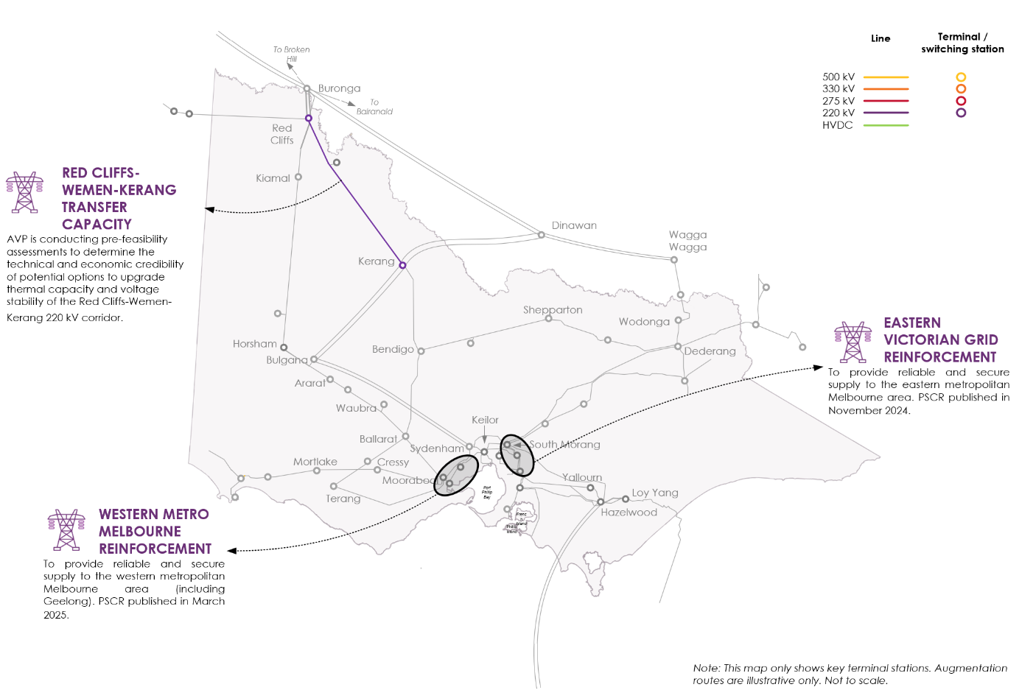

Eastern Victorian Grid Reinforcement RIT-T
Significant changes in the eastern metropolitan Melbourne network are starting to occur and are anticipated to continue over the next decade. These changes include the retirement of YWPS in 2028 and forecast demand growth projected to exceed the capacity of the eastern metropolitan network. The Latrobe Valley reconfiguration project (see Section 3.1.2) will ensure the 220 kV lines from the Latrobe Valley to Rowville remain fully utilised post-retirement of YWPS. However, due to the forecast demand growth in the eastern metropolitan area, additional investment is required to address anticipated forecast demand in the eastern metropolitan Melbourne area over the next 10 years.
If no action is taken to increase the eastern metropolitan Melbourne network capacity, then operational measures, such as dispatch constraints or load shedding, may be required to manage network loading within the thermal limits of the following assets:
- Eildon – Thomastown 220 kV line,
- Rowville A1 500/220 kV transformer during system normal, and
- Thomastown – Ringwood and Rowville – Yallourn 220 kV lines for loss of the Rowville A1 transformer.
AVP published the PSCR for this project in November 2024, outlining credible network options and technical characteristics required from non-network options to meet the identified need, being to support the forecast demand growth in the eastern metropolitan area. Network options that are being considered for the PSCR include, but are not limited to:
- bringing forward already planned VNI West works to cut the Eildon – Thomastown 220 kV line into South Morang Terminal Station, to address the forecast line overloads,
- installing a third 500/220 kV transformer at Rowville in parallel with the existing No. 1 500/220 kV transformer providing supply to the Rowville No. 3-4 220 kV Bus Group,
- installing a second 500/220 kV transformer at Cranbourne in parallel with the existing transformer and provide supply to the Rowville No. 1-2 220 kV Bus Group and transferring the Rowville No. 2 500/220 kV transformer to the Rowville No. 3-4 220 kV Bus Group in parallel with the Rowville No. 1 500/220 kV transformer, and
- replacing equipment at metropolitan terminal stations that have fault level exceedances, expected to be Keilor, Rowville, South Morang or Thomastown 220 kV assets and Templestowe and Thomastown 66 kV assets.
AVP has commenced next steps in the cost-benefit assessment process for eastern Victoria grid reinforcement. A high-level overview of next steps includes progressing:
- engineering studies to assess and identify the preferred credible options to meet the identified need, and
- cost-benefit analysis to estimate the net market benefits and rank the feasible options to determine the option that maximises the net economic benefit, as well as the optimal timing of implementation.

Western Metropolitan Melbourne Reinforcement RIT-T
The 2023 VAPR highlighted that at times of high demand in the western metropolitan area and high wind generation in and around the Western and South West Victoria REZs, the 220 kV transmission corridor between Moorabool, Geelong, Deer Park, and Keilor is becoming constrained and is anticipated to become heavily constrained over the coming decade. The main driver of this limitation is growing contribution of wind generation meeting peak demand, coupled with forecast demand growth in the Geelong and Deer Park areas. This is leading to an inability to supply loads to the western metropolitan Melbourne load centres in Geelong and Deer Park due thermal capacity limitations in the Moorabool – Geelong – Deer Park – Keilor 220 kV corridor during contingent conditions.
The identified limitations include:
- thermal overloading of Moorabool – Geelong 220 kV circuits,
- thermal overloading of Geelong – Deer Park and Geelong – Keilor lines, and
- thermal overloading of Keilor 500/220 kV transformers.
AVP published the PSCR in March 2025, outlining credible network options and technical characteristics required from non-network options to meet the identified need, being to support forecast demand growth in the western metropolitan Melbourne area.
Network options that are being considered include, but are not limited to:
- cutting Geelong – Keilor No.1 and No.3 220 kV lines into Deer Park, and potentially operating the Deer Park – Keilor circuits as normally open,
- performing works to increase line rating of existing Geelong – Moorabool 220 kV lines (replace limiting plant and install wind monitoring),
- constructing a third Geelong – Moorabool 220 kV line, and
- like-for-like replacement or replacement with 1,000 MVA transformers for three Keilor 500/220 kV transformers, and associated replacement of limiting equipment.
AVP is progressing next steps in the cost-benefit assessment process for western metropolitan Melbourne reinforcement. A high-level overview of next steps includes progressing:
- engineering studies to assess and identify the credible options able to meet the identified need, and
- cost-benefit analysis to estimate the net market benefits and rank the feasible options to determine the option that maximises the net economic benefit, as well as the optimal timing of implementation.
AusNet Services commenced a RIT-T to investigate options to replace three 500/220 kV transformers at Keilor Terminal Station to ensure safe and reliable transmission services. AusNet published the PADR in May 2025, which identifies the preferred option to replace the 750 MVA transformers with higher capacity 1,000 MVA transformers, planned to be commissioned by the end of 2030. The higher capacity Keilor Terminal Station transformers are an integral part of the Western Metropolitan Melbourne Reinforcement options being considered.
In the 2024 Victorian Transmission Connection Planning Report, Powercor identified an emerging network limitation at Deer Park Terminal Station and indicated that it would be assessing options to address the limitation. Powercor published the RIT-T PSCR in June 2025 identifying one credible option to install a third 225 MVA 220/66 kV transformer and cut in the Geelong – Keilor No.1 and No.3 220 kV transmission circuits at Deer Park Terminal Station. This project is integral in addressing the thermal limitations associated with demand growth at Deer Park.
AVP will continue working closely with AusNet Services and Powercor in progressing this cost-benefit assessment.

Red Cliffs – Wemen – Kerang Transfer Capacity
The 2024 VAPR reclassified the previously identified Red Cliffs – Wemen – Kerang 220 kV line thermal limitation from a monitored limitation to a priority limitation, driven by:
- increased power transfer capacity from New South Wales into Victoria, following upgrade of the 220 kV network between Buronga and Red Cliffs, as part of EnergyConnect, and retirement of Yallourn in mid-2028, which results in Victoria’s greater reliance on imports from New South Wales during high demand periods, and
- increased maximum demand forecasts used in the 2024 VAPR assessment.
It was observed in the 2024 VAPR assessment that VNI West significantly reduces the scale of this risk, so the timing and size of this limitation is dependent on VNI West’s commissioning timing.
Since the 2024 VAPR, AVP has commenced more detailed feasibility studies to determine credible network and non-network options capable of economically meeting the identified need. As part of these more detailed feasibility studies, AVP is also considering the voltage stability limitations and other relevant thermal limitations in the area.
Network and non-network options currently being considered include, but are not limited to:
- installing power flow management assets, such as series reactors, on the Red Cliffs – Wemen – Kerang 220 kV line to manage thermal loading on these circuits,
- contracting BESS to charge or discharge, as required, to manage thermal loading on the Red Cliffs – Wemen – Kerang 220 kV line during peak loading periods, and
- constructing a second Red Cliffs – Wemen – Kerang 220 kV line.
The ongoing feasibility studies will determine the technical and economic credibility of potential options and therefore the need for any future cost-benefit assessment or RIT-T for investments required to manage the identified limitations. In parallel to the ongoing feasibility studies, the VTP has proposed a project to upgrade the existing circuit to double-circuit in the CDP 2 program of work.

Future outlook of the DSN
This section presents the outcome of the 2025 Annual Planning Review undertaken by AVP to assess network capability and identify potential new limitations that may impact supply reliability or reduce system performance over the next 10 years.
This section also provides information on other planning activities – such as system security planning, review of existing and proposed control schemes for the DSN, and Joint Planning with DTSOs and NSPs – undertaken by AVP as the jurisdictional planner for the Victorian DSN.
Key outcomes of the Annual Planning Review
Projected network limitations
- Key outcomes of the past three VAPRs consistently demonstrate emerging network limitations and urgency of the delivery of identified augmentation projects.
- The 2025 VAPR concludes network limitations are largely consistent with those reported in the 2024 VAPR, except one new priority limitation which is mainly driven by changing connection point demand forecasts:
  - Increased demand in Western Metropolitan Melbourne is driving a new priority thermal capacity limitation on the Keilor 500/220 kV transformers A2 and A4 which could lead to a risk of load shedding. It is anticipated that remediation of this limitation can be included in the Ausnet transformer replacement RIT-T for these transformers.
System security planning activities
- System strength:
  - AVP has extended existing system strength remediation contracts to address system strength needs at Red Cliffs from 2025-26, which were identified in the 2024 System Strength Report.
  - AVP has completed the Victorian System Strength Requirement RIT-T, which has outlined the preferred portfolio to meet the system strength requirements. Procurement of system strength service agreements is ongoing and is expected to meet the forecast shortfalls of 517 MVA at Moorabool, 1,963 MVA at Hazelwood, and 561 MVA at Thomastown from 2027-28 identified in the 2024 System Strength Report.
- Inertia:
  - AEMO’s 2024 Inertia Report projected the level of inertia in Victoria falling below the inertia sub-network allocation, but did not declare an inertia gap. AVP anticipates that, following procurement of services in line with its Victorian System Strength RIT-T, it may be able to meet the majority of its obligations to provide the inertia sub-network allocation from 2 December 2027 using the solutions identified in the RIT-T.
  - AVP is investigating the least-cost options available to meet its inertia requirements to make available the inertia sub-network allocation of 11,800 megawatt seconds (MWs) from 2 December 2027.
  - Procurement of system strength services, in line with the Victorian System Strength Requirement RIT-T preferred option, will also consider the level of inertia these services can provide to ensure the holistically efficient procurement of system security services.
- Previously declared thermal overloading and voltage control gaps on the 220 kV network near Deer Park:
  - AVP commissioned a control scheme to enable higher pre-contingent loading in this area to address the thermal overloading gap, and the 2024 NSCAS Report confirmed that this mitigates the previously declared thermal overloading gap.
  - AVP has commenced the Western Metropolitan Melbourne Reinforcement RIT-T to identify a longer-term solution to manage the risk of the thermal overload limitations reemerging.
  - AVP has separately completed a Metropolitan Melbourne Voltage Management RIT-T, which has confirmed the preferred option includes installation of a new 220 kV 100 MVAr shunt capacitor at Deer Park Terminal Station to address voltage control needs in the Deer Park area.
- Thermal overloading risks following YWPS retirement:
  - To manage overloading risks for transformers between the 500 kV and 220 kV network supplying Metropolitan Melbourne following YWPS retirement in 2028-29, which were identified as emerging risks but not declared as gaps in the 2024 NSCAS Report, AVP has developed an operational solution, and is considering longer-term remediation options.
Joint planning
- AusNet Services’ 2025 asset replacement and refurbishment plans are largely consistent with those presented in the 2024 VAPR.
- AVP continues timely and effective joint planning with AusNet Services to coordinate activities associated with DSN asset replacement, retirement, derating and augmentation, to achieve optimal planning outcomes.
- AVP continues to work with other DTSOs and DBs to identify credible and cost-effective solutions to the emerging challenges caused by increased fault levels across the DSN, due to the growing generation portfolio, and managing system security at times of low demand.

Annual Planning Review methodology
The VAPR identifies opportunities to address transmission network limitations emerging over the next 10 years, where credible solutions are likely to deliver positive net market benefits. The overall planning approach is described in Appendix A2 and the identified limitations are discussed in the following sections.

Categorisation of limitations
For each network element, screening studies are typically undertaken for a base case and a worst case scenario, to capture a wide range of limitations. The worst case scenario differs, depending on the transmission network element under consideration, and is a variation on the base case scenario designed to test that specific network element. For example, in a particular location the worst case scenario may be 100% VRE output, while in another the worst case may be 0% VRE.
AVP identifies credible options to address the identified limitations and estimates the costs of the options. Options are then assessed to determine if they are likely to deliver positive net market benefits (where applicable). Based on these assessments, the limitations are categorised as shown in Figure 27 and described below:
- Priority limitations – AVP will commence detailed analysis on options to alleviate this limitation. Priority limitations have credible options to be delivered within the next 10 years that are anticipated to deliver positive net market benefits.
- Monitored limitations – AVP will continue to monitor this limitation, and either reassess it as part of the next Annual Planning Review or commence detailed analysis if triggered by a new market development.
- Identification of network limitations – the planning cycle
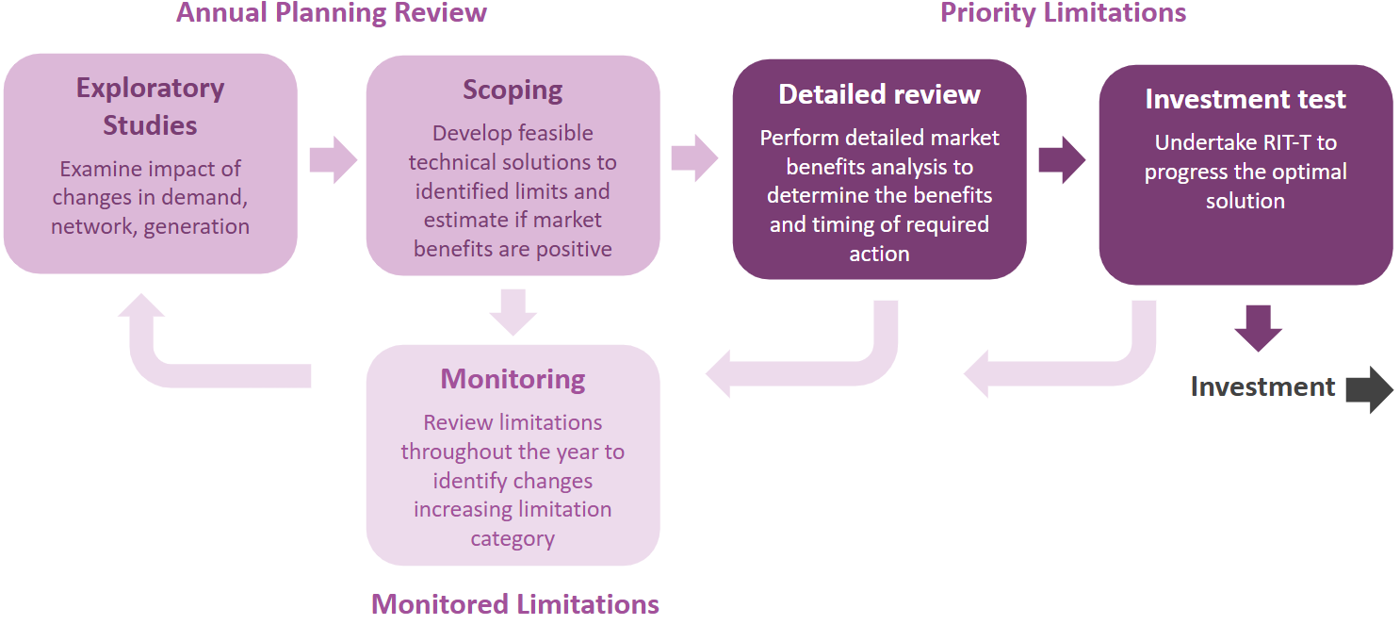

AVP performs high-level economic assessments in determining priority limitations. This analysis and categorisation can provide signals for potential non-network development opportunities, such as localised generation or demand response. Priority limitations may also include limitations needing reliability corrective actions where credible solutions are not required to deliver positive net market benefits.
To address transmission limitations, challenges, and opportunities, AVP undertakes joint planning with AEMO in its function as National Transmission Planner under the NER (ISP and System Security Planning process), other TNSPs, and Victorian DNSPs. Victorian joint planning outcomes have been incorporated into the limitation summaries presented in this section.
Figure 28 shows the priority limitations under investigation in this Annual Planning Review, assuming the network developments already progressing and discussed in Section 3.13.1 proceed. A complete list of the limitations (both priority and monitored) is in Appendix A4. Appendix A2 has more information on AVP’s approach to transmission network limitation reviews.
Note that the numbering of the limitations in this section does not reflect the ranking of most significant Victorian transmission constraints observed in 2024-25. They relate to future limitations that are forecast over the next decade that may justify network augmentation.
- Priority limitations under investigation
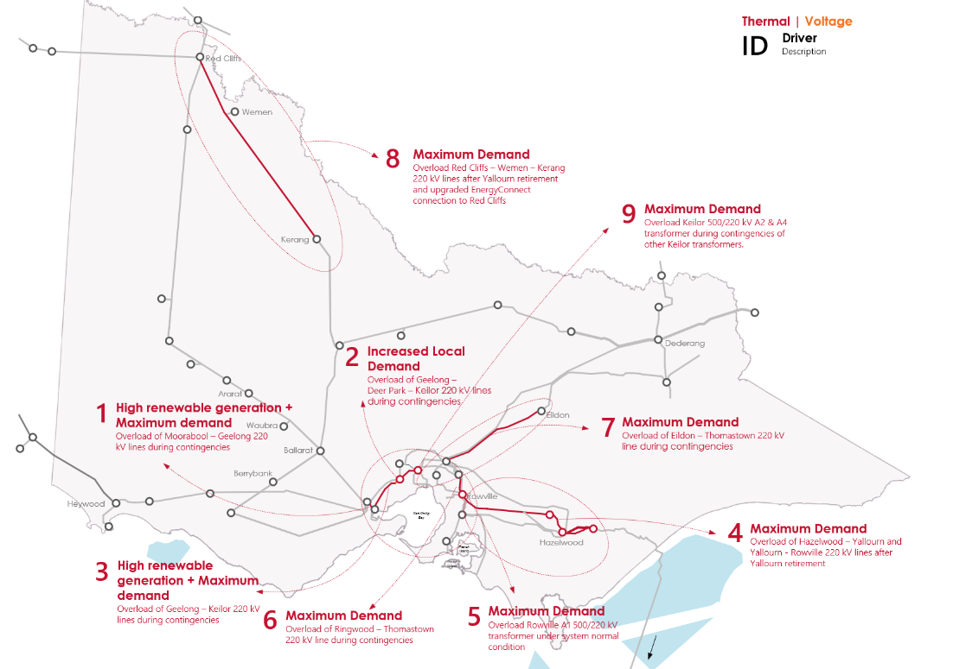

Projection of network limitations in the planning horizon

Priority limitations identified in the 2024 VAPR
The 2024 VAPR identified eight priority limitations for which AVP commenced feasibility studies and regulatory investment tests. Table 12 summarises progress made by AVP on these limitations, with further details in Section 3 of this report.
- Priority limitations from 2024 VAPR
# | Limitation (estimated constraint date) | Description | Status/next steps
1 | Thermal capacity limitation – Overloading of the Moorabool – Geelong 220 kV lines for trip of the parallel line (existing) | This limitation is due to commitment of additional renewable generation and storage capacity in South West Victoria (V4), coupled with higher demand growth in the metropolitan area and generation retirement in Latrobe Valley. | AVP published the Western Metropolitan Melbourne Reinforcement RIT-T PSCR in March 2025 and further work is underway to provide a holistic solution that will address limitations #1, #2 and #3. More detail about the options considered in the RIT-T is in Section 3.1.5.
2 | Thermal capacity limitation – Overloading of the Geelong – Deer Park line for trip of the Deer Park – Keilor line, or the Deer Park – Keilor 220 kV line for trip of the Geelong – Deer Park line (existing) | These limitations are due to demand growth in the western metropolitan area supplied from Geelong, Deer Park and Keilor terminal stations.
3 | Thermal capacity limitation – overloading Geelong – Keilor 220 kV lines for post credible contingencies (existing)
4 | Thermal capacity limitations – Transfer capacity from Latrobe Valley to Melbourne post YWPS retirement (July 2029) | This limitation is primarily due to changing flow sharing of the 500 kV and 220 kV networks from the Latrobe Valley to metropolitan Melbourne following retirement of YWPS. | AVP has identified a new switching arrangement at Hazelwood Power Station 220 kV (the modified parallel mode), for post-YWPS retirement to utilise the eastern 220 kV corridor. Changing the Latrobe Valley configuration to modified parallel mode significantly reduces the short-term risks in supplying metropolitan Melbourne. AVP is continuing to work through the delivery of this project with asset owners. More detail about this solution is in Section 3.1.2.
5 | Thermal capacity limitation – Overloading of the Rowville A1 500/220 kV transformer during system normal (July 2032) | These limitations are primarily due to higher demand growth in the Melbourne metropolitan area, which is further exacerbated by retirement of YWPS. | AVP published the Eastern Victoria Grid Reinforcement RIT-T PSCR in November 2024 and further work is underway to provide holistic solution that will address these limitations as well as limitation #7 (Eildon – Thomastown thermal limitation). This project is to address the residual risk that exists after modified parallel mode discussed in limitation #4 is implemented. More detail about the options considered in the RIT-T is in Section 3.1.5.
6 | Thermal capacity limitation – Overloading of Thomastown – Ringwood 220 kV line for loss of the Rowville A1 transformer (December 2025)
7 | Thermal capacity limitation – Overloading of Eildon – Thomastown 220 kV line for the loss of 330 kV transmission line between Dederang to South Morang (July 2029) | This limitation is caused by increased demand growth in the Melbourne metropolitan area, which is further exacerbated by changes in how power flows around the network following retirement of YWPS. These changes tend to increase VNI import into Victoria, and thus flow on the Eildon – Thomastown 220 kV line. | To manage loading on the Eildon – Thomastown 220 kV line, as part of VNI West AVP will cut the Eildon – Thomastown 220 kV line in at South Morang Terminal Station.  AVP has also commenced the Eastern Victoria Grid Reinforcement RIT-T to provide a holistic solution that will address this limitation in addition to the limitations #5 (Rowville A1 transformer thermal limitation) and #6 (Ringwood – Thomastown line thermal limitation). The Eastern Victoria Grid Reinforcement RIT-T will assess the benefits of advancing the South Morang cut-in works to manage this network limitation ahead of VNI West’s planned in service date.  More detail about the options considered in the RIT-T is in Section 3.1.5.
8 | Thermal capacity limitation – Overloading of the Red Cliffs – Wemen – Kerang corridor during periods of high demand (December 2025) | This limitation is elevated primarily due to expected increase in power transfer from New South Wales into Victoria via the upgraded 220 kV network between Buronga and Red Cliffs interconnector at times of maximum demand following completion of the EnergyConnect project. The retirement of YWPS could also increase the need for more import from New South Wales in general. | AVP has commenced a RIT-T to assess the limitation and identify credible options to address it. As part of this assessment, AVP is also considering the voltage stability limitations in the area. More detail about the project is in Section 3.1.5.

New priority limitation from 2025 VAPR
AVP’s 2025 Annual Planning Review identified one new priority limitation in the DSN, as listed in Table 13. The main driver for this new limitation is changes in the connection point forecast and increased demand forecast in the western metropolitan Melbourne area over the planning horizon. Changes in the network supply to the western metropolitan area have changed network flow paths which has also contributed to this limitation.
- New priority limitation from 2025 VAPR
# | Limitation (estimated constraint date) | Description | Status/Next steps
9 | Thermal capacity limitation – Overloading of Keilor 500/220 kV Transformer for the loss of other transformer (December 2028) and in system normal (December 2032) | This limitation is primarily due to higher connection point demand growth in the Melbourne western metropolitan area, which is further exacerbated by retirement of YWPS. | AusNet Services has commenced a replacement RIT-T for the Keilor transformers and is currently proposing replacement with higher capacity 1,000 MVA units.  The higher capacity transformers are integral to AVP’s Western Metropolitan Melbourne Reinforcement RIT-T, as discussed in Section 3.1.5, and AVP will continue working closely with AusNet Services to provide a holistic solution that will address these limitations.

Keilor 500/220 kV Transformer thermal capacity limitation (limitation #9)
Thermal loading on the Keilor 500/220 kV transformers A2 and A4 has been identified as a priority limitation at times of high demand. The primary driver behind this limitation is increasing demand in the western metropolitan area. The loading on the remaining transformers is forecast to exceed their short-term ratings (810 MVA) from 2028 following a credible contingency of a parallel transformer (N-1 overloads), leading to a risk of pre-contingent load shedding to manage system security. The risk of load shedding is forecast to increase as the loading on the transformers is forecast to exceed their continuous rating (750 MVA) from 2032, even with all three transformers in service (N overloads). See Figure 29 for more details.
- Thermal overloading of Keilor 500/220 kV A2 and A4 transformers
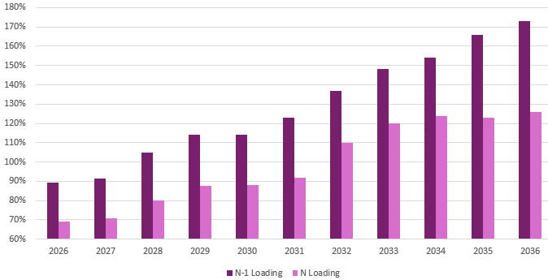

Potential options to address the overloading of the Keilor 500/220 kV A2 and A4 transformers may include, but are not limited to:
- replacing the transformers with larger units (the transformers are approaching end of serviceable life),
- installing additional 500/220 kV transformation at KTS, and
- constructing a new 500/220 kV connection point (potentially at Truganina), including associated 500 kV and 220 kV line works, and transferring load from Keilor to the new connection point.
As there is already a replacement RIT-T process underway to replace the existing transformers, AVP recommends replacing these transformers with larger units. It is anticipated that increasing the size of transformers already planned to be replaced would be the most economic solution.

Other limitations (monitored)
AVP continues to monitor transmission network limitations that may result in supply interruptions or constrain generation, but for which either there are no currently identified needs/triggers, or there are insufficient market benefits expected to justify the cost of relieving the limitation. AVP will reassess these limitations as part of the next VAPR or commence detailed analysis if triggered by a new market development.
The following sections provide more detail on new monitored limitations and existing monitored limitations impacted by new ISP anticipated or committed developments in the DSN announced since the 2024 VAPR. These developments may include announced generator connections, transmission augmentations, load forecasts, changes in historical constraint behaviour, or regulatory changes.
While the monitored limitations reported in this VAPR are identified based on the committed Victorian generation planned closure years, AVP has also carried out a sensitivity analysis to assess the impacts on these limitations due to earlier than announced generator retirements and subsequent supply uptake elsewhere, as included in the 2024 ISP Step Change scenario. More information is in Appendix A4.
- Monitored limitations
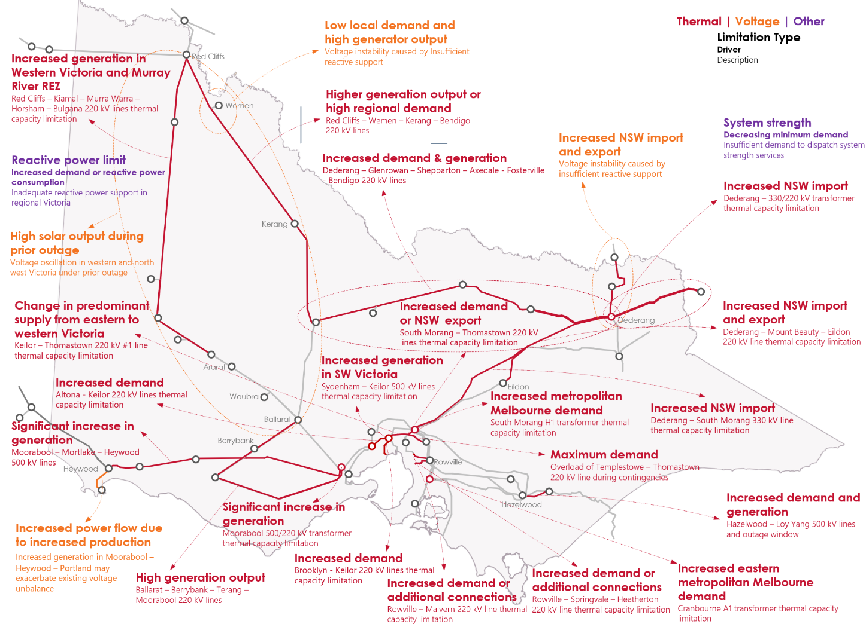

Thermal limitations
The emergence of new thermal limitations and the benefits of addressing them depend heavily on the geography and intermittency of both supply and demand. Patterns of network flow and asset utilisation continue to change in Victoria, due to drivers on the supply side such as a significant amount of new VRE projects, decommitment of large synchronous generation, and strong uptake of distributed PV.
In 2024-25, 840 MW of new generation projects connected in Victoria, and new projects continue to be proposed in regional parts of the state, where high-quality solar and wind resources are abundant (see Section 2.5). These parts of the network, however, were not originally designed to support such high generation density, and several investors have faced economic and technical challenges associated with connecting to these areas where sufficient thermal capacity is unavailable. Several projects have been and are being delivered to address these challenges (see Section 3.1.1).
In 2024-25, updated connection point forecasts showed a greater proportion of Victorian demand in the Western Metropolitan Melbourne region compared to previous years. The main drivers for this increase in the connection point forecast were continued load growth with the expansion of Melbourne west and with the number of small distribution connected data centres being established. The regional demand forecast also increased for Victoria, particularly in years 5-10 of the planning horizon, driven mainly by forecast data centre loads. Both of these changes to the forecasts have contributed to monitored limitations being identified in the Western Metropolitan Melbourne area.

Greater Melbourne – Altona to Keilor 220 kV line and Brooklyn to Keilor 220 kV line
Slight changes in the connection point forecast have increased demand in the Western Metropolitan area. The higher demand has contributed to two new monitored thermal limitations:
- The Altona to Keilor 220 kV line becomes limited for the loss of the Brooklyn to Keilor 220 kV line during times of maximum demand and high generation.
- The Brooklyn to Keilor 220 kV line becomes limited for the loss of the Altona to Keilor 220 kV line during times of maximum demand and high generation at times of maximum demand and high generation.
AVP does not currently have firm plans to address these limitations and will continue to monitor the limitations.

Northern Corridor – Dederang to South Morang 330 kV line
Based on the 2025 ESOO demand forecast, which projected a slight increase in demand compared to last year and increased interconnector flow from New South Wales to Victoria, a new monitored thermal limitation has been identified on the Dederang – South Morang 330 kV line for the loss of the other Dederang to South Morang 330 kV line. This limitation exists at times of maximum demand and high generation, and is anticipated to be addressed by VNI West when it comes into service.

Voltage stability limitations

Murray River Corridor
Voltage stability in the Murray River corridor has ranked highly among the market impact of Victorian network constraints since 2021 when constraints for this limitation were formulated. Since 2021, many projects have been initiated that reduce this limitation to monitored status, including:
- EnergyConnect,
- Koorangie BESS,
- upgrade of Murraylink VFRB, and
- VNI West.
Voltage stability in the Murray River corridor was previously investigated under anticipated future solar connections. Analysis highlighted a risk that constraints to manage this limitation may have a greater impact if additional solar generation connects prior to commissioning of EnergyConnect, however this risk is significantly mitigated if the anticipated co-located generation and BESS projects are charging during high solar periods. Beyond EnergyConnect, and based on the assumptions used in this 2025 VAPR, additional solar capacity is expected to be able to operate with reduced challenges of voltage stability during periods when market conditions allow the additional export capacity to be used. Despite the reduced impact and status of this limitation, AVP is considering this limitation alongside its Red Cliffs – Wemen – Kerang transfer capacity feasibility studies, as described in Section 3.1.5.

South West Victoria Corridor
Voltage collapse in South West Victoria due to additional generator connections and under high import from South Australia has been managed by applying a constraint since August 2022. In 2024-25, this constraint bound for 305 hours, ranking thirteenth in AVP’s constraint impact assessment.
In July 2024, the new CRTS was connected as part of Stage 1 of Golden Plains Wind Farm, which is anticipated to be completed in 2025. Completion of CRTS is expected to improve voltage stability in South West Victoria.
As noted earlier in Table 6, the RDP Stage 1 project to turn in the existing Haunted Gully – Tarrone line at Mortlake was completed in 2025 and is also expected to improve voltage stability in South West Victoria.
AVP anticipates that these augmentations will be sufficient to prevent significant challenges managing voltage stability during system normal conditions under committed and anticipated future connections to the South West Victoria 500 kV network. Further significant development in South West Victoria may trigger a need for additional investigation and that may lead to augmentations.

Observations from inclusion of VTP projects
In August 2025, VicGrid published the VTP as a plan for developing Victoria’s REZs and the transmission infrastructure required to enable that development. The plan included an assessment of three candidate development pathways for developing the network, and selected CDP1 as preferred.
AVP has conducted sensitivity studies extending over the next 10-year horizon to evaluate the impact of VicGrid’s preferred development pathway on Victoria’s transmission network. This assessment included the implementation of 9.5 GW of new proposed REZ generation (by 2035) and network augmentation projects as outlined in the VTP CDP1, in Table 2 of Appendix A2 in this VAPR.
Through the sensitivity studies performed, AVP has not identified any new limitations arising from the implementation of the VicGrid VTP network strengthening program. AVP has identified that implementation of VicGrid programs will contribute to addressing existing limitations, as shown in Figure 31.
- Impact of VicGrid VTP programs on existing limitations
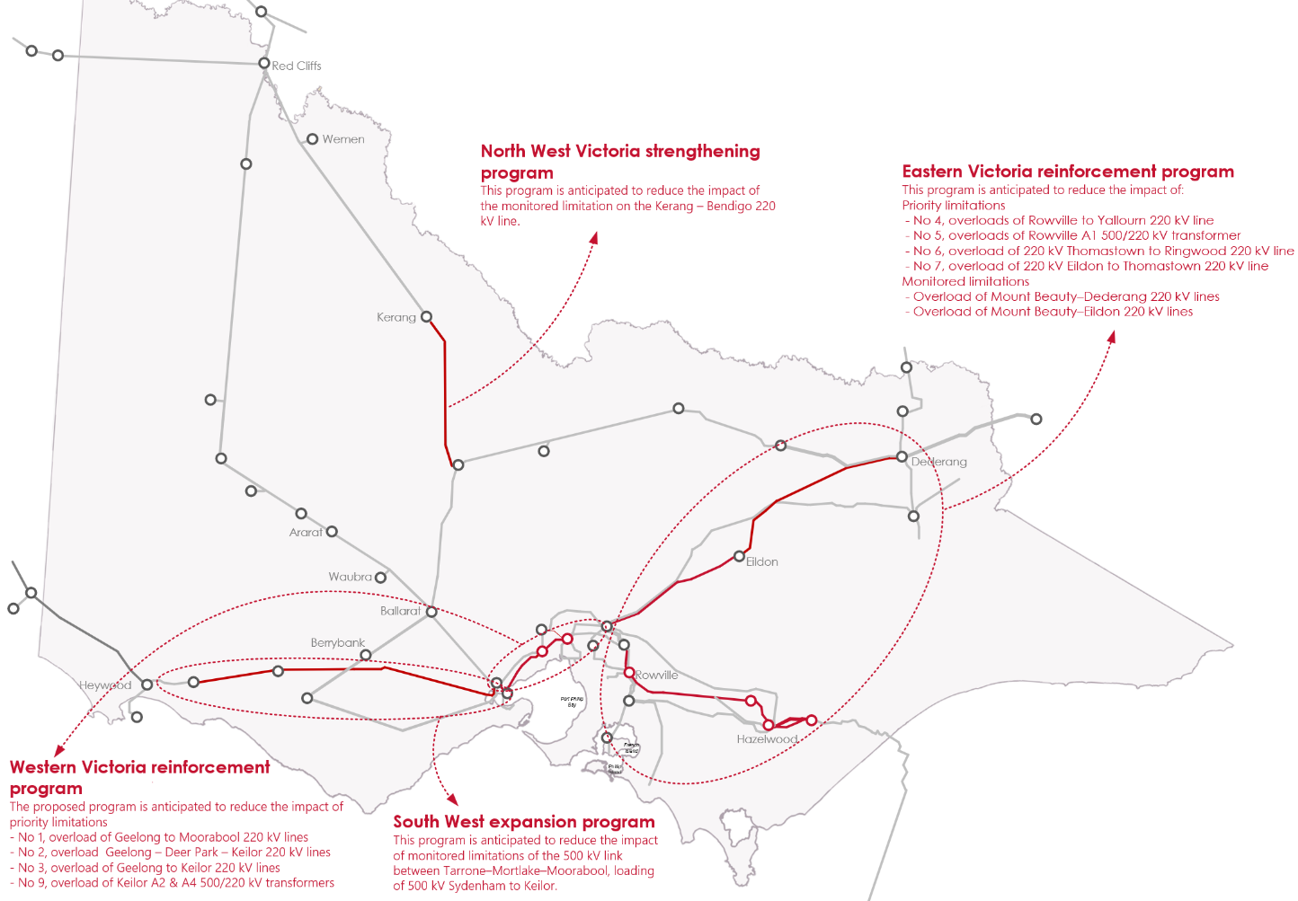

Scenario analysis of large load connections
In recent history the Victorian DSN has not seen large step changes in load, with very few transmission-connected customers being added to the network; the most notable recent load connection was for the desalinisation plant in Wonthaggi. With recent changes in technology, there is interest in both hydrogen electrolysers and data centres connecting to the transmission network, and both technologies typically have high load factors. Connecting a large amount of additional load to the network can result in supply and network capacity challenges at peak times, however the network can also benefit from these loads during periods of minimum demand.
Throughout 2024-25, AVP received over 18 GW of large load connection enquiries. The majority of those enquiries related to data centres in the western and northern metropolitan Melbourne areas, with a small amount of interest in south-eastern metropolitan Melbourne. The 2025 ESOO forecast approximately 1 GW of additional data centre load in Victoria by 2035. AVP does not anticipate that all the connection enquiry interest will eventuate within the 10-year planning horizon. If all the large load connections did intend to proceed within the planning horizon, the maximum demand for Victoria would more than double and it would not be possible to build the required generation and transmission infrastructure to reliably support the additional demand.
As most interest is in western and northern metropolitan Melbourne, where there are already existing limitations, AVP expects network augmentation will be required to facilitate many of the proposed connections.
With so many enquiries and no certainty as to which enquiries will proceed, AVP has conducted scenario analysis to identify the possible future transmission augmentations that could be completed to facilitate increased demand in the western and northern metropolitan Melbourne network. These studies are to ensure that when transmission augmentations in the western and northern metropolitan Melbourne are required to facilitate large load connections, the augmentation also supports existing Victorian consumers and aligns with AVPs plans for possible future network augmentations. This scenario analysis did not consider the additional generation infrastructure that would be required, or the additional transmission augmentations that would be needed to transfer the generated energy to the metropolitan area.
The scenarios demonstrate that new large loads in specific network locations determined which augmentations would be recommended. Based on those locations, the demand groups that influence the augmentations are shown in Table 14.
- Demand groups that influence augmentation options
# | Demand group | Demand range analysed (MW)
A | New connections to Keilor’s Western 220 kV bus group (Buses 1-3) | 1,000-3,500
B | New connections to Keilor’s Eastern 220 kV bus group (Bus 2) | 1,000-2,500
C | New connections to South Morang 220 kV | 500-1,000
D | New connections to proposed new terminal stations at Donnybrook (DBTS) Somerton (SOTS) and Truganina (TNTS) | 3,000-8,000
E | Aggregate of all connections in the other demand groups | 5,500-13,000^{A}
A. Some demands in rows A-D may be shared between the different groups (particularly the existing stations and new stations) depending on how connections are modelled; any duplication of demands has been accounted for, reducing the total to less than the sum of all listed demands.
From the analysis, AVP identified the transmission augmentations shown below in Figure 32. Selection of transmission augmentations would be based on the needs of projects that proceed, and as connection inquiries may change in future, additional projects may be required.
Beyond the options identified, it is also possible that connection proponents may establish substations in other locations that are not using existing easements or land already planned for DSN terminal stations. These sites, if included in the DSN, could also be used to facilitate connection to other additional sites or help enable the introduction of new line routes.

- Possible transmission augmentations to meet needs of large load connections
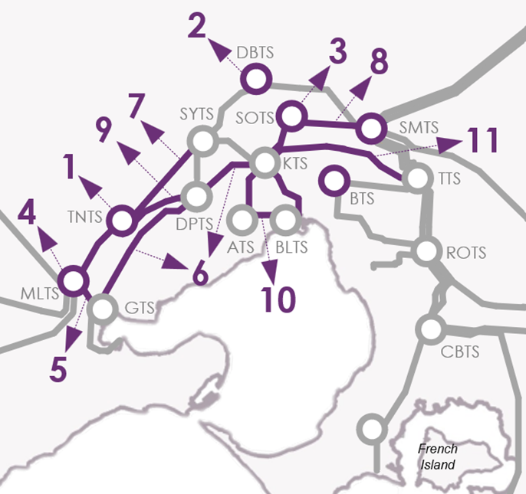 | 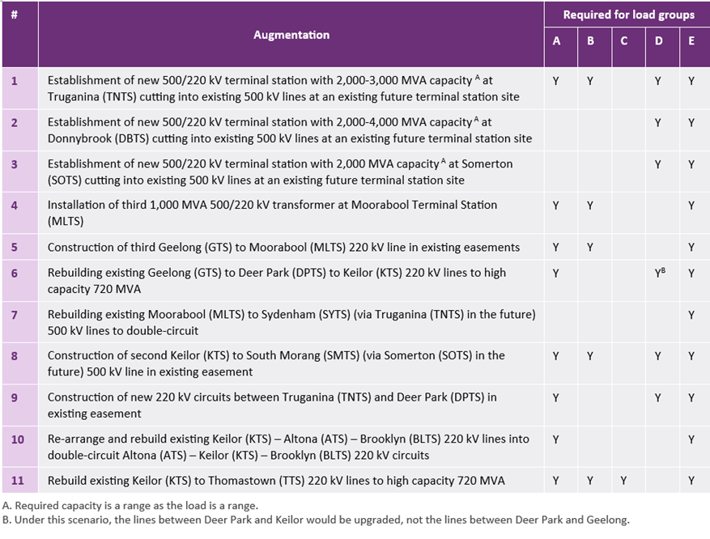

Maximum contingency size investigations
As discussed in Section 3.1 of the VNPIR, during 2024-25, the Victorian transmission DSN had a maximum allowable generation or load contingency size limit of 600 MW applied to the network for the trip a single generator or load. These limits have been set based on the size of contingency the network can withstand while remaining stable, a review is currently underway to determine if larger limits can be set in the future.
As part of the 2025 VAPR, AVP investigated increasing the maximum allowable size of single generation or load contingencies on the network. This investigation performed scenario analysis on making larger than existing connections to the network at locations where there was adequate capacity. The scenarios were tested to identify if the capability of the network was diminished by having larger connections or if any instability was created.
Based on these studies, AVP has determined that in many cases it is possible to allow a 750 MW generator connection, however there are locations where a 750 MW contingency could cause a reduction in stable Victorian supportable demand compared to an existing 600 MW generator. Based on this, AVP will increase to 750 MW but require generator connections greater than 600 MW to undertake further studies. These studies would identify the full impact of the connection and may require the generator to provide additional reactive power support to connect in a way that ensures Victorian supportable demand is not reduced because of the connection. AVP will continue investigating this limit as the network continues to change, with the possibility of increasing the limit to 750 MW with no additional provisions.
The limit for load connections will remain at 600 MW, which aligns with the current largest load single contingency in the network, however further investigation is required to assess whether further higher load loss is acceptable to the network.

System security planning for the DSN

System security criteria
As jurisdictional planner of the Victorian DSN, AVP is responsible for planning the DSN to meet the Victorian system security requirements:
- System strength – as the SSSP for Victoria, AVP is responsible for meeting the Victorian system strength requirements set by AEMO National Planning in line with NER.
- Network support and control ancillary services (NSCAS) – AVP is responsible for responding to Victorian NSCAS gaps declared by AEMO National Planning which need remediation.
- Inertia – AVP is responsible for meeting the requirements to maintain sufficient inertia within Victoria, as set by AEMO National Planning in line with the NER, from 2 December 2027.
AEMO National Planning publishes these NEM system security requirements annually.
The rapid uptake and build-out of IBR has resulted in a changing landscape for electricity supply, storage, and demand. A key part of this transition has been the retirement of synchronous generators, such as coal and gas-fired units, that have historically and inherently provided system security services such as system strength and inertia. To preserve system security, active procurement of other sources of system strength and inertia is essential to enable the network to function securely under the high penetration of IBR, such as solar and wind generation and grid-following (GFL) batteries, IBL, and inverter-based transmission links such as Murraylink and Basslink.

System strength requirements

System strength service provision and obligations
System strength describes the ability of the power system to maintain and control a stable voltage waveform at a given location, during steady state operation and following a disturbance. System strength planning is essential to enable system security to be maintained as GFL IBR and IBL (which typically demand system strength) connect to the network, and synchronous generators (which supply system strength) retire.
Inaction to maintain system strength would ultimately require the use of directions to ensure sufficient synchronous or GFM plant are online to maintain a secure power system – or, where insufficient synchronous or GFM plant is available to be directed, the inability to connect new IBR or IBL, resulting in high costs and/or reduced reliability to consumers.
The revised system strength framework establishes a proactive approach for delivering system strength across the NEM. It requires regional SSSPs to plan and procure a minimum three phase fault level and efficient system strength level, the latter of which caters to the forecast connection of IBR (inclusive of solar, wind and GFL batteries) and IBL that elect to pay the system strength charge, under NER 5.3.4B, rather than self-remediate their system strength impact. Both these requirements are detailed in AEMO’s annual System Strength Report, which provides a minimum 10-year forecast of the minimum fault level requirement and the IBR and IBL connections for which system strength must be procured

2024 System Strength Report

Insights and recommendations
The 2024 System Strength Report was published in December 2024, and subsequently updated in February 2025, by AEMO in its function as National Transmission Planner. The report provides a 10-year outlook of system strength requirements in the NEM and forecasts system strength shortfalls from 2 December 2025.
AVP, as SSSP for Victoria, has identified the preferred option for meeting its system strength requirements. This preferred option is detailed in its Victorian System Strength Requirement RIT-T, which is discussed further in Section 3.1.2.

Observed and forecast shortfalls and operational management of system strength
A system strength node is a physical location on the transmission network, at which AEMO must determine system strength requirements and apply those requirements for power system security. Using typical dispatch patterns in the absence of system strength investment, the 2024 System Strength Report identified forecast shortfalls of 517 MVA at Moorabool, 1,963 MVA at Hazelwood, and 561 MVA at Thomastown from 2027-28,. System strength services planned to be procured under the new framework from 2 December 2025 through the Victorian System Strength Requirement RIT-T will be enabled during such periods to meet the system strength standard.
The 2024 System Strength Report also identified a need for system strength services of 368 MVA at Red Cliffs from 2025-26, primarily linked with the expected end of existing system strength remediation contracts. AVP has since extended those system strength services agreements, which are now set to expire on 31 July 2026, to meet the Red Cliffs need. Provision of services beyond this timeframe is being procured; details are at Section 3.1.2.
The 2024 System Strength Report noted that voltage oscillation events have occurred in south-west Victoria under certain network outage conditions and system normal topology. Voltage and power oscillations are naturally occurring phenomena in electric power systems all over the world. If not planned for and managed, they have the potential to disrupt power systems if they do not subside following a disturbance, such as a fault or a sudden loss of generation or load. The risk of undamped voltage oscillations in south-west Victoria continues to be managed through market constraints such as V_SH_DD_MAC_FLT_965 and V_BDBU_SWVIC_FLT_965, which constrain IBR output under certain system normal and network outage conditions.
A lack of system strength was observed in the south-west Victoria area during an outage of the Sydenham – Moorabool line on 24 October 2024, requiring market direction of synchronous units. In its 2024 System Strength Report, AEMO National Transmission Planner noted that it has developed new minimum synchronous unit combinations and constraints and will assess the ongoing adequacy of minimum fault level requirements against these new minimum unit combinations as part of the 2025 System Strength Report. Moorabool – Sydenham outage limit advice was published soon after the observed oscillations event, with this new limit advice defining the minimum number of synchronous units required to be online prior to outage of a Moorabool – Sydenham circuit to prevent undamped oscillations following a credible contingency concurrent with outage of a Moorabool – Sydenham circuit.
Since publication of the 2024 System Strength Report, the Victorian network has been strengthened with completion of the Mortlake turn-in project, which cut the Haunted Gully to Tarrone 500 kV line in at Mortlake. AVP has also reviewed the existing minimum synchronous machine combinations and removed combinations from the system normal limit advice that do not meet the minimum fault level requirements. AVP plans to further update system strength limit advice following procurement of services identified as forming part of the Victorian System Strength Requirement RIT-T preferred option.

Available fault level (AFL) forecasts
The AFL is a metric used to quantify the level of system strength supply, from synchronous and GFM sources, available to support the connection and dispatch of GFL IBR, which demand system strength, in the power system. Positive AFL indicates locations where system strength is, or will be made, available to support additional IBR, while zero or negative AFL indicates locations where system strength to support additional IBR is unavailable and additional investment is currently not planned at the location in the given year.
Forecast AFL is intended to provide locational signals for IBR connections on connection points where system strength will be proactively procured to facilitate connection of IBR.
AVP as SSSP for Victoria must publish a forecast of the AFL at each system strength node over the period for which AEMO has determined system strength requirements, in a manner consistent with the methodology in the System Strength Impact Assessment Guidelines (SSIAG) . AVP has prepared this AFL forecast (see Table 15 below), in line with the SSIAG for the 2025 VAPR, using the following inputs and assumptions:
- System strength supply – system strength is supplied from both existing/committed services and new additional services that form the Victorian System Strength Requirement RIT-T PACR preferred option.
- System strength demand – all existing and committed IBR generators and storage as per the Victorian System Strength Requirement RIT-T taking into consideration the April 2025 NEM Generation Information. Existing DC interconnectors Murraylink and Basslink have also been considered.
Table 15 presents the forecast AFL (post-contingent) at system strength nodes and key Victorian buses for the next 10 years.
- Forecast of post-contingent available fault level at significant Victorian nodes in each financial year, 2025-26 to 2034-35 (MVA)
System Strength node/ bus | 2025-26 | 2026-27 | 2927-28 | 2028-29 | 2029-30 | 2030-31 | 2031-32 | 2032-33 | 2033-34 | 2034-35
Bulgana 220 kV | - | 134 | 1,709 | 1,833 | 2,177 | 2,207 | 3,062 | 3,292 | 3,114 | 3,702
Dederang 220 kV | 1,997 | 1,836 | 2,300 | 2,165 | 1,919 | 1,989 | 2,386 | 2,397 | 1,983 | 2,468
Hazelwood 500 kV | 0 | 0 | 1,210 | 2,787 | 2,358 | 2,973 | 6,460 | 6,990 | 7,264 | 8,958
Tragowel 500 kV | - | - | - | - | 3,100 | 3,184 | 4,222 | 4,402 | 3,846 | 4,894
Moorabool 220 kV | 0 | 0 | 1,202 | 1,456 | 1,536 | 1,556 | 4,184 | 5,823 | 5,637 | 6,409
Mortlake 500 kV | 0 | 51 | 1,070 | 1,260 | 1,298 | 1,311 | 2,507 | 2,954 | 2,823 | 3,273
Red Cliffs 220 kV | 0 | 510 | 704 | 670 | 770 | 786 | 887 | 895 | 818 | 945
Thomastown 220 kV | 1,031 | 1,051 | 2,434 | 2,813 | 2,692 | 2,837 | 3,948 | 4,081 | 3,989 | 4,328
Giffard (Gippsland) 500 kV | - | - | - | - | - | 3,285 | 4,870 | 5,014 | 5,140 | 5,628
Woodside (Gippsland) 500 kV | - | - | - | - | - | - | - | 5,124 | 5,248 | 6,530

System strength locational factors
AVP as SSSP for Victoria must publish the system strength locational factor and corresponding system strength node for each of its system strength connection points. AVP currently has two system strength connection points, where a connection proponent has elected to pay the system strength charge (SSC). The System Strength Locational Factor (SSLF) is one of the variables which must be used along with the System Strength Unit Price (SSUP) to calculate the SSC.
Table 16 presents the SSLF and corresponding system strength node for AVP’s system strength connection points.
- System strength locational factors
System strength connection point | System Strength Locational Factor (SSLF) | Corresponding system strength node
Cressy Terminal Station 220 kV | 1.02 | Moorabool 220 kV
Axedale Terminal Station 220 kV (proposed operational December 2026) | 1.06 | Dederang 220 kV

Inertia requirements
Inertia describes an immediate and inherent electrical response from connected devices that acts to oppose changes in frequency. Ensuring sufficient levels of inertia are available allows the power system to resist large changes in frequency that can arise following a contingency event. Conventionally, inertia is provided by large synchronous machines.
As part of the Improving Security Frameworks for the Energy Transition (ISF) rule determination made by the AEMC in March 2024, multiple changes to the management of inertia have been made, including:
- introducing a NEM-wide inertia floor for interconnected operation, alongside a modified framework to ensure security under islanded conditions,
- aligning procurement timeframes with the system strength framework,
- removing restrictions on the procurement of synthetic inertia, and
- removing the exclusion on inertia network services and system strength under the NSCAS framework to ensure there is a backstop procurement arrangement in place to procure these services where a shortfall emerges in the near term before primary frameworks can address it.
Under NER 5.20.4, AEMO published the latest Inertia Requirements Methodology in December 2024, introducing the following new requirements:
- system-wide inertia level, being the mainland inertia required to operate the mainland regions of the NEM securely, and
- inertia sub-network allocation, being the portion of the system-wide inertia level allocated to that inertia sub-network.
The 2024 Inertia Report and 2024 NSCAS Report showed the projected level of inertia in Victoria is expected to fall below the inertia sub-network allocation by 2,606 MWs in 2026-27 and 6,532 MWs in 2027-28 (see Table 17).
- Victoria inertia requirements and projections
Quantity | Value
Assumed level of 1-second frequency control ancillary services (FCAS)^{A} | 400 MW
Satisfactory inertia level | 13,700 MWs
Secure inertia level | 15,400 MWs
Inertia sub-network allocation | 11,800 MWs
Projected available inertia 99.87% of the time in 2026-27 | 9,194 MWs
Projected available inertia 99.87% of the time in 2027-28 | 5,268 MWs
Likelihood of islanding | Unlikely
Note: See AEMO, 2024 Inertia Report, at https://www.aemo.com.au/energy-systems/electricity/national-electricity-market-nem/nem-forecasting-and-planning/‌system-security-planning and AEMO, 2024 NSCAS Report, at https://www.aemo.com.au/-/media/files/electricity/nem/security_and_reliability/‌system_security_planning/2024-nscas-report.pdf
A. When determining inertia requirements in Victoria, AEMO used an operating point with no contracted Fast Frequency Response (FFR), and assumed 400 MW of 1-second FCAS, which is the amount of 1-second raise FCAS currently registered in Victoria.
Satisfactory inertia level is the minimum level of inertia required to operate an inertia sub-network in a satisfactory operating state when the inertia sub-network is islanded, and secure inertia level is the minimum level of inertia required to operate an inertia sub-network in a secure operating state when the inertia sub-network is islanded. Given its strong interconnection with neighbouring regions, Victoria is considered unlikely to island from the remainder of the power system. AVP has undertaken preliminary inertia level assessments, applying the modelling outcomes and preferred option of the Victorian System Strength Requirement RIT-T, which indicate that procurement of the preferred system strength option is sufficient to meet the majority of its obligations to provide the inertia sub-network allocation from 2 December 2027. Over the next year, AVP intends to further refine this analysis and determine if any additional investment is required to meet its requirements in full, and will include the provision of inertia services in any future system security service agreements considered under it system strength procurement activities.

Network support and control ancillary services requirements and related activities
NSCAS are non-market ancillary services that may be delivered to maintain power system security and reliability of supply of the transmission network, or to maintain or increase the power transfer capability of the transmission network. AEMO, in its function as National System Security Planner under the NER, conducts an annual assessment of NSCAS needs over a five-year horizon and, where required, declares gaps.
The 2024 NSCAS Report highlighted the following key outcomes.
- System strength services – AEMO identified a need for system strength services of 368 MVA at Red Cliffs from 2025-26, primarily linked with the expected end of existing system strength remediation contracts, but did not declare a gap considering AVP’s intention to extend the related contracts. AVP has extended this arrangement. Shortfalls were also forecast to emerge, assuming typical dispatch patterns in the absence of system strength investment, against the three-phase minimum fault level requirements at Moorabool, Hazelwood, and Thomastown from 2027-28. AEMO did not declare an NSCAS gap, noting AVP’s progress on its Victorian System Strength Requirement RIT-T (see above), which is now complete and outlines the preferred portfolio to meet the system strength requirements. Procurement of services agreements in line with the RIT-T preferred option is ongoing.
- Inertia – the projected level of inertia is forecast to fall below the inertia sub-network allocation for Victoria. However, AEMO has not declared an inertia NSCAS gap. In addition to the existing Ararat synchronous condenser and KESS system services agreements, both of which include provision of inertia, AVP is investigating the least-cost options available to meet its inertia requirements to make available the inertia sub-network allocation of 11,800 MWs from 2 December 2027. Procurement of system strength services, in line with the Victorian System Strength Requirement RIT-T preferred option, will also consider the level of inertia these services can provide to ensure the holistically efficient procurement of system security services.
- New thermal capacity limitation or voltage control gaps – AEMO has not identified any new thermal capacity limitation or voltage control gaps in Victoria. Voltage control risks at Eildon during low demand conditions from 2024-25 are being managed with an existing operational solution, but continue to be monitored.
- Previously declared thermal overload and voltage control gaps on the 220 kV network near Deer Park – the 2024 NSCAS studies confirmed the previously declared gap at Deer Park for thermal overloads. AVP has commissioned a system overload control scheme to enable higher pre-contingent loading in this area to address the thermal overloading gap, and the 2024 NSCAS Report confirmed that commissioning of this scheme closed the previously declared gap. AVP has commenced the Western Metropolitan Melbourne Reinforcement RIT-T to identify a longer-term solution to the growing thermal loading on the 220 kV network near Deer Park. Powercor has also commenced a Deer Park Terminal Station Capacity Constraint RIT-T related to this thermal overload limitation. AVP has separately completed a Metropolitan Melbourne Voltage Management RIT-T, which confirmed the preferred option includes installation of a new 220 kV 100 MVAr shunt capacitor at Deer Park Terminal Station to address voltage control needs in the Deer Park area. Procurement of the new 220 kV 100 MVAr shunt capacitor at Deer Park is expected to fill the previously declared voltage control gap near Deer Park. See sections 3.1.2 and 3.1.5 of this VAPR for more information about these RIT-Ts.
- Overloading risks for transformers between the 500 kV and 220 kV network supplying metropolitan Melbourne following YWPS retirement in 2028-29 – AEMO is continuing to monitor the tightening of this thermal overload limitation, but has not declared an NSCAS gap, noting that AVP has developed an operational solution, and is considering longer-term remediation options to manage this growing need. The Eastern Metropolitan Grid Reinforcement PSCR was published in November 2024 and the Western Metropolitan Melbourne Reinforcement PSCR was published in March 2025. See Section 3.1.5 for more information about these RIT-Ts.

Control schemes in the DSN
This section provides information about the activities undertaken by AVP in compliance with NER 5.12.2, which states that TNSPs’ Annual Planning Reports must address:
- for proposed new or modified emergency frequency control schemes, the manner in which the project relates to the most recent GPSRR, including any identified risks or recommendations relevant to system stability and frequency control,
- the emergency controls implemented under NER 5.1.8, including the NSP’s assessment of the need for new or altered emergency controls under that clause, and
- the analysis of the operation of, and any known or potential interactions between:
  - any emergency frequency control schemes or emergency controls place under NER 5.1.8, on its network, and
  - protection systems or control systems of plant connected to its network (including consideration of whether the settings of those systems are fit for purpose for the future operation of its network).
This analysis includes a description of proposed actions to be undertaken to revise these schemes or controls or systems, or to address any adverse interactions.

Need for new control schemes and ongoing review of existing control schemes
Since the 2024 VAPR, AVP has reviewed and updated a set of existing control schemes (see Section 3.1.1 for more information on delivered control scheme updates). Currently AVP is progressing the review of another set of existing control schemes and the development of new schemes to address the GPSRR’s recommendations as well as support planned projects including AVP-initiated projects, RDP Stage 1 projects directed by the Victorian Government, and major network changes in neighbouring states through joint planning with the relevant TNSPs.
In accordance with NER 5.1.8, AVP monitors changes in network configuration and operating conditions. This includes connection point demand, new generation connections, and retirements of existing generation. AVP will upgrade Victorian control schemes when needed to keep them effective and appropriate.
The following sections summarise AVP’s review and development activities related to the control schemes, segregated into the main transmission corridors.

South Western corridor
AVP is proposing a new control scheme and reviewing a number of existing control schemes to cater for the new SNI to be built under EnergyConnect Stage 2:
- AVP is proposing a new control scheme that will operate in conjunction with the SAIT RAS in South Australia to address transient instability issues associated with the new SNI. This scheme would trip Victorian generation or load which could be connected to South Australia following non-credible contingency events in the South West Victorian 500 kV corridor between Heywood and Moorabool, if a set of tripping criteria are met. By addressing these instability issues, the scheme aims to mitigate the potential risk of the mainland NEM separating into four islanded regions, a risk identified in the 2023 GPSRR. Currently AVP is finalising the proposal jointly with ElectraNet before commencing the development of the control scheme.
- When testing the proposed new control scheme, AVP identified a NEM-wide frequency instability risk, as a result of a large amount of generation in South Australia and Victoria being tripped by multiple control schemes following a non-credible contingency in the 500 kV corridor between Heywood and Moorabool post EnergyConnect Stage 2. This risk has been referred to AEMO Operations for consideration in the 2026 GPSRR.
- AVP is reviewing the existing EAPT control scheme to accommodate network performance changes post EnergyConnect Stage 2.
- AVP is also reviewing the tripping arrangements of the existing EAPT control scheme to consider tripping APD load directly, preserving auxiliary supplies to the site, rather than existing tripping actions which occur at Heywood Terminal Station.
- AVP has reviewed the need for the existing GFT schemes in the South-Western Victorian 500 kV network, and concluded that these schemes are still required post EnergyConnect Stage 2.
AVP has identified the need for a new control scheme to manage periods with high South Western generation and high HIC import into Victoria. With significant renewable generation connected to this corridor and expected increase in HIC transfer capacity (subject to internetwork testing), the simultaneous loss of both Moorabool – Sydenham 500 kV lines could result in voltage instability and severe thermal overloads in the Metropolitan Melbourne region. AVP is conducting power system studies to define the functional requirements for the new scheme and is now evaluating mitigation options – including generation trip, load shedding or both – to address both voltage instability and thermal overloading risks.

North West corridor
AVP is also conducting preliminary investigations into needs for new control schemes and modification of existing control schemes to accommodate network changes post WRL and VNI West projects:
- AVP is investigating the need for a new control scheme to manage potential stability and line thermal capacity limitation arising from non-credible loss of the proposed double-circuit 500 kV lines from Sydenham to JJTS to be developed under the WRL project and Dinawan to Tragowel under the VNI West project. Preliminary results identified a need for a new control scheme to cater for non-credible contingencies during high VNI export conditions, so further investigations are underway into potential solution options, including automatic load shedding, generation tripping or both. This project is being carried out through joint planning with Transgrid. Further studies are ongoing to evaluate the thermal impacts during VNI import conditions. See Section 3.1 for more information about WRL and VNI West.
  - AVP has identified a need to install a new anti-islanding scheme to avoid islanding the Ararat, Waubra, and Crowlands wind farms post completion of WRL. The purpose of the scheme is to safely disconnect the wind farms when they become electrically isolated from the main grid, to avoid unstable oscillations between the wind farms when islanded. The scheme will monitor the 220 kV network between Ballarat and Bulgana and initiate the scheme when appropriate. The WRL project is progressing the development and subsequent implementation of this new anti-islanding scheme.
- AVP has assessed the impact of WRL on the Murraylink VFRB scheme during import, which manages line thermal capacity limitation and voltage stability by rapidly running back Murraylink from South Australia following contingencies. The assessment concluded that following WRL commissioning the scheme will remain effective in mitigating transmission line overloading, and it will be retained without modification.
- AVP has assessed the Murraylink VFRB scheme during export, which manages line thermal capacity limitation and voltage stability by rapidly running back Murraylink to South Australia following contingencies. Following WRL commissioning, the assessment found that some currently monitored 220 kV transmission lines should be disabled in the scheme, and a new 220 kV line contingency should be added.
  - AVP has completed an investigation into the System Overload Control Scheme (SOCS) following the completion of VNI West and WRL. The scheme will be maintained, with some modifications to the transmission lines being monitored to reflect the updated network configuration.
- AVP has assessed the WRL impact on GFT schemes in the North West Victoria corridor. After WRL is commissioned, existing GFT schemes designed to address system strength issues will require updates, including removal of certain contingencies and addition of new 220 kV contingencies to align with the revised network configuration.
As part of the RDP Stage 1 minor augmentation projects, AVP is progressing development of an automatic generator runback scheme designed to manage thermal capacity limitation on the Ballarat – Bendigo and future Axedale – Fosterville – Bendigo 220 kV network. This scheme aims to dynamically reduce generator output in response to line thermal capacity limitation conditions, helping maintain network reliability and prevent thermal overloads. Development and implementation of the scheme is still progressing.

Northern corridor
AVP, jointly with Transgrid, completed an investigation into the need for a new scheme to address a risk identified in the 2022 Power System Frequency Risk Review (PSFRR) – system instability following non-credible contingencies of losing multiple transmission lines between South Morang and Murray during high export from Victoria to New South Wales.
No new control scheme has been proposed, as the anticipated VNI West development will eliminate this risk.

Eastern corridor
AVP has developed a plan to reconfigure the Latrobe Valley 220 kV network in preparation for the pending retirement of YWPS. These works include installing special protection schemes to prevent line overloads on the Hazelwood – Yallourn lines in the event of a parallel line or a Hazelwood 500/220 kV transformer outage:
- HWPS-YPS 220 kV Line Overload Scheme – under peak conditions, the loss of either the Hazelwood – Yallourn No. 1 or No. 2 220 kV line may overload the remaining in-service line. This risk is mitigated by a SOCS-based scheme that trips the Rowville – Yallourn No. 5 and No. 7 lines (see Section 3.1 for further detail).
- HWTS A1/A2 Transformer Overload Scheme – loss of either the Hazelwood 500/220 kV A1 or A2 transformer may cause overload on the remaining unit during peak demand. Overload relief is achieved by tripping Hazelwood – Yallourn No. 1 and Rowville – Yallourn No. 5 and No. 7 220 kV lines (see Section 3.1 for further detail).

Review of other schemes in the wider Victorian DSN
AVP has commissioned the following control scheme across the wider Victorian DSN:
- KOVPS – due to reductions in historical minimum demand and the forecast for Victorian regional minimum demand, high voltages in the Keilor area have emerged as a system security concern. Specifically, post-contingent voltages at the KTS 500 kV bus could exceed the short-term rating of the 500/220 kV transformers. AVP has updated the KOVPS control scheme to increase the short-term high voltage limit at the KTS 500 kV bus from 525 kV to 535 kV. The revised scheme was commissioned in January 2025.

General Power System Risk Review – planned activities
The GPSRR is an integrated, annual review of major power system risks in the NEM. AEMO, in accordance with NER 5.20A.3, undertakes this review in consultation with TNSPs. The 2025 GPSRR was published in July 2025.
Since the 2024 VAPR, AVP has completed investigation into two risks:
- 2022 PSFRR – loss of both Dederang – South Morang 330 kV lines. To avoid multiple transmission line loss following this non-credible event, the following improvements are recommended:
  - AEMO recommended that AVP prioritise the modification of the existing IECS or the implementation of a new Special Protection Scheme (SPS) to manage the non-credible contingency risk associated with the simultaneous loss of both Dederang – South Morang 330 kV transmission lines when Victoria is exporting. AEMO also encouraged collaboration with Transgrid to assess the potential benefits of enhancing this scheme to reduce the impact of such events.
  - In response, AVP conducted its own assessment and concluded that no new control scheme or modification to the existing IECS is required to manage the non-credible loss of both Dederang – South Morang 330 kV lines or Dederang – Murray 330 kV lines during Victoria export conditions. The assessment determined that following the commissioning of VNI West, this issue will be resolved.
- 2024 GPSRR – key risk and recommendation for Victoria (Risk 1): a fault on the Loy Yang B Unit 2 transformer, followed by failure of the single bus coupler circuit breaker connecting the 500 kV No. 3 bus to Loy Yang B Unit 2. This non-credible contingency could trigger backup protection schemes that, under specific operating conditions, may lead to the loss of up to 1,300 MW of generation in Victoria. The current configuration of the Loy Yang 500 kV station poses a risk of cascading failures, particularly when operating with limited synchronous generation combinations.
  - Due to the strategic importance of the site for system reliability and security, AEMO recommended that AVP prioritise the design and implementation of a solution to enhance the resilience of the Loy Yang 500 kV station, and share outcomes with AEMO for consideration in future GPSRRs.
  - In response, AVP conducted its own High Impact Low Probability (HILP) assessment and concluded that any network augmentation to modify the current configuration at Loy Yang 500 kV is unlikely to be economically justified, given the very low likelihood of the risk. As a result, no augmentations will be carried out at this stage. However, the addition of future renewable generation in the area may prompt a reassessment, which could justify augmentation on economic grounds.
The 2025 GPSRR outlined two recommendations for AVP to investigate further:
- 2025 GPSRR – recommendation for all TNSPs (Recommendation 1): rooftop solar, a key component of CER, is rapidly expanding across the NEM, with installed capacity projected to grow from 20 GW in 2025 to 72 GW by 2050. While this growth supports decarbonisation, it also reduces midday operational demand and increases the risk of MSL conditions. These conditions can compromise grid stability by displacing traditional synchronous generation.
  - To address these emerging risks, AVP will continue to develop and refine operational procedures to support secure and reliable system operation as CER penetration increases. Key activities include:
    - providing planning advice for new network developments and modifications to control schemes,
    - participating in internetwork testing,
    - reviewing maximum contingency sizes for load and generation,
    - collaborating with AEMO Operations on incident reviews and control scheme performance,
    - developing limits advice to support operational decision-making,
    - engaging in joint planning with other TNSPs, DNSPs, and DSTOs,
    - supporting day-to-day operational issues, and
    - continuing business-as-usual planning and coordination activities
- 2025 GPSRR – recommendation for all NSPs and AEMO (Recommendation 5): BESS are rapidly expanding across the NEM, with over 30 GW planned by 2050. While their fast, dispatchable capacity offers major benefits, concentrated BESS deployments, particularly in regions like South Australia, can pose risks to interconnector stability during frequency events. The GPSRR highlights the need for continuous monitoring of BESS distribution across the NEM, including Victoria and its sub-regions, to mitigate potential stability or thermal issues on interconnectors or other key transmission corridors.
  - To mitigate potential stability and thermal issues across interconnectors and key transmission corridors, the GPSRR recommends ongoing monitoring of BESS distribution across the NEM, including Victoria and its sub-regions. This includes:
    - continuing to monitor the location, control settings, and commissioning timelines of expected BESS and other fast-acting IBR connections within each network or region, and
    - regularly sharing updates on changes in IBR concentration across regions and sub-regions that may impact power system stability.
  - In response, AVP established a process in collaboration with AEMO to deliver regular updates throughout the year on BESS and other fast-acting IBR connections across Victoria. AVP will continue to assess the effectiveness of this process and determine whether adjustments are necessary prior to closing out this recommendation. During assessments, AVP has found that, given the distribution of BESS across the network, similar issues to those found in South Australia have not been present.

Joint planning activities to maintain the DSN
AVP, as the Victorian TNSP, conducts joint planning to achieve the most efficient whole of system outcome for consumers. Other NSPs, including neighbouring TNSPs and DNSPs, are engaged when identifying network needs to plan the network and facilitate new connections.
While previous sections have focused on the need for network augmentation, appropriate maintenance of Victoria’s existing network remains critical. In 2025, AEMO has again worked closely with DTSOs to assess the need for the replacement, refurbishment, derating, or retirement, of existing DSN assets that are approaching end-of-life. AusNet Services (Transmission) is currently the only DTSO with DSN asset replacement and refurbishment plans over this forecast period.

Joint planning in relation to replacement retirement or de-ratings of DSN assets
AusNet Services’ 2025 asset replacement and refurbishment plans are largely consistent with those presented in the 2024 VAPR, with some changes to scope, cost estimates and completion dates. Several projects identified in 2024 have been split into separate projects in 2025.
Since the 2024 VAPR:
- Three major DSN asset replacement projects have been delivered:
  - East Rowville Terminal Station (ERTS) Redevelopment – Stage 1 (replacement of poor condition 220/66 kV transformers, switchgear and secondary equipment),
  - ERTS Redevelopment – Stage 2, and
  - Anakie 500 kV transmission tower rebuild.
- Two asset renewal projects have reached practical completion and will be delivered in 2025:
  - BLTS 66 kV Circuit Breaker Replacement, and
  - Murray Switching Station (MSS) to Dederang Terminal Station (DDTS) No. 1 and 2 lines tower upgrades.
- There have been 11 asset renewal projects deferred to outside of the 10-year assessment horizon:
  - Tyabb Terminal Station (TBTS) B1 220/66 kV Transformer Replacement,
  - TBTS 220 kV and 66 kV Circuit Breaker Replacement,
  - Bendigo Terminal Station (BETS) B4 220/66 kV Transformer and 66 kV Circuit Breaker Replacement,
  - Fishermans Bend Terminal Station (FBTS) B3 220/66 kV Transformer and 66 kV Circuit Breaker Replacement,
  - Morwell Terminal Station (MWTS) B3 220/66 kV Transformer Replacement,
  - Ringwood Terminal Station (RWTS) B3 220/66 kV Transformer Replacement,
  - GNTS B2 220/66kV Transformer Replacement,
  - TGTS B2 220/66kV Transformer Replacement,
  - Geelong Terminal Station (GTS) B4 220/66kV Transformer and Switchgear Replacement,
  - KGTS Transformer and Switchgear Replacement, and
  - MLTS A1 1000 MVA 500/220 kV Transformer Replacement.
- Four asset renewal projects are no longer considered a major transmission asset replacement project due to scope or cost reduction:
  - Instrument Transformer Replacements,
  - Rowville Terminal Station (ROTS) 220 kV Circuit Breaker Replacement,
  - Loy Yang 66 kV Circuit Breaker Replacement, and
  - YWPS 220 kV Circuit Breaker Replacement – Stage 2.
- Five new asset replacement projects have been identified, or have now moved within the assessment horizon:
  - Rectification of Low Transmission Line Conductor Spans – Stage 2,
  - Bulk Oil 66 kV Circuit Breaker Replacement
  - Thomastown Terminal Station (TTS) B4 220/66 kV Transformer Replacement,
  - Replacement of corroded members at various transmission towers, and
  - Tower Strengthening for increased network resilience.

Asset replacement, retirement and de-ratings in the DSN

Roles and responsibilities
In Victoria, DTSOs build, own, and operate transmission network infrastructure. Each DTSO is responsible for assessing the condition of its Victorian DSN assets, and for making replacement, retirement, or de-rating decisions for those assets. As the Jurisdictional Planning Body (JPB) for Victoria, AVP’s primary involvement is in providing planning advice to the relevant DTSO (particularly on the continued system need for individual DSN assets).
Many transmission assets in the DSN were built several decades ago and are approaching end of service life. Asset condition, shifts in technology, and changing demand forecasts drive an increasing need to coordinate DSN asset renewal and augmentation activities in Victoria, and to assess both the system need and economic justification for the replacement of existing assets.

Rule requirements for DSN asset retirements/de-ratings
TAPRs must include detailed information relating to all network asset retirements and de-ratings that would result in a network constraint over the planning period. AusNet Services’ current asset renewal plan is available alongside the VAPR on AEMO’s website. Details of current replacement RIT-Ts are also available at AusNet Services’ website.
Where there is an identified need to retain an asset, AVP and AusNet Services conduct joint planning to identify the most efficient and economic option to address the identified need. The following sections provide more information about the joint planning process for asset retirement, replacement, refurbishment, and deratings.
This VAPR, and previous VAPRs, have focused on replacement, retirement and de-ratings of assets owned by AusNet Services only. AVP acknowledges that other DTSOs also own Victorian DSN assets, however the age and condition of those assets has meant a limited need to provide information in the VAPR. AVP intends to work with all DTSOs to ensure that replacement, retirements and de-ratings of all Victorian DSN assets are adequately covered in future.

Methodology
AVP and AusNet Services agreed on the approach for joint planning adopted in this VAPR:
- AVP and AusNet Services jointly selected a set of assets which are included in AusNet Services’ Asset Renewal Plan that are likely to create a DSN constraint and potentially justify RIT-Ts for replacement.
- The selected assets were grouped with their associated network components whenever possible, and a need assessment was conducted by assessing the overall network impacts of retiring the asset.
- Circuit breakers, other switchgear, and secondary systems were grouped with their respective associated network components, such as transmission circuits, transformers, generators, or reactive plants whenever possible.
- Committed projects, projects for which RIT-Ts have been completed, and projects solely associated with transmission assets that do not form part of the DSN, were excluded from the network need assessment.
- AVP did not assess the need to replace line insulators or conductors in the usual case where this amounts to less than 5% of the line replacement cost, as this cost, and system impact of line retirement, do not comprise a meaningful cost-benefit assessment.
- Most of the secondary equipment (such as communication systems and control batteries), structural assets (for example towers), and ground wires in the Asset Renewal Plan were excluded from the network need assessment for individual projects. These assets are considered essential to the associated DSN primary network components, therefore they will be needed while the associated primary network components are still in service. As there is no committed retirement of Victorian transmission lines or Victorian interconnectors at present, AVP and AusNet Services agreed that all the secondary and structural assets which are associated with the Victorian transmission lines and interconnectors are still required, without carrying out need assessment on individual projects.
- AVP undertook a desktop analysis to assess whether the retirement of the selected asset would result in a network impact (that is, a network need for its replacement). In the case of an asset retirement that causes the disconnection of a generator, the resulting reduction in supply availability was also considered.
- If the proposed retirements would cause line, transformer, or Static Var Compensator (SVC) outages, the impact of a credible contingency under worst-case operational conditions (normally either maximum or minimum demand conditions) was examined with a prior outage of the respective network elements.

Needs assessment results
Table 18 presents the summarised findings from the assets needs assessment, showing the anticipated impact to the network if the replacement/refurbishment project were not to proceed

- Network needs assessment results
Project name | Location | Total cost (nominal $M) | Target completion (December) | Major DSN assets component(s) affected | Network impact if project does not occur
Rectification of Low Transmission Line Conductor Spans: Stage 1: Ground Clearance < 6m at Maximum Operating Temperature | BATS-BETS and HWPS-ROTS No. 1 220 kV lines | 38 | 2027 | 20 spans across Ballarat – Bendigo 200 kV line, and three spans across Hazelwood – Rowville 220 kV No. 1 line | Assessing impact of retiring the affected lines is not applicable.  Constraints may apply to the operation (de-rating) of these lines during high ambient temperatures, should the ground clearances not be remediated.
Heywood to Alcoa Portland 500 kV Line Replacement | HYTS-APD line | TBA | 2028 | Heywood – Alcoa Portland lines No. 1 and No. 2  Selected towers, conductors, and ground wire | Loss of connection to Alcoa Portland and embedded wind farms, reducing supply reliability^{A}.
TTS Circuit Breaker Replacement | Thomastown Terminal Station | 36 | 2029 | Thomastown 220 kV No. 1 circuit breaker  66 kV 4B capacitor bank circuit breakers | May reduce maximum supportable demand caused by reduced reactive power margin.
ROTS Gas Insulated Line (GIL) Replacement | Rowville Terminal Station | 81 | 2029 | Rowville – South Morang 500 kV line  Rowville – Thomastown 220 kV line | Reduced reliability and interconnector capabilities
Moorabool Terminal Station Shunt Reactor Replacement | Moorabool Terminal Station | 40 | 2030 | No.1 220 kV shunt reactor | Reduced ability to manage over-voltage during periods of low demand^{B}.
KTS 500/220 kV Transformer Replacement | Keilor Terminal Station | 305 | 2031 | A2, A3 and A4 750 MVA 500/220 kV transformers  No.1 220 kV capacitor bank circuit breakers  B4 150 MVA 220/66 kV transformer | Reduced reliability and capability to meet peak demand under certain operating conditions^{C}.
South Morang Terminal Station (SMTS) 500 kV GIS and F2 500/330 kV Transformer Replacement | South Morang Terminal Station | 335 | 2032 | South Morang – Hazelwood 500 kV lines No. 1 and No. 2  South Morang – Sydenham 500 kV lines No. 1 and No. 2  South Morang – Rowville 500 kV No.3 line  South Morang – Keilor 500 kV line  F2 1000 MVA 500/330 kV transformer | Reduced reliability, interconnector capabilities and ability to meet demand.
Newport Power Station 220 kV GIS Replacement | Newport Power Station switchyard | 172 | 2032 | Newport – Brooklyn 220 kV line  Newport – Fishermans Bend 220 kV line | Loss of connection to Newport generation (noting Newport planned closure year is 2039).
Loy Yang Power Station and Hazelwood Terminal Station 500 kV Circuit Breaker Replacement - Stage 2 | LYPS Switchyard and Hazelwood Terminal Station | 77 | 2032 | Loy Yang – Hazelwood 500 kV No. 1 line double breaker switch bay  Loy Yang – Hazelwood 500 kV No. 2 line  Loy Yang – Hazelwood 500 kV No. 3 line  Hazelwood – Loy Yang 500 kV No. 2 line  Hazelwood – Loy Yang 500 kV No. 3 line  Hazelwood – Rowville 500 kV No. 3 line breaker-and-half switch bay (Hazelwood end)  Hazelwood – Cranbourne 500 kV No. 4 line breaker-and-half switch bay (Hazelwood end) | Additional generation constraints and reduced reliability.
DDTS H3 330/220kV Transformer and Circuit Breaker Replacement | Dederang Terminal Station | 56 | 2032 | H3 340 MVA 330/220 kV transformer and two 330 kV circuit breakers | Reduced reliability and capability to supply Wodonga (330 kV), Mt Beauty and Glenrowan (220 kV) and reduced Victoria to New South Wales export capability.
MWTS 66kV Circuit Breaker Replacement | Morwell Terminal Station | 36 | 2032 | Morwell to Loy Yang 66 kV lines No. 3 and No. 4 | Loss of supply for Loy Yang raw coal bunker emergency fire services, potentially resulting in no Loy Yang generation (A or B) for up to six months.
Rectification of Low Transmission Line Conductor Spans – Stage 2 | Spans along various 220 kV and 330 kV circuits | 88 | 2032 | 64 spans across 23 220 kV lines, and 34 spans across three 330 kV lines | Assessing impact of retiring the affected lines is not applicable.  Constraints may apply to the operation (de-rating) of these lines during periods of high ambient temperatures, should the ground clearances not be remediated.
A. This project merges the HYTS – APD 500 kV line replacement Stage 1 and Stage 2 projects as reported in the 2024 VAPR.
B. AusNet Services and AEMO will work together to determine the preferred option to maintain reactive support when these MLTS reactors retire. Replacement of the A1 1,000 MVA 500/220 kV transformer and the CRTS No. 1 and No. 2 500 kV shunt reactors is deferred to occur outside the assessment window, hence removed from this project.
C. AusNet Services and AEMO will continuously work together to determine the preferred option in replacing the existing Keilor transformers.
D. Replacement of these assets may be incorporated into augmentation options for upgrading GTS-MLTS and the Western Metro network.

Asset retirements
DSN assets planned for retirement, and not forming part of AusNet’s Asset Renewal Plan, are detailed in Table 19, including commentary from AVP justifying the retirement of the equipment.
- Asset retirements in the DSN
Location | Asset to be retired | Planned retirement date | Retirement justification
Horsham Terminal Station | SVC | Mid-2026 | Reduced ability to maintain voltages within limits in North West Victoria.  Dynamic voltage and reactive power requirements will be addressed by the Ararat synchronous condenser installed under RDP Stage 1 (Section 3.1.2).
Tyabb Terminal Station | 50 MVAr 66 kV capacitor bank | FY 2027-28 | Reduction in maximum supportable demand in Cranbourne and Tyabb. Some alleviation in 2029-30 from changes in network configuration in Latrobe Valley post YWPS retirement and introduction of VNI West. However, further investment required to address the reactive shortfall in later years.  The impact of this asset retirement was assessed, and investment options identified, in AVP’s Melbourne Metropolitan Voltage Management RIT-T (Section 3.1.2).
Rowville Terminal Station | 200 MVAr 220 kV capacitor bank No.1 | FY 2027-28 | Contributes to reduction in maximum supportable demand in Malvern, Heatherton and Springvale. Some alleviation in 2030 due to VNI West, however investment required to address the reactive shortfall in later years.  The impact of this asset retirement was assessed, and investment options identified, in AVP’s Melbourne Metropolitan Voltage Management RIT-T (Section 3.1.2).
Templestowe Terminal Station | 50 MVAr 66 kV capacitor bank | FY 2027-28 | Contributes to reduction in maximum supportable demand in Malvern, Heatherton and Springvale. Some alleviation in 2030 due to VNI West, however investment required to address the reactive shortfall in later years.  The impact of this asset retirement was assessed, and investment options identified, in AVP’s Melbourne Metropolitan Voltage Management RIT-T (Section 3.1.2).
Altona Terminal Station | 200 MVAr 220 kV capacitor bank | FY 2027-28 | Contributes to reduction in maximum supportable demand in metropolitan Melbourne.  The impact of this asset retirement was assessed, and investment options identified, in AVP’s Melbourne Metropolitan Voltage Management RIT-T (Section 3.1.2).
Moorabool Terminal Station | 150 MVAr 220 kV capacitor bank No. 2 | FY 2027-28 | Contributes to reduction in maximum supportable demand in metropolitan Melbourne.  The impact of this asset retirement was assessed, and investment options identified, in AVP’s Melbourne Metropolitan Voltage Management RIT-T (Section 3.1.2).
Dederang Terminal Station | 100 MVAr 220 kV capacitor bank | FY 2027-28 | Minor contribution to voltage collapse in southern New South Wales following loss of large Victorian generation or Basslink, during periods of import from New South Wales.
Dederang Terminal Station | 225 MVAr 330 kV capacitor banks No. 1 and No. 2 | FY 2027-28 | Contract expires in December 2027. AVP intend to assess the network need to retain reactive support at Dederang.
Wodonga Terminal Station | 150 MVAr 330 kV capacitor bank No. 2 | FY 2027-28 | Contract expires in December 2027. AVP intend to assess the network need to retain reactive support at Wodonga.

Asset replacement RIT-Ts
AusNet Services completed RIT-Ts for the following asset renewal projects since publication of the 2024 VAPR:
- maintaining reliable 330/220 kV transformation network services at South Morang Terminal Station (SMTS), and
- conductor and ground wire replacement – Phase 1.
AusNet Services is progressing several DSN asset renewal project RIT-Ts on primary and secondary assets as detailed below.

Tower replacement on the Heywood to Alcoa Portland 500 kV line
AusNet Services commenced this RIT-T to identify the preferred option of corrosion management for towers along the HYTS – APD 500 kV lines. This RIT-T is needed to:
- maintain the required reliability of supply to the Portland Aluminium smelter, through actively managing the risks and consequences of tower failure, and
- ensure that it complies with its regulatory obligations, including those in the Electricity Safety Act 1998.
AusNet Services published the PADR in August 2024 and intends to publish the PACR by the end of 2025.

Maintaining reliable transmission network services at South Morang Terminal Station (SMTS)
AusNet Services commenced this RIT-T to identify the preferred option of replacing 500 kV Gas Insulated Switchgear (GIS) and the F2 500/330 kV transformer. This RIT-T is needed to:
- maintain the required reliability of transmission services at SMTS, through actively managing the risks and consequences of:
  - 500 kV switchgear failure, and
  - 500/330 kV transformation failure, and
- ensure it complies with its regulatory obligations, including those in the Electricity Safety Act 1998.
AusNet Services published the PADR in September 2025 and intends to publish the PACR by the end of 2025.

Maintaining reliable transmission network services at Keilor Terminal Station (KTS)
AusNet Services commenced this RIT-T to identify the preferred option of replacing three 750 MVA 500/220 kV transformers. This RIT-T is needed to:
- maintain the required reliability of transmission services at KTS, through actively managing the risks and consequences of transformation failure, and
- ensure it complies with its regulatory obligations, including those in the Electricity Safety Act 1998.
AusNet Services published the PADR in May 2025 and intends to publish the PACR by the end of 2025.
AusNet Services and AVP will continue to work jointly to determine the preferred replacement option for the existing KTS transformers, optimising the solution for any augmentation needed to support increasing demand in the western metropolitan area.

Transmission Insulator Replacement 500 kV and 220 kV
Ausnet Services commenced this RIT-T to identify the preferred option in addressing the risk of accelerated corrosion of insulators on 500 kV and 220 kV towers.
AusNet Services published the PACR in August 2025.
More details are provided in AusNet Services’ Asset Renewal Plan, which is available with the VAPR on AEMO’s website. Details of current RIT-Ts are available at AusNet Services’ website.

Joint planning activities with other TNSPs
AVP is required to engage in joint planning with neighbouring TNSPs when:
- a credible option to alleviate a transmission network constraint involves augmentation of another TNSP’s network, and
- the constraint is not already being addressed through other mechanisms under the NER.
In fulfilling this responsibility, AVP has been actively collaborating with adjacent TNSPs on augmentation initiatives related to both upgrades of existing interconnectors and the development of new ones, including:
- inter-network testing,
- any joint RIT-T, and
- designing control schemes that may influence power system performance across multiple jurisdictions or respond to recommendations from the GPSRR.

Inter-network tests associated with the EnergyConnect project
Inter-network testing for Stage 1 of EnergyConnect was completed in April 2025. AVP is now collaborating with AEMO Operations and ElectraNet to conduct further inter-network tests aimed at releasing the full design capacity of HIC, that is, 650 MW for both import and export.

Other joint planning activities with TNSPs underway
AVP has been conducting joint planning with TNSPs over the past 12 months on the following key initiatives:
- joint VNI West RIT-T process with Transgrid,
- collaborative planning of control schemes with Transgrid to address GPSRR recommendations,
- joint development of control schemes related to VNI West separation,
- control scheme coordination for EnergyConnect in partnership with ElectraNet, and
- joint development of Marinus Link with TasNetworks.
See Section 3.1 for more details about EnergyConnect and VNI West, and Section 4.4 for more information about Victorian control schemes.

Joint planning activities with DNSPs
Each TNSP is required to undertake conduct joint planning with the DNSP of the distribution networks connected to its transmission assets. In line with this obligation, AVP participates in regular joint planning discussions with each Victorian DNSP and collaborates closely to support effective planning outcomes. This process helps identify the most efficient solutions to address the following network issues.
During 2025, the focus areas of joint planning between AVP and the DNSP were load connections to the DSN and continuing to address fault level issues. The focus around load connections was predominantly driven by data centre connection interest in the distribution network and by continued growth in the demand of existing customers which were already identified in the 2024 Transmission Connection Point Report (TCPR). This is discussed further in Section 4.6.7.

Distribution-connected data centres
The data centre connection interest in the distribution network relates to proposed projects that are of a smaller scale than those proposed to connect to the transmission network, however the scale of many of the connections is large enough to trigger the transmission network to require further investment.
The proposed locations for data centres in the distribution network to date have been similar to the locations proposed in the transmission network, and it is likely that both distribution and transmission connections will trigger similar transmission augmentation projects. In addition to the possible transmission augmentation projects identified in
Section 4.2.5, it is anticipated that, to enable distribution-connected data centres, projects to install connection asset transformers will also be required.

Distribution fault level
In planning the DSN, AEMO must use its best endeavours to ensure that fault levels at a connection point do not exceed 21.9 kiloamperes (kA) at 66 kV or 26.2 kA at 22 kV as a result of a short circuit at that connection point, unless a derogation has been agreed between AVP and the relevant DNSP. In its 2024 annual maximum fault level review, AVP assessed fault level risks under the worst-case fault contribution scenario and identified several sites requiring further management:
- GTS 66 kV fault levels could exceed the 21.9 kA limit whenever the GTS 66 kV buses are tied together due to increased fault contribution from upstream generators. To mitigate this, the buses are typically run in a split arrangement and only tied automatically during a 220/66 kV transformer outage via a Normally-Open-Auto-Close (NOAC) scheme.
- Keilor Bus 1 66 kV fault levels could exceed the 21.9 kA limit under system normal conditions. AVP is working with AusNet Services, Jemena and Powercor to assess whether the exceedance can be accommodated by aligning fault level limits with equipment ratings specified in the Use of System Agreement (UoSA) or if network or plant changes are required to reduce the fault level.

High voltage control at connection points
Control of high voltages in both transmission and distribution networks has been challenging during low/minimum demand periods, particularly with increased distributed PV generation relative to underlying demand. In January 2025, Victoria recorded a new minimum operational demand of 1,504 MW, which contributed to elevated voltage conditions on the 500 kV network.
In addition to low operational demand, reactive power injection from the distribution networks to the DSN has contributed to high DSN voltages that need to be carefully managed to stay within operational and design limits. In 2024-25, out of 32 terminal stations assessed, 28 terminal stations were found to be injecting reactive power for more than 10% of the year.
There has been no need for operational intervention to manage high voltages, due to the new reactors installed at KTS and MLTS in 2022. In addition, AVP collaborated with AEMO Operations to identify and support the development of a new system load voltage management strategy for Victoria.
As part of this strategy, the KTS OVPS was upgraded in October 2024. Before the upgrade, KTS OVPS was only operationally available under emergency conditions. This enhancement allows for a higher high voltage limit on the Keilor 500 kV Bus, reducing the risk of post-contingent high voltage limit violations.
AVP completed a RIT-T for Metropolitan Melbourne voltage management. The proposed investment is required to maintain Victorian DSN voltages within operational and design limits in the Metropolitan Melbourne during both maximum and minimum demand periods. The preferred option identified in the RIT-T involves installing additional reactive power support at 220 kV, to address high voltage control issues at transmission system voltages. Refer to Section 3.1.5 for more information about this RIT-T.

Transmission connection planning
AVP reviews DNSP plans for existing and new connection points and incorporates the impact of any distribution network modifications in its transmission planning work. AVP and DNSPs work together to resolve connection asset limitations, and this cooperation ensures a co-optimised and efficient solution for both the distribution network and the DSN.
Table 20 includes information on constraints and augmentations identified in the 2024 Transmission Connection Planning Report prepared by the Victorian DNSPs that have been assumed to be implemented for the purpose of this Annual Planning Review.
- DNSP preferred connection modifications
Location/terminal station | Preferred connection modification | DNSP impacts and considerations
Altona – Brooklyn 66 kV | Install additional transformation capacity and reconfigure 66 kV exits at ATS or BLTS by 2028. | Increased demand requiring this transformer will be included in Greater Melbourne and Geelong planning.
Altona West (No. 3 and 4 buses) 66 kV | Install additional transformation capacity and reconfigure 66 kV exits at ATS by 2028. | Increased demand requiring this transformer will be included in Greater Melbourne and Geelong planning.
Cranbourne 66 kV | Install a fourth transformer by summer 2026-27, as determined by RIT-T. | Increased demand requiring this transformer will be included in Greater Melbourne and Geelong planning.
Deer Park 66 kV | Install an additional transformer, ongoing assessments will determine the appropriate options to address the identified limitation and whether a RIT-T is required, with installation targeted by 2027. | Increased demand requiring this transformer will be included in Greater Melbourne and Geelong planning.
Glenrowan 66 kV | Additional embedded generation may justify additional 220/66 kV transformation capacity. | Monitoring embedded generation output levels will continue, as increased embedded generation will be considered in regional Victoria planning.
Keilor 66 kV | Install an additional transformer capacity and transfer 66 kV exits at KTS B(1,2,5) to KTS B(3,4) by 2028. | Increased demand requiring this transformer will be included in Greater Melbourne and Geelong planning.
Richmond 66 kV | Install a fourth transformer at Richmond Terminal Station (RTS) 66 kV by 2034 or later. | Increased demand requiring this transformer will be included in Greater Melbourne and Geelong planning.
South Morang 66 kV | Install a third South Morang 225 MVA 220/66 kV transformer by 2026. | Increased demand requiring this transformer will be included in Greater Melbourne and Geelong planning.
Templestowe 66 kV | Install a fourth 220/66 kV transformer by 2034 or later. | Increased demand requiring this transformer will be included in Greater Melbourne and Geelong planning.
Terang 66 kV | Install a third 220/66 kV transformer by 2034 or later. | Increased demand requiring this transformer will be included in Greater Melbourne and Geelong planning.
Wemen 66 kV | Additional embedded generation may justify additional 220/66 kV transformation capacity. | Monitoring embedded generation output levels will continue, as increased embedded generation will be considered in regional Victoria planning.

Proposed updates to the Transmission Development Plan
The 2025 VAPR outcomes, including the network limitations, are largely consistent with those reported in 2024 VAPR, except for one new priority limitation at the 500/220 kV Keilor transformers which is mainly driven by the increases in the demand forecast:
- The increased connection point forecast in the Western Metropolitan area, coupled with higher overall Victorian regional demand projections, is the main driver for the Keilor 500/220 kV transformers thermal limit. This limitation is anticipated to be addressed through the planned transformer replacements as part of the Ausnet Services Maintain reliable transmission network services at Keilor Terminal Station RIT-T. Replacement of these transformers with larger units was also included in VicGrid’s VTP.
Next steps after the 2025 VAPR
- Delivery of the major augmentation projects that are already underway such as WRL, VNI West and RDP Stage 1 projects.
- Delivery of both System Strength and Melbourne Metro Voltage Management projects which have commenced to address the identified network issues.
- Progress with the ongoing RIT-Ts on Eastern and Western Metropolitan Grid Reinforcement to complete them and move them into delivery stage to meet the optimal delivery time.
- Scope and progress with the recently commenced RIT-T for Red Cliff – Wemen – Kerang 220 kV line thermal limitation to justify the investment and develop it into an augmentation project.

- Government policies and initiatives
The following government policies and initiatives were considered in addition to those included in Section 2.4:
- Victorian energy storage targets – legislated in March 2024, these targets aim to connect at least 2.6 GW by 2030 and at least 6.3 GW by 2035 of short, medium and long duration energy storage systems. The inclusion of short, medium and long duration systems will allow energy to be moved around during the day to meet demand and to be supplied through longer duration imbalances.
- VRET2 – six projects have been successful under VRET2, bringing forward 623 MW of new renewable generation capacity and delivering up to 365 MW and 600 MWh of new battery energy storage. VRET2 will help meet Victoria’s legislated renewable energy targets of 40% by 2025 and 50% by 2030. VRET2 projects will also help meet Victoria’s new renewable energy storage target of at least 2.6 GW of energy storage capacity by 2030.
- VRET – in March 2024, the Victorian Government legislated the new Renewable Energy Targets for Victoria as 40% by 2025, 65% by 2030 (previously 50%) and 95% by 2035 (new). These targets include the offshore wind energy generation targets described earlier.
- Zero Emission Vehicle (ZEV) Road Map – the transport sector is one of the largest and growing sources of greenhouse gas emissions, and accounts for 25% of Victoria’s total carbon emissions. The ZEV Road Map aims for half of all light vehicle sales in Victoria to be zero emissions vehicles by 2030. The road map is supported by a range of policies and programs including rollout of EV charging infrastructure across regional Victoria and support for EV fleets, a target for all new public transport bus purchases to be ZEVs from 2025, and the establishment of a Commercial Sector Zero Emissions Vehicle Innovation Fund.
- State Electricity Commission (SEC) – the Victorian Government re-instated the SEC in October 2023 with an aim to invest in renewable energy and storage markets. The SEC’s strategic plan includes investing to accelerate the energy transition, supporting the switch to all-electric-households and building a renewable energy workforce.
- Victorian Emission Reduction Target – in May 2023, the Victorian Government confirmed the new emission reduction target for 2035. The new targets to reduce the state’s emissions are 75-80% by 2035 and net zero emissions by 2045.
- Energy innovation fund – in addition to the three offshore wind projects that secured funding under Round 1 (completed in March 2022) to support feasibility and pre-construction activities, four other projects secured funding under Round 2, including Terang 100 MW/200 MWh GFM energy storage and the Yarra Valley Water Hydrogen project. Round 3, announced on 25 June 2025 and anticipated to open applications in September 2025, will be dedicated to industrial electrification, with a focus on the food and beverage processing and manufacturing sector.
- Solar Homes Program – Solar Victoria released its Notice to Market for 2025-26, introducing two new mandatory requirements and eight new recommendations to help customers realise their investments in CER, maintain the focus on consumer protections, and continue to uplift the safety and quality of products and systems installed under the program. The Technology Guideline outlines how technology will be adopted over the life of the Solar Homes Program and commits to three priority areas that will help steer the technology supported by the program towards smarter energy use and innovation to benefit all Victorians.
- Victoria’s Gas Substitution Roadmap – this roadmap was introduced in 2022, aiming to empower households and businesses in Victoria to embrace sustainable and cost-effective alternatives from fossil gas. In the update to the roadmap published in May 2024, from 1 January 2027 new homes requiring a planning permit must be built all-electric.
- Capacity Investment Scheme (CIS) – the CIS is a Federal Government revenue underwriting scheme to accelerate investment in renewable energy generation, such as wind and solar, as well as clean dispatchable capacity, such as battery storage. On 29 July 2025, the Federal Government uplifted the CIS capacity to a total of 40 GW, which will be 26 GW of renewable generation capacity and 14 GW of clean dispatchable capacity. The expanded CIS will be rolled out from 2024 to 2027.

- Approach to network limitation review
To identify network augmentation needs, AVP investigates transmission network limitations by:
- reviewing historical network performance over the previous year, noting that past performance is becoming a weaker indicator of future performance as the demands on the DSN change, and
- reviewing future network performance under a range of demand and generation scenarios considering government policy and economic growth projections described in Section 2 and Section 3, through exploratory studies in this section.
For the purposes of the VAPR, a limitation is defined as a network element or location that, in the next 10 years:
- is forecast to be loaded to 90% of its continuous rating of a DSN network element, or experience voltages outside its normal voltage range, during system normal operating conditions,
- is forecast to be loaded to 90% of its short-term rating of a DSN network element, or experience voltages outside its contingency voltage range, following a credible contingency event,
- does not maintain the minimum three phase fault level or stable voltage waveform system strength standard for that location as determined under by AEMO under NER 5.20C.1,
- has voltage unbalance levels which do not meet the requirements outlined in NER 5.1a.7,
- has typical inertia dispatched being less than the secure operating level of inertia, where the typical inertia is the value at one standard deviation below the mean and the secure operating level of inertia is the minimum level of inertia required to operate an islanded inertia sub-network in a secure operating state,
- does not maintain sufficient reactive margins following a credible contingency event as outlined in NER 5.1.8,
- does not meet the requirements for steady-state magnitude of power frequency voltage outlined in NER 5.1.4,
- has a fault level shortfall as outlined in NER 11.143.14, or
- has a heavily restricted outage window due to other constraints and limitations.
Exploratory studies, which mainly include screening and trigger studies, are carried out to identify DSN thermal and voltage control limitations that may emerge over the next 10 years. Screening studies are used to identify expected limitations, while trigger studies are used to test the system under more extreme scenarios to identify conditions that trigger further limitations.
The VAPR analysis always incorporates a full set of state-wide screening studies, and specific trigger studies are undertaken if necessary to examine the triggers likely to cause transmission network limitations beyond the current 10-year forecasts of generation, demand, or other planning inputs.
Screening studies identify limitations by assessing network performance in terms of security and performance obligations under a range of different power system configurations. Security and performance obligations define the transmission system’s technical limitations (for example, voltage ranges, thermal limits, stability limits, maximum fault currents, and fault clearance requirements). These obligations ensure that connected assets (and the power system itself) are designed to operate within known technical limits.
In assessing the impact of limitations, AVP considers information from power system performance analysis each year for the next 10 years regarding:
- the percentage n and n-1 loadings of transmission plant associated with the network thermal capacity limitation, based on the continuous and short-term ratings respectively,
- the load and energy at risk (load at risk is the load shedding required to avoid the network limitation),
- expected unserved energy, which is the energy at risk after accounting for forced outages,
- dispatch cost, which is the additional cost from constraining generation, and
- limitation cost, which is the total additional cost due to both constraining generators and expected unserved energy.
Power system performance analysis uses conservative assumptions for demand, temperature, and wind speed to capture as many network limitations as possible for market simulation. For this reason, DSN performance analysis results (that is, the percentage loadings) can show more severe impacts than market simulations. AVP derives forecast transmission plant loadings using load flow simulations and develops load flow base cases for these simulations using inputs and assumptions aligned with AEMO’s latest IASR wherever possible. Key assumptions and inputs include:
- the 10% POE terminal station demand for maximum demand base cases,
- historical maximum power transfers for a high Victoria to New South Wales power transfer base case,
- typical generation dispatch and interconnector flow patterns under the given operating conditions,
- the system normal operational configuration for the existing Victorian transmission network,
- committed transmission network augmentation and generation projects, and other likely future projects which AVP considers relevant to network limitation review,
- standard continuous ratings and short-term ratings at 45°C and 0.6 metres per second (m/s) wind speed,
- unless indicated, 15-minute ratings for transmission lines – some transmission lines in Victoria are equipped with automatic load shedding schemes, which avoid overloading by disconnecting load blocks following a contingency, and these schemes allow lines to operate to five-minute ratings,
- the market impact of each network limitation, based on probabilistic market simulations that apply:
  - weighted 50% POE and 10% POE maximum demand forecasts (weighted 70% and 30% respectively),
  - historical wind generation availability, and historical load profiles, and
  - dynamic ratings based on historical temperature traces, and
- committed new and retired generation.
For more information, see the Victorian Electricity Planning Approach.

- Input assumptions for VAPR models
When undertaking power system analysis to identify future limitations, AVP constructs base cases which include the inputs from committed generation, transmission augmentation and stability projects in A3.1, Victorian connection point forecasts, and the Victorian region forecast from the ESOO 2025 Step Change scenario. In addition to performing base case analysis, AVP also performs sensitivity analysis of different operating scenarios primarily based on different combinations of generation dispatch and interconnector flows. In 2025 AVP also performed sensitivity analysis on the impact of the VicGrid’s VTP programs in A3.2.
- New generation, transmission and system strength projects
AVP has accounted for 4,888 MW of new generation and a 5 GW offshore wind project in Gippsland. The following new generation network augmentation, system strength, and voltage stability projects have been considered over the next decade for the network assessment and capabilities. AVP use a cut-off date for updates on projects to be included in the VAPR of July 1 each year, some projects may have changed timing or other parameters between the cut-off date and publication of the VAPR. These details are summarised in Table 21 below.
- Committed generation, transmission augmentation and system stability projects
Year | Generation project | Network augmentation and system stability projects
2024-25 | Glenrowan Solar Farm (127 MW)  (Parameter updates for equipment post project closeout) | BATS to HOTS lines uprating (Ararat to Crowlands line uprated and Ararat line dropper replaced.
2024-25 | Hawkesdale Wind Farm (97 MW)  (Parameter updates for equipment post project closeout)
2024-25 | Ryan Corner Wind Farm (218 MW) | Transmission augmentation to access renewable energy in western Victoria (Stage 1.1: MLTS-TGTS and BATS-TGTS ratings update)
2024-25 | Rangebank BESS (200 MW)  (Parameter updates for equipment post project closeout) | 500 kV line uprate (KTS-SYTS-MLTS-MOPS. MLTS-HGTS-TRTS)
2024-25 | Wunghnu Solar Farm (94 MW) | Transmission augmentation to access renewable energy in western Victoria (Stage 1.2: BETS-KGTS and KGTS-WETS-RCTS ratings update)
2024-25 | Girgarre Solar Farm (93 MW) | Minor Victoria to New South Wales Upgrade: B1 – DDTS-SMTS 330 kV lines ratings upgrade
2024-25 | Latrobe Valley BESS (100 MW) | ERTS B1, B4 transformer replacement (parameters updated)
2024-25 | Mokoan Solar Farm (46 MW)  Axedale Solar Farm and BESS (190 MW)  Fosterville Solar Farm and BESS (200 MW)  Winton North Solar Farm (100 MW)  Bennetts Creek BESS (100 MW) | ERTS B1, B4 transformer replacement (parameters updated)
2025-26 | Golden Plains Wind Far East (756 MW) Stage 1 | Mortlake Turn-in (to HGTS-TRTS 500 kV line)
2025-26 | Melbourne/Melton Renewable Energy Hub – Side A (600 MW) | Ararat Syncon (250 MVA)
2025-26 | Goorambat East Solar Farm (250 MW)
2025-26 | Mornington BESS (240 MW)
2025-26 | Terang BESS (100 MW)
2025-26 | KESS (BESS 185 MW GFM inverters)
2025-26 | Horsham Solar Farm (119 MW)
2026-27 | Carwarp Solar Farm (150 MW) | SHTS B2, B3 Transformer Replacement (parameters updated)
2026-27 | Pine Lodge BESS (250 MW)
2026-27 | Wooreen BESS (350 MW)
2026-27 | Gnarwarre BESS (250 MW)
2027-28 | Golden Plains Wind Farm Stage 2 (557 MW) | TSTS B2, B3 Transformer Replacement (parameters updated)
2027-28 | Golden Plains Wind Farm Stage 2 (557 MW) | EnergyConnect – Stage 2
2027-28 | Golden Plains Wind Farm Stage 2 (557 MW) | Capacitor banks retirements at Moorabool, Altona, Tyabb, Rowville and Templestowe as part of Metropolitan Melbourne Voltage Management
2028-29 |  | Yallourn W 4 units closure 2028 and transition to modified parallel operating mode  RCTS transformers replacement and station rearrangement  Metro voltage management RIT-T Stage 1 is:  - Install two 100 MVAr shunt reactors at ATS 220 kV  - Install one 100 MVAr shunt reactor at BLTS 220 kV
2029-30 | NA No planned generation changes | NA No planned network augmentations
2030-31 |  | Transmission augmentation to access renewable energy in western Victoria (Stage 2: BGTS-WBTS-NBATS-NSTS new 220 kV and 500 kV lines) - Western Renewable Link - MOVED from 2027-28  Installation of one 100 MVAR capacitor at DPTS 220 kV as part of Metropolitan Melbourne Voltage Management - Stage 2
2031-32 | 2 GW of offshore wind connected to Gippsland | VNI West  Marinus Link Stage 1
2032-33 |  | Marinus Link stage 2
2032-33 |  | Gannawarra Energy Storage System retirement
2032-33 |  | Ballarat Energy Storage System (30 MW) retirement
2033-34 |  | Metropolitan Melbourne Voltage Management - Stage - 3:  - Install one 100 MVAr shunt capacitor at MTS 220 kV  - Install one 100 MVAr shunt capacitor at TBTS 220 kV
2034-35 | No planned generation changes | No planned network augmentations
2025-36 | No planned generation changes | Retirement of Loy Yang A Power Station 4 units (A1-A4) – this retirement has not been announced; it is only being tested for scenario analysis
2036-37 | Increase size of offshore wind units at Gippsland to 5 GW | No planned network augmentations
- VicGrid network augmentation projects
Table 22 below outlines the transmission network augmentation programs in Victoria proposed in VicGrid’s VTP, summarising their scope, timing, and the rationale behind each initiative. These projects are from the ODP in the VTP. The 2025 VAPR has not considered CDP2 or CDP3 that are discussed in the VTP.
- VicGrid network augmentation projects
Program | Why is it needed? | Proposed year
Western Victoria reinforcement program | Augmentation and upgrade of existing infrastructure to enable onshore wind and solar integration in Western, Central Highlands, and South West REZs, while reinforcing supply to metropolitan Melbourne. | 2028 - 2030
Eastern Victoria reinforcement program | Network upgrades, including a new Hazelwood – Yallourn line, to meet rising demand in eastern Melbourne, support the east-to-west supply shift, and ensure secure connections to Gippsland and Central North REZs, including offshore wind. | 2028 - 2030
North West strengthening program | Replacement of single-circuit sections with high-capacity double-circuit lines to support additional generation in Western and North West REZs and enable efficient transfer to high-demand areas. | 2035
South West expansion program | Construction of a new 500 kV double-circuit line and associated works in south-west Victoria to accommodate high-quality wind generation and support additional capacity in the south-west and Central Highlands REZs. | 2033
Gippsland offshore wind transmission stage 2 program | Development of a new transmission loop to connect additional offshore wind generation in the Gippsland area, supporting Victoria’s 2035 and 2040 offshore wind targets and building on the initial Gippsland offshore wind project. | 2033 – 2038
Latrobe Valley strengthening program | Installation of power flow controllers and dynamic rating devices in Latrobe Valley to improve renewable integration, manage power flows, reduce congestion, and support generation transfer from Gippsland REZ and offshore wind. | 2034 – 2035
Offshore wind upgrade | Uprating of existing transmission lines from Heywood to Portland to enable connection of offshore wind generation from the Southern Ocean offshore wind area. | 2038, or earlier

- DSN limitations detail
Details for transmission network limitations are grouped geographically in the following sub-sections.
Changes in the list of limitations in this 2025 VAPR from the 2024 VAPR are:
- New limitations:
  - Overload of Keilor 500 kV A2 and A4 Transformers due to changes to connection point forecasts and an overall increase in maximum demand. More information about this limitation is in Section 4.2.
  - Overload of Dederang – South Morang 330 kV line during high demand times. This limitation is now considered to be monitored, as outlined in Section 4.2.
  - Overload of Brooklyn – Keilor 220 kV line during high demand times. This limitation is now considered to be monitored, as outlined in Section 4.2.
  - Overload of Altona – Keilor 220 kV line during high demand times. This limitation is now considered to be monitored, as outlined in Section 4.2.
- Removed limitations:
  - Overload of Dederang – Wodonga 330 kV line loading during high demand/import and during high export for the contingency trip of a Dederang – Murray 220 kV line. Due to changes in the generation mix in Victoria and New South Wales, the sharing of the interconnector lines has changed slightly, and this limitation has dropped below the thresholds to be considered monitored and has now been removed.
The possible network solutions presented in the sub-sections below should be treated as indicative only, and a RIT-T will be required to determine the full list of network and non-network options as well as the preferred option. The preferred option may include one or a combination of the solutions presented in the sub-sections below.
In this appendix, triggers are defined as the operating conditions under which a limitation may result in supply disruptions or constrain generation at increased frequency. A trigger being met will not necessarily result in any augmentations being justified, as that would be subjected to a RIT-T or appropriate consideration.
In the following tables, AEMO NTP references include the latest publications of National Transmission Planning reports, which may change names. In the 2025 VAPR, the NTP reports referenced are the 2024 ISP and the 2024 NSCAS report.
- Central North Victoria corridor
- Limitations in the Central North Victoria corridor
Limitation | Limitation type | Possible network solution | Trigger | AEMO National Transmission Planning (NTP) references | Contestable project status
Dederang – Glenrowan – Shepparton and Shepparton –Axedale – Fosterville – Bendigo 220 kV line thermal capacity limitations (minimum demand and high generation times) | Monitored | - Install an automatic load shedding and generation runback control scheme to enable the use of five-minute line rating.  - Install a wind monitoring scheme.  - Install a modular flow controller on the Bendigo – Fosterville – Axedale – Shepparton 220 kV line.  - Replace the complete line section with new double-circuit lines. | Increased demand in regional Victoria and/or increased import from New South Wales.  Large-scale new generation connected to Western Victoria and Central North areas, and congestion within Western Victoria relieved to allow the new generation to be sent out of Western Victoria. | Identified limitation as part of Central North Victoria REZ. | Any new transformer or new transmission lines are likely to be contestable projects.
- Eastern Victoria Corridor
- Limitations in the Eastern Victoria corridor
Limitation | Limitation type | Possible network solution | Trigger | AEMO NTP references | Contestable project status
Thermal capacity limitations in Latrobe Valley 220 kV corridor – Overloading Hazelwood to Yallourn to Rowville 220 kV lines post Yallourn retirement | Priority | - AVP has identified a new switching arrangement at HWPS (modified parallel mode) for post YWPS retirement to utilise the eastern 220 kV corridor.  - AVP has initiated a minor augmentation project to scope out the details of the works required to facilitate the proposed re-configuration in year 2028. The scope includes minor switching works at HWPS and implementation of a control scheme to manage post contingent overloading.  - Further thermal capacity can be unlocked through works considered in the Eastern Victoria Grid Reinforcement RIT-T. | Decommissioning of YWPS with modified parallel mode or additional generation is commissioned on the 220 kV network at HWPS, at a site east of HWPS, or on the 500 kV network east of Cranbourne Terminal Station (CBTS). | Not identified. | Works to reconfigure HWPS are unlikely to be contestable.
Hazelwood – Loy Yang 500 kV thermal capacity limitation | Monitored | - Construct a new single-circuit Hazelwood – Loy Yang 500 kV line.  - Construct a new double-circuit Hazelwood – Loy Yang 500 kV and string only one circuit.  - Construct a new double-circuit Hazelwood – Loy Yang 500 kV and string both. | Commissioning of additional generation connected at LYPS. | Identified in 2020 ISP. | Any new line is likely to be competitively sourced.
Hazelwood – Loy Yang 500 kV line outage window | Monitored | - Construct a new single-circuit Hazelwood – Loy Yang 500 kV line.  - Construct a new double-circuit Hazelwood – Loy Yang 500 kV and string only one circuit.  - Construct a new double-circuit Hazelwood – Loy Yang 500 kV and string both.  - System strength and reactive power services to reduce reliance on Loy Yang units for these services during low demand periods. | Reduction in dispatchable capacity west of Hazelwood 500 kV.  Higher and more frequent demands above 6,000 MW. | Not identified. | Any new line is likely to be competitively sourced.
- Northern Victoria corridor
- Limitations in the Northern Victoria corridor
Limitation | Limitation type | Possible network solution | Trigger | AEMO NTP references | Contestable project status
Dederang – Mount Beauty 220 kV line thermal capacity limitation | Monitored | - Install wind monitoring scheme.  - Up-rate the conductor temperature of both 220 kV circuits between Dederang and Mount Beauty to 82°C. | Increased import from New South Wales or increased export to New South Wales with high hydro generation in the area. | Not identified as a material limitation in the scenarios modelled. | If needed, these are unlikely to be contestable projects.
Dederang – South Morang 330 kV line thermal capacity limitation | Monitored | - Construct additional interconnector to New South Wales (VNI West).  - Rebuild lines rated for 500 kV and change convert stations to 500 kV.  - Construct third circuit or replace one circuit with double-circuit structures. | Increased import from New South Wales or increased export to New South Wales with high hydro generation in the area. | Not identified as a material limitation in the scenarios modelled. | If needed, these are unlikely to be contestable projects.
Mount Beauty – Eildon 220 kV line thermal capacity limitation | Monitored | - Install wind monitoring scheme.  - Up-rate Mount Beauty – Eildon – Thomastown 220 kV line, including terminations to 75°C operation. | Increased New South Wales import and export. | Not identified as a material limitation in the scenarios modelled. | If needed, this is unlikely to be a contestable project.
Eildon – Thomastown 220 kV line thermal capacity limitation | Priority | To manage thermal capacity limitation on the Eildon – Thomastown 220 kV line, as part of VNI West AVP will cut the Eildon – Thomastown 220 kV line in at South Morang Terminal Station.  Other options may include  - Install wind monitoring scheme.  - Up-rate Eildon – Thomastown 220 kV line, including terminations to 75°C operation. | Loss of Rowville A1 transformer at times of high demand in Eastern Metropolitan Melbourne. | Not identified as a material limitation in the scenarios modelled. | Wind monitoring or line up-rating are unlikely to be contestable projects.
Dederang 330/220 kV H3 transformer thermal capacity limitation | Monitored | - Install a fourth 330/220 kV transformer at Dederang (or a newly established station nearby). | At times of over 2,500 MW of imports from New South Wales and Murray generation (with the DBUSS transformer control scheme being active). | Not identified as a material limitation in the scenarios modelled. | Any new transformer is likely to be a contestable project.
Voltage stability at North Victoria/South New South Wales (import) | Monitored | - Procure network support services, including the provision of additional reactive support (generating).  - Install additional capacitor banks and/or controlled series compensation at Dederang and Wodonga terminal stations. | Increased import from New South Wales to Victoria (high demand in Victoria). | Not identified as a material limitation in the scenarios modelled. | If needed, these are both likely to be contestable projects
Voltage stability at North Victoria/South New South Wales (export) | Monitored | - Procure network support services.  - Install an SVC or a Static Compensator (STATCOM). | Increased export to New South Wales from Victoria under low demand in Victoria. | Constraint identified during high export to New South Wales. | If needed, these are both likely to be contestable projects.
- Murray River corridor
- Limitations in the Murray River corridor
Limitation | Limitation type | Possible network solution | Trigger | AEMO NTP references | Contestable project status
Voltage oscillation in western and north-west Victoria (under prior outage) | Monitored | - Non-market ancillary services (NMAS) contracts to provide system strength.  - Install automatic generation runback control schemes. | Increased probability of prior outages of local 220 kV transmission lines. Reduced system strength in the region. | Constraint identified during high solar generation and prior outage. | Any solutions are likely to be contestable projects.
Kerang – Bendigo 220 kV line thermal capacity limitation (high generation or high demand) | Monitored | - Replace the existing Kerang – Bendigo 220 kV line with a new double-circuit 220 kV circuit line and establish associated new terminal stations or existing station augmentations.  - Install an automatic load shedding control scheme to enable the use of five minute line rating. | Increased generation in regional Victoria. | Not identified as limitation as it is a localised issue. | Any solutions are likely to be contestable projects.
Red Cliffs – Wemen – Koorangie – Kerang 220 kV line thermal capacity limitation (high generation, high demand) | Priority | - Build a second Red Cliffs – Wemen – Kerang 220 kV line by either building a new single-circuit or building a new double-circuit and retiring the existing line.  - Install a Power Flow Controller (or similar device) on the Red Cliffs – Wemen – Kerang 220 kV line to divert flow away from the line at times of high demand.  - Contracting BESS to charge or discharge, as required, to manage thermal loading on the Red Cliffs – Wemen – Kerang 220 kV line during peak loading periods. | High Victorian demand post the commissioning of EnergyConnect and retirement of YWPS.  Increased generation in regional Victoria. | Identified as limitation as part of Murray River REZ. | Protection scheme or power flow controller works are unlikely to be contestable projects.
Voltage instability/collapse in North West Victoria (around Wemen Terminal Station) | Monitored | - NMAS contract for the use of spare reactive power capacity.  - Install dynamic voltage regulation such as an SVC. | Low local demand and high solar generation. | Not identified as a limitation as it is a localised issue. | Any solutions are likely to be contestable projects.
- South West Victoria corridor
- Limitations in the South West Victoria corridor
Limitation | Limitation type | Possible network solution | Trigger | AEMO NTP references | Contestable project status
Ballarat – Berrybank – Terang – Gnarwarre – Moorabool 220 kV line thermal capacity limitation | Monitored | - Install automatic generation runback control schemes.  - Replace the existing Ballarat – Berrybank – Terang – Gnarwarre – Moorabool 220 kV line with a new double-circuit 220 kV circuit line. | Increased generation in regional Victoria. | Identified as limitation as part of South West Victoria REZ. | Solutions are likely to be contestable projects.
Moorabool – Heywood – Portland 500 kV line voltage unbalance | Monitored | - A switched capacitor with individual phase switching at Heywood or near Alcoa Portland.  - Install phase switched power flow controllers at Heywood or near Alcoa Portland.  - An SVC or a STATCOM.  - Additional transposition towers along the Moorabool – Heywood – Alcoa Portland 500 KV line. | New generation connections along the Moorabool – Heywood – Alcoa Portland 500 kV line potentially introduce voltage unbalance along the line. The impact of voltage unbalance levels increases in proportion to power flow, new generation connection points, and output generated. | Limitation not found as part of 2022 ISP/2022 NSCAS Report as it is related to voltage quality. | Switched capacitor and static MVAr options are likely to be contestable projects. Line transposition is unlikely to be a contestable project.
Inadequate south-west Melbourne 500 kV thermal capacity | Monitored | - A new Moorabool – Mortlake/Tarrone – Heywood 500 kV line.  - Line limiting plant upgrades.  - Install wind monitoring dynamic line rating scheme. | Significant wind generation and/or gas generation (in addition to the existing generation from Mortlake) is connected to the transmission network in the South West Corridor. | Identified as a limitation in the 2020 ISP South West Victoria REZ Scorecard. | Any new line is likely to be a contestable project.
Moorabool 500/220 kV transformer thermal capacity limitation | Monitored | - Install an automatic generation runback control scheme.  - Install third Moorabool 500/220 kV transformer. | Large-scale new generation connected to western Victoria area, and congestion in western Victoria relieved to allow the new generation to be sent out of western Victoria. | Not identified as a material limitation in the scenarios modelled. | Any new transformer is likely to be a contestable project.
- Greater Melbourne and Geelong
- Limitations in Greater Melbourne and Geelong
Limitation | Limitation type | Possible network solution | Trigger | AEMO NTP references | Contestable project status
Ringwood – Thomastown 220 kV line thermal capacity limitation | Priority | The credible network option currently being assessed as part of Eastern Victoria Grid Reinforcement RIT-T:  - bringing forward already planned VNI West works to cut the Eildon – Thomastown 220 kV line into South Morang Terminal Station, to address the forecast line overloads,  - installing a third 500/220 kV transformer at Rowville in parallel with the existing No. 1 500/220 kV transformer providing supply to the Rowville No. 3-4 220 kV Bus Group,  - installing a second 500/220 kV transformer at Cranbourne in parallel with the existing transformer and provide supply to the Rowville No. 1-2 220 kV Bus Group and transferring the Rowville No. 2 500/220 kV transformer to the Rowville No. 3-4 220 kV Bus Group in parallel with the Rowville No. 1 500/220 kV transformer, and  - replacing equipment at metropolitan terminal stations that have fault level exceedances, expected to be Keilor, Rowville, South Morang or Thomastown 220 kV assets and Templestowe and Thomastown 66 kV assets. | Increased demand in eastern metropolitan Melbourne.  Reduced supply from Eastern Victoria and increased supply from Western Victoria. | Not identified as it is a localised issue. | Any line cut-in is unlikely to be a contestable project.  Any new transformer is likely to be a contestable project.
Templestowe – Thomastown 220 kV line thermal capacity limitation | Monitored
Rowville A1 500/220 kV transformer thermal capacity limitation | Priority
Rowville – Malvern 220 kV line thermal capacity limitation | Monitored | - Cut-in Rowville – Richmond 220 kV No. 1 and No. 4 circuits at Malvern Terminal Station to form the Rowville – Malvern – Richmond No. 3 and No. 4 circuits. | Increased demand or additional loads connected to Malvern Terminal Station. | Not identified as it is a localised issue. | Any line cut-in is unlikely to be a contestable project.
Rowville – Springvale – Heatherton 220 kV line thermal capacity limitation [1] | Monitored | - Connect a third Rowville –Springvale circuit (underground cable).  - Connect a Cranbourne – Heatherton 220 kV double-circuit overhead line. | Increased demand or additional loads connected to Springvale and Heatherton Terminal Station. | Not identified as it is a localised issue. | If needed, the third circuit is likely to be a contestable project.
South Morang H1 330/220 kV transformer thermal capacity limitation | Monitored | - Replace the existing transformer with a higher rated unit in conjunction with AusNet Services asset replacement program. | Increased demand in Metropolitan Melbourne and/or increased import from New South Wales. | Not identified as a material limitation in the scenarios modelled. | This is unlikely to be a contestable project.
Cranbourne A1 500/220 kV transformer thermal capacity limitation | Monitored | - Install a new 500/220 kV 1,000 MVA transformer at Cranbourne Terminal Station and cut in the existing Hazelwood – Rowville No. 3 500 kV line at Cranbourne. | Increased demand around the Eastern Melbourne Metropolitan area.  Reduced supply in the 220 kV metro network and increased supply from the 500 kV network. | Not identified as a material limitation in the scenarios modelled. | Any line cut-ins is unlikely to be a contestable project.  The new transformer is likely to be a contestable project.
South Morang – Thomastown No. 1 and No. 2 220 kV line thermal capacity limitation | Monitored | - Increase the transfer capability by installing wind monitoring facilities on the South Morang to Thomastown line.  - Install an automatic load shedding control scheme to enable the use of five-minute line rating.  - Install a third 500/220 kV 1,000 MVA transformer at Rowville, plus any fault level mitigation works. | Increased demand around the Melbourne Metropolitan area and/or increased export to New South Wales.  Generation planting and retirements as per the 2024 ISP Step Change scenario. | Not identified as it is a localised issue. | Any new transformer is likely to be a contestable project.
Moorabool – Geelong 220 kV line thermal capacity limitation | Priority | The credible network option currently being assessed as part of West Metro RIT-T:  - Deer Park cut-in with Moorabool to Geelong uprate.  - Cut Geelong – Keilor No.1 and No.3 220 kV lines into Deer Park and potentially operate the Deer Park – Keilor circuits as normally open. Under this arrangement Deer Park would be supplied from Geelong.  - Perform works to increase line rating of existing Geelong – Moorabool 220 kV lines (replace limiting plant and install wind monitoring).  - Constructing a third Geelong – Moorabool 220 kV line. | Large-scale new generation connected to western Victoria area, and congestion within western Victoria relieved to allow the new generation to be sent out of western Victoria.  Generation planting and retirements as per the 2024 ISP Step Change scenario.  Increased maximum demand in Metropolitan Melbourne. | Not identified as a material limitation in the scenarios modelled. | Any line cut-in is unlikely to be a contestable project  The new transformer is likely to be a contestable project.
Geelong – Keilor 220 kV line thermal capacity limitation | Priority
Keilor – Deer Park – Geelong 220 kV line thermal capacity limitation | Priority
Keilor 500/220 kV, A2 and A4 Transformer thermal capacity limitation | Priority | - Replace the transformers with larger units.  - Install additional 500/220kV transformation at KTS.  - Construct new 500/220 kV connection point (potentially at Truganina) including associated 500 kV and 220 kV line works and transfer load from Keilor to the new connection point. | Increased maximum demand in Metropolitan Melbourne. | Not identified as a material limitation in the scenarios modelled. | Any new transformer is likely to be a contestable project.
Altona to Keilor 220 kV line and Brooklyn to Keilor 220 kV line | Monitored | - Western Metropolitan Grid Reinforcement RIT-T will provide a holistic solution to address limitations | Increased maximum demand in Metropolitan Melbourne. | Not identified as it is a localised issue. | Any line cut-in is unlikely to be a contestable project.
Keilor – Thomastown No. 1 220 kV line thermal capacity limitation | Monitored | - Increase the transfer capability by installing wind monitoring facilities on the Keilor to Thomastown line.  - Install an automatic load shedding control scheme to enable the use of five-minute line rating  - Install a third 500/220 kV 1,000 MVA transformer at Rowville, plus any fault level mitigation works. | Reduced supply from Eastern Victoria and increased supply from Western Victoria. | Not identified as it is a localised issue. | The new transformer is likely to be a contestable project.
Sydenham – Keilor 500 kV line thermal capacity limitation | Monitored | - Install a new single-circuit Sydenham – Keilor 500 kV line with a rating of approximately 2,900 MVA at 35°C.  - Uprate line rating of the existing 500 kV SYTS – KTS. | Increased generation in west and south-west Victoria supplying KTS. | Not identified as a material limitation in the scenarios modelled. | The new line is likely to be a contestable project.
A. These monitored limitations assume five-minute ratings are already applied. An automatic load shedding control scheme to enable five-minute line ratings is currently available to manage this limitation.

- Western Victoria corridor
- Limitations in Western Victoria corridor
Limitation | Limitation type | Possible network solution | Trigger | AEMO NTP references | Contestable project status
Red Cliffs – Kiamal – Murra Warra – Horsham – Bulgana 220 kV line thermal capacity limitation | Monitored | - Install automatic generation runback control schemes.  - Install a new double-circuit Bulgana to Murra Warra 220 kV line via a new terminal station at Horsham. | Increased generation in Western Victoria and Murray River REZ. | Not identified. | These are unlikely to be contestable projects.
Inadequate reactive power support in Regional Victoria | Monitored | - Staged installation of additional reactive power support in regional Victoria. | Increased maximum demand and/or reactive power consumption in regional Victoria. | 2022 ISP/2024 NSCAS Report did not identify this limitation as it is a localised issue. | Additional reactive support is unlikely to be a contestable project.
- Victoria system-wide
- Limitations in the Victorian system
Limitation | Limitation type | Possible network solution | Trigger | AEMO NTP references | Contestable project status
Insufficient demand to dispatch system strength services from synchronous generation | Monitored | - System strength will be addressed with published RIT-Ts.  - Install synchronous condensers at strategic locations of the network.  - Install GFM BESS.  - Contract synchronous generation to provide system strength services. | Decreasing minimum demand | 2024 NSCAS Report did identify this limitation, however it clarified that it is expected the outcomes of the System Strength RIT-T will address the limitation. | This is likely to be a contestable project.

Abbreviations
Abbreviation | Term
ADTS | Axedale Terminal Station
AEMC | Australian Energy Market Commission
AER | Australian Energy Regulator
AFL | Available Fault Level
APD | Alcoa Portland
ARPS | Anti Resonance Protection Scheme
ATS | Altona Terminal Station
AVP | AEMO Victorian Planning
BATS | Ballarat Terminal Station
BESS | battery energy storage system
BETS | Bendigo Terminal Station
BGTS | Bulgana Terminal Station
BLTS | Brooklyn Terminal Station
BMM | business mass market
CBTS | Cranbourne Terminal Station
CDP | candidate development pathway
CER | consumer energy resources
CIS | Capacity Investment Scheme
CPTS | Carwarp Terminal Station
CRTS | Cressy Terminal Station
CWTS | Crowlands Terminal Station
DB | distribution business
DBTS | Donnybrook Terminal Station
DBUSS | Dederang Bus Split Scheme
DC | direct current
DDTS | Dederang Terminal Station
DEECA | Department of Energy Environment and Climate Action
DNSP | distribution network service provider
DSN | Declared Shared Network
DTSO | Declared Transmission System Operator
EAPT | Emergency Alcoa Potline Trip
EES | Environmental Effects Statement
ELI | Enhanced Locational Information
ERTS | East Rowville Terminal Station
ESOO | Electricity Statement of Opportunities
EV | electric vehicle
FBTS | Fishermans Bend Terminal Station
FCAS | frequency control ancillary services
FFR | fast frequency response
FID | Final Investment Decision
GETS | Goorambat East Terminal Station
GFL | grid-following
GFM | grid-forming
GFT | Generator Fast Trip
GIL | Gas Insulated Line
GIS | Gas Insulated Switchgear
GNTS | Glenrowan Terminal Station
GPSRR | General Power System Risk Review
GPTS | Golden Plains Terminal Station
GTS | Geelong Terminal Station
GW | gigawatt/s
GWTS | Gnarwarre Terminal Station
HGTS | Haunted Gully Terminal Station
HIC | Heywood Interconnector
HIC RAS | Heywood Interconnector Remedial Action Scheme
HILP | High Impact Low Probability
HOTS | Horsham Terminal Station
HVDC | high voltage direct current
HWPS | Hazelwood Power Station switchyard
IAC | Victorian Inquiry and Advisory Committee
IASR | Inputs, Assumptions and Scenarios Report
IBL | inverter based load/s
IBR | inverter based resource/s
IECS | Interconnector Emergency Control Scheme
ISF | Improving Security Frameworks
ISP | Integrated System Plan
JJTS | Joel Joel Terminal Station
JLTS | Jeeralang Terminal Station
JPB | Jurisdictional Planning Body
kA | kiloampere/s
KESS | Koorangie battery energy storage system
KGTS | Kerang Terminal Station
km | kilometre/s
KOTS | Koorangie Terminal Station
KOVPS | Keilor OVPS
KTS | Keilor Terminal Station
kV | kilovolt/s
LIL | large industrial load
LYPS | Loy Yang Power Station
m/s | metres per second
MLTS | Moorabool Terminal Station
MOPS | Mortlake Power Station
MSL | minimum system load
MSS | Murray Switching Station
MVA | megavolt ampere/s
MVAr | megavolt ampere/s reactive
MW | megawatt/s
MWh | megawatt hour/s
MWs | megawatt second/s
MWTS | Morwell Terminal Station
NEL | National Electricity Law
NEM | National Electricity Market
NER | National Electricity Rules
NEVA | National Electricity (Victoria) Act 2005
NMAS | non-market ancillary services
NOAC | Normally-Open-Auto-Close
NPV | net present value
NSCAS | network support and control ancillary services
NSP | network service provider
NVES | New Vehicle Efficiency Standard
ODP | optimal development pathway
OPGW | Optical Ground Wire
OVPS | Overvoltage Protection Scheme
OWEV | Offshore Wind Energy Victoria
PACR | Project Assessment Conclusions Report
PADR | Project Assessment Draft Report
PLTS | Pine Lodge Terminal Station
PMU | phasor measurement unit
POE | probability of exceedance
PRTS | Plumpton Terminal Station
PSCR | Project Specification Consultation Report
PSFRR | Power System Frequency Risk Review
PV | photovoltaic
PVNSG | photovoltaic non-scheduled generation
RCTS | Red Cliffs Terminal Station
RDP | REZ Development Plan
REZ | renewable energy zone
RIT-T | regulatory investment test for transmission
ROTS | Rowville Terminal Station
RTS | Richmond Terminal Station
RWTS | Ringwood Terminal Station
SAIT RAS | South Australia Interconnector Trip Remedial Action Scheme
SCIMS | Substation Control and Information System
SEC | State Electricity Commission
SMTS | South Morang Terminal Station
SNI | South Australia – New South Wales Interconnector
SOCS | System Overload Control Scheme
SOTS | Somerton Terminal Station
SPS | Special Protection Scheme
SSC | System Strength Charge
SSIAG | System Strength Impact Assessment Guidelines
SSLF | System Strength Locational Factor
SSN | system strength node
SSSP | System Strength Service Provider
SSUP | System Strength Unit Price
STATCOM | Static Compensator
SVC | Static Var Compensator
Syncon | Synchronous Condenser
SYTS | Sydenham Terminal Station
TAPR | Transmission Annual Planning Report
TBTS | Tyabb Terminal Station
TCPR | Transmission Connection Point Report
TCV | Transmission Company Victoria
TGTS | Terang Terminal Station
TNSP | transmission network service provider
TNTS | Truganina Terminal Station
TOA | Transmission Operations Australia
TTS | Thomastown Terminal Station
TWh | terawatt hour/s
UoSA | Use of System Agreement
VAPR | Victorian Annual Planning Report
VEU | Victorian Energy Upgrades
YFRB | Very Fast Runback
VNI | Victoria – New South Wales Interconnector
VNI West | Victoria – New South Wales Interconnector West
VNPIR | Victorian Network Performance and Insights Report
VPP | virtual power plant
VRE | variable renewable energy
VRET | Victorian Renewable Energy Target
VTIF | Victorian Transmission Investment Framework
VTP | Victorian Transmission Plan
WETS | Wemen Terminal Station
WRL | Western Renewables Link
YPS | Yallourn Power Station switchyard
YWPS | Yallourn West Power Station
ZEV | Zero Emissions Vehicle

See https://www.vicgrid.com.au/__data/assets/pdf_file/0029/764840/register_of_large_generator_connections-vic.pdf
‘Committed’ projects meet criteria relating to land, contracts, planning approvals, financing and construction.
See https://www.aemo.com.au/-/media/Files/Electricity/NEM/Planning_and_Forecasting/Demand-Forecasts/Operational-Consumption-definition.pdf
POE is the statistical likelihood a forecast will be met or exceeded. A 10% POE forecast is expected on average to be exceeded only one year in 10 and is based on more extreme weather conditions than a 50% forecast, which is expected to be exceeded one year in two.
During 2025 the OWEV capacity auction was delayed, however OWEV has advised this delay is not expected to impact the overall delivery timeline for the program.
See https://www.aemo.com.au/consultations/current-and-closed-consultations/ausnet-services-padr-maintain-reliable-transmission-network-services-at-keilor-terminal-station
See https://www.aemo.com.au/initiatives/major-programs/western-metropolitan-melbourne-reinforcement
At https://aemo.com.au/energy-systems/electricity/national-electricity-market-nem/nem-forecasting-and-planning/forecasting-and-planning-data/electricity-forecasting-data-portal
At https://aemo.com.au/en/energy-systems/electricity/national-electricity-market-nem/nem-forecasting-and-planning/forecasting-and-planning-data/generation-information
At https://www.vicgrid.com.au/__data/assets/pdf_file/0029/764840/register_of_large_generator_connections-vic.pdf
At https://aemo.com.au/en/energy-systems/electricity/national-electricity-market-nem/nem-forecasting-and-planning/forecasting-and-planning-data/transmission-augmentation-information
See https://www.vicgrid.com.au/transmission-planning/victorian-transmission-plan
The 2025 VTP took inputs from the 2024 ISP and 2024 ESOO, whereas the 2025 VAPR took inputs from the 2024 ISP and 2025 ESOO, which may lead to some differences.
At https://dapr.ausnetservices.com.au/ausnet_data/2023%20TCPR.pdf
See https://aemo.com.au/energy-systems/electricity/national-electricity-market-nem/nem-forecasting-and-planning/victorian-planning/victorian-transmission-network-service-provider-role
See https://www.vicgrid.com.au/about/about-vicgrid
See https://engage.vic.gov.au/download/document/31853
See https://www.vicgrid.com.au/transmission-planning/victorian-transmission-plan
At https://www.vicgrid.com.au/transmission-planning/planning-the-energy-grid
See 2024 VAPR at https://www.vicgrid.com.au/__data/assets/pdf_file/0027/763119/2024-victorian-annual-planning-report.pdf
See https://www.aemo.com.au/energy-systems/electricity/national-electricity-market-nem/nem-forecasting-and-planning/forecasting-and-reliability/nem-electricity-statement-of-opportunities-esoo
See https://aemo.com.au/en/energy-systems/major-publications/integrated-system-plan-isp/2024-integrated-system-plan-isp
For more information on reverse power flows, see the 2025 Victorian Network Performance and Insights Report (VNPIR) at https://www.vicgrid.com.au/__data/assets/pdf_file/0023/769100/2025-Victorian-Network-Performance-and-Insights-Report.pdf
For more information on MSL see: https://www.aemo.com.au/-/media/files/initiatives/der/managing-minimum-system-load/supporting-secure-operation-with-high-levels-of-distributed-resources-q4-2024.pdf?la=en And https://www.aemo.com.au/initiatives/major-programs/nem-distributed-energy-resources-der-program/managing-distributed-energy-resources-in-operations/managing-minimum-system-load
See https://www.vicgrid.com.au/transmission-planning/victorian-transmission-plan
See https://aemo.com.au/-/media/files/electricity/nem/security_and_reliability/system_security_planning/2024-inertia-report.pdf
See https://engage.vic.gov.au/download/document/31853
See https://www.vicgrid.com.au/__data/assets/pdf_file/0032/761396/2025-victorian-transmission-plan.pdf
See https://www.vicgrid.com.au/__data/assets/pdf_file/0036/762993/victorian-renewable-energy-zones-development-plan-directions-paper.pdf
During 2025 the OWEV capacity auction was delayed, however OWEV has advised this delay is not expected to impact the overall delivery timeline for the program.
See https://www.energy.vic.gov.au/renewable-energy/vicgrid/offshore-wind-transmission
See https://www.energy.vic.gov.au/renewable-energy/victorian-renewable-energy-and-storage-targets/victorian-renewable-energy-target-auction-vret2
Projects are considered unconditional when all the condition precedents have been met.
When commissioning new or upgraded plant for the first time or making a change to control system settings or mode of operation Hold Points are generally required, whereby the generating system’s overall output is constrained to a pre-defined megawatt level, which increases following successful completion of each level.
The 2025 VAPR included both large-scale and distributed generation connections in its assessment criteria (NER 5.18A).
See https://www.vicgrid.com.au/__data/assets/pdf_file/0029/764840/register_of_large_generator_connections-vic.pdf
At https://www.vicgrid.com.au/__data/assets/pdf_file/0023/769100/2025-Victorian-Network-Performance-and-Insights-Report.pdf
See https://www.aemo.com.au/-/media/files/electricity/nem/planning_and_forecasting/nem_esoo/2025/2025-electricity-statement-of-opportunities.pdf
For demand definitions, see https://www.aemo.com.au/-/media/Files/Electricity/NEM/Planning_and_Forecasting/Demand-Forecasts/Operational-Consumption-definition.pdf
See https://www.vicgrid.com.au/__data/assets/pdf_file/0023/769100/2025-Victorian-Network-Performance-and-Insights-Report.pdf
See https://www.vicgrid.com.au/__data/assets/pdf_file/0023/769100/2025-Victorian-Network-Performance-and-Insights-Report.pdf
Distributed PV, small non-scheduled generation and hydrogen production.
See https://www.energy.vic.gov.au/households/electric-and-efficiency-standards-for-buildings
See https://www.energy.vic.gov.au/victorian-energy-upgrades/about
See https://www.solar.vic.gov.au/solar-homes-program
See https://www.pm.gov.au/media/meeting-national-cabinet-working-together-deliver-better-housing-outcomes
See https://www.legislation.gov.au/C2024A00034/asmade/text
See 2025 ESOO, at https://aemo.com.au/en/energy-systems/electricity/national-electricity-market-nem/nem-forecasting-and-planning/forecasting-and-reliability/nem-electricity-statement-of-opportunities-esoo
See https://www.dcceew.gov.au/energy/programs/cheaper-home-batteries
See https://www.infrastructure.gov.au/infrastructure-transport-vehicles/vehicles/new-vehicle-efficiency-standard
See 2025 ESOO, at https://aemo.com.au/en/energy-systems/electricity/national-electricity-market-nem/nem-forecasting-and-planning/forecasting-and-reliability/nem-electricity-statement-of-opportunities-esoo
Planning approvals refers to electrical approvals; it does not include environmental/town planning or other approvals subject to Victorian Inquiry and Advisory Committee (IAC).
At https://aemo.com.au/en/energy-systems/major-publications/integrated-system-plan-isp/2022-integrated-system-plan-isp/isp-methodology
The RDP projects relate to the ISP-developed REZs for Victoria which have now been superseded by the VicGrid VTP-declared REZs. All references in the RDP projects section relate to ISP-developed REZs. The details of the ISP REZs are in https://www.aemo.com.au/-/media/files/major-publications/‌isp/‌2022/appendix-3-renewable-energy-zones.pdf?la=en
Up to 1,500 MW in optimal conditions, and 1,100 MW in peak summer demand periods.
See https://www.vicgrid.com.au/__data/assets/pdf_file/0036/762993/victorian-renewable-energy-zones-development-plan-directions-paper.pdf
Victoria Government Gazette No. S547, 14 October 2022, at http://www.gazette.vic.gov.au/gazette/Gazettes2022/GG2022S547.pdf
See https://www.aemo.com.au/initiatives/major-programs/western-victorian-regulatory-investment-test-for-transmission
WRL was originally anticipated to be in service mid-2027, as shown in previous VAPR publications, however the date has now changed to a first energisation of late 2029.
See https://www.westernrenewableslink.com.au
Additional capacity figures taken from the VNI West PACR, which may not align with proposed new REZ from the VicGrid VTP.
See https://www.aemo.com.au/-/media/files/stakeholder_consultation/consultations/nem-consultations/2025/2025-electricity-network-options-report/draft-2025-electricity-network-options-report.pdf?rev=48fb0dd2d3dd43e59d8fb92862bc27a4&sc_lang=en
See https://aemo.com.au/initiatives/major-programs/vni-west/reports-and-project-updates
See https://www.transmissionvictoria.com.au/download_file/view/209/494
See https://www.transmissionvictoria.com.au/download_file/view/93/494
See https://www.transmissionvictoria.com.au/landholders-community/vni-west-project-easement
Series compensation capacitors on both of the 500 kV circuits between Tragowel and near Bulgana, to reduce impedance on the new 500 kV network and thereby improve network load sharing with, and manage network loading on, the existing 330 kV VNI and the existing 220 kV western Victoria network between Bendigo and Kerang.
This scope may be delivered as part of South West New South Wales REZ development.
AEMO, Metropolitan Melbourne Voltage Management RIT-T, at https://aemo.com.au/initiatives/major-programs/metropolitan-melbourne-voltage-management-regulatory-investment-test-for-transmission
At https://aemo.com.au/energy-systems/electricity/national-electricity-market-nem/nem-forecasting-and-planning/system-security-planning
AEMO, Victorian System Strength Requirement RIT-T, at https://aemo.com.au/initiatives/major-programs/victorian-system-strength-requirement-regulatory-investment-test-for-transmission
See https://www.vicgrid.com.au/transmission-planning/victorian-transmission-plan
For more information, see https://www.energy.vic.gov.au/renewable-energy/vicgrid/for-businesses-and-developers and https://www.energy.vic.gov.au/renewable-energy/vicgrid/offshore-wind-transmission#heading-2
During 2025, the OWEV capacity auction was delayed, however OWEV has advised this delay is not anticipated to impact the overall delivery timeline for the program.
See https://www.energy.vic.gov.au/renewable-energy/offshore-wind-energy/offshore-wind-energy-victoria
SNI refers to the South Australia – New South Wales Interconnector, developed as part of the EnergyConnect project.
See https://aemo.com.au/-/media/files/major-publications/isp/2022/2022-documents/2022-integrated-system-plan-isp.pdf
See https://www.vicgrid.com.au/__data/assets/pdf_file/0023/769100/2025-Victorian-Network-Performance-and-Insights-Report.pdf
AEMO, Eastern Victoria Grid Reinforcement RIT-T, at https://aemo.com.au/initiatives/major-programs/eastern-victoria-grid-reinforcement
AEMO, Western Metropolitan Melbourne Reinforcement RIT-T, at https://aemo.com.au/initiatives/major-programs/western-metropolitan-melbourne-reinforcement
AusNet Services commenced a RIT-T to maintain reliable transmission network services at Keilor terminal station in October 2024, at https://www.ausnetservices.com.au/projects-and-innovation/regulatory-investment-test
Powercor commenced a RIT-T to address load constraints at Deer Park Terminal Station in June 2025, at https://www.powercor.com.au/network-planning-and-projects/network-data/
CDP2 in the VTP is based on a scenario where there is a greater amount of energy intensive industries in Victoria as compared to the ODP. This scenario requires more transmission projects to be completed to enable the generation required to supply the additional energy intensive industries.
See https://www.aemo.com.au/-/media/files/electricity/nem/security_and_reliability/system_security_planning/2024-system-strength-report.pdf
See https://www.aemo.com.au/energy-systems/electricity/national-electricity-market-nem/nem-forecasting-and-planning/system-security-planning
See https://www.aemo.com.au/-/media/files/electricity/nem/security_and_reliability/system_security_planning/2024-nscas-report.pdf
For more information, see the Victorian Electricity Planning Approach https://www.aemo.com.au/energy-systems/electricity/national-electricity-market-nem/nem-forecasting-and-planning/victorian-planning/victorian-transmission-network-service-provider-role
All existing developing, emerging and priority limitations from the 2023 Annual Planning Review have been migrated to priority limitations in the 2024 Annual Planning Review.
All existing developing, emerging and priority limitations from the 2023 VAPR have been reclassified as priority limitations in the 2024 VAPR.
See Section 3.1 of the VNPIR, at https://www.vicgrid.com.au/__data/assets/pdf_file/0023/769100/2025-Victorian-Network-Performance-and-Insights-Report.pdf
The projects listed do not include reactive power equipment in their descriptions. It is expected that reactive power augmentations such as capacitor banks will be required in addition to the projects listed and those augmentations would occur at the existing or new terminal stations where projects are proposed.
Supportable demand is determined as the largest demand able to be supported in Victoria without causing an instability or breaching the capacitive reactive power requirements as defined in S5.1.8 of the NER at any of the Victorian System Strength nodes.
At https://www.aemo.com.au/energy-systems/electricity/national-electricity-market-nem/nem-forecasting-and-planning/system-security-planning
AEMO has historically assessed fault level projections against post-contingent requirements which, following a contingency, ensure the system is in a satisfactory operating state. The fault level projections in the 2024 System Strength Report were calculated based on pre-contingent three-phase fault levels and equivalent requirements, representing a secure operating state. This approach aligns more closely with the methodology used to calculate the requirements and shifts both the availability and requirement by a consistent amount (that is, by the impact of the worst contingency event considered).
AEMO moved from 99% to a three-sigma (99.87th percentile) approach, based on its regular usage in statistics and simulation for identifying statistical significance, limiting noise in modelled outcomes, and providing a balance between rigour and usability. See https://www.aemo.com.au/-/media/files/‌electricity/nem/security_and_reliability/system_security_planning/final-nscas-description-and-quantity-procedure-determination.pdf
AEMO, Victorian Transfer Limit Advice – Outages, July 2025, p.69, at https://www.aemo.com.au/-/media/files/electricity/nem/security_and_‌reliability/‌congestion-information/victorian-transfer-limit-advice-outages.pdf
At https://www.aemo.com.au/-/media/files/stakeholder_consultation/consultations/nem-consultations/2024/ssiag/system-strength-impact-assessment-guidelines-v22.pdf?rev=34a4599d005a4687b078d1b8fe1ce917&sc_lang=en
While AVP acknowledges that the delayed construction of WRL and VNI West may ultimately impact Victoria’s system strength requirements, AVP has not quantified any associated impact in this study and will instead consider these and any other material changes following any revision of the system strength requirements, expected through publication of the 2025 System Strength Report or otherwise pursuant with the NER.
In this year’s report, post-contingent available fault levels have been reported, as they are more onerous than pre-contingent available fault levels.
The 2023 GPSRR identified that there was a potential for Moorabool contingency events to result in separation of the mainland NEM into four islanded areas – Queensland, South Australia, the network between Heywood and Moorabool, and the rest of New South Wales and Victoria.
AVP is still evaluating the benefits of a control scheme to address this contingency.
At https://aemo.com.au/en/energy-systems/electricity/national-electricity-market-nem/system-operations/general-power-system-risk-review
PSS®E load flow studies identified approximately 390 MW of load shedding and over 660 MW of generation shedding as necessary to return the network to secure operating state.
Transmission Operations Australia (TOA) provided advice that it has no planned replacements or refurbishments within the planning horizon.
At https://www.vicgrid.com.au/__data/assets/pdf_file/0040/768487/ausnet-services-asset-renewal-plan.pdf.pdf
See https://www.ausnetservices.com.au/projects-and-innovation/regulatory-investment-test
See Tower replacement on the Heywood to Alcoa Portland 500 kV PADR, at https://www.ausnetservices.com.au/-/media/project/ausnet/‌corporate-website/files/about/regulatory-investment-test/2024/rit-t_padr_tower-replacement-hyts-apd.pdfhttps://www.ausnetservices.com.au/-/media/project/ausnet/corporate-website/files/about/regulatory-investment-test/regulatory-investment-test-for-transmission-pdfs/rit-t_conductor-and-groundwire-replacement_pscr.pdf
See Maintaining reliable transmission network services at South Morang Terminal Station PADR, at https://www.ausnetservices.com.au/-/media/project/ausnet/corporate-website/files/about/regulatory-investment-test/2025/smts-f2-transformer-and-gis-replacement---padr.pdfhttps://www.ausnetservices.com.au/-/media/project/ausnet/corporate-website/files/about/regulatory-investment-test/regulatory-investment-test-for-transmission-pdfs/rit-t_conductor-and-groundwire-replacement_pscr.pdf
See Maintaining reliable transmission network services at Keilor Terminal Station PADR, at https://www.ausnetservices.com.au/-/media/‌project/‌ausnet/corporate-website/files/about/regulatory-investment-test/2025/kts-a-transformer-replacement-padr_final.pdfhttps://www.ausnetservices.com.au/-/media/project/ausnet/corporate-website/files/about/regulatory-investment-test/regulatory-investment-test-for-transmission-pdfs/rit-t_conductor-and-groundwire-replacement_pscr.pdfhttps://www.ausnetservices.com.au/-/media/project/ausnet/corporate-website/files/about/regulatory-investment-test/regulatory-investment-test-for-transmission-pdfs/rit-t_conductor-and-groundwire-replacement_pscr.pdf
See Transmission Insulator Replacement 500kV & 220kV PACR, at https://www.ausnetservices.com.au/-/media/project/ausnet/corporate-website/‌files/about/regulatory-investment-test/2025/transmission-insulator-replacement_pacr.pdfhttps://www.ausnetservices.com.au/-/media/project/ausnet/corporate-website/files/about/regulatory-investment-test/regulatory-investment-test-for-transmission-pdfs/rit-t_conductor-and-groundwire-replacement_pscr.pdf
See https://www.ausnetservices.com.au/projects-and-innovation/regulatory-investment-test
That is, with all fault current sources connected and all network components in service.
More information is in the VNPIR, see https://www.vicgrid.com.au/__data/assets/pdf_file/0023/769100/2025-Victorian-Network-Performance-and-Insights-Report.pdf
For more details, see Section 2.3.2 of the VNPIR, at https://www.vicgrid.com.au/__data/assets/pdf_file/0023/769100/2025-Victorian-Network-Performance-and-Insights-Report.pdf
At https://dapr.ausnetservices.com.au/ausnet_data/2024%20TCPR_17%20Dec.pdf
At https://www.aemo.com.au/consultations/current-and-closed-consultations/ausnet-services-padr-maintain-reliable-transmission-network-services-at-keilor-terminal-station
See https://www.energy.vic.gov.au/renewable-energy/victorian-renewable-energy-and-storage-targets#heading-1
See https://www.energy.vic.gov.au/renewable-energy/victorian-renewable-energy-and-storage-targets/victorian-renewable-energy-target-auction-vret2
See https://www.energy.vic.gov.au/renewable-energy/victorian-renewable-energy-and-storage-targets
See https://www.energy.vic.gov.au/renewable-energy/zero-emission-vehicles#heading-3
See https://www.vic.gov.au/department-transport-and-planning
See https://www.secvictoria.com.au/__data/assets/pdf_file/0007/1321/SEC-Strategic-Plan.pdf
See https://www.climatechange.vic.gov.au/climate-action-targets
See https://www.energy.vic.gov.au/grants/energy-innovation-fund
See https://www.solar.vic.gov.au/sites/default/files/2025-06/Notice-to-Market-2025%E2%80%9326_v1.pdf
See https://www.solar.vic.gov.au/technology-guidelines
See https://www.energy.vic.gov.au/renewable-energy/victorias-gas-substitution-roadmap
See https://www.dcceew.gov.au/energy/renewable/capacity-investment-scheme
See Section 3 in the VNPIR, at https://www.vicgrid.com.au/__data/assets/pdf_file/0023/769100/2025-Victorian-Network-Performance-and-Insights-Report.pdf
For more information, see Inertia Requirements Methodology Inertia Requirements and Shortfalls, at https://www.aemo.com.au/-/media/Files/‌Electricity/‌‌NEM/‌‌Security_and_Reliability/System-Security-Market-Frameworks-Review/2018/Inertia_Requirements_‌Methodology‌_‌PUBLISHED.pdf
See the Victorian Electricity Planning Approach at https://www.aemo.com.au/energy-systems/electricity/national-electricity-market-nem/nem-forecasting-and-planning/victorian-planning/victorian-transmission-network-service-provider-role
See https://www.vicgrid.com.au/__data/assets/pdf_file/0032/761396/2025-victorian-transmission-plan.pdf

