Cost Allocation Policy for Victorian Terminal Stations – Negotiated Transmission Services
20 October 2025
Prepared by: VicGrid
Version: 1.0


Important notice


This document is made available on the following basis:
Purpose
This Policy has been produced by VicGrid to provide information about shared network connections in Victoria as at the date of publication.
No Substitute
This Policy is not a substitute for, and should not be read in lieu of, the National Electricity Law (NEL), the National Electricity Rules (NER) or any other relevant laws, codes, rules, procedures or policies. Further, the contents of this Policy does not constitute legal or business advice and should not be relied on as a substitute for obtaining detailed advice about the NEL, the NER or any other relevant laws, codes, rules, procedures or policies or any aspect of the national electricity market or the electricity industry
No Warranty
While VicGrid has used due care and skill in the production of this Policy, neither VicGrid, nor any of its employees, agents and consultants make any representation or warranty as to the accuracy, reliability, completeness, or suitability of the information in this Policy.
Limitation of liability
While VicGrid has used due care and skill in the production of this Policy, neither VicGrid, nor any of its employees, agents and consultants make any representation or warranty as to the accuracy, reliability, completeness, or suitability of the information in this Policy.
Copyright
© 2025 VicGrid. The material in this document is confidential and should not be disclosed without VicGrid’s permission.

Contents
1 Purpose 1
2 Glossary and Interpretation 1
3 Principles and Application 3
4 Legal and Regulatory Framework 3
5 Related Policies and Procedures 4
6 General Concepts 4
7 Policy 4
7.1 Cost allocation summary 4
7.2 Cost allocation summary 5
7.3 Incremental Connection 6
7.4 Expansion Connections 6
7.5 Shared Network Transformers 8
7.6 Application of Policy - Examples 9
8 Connection to Existing Prescribed Service Terminal Stations 9
Appendix A – Example applications of cost allocation policy 10
Example 1: Initial stage for a breaker-and-a-half arrangement 10
Example 1a: Connection of additional facility to an existing breaker-and- a-half arrangement 11
Example 1b: Expansion of breaker-and-a-half arrangement to a double- line connection 12
Example 2: Development of a tee connected station 13
Example 2a: Expansion stage for a tee connection to double switching arrangement 14
Example 2b: Incremental stage for connection of additional generating point 15
Example 2c: Expansion stage for connecting a double switching arrangement to a second line 16

List of Tables
Table 1: Cost allocation summary 5

List of Figures
Figure 1: Illustration of example 1 10
Figure 2: Illustration of example 1a 11
Figure 3: Illustration of example 1b 12
Figure 4: Illustration of example 2 13
Figure 5: Illustration of example 2a 14
Figure 6: Illustration of example 2b 15
Figure 7: Illustration of example 2c 16

Purpose
The purpose of this policy document is to explain how VicGrid, as the Victoria transmission planner, will allocate costs between successive connection applicants to arrive at fair and reasonable pricing arrangements for negotiated transmission services that entail connection to multi connection terminal stations on the Victorian Declared Shared Network (DSN).
Specifically, the objective of this policy is to encourage multiple transmission connections to common terminal stations, in preference to multiple terminal stations servicing individual connections within close proximity to one another. The policy applies to Generation, Load and Energy Storage System connections but does not apply to:
- system support agreements (and related connection agreements) entered into with VicGrid;
- agreements for services justified by virtue of regulatory processes under the National Electricity Law (NEL) or National Electricity Rules (NER); or
- Distribution Network Service Providers for transmission shared network augmentations supporting distribution connections to the transmission system through the successful completion of a RIT-D by the DNSP and transmission regulatory requirements by VicGrid carried out via a joint planning process.
VicGrid has developed this policy to manage DSN contribution costs and access fairly and efficiently with connection parties. Establishment of multi connection terminal stations rather than a single connection terminal station for each individual project provides the following system advantages:
- Avoids multiple “cut-ins” to the connecting transmission lines, reduces the number of equipment failure points for the transmission line, thereby assisting in maintaining system security and reliability;
- Efficient use of terminal station assets, ultimately, leading to reduction in long term costs to connection applicants and consumers;
- Allows shorter lead times for applicants connecting to an existing terminal station as compared to building and constructing a new separate terminal station to accommodate network planning requirements, for example - future connection provisions, positioning, access, etc.;
- Promotes opportunity for transmission line diversions or development to increase capacity at shared terminal stations, reducing constraints for those connections.
- Assists in simplifying the planning, maintenance and operation of the transmission system, information and power system analysis.
- Reduces the complexity in relation to transmission line earthing systems
- Allows certainty for physical connections to the DSN and fairly treats project development by avoiding the potential rejections or re-negotiations for partially completed connection applications.

Glossary and Interpretation
The following terminology used within this document has the intended meaning;
Term | Description
Connection application | as per the National Electricity Rules
Connection point | as per the National Electricity Rules
Consumption loads | a facility or network that consumes electricity to meet its energy demands such as a distribution network, data centres, electrolysers, synchronous condensers, etc.
Cut in | new terminal station is connected into one or more existing transmission lines
Declared Shared Network | as per the National Electricity Law
Energy storage systems | any system which is capable of discharging or storing energy for use when required
Expansion connection | where the existing switchyard and typically the electrical bus requires extension beyond its current boundary/bench
Facility | within this document meaning a connection which exports and/or imports energy such as generators (both synchronous and asynchronous), integrated resource systems, or consumption loads, etc. that serves a particular purpose.
Incremental connection | the subsequent connection developments following the existing connections that the existing terminal station which remain within the electrical asset boundary/switchyard
Initial connection | first connection development that has established the approved terminal station
Integrated Resource Systems | as per the National Electricity Rules which are typically facilities which stores and releases energy such as hybrid facilities which contain battery, compressed air, gravity, pumped hydro, etc.
Line diversion | existing transmission line currently passing the terminal station is turned into to the existing switchyard
Multi connection | consisting of multiple connection points at a single location
National Electricity Objective | as per the National Electricity Law
Negotiated transmission services | as per the National Electricity Rules
Reactive support plant | electrical equipment design to provide network support to maintain system quality and stability such as capacitor banks, fault level management, or filtering
Shared cost | where monthly charges for shared use of transmission assets are distribution accordingly amongst the connected parties
Terminal Station | facility consisting of very high voltage switchyards and buildings which contains electrical equipment to provide multiple connection points to the Declared Shared Network, including transformation of voltage system for other networks
Use of System Agreements | contractual arrangement for transmission services between VicGrid and the connection applicant

Principles and Application
VicGrid has developed this policy to outline the following principles:
- Equitable allocation of negotiated transmission service costs between connection applicants connecting to the same terminal station.
- Efficient utilisation and augmentation of DSN transmission sites, network management and access.
- Transparency and certainty in cost charging arrangements for connection applicants. Application of these principles results in the following outcomes:
- Initial applicant requiring construction of a new terminal station will pay the full cost of their connection.
- Future connection applicants connecting to the same terminal station should pay their actual cost of connection to the terminal station and a share of the cost associated with the provision of negotiated transmission services paid by existing applicant. Generally, common costs will be shared based on capacity or the number of bays utilised by each applicant’s connection point.
- Existing applicants will not be subject to an increase in costs associated with connection of new applicants.
- This means that connection applicants should be able to share their investment costs with subsequent applicants, thereby reducing their own transmission costs.
The Guidelines for Establishing or Connection to Declared Shared Terminal Stations and Transmission Lines in Victoria, VicGrid outlines its approach in the process of establishing a terminal station for voltages of 220 kV or above.
In line with the Victorian connection access regime, the Guidelines explain that terminal stations are to be configured and positioned to allow access for multiple connections such as;
- Other generators
- Energy storage systems
- Consumption loads
- Reactive support plant
- Future transmission lines.
This policy covers three different situations where the costs of establishing and augmenting a terminal station will be allocated to the provision of negotiated transmission services.
These situations are as follows:
- An Initial Connection
- An Incremental Connection
- An Expansion Connection
This policy applies to connections involving contestable and non-contestable transmission network augmentations.

Legal and Regulatory Framework
VicGrid has declared network functions under the National Electricity Law, including:
- to plan and direct augmentation of the DSN;
- to provide shared transmission services by means of, or in connection with the DSN; and
- to provide information about the planning processes for augmentation of the DSN and to facilitate decisions for investment and the use of resources in the Victorian electricity industry.
VicGrid is the provider of shared transmission services in Victoria and the party applicants are required to approach when seeking connection to the DSN. Connection to the DSN is governed by Chapter 5 of the National Electricity Rules (NER), while Chapter 6A governs the pricing of shared transmission services.
In determining this policy, VicGrid has also been guided by the National Electricity Objective (NEO), which seeks to promote the efficient operation and investment in the market for the long-term benefit of consumers, taking account of price, quality, reliability, security, safety, and maintaining access to the DSN.

Related Policies and Procedures
This policy should be read with the following:
- Guidelines for Establishing or Connection to Declared Shared Terminal Stations and Transmission Lines in Victoria
- Contract Principles: Generation Connections to the Victorian Declared Shared Network

General Concepts
The costs associated with the establishment of a terminal station and its subsequent use, are calculated by reference to the capital cost of establishing the relevant infrastructure plus the ongoing cost of operating and maintaining it.
When a terminal station is augmented, there will be costs associated with the augmentation that are similarly calculated.
When a connection applicant seeks a connection to the DSN which requires the development of a new terminal station, the costs associated with establishing, operating and maintaining the terminal station are charged to the connection applicant as negotiated transmission services.
These costs are converted to monthly charges for the provision of shared transmission services over the operational period of time of the transmission connection and are charged in accordance with Use of System Agreements (UoSA) that connection applicants are required to enter into with VicGrid to maintain that transmission connection.
When new applicants seek connection to an existing terminal station (where the cost of the terminal station is being recouped from the initial connection applicant at whose request it was established) there will be a need to:
- Adjust the monthly charges paid by the initial applicant, resulting in a reduction.
- Allocate a portion of the forward monthly charges relating to the establishment of the terminal station to the new applicant.
Subsequent connection applicants will share the monthly charges for the operation and maintenance of the terminal station and pre-existing shared assets from when they connect. The components of the monthly charge will be apportioned between applicants to reflect the allocation of charges associated with terminal station establishment and pre-existing shared assets.
In this policy, the connection applicant seeking to connect to the DSN through the establishment of a new terminal station will be referred to as “Applicant A”. Any subsequent connection applicants will be referred to as “Applicant B”, “Applicant C”, and so on, depending on the sequence, in time, of their application to connect.

Policy

Cost allocation summary
Table 1 summarises how costs will be allocated between connection applicants for specified components of a terminal station.
A number of different bases of allocating costs are adopted as follows:
- Relative Capacity – the cost will be shared between connection applicants based on the relative capacity of their respective facilities.
- Relative Number of Bays – the cost will be shared between connection applicants based on the relative number of connection bays occupied by each connected party.
- Respective Bays – the cost of a connection bay and the associated supporting works will be allocated to the connection applicant connecting to that bay.
Further detail supporting VicGrid’s proposed allocation of costs is provided in the remainder of Section 7.
Table 1: Cost allocation summary
Item |  | Initial Connection |  | Incremental | Expansion Connection
 | One party |  | Two or more parties | One party | One party | Two or more parties
Transmission Line Diversion / Interface works (including line bay/s) | Allocated to applicant |  | Relative Capacity | Relative Capacity | Respective applicant | Additional expansion by relative capacity of new applicants
Connection Bay and Supporting Works | Allocated to applicant |  | Respective applicants | Respective applicants | Respective applicant | Respective applicants
Common Facilities | Allocated to applicant |  | Relative  to connection points | Relative  to connection points | New facilities directly associated with the expansion allocated to respective applicant | New facilities directly associated with the expansion by relative number of connection points to new applicants
Outage Costs | Allocated to applicant |  | Relative capacity | Allocated to new applicant | Allocated to new applicant | Relative capacity of new applicants

Cost allocation summary
New terminal stations will be designed in accordance with VicGrid’s Guidelines for Establishing or Connection to Declared Shared Terminal Stations and Transmission Lines in Victoria.
The design of a new terminal station to accommodate new connections will be proposed by a connection applicant and specified by VicGrid. If the connection applicant proposes a terminal station design, VicGrid will consider whether and to what extent the design of the terminal station should be modified to be consistent with VicGrid’s guidelines.
The cost of the interface and terminal station works for an Initial Connection will be allocated to the connection applicant (Applicant A) and any other applicant seeking to connect at the same time, as described below.
Interface Works will be allocated to Applicant A unless more than one applicant seeks to connect at the same time, in which case the costs will be allocated on the basis of the relative megawatt (MW) capacity of each connection applicant’s facility.
Transmission Line Diversion (Terminal Station to Existing Network) costs will be allocated to Applicant A unless more than one applicant seeks to connect at the same time, in which case the costs will be allocated on the basis of the relative MW capacity of each connection applicant’s facility.
Line Cut-in Bays will be allocated to Applicant A unless more than one applicant seeks to connect at the same time, in which case the costs will be allocated on the basis of the relative capacity by each applicant’s facility.
Connection Bays and Connection Bay Supporting Works will be allocated wholly to the connection applicant connecting to that bay as these costs are directly linked to the connection of each facility. Where two applicants connect to a single bay then the costs of that connection bay will be divided equally between the two applicants irrespective of the capacity of the applicants’ generating plant.
Common facilities will be allocated to Applicant A unless more than one applicant seeks to connect at the same time, in which case the costs will be allocated between applicants on the basis of the relative number of bays occupied by each because the majority of these expenses, including the cost of control equipment, are driven by the number of bays at the terminal station.
Outage Costs incurred during the initial construction of the terminal station will be borne upfront by Applicant A. If more than one applicant seeks to connect at the same time, the costs will be allocated on the basis of the relative MW capacity of each applicant’s generating plant.

Incremental Connection
An Incremental Connection occurs where one or more applicants intend to connect their facility at an existing terminal station without triggering the need for a major site expansion. In other words, the existing connection arrangement for the terminal station can accommodate additional connections.
To the extent these assets are providing a negotiated transmission service, the establishment costs for connection to the terminal station will be allocated from the date of the new connection as follows:
Interface works –The cost of connecting new connections to the terminal station will be allocated on the basis of the relative MW capacity of each new applicant/s.
Transmission Line Diversion (Terminal Station to Existing Network) – The costs of the transmission line assets will be allocated on the basis of the relative MW capacity of each new applicant/s.
Line Cut-in Bays – The costs of these works will be allocated on the basis of the relative MW capacity of each new applicant/s.
Connection bays and connection bay supporting works – The cost of connection bays and supporting works will be allocated to the connection applicants connecting to the respective bays irrespective of the capacity of the connection applicants’ facility as these costs are directly linked to the connection of each facility.
Common facilities – The costs of these facilities will be allocated on the basis of the relative number of connection points by each (existing and new) facility.
Outage Costs – The costs required for subsequent connections will be borne upfront by each subsequent connection applicant based on the relative MW capacity of their facility. If more than one subsequent connection applicant seeks to connect at a time, then outage costs shall be divided between those subsequent applicants based on the relative MW capacity of their facility.
Operation and maintenance charges will be apportioned between connection applicants to reflect the allocation of costs associated with terminal station establishment and pre-existing assets.
Subsequent connection applicants will also contribute to the costs (including outage costs) incurred during the initial construction of the terminal station. The methodology for determining contributions to these historical costs shall be developed in consultation with stakeholders.

Expansion Connections
An Expansion Connection occurs where subsequent connections can only be accommodated if there is a major expansion of the terminal station involving a substantial investment. Examples of a major expansion include:
- Conversion from a tee connection to double-switching or breaker-and-a-half switching of connecting transmission lines.
- Connection of the terminal station to the network via an additional transmission line.
- Extending the current switchyard within the title boundaries which involved civil works for new bays including earth grid expansion, relocation of internal site roads, lighting and fencing.
A key feature of most Expansion Connections is that the expansion benefits all connected parties, including those who were connected before the expansion, including greater reliability through additional redundancy in the case of network outages or other contingencies.
In order to ensure that existing connected parties are not subject to any increase in costs, the expansion connection applicant shall bear all expansion costs required for its connection. Consequently, an expansion connection applicant is not expected to contribute as significantly (compared with previous incremental connections) to historical costs associated with the initial development of the terminal station.
Subsequent connection applicants will pay their actual cost of connection to the terminal station and a share of the cost of the expansion works (negotiated transmission services) paid by the expansion connection applicant. Subsequent connection applicants are not expected to contribute as significantly (compared with pre-expansion incremental connections) to historical costs associated with initial establishment of the terminal station.
The methodology for determining contributions from expansion connection applicants and subsequent connection applicants to costs incurred during the initial construction of the terminal station shall be developed in consultation with stakeholders.
Allocation of negotiated transmission service costs between connecting parties is described in the following sections under two typical expansion scenarios.

Conversion from a tee connection to a double- or breaker-and-a-half switching arrangement
There is a limit to the total connections that can be connected at a terminal station via tee connections. Where this limit would otherwise be exceeded, VicGrid will require new facilities to connect via a double-breaker switching arrangement, breaker-and-a-half switching arrangement, or a second line. The type of arrangement required will vary according to the location of the connection on the network and is subject to change as the transmission system is augmented. The maximum limit, at the most favourable locations on the Victorian system, is presently around 600 MW.
To the extent that assets are providing a negotiated transmission service, where an expansion connection involves conversion from a tee connection (currently servicing Applicant A) and does not include the need to connect to an additional line to connect Applicant B, costs will be allocated upon conversion as follows:
- Interface Works – The cost of interface works associated with the conversion will be allocated to Applicant B unless additional connection applicants seek to connect at the same time, in which case the cost will be allocated between Applicant B and those other connection applicants on the basis of the relative MW capacity of each of their facilities. If Applicant C seeks to connect after the conversion has occurred, the cost of these works will be recovered from Applicant B and Applicant C also on the basis of the relative MW capacity of each of their facilities from the time they connect.
- Line Cut-in Bays – The cost of the works associated with the conversion will be allocated to Applicant B unless additional connection applicants seek to connect at the same time, in which case the cost will be allocated between them on the basis of the relative number of bays occupied by each of their facilities. If Applicant C seeks to connect after the conversion has occurred, the cost of these works will be recovered from Applicant B and Applicant C also on the basis of the relative number of bays occupied by each of their facilities.
- Connection Bays and Supporting Works – The cost of connection bays and supporting works will be allocated to the connection applicants connecting to the respective bays irrespective of the capacity of the applicants’ facilities as these costs are directly linked to the connection of each facility.
- Outage Costs –The costs incurred for each connecting facility are to be borne upfront by the relevant connection applicant. Where a single outage or series of outages is required for the simultaneous connection of two or more new facilities, these costs will be allocated between the relevant connection applicants on the basis of the relative MW capacity of each of their facilities.

Connection to an additional line
Where the expansion connection involves the need to connect the terminal station to an additional transmission line and does not include conversion from a tee connection, costs will be allocated upon connection as follows:
- Interface Works – The cost of interface works associated with the additional line connection will be allocated to Applicant B unless additional connection applicants seek to connect at the same time, in which case the costs will be allocated between them on the basis of the relative MW capacity of each of their facilities. If Applicant C seeks to connect after the additional line has been connected, the costs of these works will be recovered from the Applicant B and Applicant C also on the basis of the relative MW capacity of each of their facilities from the time they connect.
- Transmission Line Diversion (Terminal Station to Existing Network) – The costs of the works associated with the additional line connection will be allocated to Applicant B unless additional connection applicants seek to connect at the same time, in which case the costs will be allocated between them on the basis of the relative MW capacity of each of their facilities. If Applicant C seeks to connect after the additional
- line has been connected, the costs of these works will be recovered from Applicant B and Applicant C also on the basis of the relative MW capacity of each of their facilities from the time they connect.
- Line Cut-in Bays – The costs of the works associated with the additional line connection will be allocated to Applicant B unless additional connection applicants seek to connect at the same time, in which case the costs will be allocated between them on the basis of the relative number of bays occupied by each of their facilities. If Applicant C seeks to connect after the additional line has been connected, the costs of these works will be recovered from Applicant B and Applicant C also on the basis of the relative number of bays occupied by each of their facilities.
- Connection Bays and Supporting Works – The cost of connection bays and supporting works will be allocated to the connection applicants connecting to the respective bays irrespective of the capacity of the connection applicants’ facilities as these costs are directly linked to the connection of each facility.
- Outage Costs –The cost of outages required for each connecting facility are to be borne upfront by the relevant connection applicant. Where a single outage or series of outages is required for the simultaneous connection of two or more applicants, the costs will be allocated between them on the basis of the relative MW capacity of each of their facilities.

Extending the current switchyard
New terminal stations funded by connections are constructed for the immediate need of that connection. It is a requirement from Victorian transmission network planning for site to have the ability to expand to the indicative ultimate site arrangement within the property title boundaries.
As additional transmission connections are developed at this terminal station, the following arrangements are expected.
- Interface Works – The cost of interface works associated with the connection will be allocated to Applicant B unless additional connection applicants seek to connect at the same time, in which case the costs will be allocated between them on the basis of the relative MW capacity of each of their facilities. If Applicant C seeks to connect after Applicant B has been connected, the costs of these works will be recovered from the Applicant B and Applicant C also on the basis of the relative MW capacity of each of their facilities from the time they connect.
- Line Cut-in Bays – The costs of the works associated with the connection will be allocated to Applicant B unless additional connection applicants seek to connect at the same time, in which case the costs will be allocated between them on the basis of the relative number of bays occupied by each of their facilities. If Applicant C seeks to connect after the additional connection has been connected, the costs of these works will be recovered from Applicant B and Applicant C also on the basis of the relative number of bays occupied by each of their facilities.
- Connection Bays and Supporting Works – The cost of connection bays and supporting works will be allocated to the connection applicants connecting to the respective bays irrespective of the capacity of the connection applicants’ facilities as these costs are directly linked to the connection of each facility.
- Outage Costs –The cost of outages required for each connecting facility are to be borne upfront by the relevant connection applicant. Where a single outage or series of outages is required for the simultaneous connection of two or more applicants, the costs will be allocated between them on the basis of the relative MW capacity of each of their facilities.

Shared Network Transformers
A terminal station may include one or more shared network transformers connecting two switchyards at voltages of 220 kV and above (e.g. 500/220 kV). Where providing a negotiated transmission service, the cost of a shared network transformer is to be allocated between connection applicants on the basis of the relative MW capacity of each applicant’s facilities.

Application of Policy - Examples
Appendix A includes examples of the application of this policy based on the standard breaker-and-a-half configuration outlined in VicGrid’s Guidelines for Establishing or Connection to Declared Shared Terminal Stations and Transmission Lines in Victoria.

Connection to Existing Prescribed Service Terminal Stations
Where sufficient provision for expansion exists, a connection applicant may connect to an existing terminal station that is allocated to prescribed transmission services, for example, a terminal station established to supply distribution load. Such connections will generally be made on a stand-alone basis and funded entirely by the applicant as negotiated transmission services.

– Example applications of cost allocation policy
For the purpose of cost allocation based on the number of bays occupied:
- A single-switched connection or transmission line is considered to occupy one half bay.
- A double-switched connection or transmission line is considered to occupy a full bay.
- Two connections within one bay (connection facility or transmission line or both), with or without a centre circuit breaker are considered to occupy one half bay each.
Transmission line diversion works are included in the examples on the basis that the new terminal station is a significant distance from the existing line easement.

Example 1: Initial stage for a breaker-and-a-half arrangement
Figure 1 represents an existing breaker-and-a-half arrangement with one connection.
Figure 1: Illustration of example 1
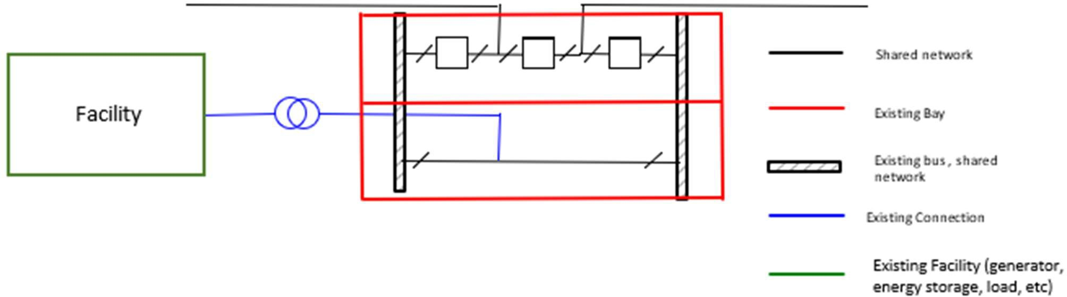

In this arrangement, one bay is occupied by the line cut-in (which is shared transmission network infrastructure) and a second bay is occupied by a single connection. Additional bays may be constructed to accommodate future connections or line cut-ins.
If all costs reflect the provision of negotiated transmission services, the connection applicant (Applicant A) must pay all costs associated with this terminal station.

Example 1a: Connection of additional facility to an existing breaker-and- a-half arrangement
Figure 2 represents an existing breaker-and-a-half arrangement with one existing and one future connection.
Figure 2: Illustration of example 1a
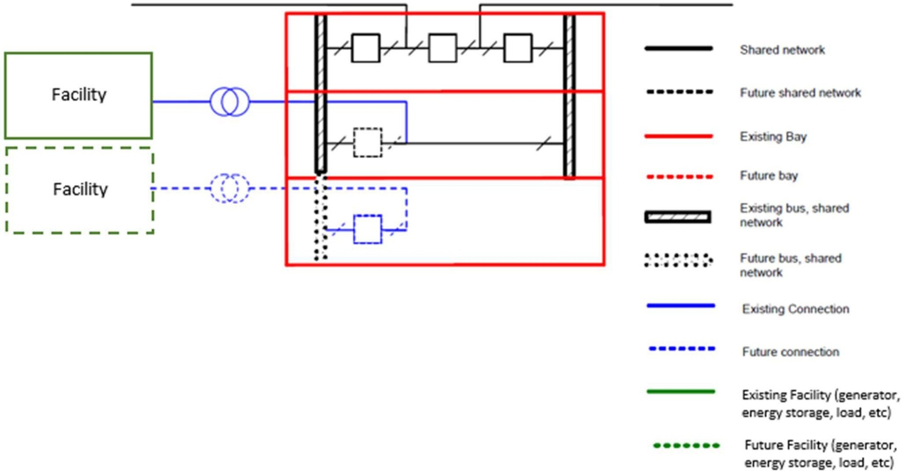
In this example, Applicant B connects its facility to one bus in a new bay, where the connection does not require connection to a second transmission line.
Applicant B would pay for the following:
- Establishment of one additional half bay to enable the connection of its facility.
- Installation of one circuit breaker in the existing bay connecting the existing facility.
- A portion of the costs of the transmission line diversion and interface works based on the relative MW capacity of its facility.
- One third of the transmission line cut-in bay.
- One third of the payment stream for the land costs of the terminal station and remaining station assets (common facilities) excluding switchyard bays and connection assets.
Applicant A’s payments for existing station assets and land would be reduced by an amount equal to the contributions from Applicant B as listed above.

Example 1b: Expansion of breaker-and-a-half arrangement to a double- line connection
In this example, a third generating plant is connecting to the terminal station, requiring the terminal station to be switched to a second connecting line. The expanded arrangement is shown in Figure 3.
Figure 3: Illustration of example 1b
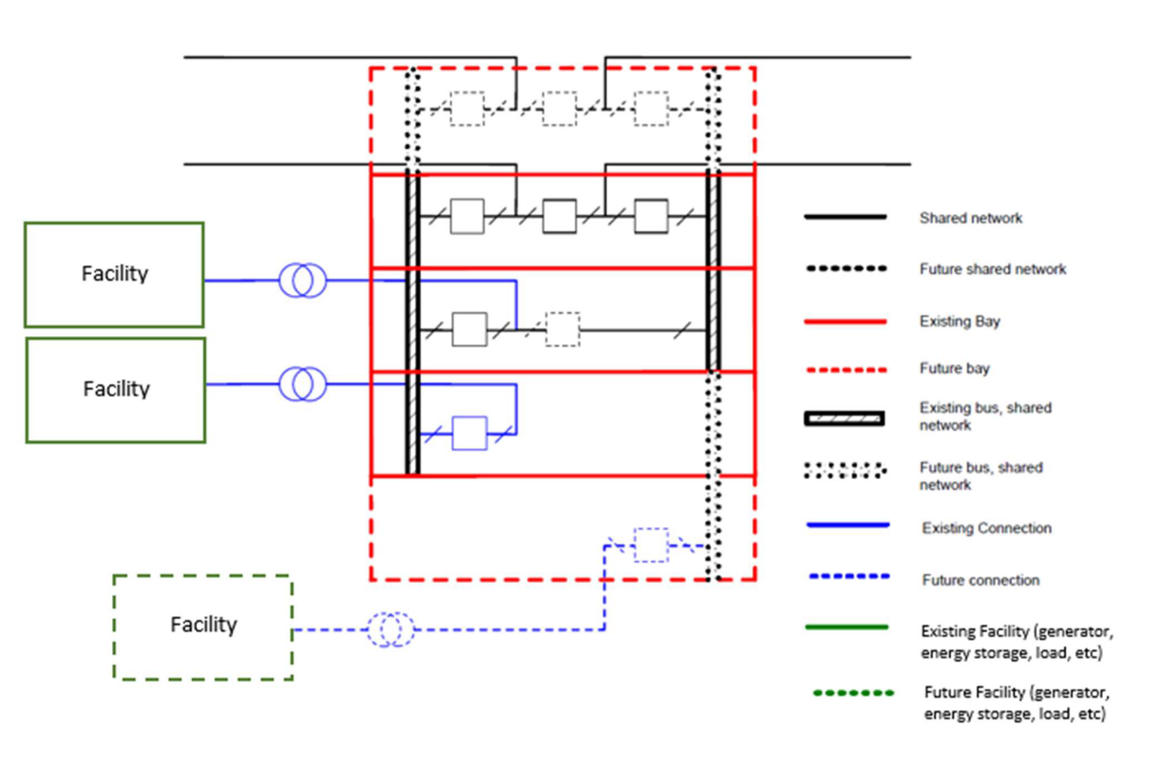
Applicant C would pay for the following:
- Second transmission line diversion costs.
- Interface works to connect the second transmission line.
- Bay housing the connection for the second transmission line.
- Establishment of one additional half bay to enable the connection of its facility.
- Extension of one bus across an existing bay to enable connection to the additional bay, including the installation of an additional circuit breaker in the bay connecting Applicant A.
The methodology for determining contributions from Applicant C and subsequent connection applicants to negotiated service costs incurred prior to the connection of the third facility shall be developed in consultation with stakeholders.

Example 2: Development of a tee connected station
Figure 4 represents a tee connection with two connections. This non-standard tee arrangement is representative of some existing terminal stations. Applicant A’s facility, Site A, occupies two bays, while Applicant B’s facility, Site B, is to occupy one bay.
Figure 4: Illustration of example 2
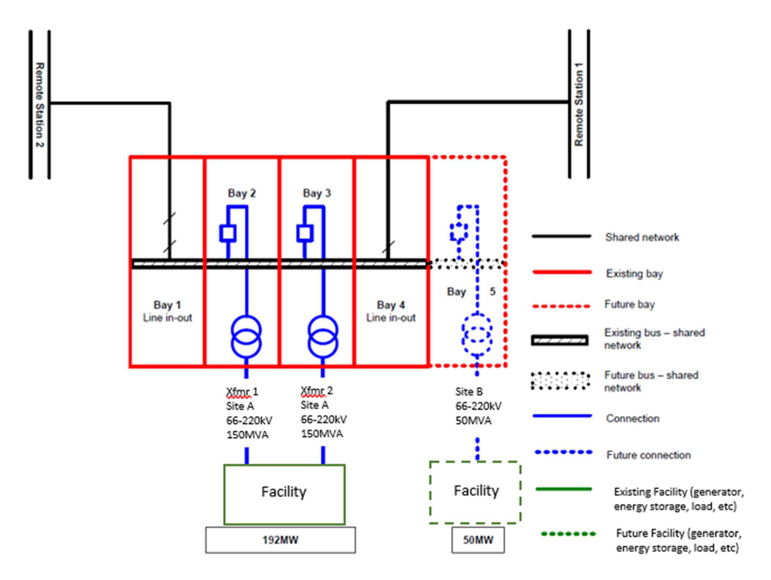
Assuming that this terminal station:
- Is designed to accommodate up to nine bays. Two bays are initially occupied by line cut-ins (shared transmission network infrastructure) and the remaining seven bays can be used to accommodate connections or future line cut-ins.
- Was wholly funded by Applicant A.
On connection of Site B, Applicant B would pay for:
- Establishment of one additional half bay (Bay 5) to enable the connection of Site B.
- 21% of the costs of the transmission line diversion and interface works [50 MW / (50 MW+192 MW)].
- One third of the transmission line cut-in bay.
- One third of the payment stream for the land cost of the terminal station and cost of the Common Facilities, excluding switchyard bays and connection assets.
Applicant A’s payments for existing station assets would be reduced by an amount equal to the contributions from Applicant B as listed above.

Example 2a: Expansion stage for a tee connection to double switching arrangement
Figure 5 represents a typical double switched arrangement with two existing connections (192 MW and 50 MW) plus one future additional facility connected to the terminal station.
Figure 5: Illustration of example 2a
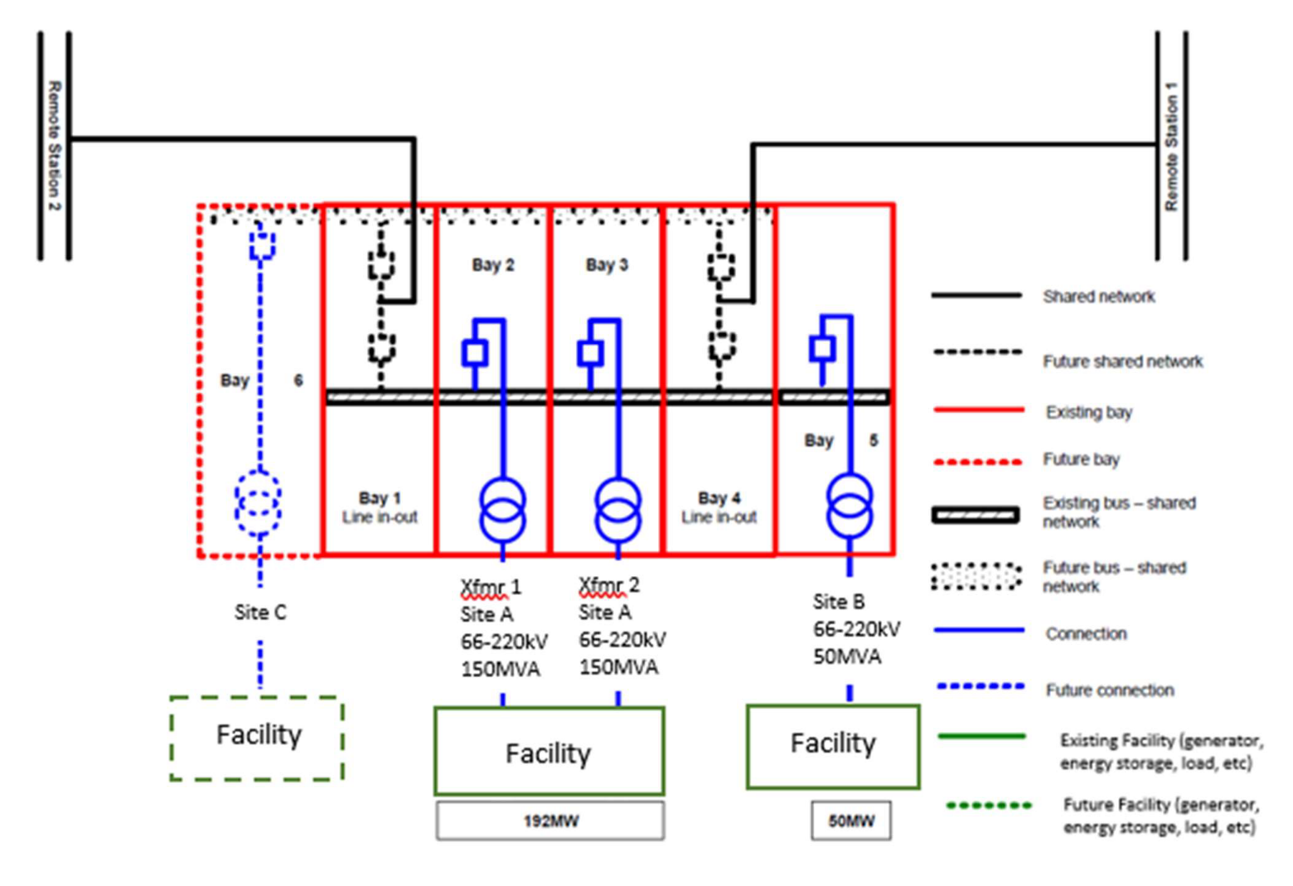
In this example, connection of Site C by Applicant C requires establishment of a second bus and four shared network transmission line circuit breakers.
Applicant C would pay for the following:
- Modification to line interface works to accommodate a double switching arrangement.
- Establishment of the second (No 2) 220 kV bus running through Bays 1, 2, 3 and 4.
- Modification to two bays (Bay 1 and Bay 4) housing the two transmission line connections, including installation of four new CBs and all associated connecting plant.
- Establishment of one additional half bay (Bay 6) to enable the connection of Site C.
The methodology for determining contributions from Applicant C and subsequent connection applicants to negotiated service costs incurred prior to the connection of Site C shall be developed in consultation with stakeholders.

Example 2b: Incremental stage for connection of additional generating point
Figure 6 represents a typical double switched arrangement with three existing connections (Site A, Site B and Site C) plus one future additional facility connected to the terminal station.
Figure 6: Illustration of example 2b
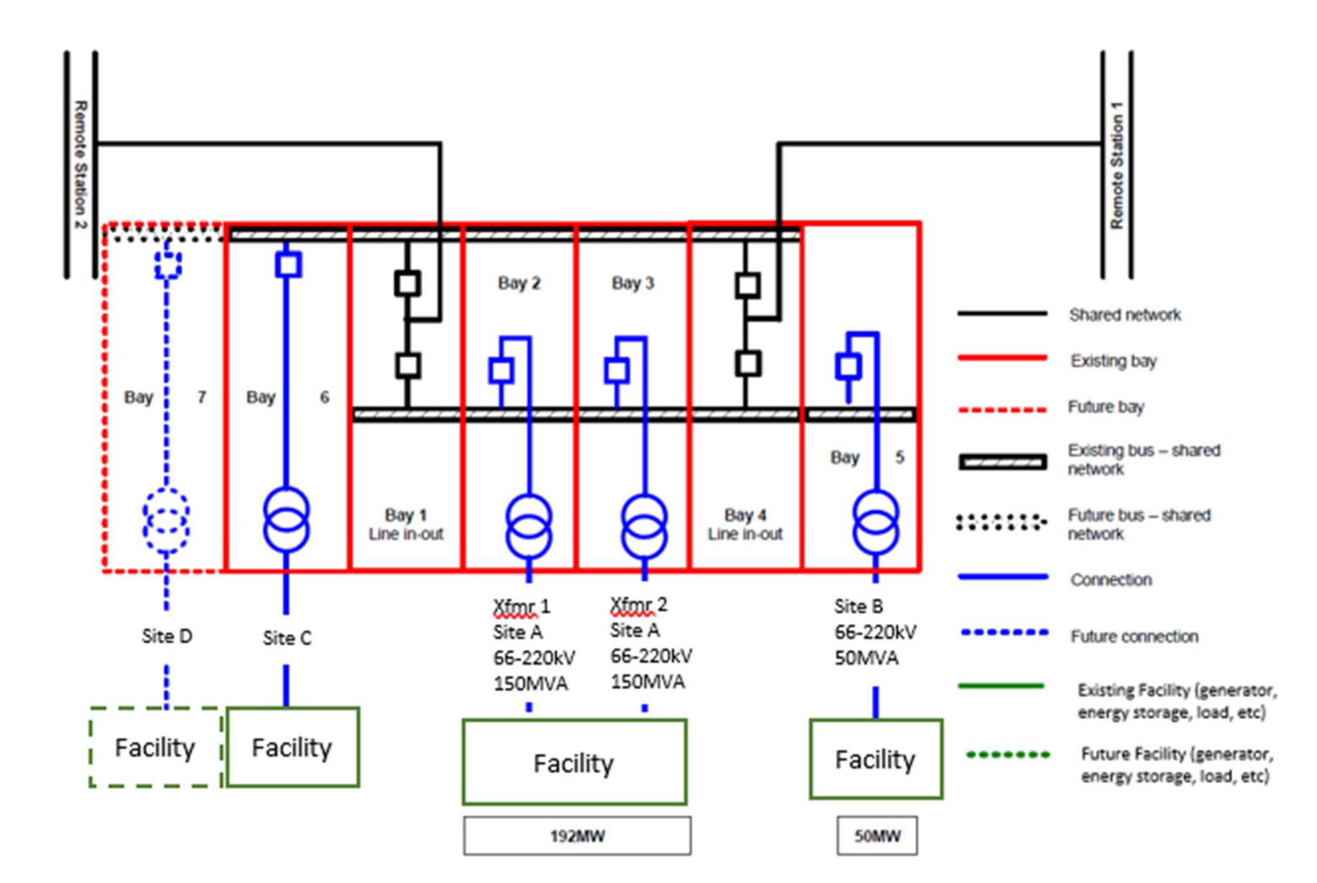
In this example, Applicant D connects Site D to the No 2 bus in a new Bay 7 adjacent to Bay 6, where the connection requires only the construction of that new bay.
Applicant D would pay for the following:
- Establishment of one additional half bay (Bay 7) to enable the connection of Site D.
- A portion of the costs of the transmission line diversion and interface works associated with the previous expansion to accommodate Site C based on the MW capacity of Site D relative to the MW capacity of Site C.
- Half the payment stream for the remaining costs paid by Applicant C:
- Establishment of the second (No 2) 220 kV bus running through Bays 1, 2, 3 and 4.
- Two bays (Bay 1 and Bay 4) housing the two transmission line connections, including four new CBs and all associated connecting plant.
Applicant C’s payments for existing station assets would be reduced by an amount equal to the contributions from Applicant D as listed above.
The methodology for determining contributions from Applicant D and subsequent applicants to negotiated service costs incurred prior to the connection of Site D shall be developed in consultation with stakeholders.

Example 2c: Expansion stage for connecting a double switching arrangement to a second line
Figure 7 represents a typical double switched arrangement with three existing connections (Site A, Site B and Site C) plus one future additional facility connecting to the terminal station.
Figure 7: Illustration of example 2c
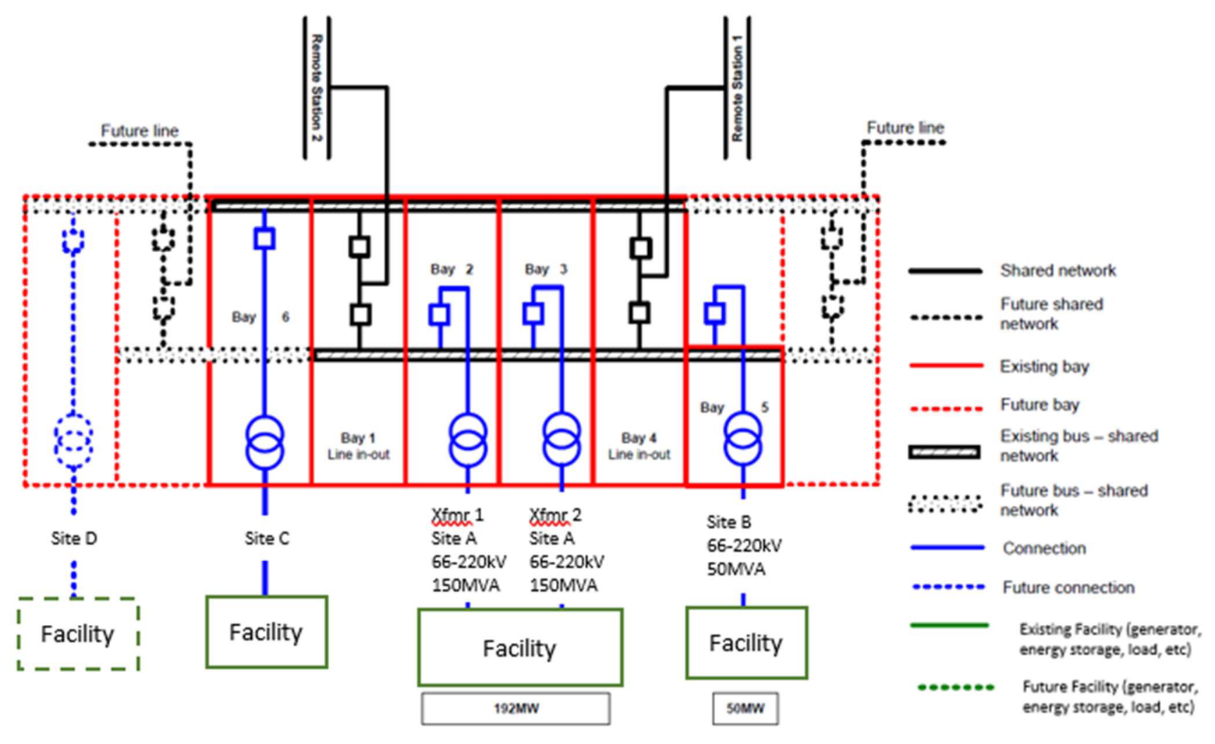
In this example, connection of Site D by Applicant D requires connection of the station to a second line. This will involve extensions to both busbars and insertion of up to four shared transmission network line breakers.
Applicant D would pay for the following:
- Second transmission line diversion costs.
- Interface works to connect the second transmission line.
- Establishment of one single switched (half) bay to enable the connection of Site D.
- Two bays, each with a connection to the second transmission line in a double CB switched arrangement.
The methodology for determining contributions from Applicant D and subsequent applicants to negotiated service costs incurred prior to the connection of Site D shall be developed in consultation with stakeholders.

