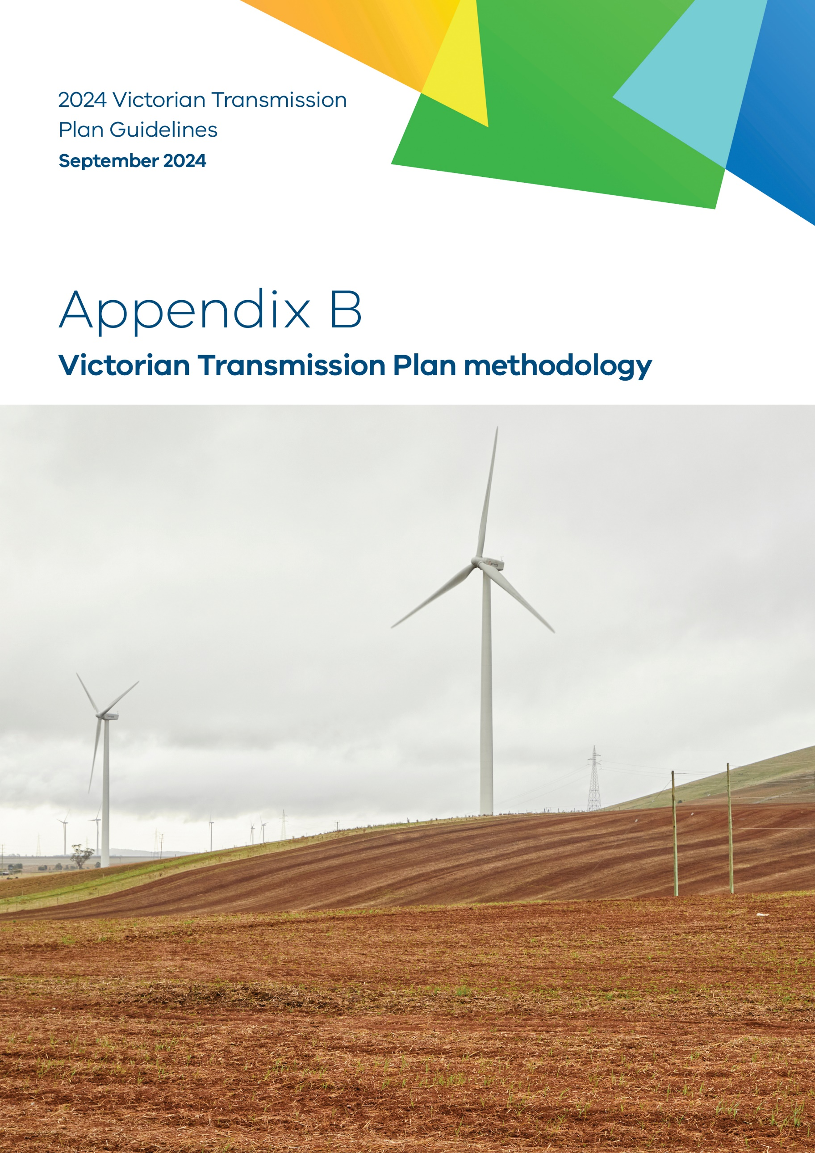
co

- VTP methodology

Purpose
This is Appendix B to the 2024 Victorian Transmission Plan Guidelines (2024 VTP Guidelines) originally published as a draft on 22 July 2024.
VicGrid is changing the way energy infrastructure is delivered in Victoria. We are putting in place a long-term strategic plan – the Victorian Transmission Plan (VTP) – to ensure we have the right infrastructure in the right place at the right time to support the energy transition.
As set out in the amendments to the National Electricity (Victoria) Act 2005 (the Act) passed in May 2024, VicGrid is required to develop and release the inaugural VTP by mid-2025. This will guide Victoria’s smooth transition to renewable energy as coal-fired retire in the following decade.
VicGrid is required to prepare and publish a set of guidelines called the 2024 Victorian Transmission Plan Guidelines (2024 VTP Guidelines) (this document), which outline how the 2025 VTP will be developed. This appendix provides further technical details on the content included in the main guidelines.
Disclaimer
The publication of the 2024 VTP Guidelines is pursuant to amendments to the National Electricity (Victoria) Act 2005 passed in May 2024, which implement the first stage of Victorian Transmission Investment Framework reforms and empower the CEO VicGrid to develop a Victorian transmission plan.
The State of Victoria and its employees do not guarantee that the publication is without flaw of any kind or is wholly appropriate for your particular purposes and therefore disclaims all liability for any error, loss or other consequence which may arise from you relying on any information in this publication.
This publication does not include all of the information that an investor, participant or potential participant in the National Electricity Market might require, and does not amount to a recommendation of any investment.
The information in this document is current at the time of printing and remains subject to change and should not be relied upon. Please visit vicgrid.vic.gov.au for the latest updates.
Copyright
© The State of Victoria Department of Energy, Environment and Climate Action 2024

Contents

Appendix B VTP methodology 1
B.1 Overview of the VTP methodology 5
B.2 Modelling for the 2025 VTP 7
B.2.1 Energy market modelling 7
B.2.2 Power systems analysis 8
B.3 Step 1 – Identifying areas for investigation 9
B.3.1 Identifying the study area 9
B.3.2 Identifying areas for investigation 9
B.4 Step 2 – Developing the generation resource plans and candidate areas 10
B.4.1 Developing the initial generation resource plans 10
B.4.2 Refine areas for investigation to candidate areas 11
B.5 Step 3 – Developing candidate transmission pathways 11
B.6 Step 4 – Assessing candidate transmission pathways 12
B.6.1 Cost-benefit analysis 12
B.6.2 Robustness analysis 13
B.6.3 Strategic land use assessment phase 2 15
B.7 Step 5 – Developing the final optimal pathway 15
B.7.1 Development of the final optimal pathway 15
B.7.2 Development of the final areas of interest for transmission projects 15


Acronyms
Term | Definition
AEMO | Australian Energy Market Operator
CER | Consumer energy resources
EV | Electric vehicles
GW | Gigawatt (one million kilowatts)
GWh | Gigawatt hour (one million kilowatt hours)
IAP2 | International Association of Public Participation
IASR | Inputs, Assumptions and Scenarios Report
IEC | International Electrotechnical Commission
IEEE | Institute of Electrical and Electronics Engineers
ISP | Integrated System Plan
MCA | Multi-criteria analysis
MW | Megawatt (one thousand kilowatts)
MWh | Megawatt hour (one thousand kilowatt hours)
NCC | National Construction Code
NEM | National Electricity Market
NER | National Electricity Rules
NEVA | National Electricity (Victoria) Act 2005
ODP | Optimal development pathway
PSS/E | Power system simulation for engineering
PV | Photovoltaic solar
RAP | Registered Aboriginal Parties
REZ | Renewable energy zone
RRN | Regional reference node
TW | Terawatt (one billion kilowatts)
TWh | Terawatt hour (one billion kilowatt hours)
VAPR | Victorian Annual Planning Report
VCR | Value of Customer Reliability
VEU | Victorian Energy Upgrades
VPP | Virtual Power Plant
VRET | Victorian Renewable Energy Targets
VTIF | Victorian Transmission Investment Framework
VTP | Victorian Transmission Plan
WACC | Weighted average cost of capital

Appendix B: VTP methodology – content summary
This appendix details the proposed methodology for developing the 2025 Victorian Transmission Plan (VTP), which involves the following 5 steps:
- Identifying areas for investigation for renewable energy generation
- Developing the generation resource plansand candidate areas
- Identifying candidate transmission pathways
- Assessing candidate transmission pathways
- Developing the final optimal pathway.
This appendix describes how each step will be completed, including brief descriptions of the tools and models we will use.
- Overview of the VTP methodology
The VTP methodology has been developed as a 5-step process designed to answer these questions:
- What areas are most suitable for renewable energy generation?
- How much wind or solar energy should we be planning for in each area?
- What additional or upgraded transmission infrastructure is needed to connect potential energy projects to the grid?
- When do we need additional or upgraded transmission infrastructure?
- What is the right mix of generation and transmission projects that is robust across all scenarios?
Section B.3 summarises the VTP methodology, including the key analysis activities, decision-making tools and outputs for each step. These steps are shown in Figure B-1 and described in further detail in sections B.3 to B.7. It should be noted that Figure B-1 presents these steps sequentially to summarise the VTP methodology on a single page; however, in practice, a number of these activities will occur in parallel and have complex interdependencies.

Figure B-1: Summary of the VTP methodology
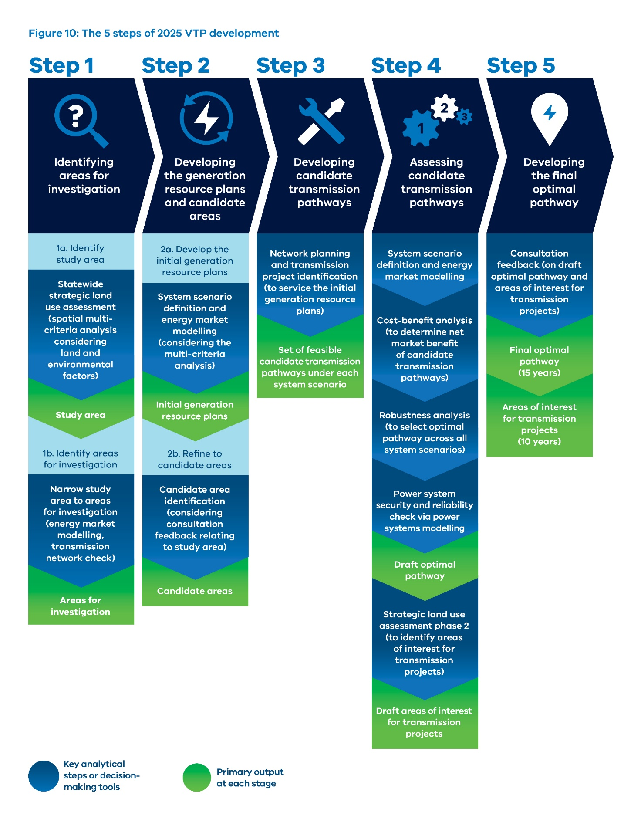
- Modelling for the 2025 VTP
Many of the methodological steps will be underpinned by energy market modelling and power systems analysis. This section explains the role of these modelling exercises and the approaches that will be taken.
- Energy market modelling
Energy market modelling will inform decisions by assessing future whole-of-system outcomes under different scenarios. This involves comparing types of costs0 to determine the least-cost path to meet demand and policy objectives as the energy system evolves.
We will undertake 2main modelling phases as part of the methodology:
- Long-term capacity expansion modelling (LT): LT determines the least-cost generation mix under a high-level network topology while meeting demand, policy objectives and assumed retirement of coal-fired power stations. Long-term modelling will identify suitable locations for new generation and provide the basis for network and transmission planning to connect these areas to the existing system.
- Short-term modelling (ST): ST uses the new entrant profile and transmission build path from the previous stage and considers additional network constraints to optimise the dispatch of electricity at half-hourly intervals. In this methodology, short-term modelling will be used to validate investment determined by the LT modelling and as the interface with power system modelling.
All market modelling will be undertaken with PLEXOS, an energy market modelling software that is widely used in industry. PLEXOS enables economic, policy and technical constraints to be overlaid on the standard electricity dispatch formulation. It also allows optimisation parameters, granularity and horizon to be selected. Figure B-2 illustrates the process flow.
Figure B-2: Energy market modelling process flow

- Power systems analysis
Power system modelling is a specialised approach used to represent the intricate workings of electrical power systems through computational simulations. To do this, we will use a power system simulation for the engineering (PSS/E) model, an advanced tool widely used within the industry. PSS/E is a software application that simulates the transmission network under various operational conditions. For the 2025 VTP, it will provide a comprehensive environment for system planning and operation, including load-flow studies, stability analysis, short-circuit analysis, and many other functions essential for ensuring network reliability and efficiency.
PSS/E will be particularly valuable for its ability to model the complex behaviours of power systems with precision and flexibility. It can handle large-scale power networks and simulate how changes in the system, such as the introduction of new generators or loads, or modifications to the network configuration, will impact overall system performance. Through its extensive library of component models and the ability to customise and extend these models, it supports detailed analysis of system response to various operating scenarios.
This process is crucial for ensuring that the power grid remains stable and efficient, minimising outages, and adapting to the evolving demands of energy consumers. Power system modelling serves as a foundational tool for designing and operating electricity networks that are both resilient and sustainable.
- Step 1 – Identifying areas for investigation
Step 1 of the methodology identifies areas for investigation for renewable energy generation, which will be achieved through a 2-part process. The first part involves a statewide strategic land use assessment to identify a renewable energy zone study area (study area). The study area shows the parts of Victoria that have potential to host a renewable energy zone (REZ), which would coordinate new energy system infrastructure, such as wind and solar generation, as well as supporting transmission lines. The second part will incorporate energy market modelling and further spatial analysis to develop areas for investigation, which will be smaller areas where generation, storage and potentially transmission infrastructure may be located within the study area.
- Identifying the study area
The key analytical step involved in identifying the study area was a strategic land use assessment.
As outlined in Section 2, the strategic land use assessment is a new land use planning process introduced into Victorian transmission planning arrangements by VicGrid under the Victorian Transmission Investment Framework (VTIF) reforms. The first phase of the assessment will inform the development of the study area.
The assessment is undertaken using a spatial multi-criteria analysis, which considers existing land uses and landscape features across the state from a number of perspectives, tailored to the needs of the 2025 VTP.
The objective of the spatial multi-criteria analysis for the strategic land use assessment is to identify areas for potential renewable energy generation that can minimise the overall impacts of development to land use and landscape values, while also keeping the costs of energy low and attracting renewable energy and transmission investment. The assessment aims to proactively assess and consult early to ensure new energy infrastructure development is planned in a way that avoids important regional and rural assets, values and landscapes and manages a range of relevant competing land uses.
- Identifying areas for investigation
The areas for investigation capture suitable locations to host generation, storage and potentially transmission infrastructure based on a range of factors additional to the strategic land use assessment. Two steps will be used to narrow the broader study area to areas for investigation.
The first step involves energy market modelling. This modelling will provide an understanding of the spatial distribution of Victoria’s generation needs and highlight smaller areas within the study area that are most suited to generation development from an economic standpoint (referred to as a least-cost generation mix). This initial energy market modelling considers a ‘maximum’ build scenario to consider all the potential areas for generation siting that could be identified through the subsequent scenario-specific modelling in Step 2.
While the strategic land use assessment includes an initial reprioritisation of certain areas based on distance to key transmission network assets, the second step to identify the areas for investigation involves a network planning review to assess the feasibility of connecting the identified areas to the transmission network. By exception, certain areas will be excluded based on a high-level assessment of project feasibility and/or cost implications.
The primary output from Step 1 will be areas for investigation. This serves as a starting point to begin identifying potential transmission project options in Step 3.
- Step 2 – Developing the generation resource plans and candidate areas
Step 2 of the methodology also has 2 parts. The first part focuses on the development of an initial generation resource plan for each system scenario. This then serves as a primary input to identify candidate areas.
- Developing the initial generation resource plans
Further energy market modelling will be used to develop scenario-specific areas for investigation and an associated generation resource plan.
The energy market modelling will be undertaken for one or more system scenarios (refer to Section 4 for further information on scenarios, inputs and assumptions). A range of system scenarios will be developed and refined to represent high impact but plausible future development of demand and supply conditions in the Victorian energy sector over the next 25 years. These will be largely aligned with scenarios considered in AEMO’s ISP.
The energy market modelling will consider the generation and storage assets required to meet Victoria’s energy needs in parallel with the complexities of energy economics. It will determine the least-cost system mix to meet demand and various government policies in each scenario. In addition to the standard generation cost, the energy market modelling in Step 2 will consider the different costs of developing new transmission capacity at various locations by using AEMO’s 2024 ISP’s linearised ($/MW) REZ transmission augmentation costs as a proxy.
For each system scenario, the generation resource plan will outline:
- which technologies to build (including storage)
- how much capacity to build
- when to build new capacity
- the location of the new generation build.
Critically, the modelling accounts for the potential for developing battery energy storage systems (BESS) to reduce transmission needs.
To incorporate broader qualitative factors in addition to the least-cost generation outcome, the location of the new generation build will consider a spatial multi-criteria analysis. This will provide valuable information on whether certain areas should be reprioritised based on the factors considered. The multi-criteria analysis will consider the following:
- Community preferences relating to the development of renewable energy generation and transmission infrastructure across Victoria;
- Land use, through detailed land-use information from the strategic land use assessment
- Generator/developer interest, including information obtained from a survey for developers of generation and storage projects; and
- Regional development indicators to assess the comparative strengths of Victoria’s regions in relation to REZ development, and how hosting a REZ could support other regional development opportunities.
We will also consider the size and location of in-service and committed generation projects. This will ensure the overall level of development in a region is considered when determining the most appropriate locations for siting future generation across the State.
The multi-criteria analysis will form an input into subsequent iterations of energy market modelling. The generation resource plan for each scenario then provides the starting point from which to identify Victoria’s transmission needs over time and will inform the power systems analysis and development of candidate transmission pathways in Step 3 of the methodology.
Section 6 of the 2024 VTP Guidelines explains how we will engage with communities and industry to develop the 2025 VTP.
- Refine areas for investigation to candidate areas
Refining areas for investigation to candidate areas is a dynamic component of the methodology. This process will consider the following:
- the study area map outlined in Step 1, based on the statewide strategic land use assessment analysis;
- the scenario-specific generation resource plans derived from the energy market modelling in Step 2; and
- feedback received through ongoing engagement with First Peoples, community and industry stakeholders; and
- where relevant, components of the multi-criteria analysis.
Based on the above, the scenario-specific generation locations from the energy market modelling will be converted into more defined geographical areas in Victoria. These candidate areas will take into consideration the underlying land use features, as well as ongoing consultation with First Peoples, community and industry. This process will also ensure the candidate areas are large enough to accommodate the generation resource plan.
A subset of these candidate areas will be prioritised to deliver the draft optimal pathway (see Step 4) and will form the draft proposed REZs. These will be published in the draft 2025 VTP and be consulted on through community and industry engagement. The 2025 VTP will publish the optimal pathway (see Step 5), and will inform the development of proposed REZs for the next 15 years. There will subsequently be a statutory process to declare REZs, noting that this sits outside the scope of the 2025 VTP.
- Step 3 – Developing candidate transmission pathways
The transmission capacity required to support the generation resource plan will be informed by generation location results from the energy market modelling in Step 2. By reviewing this against the existing transmission network capacity, constraints in the base transmission network will be identified.
Transmission network planning will be used to identify a number of candidate transmission project options that could relieve these hosting capacity constraints. A technical appraisal of the options will be performed using power systems analysis, and high-level cost estimates will be derived to inform additional energy market modelling.
The candidate transmission project options will connect candidate areas to the Declared Shared Network (DSN). Augmentations to the DSN (both upgrades and new assets) to address additional generation transmission capacity will also be identified.
This process will combine a series of candidate transmission project options across the modelling horizon, and a set of candidate pathways will be developed.
The primary outputs from Step 3 will be a series of candidate transmission pathways required to support the generation needs identified for each system scenario. The candidate transmission pathways will be a set of potential transmission projects that are technically feasible and cost-effective.
- Step 4 – Assessing candidate transmission pathways
Step 4 of the methodology uses a number of decision-making tools to assess the candidate transmission pathways across system scenarios. This includes energy market modelling followed by cost-benefit analysis and robustness analysis.
Energy market modelling in this step follows the same approach outlined in Step 2. The key difference is that the candidate pathways, including the attendant impact on REZ hosting capacity and transfer capacity to major load centres, will be included as an exogenous input to the modelling in place of the linearised $/MW transmission augmentation based on AEMO’s ISP inputs.
The energy market model will re-optimise generation investment and dispatch outcomes under each candidate pathway for every scenario. The outputs from this modelling will include a number of measures, such as generation capital and operational expenditures, unserved energy, and emissions outcomes, that will inform the cost-benefit analysis and robustness analysis.
A second phase of statewide strategic land use assessment analysis will also be undertaken to identify areas of interest for transmission corridors for the next 10 years of transmission projects identified in the optimal pathway.
- Cost-benefit analysis
A cost-benefit analysis will be used to systematically compare the costs and benefits of the candidate pathways for each system scenario against a counterfactual development path for the same respective system scenario. The cost-benefit analysis will determine the net market benefits associated with each candidate pathway, which will form a key input into the robustness analysis.
The counterfactual development path serves as the reference point for the economic analysis and represents a future with no network augmentation other than committed and anticipated projects, or small intra-regional augmentations and replacement expenditure projects. Appendix D outlines the range of existing and in-progress transmission projects (as outlined in the 2024 ISP and Victorian Annual Planning Report), including Western Renewables Link, Victoria to NSW Interconnector Westand Marinus Link (Stage 1).
The cost-benefit analysis will consider the full spectrum of impacts (costs and benefits) attributable to each candidate pathway to determine the net market benefits. The cost-benefit analysis in the 2025 VTP will broadly align with the Australian Energy Regulator’s (AER) CBA guidelines. In addition to the benefits described in the AER guidance (which denotes market benefits accruing to those who consume, produce and transport electricity in the market), the VTP CBA will consider a holistic view of benefits – both qualitative and quantitative (to the extent possible). This will enable non-market benefits to be considered, including environmental, economic and social impacts. This will ensure that the VTP CBA is consistent with the Department of Treasury and Finance Economic Evaluation Technical Guidelines and best-practice within the infrastructure sector.
In terms of costs, this cost-benefit analysis will consider:
- costs incurred in constructing or providing the projects within each candidate pathway
- operating and maintenance costs in respect of projects within each candidate pathway.
In terms of benefits, the draft 2025 VTP will clearly set out and justify the range of benefit and cost categories (and quantification approach) used within the cost-benefit analysis. As an example, the range of benefit categories is likely to include:
- capital expenditure savings
- fuel cost savings
- changes in involuntary load shedding
- emissions reductions
- differences in timing of expenditure
- changes in network losses.
- Robustness analysis
A robustness analysis will be undertaken for the candidate pathways across all system scenarios to identify the optimal pathway. This will be the most robust candidate pathway under all scenarios and uncertainties, minimising potential costs while maintaining electricity security and reliability for Victorian consumers.
The robustness analysis determines ‘regrets’ (or benefits foregone) for each candidate pathway option across each scenario, with the most robust option being the one that has the lowest amount of regret in any one scenario. The ‘regrets’ determined through this analysis are reflective of the benefits and costs considered through the cost-benefit analysis. As noted in Section B.6.1, the benefits quantified will largely align with the classes of market benefits defined within the AER CBA Guidelines, which are predominantly financial in nature. Where the quantum of ‘regrets’ is similar across multiple candidate pathways, non-financial parameters will be taken into consideration to assist in determining the optimal pathway.
Table B-1 and Table B-2 show an illustrative example of the robustness analysis. In this example, three system scenarios with weightings have been modelled and three candidate pathways are assessed against these scenarios. The conceptual net market benefits of each candidate pathway are shown in Table B-1, which would have been computed through a hypothetical cost-benefit analysis. The candidate pathway with the highest net market benefit under the range of scenarios is shown in bold.
Table B-1: Conceptual example – net market benefits ($m)
Scenario | Scenario 1 | Scenario 2 | Scenario 3
Weighting | 50% | 10% | 40%
Candidate pathway 1 | $200m | $180m | $220m
Candidate pathway 2 | $150m | $200m | $240m
Candidate pathway 3 | $150m | $300m | $200m
Maximum net market benefits for each scenario | $200m | $300m | $240m
Note: m = millions
Table B-2 then shows the ‘regrets’ associated with each of the candidate pathways under each scenario. The regret for each candidate pathway is the difference between its net market benefits and the optimal pathway for that scenario (i.e. the maximum net market benefits for each scenario).
The worst regret for each candidate pathway is shown in bold. In this conceptual example, the candidate pathway with the least-worst regret prior to consideration of scenario weightings is candidate pathway 3 – with a worst regrets of $50 million. However, when scenario weightings are incorporated, candidate pathway 2 is seen to have the least worst regrets. This candidate pathway is therefore deemed the optimal candidate pathway, exhibiting the lowest level of regret and thus most resilient in the face of uncertainty (based on the assigned scenario weightings).
Table B-2: Conceptual example – regrets analysis ($m)
Scenario | Scenario 1 | Scenario 2 | Scenario 3 | Worst regret | Weighted worst regret
Weighting | 50% | 10% | 40% | Worst regret | Weighted worst regret
Candidate pathway 1 | $0m | $120m | $20m | $120m | $12m
Candidate pathway 2 | $50m | $100m | $0m | $100m | $10m
Candidate pathway 3 | $50m | $0m | $40m | $50m | $25m
Note: m = millions

To evaluate the technical feasibility of the draft optimal pathway, a final power systems analysis check will be undertaken using the short-term dispatch model. This technical assessment seeks to ensure that the power system can operate securely, and meet reliability requirements. Through this process, any potential network constraints will be identified.
The development of the draft optimal pathway co-optimises the generation build, dispatch patterns and enabling transmission while meeting the needs of the system scenarios. This process will bring together the network constraints identified by the power systems analysis with the transmission project identification and energy market modelling and ultimately inform any updates to the draft optimal pathway.
The primary output from Step 4 is the draft optimal pathway for the next 15 years. This will be published in the draft 2025 VTP in early 2025, and feedback will be sought to inform the development of the final optimal pathway in Step 5.
- Strategic land use assessment phase 2
The second phase of the strategic land use assessment will be undertaken alongside the development of the draft optimal pathway. The purpose of phase 2 is to identify areas of interest for transmission corridors for the next 10 years of transmission projects identified in the optimal pathway. These areas will be considered by the Minister and ultimately may be defined and included as part of each REZ declaration.
For the 2025 VTP, we will identify areas of interest for transmission corridors for the next 10 years of transmission projects within the optimal pathway. Further detail regarding phase 2 of the strategic land use assessment is provided in Appendix A.
- Step 5 – Developing the final optimal pathway
Step 5 of the methodology develops the final optimal pathway. This step will incorporate stakeholder feedback on the draft optimal pathway (through consultation on the draft 2025 VTP) to develop a final optimal pathway and final areas of interest for transmission corridors.
- Development of the final optimal pathway
The draft optimal pathway developed in Step 4 will be published for consultation as a part of the draft 2025 VTP. Relevant stakeholder feedback received during consultation on the draft 2025 VTP will be used to confirm the final optimal pathway. The final optimal pathway will outline the transmission infrastructure projects required to enable REZ development over the next 15 years.
- Development of the final areas of interest for transmission projects
Similar to the optimal pathway, the draft areas of interest for transmission projectsdeveloped in Step 4 will be published for consultation as a part of the draft 2025 VTP, with relevant stakeholder feedback received during the consultation period to be considered. This step will outline the final areas of interest for those transmission projects needed in the next 10 years to enable development of proposed REZs.



This includes, for example, the cost to build and connect new generation, operate generation infrastructure (including fixed, variable and fuel costs) and the cost of unserved energy.

