VicGrid

Planning Victoria’s renewable energy zones
  - Updated February 2026
VicGrid is the body responsible for planning and developing the state’s electricity transmission network and renewable energy zones.
Our job is to balance the need for new renewable projects that will deliver reliable, affordable power as coal closes with a range of other factors, including how we minimise impacts on landholders, communities, agriculture, the environment and power bills.
We have run an 18-month process of extensive consultation and technical work to identify 6 proposed renewable energy zones across Victoria, as part of developing the 2025 Victorian Transmission Plan.
Renewable energy zones are areas we’ve identified as suitable for new solar, wind and battery projects. The areas have access to the planned transmission network so energy can flow to homes and businesses across the state.
They are strategic areas that show developers and communities where future development should be focused.
The Victorian Transmission Plan also proposes a Gippsland Shoreline zone, which is a limited area where offshore wind developers will need to locate underground cables to connect offshore wind turbines to the grid. This zone is not designed to host onshore wind and solar farms.

Factors that have shaped decisions
In designing the zones, we considered:
- access to strong winds or sunshine that could produce renewable energy
- access to existing or planned transmission infrastructure
- if farming in the area could potentially co-exist with renewable projects
- impacts on the environment and biodiversity
- impacts on local communities
- impacts on Traditional Owners and culturally sensitive areas
- regional development opportunities
- interest from renewable energy project developers.

It’s your choice
Renewable energy zones don’t change landholders’ rights to choose whether or not to host wind, solar or battery projects on their properties. It’s your choice, and we encourage you to talk to your neighbours about it.

Community engagement has shaped the zones
A lot of consultation and technical work has gone into developing the zones, and we have been listening and responding to the input from communities, landholders, Traditional Owners and industry.
We started the process in early 2024 with a statewide strategic land use assessment that took feedback from the community into account alongside information about agriculture, land use, biodiversity, and cultural and social factors.
This work identified a broad study area. Then we investigated parts of the study area to narrow in on the most suitable places for zones.
We invited feedback on the study area from July to September 2024, and then again on draft proposed zones from May to June 2025.
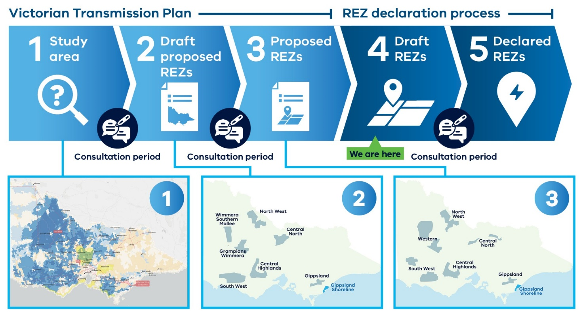
Figure 1 The process to refine and finalise renewable energy zones
Across the consultation periods, we received more than 1,500 feedback forms, 600 submissions and had conversations with more than 800 community members. All this feedback has shaped decisions about each zone’s shape, size and location.
Some areas that were unsuitable for development have been removed from zones, and new areas have been added to some zones.
We recognise the need to engage communities in new areas of zones who have not previously been consulted and listen to local views.
Since the release of the 2025 Victorian Transmission Plan, we have been meeting with community groups and stakeholders in newly added areas to discuss the zones and hear their feedback. This feedback will be taken on board as we work to finalise the zones.

Declaring renewable energy zones
The Minister for Energy and Resources is inviting another round of feedback for consideration before formally declaring each zone.
Declaring zones will allow VicGrid to begin coordinating development within the zones, put in place new rules to manage how projects gain access to the transmission network, and ensure good standards of engagement and economic benefits.

What’s a draft renewable energy zone order?
The Minister issued draft renewable energy zone orders in November 2025 for consultation.
Each draft order sets out:
- a map of the zone
- transmission projects to enable the zone
- the intended hosting capacity that the planned transmission network could support in the zone.
Hosting capacity is the total space that will be available on the grid – for existing generation, committed projects, and new projects within the zone – once planned transmission upgrades are built.
Importantly, the orders make it a requirement that solar, wind and battery projects meet government expectations for community engagement and deliver social value and economic benefits.
The boundaries of the renewable energy zones have not been finalised.
In the final zone orders, the boundaries will be aligned with nearby administrative or other existing boundaries, such as roads, local government areas or planning zones.
This process will be applied in a fair and consistent way across each zone. We will not make decisions about zone boundaries based on localised issues on individual properties or projects. These localised issues can be managed through existing planning and environmental assessments as projects move through approvals.

You are invited to make a submission
We are inviting feedback via submissions on draft renewable energy zone orders. Submissions have been extended and now close on Sunday 15 March 2026.
In designing the renewable energy zones, we’re aiming to encourage development to meet Victoria’s future energy needs while minimising impacts. In this round of consultation, we are seeking any significant new information about sensitive areas, potential impacts or areas suitable for development that we may have missed.
To find out more about each draft zone, provide feedback and to ask us questions:
- Visit the Engage Victoria webpage
- Call us on 1800 418 341 or email enquiries@vicgrid.com.au

Next steps
VicGrid will review all feedback. We will incorporate relevant new information to help us define zone boundaries or other aspects of the draft orders.
We know renewable energy zones will contain some sensitive areas that are not suitable for development, however, we only need a small area of each zone for development.
Feedback about sensitive areas may not lead to changes to the zones if concerns can be managed through existing environmental and planning assessment processes, which will continue to apply to all projects.
Feedback will be considered as part of the declaration process and will also continue to shape decisions as we develop renewable energy zones and the 2027 Victorian Transmission Plan.
The impact and effectiveness of renewable energy zones will be assessed over time, as part of developing future Victorian Transmission Plan updates.

Contact us
Phone: 1800 418 341
Email: enquiries@vicgrid.com.au
Deaf, hearing or speech impaired? Please contact the National Relay Service on 133 677 or communications.gov.au/accesshub/nrs
Need an interpreter? Contact Translating and Interpreting Service (TIS) on 131 450 (within Australia) or visit www.tisnational.gov.au
Disclaimer: The information in this document is current at the time of printing, may be subject to change and should not be relied upon. Please visit vicgrid.com.au for the latest updates.

