Guidelines for Establishing or Connection to Declared Shared Network Terminal Stations and Transmission Lines in Victoria
Prepared by: VicGrid
Version: 1.0
Effective date: 1 November 2025
Status: Final


Important notice
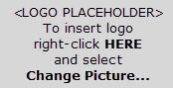

This document is made available on the following basis:
Purpose
These ‘Guidelines for Establishing or Connecting to Declared Shared Network Terminal Stations and Transmission Lines in Victoria’ (Guidelines) have been produced by the VicGrid to provide information about establishing and connecting to terminal stations and transmission lines in the Declared Shared Network in Victoria as at the release date of this document.
N0 Substitute
These Guidelines are not a substitute for, and should not be read in lieu of, the National Electricity Law (NEL), the National Electricity Rules (Rules) and any other relevant laws, codes, rules, procedures or policies. Further, the contents of these Guidelines do not constitute legal or business advice and should not be relied on as a substitute for obtaining detailed advice about the NEL, the Rules, and any other relevant laws, codes, rules, procedures or policies, or any aspect of the National Electricity Market or the electricity industry
No Warranty
While VicGrid has used due care and skill in the production of these Guidelines, neither VicGrid, nor any of its employees, agents and consultants make any representation or warranty as to the accuracy, reliability, completeness or suitability for particular purposes of the information in these Guideline.
Limitation of liability
To the extent permitted by law, VicGrid and its advisers, consultants and other contributors to these Guidelines (or their respective associated companies, businesses, partners, directors, officers or employees) shall not be liable for any errors, omissions, defects or misrepresentations in the information contained in these Guidelines, or for any loss or damage suffered by persons who use or rely on such information (including by reason of negligence, negligent misstatement or otherwise). If any law prohibits the exclusion of such liability, VicGrid’s liability is limited, at VicGrid’s option, to the re-supply of the information, provided that this limitation is permitted by law and is fair and reasonable.
Copyright
© 2025 VicGrid. The material in this document is confidential and should not be disclosed without VicGrid’s permission.

Contents
1 Introduction 1
1.1 Purpose 1
1.2 Intended audience 1
1.3 Definitions and interpretation 1
1.4 Related documents 4
2 Legal and regulatory framework 6
3 Determining the connection arrangement 6
4 Consideration for new terminal station connections 7
4.1 Community engagement 9
4.2 Economics 9
4.3 Planning and environment approvals 9
4.4 Land and easement access 10
4.5 Environmental impact assessments 10
4.6 Terminal station site selection and positioning 10
5 Consideration for existing terminal station connections 11
5.1 Existing terminal station – future connections 12
6 Establishing new terminal stations and transmission lines 12
6.1 Requirements for new terminal stations and transmission lines 12
6.2 Location of new terminal stations and transmission lines 12
7 Connecting to existing terminal stations 19
7.1 Ultimate station configuration 19
7.2 Typical connections into existing stations 19
7.3 Bay allocations 23
7.4 Interfaces 23
7.5 Joint planning 23
8 Design information 23
8.1 General 23
8.2 Safety 24
8.3 Victorian credible contingency limit 24
8.4 Transmission line/cable loading 24
8.5 Short circuit fault ratings 25
8.6 Insulation co-ordination 25
8.7 System strength 26
9 Operational requirements 26
9.1 Maintainability and safety 27
9.2 Reliability of Shared Transmission Network 27
9.3 Site expandability 27
9.4 Protection and control schemes 28
9.5 Site security and cyber attacks 28
10 Management of the Declared Shared Network In Victoria 28
10.1 Risks 28
10.2 Contestability 29
Appendix A – Land area 30
Appendix B – Examples of ultimate station configurations 31
B.1 220 kV ultimate station configuration 31
B.2 500/220 kV ultimate station configuration 31
Appendix C – Expected studies and reports 33

List of Tables
Table 1: Typical connection responsibilities 8
Table 2: Indicative terminal station footprint 13
Table 3: Benefits of fully switched arrangements 14
Table 4: Design considerations 15
Table 5: Bay arrangements 17
Table 6: Fault ratings (kA) 25
Table 7: Location of fault level nodes for Victoria 26
Table 8: Indicative minimum land area requirement for AIS terminal station bays. 30
Table 9: Indicative minimum land area requirement for GIS terminal station bays 30

List of Figures
Figure 1: Connection process flow chart 7
Figure 2: Simplified SLD - New terminal station (before commissioning) 8
Figure 3: Simplified SLD - New terminal station integration into DSN (after commissioning) 9
Figure 4: Connection to an existing terminal station (before commissioning of new connection) 11
Figure 5: Connection to an existing terminal station (after commissioning of new connection) 12
Figure 6: Accepted terminal station build locations for metro Melbourne and rural Victoria. 13
Figure 7: Example of breaker-and-a-half arrangement 21
Figure 8: Example of double breaker – double bus arrangement 22
Figure 9: Example of ultimate single line diagram for 220 kV terminal station 31
Figure 10: Example of ultimate single line diagram for 500/220 kV terminal station 32

Introduction

Purpose
The purpose of this document is to provide guidance on the connection to the Victorian Declared Shared Network (DSN). In Victoria, the transmission network is referred to as the Declared Transmission System (DTS). It comprises the DSN, typically elements rated
132 kilovolts (kV) or higher, and transmission connection assets.
As part of the connection assessments, there may be the requirement for the following, but is not limited to:
- Establishment of a new shared terminal station for a specific location
- Connecting to an existing shared terminal station
- The size and ultimate configuration of the shared terminal station
- Establishment of new shared transmissions lines
- Access and easement rights
The objective is to ensure the Victorian transmission system is developed economically and is technically robust when considering generator, load and energy storage connections, whilst maintaining power quality, security and reliability of the network.

Intended audience
This guidance document is intended to communicate VicGrid’s expectations to the following parties:
- Project developers.
- Transmission and Distribution Planning groups.
- Transmission network connected generators and customers.
- Transmission Network Service Providers (TNSPs) and Declared Transmission System Operators (DTSOs).

Definitions and interpretation

Glossary
Terms defined in the National Electricity Law (NEL) and the National Electricity Rules (NER) have the same meanings in these Procedures unless otherwise specified in this clause.
Terms defined in the NER are intended to be identified in these Procedures by italicising them, but failure to italicise a defined term does not affect its meaning.
In addition, the words, phrases and abbreviations in the table below have the meanings set out opposite them when used in these Procedures.

Term | Definition
AC | Alternating Current (50 Hz in Australia)
AEMC | Australian Energy Market Commission, which is established under section 5 of the Australian Energy Market Commission Establishment Act 2004 (SA).
AEMO | Australian Energy Market Operator Limited
AER | Australian Energy Regulator, which is established by section 44AE of the Competition and Consumer Act 2010 (Cth).
AIS | Air Insulated Switchgear
ALARP | As Low As Reasonably Practicable
AS | Australian Standards
Brownfield | Used to describe an existing site which is already developed and contains assets and services.
CB | Circuit Breaker
Connection Assets | Plant equipment that is owned by the Connection Applicant and typically located behind the facility’s connection point such as connection transformers and HV circuit breakers.
CT | Current Transformer
DAPR | Distribution Annual Planning Report
DB | Distribution Business
DC | Direct Current
DEECA | Department of Energy, Environment and Climate Action (formerly DELWP)
DELWP | Department of Environment, Land, Water and Planning
DNSP | Distribution Network Service Provider – business holding electricity distribution license. Refer to the Essential Services Commission of Victoria for latest transmission licence holders.
DSN | Declared Shared Network
DSP | Design Service Provider
DTS | Declared Transmission System
DTSO | Declared Transmission System Operator – generally a business which holds a transmission licence and are permitted to build, own and operate shared transmission assets.
Easements | A rights legally secured over land belonging to others
EES | Environmental Effects Statement
EHV | Extra High Voltage (typically >= 220 kV)
EMF | Electromagnetic Field
EPA | Environmental Protection Agency
FACT | Flexible AC transmission system device
GIS | Gas Insulated Switchgear
Greenfield | Use to define a parcel of land which is not developed and contains no existing assets and services.
HV | High Voltage
HVDC | High Voltage Direct Current
IEC | International Electrotechnical Commission
Interface Assets | Connects new shared network assets to the existing DSN, which generally relates to transmission line cut-in works and changes to protection, control and monitoring systems.
Isol | Isolator
ISP | Integrated System Plan
LV | Low Voltage
MTS | Mixed Technology Switchgear (e.g. hybrid AIS/GIS)
NEL | National Electricity Law
NEM | National Electricity Market
NEM RTO | National Electricity Market Real Time Operations
NER | National Electricity Rules
NEVA | National Electricity (Victoria) Act 2005
OHS | Occupational Health and Safety
OPGW | Optical Fibre Ground Wire
PLC | Power Line Carrier
RIT-T | Regulatory Investment Test for Transmission
Rules | Refers to the NER
SF6 | Sulphur Hexafluoride
SFAIRP | So Far As Is Reasonably Practicable
Shared  Assets | Relates to transmission lines, transmission tie transformers, busbars, circuit breakers and associated plant.
SiD | Safety in Design
Site | Parcel of land which is legally secured with buffer zones
SLD | Single Line Diagram
STATCOM | Static synchronous compensator – a FACT device which is capable of providing or absorbing reactive current to regulate voltage.
SVC | Static VAR Compensators – a FACT device which is capable of providing fast reactive power to regulate voltage, power factor and harmonics.
TCPR | Transmission Connection Planning Report
TNSP | Transmission Network Service Provider – businesses which hold electricity transmission licences. Refer to the Essential Services Commission of Victoria for the latest transmission licence holders.
TOC | Transmission Operation Centre
TUoS | Transmission Use of System
VAPR | Victorian Annual Planning Report
VT | Voltage Transformer

Interpretation
These Guidelines are subject to the principles of interpretation set out in Schedule 2 of the NEL.

Roles and responsibilities

Victorian Transmission Network Service Provider
In Victoria, VicGrid is delegated certain functions including planning and directing augmentation of the DSN, including DSN connections and procurement of services from third parties . The majority of Victoria’s high voltage (HV) electricity transmission system is currently owned, operated, and maintained by AusNet Transmission Group Pty Ltd (AusNet Services).

Declared Transmission System Operators
In Victoria, the DTS is operated by DTSOs, who can build, own and operate parts of the DSN.
Approved DTSOs hold an electricity transmission licence issued by the Essential Services Commission of Victoria. You can discuss potential DTSO options with us as part of your pre- feasibility discussions.

Transmission Operation Centre
The Transmission Operation Centre (TOC) is the central control room that manages the operation of the DTS. The control centre is operated by AusNet Services, which liaises with VicGrid’s National Electricity Market Real Time Operations (NEM RTO), TNSPs, and other DTSOs.

Related documents
For information on the connections process overview, refer to the following link: https://www.vicgrid.com.au/industry/access-and-connections/transmission-connections-process
These Guidelines should be read in conjunction with the following documents.
Title | Description | Location
Cost allocation policy for Victorian terminal stations: Negotiated transmission services | The purpose of this policy document is to explain how VicGrid will allocate costs between successive connection applicants to arrive at fair and reasonable pricing arrangements for negotiated transmission services that entail connection to multi connection terminal stations on the Victorian DSN. | https://www.vicgrid.com.au/industry/access-and-connections/transmission-connections-process/stage-4-contracts
Cost allocation policy for Victorian terminal stations: Prescribed transmission services | VicGrid has developed this policy to outline how the costs associated with new or expanded terminal stations on the Victorian DSN may be allocated between negotiated and prescribed transmission services.
National Electricity Law | The NEL is contained in a Schedule to the National Electricity (South Australia) Act 1996. It establishes the governance framework and key obligations for the National Electricity Market (NEM), including VicGrid’s role, functions, powers, and the resolution of disputes regarding access to electricity networks. | https://www.aemc.gov.au/regulation/legislation
National Electricity Rules | The National Electricity Rules govern the operation of the NEM. Changes to the NER are made by the AEMC. | https://energy- rules.aemc.gov.au/ner/historic
The NER are made under the NEL and may be amended from time to time in accordance with the NEL.
Chapter 5 contains rules for connection to the transmission network.
Power System Security Guidelines | These Power System Security Guidelines are made in accordance with NER 4.10.1, and form part of the power system operating procedures.  These Guidelines apply to VicGrid and all registered participants | https://www.aemo.com.au/-  /media/Files/Electricity/NEM/Security_an d_Reliability/Power_System_Ops/Proce dures/SO_OP_3715%20Power-System- Security-Guidelines.pdf
Victorian Annual Planning Report | The purpose of the Victorian Annual Planning Report (VAPR) is to provide information relating to electricity supply, demand, network capability, and development for Victoria’s electricity transmission declared shared network. | https://www.vicgrid.com.au/transmission-planning/planning-the-energy-grid
 | VicGrid publishes the VAPR under its declared network functions in Victoria, and in accordance with NER 5.12.
Integrated System Plan | The Integrated System Plan (ISP) is a whole-of-system plan that provides an integrated roadmap for the efficient development of the NEM over the next 20 years and beyond. | https://aemo.com.au/en/energy- systems/major-publications/integrated- system-plan-isp
Transmission Connection Planning Report | This is a joint report on transmission connection asset planning in Victoria, prepared by the five Victorian electricity distribution businesses (DBs), in accordance with the requirements of clause 3.4 of the Victorian Electricity Distribution Code and NER 5.13.2. | Victorian Distribution Network Service Provider website  Website varies from year to year.
System Strength in the NEM Explained | VicGrid has prepared this document to provide general information about VicGrid’s interpretation of the application of the NER relating to system strength in the NEM, as at the date of publication. | https://aemo.com.au/-  /media/files/electricity/nem/system- strength-explained.pdf
Contract Principles: Generation Connections to the Victorian Declared Shared Network | This document demonstrates how VicGrid aims to meet certain obligations in relation to negotiations and contracts for connections to the transmission system in Victoria by Generators. | https://www.vicgrid.com.au/industry/access-and-connections/transmission-connections-process/stage-4-contracts
Connecting Generator Clusters to the Victorian Electricity Transmission Network: A Technical Perspective | This paper looks at some of the planning issues associated with the design and administration of many applications to connect, realising that it is unlikely that all projects will proceed. The timing of connections could also be affected by factors such as economic growth, government policy and the introduction of other technologies. | https://www.vicgrid.com.au/industry/access-and-connections/transmission-connections-process/stage-4-contracts

Legal and regulatory framework
VicGrid is responsible for developing and maintaining the long term economical and technically robust Victorian electricity DSN with the appointed TNSP/DTSOs.
While a range of technical requirements for the establishment of a connection are detailed in the NER, certain technical matters regarding acceptable connection point arrangements are not.
Consistent with its function under Section 50C of the NEL, VicGrid acts to ensure that terminal stations are designed and built so that they do not inhibit any future development in line with VicGrid’s planned augmentations of the DSN, including planning for ultimate station configurations.
Augmenting the DSN can be determined under the following ways:
- By successfully conducting a Regulatory Investment Test for Transmission (RIT-T) under Chapter 5 of the NER.
- By a Ministerial Order made under Section 16Y of the National Electricity Victoria Act (NEVA).
- By a request from a third party who pays for an augmentation of the DSN. This includes requests to connect generators, load, storage and other network and non-network assets to the DSN.
Depending on the manner in which an augmentation is initiated, VicGrid’s roles are to deliver the augmentation, provide network services, and cost recovery.
In particular, costs are recovered:
- If under a RIT-T, via Transmission Use of System (TUoS) charges.
- If at the request of a third party, via the connection applicant.
Approval for practical completion for the works on the DSN is through VicGrid, which will review and approve the commissioning plans prior to proceeding with energisation. Practical completion will be granted once VicGrid is satisfied the DSN construction works comply with VicGrid’s functional specifications.

Determining the connection arrangement
Figure 1 outlines the process to determine the method of connection to the DSN. It is written from the perspective of VicGrid’s interaction with the connection applicant and is integrated with current practices, such as joint planning processes with Distribution Network Service Providers (DNSPs).
Figure 1: Connection process flow chart
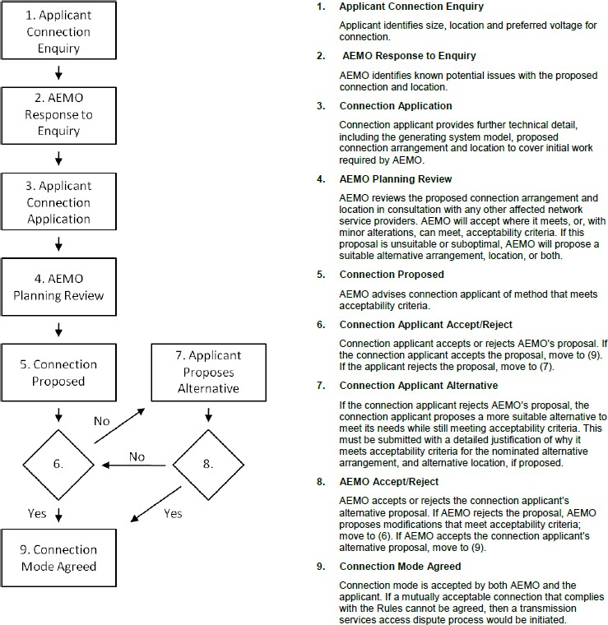

Consideration for new terminal station connections
This section provides an overview on when new terminal stations are required and how they are intended to be incorporated into the DSN to facilitate connection projects whilst minimising impacts to network operability and reliability.
There are two main scenarios when terminal stations are established on the DSN. As described in Section 2, these are through the RIT-T process or by third party connections applicants.
For both scenarios, VicGrid conducts the assessment to determine the need to establish new terminal stations and co-ordinates with connecting proponents. This is subject to the requirements following transmission planning assessments which considers other projects
proposing to connect within the same area of the network and ensuring existing network users’ quality of supply is maintained. Using this approach will assist in the reduction of network service charges for connecting parties through appropriate cost allocations and demonstrating longer term cost benefits for electricity consumers.
Figure 2 illustrates the connecting party responsibilities for new terminal stations.
Figure 2: Simplified SLD - New terminal station (before commissioning)
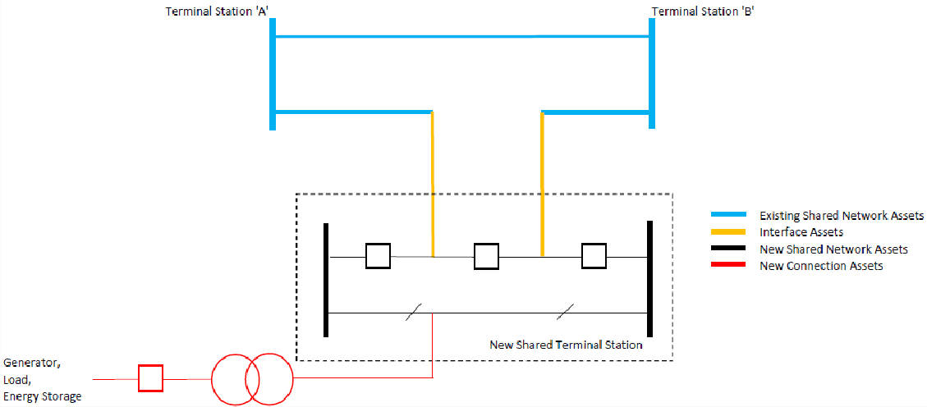

Table 1 shows the typical connection design and operation responsibilities.
Table 1: Typical connection responsibilities
Asset classification | Proponent/s | DTSO | Incumbent DTSO^{A} | VicGrid
Existing shared network assets |  |  | X
Interface/remote end assets |  |  | X
New shared network assets | XB | X |  | XC
New connection assets | XD
Generator, Load, Energy Storage | X
- Incumbent DTSO owns and operates the existing terminal station and/or transmission line.
- Proponent is required to provide land access for DTSO to establish new terminal station to connect to the DSN.
- VicGrid is required to provide the connection arrangement and ultimate arrangement in its planning role.
- New connection assets operating at the DSN transmission voltages requires the operator to be a DTSO under the NER.
- Figure 3 illustrates the operating arrangement upon completion of commissioning. The new terminal station will be classified and operated as a shared network asset.
Figure 3: Simplified SLD - New terminal station integration into DSN (after commissioning)
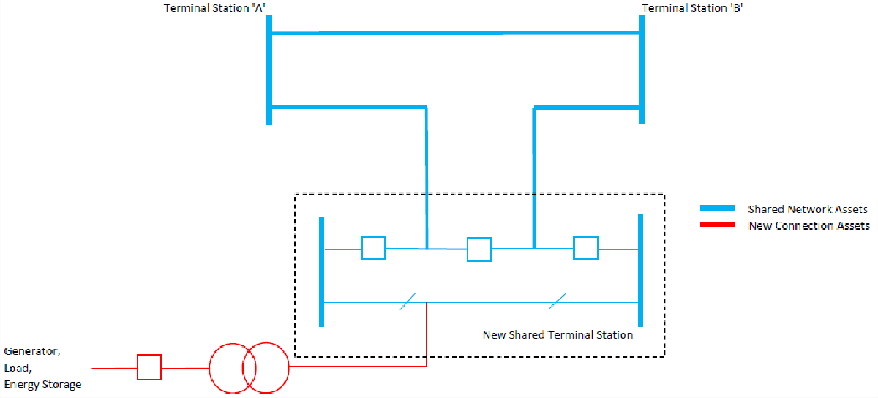
The connection points will generally always be considered at the terminal station and will be documented in the Primary Functional Requirements specifications. Unless specified by VicGrid, the connecting line between the terminal station (connection point) and the connection assets will be respectively owned and maintained by the Proponent. The terminal station droppers are owned by the respective DTSO.
Other aspects to consider during new terminal station build are the following;
- Community engagement
- Economics
- Development and planning approvals
- Land and easement access
- Environment and social impact studies
- Terminal station site selection and positioning

Community engagement
The community plays a critical role in the planning and delivery of infrastructure projects. Effective community engagement commencing early during the project lifecycle is typically required for the successful delivery of the project.
It is the responsibility of the Proponent to identify all relevant stakeholders for the project and ensure that an appropriate engagement strategy is developed and implemented.

Economics
To maximise value for the consumers of Victoria, selecting a location and design of the terminal stations which is based on economic efficiency, taking into account feasibility, practicality and longevity of the connection, must be considered.

Planning and environment approvals
Planning and environment approvals are required prior to commencing construction when establishing new connections into the existing DSN. The specific planning and environment approvals required for a new connection would be dependent on the scope of the larger project, its potential impacts and any existing approvals that are already in place.
It is the responsibility of the Proponent to undertake an assessment of all relevant local, state and federal legislation to determine the approvals pathway for the project.
For any works within existing facilities, these must comply with previously obtained conditions of planning and environment approvals.

Land and easement access
The establishment of DSN terminal stations and DSN transmission lines in Victoria must allow TNSP/DTSO rights to execute work in accordance with the NER and unrestricted access to operate and maintain the DSN.
New terminal stations cannot be installed on existing transmission easements due to the legal and contractual agreements.
Given that terminal stations and the assets within them are intended to have a long service life span, it is standard practice that the site is owned outright by the asset owner (the DTSO) rather than by lease arrangements. However, leases may be permitted under certain circumstances.
Where a transmission line is to traverse land that is not owned by the Proponent, an interest in the land will need to be acquired to allow access for construction and ongoing maintenance.
Where the line is to traverse privately-owned land, that interest would be acquired through the registration of an easement. The extent of the easement would also need to include any access roads for construction, operation and/or maintenance purposes.
Easements will need to be established between the Proponent’s connection station to the new or existing DSN terminal station where required. This will be the responsibility of the Proponent.
Actual easement widths may vary due to circumstances such as standard safety clearances of lines under high wind conditions, vegetation management, and ongoing access for maintenance and inspections.
Refer to appropriate design standards and installation policies.

Environmental impact assessments
In Victoria, significant effects are assessed in accordance with the Environment Effects Act.
Following the decision from the Department of Energy, Environment and Climate Action (DEECA), this is used to inform local governments to consider the Minister’s decision when proceeding with approving project activities.
The Proponent must prepare for the Minister’s assessment the required documents which outlines the proposed project and potential environment, social and economic impacts. The Minister will determine if an Environment Effects Statement (EES) is required.

Terminal station site selection and positioning
The following must be considered when selecting the site location for the shared terminal station.
- For augmenting the transmission capacity or security of the DSN, the location is determined by VicGrid to provide maximum net market benefit by considering cost sharing of terminal station developments.
- When establishing new connection points for DNSPs, the location is jointly determined with relevant DNSPs and VicGrid to maximise net market benefits. This is published in the Transmission Connection Planning Report (TCPR). This determination maximising net market benefits also includes associated distribution network costs and benefits, published in the relevant Distribution Annual Planning Reports (DAPRs).
- For establishing new dedicated generation, customer load, and/or energy storage connection points, VicGrid will confirm a preferred location with the connection applicants, however it is ultimately the applicant’s responsibility to finalise and agree the terminal station location.
- Soil type for resistivity will be used to comply with step and touch voltages and earth potential rises.
- Site selection and positioning will also consider:
  - Flood levels and water courses, including drainage and soil erosion.
  - Bushfire hazard and air pollution levels.
  - Cultural, biodiversity, and visual amenity significance.
  - Transmission, distribution and connection line entries and exits, including tower positioning.
  - Any planning and environment approvals requirements.
  - Access to and around the site.
The positioning of new terminal stations connecting to the DSN must not impede access for future connections to the network. VicGrid recommends new terminal stations be installed along the site boundary to allow for future line/cable entry and exits, which may be required as part of VicGrid’s long term plans for the DSN, and which will be reflected in VicGrid’s requirements for the ultimate arrangement.

Consideration for existing terminal station connections
This section provides an overview of the philosophy for existing terminal stations and how these were pre-planned based on the requirements at the time of development to ensure allowance for future connections.
VicGrid and the incumbent DNSPs have typically planned and agreed existing terminal station ultimate configuration and DSN connection assets during the initial development stage, providing for these future development.
There will be some approval requirements, subject to the significance of major works, when interfacing with existing terminal stations. This will generally relate to matters beyond the perimeter of the terminal station.
Easements and access for new transmission lines on a landowner’s property maybe be required, unless allocations within a transmission corridor are already available. As an example, responsibilities depends on the classification of the connection assets as illustrated in Figure 4 and Figure 5.
Figure 4: Connection to an existing terminal station (before commissioning of new connection)
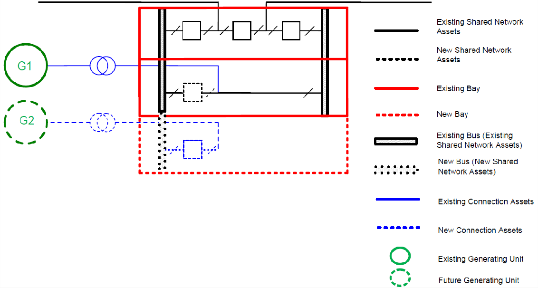

Figure 5: Connection to an existing terminal station (after commissioning of new connection)
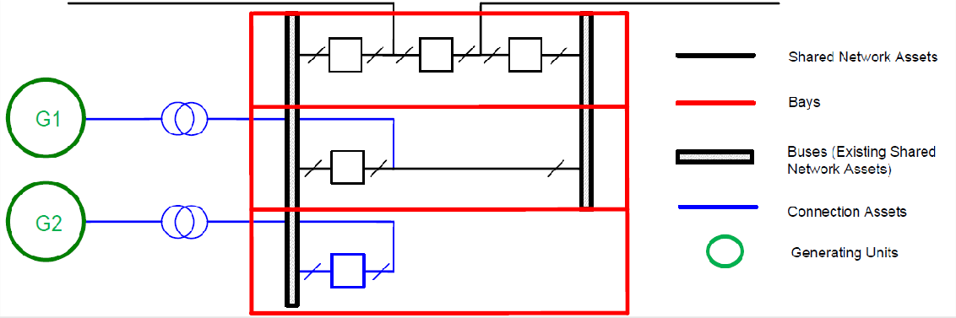
At some existing DSN terminal stations, there may be availability to connect to the 66 kV and 22 kV network. VicGrid does not manage these systems and any connection to these networks will require joint planning permission with the connected DNSPs and/or other directly connected users.

Existing terminal station – future connections
When connecting to an existing terminal station, impacts to line/cable entries and exits should be minimised to allow for future connection projects. Options to develop easements may be required on adjacent land to ensure the existing terminal station is capable of fulfilling its maximum site operability and development plan.
It is recommended that a buffer or set back around the terminal station be considered to permit this possibility.

Establishing new terminal stations and transmission lines

Requirements for new terminal stations and transmission lines
New terminal stations and/or certain transmission lines required for a proposed project which connects to the DSN will form part of the shared transmission network. The new terminal stations may either connect onto an existing transmission line or to an existing terminal station, subject to network planning requirements.
Development of a new terminal station can be initiated by any of the following;
- The annual Victorian Annual Planning Report (VAPR) identifies the need for augmentation to the DSN to deliver future capacity requirements.
- The TCPR from the DNSP identifies the need to meet their forecast demand.
- VicGrid receiving a DSN connection application.
When the need is identified, VicGrid, the DTSO/TNSP, relevant DNSP and the interested connecting parties will undertake joint planning to determine the most effective and economical plans to fulfill each party operational requirements.

Location of new terminal stations and transmission lines
Site selection for new terminal station and transmission lines is based on the specific needs for the connecting projects, with consideration of any potential and social and environmental impacts, whether it be through the RIT-T process of by third party applications.
Where there is a high concentration of connection projects, VicGrid seeks to minimise the overall cost of connection and maintain power system security by limiting the number of transmission connection locations within an area where existing infrastructure is available.
The location of new terminal station establishment should consider the following VicGrid guidance principles:
- Proximity to existing or committed terminal stations within a 5 km radius for the metro Melbourne area, 10 km for rural 220 kV Victoria, or 30 km radius for rural 500 kV Victoria. For those locations that do not meet this criteria, a new terminal station may still be permitted if the existing terminal stations cannot accommodate a new connection.
- Proximity to Extra High Voltage (EHV) transmission lines.
- Ability to obtain the necessary land to facilitate the ultimate arrangement at the existing terminal station and potential to become a strategic hub for future connections.
New transmission lines will be required where existing infrastructure is not available. The transmission line will preferably connect the new terminal station to the next closest existing terminal station/s.
Figure 6 provides examples of when consideration for new terminal stations will be established.
Figure 6: Accepted terminal station build locations for metro Melbourne and rural Victoria.
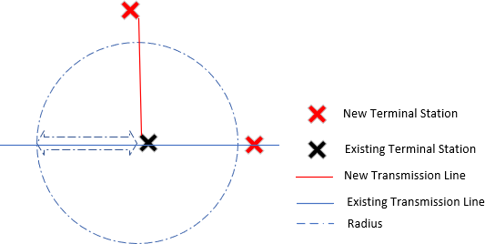

Generally, new terminal station ‘cut ins’ will be considered where the HV transmission connection is greater than a 5 km radius from an existing terminal station in the metropolitan Melbourne area. Rural 220 kV Victoria transmission line ‘cut ins’ will be accepted if outside a 10 km radius of an existing terminal station and rural 500 kV transmission line ‘cut ins’ are outside a 30 km radius.
Any proposed connections within these radii will be requested to connect to the nearest existing terminal station, subject to there being capacity. It will be the Proponent’s responsibility to engage with all relevant stakeholders, select a preferred alignment between their project site and the existing terminal station and obtain all necessary approvals and easements. The connections may either be overhead conductor or underground cables.
Consistent with this principle of a minimum distance between adjacent stations there is a minimum footprint for new terminal stations, varying with the line voltage, to provide for future connections, as shown in the following table.
Table 2: Indicative terminal station footprint
Line voltage (kV) | Station area (hectares (Ha)) | Switchgear diameters | Capacity generation connected (megavolt amperes (MVA))
500 | 22 | 8 x 500 kV, 8 x 330 kV or  220 kV | 6,000
330 | 11 | 8 x 330 kV  8 x 220 kV | 4,000
275 | 11 | 8 x 275 kV  8 x 220 kV | 3,000
220 | 8 | 8 x 220 kV  8 x 132 kV or 66 kV | 2,000
220 | 4 | 8 x 220 kV | 2,000
Existing transmissions lines will not be diverted to a new generator location. This means the existing transmission easement needs to pass nearby the proponent’s acquired land, e.g. a number of spans subject to obtaining the required additional easements.

Initial arrangement for new terminal stations
Due to the current nature of new connections to the DSN, multiple terminal stations are being established along existing transmission line routes which are driven by the Proponent’s connection needs for development of their projects.
To assist in facilitating connections and also maintaining transmission network development, VicGrid requires new shared terminal stations accommodate the ultimate station configuration requirements through consultation during the connection process. This is determined through discussions between the Proponent and VicGrid’s planning team to ensure future network development and connections can be facilitated when required.
These network developments may include but are not limited to future transmission line tie ins to increase transmission capacity, allow opportunity for service providers to connect network support plant, and permit connections by other projects built nearby.
VicGrid requires any new terminal station which cuts into an existing transmission line will include the following:
- A fully switched arrangement comprising a minimum of three (3) circuit breakers in two (2) breaker-and-a-half diameters for a single connection point (see Figure 2 and Figure 3).
- Provision to expand the terminal station to accommodate an ultimate station arrangement which will be agreed with VicGrid (see Section 6.2.2).
Table 3 below summaries the benefits for this fully switched initial arrangement.
Table 3: Benefits of fully switched arrangements
Condition | Benefits
Availability (unplanned outages) | A fault will trip the respective line only, therefore maintaining availability with the generator, load or energy storage being able to continue generating/consuming power through the remaining line.
Availability (unplanned outages) | As the line is sectionalised, shortened line inspections post events is required, allowing for quicker line restoration and less personnel.
Availability (planned outages) | Marginal reduction in availability as line equipment is maintained concurrently. These may be CBs, disconnectors/isolators, line insulators, communication equipment, etc.
Economics | Lower network service connection costs where multiple parties can connect in close proximity and therefore lower costs flow on to electricity consumers.
Expandability | Provisions for future augmentation with reduced disruption to established connections without high cost.
Network reliability | Ability to ensure the line remains in service whilst faults are addressed at the terminal station.
Protection systems – commissioning and maintenance | Reduced number of team members required for line section and remote terminal station commissioning, therefore quicker and reduced complexity with testing and maintenance arrangements.
Protection systems – commissioning and maintenance | Rollout of established protection and control schemes without the need for complex arrangements which can arise for a soft tee arrangement.
It is noted that adding plant or equipment may impact network reliability. However this depends on a range of factors, including the type and quality of product selected, plans and frequency of inspection, maintenance routines, and proper operation of the equipment.

Ultimate station planned configuration
VicGrid requires any new shared terminal station to be developed with consideration of an ultimate station arrangement.
An ultimate arrangement is necessary for maintaining long-term access to the DSN for future transmission network users, minimising the number of terminal stations to maintain, managing community expectations, and ensuring reliable supply for all network users. Refer to Appendix B for examples of ultimate arrangements.
This can be achieved by implementing the following:
- Plan initial, and reasonably possible future, DSN and connection requirements.
- Determine access arrangements, including future connections for lines in and out of the terminal station.
- Select sites cognisant of expected initial and future land access agreements and easement rights.
- Participate in joint planning with other connection users.
- Engage and communicate with the local community and stakeholders to agree on expectations, but not before the previous dot points, so there is a meaningful, specific, credible plan on which to consult.
- Purchase initially the planned ultimate site, or firm rights to purchase portions of this ultimate site progressively, before assets are established. Site lease is not satisfactory as the planning risk is unacceptable.
- Secure planning approvals as each planned stage is justified to proceed, also providing a future plan with best timeline to minimise unexpected developments.
- Determine the cost apportionments for land acquisition, earthworks, and connection assets between the multiple connecting parties.

Design consideration
To assist with the design considerations and planning for the ultimate station configuration, the terminal station establishment must address the aspects, but not limited to the following list based on transmission network users’ requirements.
Table 4: Design considerations
Factor | Consideration
Alignment with VicGrid’s long-term plans | VicGrid will seek to ensure that the ultimate station configuration is appropriate for its planning needs beyond the next 30 years.  However, the design life of the station shall be for a minimum of 50 years.  VicGrid’s long-term planning will incorporate the long-term plans presented in the TCPR.
Alternative termination and switching | VicGrid will review the requirement for major transmission augmentation; for example, future High Voltage Direct Current (HVDC) termination point. If so, space will be allocated for this.
Fault level mitigation | VicGrid will consider the maximum fault levels for the life of the terminal station, including the impact of planned future modifications to the DSN.  Equipment ratings must be selected for this fault level to minimise the risks to safety to persons and assets.  Fault level reduction equipment will only be considered once the terminal station approaches the ultimate station configuration, subject to economic considerations.
Land-use planning | The proposed terminal station must be capable of staged development and expansion to the ultimate station configuration for future connections serviced by the terminal station.  The terminal station must also comply with all local, state and federal legislation and guidelines relating to visual impact, noise, contamination and electromagnetic fields (EMF).
Likely and potential generation connections | The size of the largest generation contingency will be assessed. If this exceeds a defined valueª, further cost may be incurred and/or dispatch may be co-optimised with available FCAS.
Load forecast | Standard ratings of plant equipment will be adopted, such as when sizing power transformers, subject to requirements of proponent funding the plant.
Power quality | The ultimate station configuration will include any necessary provision required to maintain power quality.  Maintaining harmonic levels below the permitted limits may require provisions for filtering equipment in addition to any required voltage control plant.  Point on wave switching and/or pre-insertion resistors may be required to reduce the stress during switching operations and minimize disturbances on the power system.
Reactive power, system strength, and inertia support | VicGrid will review reactive power, system strength, and inertia support requirements, if any, at the station and if required, recommend allowance of space for plant providing these services such as:  - Circuit breaker switched shunt capacitors  - Static VAR compensators (SVCs).  - Shunt reactors.  - Static synchronous compensator (STATCOMs).  - Synchronous condensers.  - Grid forming / firming inverters.  - Flywheels.  - Battery energy storage system (BESS) synthetic inertia devices.
Reliability and security | The terminal station will be such that power system security is maintained for the credible loss of any single element of the DSN (as discussed in VicGrid’s Power System Security Guidelines SO_OP3715).  The ultimate station configuration will take into consideration any benefits that might arise from diversity and the mitigation of high-impact low-probability events.
Site requirements | Sufficient land must be allowed to ensure safe operations, road and service access, social and environmental impact mitigation, new (or extension of) control and service buildings, diversion of transmission circuits (if required) and the required number of switching bays.
Transmission tie transformers | Where required, provision will be made for installation of transmission tie transformers, switchgear, instrument transformers and busbars ( for example: 500/220 kV, 330/220 kV).
- A value that VicGrid will assess and define periodically depending on the existing capability of the transmission system.
The terminal station switchyard consists of ‘bays’ which are the locations where transmission lines, generators, loads or energy storage are physically connected. The switchyard also contains the sectionalised HV busbars via the necessary bus coupler circuit breakers.
The number of bays in the ultimate station configuration will be based on the following:
- Total amount of generation or load to be connected to one busbar.
- Risk of losing generation or load during a busbar fault.
- Impact of loss of generation or load on the power system.
The bay arrangements are typically subject to the considerations in Table 5.
Table 5: Bay arrangements
Station element | Key considerations | Guidelines
Incoming and outgoing DSN transmission line bays | - Alignment with VicGrid long-term plans  - Reliability and security | - Provide bays for the maximum number of incoming and outgoing transmission circuits as identified in the long-term planning documents.  - Bay allocations of incoming and outgoing transmission lines will be on a case-by-case basis with due consideration of reliability and security of supply.
Incoming/outgoing bays, connecting to DSN | - Connection enquiries  - Likely and potential generation/ energy storage connections  - Load forecasts | - Provide one bay per connection point, or additional bays are justified by the connection enquiry.  - Allow two connections per diameter, provided the effects of simultaneous failure have been considered and allowed for, and if economically reasonable.  - Restrict the terminal station to a maximum aggregate directly connected generation capacity. This is a reliability consideration for low-probability events. Typically, the maximum aggregate generation will be in the range of 2,000-3,000 megawatts (MW). For some terminal stations, the maximum generation limits may be lower.  - Provide for connection of future load forecast in consultation with local DNSPs.  - Allocate connection bays for supplying future demand, up to a typical maximum of 250 MVA (66 kV), 1,000 MVA (220 kV or 500 kV) per connection. The actual maximum will be calculated  - based on the probabilities and consequences of possible failures.  - Some terminal stations may connect to the main grid via segregated multiple 500 kV circuits. These effectively comprise two terminal stations and may connect up to 8,000 MW generation/ energy storage systems.
Transmission tie (220 kV or 500 kV requirements) | - Connection capacity requirement  - between the two voltage levels | - Provide for future voltage transformation capacity between 220 kV and 500 kV (if required).  - Allocate bays for 220/500 kV transformers, allowing a typical maximum of 1,000 MVA per transformer (3-phase).
Capacitor and/or reactor bays  (220 kV or 500 kV)  – if required | - Reactive power support requirements  - Fault level mitigation requirements | - Provide for connection of circuit breaker-switched shunt capacitors, allowing a typical maximum of 200 megavolt amperes reactive (MVAr) per connection. ^{A}  - Provide for connection of SVCs/STATCOM with a rating of at least 200 MVAr in the electrical vicinity of a major load centre, allowing one connection per SVC/STATCOM.  - Provide for series reactors for 220 kV lines and/or busbar ties in stations, if analysis shows these being required.  - Provide for 50-200 MVAr shunt reactors to compensate for 220 kV underground cables or long 500 kV lines (if anticipated) terminating at the station.  - Base capacity on not exceeding 3% voltage step when switching the device.
Synchronous condenser bays (if required) | Power system strength and stability | - Provide for synchronous condenser where modern power electronics are installed, if analysis shows these being required.
Spare incoming and outgoing bays (500 kV or 220 kV) | Alternative termination and switching requirements | - Provide for at least two line connections at each transmission voltage anticipated for the station (currently 500 kV or 220 kV). These may not necessarily be on the same diameter.
- Subject to analysis which determines another maximum value is appropriate.

Technical considerations
The initial feasibility design will support the development of terminal stations that are flexible and economical which allows for future expansion to accommodate geographically dispersed generation sources, loads and increased intra- and inter-regional DSN capacity and/or performance.
The engineering feasibility design will provide further detailed information on the new terminal station to stakeholders.
Selecting a site location will need to consider the following aspects:
- Existing DSN line easements and station locations.
- Forecast renewable generation, storage, load, and transmission developments.
- Community planning and involvement.
- Potential social and environmental impacts.
- Topography.
- Site access.
- Ground conditions.
- Pollution.
Based on the location of the terminal station, local issues and planning considerations will have an impact on the type of technology to be implemented for the primary plant. The following are common types of available technologies used for these system voltages:
- Air Insulated Switchgear (AIS).
- Gas Insulated Switchgear (GIS).
- Mixed Technology Switchgear (MTS) – combination of AIS and GIS.
Also, the operability and maintainability of the terminal station will need consideration depending on how remote the site is from populated areas. This may mean different operating philosophies will need to be implemented, such as:
- Remote operations availability.
- Interfaces for communication and control systems.
- Backup auxiliary supplies.
- Reliability.
- Site security.

Commercial considerations
The key activities that involve VicGrid and the connection applicants in making commercial arrangements are as follows:
- Acquisition of freehold land for the new terminal station or securing access to areas(s) within an existing terminal station for the new connection assets and any required new shared network assets to establish the augmentation.
- Engagement with the DTSO/TNSP for the required network augmentation works.
- Cost benefits to electricity consumers.
- Equipment layout and technical evaluations.
- Connection interfaces and complexity.
- Project size, timeline and funding arrangements.
- Proponent/entity financial status or backing.
The details of commercial considerations and processes are further provided in Contract Principles: Generation Connections to the Victorian Declared Shared Network.

Connecting to existing terminal stations
The Victorian electricity transmission network includes many terminal stations built across the state from the 1950-60s when the transmission network moved to 220 kV levels and the 500 kV terminal stations entered service in the 1970s. These terminal stations have remained in service and been upgraded as required to meet current connection requirements and bulk power transfer demands.

Ultimate station configuration
Existing terminal stations were typically based on scenarios and future changes to the DSN over a 40-year period. This is commonly termed the ultimate station configuration to consider the life of the electricity network, terminal stations and connection requirements that may need redevelopment or upgrading to ensure the network remains operable and reliable.
Over the years, these terminal stations will have undergone expansions or redeveloped, especially in urbanised areas.
As these stations are shared with other connection users, ultimate station configuration may change over time regarding planned allocations. Changes to these planned allocations requires joint planning discussions.

Typical connections into existing stations
Switchyards for 220 kV and above are typically designed as ‘breaker-and-a-half’ arrangements. There will be a limitation on the number of bays available at each existing site subject to the availability of land allocation. Each bay provides for three circuit breakers between two buses to allow for flexible operation and switching without disruption to services. See Figure 7 for layout.
At some existing 220 kV, 330 kV and 500 kV switchyards, ‘double breaker – double bus’ arrangements may also be implemented. See Figure 8 for layout. These sites are becoming restrictive as sites are posing challenges towards site redevelopment.
The circuit breakers are provided with two isolators and earth switches for isolation of the relevant connection point without impact to the operability of the transmission network.
Connection Applicants’ proposed installation location and preferred connection into the transmission network should be discussed with VicGrid as early as possible. VicGrid will be able to advise on the practicality as part of the Connection Enquiry process for the Connection Applicant’s feasibility studies.

Figure 7: Example of breaker-and-a-half arrangement
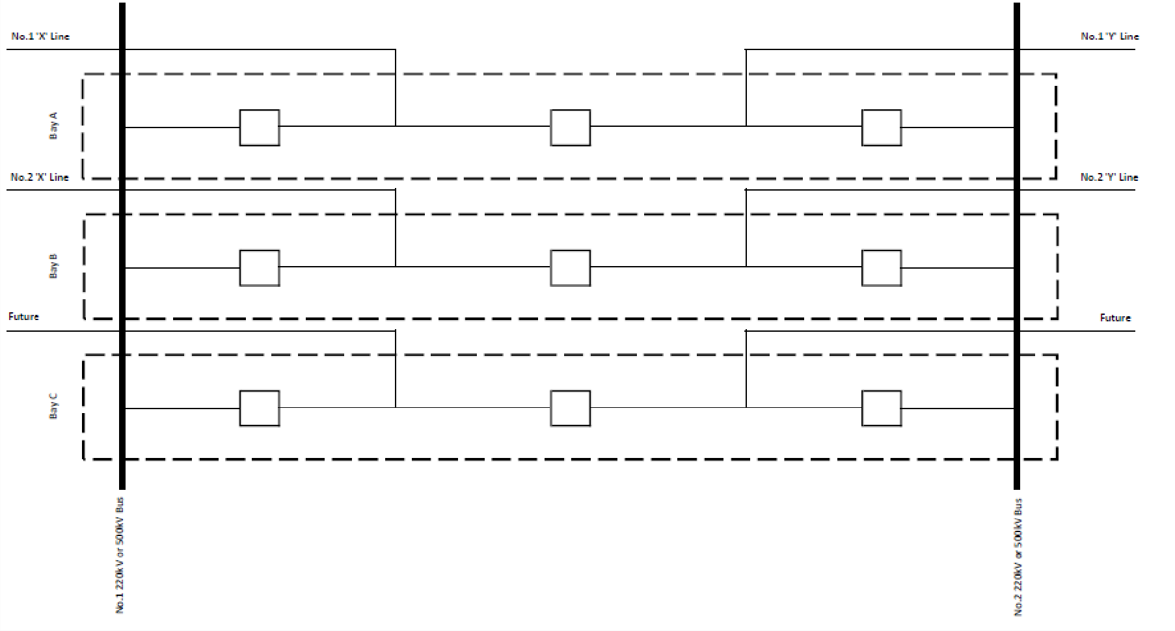

Figure 8: Example of double breaker – double bus arrangement
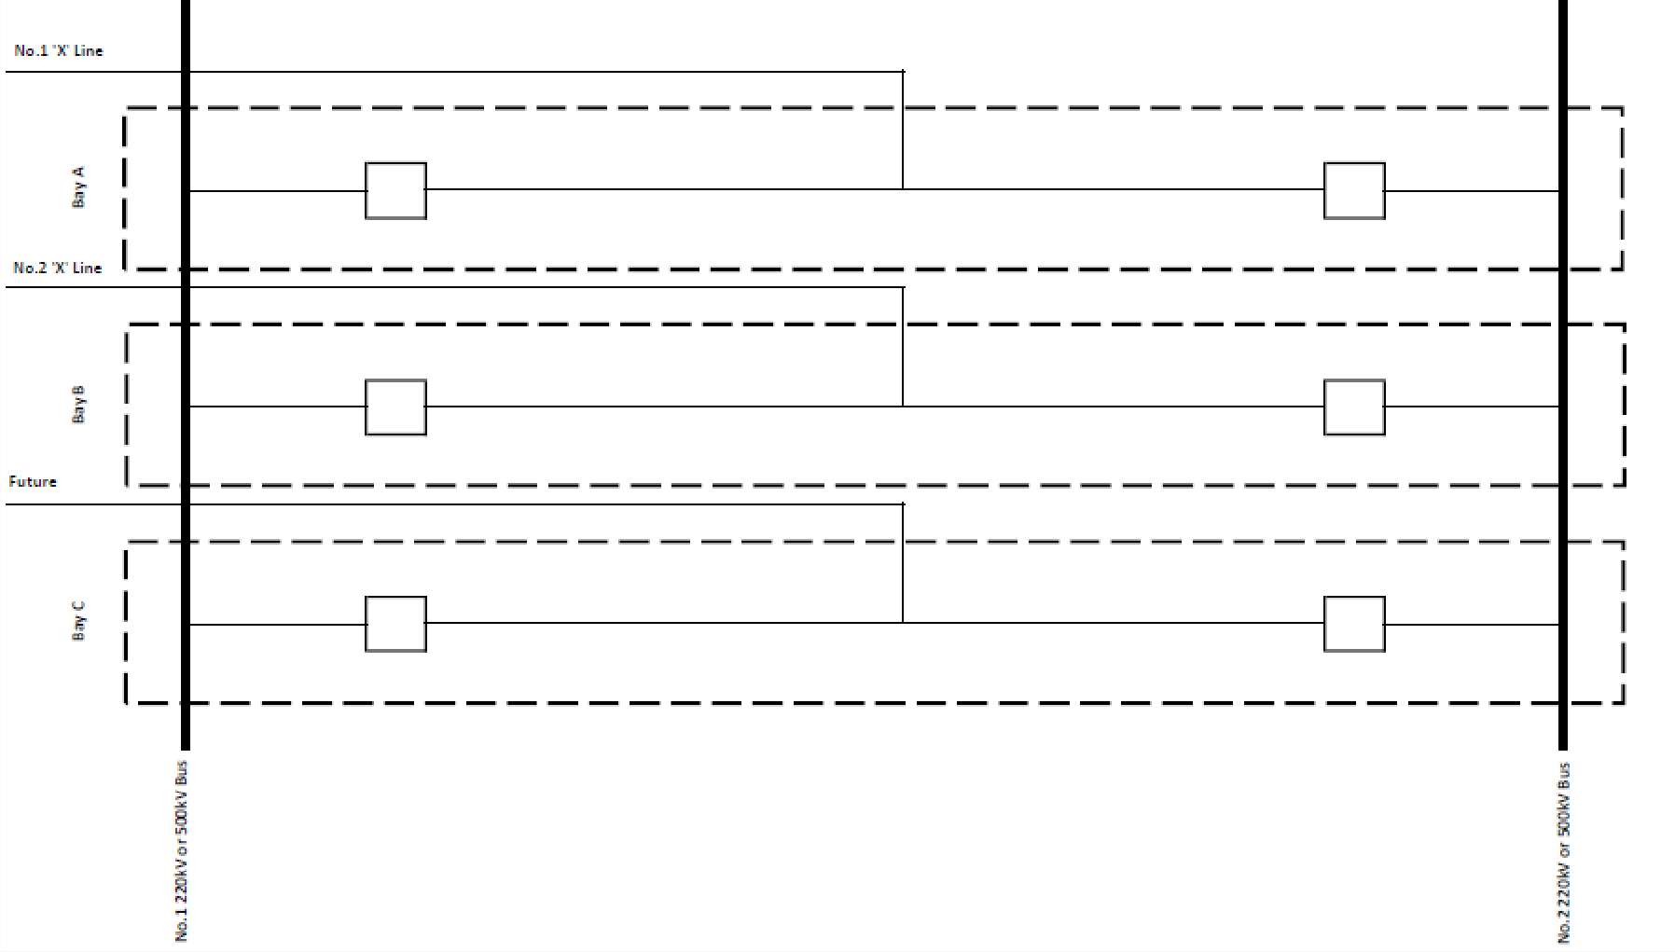

Bay allocations
Bay allocations within the DSN are subject to annual planning assessments and augmentation projects to meet network capability, reliability and security requirements. Subject to expected net market benefits, only committed projects will receive a reserved bay allocation, which may involve switchyard extension, if spare bays are unavailable.
In the event there are several connection applicants enquiring for the same connection point, VicGrid will co-ordinate the applications and develop a working group with affected applicants to reach agreement on a fair and reasonable resolution.

Interfaces
The new connection assets will need to consider the existing primary and secondary interfaces at the respective existing terminal station and network topology. This may include integration with complex control schemes to ensure the safety, operability and reliability of the network.
VicGrid will advise the type of control schemes implemented at preferred connection locations during the connection process. These installations will consist of local and remote end works to establish new or modify the functionality to the existing control systems.

Joint planning
When the need is identified, VicGrid, the DTSO/TNSP, the relevant DNSP and the connection parties will undertake joint planning in accordance with NER 5.6.2(c)(1) to determine the most effective and economical plans to fulfill each party’s operational requirements.

Design information
The following sections provides information which must be complied with for all DSN terminal stations, transmission circuits and augmentations.

General
The terminal station and/or transmission lines must meet the following requirements;
- Designed and constructed with a minimum safe, economic, operating life of 50 years.
- Comply with the functional specifications prepared by VicGrid.
- Comply with all relevant Australian Standards including (but not limited to)
  - AS 1158.2 – Lighting for roads and public spaces Computer procedures for the calculation of light technical parameters for Category V and Category P lighting.
  - AS 1170 – Structural design actions.
  - AS 1768 – Lightning Protection.
  - AS 2067 – Substations and high voltage installations exceeding 1 kV a.c.
  - AS 3000 – Electrical installations (known as the Australian/New Zealand Wiring Rules).
  - AS 4100 – Steel Structures.
  - AS 7000 – Overhead line design.
  - AS 60076 – Power Transformers.
  - AS 60479 – Effects of current on human beings and livestock.
  - AS 62271 – High-voltage switchgear and control gear.
  - ENA DOC 045-2022 – Substation Earthing Guide.
  - IEC 60071 – Insulation co-ordination.
  - IEC 60865 – Short circuit currents – Calculations of effects.
- Not materially degrade the reliability and security of the DSN.
- Be consistent with long-term transmission and distribution plans.
- Be compatible with future generation developments and the need to supply future load growth in the area/region where required.
- Be developed in stages to accommodate the additional capacity requirements for the location and transmission and distribution networks as required.
- Have equipment ratings that comply with the ultimate system rating levels to allow safe and reliable operation without the need for uneconomic future remediation works.
- Meet the climatic, seismic and topographical conditions for the installed locations.
- Meet any planning and environment approvals requirements.
- Consider construction and operational issues such as:
  - Outage frequency and recall times.
  - Crossovers and induction from parallel transmission circuits.

Safety
Safety of people and assets is paramount for all those who will interact with the system. This applies to network users, personnel, the public and the environment.
- The terminal station development must implement Safety in Design principles.
- All identified hazards must be addressed through the safety control hierarchy so far as reasonably practicable.
- Safety clearances must comply with AS 2067 and other applicable standards.
- All metallic structures are to be earthed and proven safe.
- Step-touch voltages must be within safe voltage levels in accordance with relevant earthing standards.
- Exposure to electrical and magnetic fields from transmission circuits must be minimised at affected areas such as proximity to occupied buildings, metallic fences and pipelines, telecommunication lines, or publicly frequented areas.

Victorian credible contingency limit
VicGrid will consider the capacity of generation that may be disconnected following a credible contingency event when determining the proposed connection arrangement to the DSN. This disconnection is currently limited to 600 megawatts (MW) based on the largest single generating unit and ancillary service requirements in Victoria. Connections above this threshold will require detailed assessment with VicGrid Operations to determine acceptability.
Registered Victorian generator list can be found at: https://www.aemo.com.au/-/media/Files/Electricity/NEM/Participant_Information/NEM-Registration-and-Exemption-List.xls.

Transmission line/cable loading
VicGrid envisages that approximately two (2) gigawatts (GW) or more of power transfer will required separate overhead lines on separate tower, ideally on separate easements to meet system security and diversity requirements. If separate easements cannot be obtained, a single easement with sufficient clearance between circuits is required to limit physical damage from asset failures is required.
Underground cables must be suitably rated to meet the power transfer requirements and separated to minimise the risk of common failure.
Line and cable rating studies and reports will be required to support the design installation and provide information for network operability.
Transpositions of conductors may be required on long transmission circuits to reduce current and voltage unbalance.

Short circuit fault ratings
Victoria has different short circuit fault ratings based on the voltage and geographical regions of transmission assets. The Latrobe Valley and the 500 kV transmission network are known to have a higher fault rating due to the historically centralised generation aggregation of large synchronous machines.
Future short circuit fault rating requirements are presented in Table 6.
New connections should not jeopardise the system design integrity. Any dispensation must be approved by VicGrid and supported by comprehensive risk assessment with mitigations and documented evidence that shows no degradation of the transmission network capabilities, and safety people and assets.
Table 6: Fault ratings (kA)
System nominal voltage (kV) | System maximum voltage (kV) | Location | Equipment rating
System nominal voltage (kV) | System maximum voltage (kV) | Location | Nominal fault level kARMS | X/R ratio (CB interruption)
500 | 550 | Latrobe Valley | 50 | 30-35
500 | 550 | Metro | 50 | 30-35
500 | 550 | Country | 50 | 30-35
330 | 362 | All | 50 | 30
220 | 245 | Latrobe Valley | 50 | 30

System nominal voltage (kV) | System maximum voltage (kV) | Location | Equipment rating
System nominal voltage (kV) | System maximum voltage (kV) | Location | Nominal fault level kARMS | X/R ratio (CB interruption)
 |  | Metro | 40 | 30
 |  | Country | 40 | 30
132 | 145 | All | 40 | 30
66 | 72.5 | Latrobe Valley | 31.5 | 30
66 | 72.5 | Metro | 31.5 | 30
66 | 72.5 | Country | 31.5 | 30
22 | 24 | Latrobe Valley | 31.5 | 30
22 | 24 | Metro | 31.5 | 30
22 | 24 | Country | 31.5 | 30

Insulation co-ordination
Insulation co-ordination studies are conducted to ensure the electrical strengths of the selected plant which make up the transmission system and their protective devices match the system characteristics for the required voltage ranges.
These studies are required to determine the minimum risks to reliability from insulation failure of major plant and equipment. The studies must be in accordance with IEC 60071.
Proponents must provide these studies to ensure compatibility with the DSN.

System strength
System strength is important to the operability of a power system and is required to ensure:
- Network stability and power quality is maintained within standard range.
- Stable operation of inverter-based resources.
- Protection equipment operate correctly during disturbances.
- Correct and co-ordinated operation of generator control systems.
Three phase fault current levels are typically higher in strong transmission systems or where the network area contains a large number of online synchronous machines. These fault levels are calculated at network nodes called fault level nodes.
Table 7 provides details of the location of the allocated fault level nodes across the Victorian transmission network.
Table 7: Location of fault level nodes for Victoria
Fault Level Nodes | Minimum three phase fault level (MVA) Pre- contingency | Minimum fault current (kA) | Minimum three phase fault level (MVA) Post- contingency | Minimum fault current (kA)
Hazelwood 500 kV | 7,700 | 8.9 | 7,150 | 8.3
Dederang 220 kV | 3,500 | 9.2 | 3,300 | 8.7
Thomastown 220 kV | 4,700 | 12.3 | 4,500 | 11.8
Red Cliffs 220 kV | 1,786 | 4.7 | 1,036 | 2.7
Moorabool 220 kV | 4,600 | 12.1 | 4,050 | 10.6
Refer to VicGrid’s published document, ‘System Strength – System strength in the NEM explained’ and ‘2022 System Strength Report‘for further details.
Under the NER, VicGrid is required to undertake a system strength impact assessment and, if an impact is identified, the Proponent and VicGrid will need to agree a system strength remediation scheme.

Operational requirements
Connection arrangements of lesser standard than a breaker-and-a-half schemes impacts business operations of operators and TNSPs discharging their responsibilities under the Rules. These alternatives arrangements have resulted in the following issues such as:
- Added management requirements with co-ordination of outages, including opex costs incurred by consumers.
- Dispatching and managing work teams at multiple sites, increasing operational costs, time and risk to network and personnel safety.
- Corporate reputation associated with outages (planned and unplanned).
- Additional protection complications and costs for remote end works.
- Additional security and reliability risk placed on customers.
- Less operational flexibility to isolate sections of transmission lines.

Maintainability and safety
VicGrid and the DTSO/TNSP must ensure that the time required to apply isolations and earthing in preparation for planned and unplanned maintenance works are kept to a minimum. It is important to ensure that the time taken to perform these operations is not disproportionate to the time required to carry out the maintenance to allow the DTSO/TNSP to meet the requirements of NER S5.1.2.1(d) or introduce inefficiencies to remain within the time required by this clause.
The increased complexity in isolation of a line with tee connections increases the risk of human error and the risk of safety incidents. Although isolation is often completed by motorised equipment, earthing is almost always completed on-site through manual operated earth switches or portable earths and visually verified.
Tee connections to the DSN are to be avoided as the above is exacerbated with increased line length and distances between connections. New connections must not lead to unnecessary interruptions to other users when one user requires work on their connection equipment.

Reliability of Shared Transmission Network
The reliability of transmission lines is critical to the efficient and effective operation of the DSN.
VicGrid’s planning obligations will generally prevent the development of connections which reduce the reliability of the DSN, as the effects of outages may increase market price volatility. Reduction in reliability and availability of the existing DSN and associated network user impacts must be minimised or avoided where possible.
Terminal station bypass functionality may be required to accommodate for catastrophic events where the loss of a terminal station has occurred. This will be determined based on the criticality of the section of transmission line where restoration of supply is mandatory, such as 500 kV radial lines or single circuit transmission lines.

Site expandability
VicGrid recognises that property development across Victoria can result in low availability of land for new terminal stations, a high cost of purchase or acquisition, or both when extending the DSN in densely populated areas.
The land around existing terminal stations can become a constraint, severely limiting network expansion and restricting VicGrid’s ability to meet the requirements of a growing load and greater penetration of generation.
Therefore, new connections to the DSN will require consideration for suitable land provision to accommodate the ultimate arrangement configuration agreed with VicGrid’s long term planning requirements.
This includes providing sufficient connection equipment at the initial connection stage to:
- To minimise disruption to existing customers for future connections.
- Prevent additional degradation in power transfer capability during expansion.
The capacity to expand control building to accommodate an ultimate arrangement must also be considered in the initial design.
The ultimate station configuration must be considered when locating plant and equipment for any initial connection.
Due to higher costs associated with completing civil works once an initial connection asset is operational, the connecting applicant may be required to level and provide drainage of this site for the ultimate arrangement configurations.
The earth grid should be established to allow safe operation while the site is partially developed and to be easily extended to accommodate the ultimate station configuration.
As the site is developed to the ultimate station configuration, connection costs will be shared with future connection parties according to VicGrid’s Cost Allocation Policy in Victoria.
Purchasing additional land is to be avoided, but if needed, costs will be shared similarly.

Protection and control schemes
Any protection and control schemes established on existing lines as part of a new connection must be at the pre-existing performance, speed of operation, and level of security or better. There may be the need to increase these requirements if the connection reduces the critical clearing times in the area.
Optical Ground Wire (OPGW) is used in Victoria for differential protection schemes. Additional OPGW or comparable performance communication bearers may be required for under-developed parts of the network.
The DSN has some complex control schemes in service to ensure operability and reliability are maintained, while minimising the risks to system security. New connections may be required to integrate with these existing schemes or implement additional schemes if deemed required by VicGrid. These shall be reflected in the relevant Protection and Control Requirement specifications.

Site security and cyber attacks
Under the Security of Critical Infrastructure Act, terminal stations are considered to be a critical electricity asset, due to their need in the National Electricity Grid. Therefore it is important that DTSOs ensure unauthorised access and malicious intervention are prevented.
The following list should be considered, but not limited in establishing and maintaining terminal stations.
- Be fully fenced to prevent public access and ensure public safety.
- Provide perimeter detections to raise the attention for intervention.
- Security cameras and monitored access to ensure authorised access only.
- Secure card access through gates and into buildings with remote overrides from the operational control centre.
- IT, substation protection systems, including SCADA and communications, must be protected from cyber-attacks.
- Site layout should factor in deterrents where equipment and materials are stored.

Management of the Declared Shared Network In Victoria

Risks
Risk management is an ongoing process to evaluate changes as these are introduced to the system. This may result in establishing new control measures to mitigate these risks or implement solutions to eliminate these entirely. This is executed by reviewing and analysing the available information to make informed decisions to ensure the operability and reliability of the DSN.
Risks can either be:
- Accepted by acknowledging not all risks are able to be eliminated,
- Avoided by preventing incidents from occurring,
- Mitigated by reducing the consequences, or
- Transferred to contracts or other commercial mechanisms.
Designs must consider the following risks which may apply, among others:
- Equipment failure.
- Fire/explosion.
- Fire protection, for example, minimum distances, coordination of facility builds.
- Conductor drop.
- Leaks or emissions, for example, oil or sulphur hexafluoride (SF6).
- Easements (need to accommodate easements for possible ultimate Single Line Diagram (SLD)).
- Avoid single points of failure in ultimate station configuration – physical aspects.
- Where avoidable, a credible contingency would not cause multiple failures.
VicGrid has the overall responsibility to ensure all parties comply with DSN operability and reliability requirements. Where connecting parties decide to deviate from VicGrid’s expectations, cost versus benefits analysis should be provided by the requestor to ensure the DSN and other network parties are not impacted.

Safety in Design
Safety in Design (SID) is a risk mitigation assessment requirement under local OHS requirements.
For Victoria, this is located in the Victorian Occupational Health and Safety Act 2004 (OHS Act) – Sections 27 and 28.
This obligation applies to all persons who have input into the direction and outcome of a design. This includes the development of new design installations, modification to existing designs, and the selection and procurement of equipment that will be operated and maintained within the installation.
The SID mitigations are managed through the project lifecycle phase to eliminate or minimise the identified risks to a level So Far As Is Reasonably Practicable (SFAIRP) or As Low As Reasonably Practicable (ALARP).
This SID process applies to the whole of asset life cycle, meaning it must be considered through the concept, scoping, design, construction and service life, including decommissioning and demolition phases.
SID must include the following:
- Identify the introduction of new and review of existing hazards.
- Assessment of the risks and hazards.
- Application of control measures to eliminate or manage these risks or hazards.

Contestability
VicGrid is responsible for the determination of contestability of augmentation works on the DSN, as specified in Clause 8.11.6 of the NER and is the intermediatory with the DTSO and Connection Applicants during contractual agreements.
Augmentation works are either negotiated or prescribed services to meet the connection requirements.
For further information, refer to the following website: https://www.vicgrid.com.au/industry/access-and-connections/transmission-connections-process/stage-4-contracts

– Land area
The following table is for indicative purposes only and should be confirmed by a Design Service Provider (DSP). Extra land must be made available to allow other terminal station requirements, such as, but not limited to, reactive support plant, lightning protection, roads, buildings and storage areas.
The number of terminal station bays required varies from terminal stations subject to the needs of the connection projects and network planning, such as number of lines, number of generators or load connections, and number of power transformers.
Table 8: Indicative minimum land area requirement for AIS terminal station bays.
AIS terminal station arrangement | Minimum required land area for AIS/outdoor in square metres  (width x length in metres)
AIS terminal station arrangement | 500 kV | 330 kV | 275 kV | 220 kV
One-and-a-half CB diameter | 5,670 (30.48x186) | 2,350 (18.29x128) | 2,300 (18.29x125) | 1,830 (15.24x120)
Double bus diameter | 4,090 | 1,570 | 1,540 | 1,270
 | (30.48x134) | (18.29x85.35) | (18.29x84) | (15.24x82.7)
Shunt reactor bay | 1,020 | 520 | 520 | 390
 | (30.48x33.2) | (18.29x28) | (18.29x28) | (15x26)
 | 500/220 kV | 330/220 kV |  | 220/66 kV
Transmission tie | 1,250 | 670 | 650 | 400
transformer bay outdoor | (43x29) (1,000 MVA) | (18.29x36.6) (340 MVA) | (18.29x34) (340 MVA) | (22x18) (150 MVA)
 |  | 800 (40x20) | 780 (40x19.4)
 |  | (700 MVA) | (700 MVA)

Table 9: Indicative minimum land area requirement for GIS terminal station bays
GIS terminal station arrangement | Minimum required land area for GIS/outdoor in square metres
GIS terminal station arrangement | 500 kV | 330 kV | 275 kV | 220 kV
One-and-a-half CB diameter | 112 | 112 | 112 | 112
Double bus diameter | 91 | 91 | 91 | 91
Shunt reactor bay | 63 | 63 | 63 | 63
 | 500/220 kV | 330/220 kV
Transmission tie transformer bay outdoor | 320  (1,000 MVA) | 270  (400 MVA) | 270  (270 MVA) | 200  (150 MVA)

– Examples of ultimate station configurations
The ultimate single line diagrams within this section provides an VicGrid’s network planning expectations for a connection applicant that develops a new terminal station or connects to an existing terminal station.

220 kV ultimate station configuration
The ultimate single line diagram shown in Figure 9 considers provisions for:
- Six (6) 220 kV one-and-a-half CB diameters.
- Two (2) 220 kV new or existing transmission lines (incoming and outgoing).
- Six (6) possible generator and/or load transmission system users.
- Two (2) possible transformation tie transformer (if applicable).
Figure 9: Example of ultimate single line diagram for 220 kV terminal station
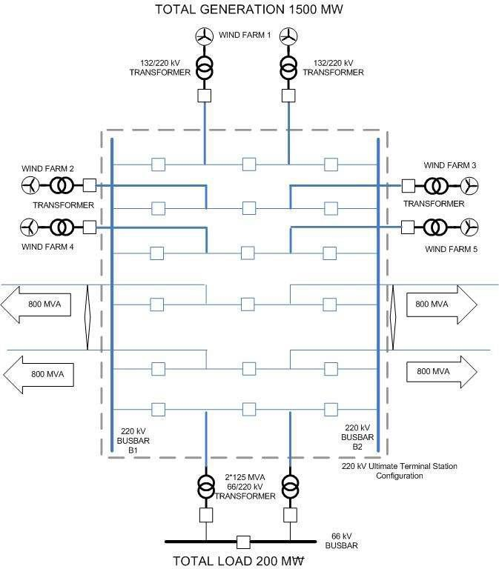
Detailed site layouts showing the ultimate arrangement shall be developed during the detailed design stage for agreement.

500/220 kV ultimate station configuration
The ultimate single line diagram shown in Figure 10 considers provisions for:
- Eight (8) 500 kV one-and-a-half CB diameters.
- Four (4) 500 kV new or existing transmission lines (incoming and outgoing).
- Provision for four (4) 500 kV generator and/or load transmission system users.
- Four (4) 500/220 kV transformation tie transformers.
- Four (4) 220 kV one-and-a-half CB diameters.
- Provision for four (4) 220 kV generator, load and or transmission lines.
Figure 10: Example of ultimate single line diagram for 500/220 kV terminal station
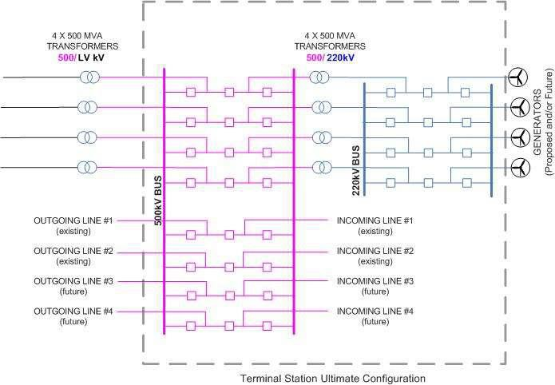

– Expected studies and reports
Whether establishing new or modifying existing terminal stations, studies are typically undertaken to prepare the following reports during the project phase.
These should only be used as a guide. Deliverables shall be specified in agreements in accordance with good engineering and design practices.
- Environmental Impact Statement or Environmental Effects Statement in accordance with local and state laws.
- Basis of Design Report.
- Safety in Design Report.
- Busbar Design Report.
- Electrical Clearance Design Report.
- Short Circuit Force Calculation Report.
- Lightning Protection Study Report.
- Insulation Co-ordination Study Report.
- Earthing Study and Design Report.
- Earthing Test Reports.
- Electromagnetic Field/Low Frequency Induction Study Report.
- Cable Design Report.
- Harmonic Filter Design Report.
- Lighting Report.
- Structural Design Report.
- Geotechnical Investigation Reports.
- Site Survey Report.
- Soil Contamination Report.
- Flood level and Hydrology Report.
- Building Inspection Reports.
- Fire Protection Study Report.
- Acoustic Noise Report.
- AC and DC system Design Reports.
- Protection Setting Calculation Reports.
- Protection Relay Compliance Test Reports.
- SCADA and Communication Design Reports.
- Type Test Reports.
- FAT and SAT verification reports, including Inspection and Test Plans.
- CB Timing and CT Test Report.
Note, the above list is not exhaustive and may require additional studies or reports to meet the needs of the project satisfactorily. These documents will support the assessment for DSN first energisation and practical completion.

https://www.aemc.gov.au/sites/default/files/content/4ea65c9e-2995-4164-ab4e-ed2584efd126/Fact-sheet-how-transmission- frameworks-work-in-the-NEM.PDF
https://www.vicgrid.com.au/industry/access-and-connections/transmission-connections-process/stage-4-contracts
Subject to contestability assessment in accordance with NER 8.11.6, 8.11.7 and 8.11.8.
GIS substations are more compact in design than AIS substations, If GIS is implemented, then additional bays or adaptor sections will be required at the initial development stage to reduce the outage duration when future expansions are required. Also, GIS equipment availability for future works may cause inter-connection issues which will require additional space to resolve
https://aemo.com.au/-/media/files/electricity/nem/network_connections/vic/0174-0021-pdf.pdf
Not a final layout
Not a final layout
https://aemo.com.au/-/media/files/electricity/nem/system-strength-explained.pdf
https://aemo.com.au/-/media/files/electricity/nem/planning_and_forecasting/operability/2022/2022-system-strength- report.pdf?la=en

