October 2025

Offshore wind transmission in Gippsland

Corridor and draft preferred route refinement summary
VicGrid is developing the shared transmission line to connect offshore wind energy generated off the Gippsland coast to Victoria’s electricity grid.
This summary provides an update on how we’ve narrowed down the original study area to identify a corridor, and a draft preferred route within that corridor.
Choosing a corridor and identifying a draft preferred route are important steps. This provides landholders with greater clarity and allows targeted technical studies to begin.

What we’ve done so far
In March 2024, we announced a study area for further investigations. This allowed us to carry out technical assessments and speak with local communities, landholders, key stakeholders and First Peoples.
To narrow the study area, we used criteria to identify places that were too sensitive or too technically challenging for transmission infrastructure.
As a result, we ruled out certain locations, including:
• Holey Plains State Park, and
• areas near the Loy Yang Power Station.

The corridor and draft preferred route
Defining a broad study area for further investigation allowed us to then identify a corridor – or area of connected land – to keep investigating as we work towards confirming the final preferred route and easement for the new transmission line.
To define the corridor, we:
• mapped homes, environmental values and areas with technical challenges
• considered possible pathways for the new transmission line
• applied our refinement criteria to compare and assess these options.
Through this process, we identified a draft preferred route. This route reduces impacts on homes and on areas of high environmental value including Mullungdung State Forest and the Giffard Flora Reserve.
We carried out targeted site checks and desktop studies to confirm our understanding. These steps have allowed us to further refine the corridor and identify a draft preferred route, meaning we can now provide landholders with greater clarity about where the transmission line will be located.
The draft preferred route is not final.
We expect that findings from studies and conversations with landholders may still lead to changes before the preferred route is confirmed.
We’re now looking to speak with landholders in the draft preferred route area to seek further feedback and input. We know we need to undertake further technical work and environmental studies, alongside community and landholder feedback, to help refine the route.
We’ll keep refining the draft preferred route in consultation with landholders and technical experts with an intent to announce a preferred route in early 2026.
The draft preferred route is around 60 kilometres long. Its width varies – most of it is around 200 metres wide, with some sections up to 500 metres wide. This gives specialists a focused area to carry out detailed investigations and technical studies as part of the Environment Effects Statement (EES).

How we identified a draft preferred route
To map the draft preferred route, we applied a clear set of decision-making criteria alongside our guiding principles. Together, these ensure the draft preferred route is both logical and respectful of community, environmental and cultural values.
Our guiding principles | Applying our principles to the  draft preferred route
We aim to:  • Minimise impacts on landholders and  communities, including views and  amenity.  • Minimise impacts on the natural environment.  • Respect and protect First Peoples’  cultural values and aspirations.  • Minimise impacts on existing and future  land use.  • Keep costs impacts to energy consumers and generators as low as possible.  • Reduce engineering challenges during  construction and avoid clashes with  existing infrastructure. | When selecting a draft preferred route, we aimed to:  • Minimise impacts on homes, farmland  and sensitive environments like Merriman  Creek.  • Avoid areas with significant biodiversity  values.  • Align with existing infrastructure like the  Basslink transmission line and the Saline  Wastewater Outfall Pipeline.  • Reduce visual and amenity impacts.  • Limit costs to consumers and complexity  in construction.  • Avoid cultural heritage sites where  possible.

Other technical considerations
• The number of Basslink crossings required
• Avoiding unnecessary changes in the direction of the line
• Construction challenges, such as difficult terrain
Co-locating with existing easements and infrastructure
We aim to follow existing infrastructure easements wherever possible. However, there are limits to how close the new transmission line can be placed alongside them.
In particular, further studies are needed with the owners and operators of Basslink to confirm safe distances. The final separation between Basslink and the new transmission line may need to change depending on the results of these studies, to ensure safety, performance and reliability of both systems.
Commercial landholders
We’ve received feedback from commercial landholders. Their input is helping us consider land use, access routes, and how transmission infrastructure can work alongside ongoing business operations.

Corridor and draft preferred route
The draft preferred route will be further refined in consultation with landholders and technical experts with an intent to announce a preferred route in early 2026.
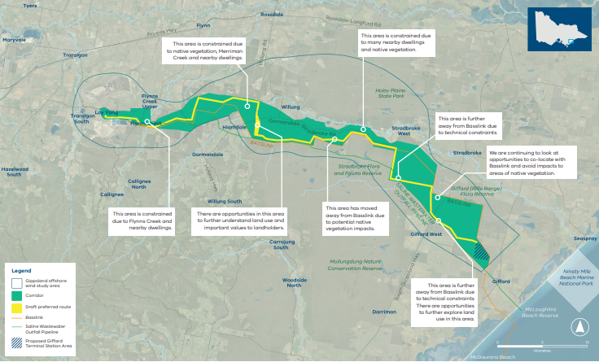

Giffard terminal station to Stradbroke
The new transmission line will connect to the proposed terminal station in Giffard. This is where offshore wind energy projects will connect their infrastructure into the grid.
Refining the terminal station location
The proposed terminal station area has been refined to rule out unsuitable sites, such as:
• areas close to homes
• land with incompatible uses
• areas with sensitive biodiversity values.
To confirm the final location, we need to consider:
• the size and availability of land needed
• proximity to existing easements and infrastructure
• environmental factors, such as flooding risk
• potential impacts on community amenity, including noise and views
• how close it is to offshore wind projects
• how easily offshore wind developers can access it.
The draft preferred route in this area
From Giffard, the draft preferred route follows the Saline Wastewater Outfall Pipeline, passing through farmland (including plantations) and crossing the South Gippsland Highway. This alignment avoids nearby homes where possible.
We are continuing to look at opportunities to co-locate with Basslink and avoid impacts to areas of native vegetation. Key factors that shaped the route include:
• homes along South Gippsland Highway and potential impacts on views
• important environmental areas such as the Giffard (Rifle Range) Flora Reserve and Mullungdung State Forest
• proximity to existing infrastructure and easements.

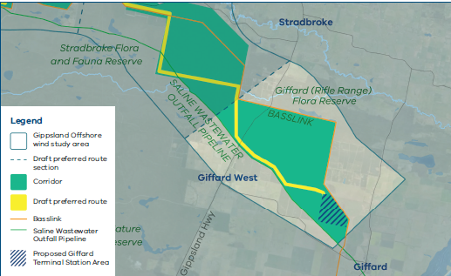

Stradbroke to Willung
The eastern part of the corridor between Stradbroke and Willung is mostly public reserves and farmland, including plantation areas. There are some homes in the northern part of this section, closer to Merriman Creek.
The draft preferred route
In this area, the draft preferred route will:
• travel mostly through plantation land
• cross and then follow the existing Basslink easement near Gormandale-Stradbroke Road.
Following the Basslink easement helps avoid nearby homes and protects important environmental values in the Stradbroke Flora and Fauna Reserve.
Key factors in this area
• proximity to existing infrastructure and easements
• a suitable location for a Basslink crossing
• homes north of Gormandale-Stradbroke Road and possible impacts on views
• environmental values in the Stradbroke Flora and Fauna Reserve.
Crossing Basslink
The transmission line will likely need to cross the Basslink infrastructure in this section. This helps reduce impacts between Stradbroke West and Hiamdale, where the environment is more sensitive.
Crossing Basslink will require extra infrastructure – such as steel gantries – to make sure the new lines safely clear the existing ones.
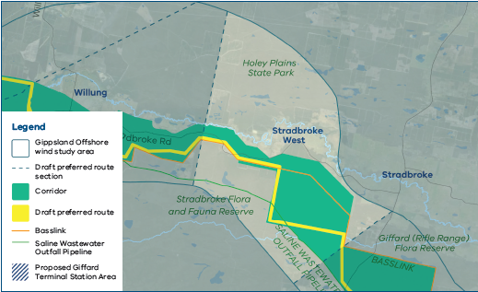

Willung to Hiamdale
This section of the corridor is complex because it has:
• many nearby homes
• sensitive biodiversity values
• the need to cross Merriman Creek.
The draft preferred route
In this area, the draft preferred route will:
• mostly follow the Basslink easement and the Saline Wastewater Outfall Pipeline to keep away from homes near Gormandale- Stradbroke Road and Willung
• avoid potential native vegetation impacts
• travel north along Flemings Road where there are opportunities to further understand land use and important values to landholders.
• cross Merriman Creek north of Willung.
Key factors in decision making
• homes along Gormandale-Stradbroke Road and near Willung
• potential visual impacts, especially across the valley
• landholders in Hiamdale who already host transmission infrastructure
• proximity to existing easements and infrastructure
• choosing the most suitable location to cross Merriman Creek while protecting environmental values.
Benefits of this alignment
• following Flemings Road allows the line to potentially use existing treelines, which may help reduce visual impacts across the valley
• crossing Merriman Creek north of Willung avoids the Merriman Creek Flora Reserve and sensitive habitats along the creek line.

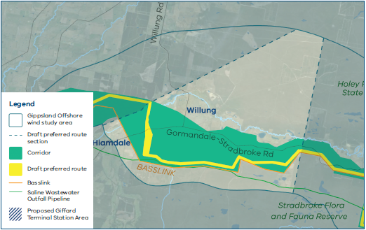

Hiamdale to Flynns Creek
In this section, the draft preferred route runs entirely through plantation land. We’ll keep working with landholders to look at options that reduce impacts on plantation operations.
Key factors in this area
• proximity to existing infrastructure and easements
• potential impacts on plantation operations
• homes along Hyland Highway and possible impacts on views
• environmental values in the Gormandale Flora Reserve.

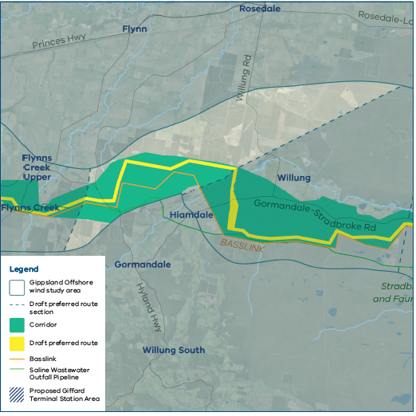

Flynns Creek to Loy Yang Power Station
In this section, the draft preferred route runs north of the existing Basslink transmission line.
Key factors in this area
• homes and other buildings along Scales Road
• proximity to existing easements and infrastructure
• the need to connect into the Loy Yang Power Station.
• proximity to Flynns Creek.
Entry point at Loy Yang
The transmission line must enter the Loy Yang switchyard from the north of Basslink. This is because:
• ground conditions south of Loy Yang Power Station aren’t suitable
• the area already has many existing overhead transmission lines and easements, which limit entry options.
At Loy Yang, two new 500 kV switchbays will be built in the switchyard to connect the
new transmission lines into the existing grid (switchbays are connection points that allow new lines to safely join the electricity network).
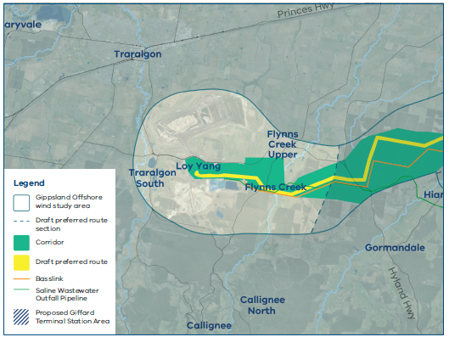

Landholder and community feedback
Since early 2023, we’ve been speaking with landholders and the wider Gippsland community about the proposed transmission line.
What we’ve heard
Community and landholders want the transmission line to:
• Follow or stay close to existing infrastructure where possible.
• Use public land and plantations instead of private land where possible.
• Avoid native vegetation, sensitive habitats and species.
• Reduce impacts on private landholders and farming businesses.
What landholders have told us about their properties
Landholders have shared detailed information that’s helping us refine the design, including:
• Land use farming – crop and livestock practices.
• Environment – local plants and animals.
• Cultural and historical features – significant buildings, connections to the land.
• Amenity – scenic viewpoints and places of value on their properties.
• Infrastructure – homes, sheds, irrigation systems and other key structures.
We appreciate the time landholders have taken to provide this information. It’s shaping how we plan and refine the project.

Speaking with landholders in the draft preferred route
We’re now looking to speak with landholders in and near the draft preferred route area to seek further feedback and input.
The preferred route and location of transmission towers will be shaped by:
• detailed site investigations and field surveys
• input from landholders, key stakeholders, communities and Traditional Owners.
Our landholder engagement team will contact landholders in and near the corridor and draft preferred route by phone, letter and through property visits.
We’ll be asking for more detailed input and seeking long-term access to properties for investigations. This will help us identify:
• the most suitable route for the transmission line
• where towers could be placed
• any specific issues or construction considerations.

Next steps
1. Detailed studies and engagement
We’re continuing detailed site investigations, technical assessments and discussions with landholders, Traditional Owners and asset owners to help determine the preferred route.
We know we need to undertake further technical work and environmental studies, alongside community and landholder feedback, to help refine the route.
2. Confirming a preferred route
We intend to announce a preferred route in early 2026.
The preferred route is a key component of the reference design which will form part of the Environment Effects Statement public documents.
3. Working with a delivery partner
We’ll then work closely with a delivery partner to:
• set the final easement (70-100 metres wide)
• confirm the exact location of the towers (spaced about 450-500 metres apart)
• design, build and maintain the transmission line
• negotiate payments with landholders.
We’ll continue to keep landholders informed as these steps progress and provide support throughout the process.

